小程序 获取二维码：

https://developers.weixin.qq.com/miniprogram/dev/api/qrcode.html

图片前缀 : <http://ticket.pc-online.cc/upload/>

取小程序用户信息 ：<http://ticket.pc-online.cc/mobile/applet/get_weixin>

保存小程序用户信息：

[http://ticket.pc-online.cc/mobile/applet/wxuser_add](http://ticket.pc-online.cc/mobile/applet/pro_list)

参数：【openid,country,province,city,gender,nickName,avatarUrl】

首页 活动列表

<http://ticket.pc-online.cc/mobile/applet/pro_list>?keyword= &city= &mid= &page=

参数：keyword 标题关键字 city 城市id，0或空为全部

mid 活动方id page 页数

返回：

{

"status": 0,

"data": {

"list": [{

"id": "210",

"activity": "sector", //活动方

"goods_name": "标题新发布产品", //标题图片

"type": "1", //1单日，2本月多日，3跨月多日

"city": "2", //城市

"cover": "11\/2017\/1203\/1512316058870.png", //logo图

"cover2": "11\/2017\/1203\/1512316058870.png", //封面

"status": "1",

"begin": "2017-12-23", //开始日期

"end": "",

"minprice": "100", //最小价格

"date": "12\/23", //显示的日期

"is_end": "end" //end是结束，over是售罄

}, {}]

}

}

1. 产品详情

[http://ticket.pc-online.cc/mobile/applet/product_info?tid=2](http://ticket.pc-online.cc/mobile/applet/product_info?tid=1)0 参数为活动的id

{

"status": 0,

"data": {

"person": [{ //人物列表

"img": "11\/2018\/0729\/1532860889443.jpg", //logo

"picture": "11\/2018\/0729\/1532873571769.jpg" //人物照片

}, {

"img": "11\/2018\/0729\/1532873577518.jpg",

"picture": "11\/2018\/0729\/1532873582056.jpg"

}],

"info": {

"id": "20",

"activity": "丛林文化", //活动方

"mobile": "+86 137-2553-8273", //电话

"type": "3",

"city": "2", // 城市

"goods_name": "丛林文化", //活动标题

"address": "深圳市宝安西乡",

"cover": "11\/2017\/0908\/1504875469209.png", // logo图

"cover2": "11\/2018\/0729\/1532860774632.jpg", // 封面图

"goods_desc": "活动简介活动简介活动简介活动简介活动简介活动简介活动简介活动简介活动简介",

"notify": ["本消费券只能在深圳使用", "未满18岁请勿购买，概不退款", "显示器活动简介活动简介"], //须知多条

"status": "1",

"begin": "2017-10-09",

"end": "2017-10-13",

"hour_b": "20",

"hour_e": "",

"is_post": "0", //是否邮寄，1 是

"is_idnum": "0", //是否填身份证， 1是

"minprice": "5", //最小价格

"sale_start": "1504875360", //开始销售时间

"sale_end": "1504876360",

"date": "10\/09-10\/13",

"image_arr": ["11\/2017\/0908\/1504875502220.jpg", "11\/2017\/0908\/1504875531261.jpg"], //详情多图

"is_end": "end",

"total": 200

},

"anew": [{ //票种表

"select": "预售", //票种名

"price": "5", // 价格

"nums": "100", //数量

"max": "2", //最多可卖张数

"is_over": 0

}, {

"select": "普通",

"price": "100",

"nums": "100",

"max": "2",

"is_over": 0

}],

"recommend": [{ //推荐列表

"id": "19",

"activity": "sector",

"goods_name": "测试标题",

"type": "1",

"cover": "11\/2017\/0908\/1504875310230.png",

"cover2": "",

"begin": "2017-09-09",

"end": "2017-09-09",

"goods_img": "11\/2017\/0908\/1504875829356.jpg|11\/2017\/0908\/1504875852754.jpg",

"date": "09\/09",

"image": "11\/2017\/0908\/1504875829356.jpg"

}, {

"id": "20",

"activity": "丛林文化",

"goods_name": "丛林文化",

"type": "3",

"cover": "11\/2017\/0908\/1504875469209.png",

"cover2": "",

"begin": "2017-10-09",

"end": "2017-10-13",

"goods_img": "11\/2017\/0908\/1504875502220.jpg|11\/2017\/0908\/1504875531261.jpg",

"date": "10\/09-10\/13",

"image": "11\/2017\/0908\/1504875502220.jpg"

}]

}

}

三．城市列表及banner

<http://ticket.pc-online.cc/mobile/applet/city_banner>

返回类型

{

"status": 0,

"data": {

"citys": [{

"id": "1",

"name": "北京",

"pid": "0",

"rank": "0"

}, {

"id": "2",

"name": "深圳",

"pid": "0",

"rank": "0"

}, {

"id": "3",

"name": "上海",

"pid": "0",

"rank": "0"

}, {

"id": "4",

"name": "广州",

"pid": "0",

"rank": "0"

}, {

"id": "5",

"name": "佛山",

"pid": "0",

"rank": "0"

}],

"cover": "11\/2018\/0714\/1531559219757.jpg", //banner图片

"blink": "http:\/\/www.baidu.com" //链接

}

}

四．隶属于 页面

<http://ticket.pc-online.cc/mobile/applet/member>

{

"status": 0,

"data": {

"member": "隶属于隶属于\n隶属于"

}

}

1. 保险条例 页面

http://ticket.pc-online.cc/mobile/applet/insurance

{

"status": 0,

"data": {

"insurance": "保险条例保险条例\n保险条例"

}

}

1. 售后声明 页面

http://ticket.pc-online.cc/mobile/applet/aftersales

{

"status": 0,

"data": {

"aftersales": "售后声明售后声明\n售后声明\n售后声明"

}

}

1. 联系方式 页面

<http://ticket.pc-online.cc/mobile/applet/contact>

{

"status": 0,

"data": {

"contact": "联系方式联系方式\n联系方式\n联系方式"

}

}

1. 提交订单

<http://ticket.pc-online.cc/mobile/applet/create_order>

参数post:

tid 活动Id

name 姓名

mobile 手机

nums 数量

address 地址

sele 票种

返回：（还要调试）

1. 提交保险信息

[http://ticket.pc-online.cc/mobile/applet/safe_person](http://ticket.pc-online.cc/mobile/applet/create_order)

参数：order_num 订单号

person 保险人信息 ，数组格式 array(0=>array(‘username’=>’李炎宗’, ’mobile’=>’13800138000’, ‘idnum’=>’44092119.....’));

十．用户订单中心

[http://ticket.pc-online.cc/mobile/applet/user_order](http://ticket.pc-online.cc/mobile/applet/create_order)

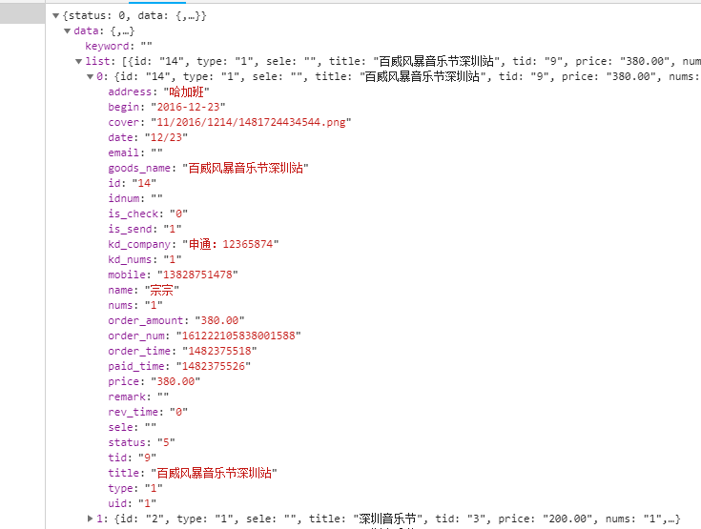

/************************** 特饮部分 *********************************/

一．特饮专栏

<http://ticket.pc-online.cc/mobile/applet/drink_list>?city=&page=1&keyword=

city: 城市 page：页数 keyword：关键字

{

"status": 0,

"data": {

"list": [{

"id": "1",

"drink_name": "波特嘉金色气泡酒 x 2",

"rank": "0",

"city": "2",

"price": "150.00",

"address": "深圳宝安西乡固戍二路22",

"cover": "11\/2018\/0731\/1533021820830.jpg",

"logo_pic": "11\/2018\/0731\/1533021778437.png",

"show_pic": "11\/2018\/0731\/1533021832485.jpg",

"order_pic": "11\/2018\/0731\/1533021848088.jpg",

"status": "1",

"sale_start": "1531724220",

"sale_end": "1532069820",

"is_post": "1",

"is_idnum": "2",

"ctime": "1531724632"

}],

"nums": "1"

}

}

1. 特饮详情

<http://ticket.pc-online.cc/mobile/applet/drink_info?id=1>

{

"status": 0,

"data": {

"info": {

"id": "1",

"drink_name": "波特嘉金色气泡酒 x 2",

"rank": "0",

"city": "2",

"price": "150.00",

"address": "深圳宝安西乡固戍二路22",

"cover": "11\/2018\/0731\/1533021820830.jpg",

"logo_pic": "11\/2018\/0731\/1533021778437.png",

"show_pic": "11\/2018\/0731\/1533021832485.jpg",

"order_pic": "11\/2018\/0731\/1533021848088.jpg",

"status": "1",

"sale_start": "1531724220",

"sale_end": "1532069820",

"is_post": "1",

"is_idnum": "2",

"ctime": "1531724632"

}

}

}

1. 创建订单

<http://ticket.pc-online.cc/mobile/applet/news_order>

1. 购买成功

[http://ticket.pc-online.cc/mobile/applet/b](http://ticket.pc-online.cc/mobile/applet/news_order)uysuccess

1. 特饮订单中心

[http://ticket.pc-online.cc/mobile/applet/o](http://ticket.pc-online.cc/mobile/applet/news_order)rder_center

六．订单详情

[http://ticket.pc-online.cc/mobile/applet/order](http://ticket.pc-online.cc/mobile/applet/news_order)_info?oid=