测试版代码所在svn 路径: svn://120.24.159.167/tau

前端页面所在目录：

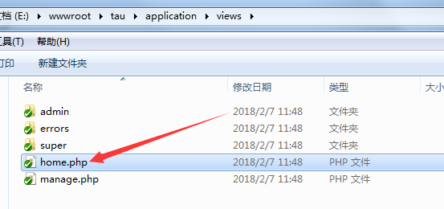

图片、样式等所在目录：

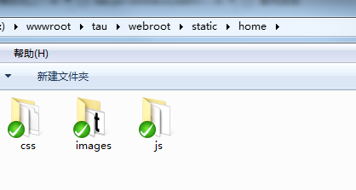

1. 关于页

<http://tau.pc-online.cc/admin/api/ajax_about>

返回：

{

"intro": "何方 设计事务所（HO）......", //公司简介

"idea": "策略 Strategy\n设计策略是辨识设计条件和制定”, //业务范围

"video_link": "http:\/\/www.baidu.com\/video", //视频链接

"audio_link": "http:\/\/www.youku.com\/audio", //音频链接

"man_img":["11\/2018\/0205\/1517841568636.jpg", "11\/2018\/0205\/1517841578714.jpg"], //人物图片链接（多个）

"person_desc": ["hilhklioiooo", "klj;lkhjlfjytdtyj"] //人物介绍

}

1. 联系页

http://tau.pc-online.cc/admin/api/ajax_contacts

返回：

{

"contact": "李先生",

"email": "explode@email.com",

"mobile": "13800138000",

"address": "广东省深圳市宝安区",

"wx_number": "wxdfldieekj",

"ewm_url": "11\/2018\/0204\/1517756227436.jpg"

}

1. 产品列表

http://tau.pc-online.cc/admin/api/product_list

返回：

{

"status": 1,

"msg": "返回成功",

"data": {

"list": [{

"id": "11",

"type": "优秀案例",

"title": "小游戏集合",

"cate": "4",

"cover": "11\/2018\/0207\/1517986258019.png",

"goods_img": "11\/2018\/0207\/1517986262387.png|11\/2018\/0207\/1517988509543.png",

"goods_desc": "小游戏集合小游戏集合小游戏集合小游戏集合",

"video_link": "http:\/\/www.baidu.com\/video",

"audio_link": "",

"h5_link": "",

"rank": "1",

"ctime": "1517986280"

}, {

"id": "10",

"type": "普通案例",

"title": "测试产品",

"cate": "1",

"cover": "11\/2018\/0207\/1517983513601.png",

"goods_img": "11\/2018\/0207\/1517983231909.png|11\/2018\/0207\/1517983517239.png",

"goods_desc": "土木工程回测试",

"video_link": "http:\/\/tau.pc-online.cc\/video",

"audio_link": "http:\/\/tau.pc-online.cc\/audio",

"h5_link": "http:\/\/tau.pc-online.cc\/admin\/h5",

"rank": "2",

"ctime": "1517984031"

}],

"nums": "2"

}

}

1. 产品详情

<http://tau.pc-online.cc/admin/api/product_info?id=10> 参数

返回：

{

"status": 1,

"msg": "返回成功",

"data": {

"id": "10",

"type": "普通案例",

"title": "测试产品",

"cate": "1",

"cover": "11\/2018\/0207\/1517983513601.png",

"goods_img": "11\/2018\/0207\/1517983231909.png|11\/2018\/0207\/1517983517239.png",

"goods_desc": "土木工程回测试",

"video_link": "http:\/\/tau.pc-online.cc\/video",

"audio_link": "http:\/\/tau.pc-online.cc\/audio",

"h5_link": "http:\/\/tau.pc-online.cc\/admin\/h5",

"rank": "2",

"ctime": "1517984031"

}

}