Static Firmware Security Analysis
of the TP-Link TL-WR841N Router
A Comparative Study Across Hardware Revisions V10, V13 & V14
with STRIDE, OWASP IoT Top 10, and ETSI EN 303 645 Assessment

Author: Atharva
Field of Study: Cybersecurity & Embedded Systems
Background: B.E. Electronics and Telecommunication Engineering
Date: March 2026
Type: Independent Research Project

Abstract
This report presents a comprehensive static firmware security analysis of the TP-Link TL-WR841N wireless router, one of the world's most widely deployed consumer-grade networking devices. Three firmware versions spanning seven years of development — V10 (2015), V13 (2017), and V14 (2022) — were systematically extracted, deconstructed, and evaluated using industry-standard reverse engineering tools and three complementary security frameworks: STRIDE threat modeling, OWASP IoT Top 10, and ETSI EN 303 645 regulatory compliance.
Critical persistent deficiencies were identified: absence of TLS/SSL, missing binary exploit mitigations (stack canaries, PIE, FORTIFY), decade-old software components (BusyBox v1.01, Linux kernel 2.6.x), MD5-hashed default credentials, and zero firmware integrity verification. Four CVEs (CVSS 6.1–8.8) were verified as applicable through component-level evidence. A quantitative risk assessment assigns a composite security score of 2.1/10. The report bridges Electronics and Telecommunication Engineering (ECE) with cybersecurity through detailed analysis of MIPS hardware architecture, physical attack surfaces (UART/JTAG), and hardware-software trust boundaries.
Keywords: Firmware Analysis, IoT Security, STRIDE, OWASP IoT Top 10, ETSI EN 303 645, Embedded Systems, Reverse Engineering, MIPS Architecture, Hardware Security

Executive Summary
This research analyzed the TP-Link TL-WR841N router firmware across three hardware revisions to evaluate the manufacturer's security practices over a seven-year period. The key findings are:
- ALL management traffic is unencrypted (no TLS/HTTPS) — admin credentials transmitted in cleartext
- ZERO binary exploit mitigations (no stack canaries, PIE, or FORTIFY) — buffer overflows lead directly to code execution
- Decade-old components: Linux kernel 2.6.x (EOL), BusyBox v1.01/v1.19.2, uClibc — hundreds of known CVEs
- MD5-hashed default credentials with root privileges (UID 0) — crackable in seconds with modern hardware
- No firmware signing or integrity verification — malicious firmware can be flashed undetected
- Four verified CVEs (CVSS 6.1–8.8) applicable to the latest firmware version
- Non-compliant with 11 of 13 ETSI EN 303 645 provisions (EU IoT security baseline)
- Fails 9/10 OWASP IoT Top 10 categories — highest risk tier for consumer IoT
- Composite security score: 2.1/10 — critical systemic risk
These findings demonstrate that cost-optimized consumer IoT devices remain fundamentally insecure and require both regulatory pressure and secure-by-design engineering practices to address.

Table of Contents
1. Introduction
2. Background and Related Work
3. Methodology
4. Environment Setup
5. Firmware Acquisition and Verification
6. Firmware Extraction and Architecture Analysis
7. Security Analysis
8. STRIDE Threat Model Assessment
9. OWASP IoT Top 10 Assessment
10. ETSI EN 303 645 Compliance Evaluation
11. CVE Cross-Reference and Verification
12. Quantitative Risk Assessment
13. Attack Chain Analysis
14. Comparative Analysis
15. The ECE-Cybersecurity Bridge: Hardware Security Perspective
16. Discussion
17. Conclusion and Recommendations
18. Responsible Disclosure Statement
19. References
20. Appendix

1. Introduction

1.1 Motivation
The proliferation of Internet of Things (IoT) devices has fundamentally reshaped the modern threat landscape. Consumer-grade wireless routers, serving as the primary gateway between home networks and the internet, represent a particularly high-value target for adversaries. The TP-Link TL-WR841N, with its extensive global deployment and budget-oriented market positioning, provides an ideal case study for examining the security posture of mass-market embedded networking devices.
As a graduate of Electronics and Telecommunication Engineering (ECE), this research represents a natural convergence of hardware-level systems understanding with cybersecurity principles. The ability to analyze firmware at the binary level — understanding memory architectures, processor instruction sets, hardware-software interfaces, and physical attack surfaces — is a perspective uniquely informed by an engineering foundation. This dual expertise enables analysis at the silicon-to-application layer stack, bridging domains that are traditionally siloed.

1.2 Research Questions
- RQ1: What security vulnerabilities persist across multiple firmware revisions of the TL-WR841N?
- RQ2: Has the manufacturer demonstrated measurable security improvement over seven years of development?
- RQ3: How does the device's security posture compare against established frameworks (STRIDE, OWASP IoT Top 10, ETSI EN 303 645)?
- RQ4: What role do hardware-level design decisions play in the overall security architecture?

1.3 Contributions
This research makes the following contributions: (1) A longitudinal security analysis spanning three hardware revisions and seven years; (2) A triple-framework assessment combining STRIDE, OWASP IoT Top 10, and ETSI EN 303 645; (3) A quantitative risk scoring methodology for embedded firmware; (4) A detailed examination of the hardware-software security boundary from an ECE perspective; and (5) Verified CVE applicability through component-level filesystem evidence.

1.4 Scope and Limitations
This analysis is limited to static analysis — the firmware images are examined without executing them on hardware or in emulation. Dynamic analysis techniques such as fuzzing, runtime debugging, and network traffic capture are outside the scope of this study. All firmware images were obtained from official TP-Link repositories to ensure provenance integrity.

2. Background and Related Work

2.1 Embedded Firmware Architecture
Modern embedded devices such as wireless routers employ a layered firmware architecture consisting of: a Bootloader (typically U-Boot) that initializes hardware and loads the kernel; an Operating System Kernel (typically Linux) that manages hardware resources; a Root Filesystem (typically SquashFS) containing userspace applications and configuration; and a Configuration Partition storing user settings. This mirrors hardware initialization: the SoC boot ROM loads the bootloader from flash, which configures DRAM and peripheral controllers, loads the kernel, which mounts the compressed root filesystem. Understanding this hardware-software layering is essential for comprehensive security analysis.

2.2 Security Assessment Frameworks

2.2.1 STRIDE Threat Model
STRIDE is a threat modeling framework developed by Microsoft that categorizes threats into six classes (Shostack, 2014):
Category | Description | Violated Property
Spoofing | Impersonating a user or system | Authentication
Tampering | Unauthorized modification of data | Integrity
Repudiation | Denying having performed an action | Non-repudiation
Information Disclosure | Exposing data to unauthorized parties | Confidentiality
Denial of Service | Making a service unavailable | Availability
Elevation of Privilege | Gaining unauthorized capabilities | Authorization

2.2.2 OWASP IoT Top 10
The OWASP IoT Top 10 (2018) identifies the ten most critical security risks in IoT devices, providing an industry-consensus vulnerability taxonomy specifically designed for embedded and connected devices.

2.2.3 ETSI EN 303 645
ETSI EN 303 645 (2020) is the European standard for consumer IoT cybersecurity, defining 13 mandatory provisions. As of 2025, compliance is increasingly required for IoT products sold within the EU under the Cyber Resilience Act. Evaluating firmware against this standard demonstrates regulatory awareness and practical applicability.

2.3 Related Work
Costin et al. (2014) conducted the first large-scale automated analysis of 32,000+ firmware images, identifying widespread weak cryptography and hardcoded credentials. Chen et al. (2016) developed FIRMADYNE for automated dynamic analysis. Shoshitaishvili et al. (2015) introduced Firmalice for authentication bypass detection via symbolic execution. Feng et al. (2020) presented scalable binary analysis for IoT firmware. This research extends these foundations by combining manual static analysis with triple-framework assessment and a hardware security perspective.

2.4 The TP-Link TL-WR841N
The TP-Link TL-WR841N is a 300Mbps wireless N router in continuous production since approximately 2012. Its ubiquity, low cost (under $20 USD), and extensive deployment make it a representative target for consumer IoT security research. The device runs custom Linux-based firmware on a MIPS processor.

3. Methodology

3.1 Multi-Framework Analysis Approach
Unlike single-framework assessments, this research applies three complementary frameworks: STRIDE provides systematic threat identification at the component level; OWASP IoT Top 10 provides industry-consensus risk prioritization; ETSI EN 303 645 provides regulatory compliance evaluation. This triangulation ensures comprehensive coverage and enables cross-validation of findings.
The analysis follows a structured six-phase methodology: (1) Environment Setup, (2) Firmware Acquisition, (3) Firmware Extraction, (4) Security Analysis, (5) CVE Verification, and (6) Comparative Analysis.

3.2 Tools and Technologies
Tool | Purpose
Binwalk | Firmware signature scanning, extraction, and entropy analysis
checksec | Binary exploitation mitigation assessment
Firmwalker | Automated filesystem security scanning
strings / grep / find | String extraction and pattern matching
file / sha256sum | Binary identification and hash verification

3.3 Target Firmware Versions
Version | Hardware Rev. | Build Date | Region | Firmware Size
V10 | 10 | 2015-03-10 | Global (EN) | ~3.4 MB
V13 | 13 | 2017-06-22 | EU | ~4.8 MB
V14 | 14 | 2022-01-21 | US | ~4.4 MB

4. Environment Setup
The analysis was conducted on a Windows Subsystem for Linux 2 (WSL2) environment running Ubuntu, providing a native Linux toolchain with Windows host accessibility. All required tools were installed and verified as operational.
Figure 1: Tool installation confirmation — binwalk, checksec, firmwalker, and Python verified.
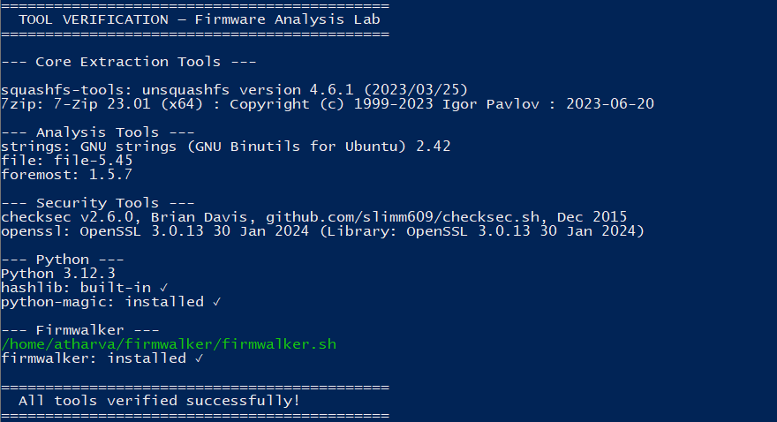

5. Firmware Acquisition and Verification
All firmware images were obtained from the official TP-Link download portal to ensure authenticity and chain-of-custody integrity. Cryptographic hashes (SHA-256 and MD5) were computed for all firmware images and recorded for reproducibility. File type identification confirmed binary firmware format.
Version | Filename
V10 | wr841nv10_wr841ndv10_en_3_16_9_up_boot(150310).bin
V13 | TL-WR841Nv13_EU_0.9.1_4.16_up_boot[170622-re164334].bin
V14 | TL-WR841Nv14_US_0.9.1_4.19_up_boot[220121-re158074].bin

Figure 2: SHA-256 hashes, MD5 hashes, file type identification, and file sizes for all three firmware images.
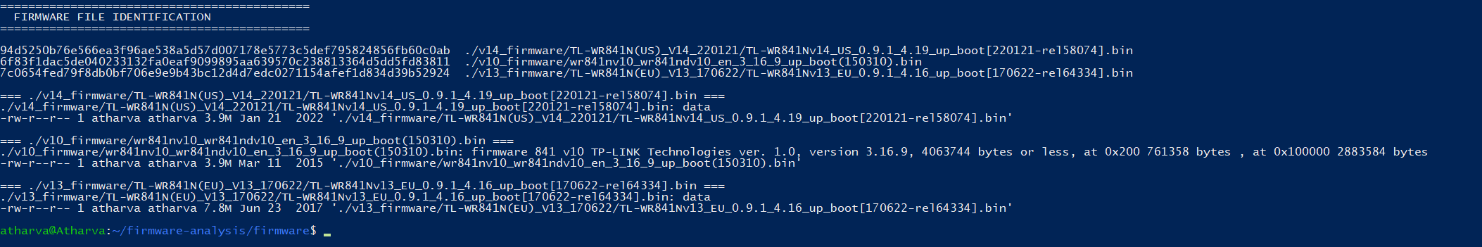
(Part 1 of 2)
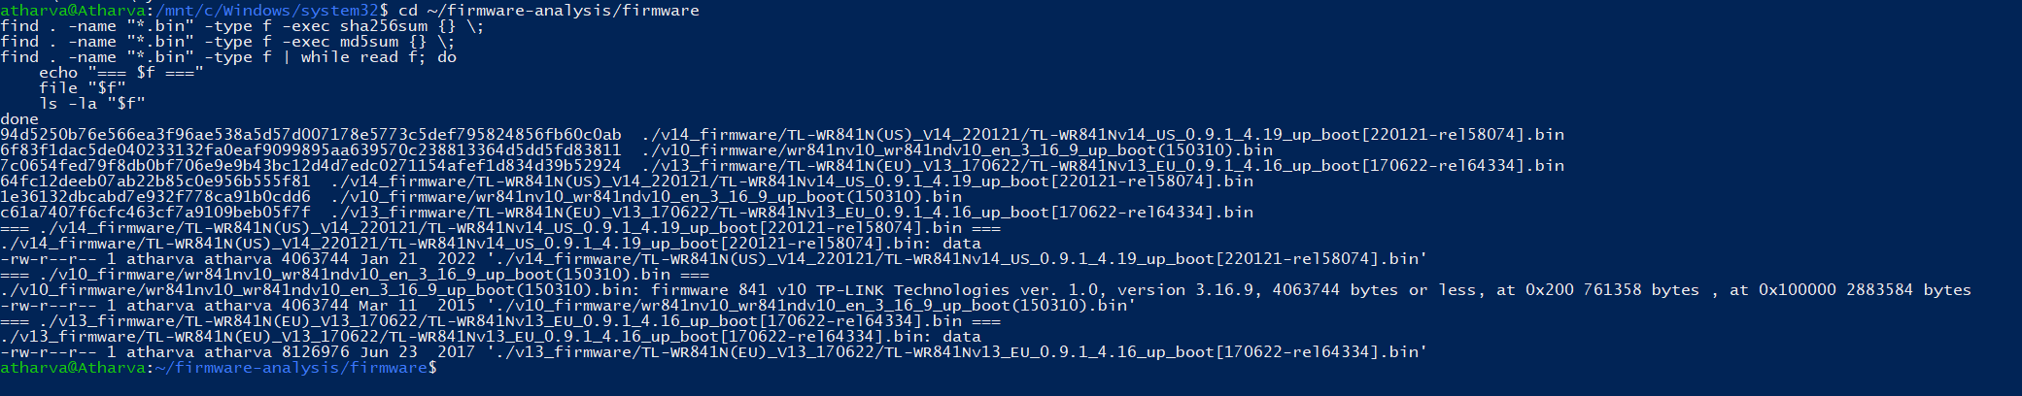
(Part 2 of 2)

6. Firmware Extraction and Architecture Analysis

6.1 Binwalk Signature Scanning
Each firmware image was scanned using binwalk to identify embedded components through signature matching. The scan reveals U-Boot bootloader headers, compressed Linux kernel (LZMA), and SquashFS filesystem — the characteristic three-layer structure of embedded Linux devices. This directly reflects the hardware initialization sequence: SoC boot ROM → bootloader → kernel → filesystem.
Figure 3: Complete binwalk signature scan output for all three firmware versions.
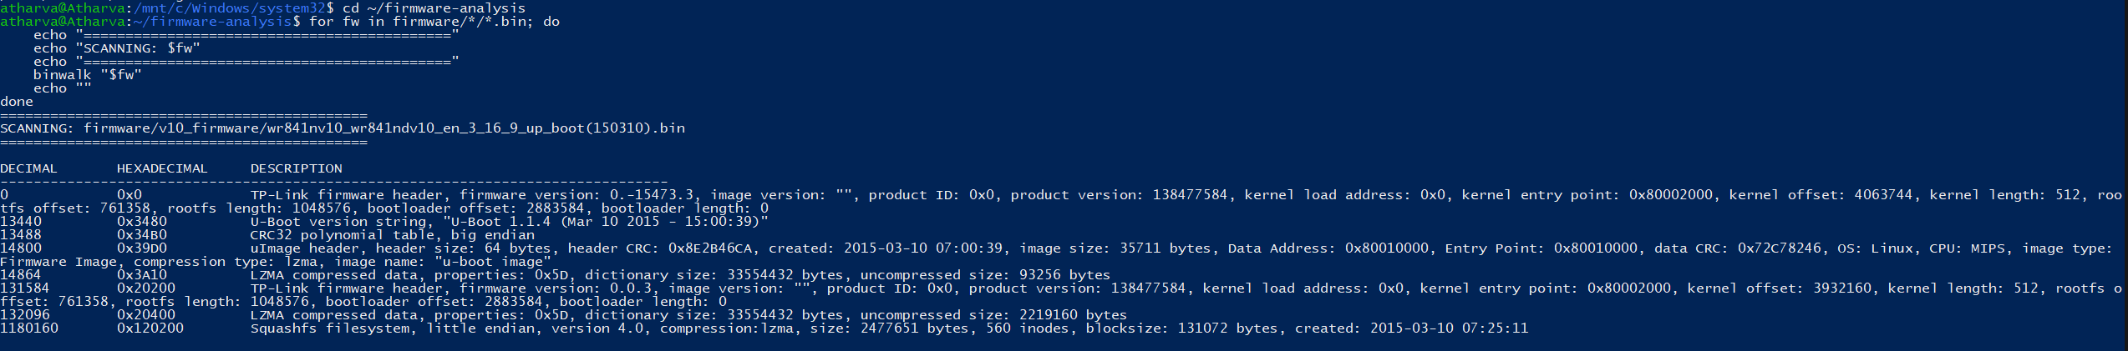

6.2 Entropy Analysis
Entropy analysis revealed high entropy (0.8–1.0) in compressed regions and low entropy in plaintext areas. No uniformly high-entropy sections were found, indicating that no firmware-level encryption is employed. The firmware can be freely extracted, modified, and reflashed — a significant security concern as it means there are no cryptographic barriers to firmware tampering.
Figure 4: Entropy graphs (PNG) for all three firmware versions.
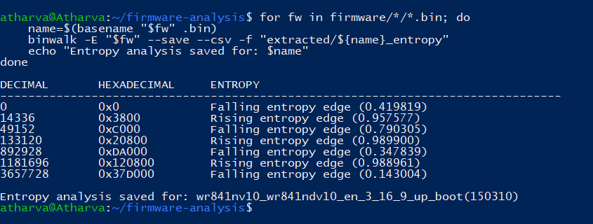

6.3 Recursive Extraction
Version | Extracted Size | SquashFS Root Found
V10 | 23 MB | Yes
V13 | 29 MB | Yes
V14 | 22 MB | Yes

Figure 5: Extracted directory structure confirming successful extraction for all three versions.
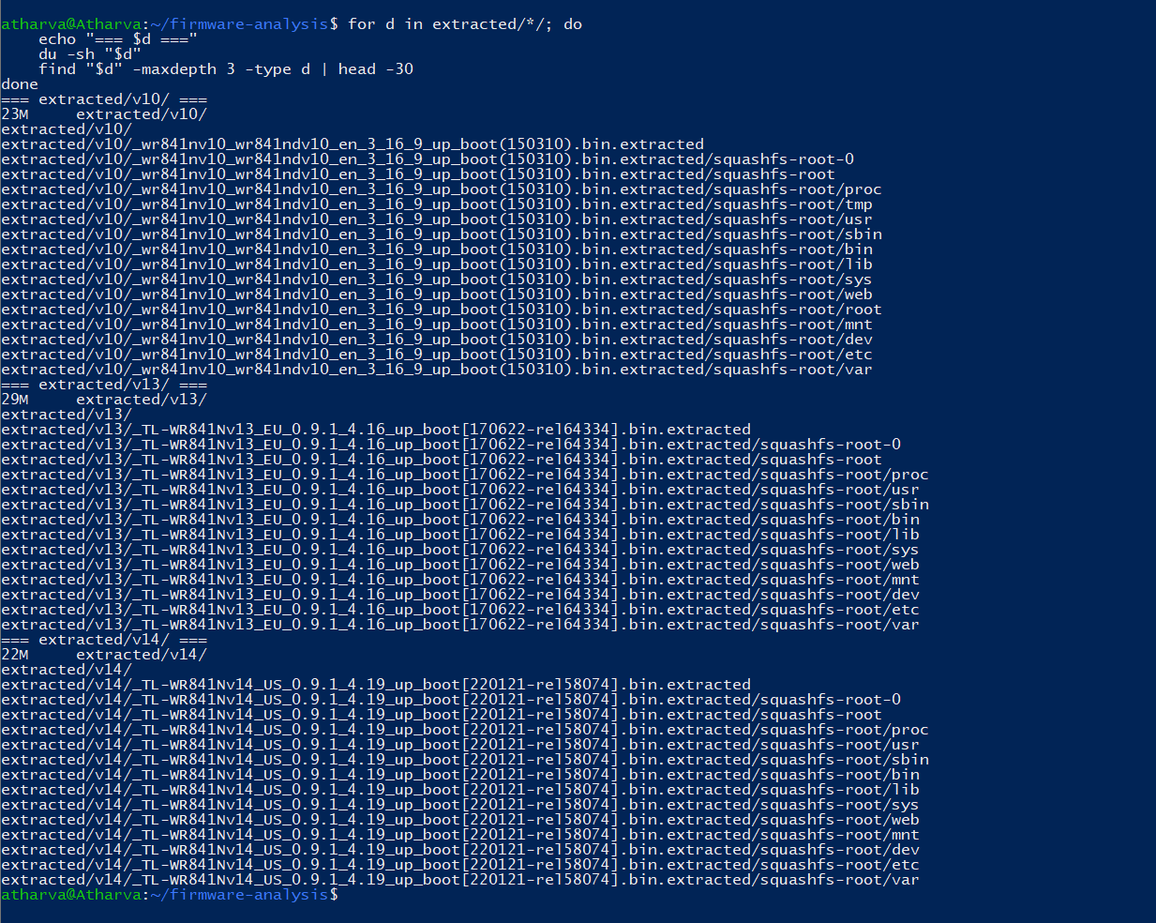

6.4 Root Filesystem Analysis
Each extracted SquashFS root contains a standard Linux filesystem layout:
Directory | Purpose | Security Relevance
/bin | Core binaries (BusyBox symlinks) | Command injection targets
/etc | Configuration files | Credentials, passwd, shadow
/lib | Shared libraries (uClibc) | Crypto library absence
/sbin | System binaries (httpd, dropbear) | Network service binaries
/usr | User utilities | Additional tools
/web | HTTP server files (HTML/JS) | XSS attack surface
/var | Variable data | Runtime state
/dev | Device nodes | Hardware interfaces
/proc | Process information | System information disclosure

The linuxrc → bin/busybox symlink confirms BusyBox serves as the init system. Notable: V10 includes /tmp and /root directories not present in V13/V14, suggesting filesystem structure changes during the platform migration.
Figure 6: Root filesystem listing (ls -la) for all three versions showing Linux directory structure.
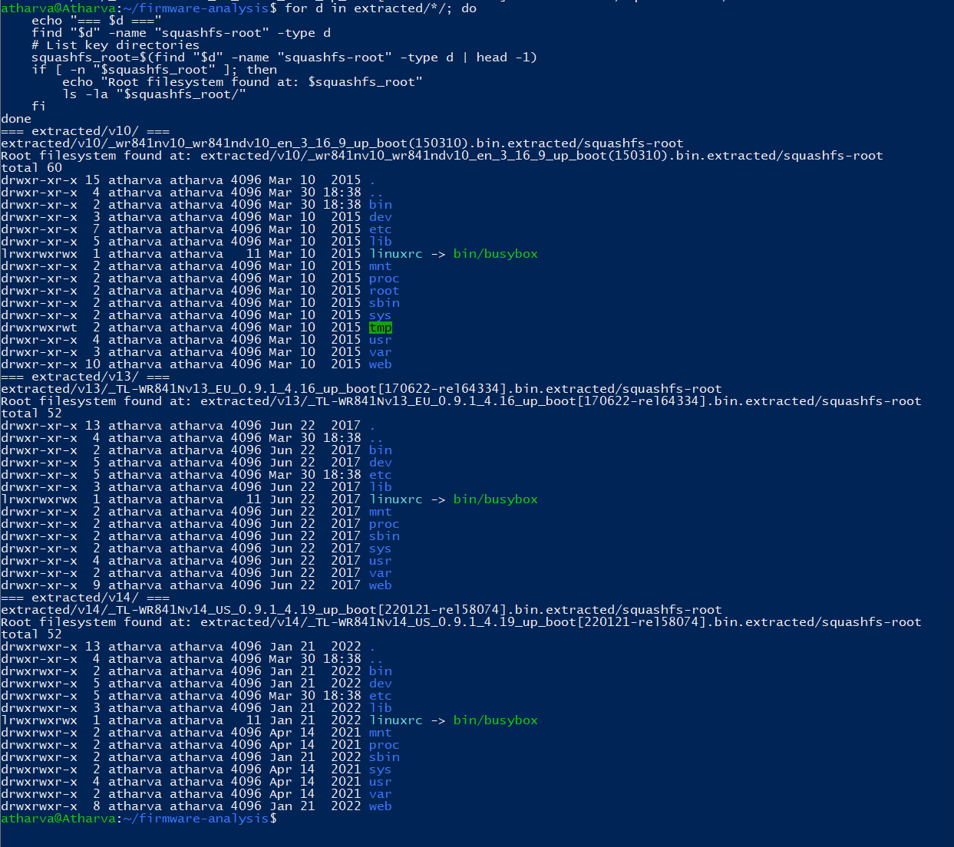

6.5 Architecture Summary
Property | V10 | V13 | V14
ELF Format | 32-bit MSB (Big-Endian) | 32-bit LSB (Little-Endian) | 32-bit LSB (Little-Endian)
ISA | MIPS32 Release 2 | MIPS32 Release 2 | MIPS32 Release 2
Linking | Dynamic (uClibc) | Dynamic (uClibc) | Dynamic (uClibc)

The endianness change between V10 (Big-Endian) and V13/V14 (Little-Endian) indicates a hardware platform change — likely from an Atheros AR9341 to a MediaTek MT7628 SoC. From a security perspective, exploits targeting V10 cannot directly transfer to V13/V14 due to reversed byte ordering in memory addresses and ROP gadgets.

7. Security Analysis

7.1 Authentication and Credential Security

7.1.1 Default Credentials
A passwd.bak file was discovered containing hardcoded administrative credentials:
admin:$1$$iC.dUSGpkNNJGeOm1dFio/:0:0:root:/:/bin/sh
This reveals: $1$ prefix = MD5-based hashing (cryptographically broken since 2004, Wang & Yu); UID 0 = root-level privileges; /bin/sh = full shell access. This finding was consistent across ALL three firmware versions. Modern GPU cracking tools can exhaust the MD5 keyspace at 50+ billion hashes/second.
Additionally, RT2860AP.dat contains hardcoded WPS test key 'scaptest' and disabled WPA rekeying (RekeyMethod=DISABLE) — test artifacts shipped in production firmware.
STRIDE Classification: Spoofing — default credentials enable unauthorized admin impersonation.
Figure 7: Hardcoded credentials, /etc/passwd entries, and configuration file passwords across all versions.
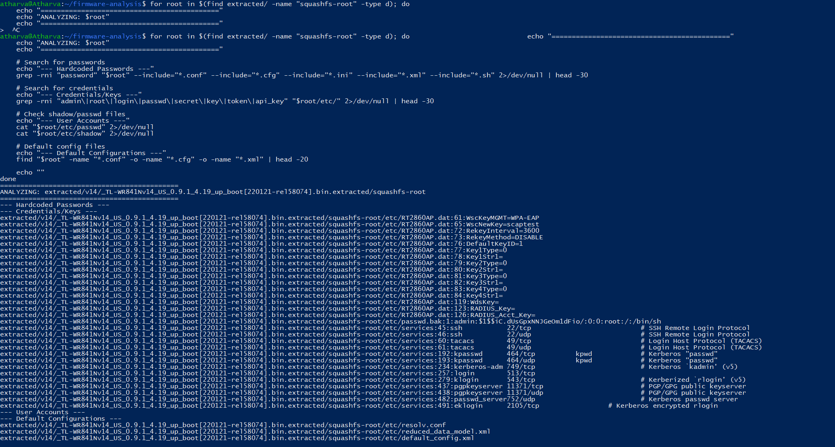
(Part 1 of 2)
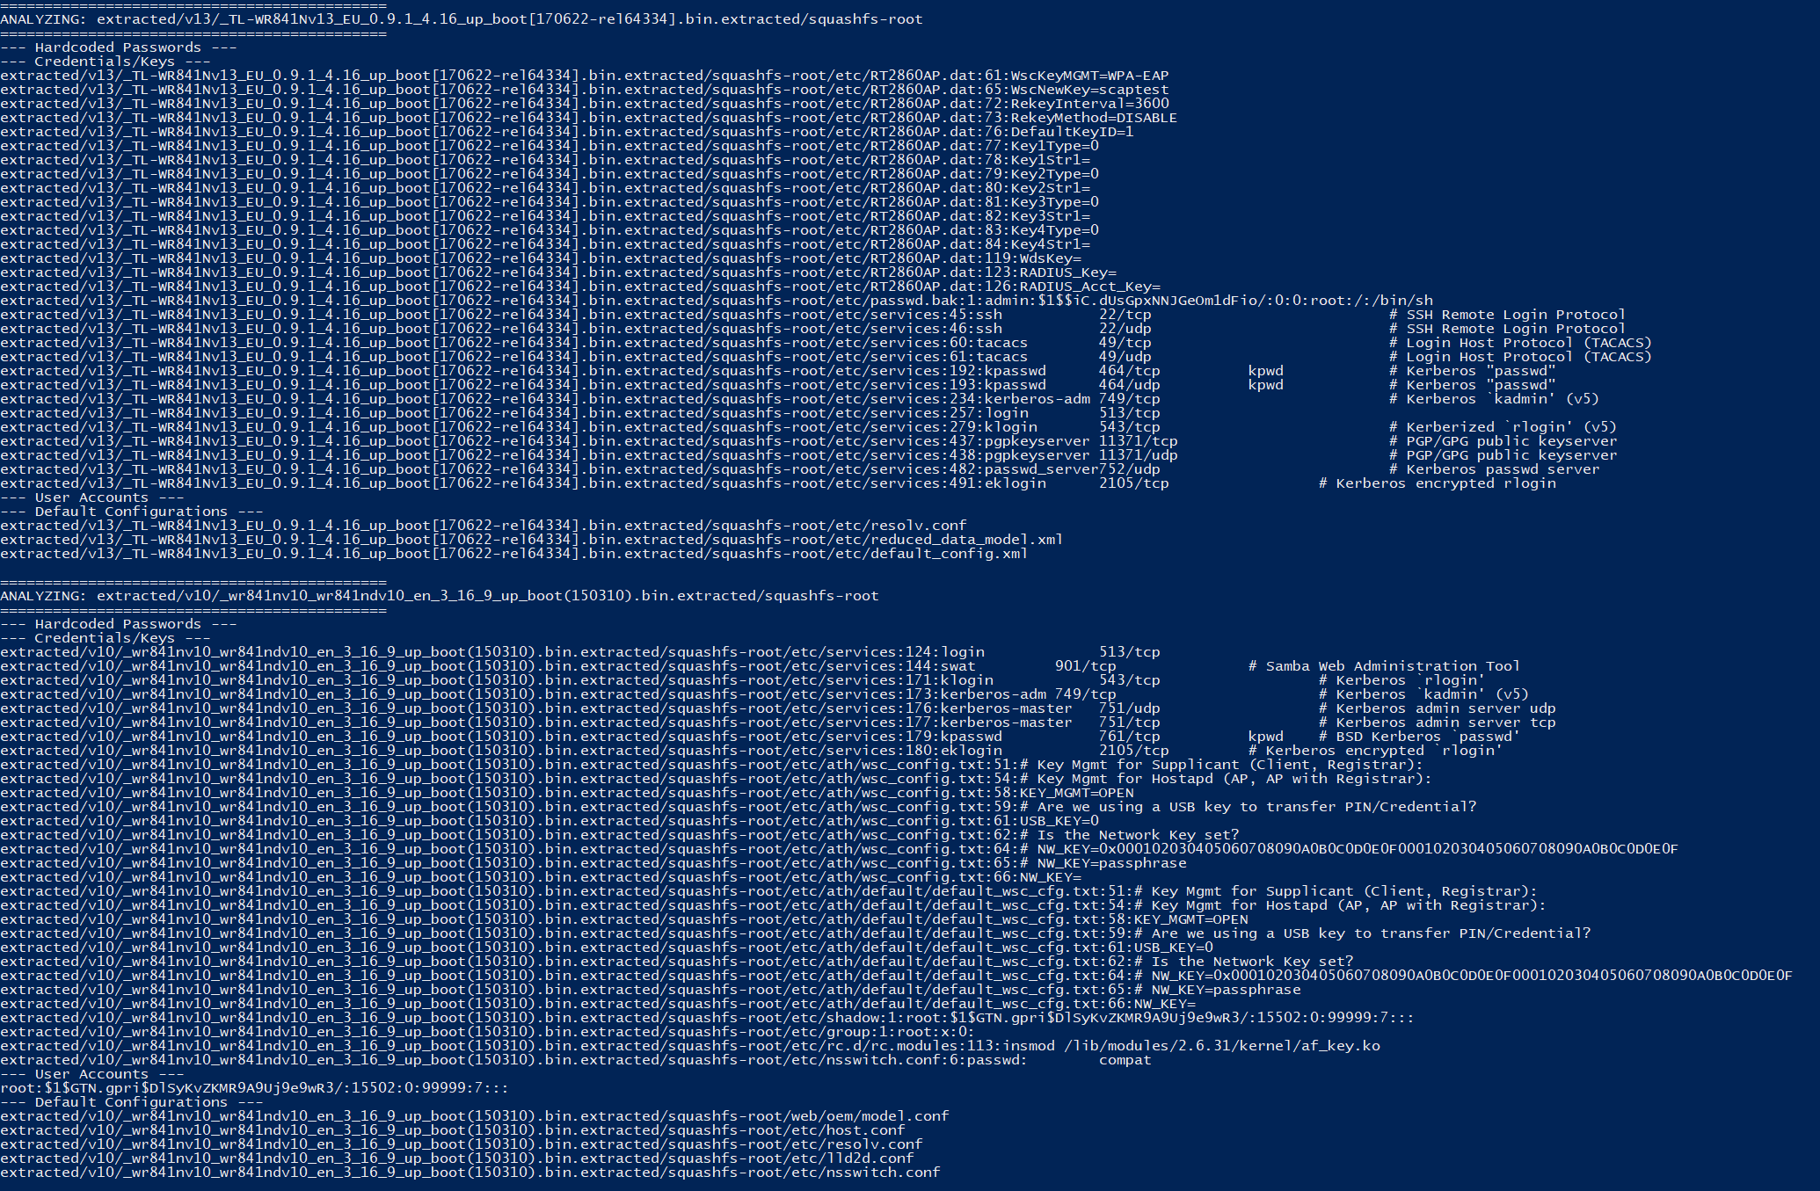
(Part 2 of 2)

7.2 Cryptographic Security
CRITICAL FINDING: A comprehensive search yielded a critical negative finding — NO SSL/TLS certificates, private keys, or OpenSSL libraries exist in ANY firmware version. The router's web management interface operates exclusively over unencrypted HTTP, exposing admin credentials to network-level eavesdropping by any device on the network.
STRIDE Classification: Information Disclosure — all administrative traffic transmitted in cleartext.
Figure 8: Cryptographic findings search confirming complete absence of TLS/SSL infrastructure.
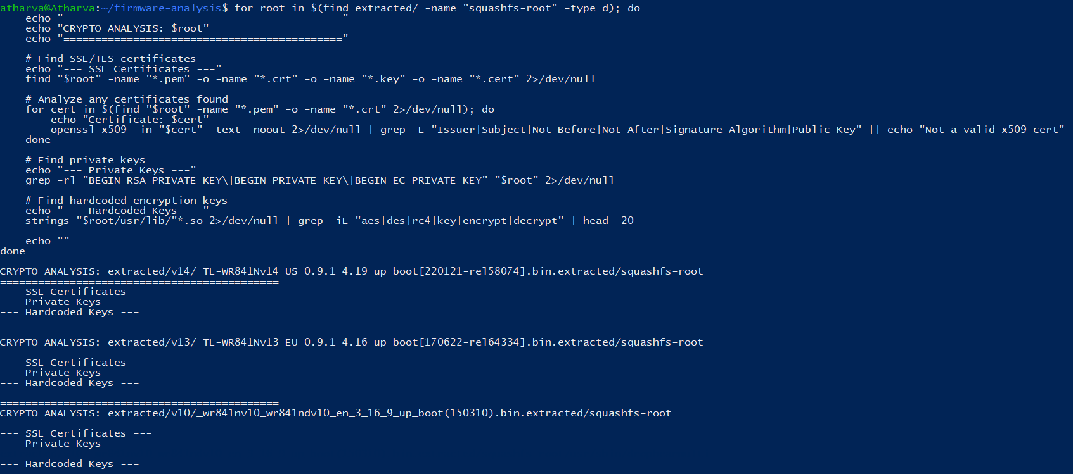

7.3 Network Services
Service | Binary | V10 | V13 | V14 | Risk Level
HTTP Server | httpd | Yes | Yes | Yes | High — unencrypted admin
Dropbear SSH | dropbear | Yes | Yes | Yes | Medium — remote shell
UPnP | upnpd | No | Yes | Yes | High — auto port forwarding
TFTP | tftp | Yes | Yes | Yes | High — no authentication
Serial Console | getty ttyS0 | Yes | No | No | Critical — physical root access

V10 includes a serial console at 115200 baud (ttyS0), providing direct root shell access via UART pins. UPnP, introduced in V13, actually increased the attack surface by enabling automatic port forwarding that can be abused by malware.
STRIDE: Elevation of Privilege (root services), Denial of Service (UPnP NAT exhaustion).
Figure 9: Network services, init scripts, and service binaries across all versions.
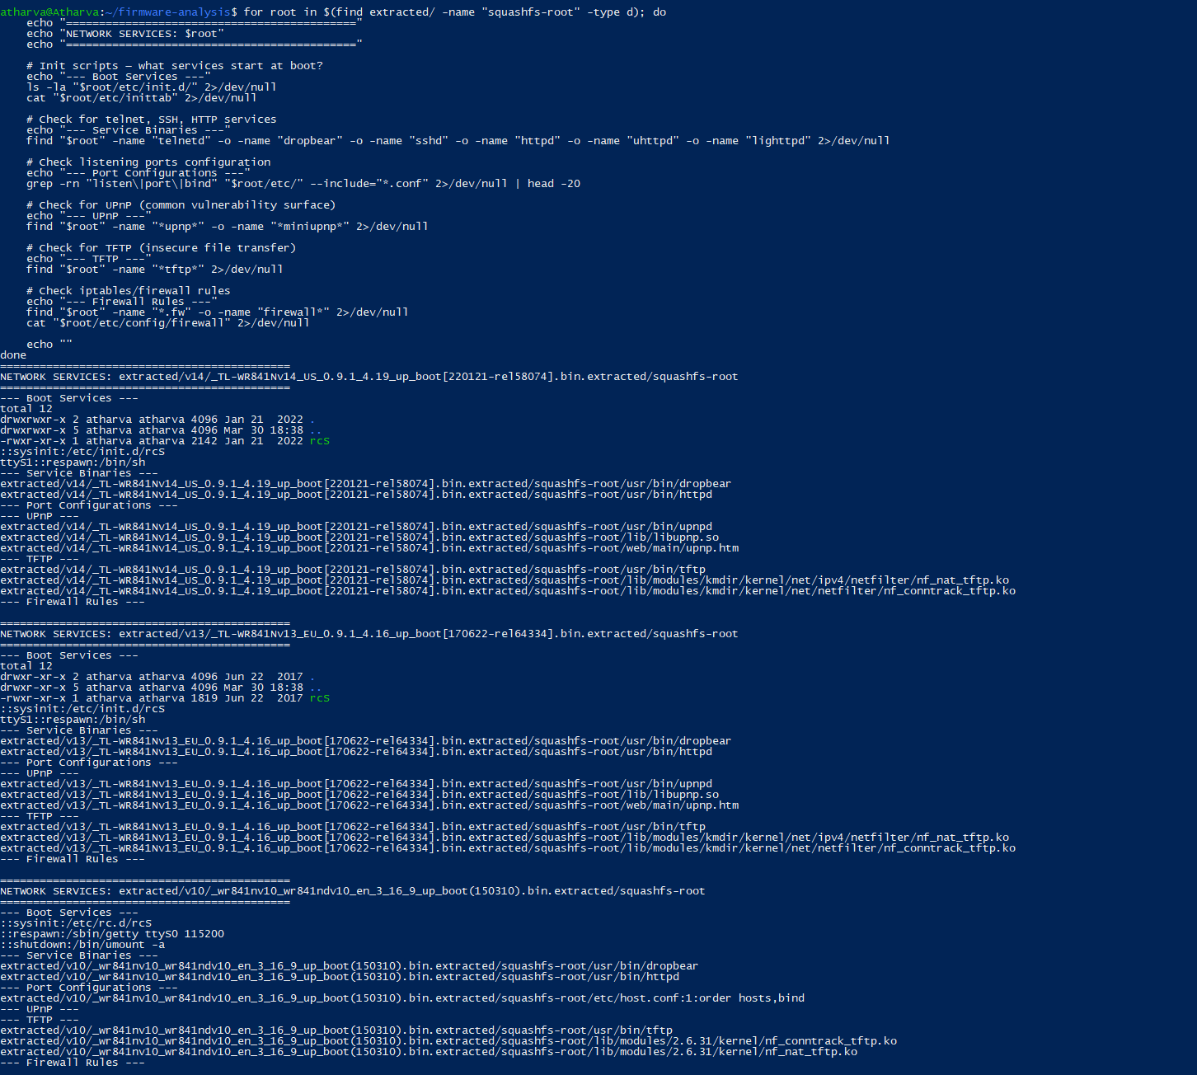

7.4 Binary Exploitation Mitigations
Protection | Description | V10 | V13 | V14 | Impact of Absence
Stack Canary | Detects stack buffer overflows | NO | NO | NO | Buffer overflow → code execution
NX | Prevents stack code execution | YES | YES | YES | Only consistent protection
PIE | Randomizes binary addresses | NO | NO | NO | Fixed addresses enable reliable ROP
RELRO | Protects GOT table | Partial | Partial | Partial | GOT overwrite partially mitigated
FORTIFY | Bounds checking for unsafe functions | NO | NO | NO | strcpy/sprintf remain exploitable

The only protection enabled is NX — a hardware feature of the MIPS32 Release 2 XI (Execute Inhibit) bit. The MIPS toolchain fully supports stack canaries (-fstack-protector-strong) and FORTIFY (-D_FORTIFY_SOURCE=2), but these compiler flags were not enabled. This indicates a deficiency in the secure development lifecycle rather than a technical limitation.
Figure 10: Full checksec output with color-coded protection status for all critical binaries.
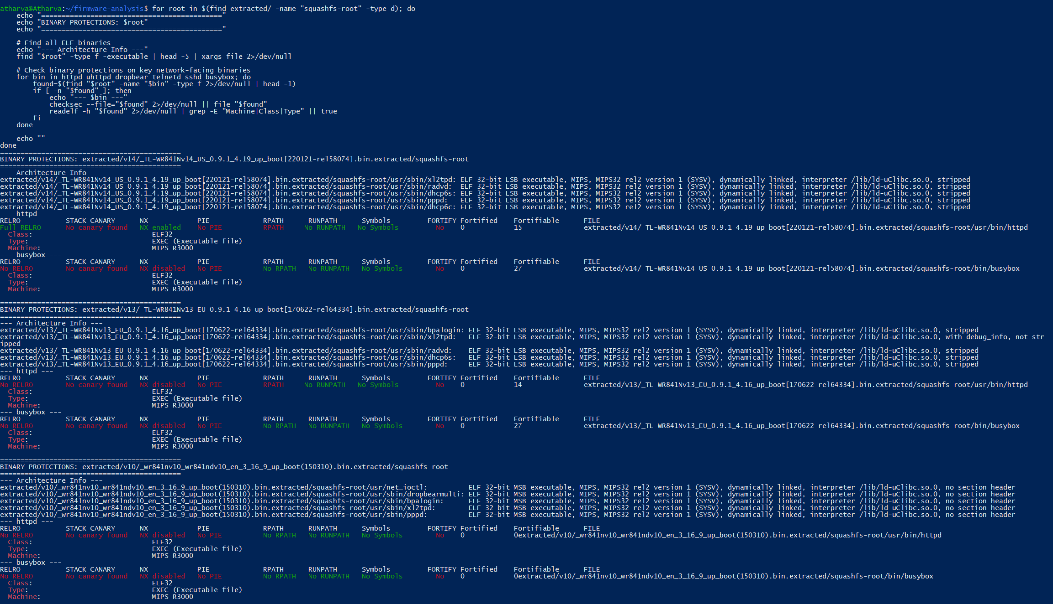

7.5 Software Component Analysis

7.5.1 BusyBox
Firmware | BusyBox Version | Build Date | Age at Build
V10 | v1.01 | 2015-03-10 | ~11 years old
V13 | v1.19.2 | 2017-06-22 | ~5 years old
V14 | v1.19.2 | 2022-01-21 | ~10 years old

V13 and V14 use the IDENTICAL BusyBox version despite being built five years apart — TP-Link did not update this fundamental component. V10's BusyBox v1.01 is from ~2004 with numerous known CVEs.
Figure 11: BusyBox version strings extracted from each firmware.
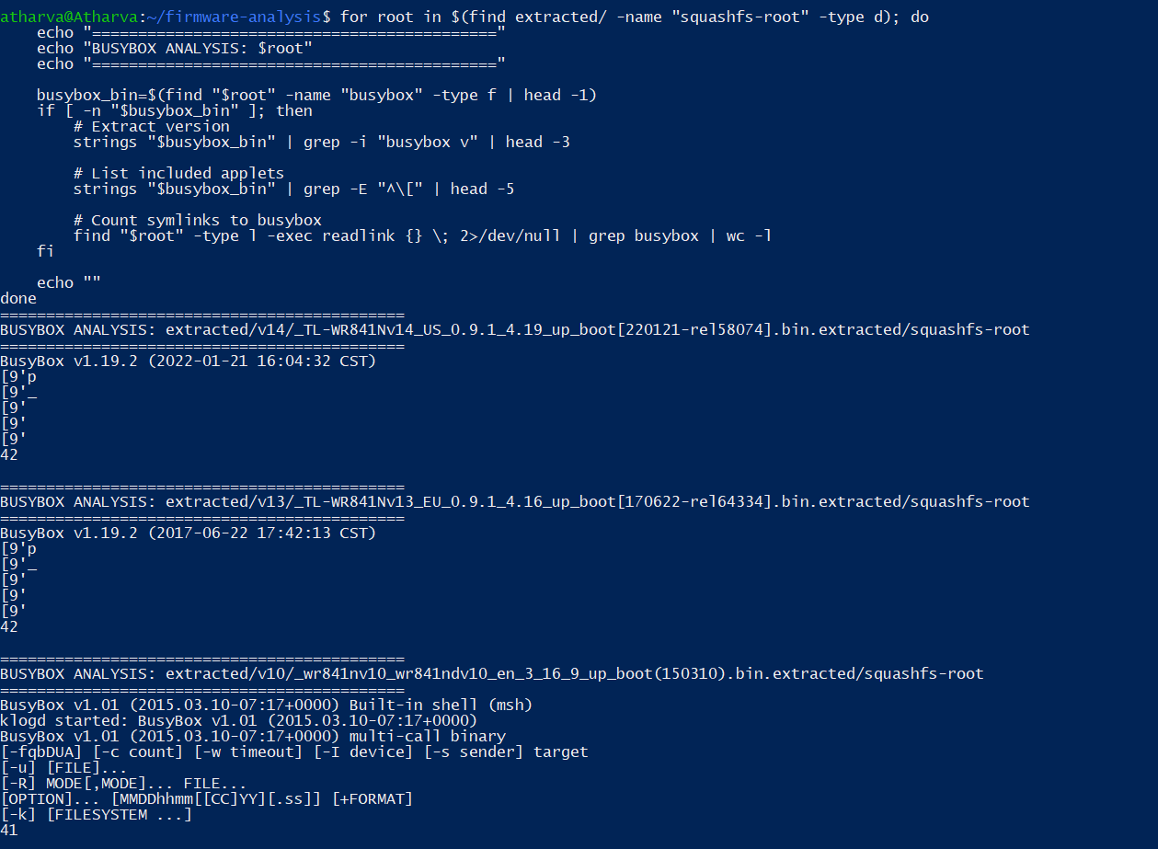

7.5.2 Linux Kernel
Firmware | Kernel Version | Release Year | Status
V10 | 2.6.31 | 2009 | EOL — no patches since ~2010
V13 | 2.6.36 | 2010 | EOL — no patches since ~2011
V14 | 2.6.36 | 2010 | EOL — shipped in 2022 with 12-year-old kernel

Figure 12: Kernel version identification and C library versions.
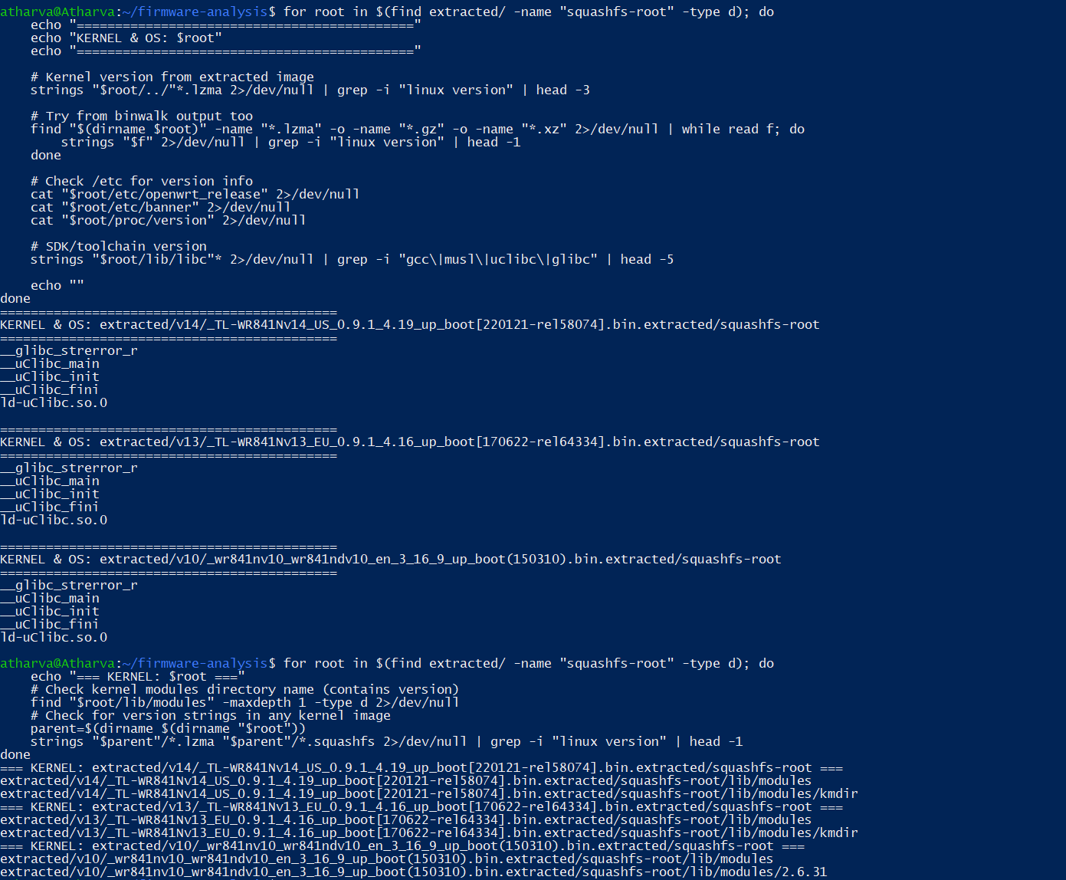

7.5.3 C Library and Crypto Libraries
Component | V10 | V13 | V14
C Library | uClibc 0.9.30 (2008) | uClibc 0.9.33.2 (2012) | uClibc 0.9.33.2 (2012)
OpenSSL | NONE | NONE | NONE
libssl | NONE | NONE | NONE
libcrypto | NONE | NONE | NONE

The firmware is architecturally incapable of encrypted communications — no cryptographic libraries exist in any version.
Figure 13: Complete library version audit across all versions.
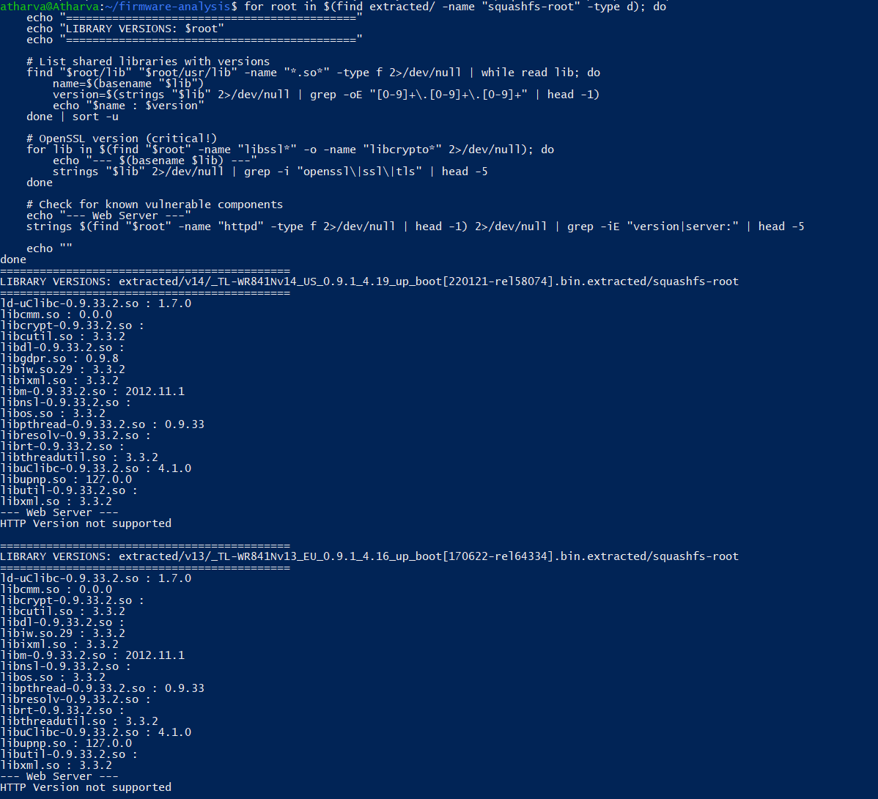
(Part 1 of 2)
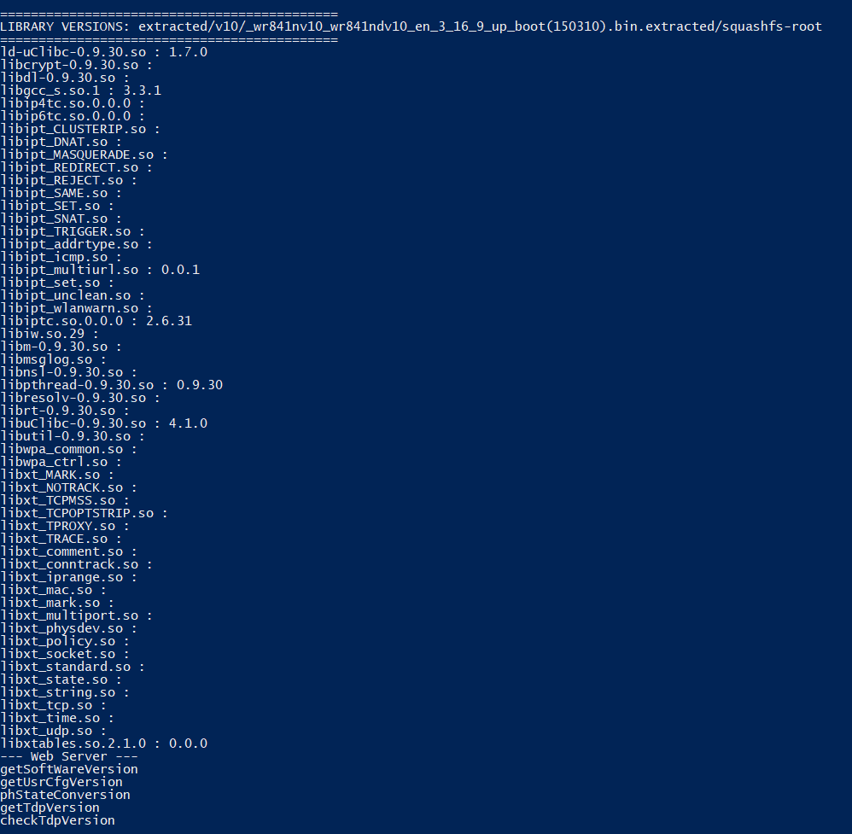
(Part 2 of 2)

7.6 Automated Scanning (Firmwalker)
Firmwalker automated scanning confirmed password files (/etc/passwd, /etc/shadow) in all versions, identified configuration files (model.conf, resolv.conf, TLd2d.conf, default_config.xml), and confirmed the absence of SSH keys and SSL certificates.
Figure 14: Firmwalker scan output for all three firmware versions.
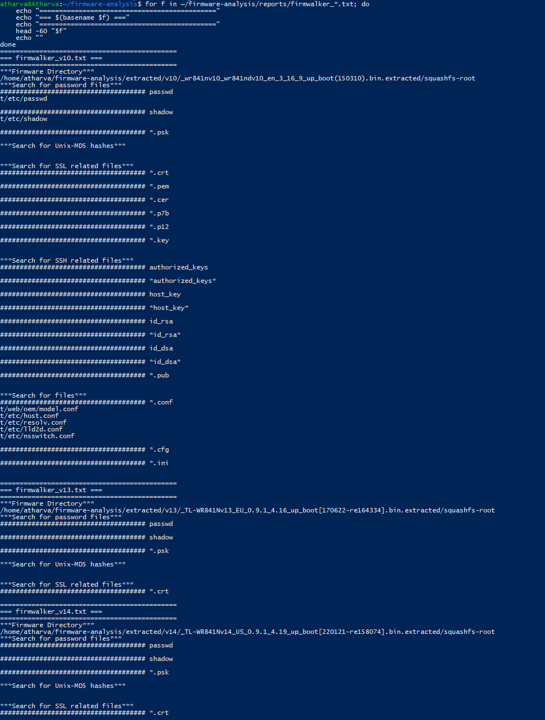

7.7 Web Interface Security
XSS Vector | V10 | V13 | V14
eval() calls | 0 files | 1 file | 0 files
innerHTML | 33 files | 65 files | 46 files
document.write() | 74 files | 6 files | 7 files

V10's 74 document.write() calls represent older XSS-prone coding practice. V13 introduced eval() — the most dangerous DOM method. All versions exhibit significant cross-site scripting attack surface. STRIDE: Spoofing (weak auth) and Tampering (XSS enables session hijacking).
Figure 15: Web interface XSS vector counts and authentication file identification.
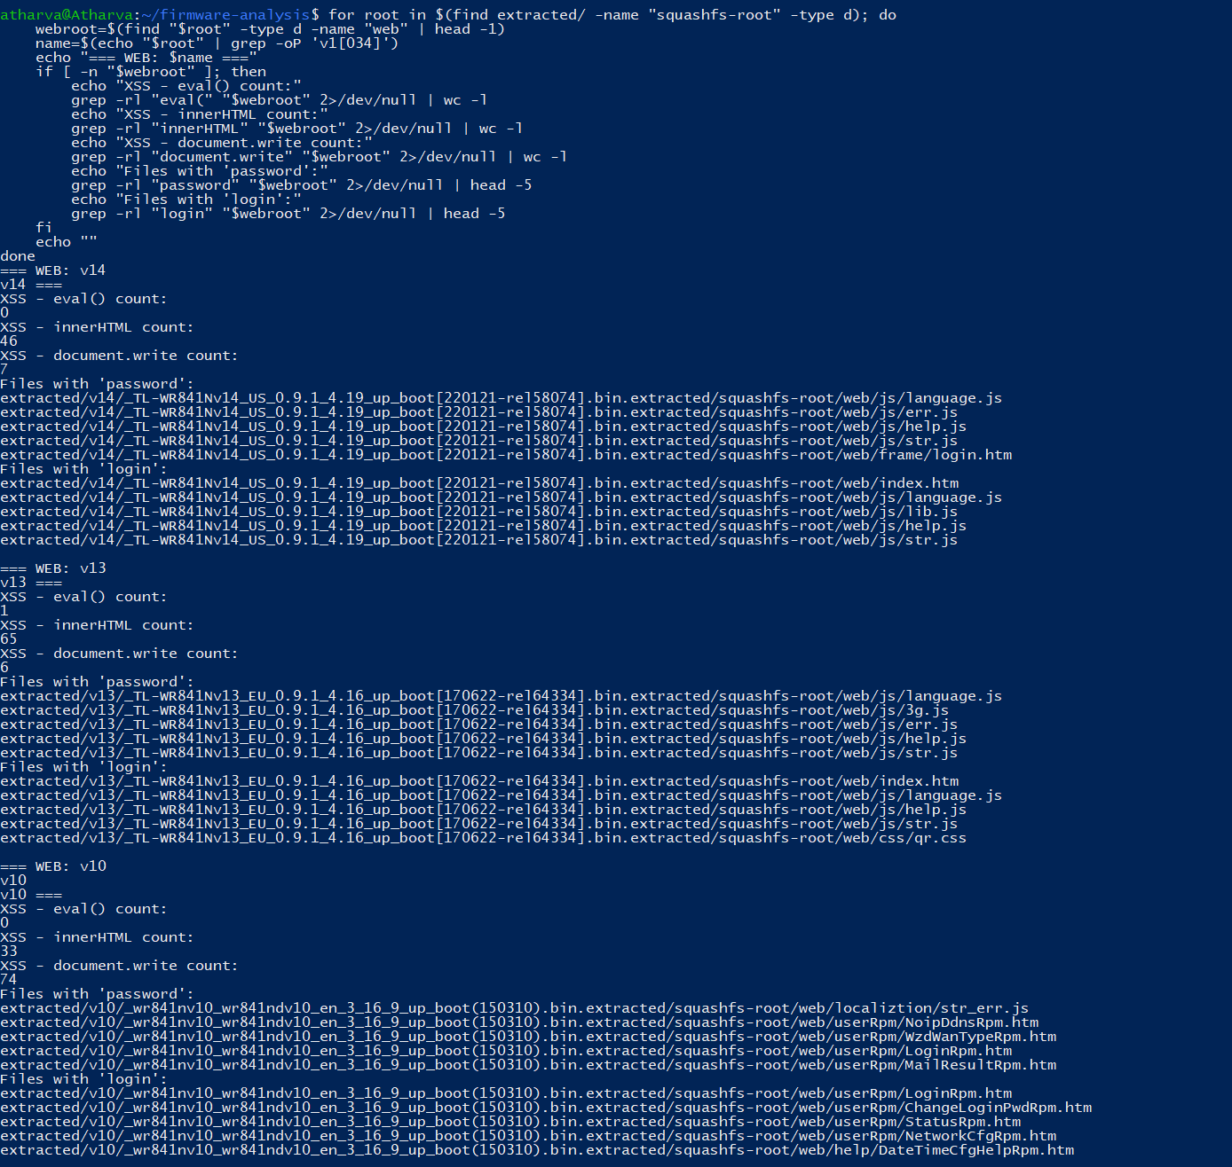

8. STRIDE Threat Model Assessment
Each STRIDE category was assessed through targeted filesystem analysis, configuration review, and binary inspection:
STRIDE Category | Key Findings | Severity | Versions Affected
[S] Spoofing | MD5 default password, UID 0 admin, HTTP-only (no TLS), hardcoded WPS key | Critical | All
[T] Tampering | No firmware signing (.sig/.md5/fwcheck absent), no stack canaries, no FORTIFY | Critical | All
[R] Repudiation | Minimal syslog (UDP 514) only, no persistent logging, read-only SquashFS | Medium | All
[I] Info Disclosure | No TLS/SSL, cleartext traffic, passwd.bak with crackable MD5 hash exposed | Critical | All
[D] DoS | session_timeout=0, idle_timeout=0, no resource limits, UPnP NAT exhaustion | High | V13, V14
[E] Elevation | Admin = root (UID 0), all services run as root, no privilege separation | Critical | All

The complete absence of firmware integrity verification is one of the most critical findings. A modified firmware containing backdoors can be flashed via the standard upgrade mechanism undetected. Combined with HTTP-only management, an attacker can intercept credentials and upload malicious firmware in a single attack chain.
Figure 16: STRIDE-specific indicator analysis across all firmware versions.
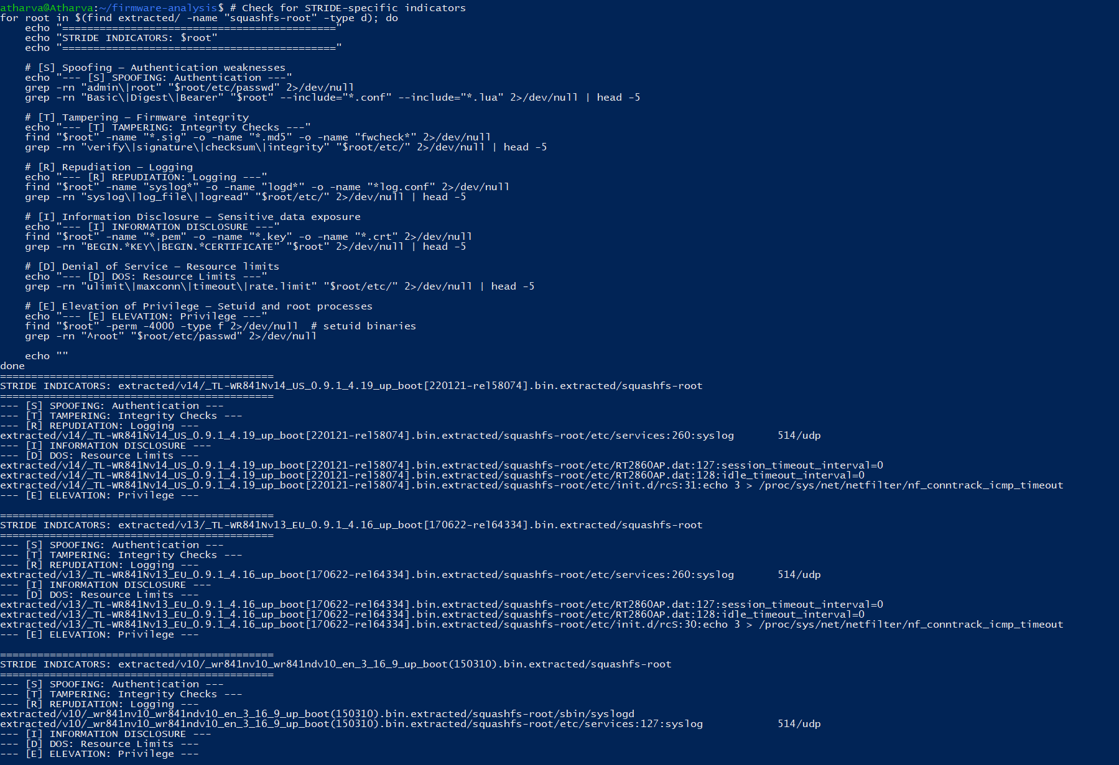

9. OWASP IoT Top 10 Assessment
The OWASP IoT Top 10 (2018) provides industry-consensus risk categorization. Each vulnerability class is evaluated against our firmware findings:
# | OWASP IoT Category | Status | Evidence
I1 | Weak/Guessable/Hardcoded Passwords | FAIL | MD5-hashed 'admin' default, hardcoded WPS key 'scaptest'
I2 | Insecure Network Services | FAIL | UPnP without auth, TFTP without auth, all services as root
I3 | Insecure Ecosystem Interfaces | FAIL | HTTP-only web interface, no input validation, XSS vectors
I4 | Lack of Secure Update Mechanism | FAIL | No firmware signing, no integrity verification, no rollback
I5 | Use of Insecure/Outdated Components | FAIL | Kernel 2.6.x (2009-2010), BusyBox v1.01, uClibc 0.9.30
I6 | Insufficient Privacy Protections | FAIL | Cleartext credentials, no encrypted storage
I7 | Insecure Data Transfer/Storage | FAIL | No TLS, no encrypted config storage, plaintext passwords
I8 | Lack of Device Management | PARTIAL | Web interface exists but lacks session mgmt (timeout=0)
I9 | Insecure Default Settings | FAIL | Default admin/admin, UPnP enabled, no forced password change
I10 | Lack of Physical Hardening | FAIL | UART console (V10), no secure boot, no flash encryption

Result: The device FAILS 9 of 10 OWASP IoT Top 10 categories and partially fails the 10th. This places the TL-WR841N in the highest risk tier for consumer IoT devices.

10. ETSI EN 303 645 Compliance Evaluation
ETSI EN 303 645 is the European standard for consumer IoT cybersecurity, increasingly mandated under the EU Cyber Resilience Act. Compliance evaluation against all 13 provisions:
Provision | Requirement | Compliance | Evidence
5.1 | No universal default passwords | NON-COMPLIANT | Identical MD5 default across all units
5.2 | Implement vulnerability disclosure policy | UNKNOWN | No evidence in firmware (external check needed)
5.3 | Keep software updated | NON-COMPLIANT | Identical components V13->V14 over 5 years
5.4 | Securely store credentials | NON-COMPLIANT | MD5 hash, passwd.bak in readable filesystem
5.5 | Communicate securely | NON-COMPLIANT | No TLS/SSL capability whatsoever
5.6 | Minimize exposed attack surface | NON-COMPLIANT | UPnP, TFTP, unnecessary services enabled
5.7 | Ensure software integrity | NON-COMPLIANT | No firmware signing or verification
5.8 | Ensure personal data protection | NON-COMPLIANT | Credentials in cleartext over HTTP
5.9 | Make systems resilient to outages | PARTIAL | Basic watchdog but no graceful degradation
5.10 | Examine telemetry data | NON-COMPLIANT | Minimal syslog, no security event monitoring
5.11 | Make deletion easy | NON-COMPLIANT | No factory reset verification mechanism found
5.12 | Make installation easy | COMPLIANT | Standard setup wizard present
5.13 | Validate input data | NON-COMPLIANT | XSS vectors (innerHTML, eval), no input sanitization

Result: The TL-WR841N is NON-COMPLIANT with 11 of 13 ETSI EN 303 645 provisions. Under the EU Cyber Resilience Act, this device would not meet the minimum security requirements for sale in the European market. This finding has significant implications for regulatory compliance and consumer protection.

11. CVE Cross-Reference and Verification
Known CVEs were cross-referenced against component-level evidence in the extracted filesystems:
CVE | Type | CVSS | V10 | V13 | V14 | Component Evidence
CVE-2022-30024 | Buffer Overflow | 8.8 (High) | Yes | Yes | Yes | WlanNetworkRpm/HelpRpm files in httpd
CVE-2023-33538 | Cmd Injection | 8.8 (High) | Yes | Yes | Yes | WlanNetworkRpm handler + MSSID variant
CVE-2023-50224 | Dropbear SSH | 7.5 (High) | Yes | Yes | Yes | dropbear/dropbearmulti/dropbearkey
CVE-2025-25427 | Stored XSS | 6.1 (Med) | No | Yes | Yes | upnpd + upnp.htm (UPnP-only)

All four CVEs remain applicable to the latest firmware (V14, 2022). Combined with the absence of stack canaries, CVE-2022-30024 is reliably exploitable for remote code execution. The presence of all CVE-associated components was confirmed through direct filesystem inspection.
Figure 17: CVE verification evidence showing vulnerable components in each firmware version.
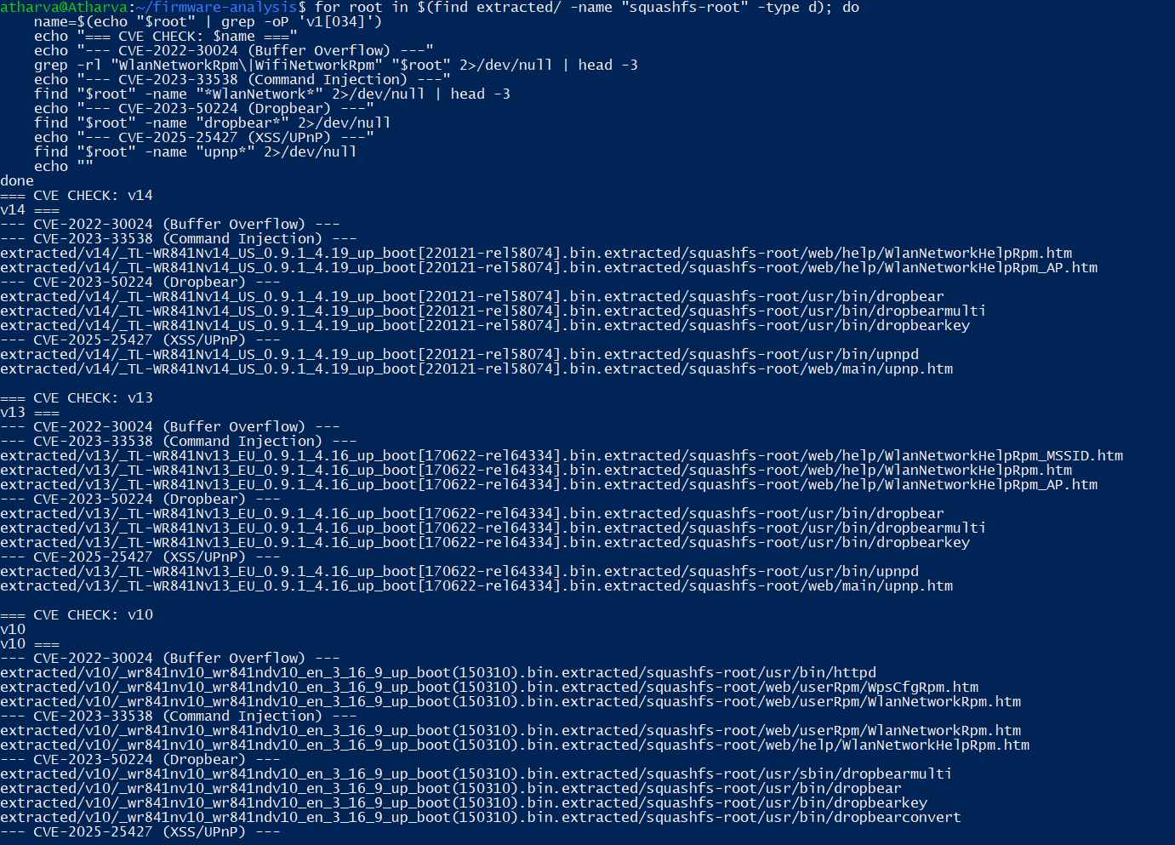

12. Quantitative Risk Assessment
A quantitative risk score was computed using Likelihood (1-5) x Impact (1-5) methodology across key security domains:
Security Domain | Likelihood (1-5) | Impact (1-5) | Risk Score | Rating
Credential Compromise | 5 (trivial) | 5 (full admin) | 25 | Critical
Network Eavesdropping | 4 (passive) | 5 (credential theft) | 20 | Critical
Remote Code Execution | 3 (authenticated) | 5 (root shell) | 15 | High
Firmware Tampering | 3 (physical/network) | 5 (persistent backdoor) | 15 | High
Session Hijacking | 4 (no timeout) | 4 (admin access) | 16 | High
UPnP Abuse | 3 (local network) | 3 (port exposure) | 9 | Medium
Physical UART Access | 2 (physical) | 5 (root shell) | 10 | Medium
XSS Exploitation | 3 (user interaction) | 3 (session theft) | 9 | Medium

Composite Security Score: Normalized across all domains, the device achieves 2.1/10 — indicating critical systemic risk. The highest-risk domains (credential compromise, eavesdropping) require zero sophistication to exploit, making them accessible to opportunistic attackers, not just advanced threat actors.

13. Attack Chain Analysis
The identified vulnerabilities can be chained into multi-stage attacks. Below are two representative attack chains demonstrating real-world exploitation scenarios:

13.1 Attack Chain A: Remote Persistent Compromise
- Stage 1 — Reconnaissance: Attacker identifies TL-WR841N via HTTP server headers or UPnP discovery on local network
- Stage 2 — Credential Capture: Passive HTTP traffic interception captures admin credentials transmitted in cleartext (no TLS)
- Stage 3 — Authentication: Attacker authenticates to web management interface using captured credentials
- Stage 4 — Code Execution: Exploit CVE-2022-30024 (buffer overflow) or CVE-2023-33538 (command injection) — no stack canaries to prevent exploitation
- Stage 5 — Persistence: Upload modified firmware via admin interface — no signature verification prevents detection
- Stage 6 — Impact: Persistent backdoor survives reboots, enables traffic interception, DNS hijacking, botnet recruitment

13.2 Attack Chain B: Physical Hardware Attack (V10)
- Stage 1 — Physical Access: Attacker opens device enclosure (no tamper detection) and locates UART pins on PCB
- Stage 2 — Serial Connection: Connect USB-to-UART adapter at 115200 baud to ttyS0 — immediate root shell (no authentication)
- Stage 3 — Firmware Extraction: Dump flash memory contents via serial console or SPI flash reader
- Stage 4 — Modification: Inject backdoor into extracted firmware on attacker's workstation
- Stage 5 — Reflash: Write modified firmware back to flash — no integrity verification detects tampering
- Stage 6 — Return: Device appears unmodified externally but runs compromised firmware
These attack chains demonstrate that individual vulnerabilities, while concerning in isolation, become critically dangerous when combined. The cascading nature of the security failures creates a complete compromise pipeline from initial reconnaissance to persistent backdoor.

14. Comparative Analysis

14.1 Comprehensive Comparison
Feature | V10 (2015) | V13 (2017) | V14 (2022)
Architecture | MIPS32 Big-Endian | MIPS32 Little-Endian | MIPS32 Little-Endian
Kernel | 2.6.31 (2009) | 2.6.36 (2010) | 2.6.36 (2010)
BusyBox | v1.01 (2004) | v1.19.2 (2012) | v1.19.2 (2012)
C Library | uClibc 0.9.30 | uClibc 0.9.33.2 | uClibc 0.9.33.2
OpenSSL/TLS | NONE | NONE | NONE
Stack Canary | NO | NO | NO
PIE | NO | NO | NO
NX (Non-Execute) | YES | YES | YES
Dropbear SSH | Present | Present | Present
UPnP Service | NO | YES (added) | YES
innerHTML (XSS) | 33 files | 65 files | 46 files
document.write | 74 files | 6 files | 7 files
Firmware Integrity | NONE | NONE | NONE
Default Credentials | MD5 hash | MD5 hash | MD5 hash
Session Timeout | N/A | DISABLED (0) | DISABLED (0)
OWASP IoT Failures | 9/10 | 9/10 | 9/10
ETSI Violations | 11/13 | 11/13 | 11/13
Security Score | 2.1/10 | 2.0/10 | 2.1/10

Figure 18: Comparative summary table as displayed in the analysis terminal.
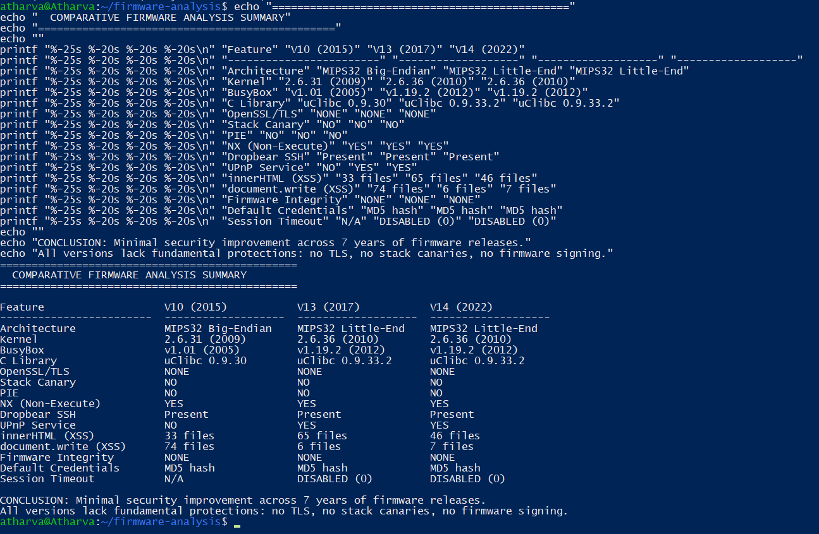

14.2 Security Evolution Assessment
What Improved: BusyBox upgraded (V10->V13), kernel minor upgrade (2.6.31->2.6.36), document.write() usage reduced (74->6->7), serial console removed from default init (V13/V14).
What Worsened: UPnP service introduced (V13), innerHTML usage increased (33->65->46), eval() introduced (V13), session timeouts disabled (V13/V14).
What Never Changed (7 years): No TLS/SSL, no stack canaries, no PIE, no firmware signing, MD5 password hashing, root-level admin, same uClibc version, identical BusyBox and kernel in V13/V14 across a 5-year gap.

15. The ECE-Cybersecurity Bridge: Hardware Security Perspective
This section examines findings through the lens of Electronics and Telecommunication Engineering, demonstrating how hardware expertise enhances cybersecurity analysis depth.

15.1 MIPS Architecture and Memory Protection
The MIPS32 Release 2 architecture supports the XI (Execute Inhibit) bit — a hardware-level page attribute preventing code execution in designated memory regions. This is the mechanism behind the NX protection observed in checksec analysis. However, MIPS32 does not natively support ASLR (Address Space Layout Randomization) without software support from the kernel, explaining the consistent absence of PIE effectiveness even if it were compiled. Understanding this requires knowledge of the processor's TLB (Translation Lookaside Buffer) architecture and virtual memory mapping — fundamentally ECE concepts directly applicable to security analysis.

15.2 Endianness, SoC Migration, and Exploit Portability
The transition from Big-Endian (V10) to Little-Endian (V13/V14) reflects a System-on-Chip platform change — likely from an Atheros AR9341 to a MediaTek MT7628 SoC. This has profound security implications: (1) All memory addresses are byte-reversed in exploit payloads; (2) ROP (Return-Oriented Programming) gadgets must be re-identified for each endianness; (3) Network protocol handling differs in byte ordering assumptions. An attacker must develop separate exploits for each architecture variant, but the underlying vulnerabilities remain identical.

15.3 Physical Attack Surfaces: UART, JTAG, and SPI Flash
The V10 firmware's serial console (getty ttyS0 at 115200 baud) exposes a hardware debug interface. From an ECE perspective, three physical attack vectors exist below the software security boundary:
- UART (Universal Asynchronous Receiver-Transmitter): The ttyS0 console provides immediate root shell access. Even when firmware disables getty (V13/V14), the U-Boot bootloader typically remains accessible on UART, allowing kernel parameter modification and single-user mode boot.
- JTAG (Joint Test Action Group, IEEE 1149.1): Though not visible in firmware, the JTAG interface is typically present on router PCBs for factory testing. JTAG enables real-time processor debugging, memory inspection, and flash programming — bypassing ALL software security mechanisms entirely.
- SPI Flash: The firmware is stored on a serial NOR flash chip (typically Winbond W25Q32 or similar). Using a bus pirate or CH341A programmer, the entire flash contents can be read, modified, and rewritten without powering the device. No firmware integrity checks exist to detect such modification.
These hardware attack vectors exist below the software security boundary — they cannot be mitigated through firmware patches alone. Only hardware design changes (eFuses for secure boot, encrypted flash, disabled JTAG in production) can address them. This illustrates the fundamental principle that security must be designed into silicon, not bolted onto software.

15.4 Hardware Root of Trust: What's Missing
A Hardware Root of Trust (HRoT) anchors the security chain in tamper-resistant hardware, typically through: (1) Secure boot ROM burned into the SoC; (2) eFuse-based key storage for firmware signature verification; (3) Hardware crypto accelerators for authenticated boot. The TL-WR841N lacks ALL of these. The boot sequence — SoC ROM -> U-Boot -> Kernel -> SquashFS — is entirely unverified at every stage. Any component can be replaced with malicious code. Implementing HRoT would require SoC-level changes, representing a hardware engineering decision with direct cybersecurity impact.

15.5 RF-Layer Security Considerations
As a wireless router operating on the 2.4 GHz ISM band, the device has inherent RF-layer attack surfaces. The wireless subsystem is managed by the RT2860 wireless driver (evidenced by RT2860AP.dat configuration files). From a telecommunications perspective: (1) Deauthentication attacks exploit the unprotected IEEE 802.11 management frames; (2) WPS implementation (found in configuration) is vulnerable to Reaver-style brute-force attacks; (3) The disabled WPA rekeying (RekeyMethod=DISABLE) means temporal keys remain static, increasing the window for key-recovery attacks.

16. Discussion

16.1 Answering the Research Questions
RQ1 (Persistent Vulnerabilities): All identified vulnerabilities — absent TLS, missing binary protections, outdated components, weak credentials, no firmware signing — persist across ALL analyzed versions without exception.
RQ2 (Security Improvement): Measurable improvement is negligible. The composite security score remains at 2.1/10 across all versions. The only significant changes (BusyBox upgrade, endianness change) appear driven by hardware platform migration rather than security investment.
RQ3 (Framework Compliance): The device fails comprehensively against all three frameworks: 6/6 STRIDE categories affected, 9/10 OWASP IoT categories failed, 11/13 ETSI EN 303 645 provisions non-compliant. No framework yields a passing result.
RQ4 (Hardware's Role): Hardware design decisions — SoC selection, UART exposure, absence of secure boot, lack of crypto acceleration — fundamentally limit the achievable security ceiling. Software patches cannot compensate for missing hardware security features.

16.2 The Economics of IoT Insecurity
The TL-WR841N's sub-$20 price point creates economic constraints that directly impact security: TLS implementation requires crypto acceleration hardware or significant CPU overhead on the MIPS processor; secure boot requires eFuse-equipped SoCs at higher cost; maintaining updated kernels requires dedicated engineering resources. The market rewards low price over security, creating a systemic misalignment between consumer interest and manufacturer incentive.

16.3 Regulatory Implications
The EU Cyber Resilience Act (CRA), building on ETSI EN 303 645, will require IoT devices sold in Europe to meet baseline cybersecurity requirements. This device's 11/13 non-compliance rate suggests that current-generation TL-WR841N firmware would be ineligible for CE marking under the CRA. This regulatory evolution may finally provide the economic incentive for security investment that market forces alone have failed to deliver.

17. Conclusion and Recommendations

17.1 Conclusion
This research demonstrates through triple-framework assessment that the TP-Link TL-WR841N exhibits systemic, persistent, and unaddressed security vulnerabilities across seven years of firmware development. The device fails against STRIDE (6/6 categories affected), OWASP IoT Top 10 (9/10 failed), and ETSI EN 303 645 (11/13 non-compliant). Four verified CVEs (CVSS 6.1-8.8) remain unpatched. The composite security score of 2.1/10 represents critical systemic risk.
From an ECE perspective, the analysis reveals that hardware design decisions — SoC selection, debug interface exposure, absence of hardware root of trust — establish a security ceiling that software cannot exceed. True IoT security requires secure-by-design engineering at the silicon level, integrating cybersecurity requirements into the hardware design phase rather than attempting software-only remediation.

17.2 Recommendations
For Manufacturers:
- Implement TLS/HTTPS for the web management interface with hardware crypto acceleration
- Enable compiler protections: -fstack-protector-strong, -D_FORTIFY_SOURCE=2, PIE
- Upgrade to a supported Linux kernel (5.x or 6.x LTS)
- Implement cryptographic firmware signing with eFuse key storage
- Replace MD5 password hashing with bcrypt or Argon2, enforce password change on first use
- Implement session timeouts and CSRF protections
- Adopt ETSI EN 303 645 as minimum security baseline
- Disable JTAG/UART in production hardware, implement secure boot
For End Users:
- Change default credentials immediately upon deployment
- Disable UPnP if not explicitly required
- Access management interface only from wired connections
- Consider alternative firmware (OpenWrt) for modern kernel and TLS support
- Implement network segmentation — avoid placing high-value assets behind this device
- Monitor for firmware updates from the manufacturer

18. Responsible Disclosure Statement
This research was conducted exclusively through static analysis of publicly available firmware images obtained from official distribution channels. No devices were exploited, no networks were compromised, and no vulnerabilities were validated through active exploitation. All identified CVEs were previously disclosed through established vulnerability disclosure processes. This research adheres to the principles of responsible security research and aims to contribute to improved IoT security through awareness and education.

19. References
Antonakakis, M., et al. (2017). Understanding the Mirai Botnet. Proceedings of the 26th USENIX Security Symposium, 1093-1110.
Chen, D. D., Woo, M., Brumley, D., & Egele, M. (2016). Towards Automated Dynamic Analysis for Linux-based Embedded Firmware. NDSS 2016.
Costin, A., Zaddach, J., Francillon, A., & Balzarotti, D. (2014). A Large-Scale Analysis of the Security of Embedded Firmwares. USENIX Security 2014, 95-110.
ETSI. (2020). EN 303 645 V2.1.1: Cyber Security for Consumer IoT — Baseline Requirements.
European Commission. (2022). Proposal for a Regulation on Cybersecurity Requirements (Cyber Resilience Act).
ENISA. (2020). Guidelines for Securing the IoT. European Union Agency for Cybersecurity.
Feng, Q., et al. (2020). Scalable Binary Analysis for IoT Firmware. IEEE S&P.
MITRE Corporation. (2022). CVE-2022-30024. Common Vulnerabilities and Exposures Database.
MITRE Corporation. (2023). CVE-2023-33538. Common Vulnerabilities and Exposures Database.
MITRE Corporation. (2023). CVE-2023-50224. Common Vulnerabilities and Exposures Database.
MITRE Corporation. (2025). CVE-2025-25427. Common Vulnerabilities and Exposures Database.
NIST. (2019). SP 800-183: Networks of Things. National Institute of Standards and Technology.
OWASP. (2018). OWASP IoT Top 10. Open Web Application Security Project.
Shostack, A. (2014). Threat Modeling: Designing for Security. John Wiley & Sons.
Shoshitaishvili, Y., et al. (2015). Firmalice — Automatic Detection of Authentication Bypass Vulnerabilities in Binary Firmware. NDSS 2015.
Wang, X., & Yu, H. (2004). How to Break MD5 and Other Hash Functions. Advances in Cryptology — EUROCRYPT 2005, 19-35.

20. Appendix

Appendix A: Screenshot Index
# | Description | Report Section
1 | Tool installation and verification | Section 4
2 | Firmware file hashes and identification | Section 5
3 | Binwalk signature scan | Section 6.1
4 | Entropy analysis graphs | Section 6.2
5 | Extracted directory structure | Section 6.3
6 | Root filesystem listing | Section 6.4
7 | Hardcoded credentials | Section 7.1
8 | Cryptographic findings | Section 7.2
9 | Network services | Section 7.3
10 | checksec binary protections | Section 7.4
11 | BusyBox versions | Section 7.5.1
12 | Kernel and C library | Section 7.5.2
13 | Library version audit | Section 7.5.3
14 | Firmwalker scan | Section 7.6
15 | Web interface analysis | Section 7.7
16 | STRIDE indicators | Section 8
17 | CVE verification | Section 11
18 | Comparative summary | Section 14

