Defence Drone Navigation using GBFS and A* Search
Course: AIMLCZG557/AECLZG557 | Assignment: PS4 | Group: G116

1. Project Summary
An autonomous UAV navigates an 8×8 grid from Start (0,0) to Goal (6,7), avoiding No-Fly Zones (N) and minimizing Weather Hazard (W) penalties. Implemented: GBFS with h1 (Euclidean), GBFS with h2 (Bounding-Box Risk-Weighted), and A* with h1 for comparison.

2. Environment & Problem Modelling
Symbol | Description | Cost
S | Start Node (0,0) | 1
E | Goal Node (6,7) | 1
. | Safe Airspace | 1
W | Weather Hazard | 4
N | No-Fly Zone | Blocked

Environment Statistics: ● Grid Size = 8 × 8 ● No-Fly Zones = 8 ● Weather Hazards = 7 ● Start = (0,0) ● Goal = (6,7)

3. PEAS Components
Component | Description
Performance | Minimize path cost; reach goal; avoid N zones; reduce W penalties
Environment | 8×8 grid, static, fully observable, deterministic, single agent
Actuators | Orthogonal movement (N/S/E/W); navigation controller
Sensors | GPS position; grid map; obstacle/weather/goal detection

4. Alternate Modelling Approach
Primary model: 2D matrix grid with O(1) cell lookup. Alternate: explicit graph G=(V,E) where V = passable cells (56 nodes) and E = orthogonal edges with transition costs. Performance: matrix is faster for neighbour expansion on dense grids; graph model uses less memory on sparse/large maps and scales better when the grid is not rectangular. For this 8×8 assignment both are equivalent; matrix was chosen for simplicity.

5. System Architecture
Component | Choice | Reason
Environment | 2D Matrix | O(1) access
OPEN | Priority Queue (heap) | Efficient min-h extraction
CLOSED | Hash Set | O(1) revisit check
Path | Parent dict | O(path) reconstruction

6. Heuristic Engineering & Execution Flow
Heuristic h1 – Euclidean Distance
h1(n) = √((xr−xg)² + (yr−yg)²). Fast, goal-directed, admissible for A*.
Heuristic h2 – Bounding-Box Risk-Weighted
h2(n) = Manhattan(n,goal) × avg(cell costs in bounding box from n to goal). Future-aware: penalises paths through high-cost hazard regions. Example: h2(3,3)=15.40.
GBFS Algorithm
1. Pop min-h node from OPEN 2. If goal, stop 3. Add to CLOSED 4. Expand neighbours 5. Repeat
Execution Flow (Sequence Diagram)
1. Read inputPS04.txt → Load 8×8 grid, start (0,0), goal (6,7)
2. Run GBFS-h1 → Euclidean heuristic search, record path & metrics
3. Run GBFS-h2 → Bounding-box heuristic search, record path & metrics
4. Run A*-h1 → Optimal path benchmark with f(n)=g(n)+h(n)
5. Write outputPS04.txt → Metrics table, PEAS, trap check, complexity
6. Generate PNG charts → Grid paths, comparison, heuristic plots
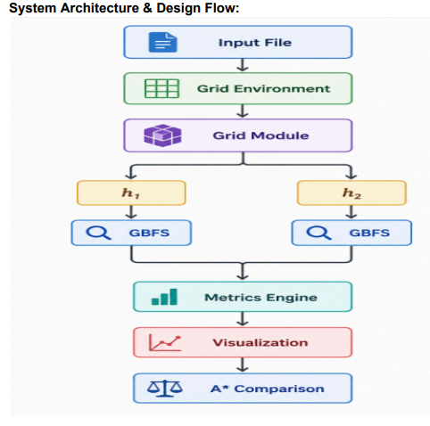

Data Structures & Tie-Breaking
Structure | Role | Complexity
heapq (OPEN) | Frontier priority queue | push/pop O(log n)
set (CLOSED) | Explored nodes | add/lookup O(1)
dict (parent) | Path reconstruction | O(1) lookup

Node priority on equal h: North > East > South > West (counter tie-break in heap).

7. Results & Comparison (outputPS04.txt)
Metrics Table
Metric | Description | GBFS-h1 | GBFS-h2 | A*-h1
Nodes Expanded | Total explored nodes | 14 | 14 | 29
Runtime | Execution time (ms) | 0.1390 | 0.1910 | 0.2279
Memory Usage | OPEN + CLOSED size | 23 | 28 | 40
Total Path Cost | Sum of transition costs | 17 | 17 | 14
Path Length | Total moves | 13 | 13 | 13
Heuristic | Heuristic value at start | 9.2195 | 29.4821 | 9.2195

GBFS vs A* Comparison (Heuristic h1)
Criterion | GBFS (h1) | A* (h1)
Complete? | Yes (with closed set) | Yes
Optimal? | No | Yes
Nodes Expanded | 14 | 29
Runtime (ms) | 0.1390 | 0.2279
Memory Usage | 23 | 40
Total Path Cost | 17 | 14
Path Length | 13 | 13
Faster to goal? | Yes (fewer nodes, lower ms) | No (more exploration)

Trap Identification (Expectation 6)
Heuristic | H-Value | Trapped at Node | Iteration | Escaped To | Escape Iter.
— | — | No traps detected | — | — | —

Both GBFS heuristics found 13-move paths costing 17 (1 weather zone). A* found optimal cost 14 with zero weather penalties.

8. Analysis, Visualizations & Conclusion
Heuristic & Algorithm Comparison Charts
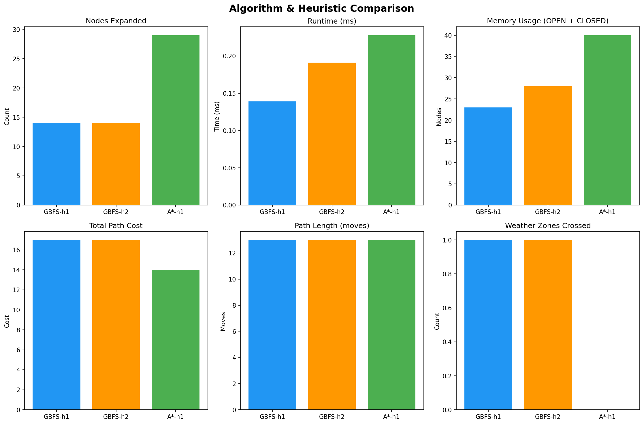

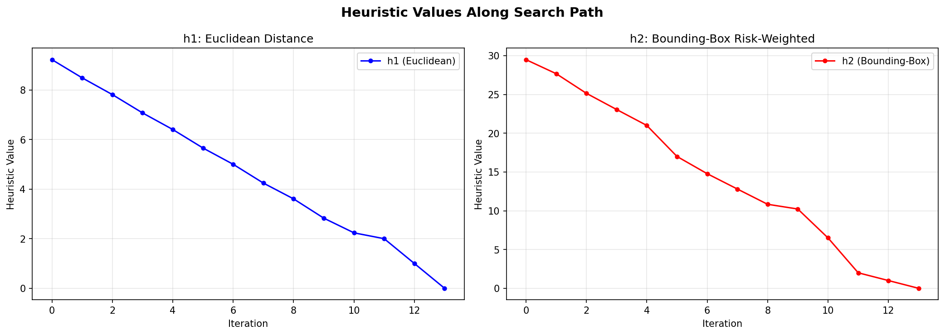

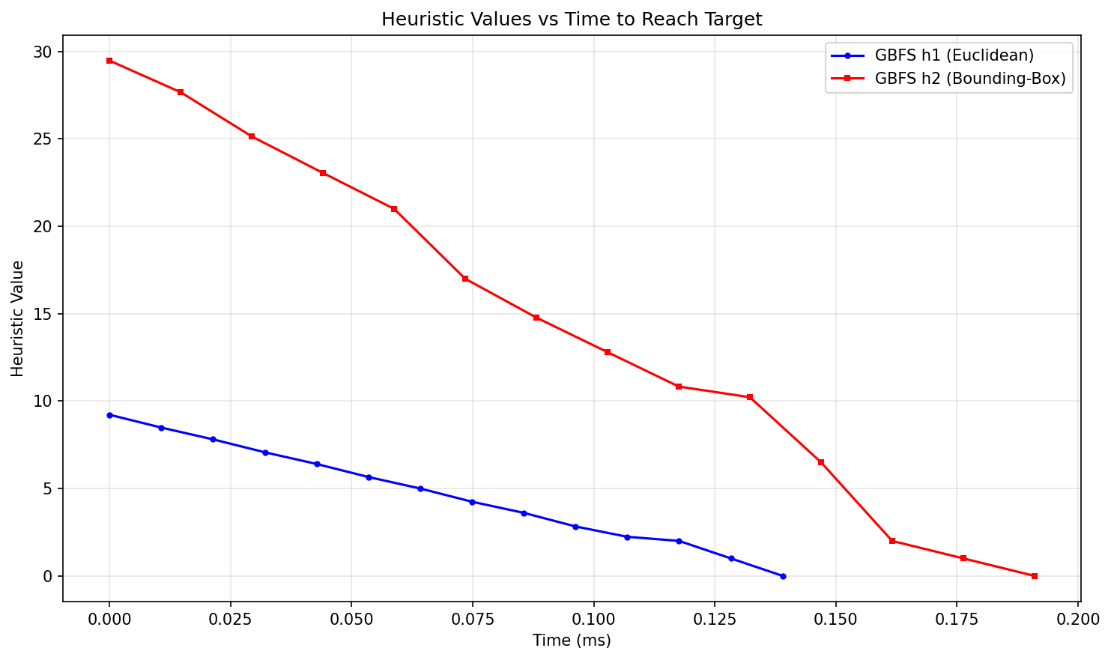

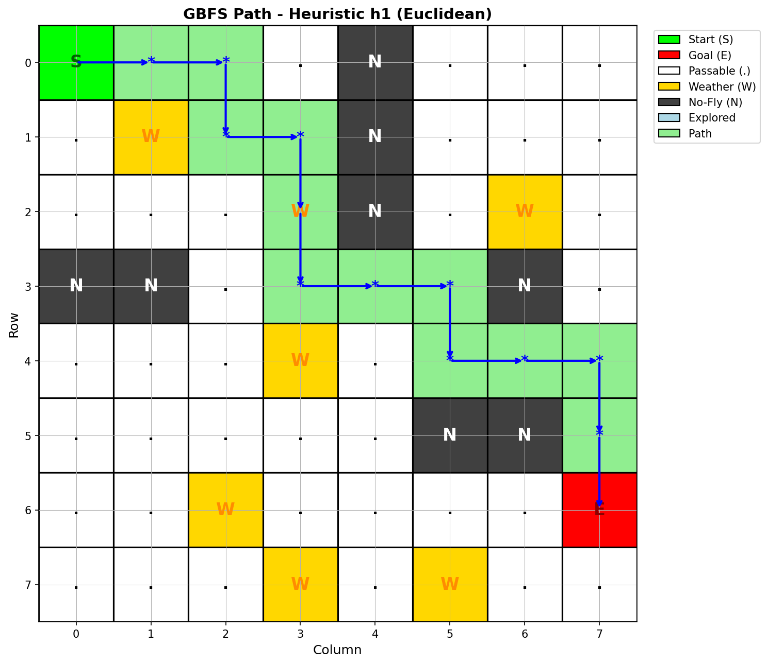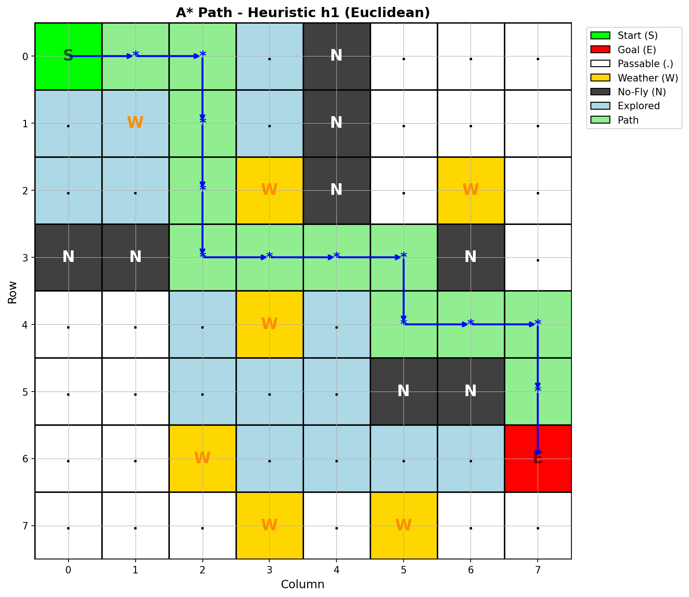

Complexity Analysis
Algorithm | Time | Space | Nodes | Notes
GBFS h1 | O(V log V) | O(V) | 14 | Fastest; not optimal
GBFS h2 | O(V log V) | O(V) | 14 | Risk-aware; higher h2 compute
A* h1 | O(V log V) | O(V) | 29 | Optimal path; more exploration

Heuristic Analysis
h1 (Euclidean): fastest runtime (0.139 ms), simple geometry, ignores hazard layout. h2 (Bounding-Box): higher start h=29.48, accounts for future hazard costs; same path cost on this grid. h1 is better for speed; h2 is better for hazard-aware routing on complex maps.

9. Conclusion
GBFS is complete with a closed set on finite grids but not optimal — it found cost-17 paths vs A* optimal cost-14. GBFS-h1 is fastest (14 nodes, 0.139 ms); A* guarantees optimality at higher cost (29 nodes, 0.228 ms). GBFS-h2 balances efficiency with risk awareness. Recommendation: A* for mission-critical optimality; GBFS-h1 for real-time response; GBFS-h2 for hazard-dense environments.
Additional visualizations in output: grid_initial, grid_gbfs_h2, heuristic_heatmaps, nodes_explored.

