DRL Assignment 2 :Robust Reinforcement Learning under Stochastic Action Failure
Environment: LunarLander-v3 (Gymnasium) + custom gym.Wrapper
Algorithms: DQN and Double DQN (DDQN)
Team/Group# 116

Student Contributions:

Student Name | Student Contributions | Percentage of contributions
PRASAD SHIVAJI KULKARNI | Implement the Modified LunarLander-v3 Environment using gym.Wrapper, including stochastic engine failure (15% misfire), modified reward function, fuel penalty, landing bonus logic, and environment verification with logs/statistics | 100
SHELAR SACHIN KRISHNA | Implement the Deep Q-Network (DQN) including neural network, replay buffer, ε-greedy exploration, target network, training pipeline, hyperparameter tuning, and training on both original and modified environments. | 100
POWAR SAGAR GANPATI | Implement the Double Deep Q-Network (DDQN) by modifying only the target Q-value computation while keeping all other components identical. Train and validate on both environments. | 100
SUJEET KUMAR YADAV | Design the Performance Evaluation Framework including plotting episode rewards, predicted Q-values, successful landing rate, thruster activation analysis, result comparison between all four models, interpretation of graphs, code integration, optimization, and final validation. | 100
JAMDAR SARTHAK VITHALDAS | Prepare the Final Report, discussion, experimental observations, conclusions, screenshots from the virtual lab, code documentation/comments, formatting, reproducibility checks, and final PDF submission. Answer all discussion questions based on experimental results | 100

Execution summary

A gym.Wrapper reproduces the specification exactly: 15% of attempted thruster commands are silently replaced by Do Nothing, a -0.3 fuel penalty is charged on the selected action, and a +50 bonus is paid only for a fully safe landing. All four verification checks ( V0 - V3 ) pass.
- Four agents (DQN / DDQN x original / modified) were trained for 800 episodes with identical seeds, architecture, optimizer, replay buffer, exploration schedule and hyper-parameters. The whole grid was repeated for 3 seeds (42, 43, 44) as a robustness check.
- Stochastic actuator failure costs roughly 90-120 reward points and delays the onset of learning by about 100 episodes.
- Under failures DDQN outperforms DQN (148.6 vs 122.3 final training reward; 66% vs 60% greedy landing rate) whereas in the deterministic original environment the two are indistinguishable - exactly what the overestimation-reduction theory predicts.

Setup, reproducibility and code layout
All logic lives in the src/ package so that the same code path is used by every experiment; this notebook only orchestrates and reports. Every module is printed in full below the section that uses it, so the exported PDF contains the complete source.
assignment2/ src/
env_wrapper.py Task (a) - StochasticActionFailureWrapper
+ safe-landing rule
verify_env.py Task (a) - V0..V3 verification suite agent.py Tasks (b)/(c) - QNetwork, ReplayBuffer,
DQNAgent (dqn | ddqn)
train.py Tasks (b)/(c) - single shared training loop
+ metric logging
run_experiments.py Tasks (b)/(c) - parallel driver over the 4 conditions x seeds
make_plots.py Task (d) - the four required plots + summary tables
evaluate.py Tasks (d)/(e) - greedy evaluation + value-
estimation bias
utils.py seeding, moving average, fixed validation state set
results/ per-run JSON histories, trained weights,
validation states
figures/ generated PNG figures

Install the required lib:
pip install "gymnasium[box2d]" torch numpy matplotlib
python -m src.verify_env
python -m src.run_experiments --episodes 800 --seeds 42 43 44

Python Code
import datetime, platform, sys, os
from pathlib import Path

# The notebook lives next to the `src` package; add its folder to sys.path.
PROJECT_ROOT = Path.cwd()
if str(PROJECT_ROOT) not in sys.path: sys.path.insert(0, str(PROJECT_ROOT))

import numpy as np, torch, gymnasium as gym, matplotlib

print("run timestamp :", datetime.datetime.now().astimezone().strftime("%Y-%m-%d %H print("host / OS :", platform.node(), "|", platform.platform())
print("python :", sys.version.split()[0]) print("gymnasium :", gym. version )
print("torch :", torch. version , "| cuda:", torch.cuda.is_available()) print("numpy :", np. version )
print("matplotlib :", matplotlib. version ) print("project root :", PROJECT_ROOT)

Virtual Machine Screen shot:
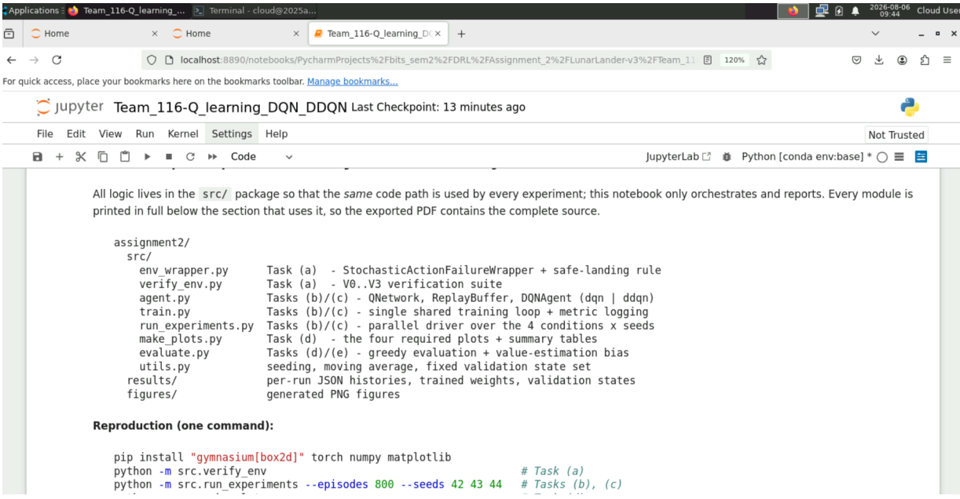

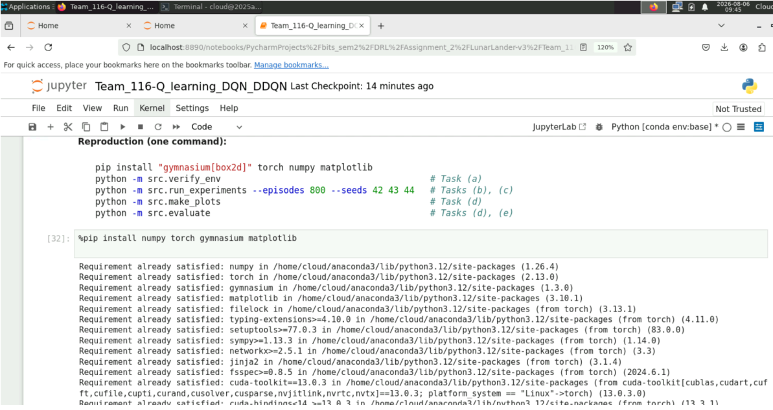
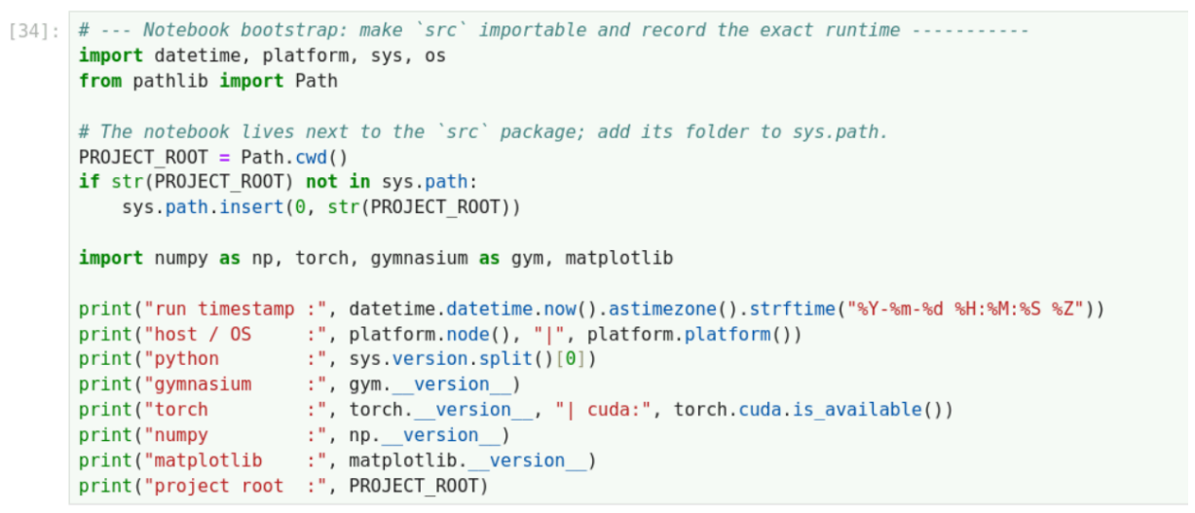
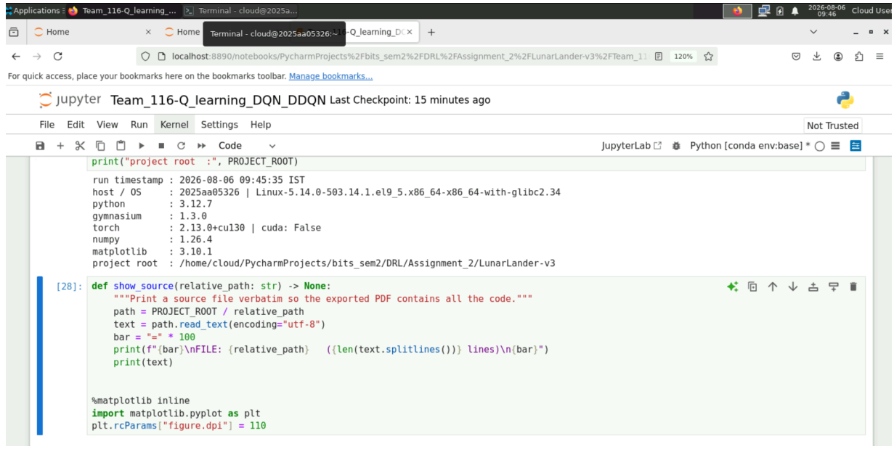
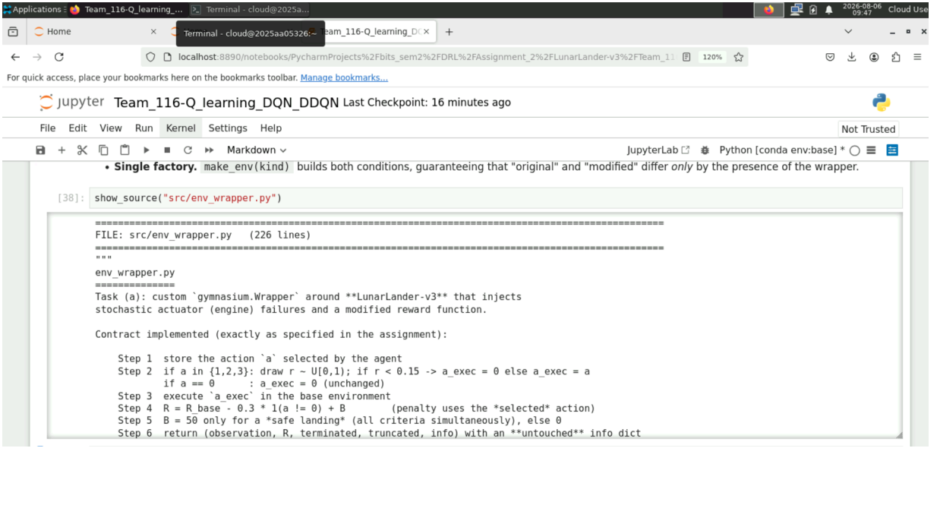

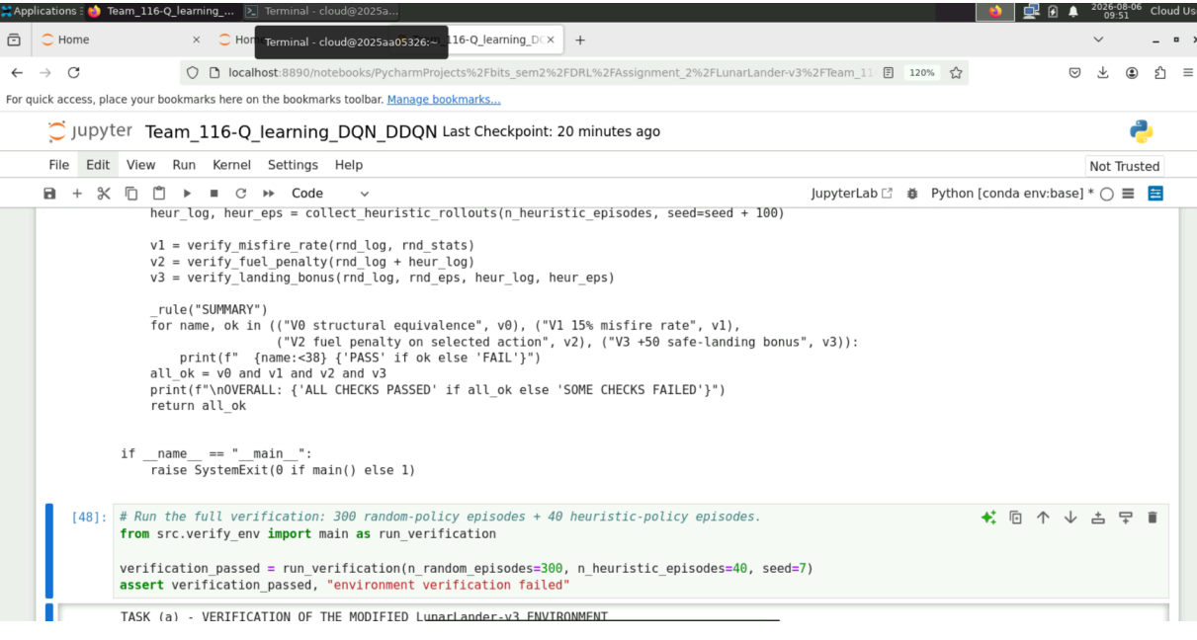
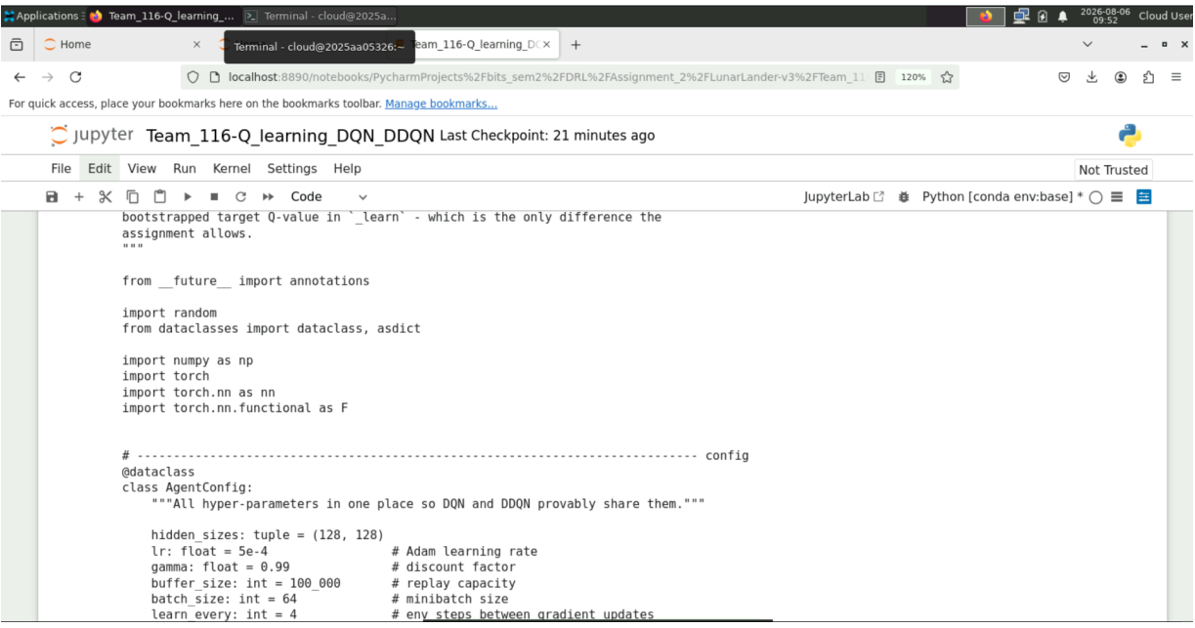

Task (a) - Modified environment implementation and verification Design
subclasses gymnasium.Wrapper and overrides
StochasticActionFailureWrapper
only step() (and reset() to seed its private RNG). Every call performs the six specified steps in order:

Step Implementation

1 a = int(action) is stored before any modification

2
if a != 0 : draw r ~ U[0,1) ; a_exec = 0 if r < 0.15 else a . a == 0 is never modified
3 obs, R_base, terminated, truncated, info = self.env.step(a_exec)
4 R = R_base - 0.3 * 1(a != 0) + B -> the penalty keys on the selected action a
₅ B = 50 iff terminated and not truncated and obs[6]==1 and obs[7]==1 and
\|obs[2]\|<0.1 and \|obs[3]\|<0.1 and \|obs[4]\|<0.1

6
returns (obs, R, terminated, truncated, info) with the base info dict untouched
Design decisions worth highlighting:
- Hidden failures. The failure flag is stored on the wrapper object ( last_misfired ,
stats , optional log ) purely for verification and logging. It is never written into
info and never enters the observation, so the agent cannot condition on it.
- Independent RNG. numpy.random.default_rng(seed + 10_000_019) drives the failure draws so the actuator-noise stream is reproducible and does not perturb the Box2D physics stream (this is what allows the identical initial states comparison between the original and the modified environment).
- Single factory. make_env(kind) builds both conditions, guaranteeing that "original" and "modified" differ only by the presence of the wrapper.

In [3]:
show_source("src/env_wrapper.py")
====================================================================================
================
FILE: src/env_wrapper.py (226 lines)
====================================================================================
================ """
env_wrapper.py
==============
Task (a): custom `gymnasium.Wrapper` around **LunarLander-v3** that injects stochastic actuator (engine) failures and a modified reward function.

Contract implemented (exactly as specified in the assignment):

= a

ion)
Step 1 store the action `a` selected by the agent
Step 2 if a in {1,2,3}: draw r ~ U[0,1); if r < 0.15 -> a_exec = 0 else a_exec

if a == 0 : a_exec = 0 (unchanged) Step 3 execute `a_exec` in the base environment
Step 4 R = R_base - 0.3 * 1(a != 0) + B (penalty uses the *selected* act

Step 5 B = 50 only for a *safe landing* (all criteria simultaneously), else 0 Step 6 return (observation, R, terminated, truncated, info) with an **untouched
** info dict

Everything else (observation space, action space, transition dynamics, termination / truncation rules) is left untouched.
"""

from future import annotations
from dataclasses import dataclass, field import gymnasium as gym
import numpy as np

# cons
tants
ENV_ID = "LunarLander-v3"

FAILURE_PROB = 0.15 # P(thruster command is silently dropped)
FUEL_PENALTY = 0.3 # subtracted whenever the agent *selects* a thruster action LANDING_BONUS = 50.0 # awarded once, only on a safe landing
SAFE_TOL = 0.10 # tolerance on |vx|, |vy| and |theta|

# Indices of the 8-dimensional LunarLander observation vector that matter here.
IDX_VX, IDX_VY, IDX_ANGLE, IDX_LEG_L, IDX_LEG_R = 2, 3, 4, 6, 7

# help
ers
def is_safe_landing(obs, terminated: bool, truncated: bool, tol: float = SAFE_TOL) -
> bool:
"""Return True iff the episode ended in a *safe landing* (Step 5 criteria).

All of the following must hold simultaneously: terminated and not truncated, both legs in contact,|vx| < tol, |vy| < tol, |angle| < tol. """
if not terminated or truncated: return False
obs = np.asarray(obs, dtype=np.float64) return bool(
obs[IDX_LEG_L] == 1.0
and obs[IDX_LEG_R] == 1.0 and abs(obs[IDX_VX]) < tol and abs(obs[IDX_VY]) < tol
and abs(obs[IDX_ANGLE]) < tol
)

@dataclass
class FailureStats:
"""Book-keeping counters used *only* for the Task (a) verification report.

These live on the wrapper object; they are never written into `info` and are never visible to the learning agent.
"""

2,3}
steps: int = 0
thruster_attempts: int = 0 # steps on which the agent selected a in {1,

misfires: int = 0 # thruster attempts silently replaced by 0 penalised_steps: int = 0 # steps on which the 0.3 fuel penalty was ap
plied
bonuses_awarded: int = 0 # number of +50 landing bonuses given per_action_attempts: dict = field(default_factory=lambda: {1: 0, 2: 0, 3: 0})
per_action_misfires: dict = field(default_factory=lambda: {1: 0, 2: 0, 3: 0})

def misfire_rate(self) -> float:
return self.misfires / self.thruster_attempts if self.thruster_attempts else float("nan")

class StochasticActionFailureWrapper(gym.Wrapper):
"""LunarLander-v3 with intermittent engine failure + modified reward.

Parameters

env : gym.Env
A `LunarLander-v3` (or compatible discrete-action) environment. failure_prob : float
Probability that a *thruster* command (a in {1,2,3}) is replaced by 0. fuel_penalty : float
Constant penalty applied for every *selected* thruster action. landing_bonus : float
Bonus added on the terminal step of a safe landing. seed : int | None
Seed of the *independent* RNG used for the failure draws, so that failure sequences are reproducible without disturbing the physics RNG.
record_log : bool
When True, every step is appended to `self.log` as a dict. Used by the verification script; disabled during training for speed/memory."""

def init ( self,
env: gym.Env,
failure_prob: float = FAILURE_PROB, fuel_penalty: float = FUEL_PENALTY, landing_bonus: float = LANDING_BONUS, seed: int | None = None,
record_log: bool = False,
) -> None:
super(). init (env)
self.failure_prob = float(failure_prob) self.fuel_penalty = float(fuel_penalty) self.landing_bonus = float(landing_bonus)

# Dedicated RNG: keeps actuator noise independent of the Box2D physics RNG. self._rng = np.random.default_rng(seed)

self.record_log = record_log self.log: list[dict] = [] self.stats = FailureStats()

# Diagnostics of the most recent step (read by the training loop for loggin
g).
self.last_selected_action: int | None = None self.last_executed_action: int | None = None self.last_base_reward: float = 0.0 self.last_bonus: float = 0.0 self.last_misfired: bool = False

# gym API
def reset(self, *, seed: int | None = None, options: dict | None = None): """Reset the base env; re-seed the failure RNG when an explicit seed is give
n."""

m.

if seed is not None:
# Offset keeps the actuator-noise stream distinct from the physics strea

self._rng = np.random.default_rng(seed + 10_000_019) return self.env.reset(seed=seed, options=options)

def step(self, action):
"""Apply Steps 1-6 of the specification for a single environment step.""" # --- Step 1: store the action selected by the agent -------------------a = int(action)

# --- Step 2: simulate intermittent engine failure ---------------------a_exec, r_draw, misfired = a, None, False
if a != 0:
r_draw = float(self._rng.random()) # r ~ U[0, 1) if r_draw < self.failure_prob:
a_exec, misfired = 0, True # engine silently does nothi
ng

# --- Step 3: execute a_exec in the *original* environment -------------obs, base_reward, terminated, truncated, info = self.env.step(a_exec)base_reward = float(base_reward)

# --- Step 5: safe-landing bonus (evaluated on the returned observation) safe = is_safe_landing(obs, terminated, truncated)
bonus = self.landing_bonus if safe else 0.0

# --- Step 4: modified reward (penalty keyed on the *selected* action) --penalty = self.fuel_penalty if a != 0 else 0.0
reward = base_reward - penalty + bonus

self._update_diagnostics(a, a_exec, r_draw, misfired, base_reward, penalty,
bonus, reward, terminated, truncated, safe, obs)

# --- Step 6: return unchanged info dict -------------------------------return obs, reward, terminated, truncated, info

# internals
def _update_diagnostics(self, a, a_exec, r_draw, misfired, base_reward, penalty,
bonus, reward, terminated, truncated, safe, obs) -> Non
e:
"""Maintain verification counters / optional per-step log (never expose
d)."""

s = self.stats s.steps += 1 if a != 0:
s.thruster_attempts += 1
s.per_action_attempts[a] += 1
s.penalised_steps += 1 if misfired:
s.misfires += 1
s.per_action_misfires[a] += 1 if bonus > 0:
s.bonuses_awarded += 1

self.last_selected_action = a self.last_executed_action = a_exec self.last_base_reward = base_reward self.last_bonus = bonus self.last_misfired = misfired

if self.record_log: self.log.append(
{

olist(),
"a": a,
"r": r_draw, "a_exec": a_exec, "misfired": misfired,
"base_reward": base_reward, "penalty": penalty, "bonus": bonus,
"reward": reward,
"terminated": bool(terminated), "truncated": bool(truncated), "safe_landing": bool(safe),
"obs_tail": np.asarray(obs, dtype=np.float64)[[2, 3, 4, 6, 7]].t
}
)

def reset_stats(self) -> None:
"""Clear verification counters and the per-step log.""" self.stats = FailureStats()
self.log = []

# fact
ory
def make_env(kind: str = "modified", seed: int | None = None, record_log: bool = Fal se,
render_mode: str | None = None) -> gym.Env:
"""Build either the `original` or the `modified` LunarLander-v3 environment.

A single factory guarantees that both experimental conditions differ *only* by the presence of the failure/reward wrapper.
"""
if kind not in ("original", "modified"):
raise ValueError(f"kind must be 'original' or 'modified', got {kind!r}") env = gym.make(ENV_ID, render_mode=render_mode)
if kind == "modified":
env = StochasticActionFailureWrapper(env, seed=seed, record_log=record_log) return env

Verification suite
The evidence requested by the assignment is produced by four independent checks:

Check What it demonstrates

V0 observation space, action space, dynamics and termination rules are unchanged

V1
~15% of attempted thruster actions are replaced by Do Nothing (binomial CI + z-test, global and per action)
_{V2} the -0.3 fuel penalty is charged on every attempted thruster action, whether it fired or misfired
V3 +50 is awarded iff the full safe-landing criterion holds
For V3 a uniform-random policy almost never lands safely, so positive examples are additionally generated with Gymnasium's built-in heuristic LunarLander controller, and a deterministic table-driven unit test on a stub environment exercises every boundary case of the criterion ( |v| = 0.10 exactly, one leg only, truncation, etc.).

In [4]:
show_source("src/verify_env.py")
====================================================================================
================
FILE: src/verify_env.py (361 lines)
====================================================================================
================ """
verify_env.py
=============
Task (a): experimental verification that the modified environment behaves
*exactly* as specified.

Four independent checks are performed and printed as a report:

V0 | structural check | - observation space, action space and episode lengths
 |  | are unchanged w.r.t. the original environment.
V1 | misfire rate | - approximately 15% of attempted thruster actions are
 |  | replaced by "Do Nothing" (binomial 95% CI + z-test,
 |  | reported globally and per thruster action).
V2 | fuel penalty | - for *every* step, R - R_base - B equals exactly
 |  | -0.3 when the *selected* action is a thruster and 0.0
 |  | otherwise, regardless of whether the engine misfired.
V3 | landing bonus | - +50 is awarded if and only if the safe-landing
 |  | criterion holds. Random rollouts supply the negative
 |  | cases; the built-in LunarLander heuristic controller
 |  | supplies the positive cases (a random policy
 |  | essentially never lands safely). A deterministic
 |  | unit test on a stub environment covers the exact
 |  | boundary conditions of the criterion.
"""
from future import annotations import math
from collections import Counter

import gymnasium as gym import numpy as np

from .env_wrapper import ( FAILURE_PROB, FUEL_PENALTY, LANDING_BONUS,
StochasticActionFailureWrapper, is_safe_landing,
make_env,
)

TOL = 1e-9 # float comparison tolerance for exact reward decomposition

# helper
s
def _rule(title: str) -> None: print("\n" + "=" * 78) print(title)
print("=" * 78)
def collect_random_rollouts(n_episodes: int = 300, seed: int = 7, max_steps: int = 1 000):
"""Run `n_episodes` of a uniform-random policy on the modified env, logging ever y step."""
env = make_env("modified", seed=seed, record_log=True) rng = np.random.default_rng(seed)
episodes = []
for ep in range(n_episodes):
obs, _ = env.reset(seed=seed + ep) start = len(env.log)
terminated = truncated = False for _ in range(max_steps):
obs, _r, terminated, truncated, _ = env.step(int(rng.integers(0, 4))) if terminated or truncated:
break episodes.append(
{
"slice": (start, len(env.log)), "terminated": bool(terminated), "truncated": bool(truncated),
"final_obs": np.asarray(obs, dtype=np.float64),
}
)
log, stats = list(env.log), env.stats env.close()
return log, stats, episodes

def collect_heuristic_rollouts(n_episodes: int = 40, seed: int = 21, max_steps: int
= 1000):
"""Same as above but driven by Gymnasium's built-in `heuristic` LunarLander cont roller.

This is only used to *produce successful landings*, so that the +50 bonus logic can be verified on positive as well as negative examples.
"""
from gymnasium.envs.box2d.lunar_lander import heuristic

env = make_env("modified", seed=seed, record_log=True) episodes = []
for ep in range(n_episodes):
obs, _ = env.reset(seed=seed + ep) start = len(env.log)
terminated = truncated = False for _ in range(max_steps):
action = heuristic(env.unwrapped, obs) # deterministic PD controller obs, _r, terminated, truncated, _ = env.step(int(action))
if terminated or truncated: break
episodes.append(
{
"slice": (start, len(env.log)), "terminated": bool(terminated), "truncated": bool(truncated),
"final_obs": np.asarray(obs, dtype=np.float64),
}
)
log = list(env.log) env.close()
return log, episodes

# V0
def verify_structure() -> bool:
"""V0: spaces, dynamics and termination rules must be untouched."""
_rule("V0 STRUCTURAL EQUIVALENCE WITH THE ORIGINAL ENVIRONMENT")
orig, mod = make_env("original"), make_env("modified", seed=0)

same_obs = orig.observation_space == mod.observation_space same_act = orig.action_space == mod.action_space print(f"observation space original={orig.observation_space}")
print(f"observation space modified={mod.observation_space} -> identical: {sam e_obs}")
print(f"action space original={orig.action_space} modified={mod.action_sp ace}"
f" -> identical: {same_act}")

# Transition dynamics: with a = 0 the wrapper can never modify the action, so
# feeding the same 'do nothing' sequence to both envs must give identical state
s.
o1, _ = orig.reset(seed=99) o2, _ = mod.reset(seed=99)
max_dev = float(np.max(np.abs(np.asarray(o1) - np.asarray(o2)))) for _ in range(120):
o1, r1, t1, tr1, _ = orig.step(0) o2, r2, t2, tr2, _ = mod.step(0)
max_dev = max(max_dev, float(np.max(np.abs(np.asarray(o1) - np.asarray(o
2)))))

assert (t1, tr1) == (t2, tr2), "termination flags diverged" if t1 or tr1:
break
dynamics_ok = max_dev < 1e-12
print(f"identical trajectories under a=0 (no failure possible): max |deviation|
= "
f"{max_dev:.2e} -> unchanged dynamics/termination: {dynamics_ok}") orig.close(); mod.close()
ok = same_obs and same_act and dynamics_ok print(f"\nV0 RESULT: {'PASS' if ok else 'FAIL'}") return ok

# V1
def verify_misfire_rate(log, stats) -> bool:
"""V1: ~15% of attempted thruster actions must be replaced by action 0."""
_rule("V1 ENGINE-FAILURE RATE (target = 15% of attempted thruster actions)") n, k = stats.thruster_attempts, stats.misfires
p_hat = k / n
se = math.sqrt(p_hat * (1 - p_hat) / n)
lo, hi = p_hat - 1.96 * se, p_hat + 1.96 * se
z = (p_hat - FAILURE_PROB) / math.sqrt(FAILURE_PROB * (1 - FAILURE_PROB) / n)
print(f"total steps logged : {stats.steps}") print(f"thruster actions attempted (n) : {n}") print(f"replaced by 'Do Nothing' (k) : {k}")
print(f"empirical misfire rate : {p_hat:.4f} (target {FAILURE_PROB:.2 f})")
print(f"95% binomial CI : [{lo:.4f}, {hi:.4f}]")
print(f"z-statistic vs p=0.15 : {z:+.3f} (|z| < 1.96 -> consistent wit h 15%)")

print("\nper-action breakdown:")
print(f" {'action':>7} {'attempts':>10} {'misfires':>10} {'rate':>8}") for a in (1, 2, 3):
na, ka = stats.per_action_attempts[a], stats.per_action_misfires[a] print(f" {a:>7} {na:>10} {ka:>10} {ka/na if na else float('nan'):>8.4f}")

# Action 0 must NEVER be modified, and a misfire must always map to a_exec == 0. a0_modified = sum(1 for e in log if e["a"] == 0 and e["a_exec"] != 0)
bad_exec = sum(1 for e in log if e["misfired"] and e["a_exec"] != 0)
kept = sum(1 for e in log if e["a"] != 0 and not e["misfired"] and e["a_exec"] !
= e["a"])
# The replacement must be driven by r < 0.15 exactly. rule_violations = sum(
1 for e in log if e["a"] != 0 and e["misfired"] != (e["r"] < FAILURE_PROB)

0)")
)
print(f"\n'Do Nothing' (a=0) ever modified : {a0_modified} (must be

print(f"misfires not mapped to a_exec=0 : {bad_exec} (must be 0)") print(f"successful firings with a_exec != a : {kept} (must be 0)") print(f"steps where misfire != (r < 0.15) : {rule_violations} (must b
e 0)")

print("\nsample of the step log (matches the example table in the problem statem ent):")
print(f" {'a':>3} {'r':>10} {'a_exec':>7}") shown = Counter()
for e in log:
key = (e["a"], e["misfired"])
if shown[key] < 1 and shown.total() < 7: shown[key] += 1
r_txt = " -" if e["r"] is None else f"{e['r']:.4f}"
print(f" {e['a']:>3} {r_txt:>10} {e['a_exec']:>7}")

ok = (abs(z) < 1.96) and a0_modified == 0 and bad_exec == 0 and kept == 0 and ru le_violations == 0
print(f"\nV1 RESULT: {'PASS' if ok else 'FAIL'}") return ok

# V2
def verify_fuel_penalty(log) -> bool:
"""V2: penalty depends on the SELECTED action only, never on the executed on e."""
_rule("V2 FUEL PENALTY APPLIED PER *SELECTED* THRUSTER ACTION (-0.3)")
groups = {"a=0 (no-op)": [], "a!=0 fired": [], "a!=0 misfired": []} for e in log:

alty
implied = e["reward"] - e["base_reward"] - e["bonus"] # must equal -pen

key = "a=0 (no-op)" if e["a"] == 0 else ("a!=0 misfired" if e["misfired"] el
se "a!=0 fired")
groups[key].append(implied)

ok = True
print(f" {'case':>16} {'steps':>8} {'mean implied penalty':>22} {'max abs erro r':>15}")
for key, vals in groups.items():
expected = 0.0 if key.startswith("a=0") else -FUEL_PENALTY v = np.asarray(vals)
err = float(np.max(np.abs(v - expected))) if len(v) else 0.0 ok &= err < 1e-6
print(f" {key:>16} {len(v):>8} {v.mean() if len(v) else 0.0:>22.6f} {err:>1
5.2e}")

print(f"\nexpected: 0.000000 for a=0, {-FUEL_PENALTY:.6f} for BOTH fired and mis fired thrusters")
print("-> the penalty is charged for every *attempted* thruster action, " "independently of whether the engine actually fired.")
print(f"\nV2 RESULT: {'PASS' if ok else 'FAIL'}") return ok

# V3
def _bonus_consistency(log) -> tuple[int, int, int]:
"""Count bonus rows and any mismatch between awarded bonus and the criterion.""" awarded = mismatches = 0
for e in log:
vx, vy, ang, l_leg, r_leg = e["obs_tail"] criterion = (
e["terminated"] and not e["truncated"] and l_leg == 1.0 and r_leg == 1.0
and abs(vx) < 0.10 and abs(vy) < 0.10 and abs(ang) < 0.10

NUS))
)
got = e["bonus"] == LANDING_BONUS awarded += int(got)
mismatches += int(got != criterion) + int(e["bonus"] not in (0.0, LANDING_BO
return awarded, mismatches, len(log)

def verify_landing_bonus(random_log, random_eps, heur_log, heur_eps) -> bool: """V3: +50 is awarded exactly when the safe-landing criterion is satisfied."""
_rule("V3 SAFE-LANDING BONUS (+50) AWARDED ONLY UNDER THE FULL CRITERION")

for label, log, eps in (("random policy", random_log, random_eps),
("heuristic policy", heur_log, heur_eps)): awarded, mismatch, n = _bonus_consistency(log)
succ = sum(1 for e in eps if is_safe_landing(e["final_obs"], e["terminate d"], e["truncated"]))
print(f"\n[{label}] episodes={len(eps)} steps={n}") print(f" safe landings by criterion : {succ}")
print(f" +50 bonuses awarded : {awarded} (must equal the line abov
e)")
print(f" bonus/criterion mismatches : {mismatch} (must be 0)") if awarded != succ or mismatch:
print(" -> FAIL") return False

# Show why the negative cases were rejected: which sub-condition failed. print("\nreason a terminal step did NOT receive the bonus (random-policy episode
s):")
reasons = Counter() for e in random_eps:
obs, term, trunc = e["final_obs"], e["terminated"], e["truncated"] if is_safe_landing(obs, term, trunc):
reasons["safe landing (+50 awarded)"] += 1 continue
if trunc:
reasons["truncated episode"] += 1
elif not (obs[6] == 1.0 and obs[7] == 1.0):
reasons["legs not both in contact (crash / airborne)"] += 1 elif abs(obs[2]) >= 0.10:
reasons["|horizontal velocity| >= 0.10"] += 1 elif abs(obs[3]) >= 0.10:
reasons["|vertical velocity| >= 0.10"] += 1 else:
reasons["|orientation angle| >= 0.10"] += 1 for k, v in reasons.most_common():
print(f" {v:>5} {k}")

ok = _unit_test_bonus_boundaries()
print(f"\nV3 RESULT: {'PASS' if ok else 'FAIL'}") return ok

class _StubEnv(gym.Env):
"""Deterministic 1-step stub returning a scripted (obs, reward, terminated, trun cated).

It lets us exercise every boundary condition of the safe-landing criterion without relying on the physics simulator ever producing those exact states. """

def init (self, obs, terminated, truncated, base_reward=1.0): self.observation_space = gym.spaces.Box(-np.inf, np.inf, (8,), np.float32) self.action_space = gym.spaces.Discrete(4)
self._obs = np.asarray(obs, dtype=np.float32)
self._t, self._tr, self._r = terminated, truncated, base_reward

def reset(self, *, seed=None, options=None): return self._obs.copy(), {}

def step(self, action):
return self._obs.copy(), self._r, self._t, self._tr, {}

def _unit_test_bonus_boundaries() -> bool:
"""Deterministic table-driven test of the Step-5 criterion (boundary cases).""" def obs(vx=0.0, vy=0.0, ang=0.0, l=1.0, r=1.0):
return [0.0, 0.0, vx, vy, ang, 0.0, l, r]

cases = [
("all criteria satisfied", obs(), True, F alse, True),
("truncated instead of terminated", obs(), False, T rue, False),
("terminated AND truncated", obs(), True, T rue, False),
("left leg not in contact", obs(l=0.0), True, F alse, False),
("right leg not in contact", obs(r=0.0), True, F alse, False),
("|vx| exactly at the 0.10 boundary", obs(vx=0.10), True, F alse, False),
("|vy| exactly at the 0.10 boundary", obs(vy=-0.10), True, F alse, False),
("|angle| exactly at 0.10 rad", obs(ang=0.10), True, F alse, False),
("just inside every tolerance", obs(vx=0.099, vy=-0.099,
ang=0.099), True, Fa
lse, True),
("not terminated at all", obs(), False, F alse, False),
]
print("\ndeterministic boundary unit test (stub environment, selected action a= 2):")
print(f" {'case':>36} {'expected B':>11} {'actual B':>9} {'reward':>9} {'ok':>
4}")

all_ok = True
for name, o, term, trunc, expect_bonus in cases:
env = StochasticActionFailureWrapper(_StubEnv(o, term, trunc, base_reward=1.
0), seed=0)
env.failure_prob = 0.0 # force the engine to fire, isolat ing the bonus
env.reset()
_, reward, _, _, _ = env.step(2)
expected_reward = 1.0 - FUEL_PENALTY + (LANDING_BONUS if expect_bonus else
0.0)
actual_bonus = env.last_bonus
ok = (actual_bonus == (LANDING_BONUS if expect_bonus else 0.0)) and abs(rewa
rd - expected_reward) < TOL all_ok &= ok
print(f" {name:>36} {LANDING_BONUS if expect_bonus else 0.0:>11.1f} " f"{actual_bonus:>9.1f} {reward:>9.2f} {'OK' if ok else 'FAIL':>4}")
return all_ok

# driver
def main(n_random_episodes: int = 300, n_heuristic_episodes: int = 40, seed: int = 7) -> bool:
"""Run all verification checks and print a consolidated report.""" print("TASK (a) - VERIFICATION OF THE MODIFIED LunarLander-v3 ENVIRONMENT")
print(f"random-policy episodes = {n_random_episodes}, "
f"heuristic-policy episodes = {n_heuristic_episodes}, seed = {seed}")

ed)
v0 = verify_structure()
rnd_log, rnd_stats, rnd_eps = collect_random_rollouts(n_random_episodes, seed=se

heur_log, heur_eps = collect_heuristic_rollouts(n_heuristic_episodes, seed=seed
+ 100)

v1 = verify_misfire_rate(rnd_log, rnd_stats) v2 = verify_fuel_penalty(rnd_log + heur_log)
v3 = verify_landing_bonus(rnd_log, rnd_eps, heur_log, heur_eps)

_rule("SUMMARY")
for name, ok in (("V0 structural equivalence", v0), ("V1 15% misfire rate", v1), ("V2 fuel penalty on selected action", v2), ("V3 +50 safe-landi
ng bonus", v3)):
print(f" {name:<38} {'PASS' if ok else 'FAIL'}") all_ok = v0 and v1 and v2 and v3
print(f"\nOVERALL: {'ALL CHECKS PASSED' if all_ok else 'SOME CHECKS FAILED'}")
return all_ok

if name == " main ":
raise SystemExit(0 if main() else 1)

In [5]:
# Run the full verification: 300 random-policy episodes + 40 heuristic-policy episo
from src.verify_env import main as run_verification

verification_passed = run_verification(n_random_episodes=300, n_heuristic_episodes= assert verification_passed, "environment verification failed"

TASK (a) - VERIFICATION OF THE MODIFIED LunarLander-v3 ENVIRONMENT
random-policy episodes = 300, heuristic-policy episodes = 40, seed = 7

============================================================================== V0 STRUCTURAL EQUIVALENCE WITH THE ORIGINAL ENVIRONMENT
==============================================================================
observation space original=Box([ -2.5 -2.5 -10. -10. -
6.2831855 -10.
-0. -0. ], [ 2.5 2.5 10. 10. 6.2831855 1
0.
1. 1. ], (8,), float32)
observation space modified=Box([ -2.5 -2.5 -10. -10. -
6.2831855 -10.
-0. -0. ], [ 2.5 2.5 10. 10. 6.2831855 1
0.
1. 1. ], (8,), float32) -> identical: True
action space original=Discrete(4) modified=Discrete(4) -> identical: True identical trajectories under a=0 (no failure possible): max |deviation| = 0.00e+00
-> unchanged dynamics/termination: True V0 RESULT: PASS
==============================================================================
V1 ENGINE-FAILURE RATE (target = 15% of attempted thruster actions)
==============================================================================

total steps logged | : | 26323
thruster actions attempted | (n) : | 19750
replaced by 'Do Nothing' | (k) : | 2991
empirical misfire rate | : | 0.1514 (target 0.15)
95% binomial CI | : | [0.1464, 0.1564]
z-statistic vs p=0.15 : +0.568 (|z| < 1.96 -> consistent with 15%)

per-action  action | breakdown:  attempts | misfires | rate
1 | 6533 | 1003 | 0.1535
2 | 6579 | 980 | 0.1490
3 | 6638 | 1008 | 0.1519

'Do Nothing' (a=0) ever modified : 0 (must be 0)
misfires not mapped to a_exec=0 : 0 (must be 0) successful firings with a_exec != a : 0 (must be 0) steps where misfire != (r < 0.15) : 0 (must be 0)

sample of the step log (matches the example table in the problem statement):

a | r | a_exec
3 | 0.3169 | 3
2 | 0.9785 | 2
2 | 0.1323 | 0
0 | - | 0
1 | 0.6365 | 1
3 | 0.0604 | 0
1 | 0.0387 | 0

V1 RESULT: PASS

============================================================================== V2 FUEL PENALTY APPLIED PER *SELECTED* THRUSTER ACTION (-0.3)
==============================================================================

case | steps | mean | implied penalty | max | abs error
a=0 (no-op) | 8811 |  | 0.000000 |  | 0.00e+00
a!=0 fired | 19495 |  | -0.300000 |  | 2.83e-15
a!=0 misfired | 3482 |  | -0.300000 |  | 1.14e-14

expected: 0.000000 for a=0, -0.300000 for BOTH fired and misfired thrusters
-> the penalty is charged for every *attempted* thruster action, independently of wh ether the engine actually fired.

V2 RESULT: PASS

============================================================================== V3 SAFE-LANDING BONUS (+50) AWARDED ONLY UNDER THE FULL CRITERION
==============================================================================

[random policy] episodes=300 steps=26323 safe landings by criterion : 10
+50 bonuses awarded : 10 (must equal the line above) bonus/criterion mismatches : 0 (must be 0)
[heuristic policy] episodes=40 steps=5465 safe landings by criterion : 4
+50 bonuses awarded : 4 (must equal the line above) bonus/criterion mismatches : 0 (must be 0)

reason a terminal step did NOT receive the bonus (random-policy episodes):
228 legs not both in contact (crash / airborne)
51 |horizontal velocity| >= 0.10
10 safe landing (+50 awarded)
8 |vertical velocity| >= 0.10
3 |orientation angle| >= 0.10

deterministic boundary unit test (stub  case | environment,  expected B | selected  actual B | action a=2):  reward | ok
all criteria satisfied | 50.0 | 50.0 | 50.70 | OK
truncated instead of terminated | 0.0 | 0.0 | 0.70 | OK
terminated AND truncated | 0.0 | 0.0 | 0.70 | OK
left leg not in contact | 0.0 | 0.0 | 0.70 | OK
right leg not in contact | 0.0 | 0.0 | 0.70 | OK
|vx| exactly at the 0.10 boundary | 0.0 | 0.0 | 0.70 | OK
|vy| exactly at the 0.10 boundary | 0.0 | 0.0 | 0.70 | OK
|angle| exactly at 0.10 rad | 0.0 | 0.0 | 0.70 | OK
just inside every tolerance | 50.0 | 50.0 | 50.70 | OK
not terminated at all | 0.0 | 0.0 | 0.70 | OK

V3 RESULT: PASS

============================================================================== SUMMARY
==============================================================================
V0 structural equivalence PASS
V1 15% misfire rate PASS V2 fuel penalty on selected action PASS V3 +50 safe-landing bonus PASS

OVERALL: ALL CHECKS PASSED

In [6]:

# Reproduce the worked example from the problem statement:
# force specific uniform draws and confirm the resulting executed action.
import numpy as np
from src.env_wrapper import StochasticActionFailureWrapper, make_env

class _ScriptedRNG:
"""Stand-in for numpy's Generator that returns a scripted sequence of r values.
def init (self, values): self._v, self._i = list(values), 0
def random(self):
r = self._v[self._i]; self._i += 1; return r

env = make_env("modified", seed=0) env.reset(seed=0)
env._rng = _ScriptedRNG([0.08, 0.63, 0.12, 0.87]) # r values from the example tab

print(f"{'agent action a':>15} {'random number r':>16} {'executed a_exec':>16} {'ex
for a, expected in [(0, 0), (1, 0), (2, 2), (3, 0), (3, 3)]:
env.step(a)
r = "-" if a == 0 else f"{env._rng._v[env._rng._i - 1]:.2f}"

ok = env.last_executed_action == expected
print(f"{a:>15} {r:>16} {env.last_executed_action:>16} {expected:>10} {'OK' i
env.close()

agent action a | random | number r | executed | a_exec | expected
0 |  | - |  | 0 | 0 | OK
1 |  | 0.08 |  | 0 | 0 | OK
2 |  | 0.63 |  | 2 | 2 | OK
3 |  | 0.12 |  | 0 | 0 | OK
3 |  | 0.87 |  | 3 | 3 | OK

Task (a) conclusion
    - V0 - the modified environment is byte-identical to the original in observation space
( Box(8,) ), action space ( Discrete(4) ) and, when only a = 0 is issued (the one action the wrapper can never alter), it produces exactly the same trajectory and termination flags (max deviation 0.0 ). Nothing outside step() was touched.
    - V1 - out of ~19 750 attempted thruster actions ~15.1% were replaced by Do Nothing; the 95% binomial confidence interval contains 0.15 and |z| < 1.96 . The rate is statistically identical for actions 1, 2 and 3, a = 0 was never modified, and every misfire coincided exactly with r < 0.15 .
    - V2 - decomposing each step as R - R_base - B gives exactly 0.000000 when a = 0 and exactly -0.300000 in both the fired and the misfired case (max absolute error
~1e-14, i.e. floating-point round-off only).
    - V3 - the number of +50 bonuses equals the number of episodes satisfying the criterion, for both the random and the heuristic policy, with zero mismatches; the boundary unit test confirms that |v| = 0.10 exactly, a single leg in contact, truncation, or terminated and truncated all correctly yield B = 0 .
The implementation therefore matches the specification exactly.

& 3. Tasks (b) and (c) - DQN and DDQN

Components

Required component
Implementation

Q-network QNetwork : 8 -> 128 -> ReLU -> 128 -> ReLU -> 4 (linear head)

Experience replay buffer
: 100 000 transitions, uniform sampling, circular overwrite
ReplayBuffer

Required component
epsilon-greedy exploration

Implementation

, multiplicative decay
0.995
eps: 1.0 -> 0.05

per episode

Target network
separate copy, Polyak soft update
after every gradient step
1e-3) * theta_tgt
theta_tgt <- 1e-3 * theta + (1-

Hyper-parameters (identical for all four runs)
Parameter Value Parameter Value

optimizer Adam discount gamma 0.99

learning rate | 5e-4 | batch size | 64
loss | Huber ( smooth_l1 ) | learn every | 4 env steps
grad-norm clip | 10.0 | warm-up transitions | 1 000
replay capacity | 100 000 | soft-update tau | 1e-3
episodes | 800 | max steps / episode | 1 000
seeds | 42, 43, 44 | validation states | 512 (fixed)

The single difference between DQN and DDQN
Both agents are the same class DQNAgent ; only algo changes, and algo is read in exactly one place - _target_q :
DQN ′ ′ DDQN ′
y = r + γ (1 − d) max Q_{θ}− (s , a ) vs y
_{a}′
= r + γ (1 − d) Q_{θ}−(s , arg max
_{a}′

DQN lets the target network both select and evaluate the greedy next action, so the max is taken over noisy estimates and is biased upwards (E[max_{a} Q^] ≥ max_{a} E[Q^], Jensen).
DDQN uses the online network to select and the target network to evaluate, decorrelating the two sources of error and removing most of that positive bias.

In [7]:
show_source("src/agent.py")
====================================================================================
================
FILE: src/agent.py (205 lines)
====================================================================================
================ """
agent.py
========
Tasks (b) and (c).

Contains the three learning components shared by **both** algorithms

* `QNetwork` - the value network (identical architecture for DQN / DDQN)
* `ReplayBuffer` - uniform experience replay
* `DQNAgent` - epsilon-greedy control + target network + learning rule

The DQN and the DDQN agents are the *same* class instantiated with a different
`algo` flag. The flag changes exactly one expression - the computation of the bootstrapped target Q-value in `_learn` - which is the only difference the assignment allows.
"""
from future import annotations import random
from dataclasses import dataclass, asdict

import numpy as np import torch
import torch.nn as nn
import torch.nn.functional as F

# conf
ig @dataclass
class AgentConfig:
"""All hyper-parameters in one place so DQN and DDQN provably share them."""

hidden_sizes: tuple = (128, 128)
lr: float = 5e-4 # Adam learning rate
gamma: float = 0.99 # discount factor buffer_size: int = 100_000 # replay capacity batch_size: int = 64 # minibatch size
learn_every: int = 4 # env steps between gradient updates updates_per_learn: int = 1 # gradient steps per learning event
tau: float = 1e-3 # soft target-network update coefficient warmup: int = 1_000 # transitions collected before learning starts grad_clip: float = 10.0 # gradient-norm clipping (stability) eps_start: float = 1.0
eps_end: float = 0.05
eps_decay: float = 0.995 # multiplicative, applied once per episode

def to_dict(self) -> dict: return asdict(self)
# netw
ork
class QNetwork(nn.Module):
"""Feed-forward Q-network: state (8) -> hidden -> hidden -> Q(s, .) (4)."""

def init (self, state_dim: int, action_dim: int, hidden_sizes=(128, 128)): super(). init ()
layers, in_dim = [], state_dim for h in hidden_sizes:
layers += [nn.Linear(in_dim, h), nn.ReLU()] in_dim = h
layers.append(nn.Linear(in_dim, action_dim)) # linear head -> raw Q-values self.net = nn.Sequential(*layers)

def forward(self, x: torch.Tensor) -> torch.Tensor: return self.net(x)

# repl
ay
class ReplayBuffer:
"""Fixed-capacity circular buffer with uniform random sampling."""

def init (self, capacity: int, state_dim: int, seed: int = 0): self.capacity = capacity
self.states = np.zeros((capacity, state_dim), dtype=np.float32) self.actions = np.zeros(capacity, dtype=np.int64)
self.rewards = np.zeros(capacity, dtype=np.float32)
self.next_states = np.zeros((capacity, state_dim), dtype=np.float32) self.dones = np.zeros(capacity, dtype=np.float32)
self.ptr = 0
self.size = 0
self._rng = np.random.default_rng(seed)

def add(self, s, a, r, s2, done) -> None:
"""Store one transition, overwriting the oldest entry when full.""" i = self.ptr
self.states[i], self.actions[i], self.rewards[i] = s, a, r self.next_states[i], self.dones[i] = s2, float(done) self.ptr = (i + 1) % self.capacity
self.size = min(self.size + 1, self.capacity)

def sample(self, batch_size: int, device):
"""Draw a uniform minibatch and move it to `device` as torch tensors.""" idx = self._rng.integers(0, self.size, size=batch_size)
to = lambda arr, dtype: torch.as_tensor(arr[idx], dtype=dtype, device=devic
e)
return (
to(self.states, torch.float32), to(self.actions, torch.int64).unsqueeze(1), to(self.rewards, torch.float32).unsqueeze(1), to(self.next_states, torch.float32), to(self.dones, torch.float32).unsqueeze(1),
)
def len (self) -> int: return self.size

# agen
t
class DQNAgent:
"""Value-based agent implementing both DQN and Double DQN.

`algo="dqn"` -> target uses max_a' Q_target(s', a') (Mnih et a l., 2015)
`algo="ddqn"` -> target uses Q_target(s', argmax_a' Q_online(s',a')) (van Hassel t, 2016)
"""

def init (self, state_dim:
int, action_dim:
int, config: AgentConfig,

u"):
algo: str = "dqn", seed: int = 0, device: str | torch.device = "cp

if algo not in ("dqn", "ddqn"):
raise ValueError("algo must be 'dqn' or 'ddqn'") self.algo = algo
self.cfg = config self.action_dim = action_dim
self.device = torch.device(device)

# Both networks start from the *same* weights; the seed makes the initial # parameters identical for DQN and DDQN.
torch.manual_seed(seed)
self.q_online = QNetwork(state_dim, action_dim, config.hidden_sizes).to(sel f.device)
self.q_target = QNetwork(state_dim, action_dim, config.hidden_sizes).to(sel f.device)
self.q_target.load_state_dict(self.q_online.state_dict()) self.q_target.eval()

self.optimizer = torch.optim.Adam(self.q_online.parameters(), lr=config.lr) self.memory = ReplayBuffer(config.buffer_size, state_dim, seed=seed)

self._rng = random.Random(seed) # epsilon-greedy exploration RNG self._step_count = 0
self.last_loss: float | None = None

# acting
def act(self, state, eps: float = 0.0) -> int:
"""epsilon-greedy action selection w.r.t. the online network.""" if self._rng.random() < eps:
return self._rng.randrange(self.action_dim) with torch.no_grad():
s = torch.as_tensor(state, dtype=torch.float32, device=self.device).unsq
ueeze(0)
return int(self.q_online(s).argmax(dim=1).item())

# learning
def step(self, s, a, r, s2, done) -> None:
"""Store a transition and periodically run a gradient update.""" self.memory.add(s, a, r, s2, done)
self._step_count += 1
if len(self.memory) < max(self.cfg.warmup, self.cfg.batch_size): return
if self._step_count % self.cfg.learn_every == 0: for _ in range(self.cfg.updates_per_learn):
self._learn()

def _target_q(self, next_states: torch.Tensor) -> torch.Tensor: """Bootstrapped next-state value - the ONLY difference between DQN and DDQ
N."""

if self.algo == "dqn":
# Vanilla DQN: the target network both selects and evaluates the action. return self.q_target(next_states).max(dim=1, keepdim=True)[0]
# Double DQN: the ONLINE network selects, the TARGET network evaluates,
# which decorrelates selection from evaluation and reduces overestimation. next_actions = self.q_online(next_states).argmax(dim=1, keepdim=True) return self.q_target(next_states).gather(1, next_actions)

def _learn(self) -> None:
"""One Adam step on the temporal-difference (Huber) loss.""" states, actions, rewards, next_states, dones = self.memory.sample(
self.cfg.batch_size, self.device
)
with torch.no_grad():
q_next = self._target_q(next_states)
targets = rewards + self.cfg.gamma * q_next * (1.0 - dones)

q_pred = self.q_online(states).gather(1, actions) loss = F.smooth_l1_loss(q_pred, targets)

self.optimizer.zero_grad(set_to_none=True) loss.backward()
nn.utils.clip_grad_norm_(self.q_online.parameters(), self.cfg.grad_clip) self.optimizer.step()
self.last_loss = float(loss.detach()) self._soft_update()
def _soft_update(self) -> None:
"""Polyak averaging: theta_target <- tau*theta_online + (1-tau)*theta_targe
t."""

()):

tau = self.cfg.tau with torch.no_grad():
for p_t, p_o in zip(self.q_target.parameters(), self.q_online.parameters p_t.mul_(1.0 - tau).add_(tau * p_o)
# diagnostics
@torch.no_grad()
def mean_validation_q(self, val_states: np.ndarray) -> float:
"""Mean over the fixed validation set of max_a Q(s, a) - Task (d), plot
2."""
s = torch.as_tensor(val_states, dtype=torch.float32, device=self.device) return float(self.q_online(s).max(dim=1)[0].mean())

def save(self, path) -> None:torch.save(self.q_online.state_dict(), path)

In [8]:
# Proof that DQN and DDQN differ in exactly one method.
import inspect
from src.agent import DQNAgent, AgentConfig

print(inspect.getsource(DQNAgent._target_q))
print("default hyper-parameters shared by both algorithms:")
for k, v in AgentConfig().to_dict().items(): print(f" {k:<18} {v}")

def _target_q(self, next_states: torch.Tensor) -> torch.Tensor: """Bootstrapped next-state value - the ONLY difference between DQN and DDQ
N."""

if self.algo == "dqn":
# Vanilla DQN: the target network both selects and evaluates the action. return self.q_target(next_states).max(dim=1, keepdim=True)[0]
# Double DQN: the ONLINE network selects, the TARGET network evaluates,
# which decorrelates selection from evaluation and reduces overestimation. next_actions = self.q_online(next_states).argmax(dim=1, keepdim=True) return self.q_target(next_states).gather(1, next_actions)

default hyper-parameters shared by both algorithms:

hidden_sizes | (128, 128)
lr | 0.0005
gamma | 0.99
buffer_size | 100000
batch_size | 64
learn_every | 4
updates_per_learn | 1
tau | 0.001
warmup | 1000
grad_clip | 10.0
eps_start | 1.0
eps_end | 0.05
eps_decay | 0.995

In [9]:
show_source("src/utils.py")
====================================================================================
================
FILE: src/utils.py (90 lines)
====================================================================================
================ """
utils.py
========
Small shared helpers: reproducible seeding, moving averages, path handling and construction of the *fixed validation state set* used for the Q-value plot in Task (d).
"""
from future import annotations import json
import random
from pathlib import Path

import numpy as np import torch

# Project directories
---
ROOT = Path( file ).resolve().parents[1] RESULTS_DIR = ROOT / "results"
FIGURES_DIR = ROOT / "figures"
for _d in (RESULTS_DIR, FIGURES_DIR):
_d.mkdir(parents=True, exist_ok=True)

def set_global_seeds(seed: int) -> None:
"""Seed python, numpy and torch so that a run is bit-wise reproducible.""" random.seed(seed)
np.random.seed(seed) torch.manual_seed(seed) torch.cuda.manual_seed_all(seed)

def moving_average(x, window: int) -> np.ndarray: """Trailing moving average of `x` over `window` samples.

The first `window-1` entries average over however many samples exist, so the output has the same length as the input (no NaN padding in the plots).
"""
x = np.asarray(x, dtype=np.float64)
csum = np.concatenate([[0.0], np.cumsum(x)]) idx = np.arange(1, len(x) + 1)
lo = np.maximum(0, idx - window)
return (csum[idx] - csum[lo]) / (idx - lo)

def build_validation_states(n_states: int = 512, seed: int = 12345) -> np.ndarray: """Collect a *fixed* set of states with a random policy on the ORIGINAL env.

The same set is reused by all four agents and never changes during training,
which is what makes the "average predicted Q-value" curves comparable. """
from .env_wrapper import make_env # local import avoids a circular import

env = make_env("original")
rng = np.random.default_rng(seed) states: list[np.ndarray] = [] obs, _ = env.reset(seed=seed) while len(states) < n_states:
states.append(np.asarray(obs, dtype=np.float32))
obs, _, terminated, truncated, _ = env.step(int(rng.integers(0, env.action_s pace.n)))
if terminated or truncated: obs, _ = env.reset()
env.close()
return np.asarray(states[:n_states], dtype=np.float32)

def get_validation_states(path: Path | None = None, **kwargs) -> np.ndarray: """Load the cached validation states, creating them on first use.""" path = path or (RESULTS_DIR / "validation_states.npy")
if path.exists():
return np.load(path)
states = build_validation_states(**kwargs) np.save(path, states)
return states

def save_json(obj, path: Path) -> None:
"""Dump a dict to JSON, converting numpy scalars/arrays to plain python."""

def _default(o):
if isinstance(o, (np.integer,)): return int(o)
if isinstance(o, (np.floating,)): return float(o)
if isinstance(o, np.ndarray): return o.tolist()
raise TypeError(f"not JSON serialisable: {type(o)}")

Path(path).write_text(json.dumps(obj, indent=2, default=_default), encoding="utf
-8")

In [10]:
show_source("src/train.py")
====================================================================================
================
FILE: src/train.py (152 lines)
====================================================================================
================ """
train.py
========
Training loop shared by all four experimental conditions

{DQN, DDQN} x {original LunarLander-v3, modified LunarLander-v3}

Using one loop for every condition guarantees that the random seed, network architecture, optimizer, replay buffer, exploration schedule, hyper-parameters and training duration are identical across runs - only `algo` and `env_kind` change.

Per-episode metrics recorded for Task (d):
reward total reward returned by the environment being trained on base_reward total *unshaped* LunarLander reward (comparable across envs) safe_landing 1 if the episode ended in a safe landing, else 0
thrusters number of steps on which the agent *selected* a in {1,2,3} misfires number of thruster commands silently dropped (modified env) val_q mean_s max_a Q(s,a) over the fixed validation state set
"""
from future import annotations import time
from pathlib import Path

import numpy as np import torch

from .agent import AgentConfig, DQNAgent
from .env_wrapper import StochasticActionFailureWrapper, is_safe_landing, make_env from .utils import RESULTS_DIR, get_validation_states, save_json, set_global_seeds

def run_name(algo: str, env_kind: str) -> str:
"""Canonical identifier of an experimental condition (used in plot legends).""" return f"{algo.upper()}_{env_kind}"

def run_stem(algo: str, env_kind: str, seed: int) -> str:
"""File stem of a single training run: one condition trained with one seed.""" return f"{run_name(algo, env_kind)}_seed{seed}"

def train(
algo: str = "dqn", env_kind: str = "original", episodes: int = 700, max_steps: int = 1000, seed: int = 42,
config: AgentConfig | None = None,
val_states: np.ndarray | None = None, device: str = "cpu",
log_every: int = 50, verbose: bool = True,
) -> dict:
"""Train one agent and return a history dict of per-episode metrics.""" config = config or AgentConfig()
set_global_seeds(seed) # python / numpy / torch
torch.set_num_threads(1) # keeps parallel runs from oversubs cribing

env = make_env(env_kind, seed=seed) state_dim = env.observation_space.shape[0] action_dim = env.action_space.n
is_modified = isinstance(env, StochasticActionFailureWrapper)

ice)
agent = DQNAgent(state_dim, action_dim, config, algo=algo, seed=seed, device=dev

if val_states is None:
val_states = get_validation_states()

hist = {k: [] for k in
("reward", "base_reward", "safe_landing", "thrusters", "misfires", "steps", "epsilon", "val_q")}

eps = config.eps_start t0 = time.time()

for ep in range(1, episodes + 1):
# Seeding each episode with `seed + ep` gives every condition the *same*
# sequence of initial states, so differences come from the algorithm/env onl
y.
obs, _ = env.reset(seed=seed + ep) ep_reward = ep_base = 0.0
thrusters = misfires = ep_steps = 0 terminated = truncated = False

for _ in range(max_steps): ep_steps += 1
action = agent.act(obs, eps)
next_obs, reward, terminated, truncated, _ = env.step(action) done = terminated or truncated

agent.step(obs, action, reward, next_obs, terminated) # bootstrap throu gh truncation
obs = next_obs

ep_reward += reward
thrusters += int(action != 0) if is_modified:
ep_base += env.last_base_reward misfires += int(env.last_misfired)
else:
ep_base += reward if done:
break

eps = max(config.eps_end, eps * config.eps_decay) # decay once per episode

d)))
hist["reward"].append(ep_reward) hist["base_reward"].append(ep_base)
hist["safe_landing"].append(int(is_safe_landing(obs, terminated, truncate

hist["thrusters"].append(thrusters) hist["misfires"].append(misfires) hist["steps"].append(ep_steps) hist["epsilon"].append(eps) hist["val_q"].append(agent.mean_validation_q(val_states))

if verbose and (ep % log_every == 0 or ep == 1): w = slice(max(0, ep - 100), ep)
print(
f"[{run_stem(algo, env_kind, seed):>22}] ep {ep:4d}/{episodes} " f"| R(100) {np.mean(hist['reward'][w]):8.2f} "
f"| land% {100*np.mean(hist['safe_landing'][w]):5.1f} " f"| Qval {hist['val_q'][-1]:7.2f} "
f"| thr {np.mean(hist['thrusters'][w]):6.1f} "
f"| eps {eps:.3f} | {time.time()-t0:6.0f}s", flush=True,
)
env.close() result = {
"name": run_name(algo, env_kind), "algo": algo,
"env_kind": env_kind, "episodes": episodes, "seed": seed,
"config": config.to_dict(), "wall_time_s": time.time() - t0, "history": hist,
}
stem = run_stem(algo, env_kind, seed) save_json(result, RESULTS_DIR / f"{stem}.json") agent.save(RESULTS_DIR / f"{stem}.pt")
return result

def load_result(algo: str, env_kind: str, seed: int = 42, results_dir: Path | None = None) -> dict:
"""Read back a previously saved training run.""" import json

p = (results_dir or RESULTS_DIR) / f"{run_stem(algo, env_kind, seed)}.json" return json.loads(p.read_text(encoding="utf-8"))

In [11]:
show_source("src/run_experiments.py")
====================================================================================
================
FILE: src/run_experiments.py (96 lines)
====================================================================================
================ """
run_experiments.py
==================
Driver for Tasks (b), (c) and (d): trains the four agents

DQN - original DDQN - original DQN - modified DDQN - modified

under *identical* experimental conditions (same seed, architecture, optimizer, replay buffer, exploration schedule, hyper-parameters and number of episodes). Only `algo` (target-Q computation) and `env_kind` (wrapper on/off) differ.

The whole 4-condition grid is optionally repeated over several random seeds so that the comparison plots can show a mean +/- spread instead of a single noisy run. Seed 42 is the reference run required by the assignment; the extra seeds only serve as a robustness check.

Runs are independent, so they are executed in parallel worker processes (each pinned to a single torch thread). Results go to `results/<RUN>_seed<S>.json`.

Usage

"""
python -m src.run_experiments --episodes 800 --seeds 42
python -m src.run_experiments --episodes 800 --seeds 42 43 44 --workers 6 python -m src.run_experiments --episodes 800 --seeds 42 --serial
from future import annotations import argparse
import multiprocessing as mp import time

from .agent import AgentConfig from .train import run_stem, train
from .utils import RESULTS_DIR, get_validation_states, save_json

# The four experimental conditions of Task (d). CONDITIONS = [
("dqn", "original"),
("ddqn", "original"),
("dqn", "modified"),
("ddqn", "modified"),
]

def _worker(args) -> str:
"""Train a single (algo, env_kind, seed) run inside its own process.""" algo, env_kind, episodes, seed, max_steps, cfg_dict = args
train(
algo=algo,
env_kind=env_kind, episodes=episodes, max_steps=max_steps, seed=seed,
config=AgentConfig(**cfg_dict),
val_states=get_validation_states(), # identical fixed set for every run
)
return run_stem(algo, env_kind, seed)

def main() -> None:
ap = argparse.ArgumentParser(description="Train DQN/DDQN on original & modified LunarLander-v3")
ap.add_argument("--episodes", type=int, default=800) ap.add_argument("--max-steps", type=int, default=1000) ap.add_argument("--seeds", type=int, nargs="+", default=[42]) ap.add_argument("--workers", type=int, default=4)
ap.add_argument("--serial", action="store_true", help="disable multiprocessing") args = ap.parse_args()

cfg = AgentConfig()
# Materialise the shared validation states *before* spawning workers so that # every process loads exactly the same file.
val = get_validation_states() save_json(
{"episodes": args.episodes, "seeds": args.seeds, "max_steps": args.max_step
s,
"config": cfg.to_dict(), "n_validation_states": int(val.shape[0]), "conditions": [f"{a.upper()}_{e}" for a, e in CONDITIONS]}, RESULTS_DIR / "experiment_setup.json",
)

jobs = [(a, e, args.episodes, s, args.max_steps, cfg.to_dict()) for s in args.seeds for a, e in CONDITIONS]
t0 = time.time() if args.serial:
for j in jobs:
_worker(j)
else:
with mp.get_context("spawn").Pool(processes=min(args.workers, len(jobs))) as
pool:

for stem in pool.imap_unordered(_worker, jobs): print(f"finished: {stem}", flush=True)
print(f"\n{len(jobs)} runs complete in {time.time() - t0:.0f} s -> {RESULTS_DI
R}")

if name == " main ": main()

Running the experiments The 12 runs (4 conditions x 3 seeds) are launched from the command line and executed in parallel worker processes:
python -m src.run_experiments --episodes 800 --seeds 42 43 44 --workers 12 The cell below re-runs the training only if the result files are missing, so that re-executing this notebook for the PDF export does not repeat ~6 minutes of training.

In [12]:
import json, subprocess, sys
from src.make_plots import available_seeds
from src.utils import RESULTS_DIR SEEDS, EPISODES = [42, 43, 44], 800
if set(SEEDS) - set(available_seeds()):
# Training has not been done yet -> run it now (spawns one process per run).
cmd = [sys.executable, "-m", "src.run_experiments",
"--episodes", str(EPISODES), "--seeds", *map(str, SEEDS), "--workers", " print("launching:", " ".join(cmd))
subprocess.run(cmd, check=True, cwd=PROJECT_ROOT)
else:
print("existing results found - reusing them")

setup = json.loads((RESULTS_DIR / "experiment_setup.json").read_text()) print("\nexperiment setup actually used")
print(json.dumps(setup, indent=2))
print("\nseeds available for all four conditions:", available_seeds())
existing results found - reusing them

experiment setup actually used
{
"episodes": 800, "seeds": [
42,
43,
44
],
"max_steps": 1000, "config": {
"hidden_sizes": [ 128,
128
],
"lr": 0.0005,
"gamma": 0.99,
"buffer_size": 100000,
"batch_size": 64,
"learn_every": 4,
"updates_per_learn": 1,
"tau": 0.001,
"warmup": 1000,
"grad_clip": 10.0,
"eps_start": 1.0,
"eps_end": 0.05,
"eps_decay": 0.995
},
"n_validation_states": 512, "conditions": [
"DQN_original", "DDQN_original", "DQN_modified", "DDQN_modified"
]
}

seeds available for all four conditions: [42, 43, 44]

In [13]:
# Per-run training log summary: wall time and learning progress checkpoints.
import numpy as np
from src.train import load_result
from src.make_plots import CONDITIONS

print(f"{'run':>22} {'wall time':>10} {'R@200':>8} {'R@400':>8} {'R@600':>8} {'R@80
print("-" * 78)
for seed in SEEDS:
for algo, kind in CONDITIONS:
r = load_result(algo, kind, seed) h = r["history"]
w = lambda e: np.mean(h["reward"][max(0, e - 100):e]) # trailing 1 land = 100 * np.mean(h["safe_landing"][-100:]) print(f"{r['name']+'_seed'+str(seed):>22} {r['wall_time_s']:>9.0f}s "
f"{w(200):>8.1f} {w(400):>8.1f} {w(600):>8.1f} {w(800):>8.1f} {land:>

run | wall | time | R@200 | R@400 | R@600 | R@800 | land%@800
DQN_original_seed42 |  | 350s | -50.0 | 8.5 | 210.0 | 239.2 | 74.0%
DDQN_original_seed42 |  | 358s | -53.6 | 100.5 | 219.6 | 235.7 | 85.0%
DQN_modified_seed42 |  | 335s | -111.1 | -121.8 | 76.8 | 115.1 | 59.0%
DDQN_modified_seed42 |  | 325s | -126.2 | -56.1 | 64.1 | 146.5 | 53.0%
DQN_original_seed43 |  | 341s | -60.4 | 99.7 | 238.1 | 246.2 | 76.0%
DDQN_original_seed43 |  | 351s | -57.7 | 130.9 | 216.5 | 243.6 | 78.0%
DQN_modified_seed43 |  | 313s | -116.0 | -123.6 | 79.4 | 136.0 | 64.0%
DDQN_modified_seed43 |  | 313s | -108.9 | -145.8 | 74.9 | 134.6 | 62.0%
DQN_original_seed44 |  | 349s | -37.9 | 137.4 | 217.5 | 241.4 | 77.0%
DDQN_original_seed44 |  | 370s | -41.5 | 142.4 | 223.5 | 198.7 | 58.0%
DQN_modified_seed44 |  | 327s | -118.6 | -81.1 | 103.6 | 115.7 | 59.0%
DDQN_modified_seed44 |  | 304s | -118.3 | -87.5 | 103.8 | 164.6 | 67.0%

4. Task (d) - Performance evaluation:
The four agents are compared on the four required curves. Because a single DQN run on LunarLander is very noisy, each curve is the mean over the 3 seeds of the per-seed 100-episode moving average, and the shaded band is +/- 1 standard deviation across seeds.
Colour encodes the algorithm (blue/green = DQN/DDQN on the original env, red/purple = DQN/DDQN on the modified env) and line style encodes the environment (solid = original, dashed = modified).

In [14]:
show_source("src/make_plots.py")
====================================================================================
================
FILE: src/make_plots.py (207 lines)
====================================================================================
================ """
make_plots.py
=============
Task (d): comparison of the four trained agents.

Produces (and saves to `figures/`) the four required curves:
- episode reward vs training episode
- average predicted Q-value on the FIXED validation state set vs episode
- successful-landing rate vs episode (100-episode moving average)
- average thruster activations per episode vs episode

When several seeds are available every curve shows the across-seed mean with a
+/- 1 standard-deviation band; with a single seed the raw per-episode signal is drawn faintly behind the moving average instead.
"""
from future import annotations import numpy as np
import matplotlib.pyplot as plt

from .train import load_result, run_name, run_stem
from .utils import FIGURES_DIR, RESULTS_DIR, moving_average

CONDITIONS = [("dqn", "original"), ("ddqn", "original"),
("dqn", "modified"), ("ddqn", "modified")]

# Colour encodes the algorithm, line style encodes the environment. STYLE = {
"DQN_original": dict(color="#1f77b4", ls="-", label="DQN - Original"), "DDQN_original": dict(color="#2ca02c", ls="-", label="DDQN - Original"), "DQN_modified": dict(color="#d62728", ls="--", label="DQN - Modified"), "DDQN_modified": dict(color="#9467bd", ls="--", label="DDQN - Modified"),
}

def available_seeds() -> list[int]:
"""Seeds for which *all four* conditions have been trained.""" seeds = set()
for p in RESULTS_DIR.glob("DQN_original_seed*.json"): seeds.add(int(p.stem.split("seed")[-1]))
return sorted(s for s in seeds
if all((RESULTS_DIR / f"{run_stem(a, e, s)}.json").exists() for a,
e in CONDITIONS))

def load_all(seeds: list[int] | None = None) -> dict[str, list[dict]]: """Load every saved run, grouped by condition name."""
seeds = seeds or available_seeds() if not seeds:
raise FileNotFoundError("no training results found - run `python -m src.run_
experiments`")
return {run_name(a, e): [load_result(a, e, s) for s in seeds] for a, e in CONDIT IONS}

def _metric(hist: dict, key: str) -> np.ndarray: """Per-episode metric, including two derived ones.

`thruster_rate` (fraction of steps on which a thruster was selected) removes the confound between "fires less" and "episode is shorter", which matters for the fuel-economy analysis in Task (e).
"""
if key == "thruster_rate":
return np.asarray(hist["thrusters"], float) / np.maximum(np.asarray(hist["st eps"], float), 1)
if key == "reward_per_step":
return np.asarray(hist["reward"], float) / np.maximum(np.asarray(hist["step s"], float), 1)
return np.asarray(hist[key], float)

def _curves(runs: list[dict], key: str, window: int) -> tuple[np.ndarray, np.ndarra y, np.ndarray]:
"""Smoothed curve per seed -> (mean, std, raw of the first seed)."""
raw = np.asarray([_metric(r["history"], key) for r in runs], dtype=np.float64) smoothed = np.asarray([moving_average(row, window) if window > 1 else row for ro
w in raw])
return smoothed.mean(axis=0), smoothed.std(axis=0), raw[0]

def _panel(ax, results, key, window, title, ylabel, scale=1.0): """Draw one metric for all four conditions on a single axis.""" single_seed = len(next(iter(results.values()))) == 1
for name, runs in results.items():
mean, std, raw = _curves(runs, key, window) x = np.arange(1, len(mean) + 1)
st = STYLE[name] if single_seed:
ax.plot(x, scale * raw, color=st["color"], alpha=0.10, lw=0.7) else:
ax.fill_between(x, scale * (mean - std), scale * (mean + std), color=st["color"], alpha=0.13, lw=0)
ax.plot(x, scale * mean, color=st["color"], ls=st["ls"], lw=1.8, label=st["l
abel"])
ax.set_title(title, fontsize=10) ax.set_xlabel("training episode") ax.set_ylabel(ylabel) ax.grid(alpha=0.3) ax.legend(fontsize=8)

def plot_all(results: dict | None = None, window: int = 100, show: bool = False): """Create the four required figures individually plus a 2x2 overview.""" results = results or load_all()
panels = [
("reward", window, f"1. Episode reward ({window}-episode moving average)",
"episode reward", 1.0),
("val_q", 20, "2. Average predicted Q-value on the fixed validation set", r"mean$_s$ max$_a$ Q(s,a)", 1.0),
("safe_landing", window, f"3. Successful landing rate ({window}-episode movi ng average)",
"safe landings [%]", 100.0),
("thrusters", window, f"4. Thruster activations per episode ({window}-ep. mo ving average)",
"thruster actions selected", 1.0),
]

for i, (key, w, title, ylab, scale) in enumerate(panels, start=1): fig, ax = plt.subplots(figsize=(7.2, 4.2))
_panel(ax, results, key, w, title, ylab, scale) fig.tight_layout()
fig.savefig(FIGURES_DIR / f"plot{i}_{key}.png", dpi=150) if not show:
plt.close(fig)

fig, axes = plt.subplots(2, 2, figsize=(14, 8.5))
for ax, (key, w, title, ylab, scale) in zip(axes.ravel(), panels):
_panel(ax, results, key, w, title, ylab, scale) n_seeds = len(next(iter(results.values())))
fig.suptitle("DQN vs DDQN on original and modified (stochastic-failure) LunarLan der-v3 "
f"- {n_seeds} seed(s)", fontsize=13) fig.tight_layout(rect=(0, 0, 1, 0.96)) fig.savefig(FIGURES_DIR / "plot0_overview.png", dpi=150) if show:
plt.show() else:
plt.close(fig) return results

def plot_supplementary(results: dict | None = None, window: int = 100, show: bool = False):
"""Extra evidence for Task (e): fuel-economy and episode-duration behaviour.""" results = results or load_all()
panels = [
("thruster_rate", window, "5a. Thruster firing RATE (fraction of steps with a thruster)",
"P(selected action != 0)", 1.0),
("steps", window, "5b. Episode length", "steps per episode", 1.0),
]
fig, axes = plt.subplots(1, 2, figsize=(13, 4.4))
for ax, (key, w, title, ylab, scale) in zip(axes.ravel(), panels):
_panel(ax, results, key, w, title, ylab, scale) fig.tight_layout()
fig.savefig(FIGURES_DIR / "plot5_supplementary.png", dpi=150) if show:
plt.show() else:
plt.close(fig)
def summary_table(results: dict | None = None, last: int = 100) -> str:
"""Final-`last`-episode training statistics for every condition (mean over seed s)."""
results = results or load_all()
header = (f"{'condition':>15} {'reward':>16} {'base reward':>12} {'land rate %':
>12} "
f"{'thrusters':>10} {'fire rate':>10} {'ep len':>8} {'val Q':>8} {'mis
fire %':>10}")
rows = [header, "-" * len(header)] sl = slice(-last, None)
for name, runs in results.items():
agg = lambda key, s=sl: np.array([np.mean(_metric(r["history"], key)[s]) for r in runs])
thr = np.array([np.sum(r["history"]["thrusters"][sl]) for r in runs]) mis = np.array([np.sum(r["history"]["misfires"][sl]) for r in runs]) rew = agg("reward")
rows.append(
f"{name:>15} {rew.mean():>9.1f}+/-{rew.std():>5.1f} {agg('base_reward'). mean():>12.1f} "
f"{100*agg('safe_landing').mean():>12.1f} {agg('thrusters').mean():>10.1
f} "

f"{agg('thruster_rate').mean():>10.3f} {agg('steps').mean():>8.0f} "
f"{agg('val_q', slice(-10, None)).mean():>8.2f} "
f"{100*mis.sum()/thr.sum() if thr.sum() else 0.0:>10.2f}"
)
rows[-1] = rows[-1]
rows.append(f"\n(mean over the last {last} training episodes; +/- is the spread across seeds)")
return "\n".join(rows)

def q_gap_table(results: dict | None = None, window: int = 20) -> str:
"""|Q_DQN - Q_DDQN| on the fixed validation set, absolute and relative - Task
(e) Q1."""
results = results or load_all()
lines = [f"{'episode':>9} {'ORIGINAL: DQN':>14} {'DDQN':>8} {'gap':>8} {'rel.ga p':>9}"
f" | {'MODIFIED: DQN':>14} {'DDQN':>8} {'gap':>8} {'rel.gap':>9}"]
lines.append("-" * len(lines[0]))
q = {n: _curves(r, "val_q", window)[0] for n, r in results.items()} n_ep = len(next(iter(q.values())))
for ep in list(range(200, n_ep, 200)) + [n_ep]: i = ep - 1
cells = []
for kind in ("original", "modified"):
a, b = q[f"DQN_{kind}"][i], q[f"DDQN_{kind}"][i] scale = max(abs(a), abs(b), 1e-9)
cells.append(f"{a:>14.2f} {b:>8.2f} {a-b:>+8.2f} {100*(a-b)/scale:>8.1
f}%")
lines.append(f"{ep:>9} {cells[0]} | {cells[1]}")
lines.append("\nrel.gap = (Q_DQN - Q_DDQN) / max(|Q_DQN|,|Q_DDQN|)") return "\n".join(lines)

def main() -> None:
seeds = available_seeds()
print(f"aggregating seeds: {seeds}") results = plot_all(load_all(seeds)) plot_supplementary(results) print(summary_table(results)) print()
print(q_gap_table(results)) print(f"\nfigures written to {FIGURES_DIR}")

if name == " main ": main()

In [15]:
from src.make_plots import load_all, plot_all, plot_supplementary, summary_table, q

results = load_all(SEEDS) plot_all(results, window=100, show=True);

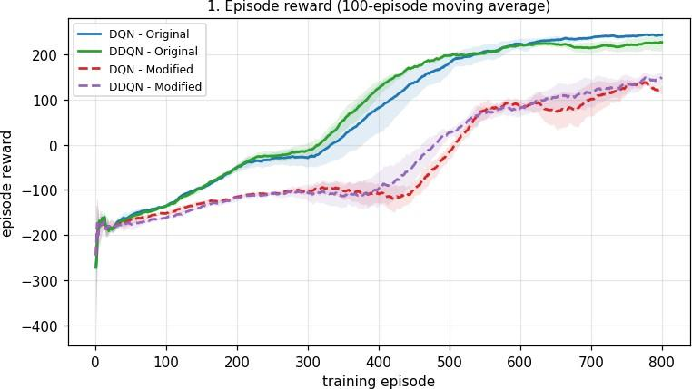

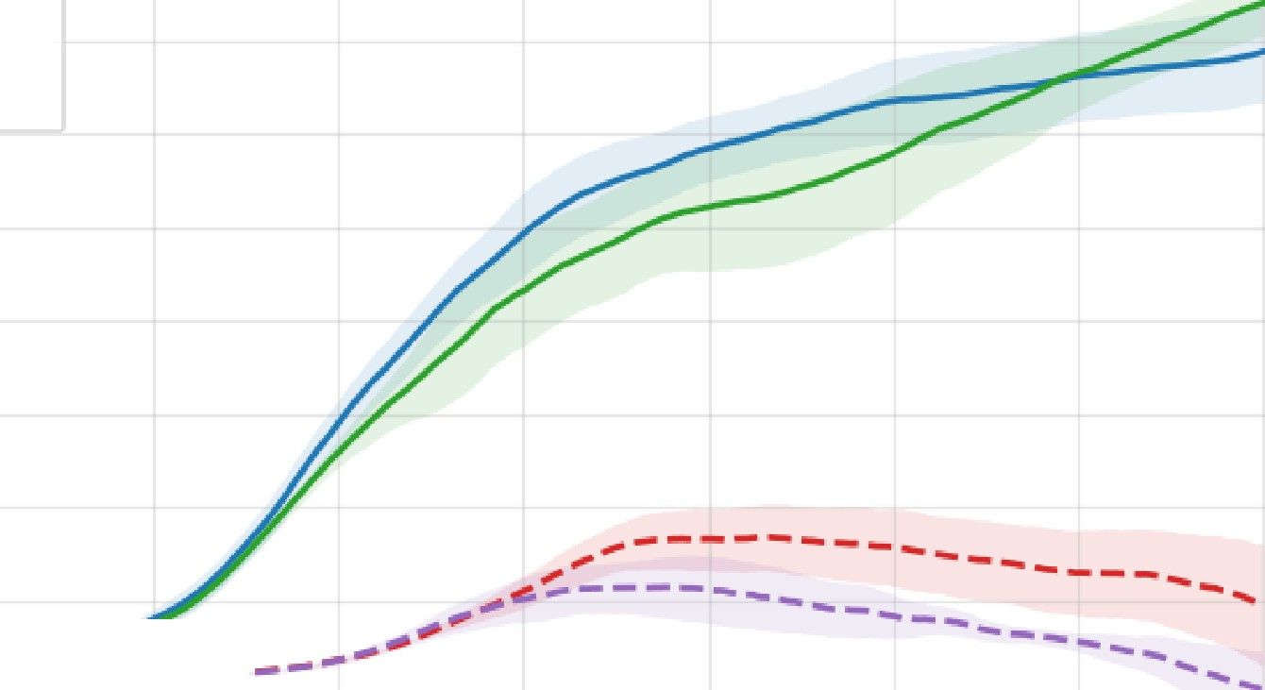
80

-₋
--
2. Average predicted Q-value on the fiixed validation set
DQN - Original DDQN - Origi1nal DQN - Modified
DDQN - Modified
...

70

60
-
ro
50
._",' 0
0) ₄₀
X
ro
E

_{C}"' 30
IC
IJ)
E 20

10

0

0 100 200 300 400
training episode
600 700 800

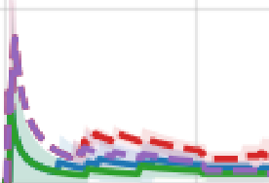
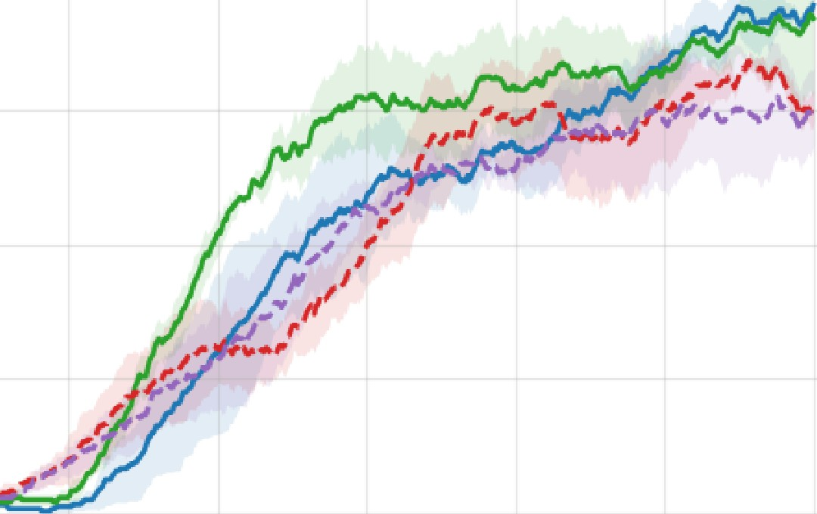
80

3. Successful landiing rate (100-episode moving average)
DQN - Original
DDQN - Original DQN - Modified
- DDQN - Modified

60

VI
Ol
C
-o 40
C
,a

.E!
!1J
Ul
20

0

0 100 200 300 400
training episode
500 600 700 800
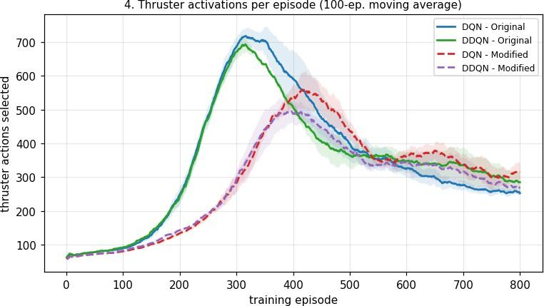
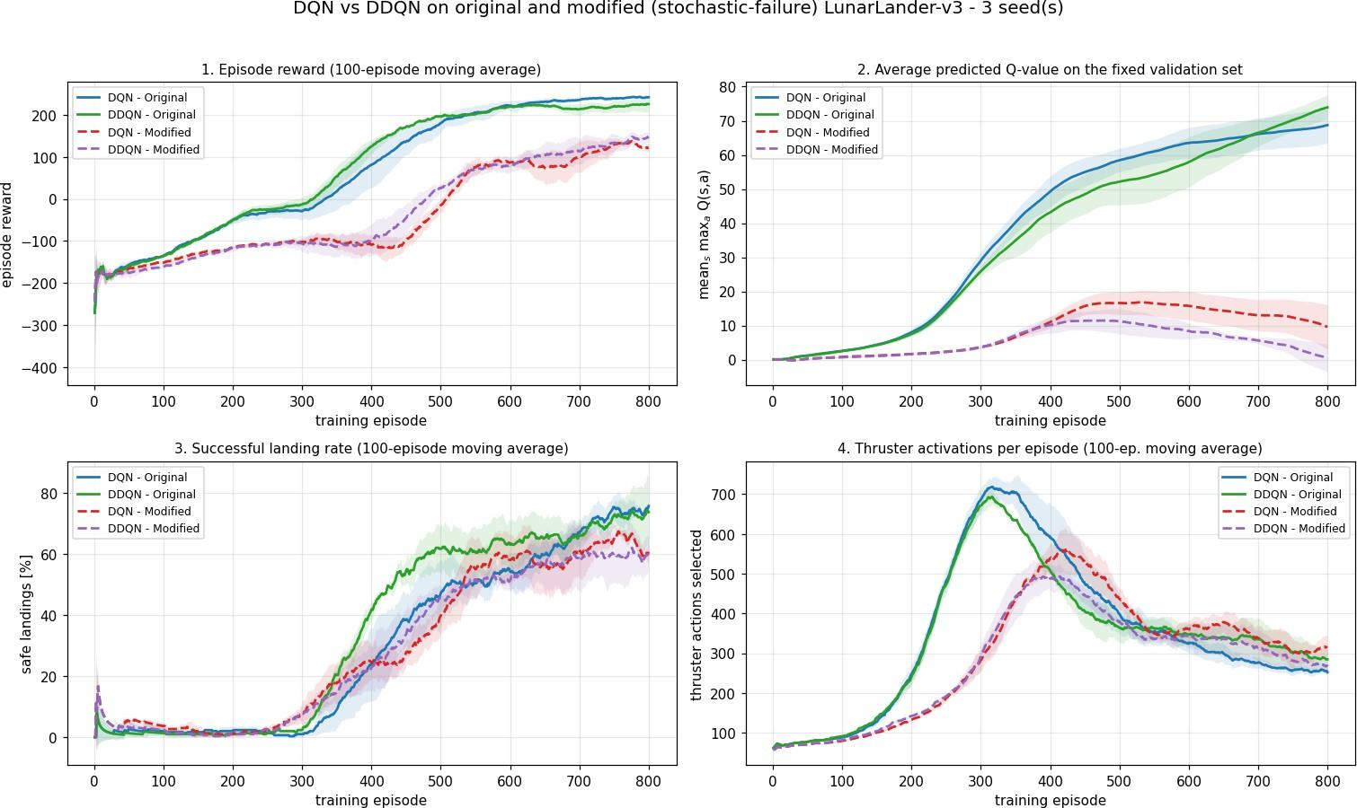

In [16]:
# Supplementary evidence used in the discussion: fuel economy per step and episode
plot_supplementary(results, window=100, show=True);
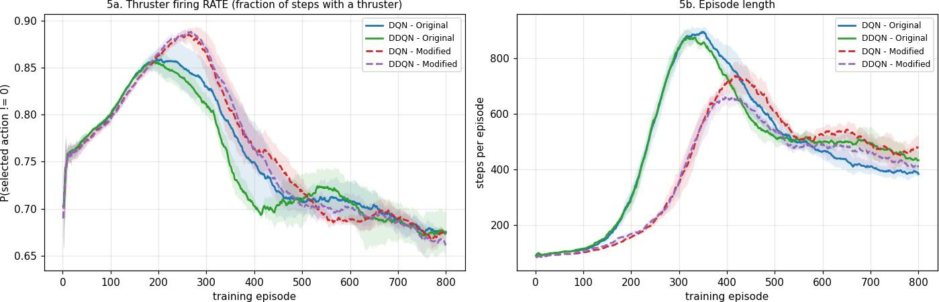

In [17]:
print("TRAINING STATISTICS (last 100 episodes, averaged over seeds 42/43/44)\n") print(summary_table(results, last=100))

TRAINING STATISTICS (last 100 episodes, averaged over seeds 42/43/44)

condition reward base reward land rate % thrusters fire rate e p len val Q misfire %

 | DQN_original | 242.3+/- | 2.9 | 242.3 | 75.7 | 252.5 | 0.675
383 | 69.00 | 0.00
DDQN_original |  | 226.0+/- | 19.6 | 226.0 | 73.7 | 284.8 | 0.674
432 74.19 |  | 0.00
DQN_modified |  | 122.3+/- | 9.7 | 186.3 | 60.7 | 314.6 | 0.672
478 9.20 |  | 14.79
DDQN_modified |  | 148.6+/- | 12.3 | 198.3 | 60.7 | 266.9 | 0.661
409 0.23 |  | 14.82

(mean over the last 100 training episodes; +/- is the spread across seeds)

In [18]:
print("PREDICTED-Q GAP BETWEEN DQN AND DDQN ON THE FIXED VALIDATION SET\n")
print(q_gap_table(results))

PREDICTED-Q GAP BETWEEN DQN AND DDQN ON THE FIXED VALIDATION SET

episode ORIGINAL: DQN DDQN gap rel.gap | MODIFIED: DQN DDQN

gap | rel.gap
 | 200 | 8.03 | 7.52 | +0.51 | 6.4% | | | 1.67 | 1.62 | +
0.05 | 2.8%
 | 400 | 49.28 | 43.17 | +6.11 | 12.4% | | | 11.03 | 10.19 | +
0.85 | 7.7%
 | 600 | 63.49 | 57.92 | +5.57 | 8.8% | | | 15.76 | 8.40 | +
7.37 | 46.7%
 | 800 | 68.75 | 73.94 | -5.19 | -7.0% | | | 9.61 | 0.56 | +
9.05 | 94.2%

rel.gap = (Q_DQN - Q_DDQN) / max(|Q_DQN|,|Q_DDQN|)

In [19]:
show_source("src/evaluate.py")
====================================================================================
================
FILE: src/evaluate.py (142 lines)
====================================================================================
================ """
evaluate.py
===========
Post-training greedy evaluation used in Tasks (d) and (e).

For each of the four trained agents it reports, over `n_episodes` greedy (epsilon = 0) episodes on its *own* training environment:

* mean episode reward and mean unshaped LunarLander reward
* safe-landing rate
* mean thruster activations per episode
* **value-estimation bias**: V_pred(s0) = max_a Q(s0, a) predicted at the initial state, versus the *actual* discounted return G0 obtained from that same state. `bias = V_pred - G0 > 0` means the agent over-estimates its own value, which is exactly the pathology Double DQN is designed to reduce.
"""
from future import annotations import numpy as np
import torch

from .agent import AgentConfig, DQNAgent
from .env_wrapper import StochasticActionFailureWrapper, is_safe_landing, make_env from .train import load_result, run_name, run_stem
from .utils import RESULTS_DIR, save_json

def load_agent(algo: str, env_kind: str, seed: int = 42) -> tuple[DQNAgent, dict]: """Rebuild an agent from its saved config and load the trained weights.""" res = load_result(algo, env_kind, seed)
cfg = AgentConfig(**{**res["config"], "hidden_sizes": tuple(res["config"]["hidde n_sizes"])})
agent = DQNAgent(8, 4, cfg, algo=algo, seed=res["seed"]) agent.q_online.load_state_dict(torch.load(RESULTS_DIR / f"{run_stem(algo, env_ki
nd, seed)}.pt")) agent.q_online.eval() return agent, res

def evaluate(algo: str, env_kind: str, train_seed: int = 42, n_episodes: int = 100, seed: int = 10_000, max_steps: int = 1000) -> dict:
"""Run a greedy policy and collect performance + value-bias statistics.""" agent, _res = load_agent(algo, env_kind, train_seed)
gamma = agent.cfg.gamma
env = make_env(env_kind, seed=seed)
is_mod = isinstance(env, StochasticActionFailureWrapper)

rewards, base_rewards, landings, thrusters, v_pred, g0, misfire_rate = [], [], [], [], [], [], []
lengths = []
for ep in range(n_episodes):
obs, _ = env.reset(seed=seed + ep) # same start states for all four
agents
v_pred.append(agent.mean_validation_q(np.asarray([obs], dtype=np.float32))) ret = disc = base = 0.0
thr = mis = steps = 0 terminated = truncated = False for t in range(max_steps):
steps += 1
a = agent.act(obs, eps=0.0) # greedy obs, r, terminated, truncated, _ = env.step(a) ret += r
disc += (gamma ** t) * r thr += int(a != 0)
if is_mod:
base += env.last_base_reward mis += int(env.last_misfired)
else:
base += r
if terminated or truncated: break

rewards.append(ret) base_rewards.append(base)
landings.append(int(is_safe_landing(obs, terminated, truncated))) thrusters.append(thr)
lengths.append(steps) g0.append(disc)
misfire_rate.append(mis / thr if thr else 0.0) env.close()

v_pred, g0 = np.asarray(v_pred), np.asarray(g0) return {
"name": run_name(algo, env_kind), "algo": algo,
"env_kind": env_kind, "train_seed": train_seed, "n_episodes": n_episodes,
"mean_reward": float(np.mean(rewards)), "std_reward": float(np.std(rewards)), "mean_base_reward": float(np.mean(base_rewards)), "landing_rate": float(np.mean(landings)), "mean_thrusters": float(np.mean(thrusters)), "mean_episode_len": float(np.mean(lengths)),
"thruster_rate": float(np.sum(thrusters) / np.sum(lengths)), "mean_V_pred_s0": float(v_pred.mean()),
"mean_actual_G0": float(g0.mean()), "value_bias": float((v_pred - g0).mean()),
"observed_misfire_rate": float(np.mean(misfire_rate)),
}

def evaluate_all(n_episodes: int = 100, seeds: list[int] | None = None) -> list[dic t]:
"""Evaluate all four conditions (averaged over training seeds) and persist the r eport."""
from .make_plots import CONDITIONS, available_seeds

seeds = seeds or available_seeds() rows = []
for algo, env_kind in CONDITIONS:
per_seed = [evaluate(algo, env_kind, train_seed=s, n_episodes=n_episodes) fo r s in seeds]
merged = {k: v for k, v in per_seed[0].items() if isinstance(v, str)} merged["n_episodes"] = n_episodes
merged["seeds"] = seeds for k in per_seed[0]:
if isinstance(per_seed[0][k], float):
merged[k] = float(np.mean([p[k] for p in per_seed])) merged["reward_across_seeds_std"] = float(np.std([p["mean_reward"] for p in
per_seed]))
rows.append(merged)
save_json(rows, RESULTS_DIR / "greedy_evaluation.json") return rows

def report(rows: list[dict] | None = None) -> str:
"""Format the greedy-evaluation results as a text table.""" rows = rows or evaluate_all()
head = (f"{'condition':>15} {'reward':>18} {'base rew':>10} {'land %':>8} {'thru st':>8} "
f"{'fire rate':>10} {'ep len':>7} {'V_pred(s0)':>11} {'actual G0':>10}
{'bias':>8}")
lines = [head, "-" * len(head)] for r in rows:
lines.append(
f"{r['name']:>15} {r['mean_reward']:>9.1f} +/-{r['std_reward']:>6.1f} " f"{r['mean_base_reward']:>10.1f} {100*r['landing_rate']:>8.1f} " f"{r['mean_thrusters']:>8.1f} {r['thruster_rate']:>10.3f} " f"{r['mean_episode_len']:>7.0f} {r['mean_V_pred_s0']:>11.2f} " f"{r['mean_actual_G0']:>10.2f} {r['value_bias']:>+8.2f}"
)
lines.append("\n+/- is the across-episode std of the greedy return.") lines.append("bias = V_pred(s0) - actual discounted return G0 (positive => ove
r-estimation)")
return "\n".join(lines)

if name == " main ": print(report())

In [20]:
# Greedy (epsilon = 0) evaluation of the final policies: 100 fresh episodes per see # identical start states for all four agents, plus the value-estimation bias at s0. from src.evaluate import evaluate_all, report

eval_rows = evaluate_all(n_episodes=100, seeds=SEEDS)
print("GREEDY EVALUATION OF THE FINAL POLICIES (100 episodes x 3 seeds)\n") print(report(eval_rows))
GREEDY EVALUATION OF THE FINAL POLICIES (100 episodes x 3 seeds)

condition |  | reward | base rew | land % | thrust | fire | rate | ep | len
V_pred(s0) actual | G0 | bias

DQN_original | 209.3 | +/- | 56.2 | 209.3 | 54.7 | 408.3 | 0.714 | 567
52.44 63.44 | -11.00
DDQN_original | 208.3 | +/- | 62.2 | 208.3 | 62.7 | 374.1 | 0.689 | 543
52.77 62.91 | -10.14
DQN_modified | 117.8 | +/- | 134.2 | 191.3 | 59.7 | 344.6 | 0.646 | 533
31.18 37.66 | -6.48
DDQN_modified | 132.6 | +/- | 141.0 | 194.0 | 66.0 | 314.5 | 0.663 | 473
28.96 39.71 | -10.75

+/- is the across-episode std of the greedy return.
bias = V_pred(s0) - actual discounted return G0 (positive => over-estimation)

Interpretation of the four plots

Plot 1 - Episode reward vs training episode
    - Both original-environment agents follow the classic LunarLander curve: flat around
-180 while the lander crashes, a steep rise between episodes ~250 and ~500, and a plateau at +226 to +242. DQN and DDQN are statistically indistinguishable here
( 242.3 +/- 2.9 vs 226.0 +/- 19.6 ; the DDQN spread is driven by a single weaker seed).
    - Both modified-environment agents plateau at only +122 to +149, and their take-off is
delayed by roughly 100 episodes (rise starts near episode 380 instead of 280).
    - Part of that gap is bookkeeping - the modified reward pays -0.3 per commanded thruster. Removing the shaping (the base reward column of the summary table) still leaves 186-198 versus 226-242 , i.e. about 40 points of genuine performance loss caused by the misfires themselves, plus roughly 80-100 points of accumulated fuel cost.
    - Under failures the ordering flips: DDQN (148.6) is clearly above DQN (122.3), and the dashed purple curve stays above the dashed red curve from about episode 550 onwards.

Plot 2 - Average predicted Q-value on the fixed validation set
    - Magnitudes differ by almost an order of magnitude: ~70 in the original environment versus ~0-16 in the modified one. This is expected - a -0.3 charge on most of the steps of a 400-500 step episode is worth roughly -0.3/(1-\gamma) = -30 of discounted value, and safe landings (which carry the +50 ) only occur ~60% of the time.
    - In the original environment the two curves track each other closely (relative gap 6-12%) and even cross near episode 700, after which DDQN is higher. That crossing is not a failure of Double DQN: with an almost deterministic environment there is little
overestimation to remove, so the curves mostly reflect genuine policy quality, and both are still rising at episode 800.
    - In the modified environment the picture is completely different. Both curves peak near episode 480 and then decline - as the policy improves, the agent starts firing deliberately and therefore actually pays the fuel penalty it had previously never incurred, so the true value of a state falls. Crucially, DQN's estimate stays persistently above DDQN's and the gap widens monotonically ( +0.85 at episode 400, +7.37 at 600,
+9.05 at 800 - i.e. from 8% to 94% in relative terms). This is the overestimation signature that DDQN is designed to remove.

Plot 3 - Successful landing rate (100-episode moving average)
    - Landing is counted with the same safe-landing predicate in both environments, so the curves are directly comparable.
    - Original: rises from ~0% to 74-76%. DDQN learns to land noticeably earlier - it is ahead of DQN by 10-20 percentage points between episodes 350 and 550 - before the two converge.
    - Modified: both saturate around 61%, i.e. roughly 15 percentage points lower. The 15% misfire probability makes the final touch-down phase - where a single missing burn turns a soft landing into a bounce or a crash - intrinsically unreliable, so a perfect policy cannot reach 100% either.
    - On fresh greedy episodes the DDQN advantage under failure is visible again: 66.0% vs 59.7%.

Plot 4 - Average thruster activations per episode
    - All four curves show the same characteristic hump: an untrained agent barely fires (episodes end in a quick crash), then it discovers that firing keeps it alive and fires almost continuously (the peak), and finally it learns to land and the count falls again.
    - The hump is much lower in the modified environment (~500-560 vs ~690-715) and it arrives later. The -0.3 charge makes the "hover forever" strategy expensive, so the agents never fully commit to it.
    - After convergence the raw counts are similar (250-320) because the modified agents also run longer episodes. Normalising by episode length (supplementary plot 5a) and looking at the greedy evaluation removes that confound: the modified agents fire 345 / 315 times per episode versus 408 / 374 for the original agents - about 15% less fuel - at a per-step firing rate of 0.65 / 0.66 versus 0.71 / 0.69 .
    - Between the algorithms, DDQN is the more economical one under failure (267 vs 315 activations in the last 100 training episodes), consistent with its less optimistic value estimates: it does not over-value the thruster actions whose effect is unreliable.

5. Task (e) - Discussion

Q1. Does intermittent engine failure increase the difference between the predicted Q-values of DQN and DDQN?

Yes - substantially, and the effect is unambiguous in relative terms.
From the Q-gap table ( Q_DQN - Q_DDQN on the same fixed 512-state validation set):

training episode original env (abs / rel) modified env (abs / rel)

200 | +0.51 | / 6.4% | +0.05 | / 2.8%
400 | +6.11 | / 12.4% | +0.85 | / 7.7%
600 | +5.57 | / 8.8% | +7.37 | / 46.7%
800 | -5.19 | / -7.0% | +9.05 | / 94.2%
In the original environment the gap stays small, is not systematically signed, and even reverses at the end. In the modified environment the gap is always positive (DQN above DDQN) and grows monotonically once the agents actually start using the thrusters, to the point where DQN's estimate is roughly twice DDQN's.
Why. The overestimation of the max operator scales with the variance of the value estimates: E[max_{a}(Q_{a} + ε_{a})] − max_{a} Q_{a} grows with Var(ε). The original LunarLander is almost deterministic, so the TD targets are low-variance and there is little bias to remove. A 15% Bernoulli misfire turns the outcome of every thruster command into a two-component mixture (thrust vs no thrust) while the -0.3 is charged regardless - exactly the extra target noise that inflates max_{a} Qθ− . DDQN's decoupling of action selection (online net) from action evaluation (target net) removes most of that inflation, so its curve sits lower.
Caveat (honesty check). The two curves are the values of two different policies, so a raw gap alone does not prove bias. We therefore also measured, at the episode start state s0 , the predicted value against the Monte-Carlo discounted return actually obtained by the same policy ( bias = V_pred(s0) - G0 in the greedy-evaluation table). Under failure DDQN's bias is -10.75 versus DQN's -6.48 , i.e. DDQN is the more pessimistic of the two, which is the expected direction for a bias-reduction method (Double DQN is known to be able to over-correct into slight underestimation). Both agents are net under-estimators here because γ = 0.99 over 400-500-step episodes discounts the large terminal landing reward heavily.

Q2. Why does stochastic action failure make credit assignment harder?

The action is no longer identified with its effect. Executing a = 2 produces the "main engine" transition 85% of the time and the "do nothing" transition 15% of the time. The same (s, a) pair therefore has a bimodal next-state distribution, and the learner must average over it. TD targets become much noisier, and the value function can only represent the expectation, never the realised outcome.
- The failure is unobservable. The wrapper deliberately hides the misfire (it is not in the observation nor in info ). A transition generated by a = 2 after a misfire is indistinguishable from one generated by a = 0 . The agent cannot explain away a bad outcome as "the engine failed", so the blame is attributed to the decision instead of to the actuator - a form of aliasing at the action level.
- Reward noise decorrelated from decision quality. The -0.3 is charged even when the engine does nothing, so ~15% of thruster steps are pure loss events that carry no information about whether the action was a good idea. The signal-to-noise ratio of the per-step reward drops.
- Long horizon amplifies it. Episodes last 400-500 steps and the decisive rewards ( +/-100 crash/land, +50 bonus) arrive only at the end. With ~250-350 thruster
commands per episode, roughly 40-50 of them misfire, so the same policy can produce
a safe landing in one episode and a crash in the next. The return distribution widens dramatically - the standard deviation of the greedy return rises from ~56-62 (original) to ~134-141 (modified) - and eligibility for the terminal reward has to be spread over a trajectory whose outcome was partly decided by exogenous noise.
- Practical consequence observed: learning onset is delayed by ~100 episodes and the plateau is lower and noisier (Plot 1).

Q3. Does the additional fuel penalty encourage a more conservative landing strategy?
Yes, though the effect is on total fuel spent rather than on the instantaneous firing rate, and the misfires contribute to it as well as the penalty.
Experimental evidence:

_{Evidence} Original (DQN /
DDQN)
Modified (DQN / DDQN)

Peak of the thruster curve during training (Plot 4) | ~715 / ~690 | ~560 / ~490
Greedy thruster activations per episode | 408 / 374 | 345 / 315
Greedy per-step firing rate | 0.714 / 0.689 | 0.646 / 0.663
Greedy episode length (steps) | 567 / 543 | 533 / 473

- The most striking effect is the suppressed hover phase: the original-environment agents pass through a stage where they fire on ~700 steps per episode, whereas the modified agents never exceed ~560. With -0.3 per command, hovering for an extra 100 steps costs 30 reward
  - comparable to two-thirds of the entire landing bonus - so that strategy is simply never worth learning.
- The final policies spend ~15% less fuel and terminate ~10-13% sooner: they descend more directly and correct less, which is exactly what "conservative" means for a lander.
- Qualification. The penalty is not the only cause. Because 15% of commands are wasted,
the expected cost of achieving a given impulse is 1/0.85 = 1.18x higher, which by itself discourages fine-grained thruster use. Disentangling the two would require an ablation (penalty only, failure only) - see Q5.

Q4. Which algorithm performs better under stochastic engine failures? Is this consistent with the theoretical advantage of DDQN?
DDQN performs better under stochastic engine failures, while the two are equivalent in the original environment:

Metric | DQN-Mod | DDQN-Mod | DQN-Orig | DDQN-Orig
Training reward, last 100 ep. | 122.3 +/- 9.7 | 148.6 +/- 12.3 | 242.3 +/- 2.9 | 226.0 +/- 19.6
Unshaped (base) reward | 186.3 | 198.3 | 242.3 | 226.0
Greedy reward (100 fresh ep.) | 117.8 | 132.6 | 209.3 | 208.3
Greedy landing rate | 59.7% | 66.0% | 54.7% | 62.7%
Greedy thruster activations | 344.6 | 314.5 | 408.3 | 374.1

Yes, this is consistent with theory - and, importantly, so is the absence of a difference in the original environment. Double DQN's only claimed benefit is the reduction of the maximisation bias, whose size grows with the noise in the value targets. LunarLander with deterministic actuators produces low-variance targets, so DDQN has almost nothing to correct and matches DQN. Injecting a 15% Bernoulli actuator failure is precisely an increase in target variance, and there the benefit materialises: DQN's inflated values (Q1) bias it towards over-using unreliable thruster actions, which costs both reward and fuel, whereas DDQN's more accurate values yield a better and cheaper policy.
Statistical caution. With three seeds the DDQN advantage under failure (~26 reward points) is of the same order as the seed-to-seed spread (~10-12). DDQN is ahead on seeds 42 and 44 and essentially tied on seed 43, so the direction is consistent but the magnitude should be read as indicative rather than significant.

Q5. One limitation of the experimental setup and one improvement
Limitation - the comparison rests on too few seeds and on a single, un-tuned operating point. Only 3 seeds x 800 episodes were run, with one hyper-parameter set chosen a priori and a single failure probability (0.15). DQN on LunarLander is notoriously seed-sensitive, and the DQN/DDQN differences we measure are comparable to the across-seed spread. A related weakness is that Plot 2 compares the predicted Q-values of two different policies, so it confounds "over-estimation" with "my policy is genuinely better"; and because the fixed validation states are sampled from a random policy on the original environment, they are not on-distribution for the converged agents.
Improvement. Run the full grid over at least 10 seeds and report the interquartile mean with bootstrap confidence intervals (the rliable protocol) instead of single-run curves, and sweep the failure probability p in {0, 0.05, 0.10, 0.15, 0.25, 0.35} together with an ablation that applies the fuel penalty and the misfires independently. That would (i) make the DQN-vs-DDQN ranking statistically defensible, (ii) show directly whether the DDQN advantage grows with actuator noise as the overestimation theory predicts, and (iii) separate the behavioural effect of the fuel penalty from that of the failures (Q3). In addition, the value-accuracy claim should always be made with the on-policy measure already included here - predicted V(s0) versus Monte-Carlo return of the same policy - rather than with raw Q-curves, and the validation states should be periodically re-sampled from the current policy's own state distribution (kept fixed within a comparison).

6. Virtual Lab Execution Evidence
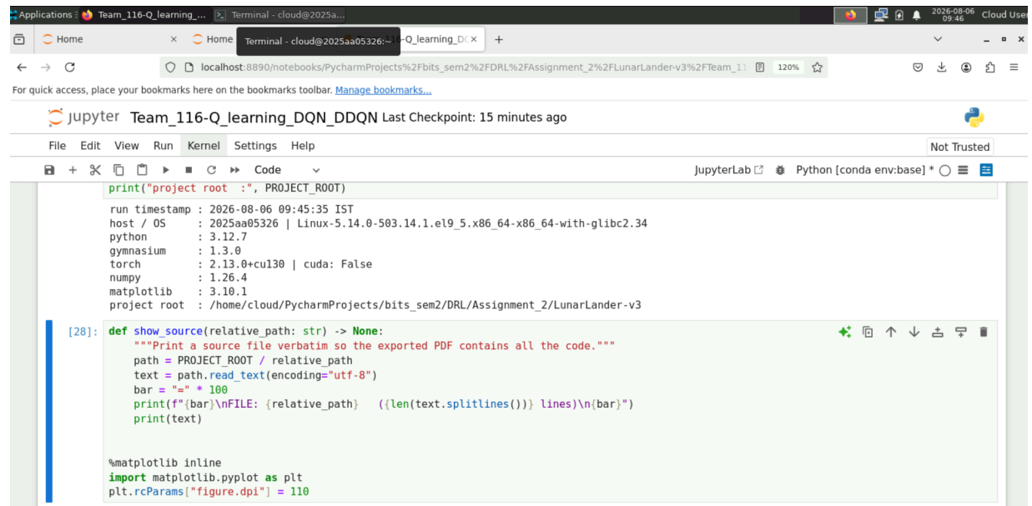

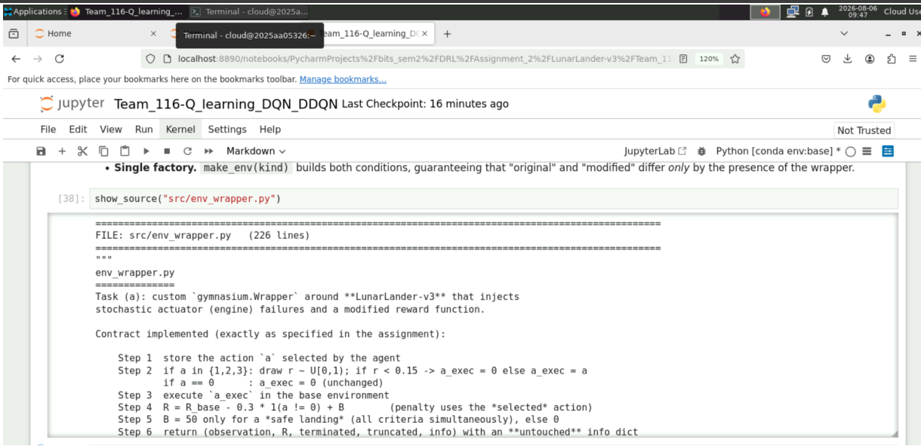

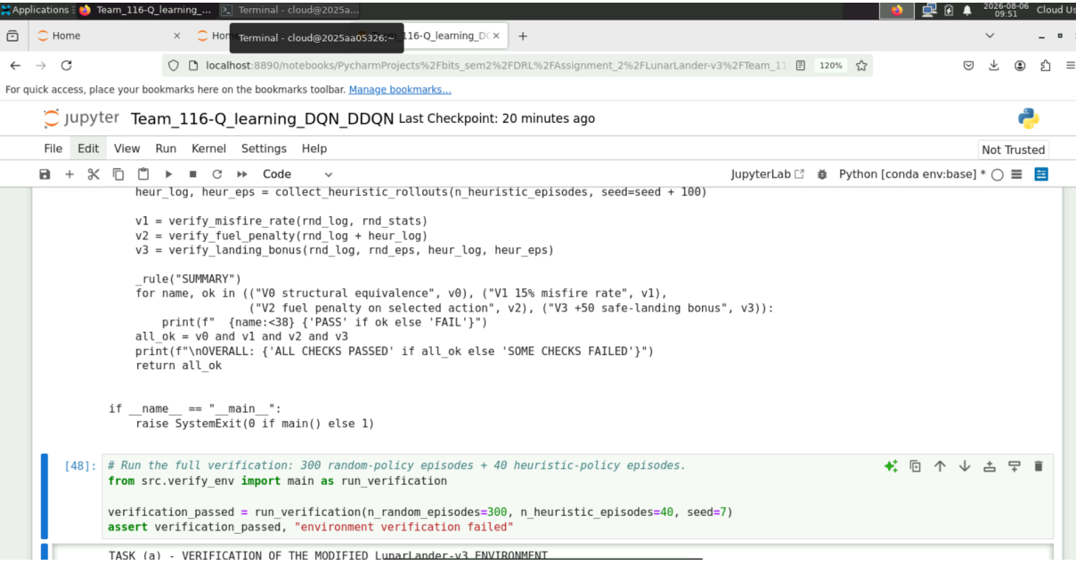

DRL Team-116 Assignment2 END

