Web Science
Quiz 1: March 12, 2015
100 points max

- HTML 5 (25 points): One of the first things we covered was HTML 5

  - (10) What is HTML5 and how does it differ from earlier versions of HTML?

HTML5 is a markup language used to structure and present content on the web. HTML5 provides tags to structure information and give it semantic meaning. HTML5 is different from earlier version of HTML because it has added functionality and markup tags to provide more meaning to the information in the document (ex: header and footer, article, section, audio, video, and canvas).

  - (10) How would we represent a thematic grouping of content in an HTML document? Why is it important?

Content is grouped thematically using tags to describe the content. For example, a <header> tag would be placed around content found at the top of the page. Different parts of the page can be sectioned off using <section> or <aside> or <figure>. Without these tags, we might use a <div> with a user-generated class or id that would not provide as much semantic meaning if the ids or classes are not standardized. These new HTML5 tags therefore help standardize the categorization of information in the document.
Ultimately, we represent a thematic grouping of content in an HTML document because we want sites to present data in a meaningful manner. Grouping content based on a theme provides more significance to each grouping and provides greater specificity to the reader.

  - (5) Describe the difference between cookies and local storage. When would you use one or the other?

Cookies are read on the server-side, whereas local storage is read on the client-side. Therefore if your server needs to access data, cookies should be used, and if your client (such as Javascript) needs to access the data, then local storage is used.

- Node.js : (25 points) Create a webserver in node.js which will output a simple html page that contains a form when a request is received on http://localhost:3000. The form should contain an input field, a button and an output field that displays a greeting to the user when the button is clicked (as shown below).

See attached files

- Web application framework (25 points)
  - (5) What is it?

A web application framework, is used to structure dynamic web applications. Every server-side framework essentially provides a foundation to build an application on. They provide a template, of sorts, to help manage common server-side functions (handling user sessions, caching, etc.).

  - (5) Why do we use it?

We use frameworks to help streamline the web application development process by allowing us to utilize commonly used and pre-developed features across every application. Developers no longer have to re-develop key features for every web application they develop.

  - (10) Describe the difference between the front-end and back-end.

Front-end frameworks assist developers create parts of the site which are user-facing and helps form the interface which the user interacts with. Front-end often deals with styling and presentation of data. The front-end frameworks essentially create a cohesive skeleton upon which the back-end development will function.
Back-end frameworks help developers provide the primary functionality to the site, and is built using server-side languages and databases. Back-end frameworks often deals with dynamic representation of data and performing common server-side tasks.

  - (5) Give two examples of frameworks.
Express and Bootstrap are both web application frameworks

- APIs (10 points)
  - (5) What are the characteristics of RESTful APIs how do they differ from other web service architectures?

RESTful APIs are very lightweight and rely entirely on HTTP standards to interact with a certain service. REST is built for the web. RESTful APIs do not require the client to know anything about the structure of the API and the server does all of the work by handling information the client needs to interact with the service. Essentially, the browser will not know where or what information to submit.

Other web service architectures, such as SOAP, have their own protocols and focus on presenting application logic as services. Other web services also do not deal with performance and scalability to the same degree as REST. SOAP-based reads, specifically, cannot be cached. SOAP also has a standard messaging system to deal with communication failures, has a strong transaction system, and also adds some enterprise security features. Ultimately, without much of an emphasis on presenting data, other web service architectures are important and useful but often serve a different purpose.

  - (5) Give an example of where a RESTful API would be preferred and why.

An example of where a RESTful API would be preferred would be if you are trying to access and present data instead of a specific operation. RESTful APIs use standard HTTP and really shines in delivering data by permitting many different data formats (whereas SOAP only permits XML).

- (15) Explain in detail what the following code does;

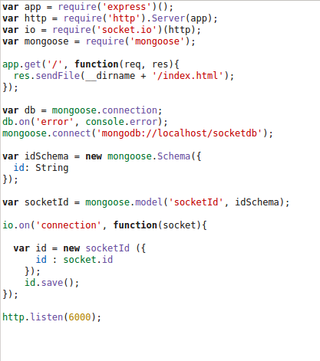
The code serves the index.html file through the server listening on port 6000. It then sets up a mongoose connection and uses mongoose.connect to connect to a MongoDB database. The idSchema = new mongoose.Schema then creates a schema that maps to a MongoDB collection and defines the documents within the collection (has one defined variable of ‘id’ which is a string). Afterwards, mongoose.model creates a model named ‘socketId’ of the schema so we can work with it.
Io.on() then creates a connection with the socket on another html page.
id is then set to equal a new instance of the socketId model with an id variable set to the socket’s id (a unique id associated with the socket connection).
The id.save then saves the socket id to preserve the connection.

