Eddie Philip Gurnee
Tyler Charles Hoffman
2015-03-06
COSC 571

Best Buy Books Project
Phase 2 – ER diagram and Three Screens

ER Diagram

Available at http://db2.emich.edu/~201501_cosc471_group04/admin/data/ER_Diagram.pdf

Justifications:
Customer:
One_Click_Buying – Customers should be allowed to click on the "Buy It Now" button to immediately create an order of the item selected using the default destination and default pay method.
Date_Of_Birth – Customers should recieve an e-mail wishing them a happy birthday and giving them a coupon.
Prime_Member – Customers that are prime members do not need to pay for shipping and sometimes recieve coupons.
Loyalty_Points – Earned when books are purchased.
Customers can have mutiple credit cards stored, but credit cards are associated with only one customer.
Customers have a wishlist that they can add books to.

Credit Card:
Default_Card – A customer's card to be used in One-Click buying.
Name_On_Card – If the name on a card is different than the stored customer name, that needs to be stored.
Type – If the card is debit or credit.
Still_Valid – indicates whether the date the card is being use is before the expiration date.
Customer uses a specific credit card to place any number of orders.

Order:
Delivery_Status – The current state of delivery based on the date was created, the date the order is viewed, and the length of the delivery to the order's location.
Based on a location, it'll take an order a specific amount of time to get there and will cost a certain amount of money to ship.

Delivery_Location:
Default_Location – A customer's address to be used in One-Click buying.
Phone_Contact – Any phone number and carrier of someone to contact if issues occur or when the delivery arrives.
Customers can have two delivery locations stored; one for their home and another for a commonly used location.
Multiple accounts can order deliveries to the same address.

Coupon:
Customers can receive coupons that have a dollar value that can be applied to some orders to reduce cost.
Only up to three coupons can be applied to an order.

Book:
Books can be in a series with other books (trilogy, nonology, duology, etc), as well as being similar to other books, though only the five most similar books are stored.
Books need to have a genre and can have up to three (to accomodate teen paranormal romance).

Genre:
Each genres has a most popular book, and keeps track of how many were purchased so far this month.

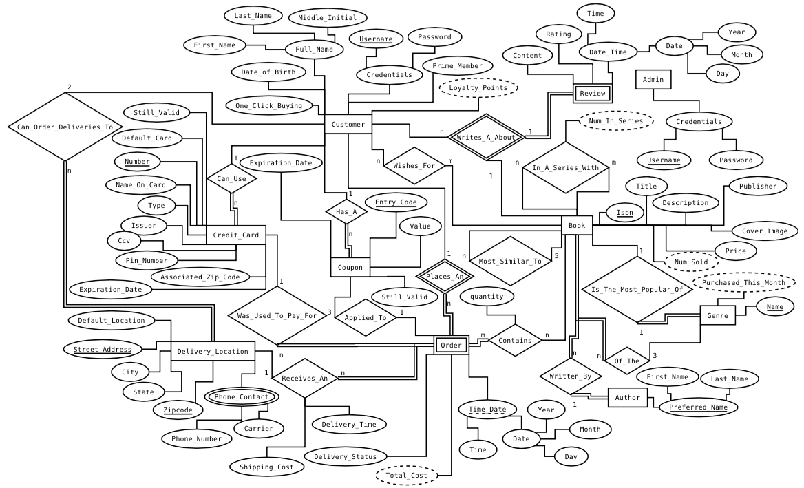

Links to Functional Pages

Main page
http://db2.emich.edu/~201501_cosc471_group04/

Search
http://db2.emich.edu/~201501_cosc471_group04/search.php

Results – This was a search for Absolute Java
http://db2.emich.edu/~201501_cosc471_group04/search.php?query=Absolute+Java

Feel free to search for anything written by H.P. Lovecraft, i.e. Call of Cthulhu, The Shadow Over Innsmouth, The Dunwich Horror, etc.

