
PowerChain | CRISIS
Full Engineering & Operations Documentation
Crisis Capital Network · Solana Runtime · Provider Resolution · Security · Operations
Version 1.0.0
29 August 2026
CORE OPERATING RULE
Mainnet means live. Missing authoritative data is unavailable or degraded - never zeroed, guessed, or silently replaced by demo data.

DOCUMENT GUIDE

How to use this handbook
A consolidated reference for engineering, operations, security and integration teams.
Audience | Start here
Developer | Quick Start -> API -> SDK -> Testing
SRE / Operations | Architecture -> Providers -> Runbook -> Troubleshooting
Security | Security Model -> Web Proxy -> Production Gate
Solana engineer | Runtime -> Program Verification -> Token Inspection -> Market Data
Product / Partner | Architecture -> PWRC Utility -> Fees -> Cross-chain -> Glossary

Repository documentation
The canonical Markdown index is docs/README.md. This handbook summarizes and connects those documents; the Markdown files remain the easiest source for code-adjacent updates.
01

System architecture
One canonical service path from Solana/providers to the browser.
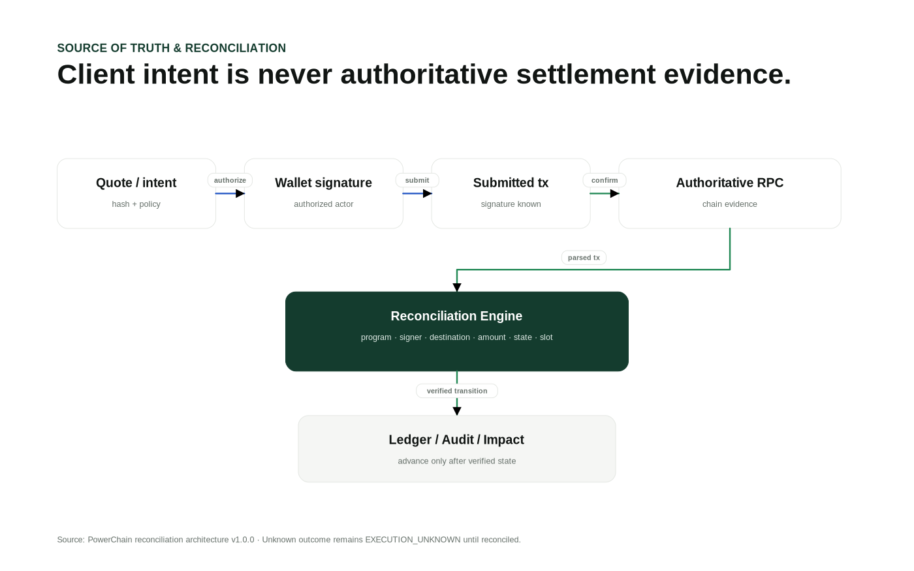
Source-of-truth architecture and authority boundaries.
Solana RPC / Helius + market providers
↓
@powerchain/crisis-solana-api
↓
Fastify API
↓
Next.js server-only proxy
↓
React operations UI / typed API client

Key boundaries
- Solana RPC is authoritative for chain state and token supply/decimals.
- Market providers contribute display/analytics observations; they cannot overwrite on-chain token truth.
- The browser talks to the website origin; private provider credentials stay in the backend.
- Compatibility aliases reuse the canonical service functions.
02

Quick start and workspace
Target toolchain, configuration and first successful requests.
Workspace | Responsibility
apps/backend | Fastify runtime and security middleware
backend | Canonical Solana service/routes/types
apps/web | Next.js proxy and operations UI
packages/api-client | Typed browser/server API client
packages/* | Policy, fees, utility, bridge, factory, rewards and chart domains
docs | Engineering/operations documentation

cp apps/backend/.env.example apps/backend/.env
cp apps/web/.env.example apps/web/.env.local
corepack enable
pnpm install
pnpm dev

TOOLCHAIN
Production releases require Node >=24.20.0, pnpm 11.24.0 and a real committed pnpm-lock.yaml. The source archive does not fabricate a lockfile.

03

HTTP API reference
System, canonical Solana and compatibility routes.
Method / Path | Purpose
GET /api/v1/health | Liveness
GET /api/v1/ready | RPC/cluster readiness
GET /api/v1/config/public | Non-secret runtime configuration
GET /api/v1/providers/status | Redacted provider telemetry
GET /api/v1/openapi.json | OpenAPI JSON
GET /api/v1/solana/overview | Cluster/RPC overview
GET /api/v1/solana/programs | Program deployment verification
GET /api/v1/solana/market?mint= | Market resolution for explicit mint
GET /api/v1/solana/assets/:mint | SPL/Token-2022 inspection
WS /api/v1/ws/solana | Bounded overview/program snapshots

Compatibility aliases
GET /api/solana/overview
GET /api/token/market?mint=<address>
GET /api/assets/:mint

Aliases emit deprecation/successor headers and call the same implementation. Only /api/token/market may use backend-configured PWRC_MINT when mint is omitted.
04

Solana runtime
Cluster health, genesis binding, blockhash and cache behavior.
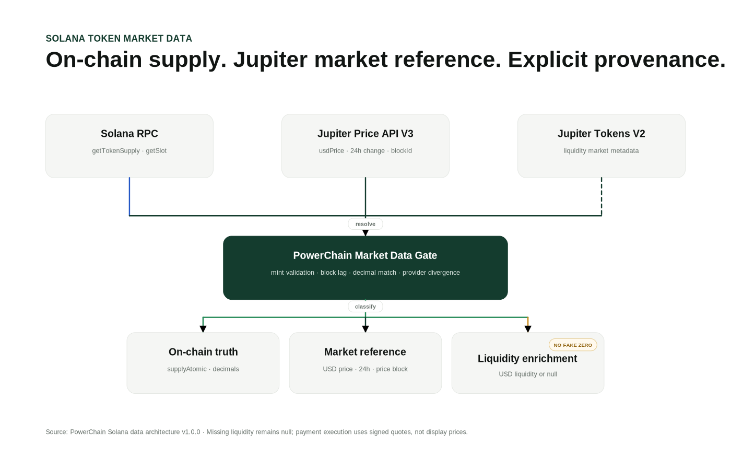
Solana market-data architecture: RPC truth plus provider observations.
RPC method | Use
getHealth | Cluster health
getSlot | Current slot
getBlockHeight | Block height
getEpochInfo | Epoch/slot index
getVersion | Solana core / feature set
getLatestBlockhash | Operational blockhash telemetry
getGenesisHash | Cluster binding
getSupply | SOL supply
getTokenSupply | Mint supply/decimals
getAccountInfo | Mint/program inspection
getMultipleAccounts | Batch program verification

CLUSTER SAFETY
SOLANA_EXPECTED_GENESIS_HASH should be configured in production. A mismatch fails readiness rather than silently accepting the RPC endpoint.

05

Launchpad and program verification
Configured IDs are inputs; executable account state is proof.
Program verification batches account inspection and distinguishes configured values from verified deployments.
State | Meaning
DEPLOYED | Exists, executable and loader accepted
NOT_FOUND | Configured account absent
UNCONFIGURED | No ID provided
INVALID_CONFIGURATION | Configured value is not a valid Solana key

Production-required Launchpad bindings
- SOLANA_LAUNCHPAD_REGISTRY_PROGRAM_ID
- SOLANA_LAUNCH_POLICY_PROGRAM_ID
- SOLANA_TOKEN_FACTORY_PROGRAM_ID
Additional vesting, escrow and Crisis program IDs can be configured without changing the verification model. Do not document or deploy guessed program IDs.
06

SPL and Token-2022 inspection
Supply, decimals, authorities and extensions are read from the mint account.
The asset endpoint calls getTokenSupply plus raw/jsonParsed account inspection. The account owner classifies classic SPL Token vs Token-2022.
Field group | Meaning
tokenProgramKind | SPL_TOKEN, TOKEN_2022 or UNKNOWN
supplyAtomic / decimals | RPC-authoritative mint supply
initialized | Mint initialization state
mintAuthority | Current mint authority or null
freezeAuthority | Current freeze authority or null
extensions[] | RPC-parsed Token-2022 extension state
metadata | Optional Helius enrichment only

AUTHORITY TRUTH
Helius metadata and market APIs never replace RPC supply, decimals, mint authority or freeze authority.

07

Market-data resolution
Source-aware price selection with divergence, freshness and confidence gates.
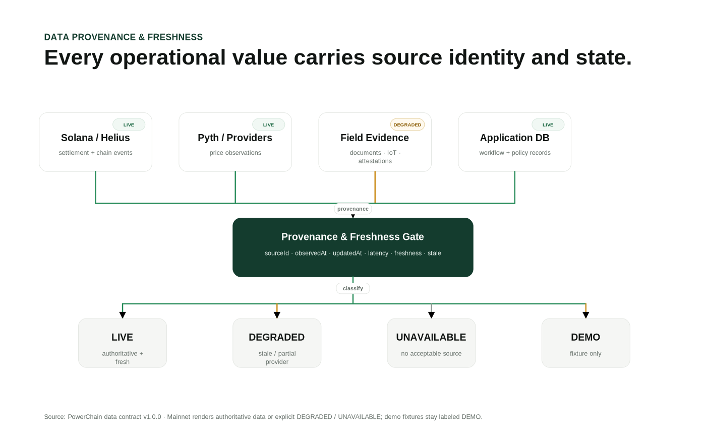
Data provenance and freshness gate.
Pyth
↓
Jupiter Price V3
↓
CoinGecko
↓
CoinMarketCap
↓
Birdeye
↓
Helius DAS

Gate | Behavior
Provider priority | First valid observation in configured order is primary
Divergence | Large cross-provider spread degrades response
Pyth confidence | Confidence/price ratio over limit degrades
Jupiter block lag | Price block too far behind RPC slot degrades
Decimal mismatch | Jupiter vs RPC decimal mismatch degrades
No valid price | 503 MARKET_DATA_UNAVAILABLE

The response explicitly marks market information as DISPLAY_AND_ANALYTICS_ONLY.
08

Provider observability
Redacted health without leaking credentials.
/api/v1/providers/status exposes capability, configuration state, last latency, failure count, last check and redacted error code for operators.
Telemetry | Why it matters
configured | Distinguishes optional/unconfigured from failing
state | LIVE/DEGRADED/UNCONFIGURED/UNKNOWN
latencyMs | Detects slow upstreams
consecutiveFailures | Detects sustained provider failure
cache.entries | Shows cache footprint
cache.inFlight | Shows upstream request pressure

SECRET BOUNDARY
Provider status never returns RPC URLs, API keys, auth headers or internal tokens.

09

Next.js proxy and browser security
Same-origin browser APIs without shipping provider secrets.
Browser -> website /api/* -> server-only proxy -> Fastify -> providers

- POWERCHAIN_API_URL is server-only.
- POWERCHAIN_INTERNAL_API_TOKEN is attached by the Next.js server.
- Proxy requests use no-store and a 10-second timeout.
- Proxy loops are rejected.
- Sensitive NEXT_PUBLIC_* configuration is rejected by the production gate.
10

Realtime WebSocket protocol
Bounded operational snapshots, not raw RPC streaming.
WS /api/v1/ws/solana supports overview and programs topics. The server sends a hello frame, immediate snapshot and 30-second interval snapshots.
Limit | Value
Max WebSocket payload | 8 KiB
Application messages per connection | 30
Incoming message size check | 4096 bytes
Allowed topics | overview, programs
Policy-close code | 1008

AUTHORITY
Realtime snapshots are observability data. They are not settlement confirmation or treasury evidence.

11

Security model
Fail closed at every authority boundary.

Source-of-truth and trust-boundary view.
PWRC -> utility
Identity -> actor
Role -> scope
Policy -> allowed action
Approval -> authorization
Signer -> execution
Solana -> settlement evidence
Evidence -> real-world proof

- Constant-time internal-origin token comparison.
- Explicit CORS in production.
- Helmet + 1 MiB body limit + rate limiting.
- Request IDs and redacted logs.
- No-store API responses.
- No AI/token/provider response can grant treasury authority.
12

Production deployment gate
Configuration must prove the target environment is real.
Required gate | Reason
Node >=24.20.0 / pnpm 11.24.0 | Pinned toolchain
pnpm-lock.yaml | Reproducible install
mainnet-beta + dev fallback off | No public-development path
Private RPC/Helius | Production capacity
Expected genesis hash | Cluster binding
Internal token >=32 chars | Origin authentication
Explicit CORS | Browser origin control
Required Launchpad IDs | Deployment binding
Credentialed market provider | No keyless production market dependency
No sensitive NEXT_PUBLIC_* | Browser secret prevention

13

Operations runbook
What operators check every day and during incidents.
Daily: readiness -> provider status -> Solana overview -> required programs -> market degradation -> application/provider error rates.

High-priority incidents
Incident | Immediate action
RPC unavailable | Stop financial execution; validate private RPC/Helius
Genesis mismatch | Stop execution; verify cluster/config
Market divergence | Inspect observations/freshness/confidence/block lag
Required program missing | Disable affected capability; verify deployment evidence
Provider key exposure | Rotate secret, rebuild, audit browser artifacts
Unknown transaction outcome | Use EXECUTION_UNKNOWN; reconcile before retry

14

Testing and release validation
Source checks, runtime smoke tests and target-environment gates.
pnpm check:source
pnpm typecheck
pnpm test
pnpm build
NODE_ENV=production POWERCHAIN_ENV=production pnpm check:production

The deterministic runtime smoke test stubs RPC/Jupiter responses and verifies overview, market, Token-2022 inspection and provider telemetry. It does not replace live devnet/mainnet integration tests.
15

PWRC utility and authority separation
Power Units and utility tiers are service entitlements, not RBAC.
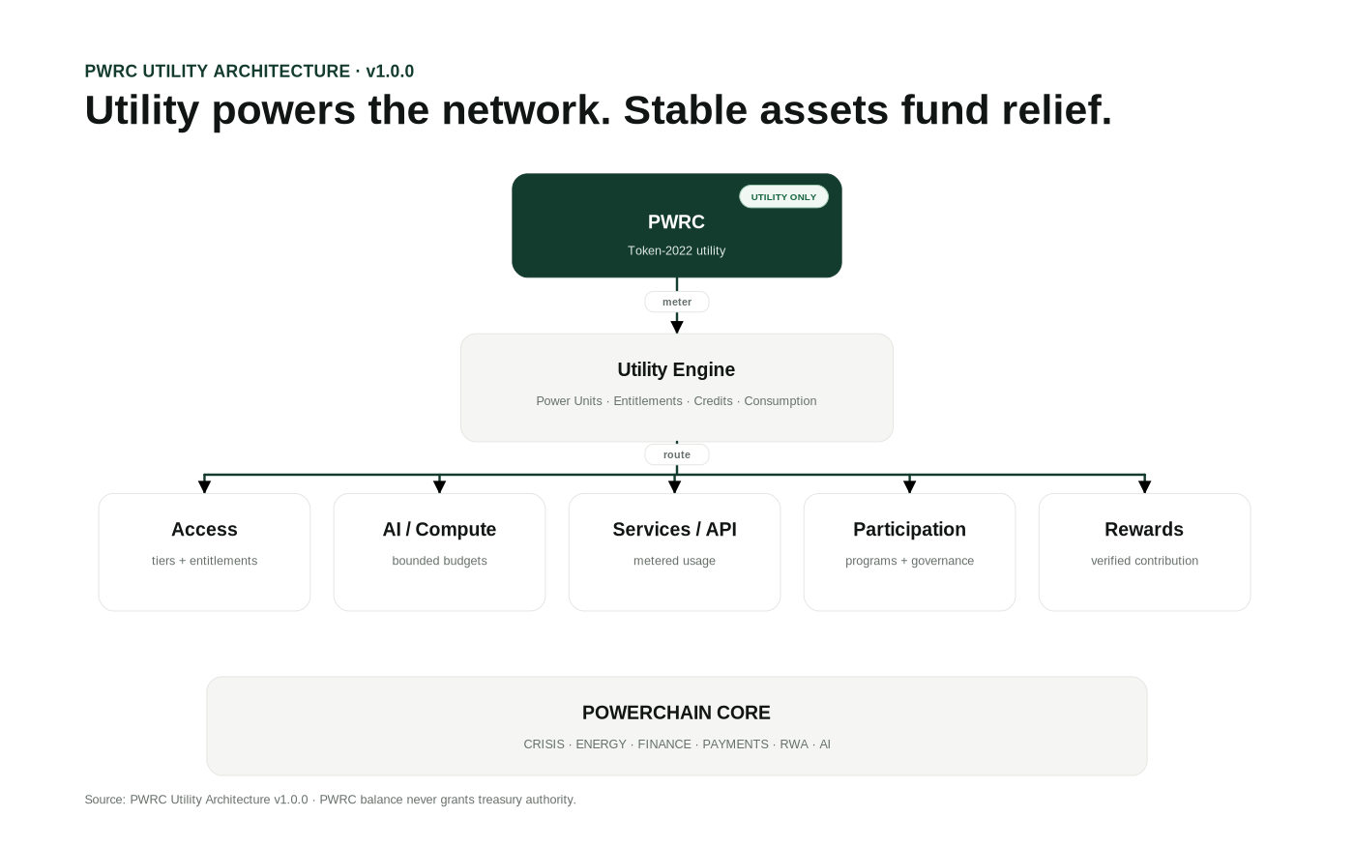
PWRC utility architecture.
Category | Examples
ACCESS | Entitlements and tiers
COMPUTE | AI workloads
SERVICES | Reports/data services
PARTICIPATION | Programs
GOVERNANCE | Economic governance
INCENTIVES | Reviewed rewards
REPUTATION | Eligibility input
NETWORK | API/service consumption

FINANCIAL BOUNDARY
PWRC balance alone never grants FUND, ALLOCATE, ESCROW, RELEASE, COMMISSION, BRIDGE, MINT or REWARD authority.

16

Fees and successful-funding economics
Contributor charges and post-success commission are separate.
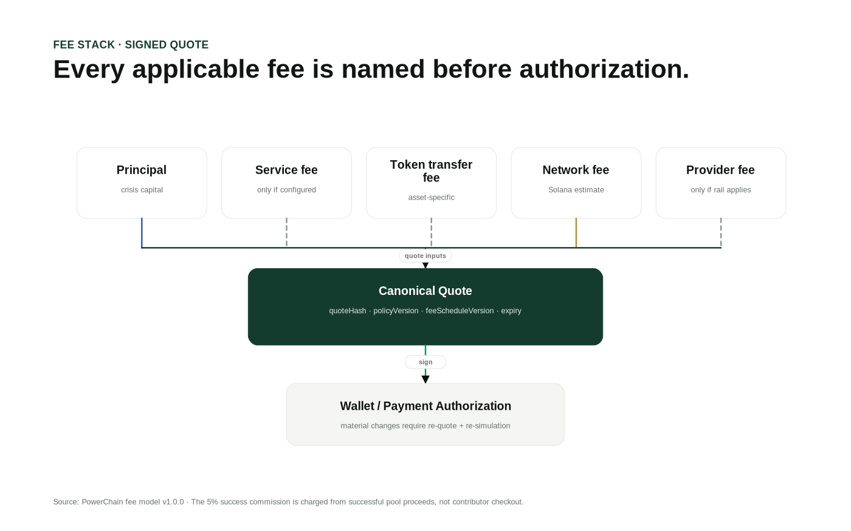
Fee-stack semantics.
Contributor checkout may include principal, service fee, token transfer fee, estimated network fee and provider/onramp fee. The successful-funding commission is not charged at contributor authorization.
Successful pool proceeds
-> 5% total
-> 2 percentage points Community Treasury
-> 3 percentage points Ecosystem & Development

17

Cross-chain security
CCTP, CCIP and wrapped-PWRC routes use different trust assumptions.
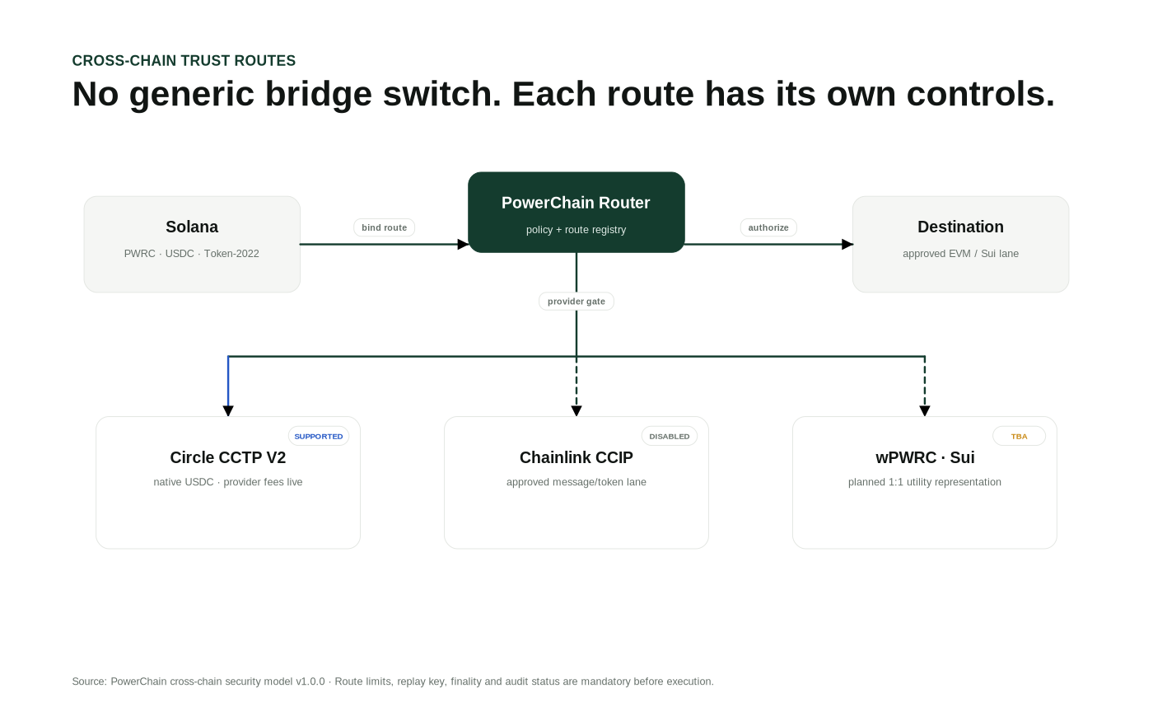
Cross-chain route security model.
- Route status must be LIVE.
- Audit flag is required.
- Route ID/version and replay domain must match.
- Transfer IDs are replay-protected.
- Per-transfer and outstanding caps are enforced.
- Wrapped supply cannot exceed verified backing.
18

Token factory and community rewards
Production review is not the same as automatic issuance.
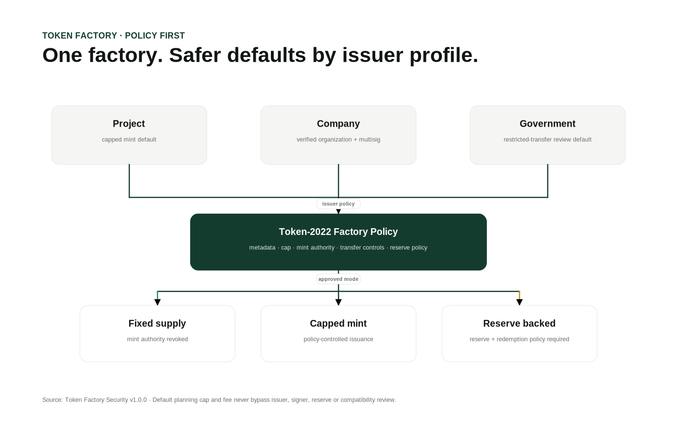
Token factory issuer-profile architecture.

Token factory
Project, Company and Government profiles share policy validation for ticker, metadata, decimals, supply cap, reserve-backed rules, restricted-transfer review and confidential-transfer review.

Rewards
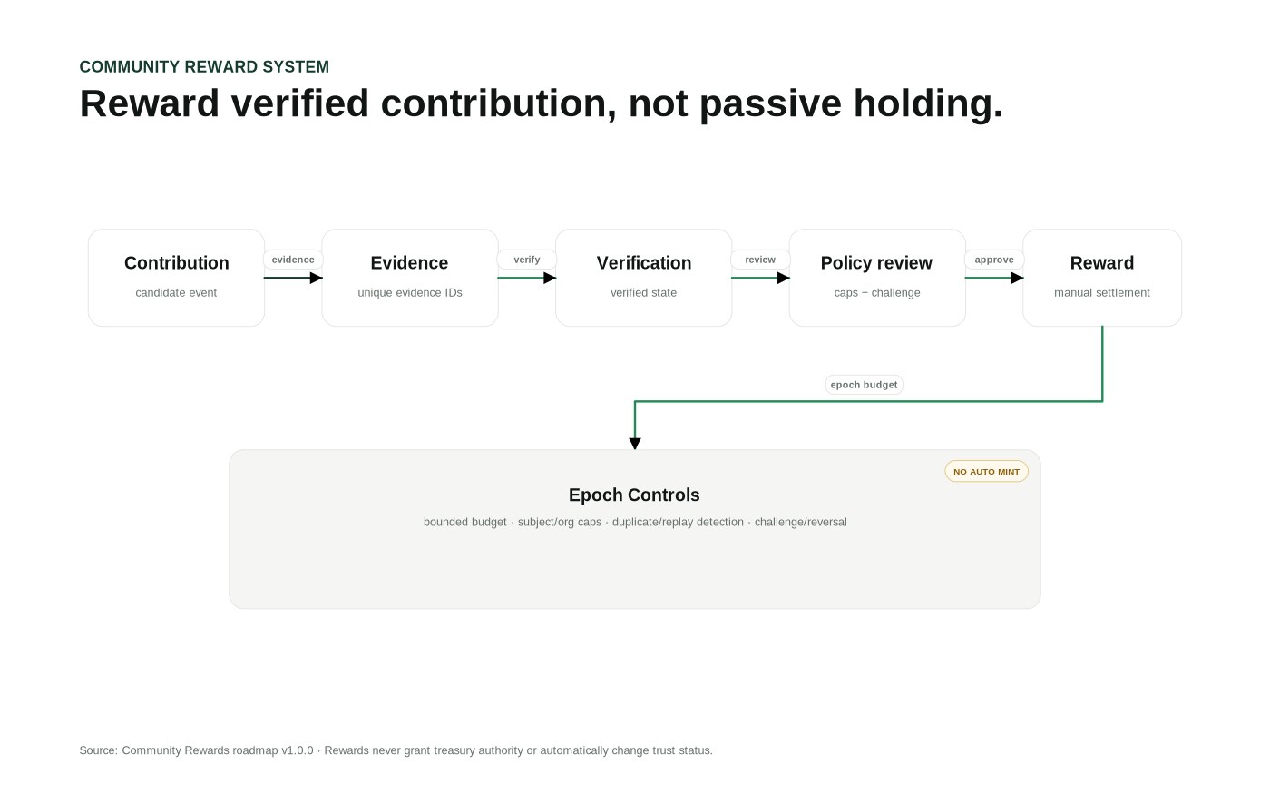
Evidence-bound community reward flow.
Reward epochs enforce evidence, duplicate/replay prevention, subject/org caps and total epoch budget. Recommendations never auto-mint; authority remains REWARD_POLICY_REVIEW.
19

Charts and data provenance
Every live visual should answer where, when and how trustworthy.
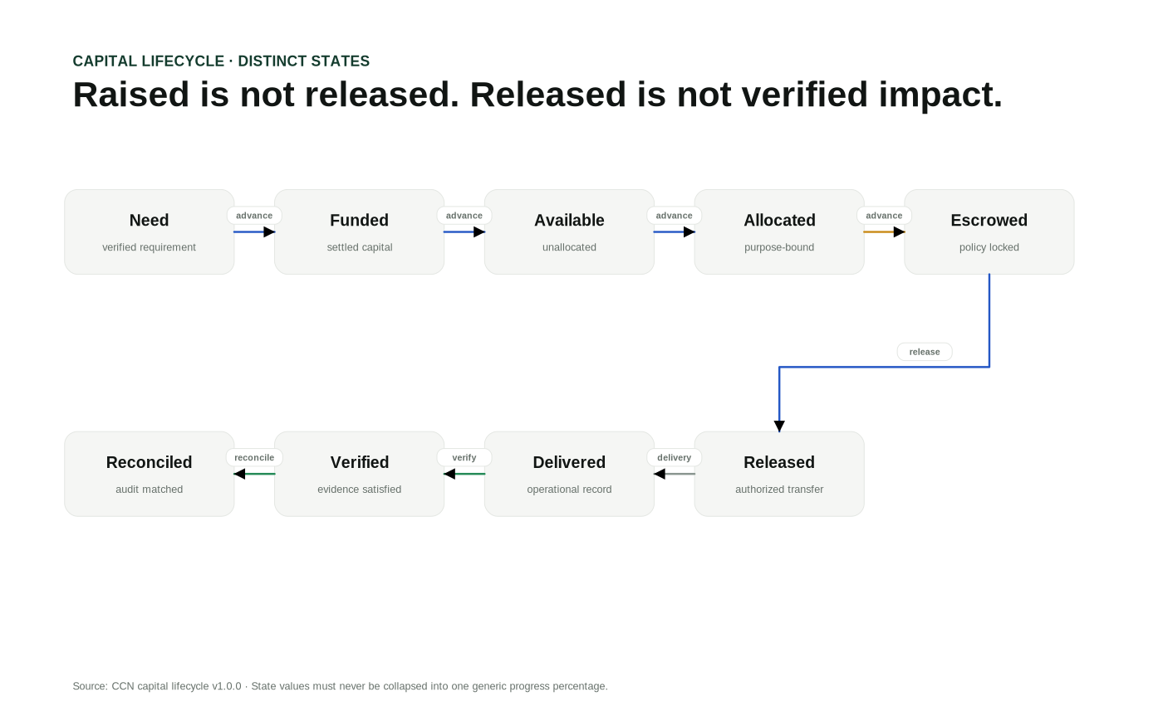
Capital lifecycle visualization.
Charts use LIVE, DEMO, STATIC, DEGRADED, TBA and UNAVAILABLE modes. LIVE without a source becomes unavailable; stale live data becomes degraded. Missing provider data is not rendered as zero.

Architecture visual rules
- Orthogonal connectors and explicit arrowheads.
- Semantic connector labels.
- Dashed paths for optional/degraded/TBA edges.
- Status/source annotations.
- Dark forest-green cards use white text for contrast.
20

SDK, Postman and integration workflow
How clients should integrate without bypassing the platform boundary.
const api = new PowerChainApiClient("");
await api.ready();
await api.solanaOverview();
await api.solanaPrograms();
await api.solanaMarket(mint);
await api.solanaAsset(mint);

New code should use canonical client methods. Compatibility methods exist only for migration. The Postman collection supports both backend-origin and website-origin verification.
21

Troubleshooting guide
Diagnose configuration, provider, proxy and token-inspection failures.
Error | First check
POWERCHAIN_API_URL_REQUIRED | apps/web/.env.local
POWERCHAIN_API_PROXY_LOOP | Backend URL must not equal website origin
BACKEND_ORIGIN_AUTH_REQUIRED | Internal token alignment
MARKET_DATA_UNAVAILABLE | Provider credentials/priority/token support
PWRC_MINT_NOT_CONFIGURED | Legacy default only
UNSUPPORTED_TOKEN_PROGRAM | Address/cluster correctness
INVALID_CONFIGURATION | Program ID format
Lockfile missing | Generate with pinned pnpm in target environment

22

Glossary and final release checklist
Common terminology and the minimum path to a production claim.
Term | Meaning
Canonical route | Supported /api/v1 contract
Compatibility alias | Deprecated route calling canonical service
Genesis binding | Expected vs active cluster genesis hash
Market observation | Provider price/liquidity/volume sample with provenance
Power Units | PWRC service-metering abstraction
EXECUTION_UNKNOWN | Transaction outcome not yet established
Deployment verification | Executable program account + accepted loader

Production claim checklist
- Frozen dependency install passes.
- Typecheck/test/build pass.
- Production gate passes.
- Readiness returns intended cluster.
- Required programs verify.
- Provider credentials and telemetry are healthy.
- Browser bundles contain no provider secrets.
- Runbooks and rollback are approved.
- Deployment evidence records commit/image/config/program IDs.
FINAL RULE
Source support is not the same as deployed capability. Production status must be backed by the target environment, not by documentation alone.

