
PowerChain
DISASTER RELIEF | CRISIS CAPITAL NETWORK

Verified capital infrastructure
for disaster response, recovery
and measurable impact.
PWRC Utility Architecture · Visual Data Semantics · Solana Settlement · Evidence & Impact Fabric
Technical Whitepaper - Architecture & Data Edition
Version 1.0.0
28 August 2026
CORE PRINCIPLE
PWRC powers utility around the response. Stable assets fund the response. Identity and policy control authority. Cryptographic signers execute value movement. Evidence proves real-world outcomes.

DOCUMENT MAP

Whitepaper contents
This edition aligns the whitepaper with the upgraded chart, connector, provenance and deployment-status system used across the PowerChain Crisis UI and architecture exports.
Section | Focus
01 | Executive summary - capital to outcomes.
02 | CCN architecture - bounded networks and truth layers.
03 | Capital lifecycle - explicit financial states and reconciliation.
04 | Fee model - contributor fees versus post-success commission.
05 | PWRC utility - Power Units and authority separation.
06 | Token factory - issuer profiles and mint-secret boundary.
07 | Cross-chain - CCTP, CCIP and wPWRC/Sui fail-closed routes.
08 | Security control plane - identity, policy, signer and reconciliation.
09 | Community rewards - bounded evidence-based incentives.
10 | Evidence & impact - proof beyond transaction confirmation.
11 | UX/UI - public, operator, treasury and auditor experiences.
12 | Nepal demo fixture - explicitly non-live product data.
13 | Data/oracles - source provenance, freshness and provider state.
14 | Visual data system - arrows, edge states, charts and accessibility.
15 | Production readiness - mainnet release gates.
16 | Strategic roadmap - activation sequence within v1.0.0.
17 | Conclusion & references - governing invariants and sources.

EXECUTIVE SUMMARY

PowerChain connects capital to outcomes
PowerChain Crisis is a capital-coordination and evidence system for verified emergency response. It separates crisis intelligence, stable-asset capital, response execution, trust, settlement and proof of impact so no single wallet, token, AI model or database becomes the entire control plane.
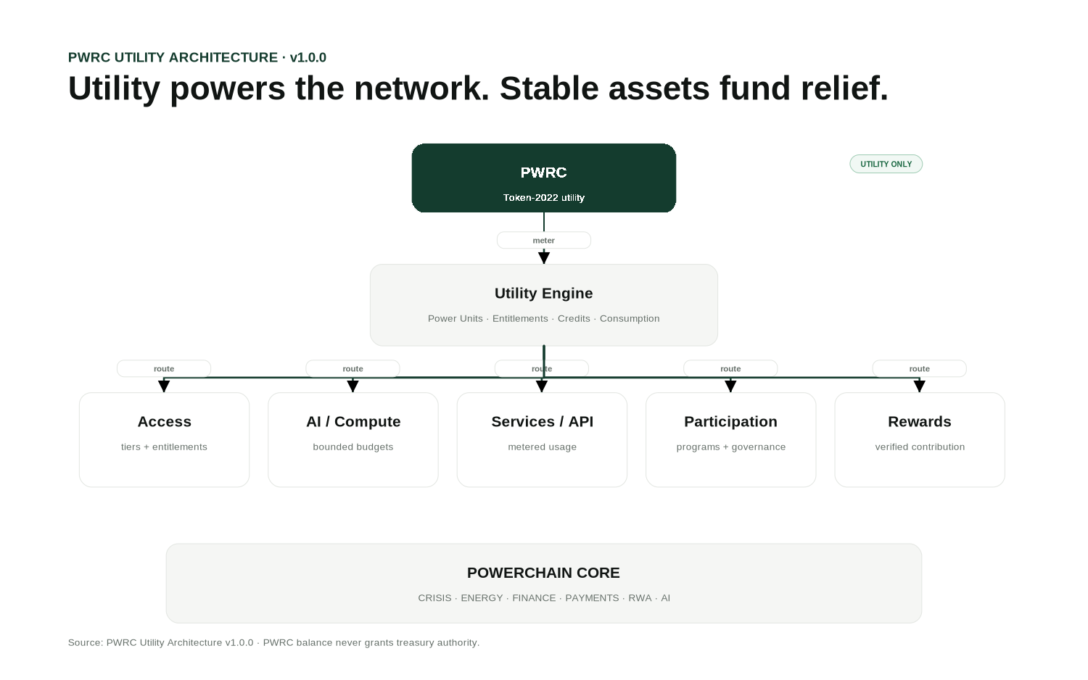
Figure 1. PWRC is a network utility layer, not crisis donor capital.
Challenge | PowerChain control
Slow / fragmented funding | Solana settlement, checkout, Solana Pay and portable Actions/Blinks.
Misallocation risk | Purpose-bound pools, allocation policy, escrow and approval thresholds.
Weak transparency | Explicit financial states and public capital-to-impact views.
Procurement risk | Supplier controls, explainable integrity signals and evidence.
Difficult verification | Evidence Fabric, field verification and Impact Passports.
AI overreach | AI may recommend; policy and authorized signers control irreversible actions.

ARCHITECTURE

Five connected networks inside CCN
The Crisis Capital Network is a network of bounded domains. The product UI can unify them, but the data and authority models remain separate.
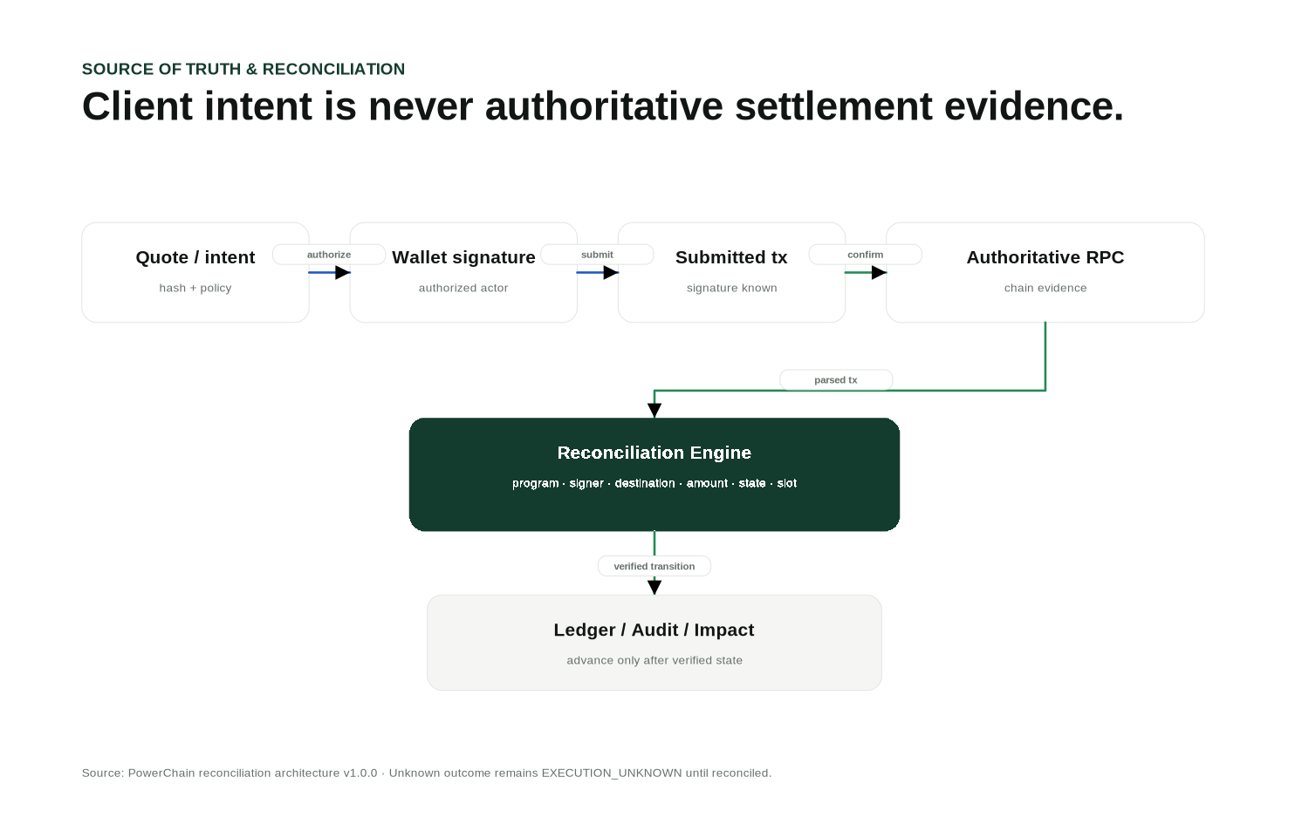
Figure 2. Source-of-truth routing separates Solana settlement, external observations, operational data and evidence before state reaches the UI.
Network | Primary responsibility
Crisis | Canonical crisis identity, severity, geography, lifecycle and verified need.
Capital | Pools, capital gap, allocations, escrow and funding intents.
Response | Organizations, suppliers, procurement, logistics and field operations.
Trust | Identity, evidence, policy, risk, verification, attestations and audit.
Settlement | Solana programs/tokens, Actions/Blinks and provider-specific cross-chain settlement.

Truth layers
- Solana is authoritative for blockchain settlement and program/token state.
- PostgreSQL/Supabase is authoritative for operational workflows, organizations, policies, evidence metadata and audit indexes.
- Private object storage holds raw sensitive evidence.
- The event engine normalizes authoritative chain/application events for ledger, risk, notifications and analytics.

CAPITAL CONTROL

Financial states remain distinct
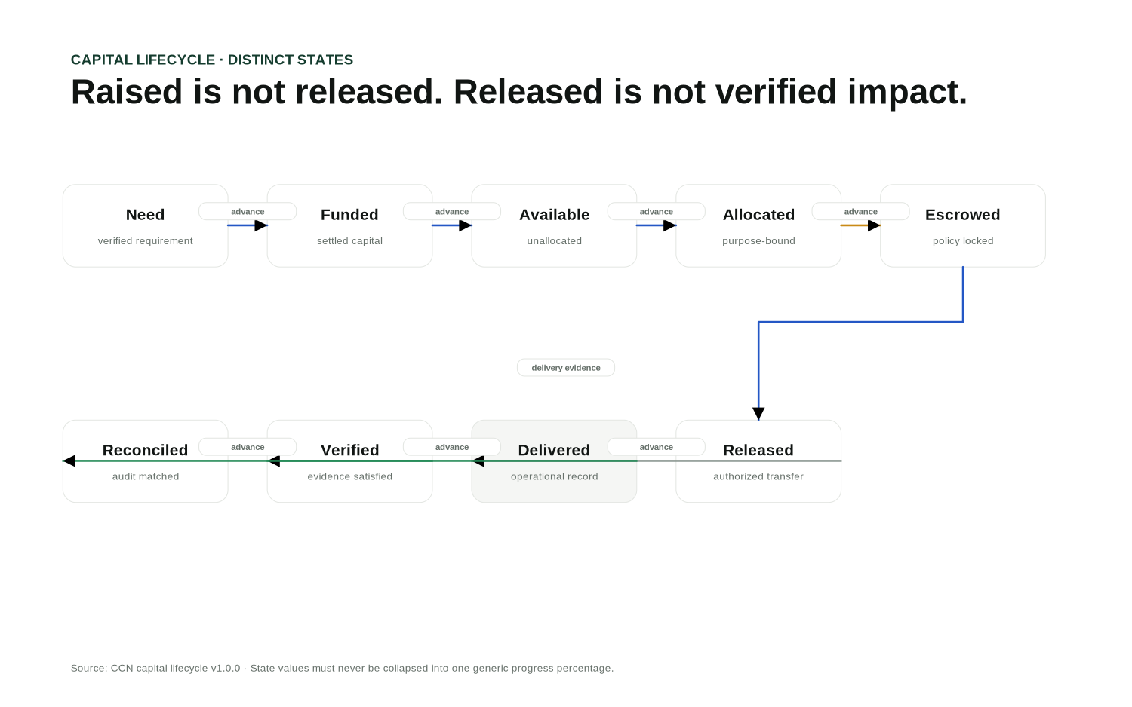
Figure 3. Capital progresses through explicit states; arrows represent allowed lifecycle transitions rather than decorative flow.
State | Meaning
NEED | Verified capital requirement.
COMMITTED | Capital promised/reserved by an accepted source.
AVAILABLE | Settled capital available to allocate.
ALLOCATED | Budget assigned to a permitted purpose/recipient class.
ESCROWED | Purpose-bound capital reserved under release conditions.
RELEASED | Authorized blockchain/payment movement completed.
DELIVERED | Operational delivery record exists.
VERIFIED | Required evidence/verification threshold is satisfied.
RECONCILED | Financial and operational records agree.

FEE MODEL

Show the entire fee stack before authorization
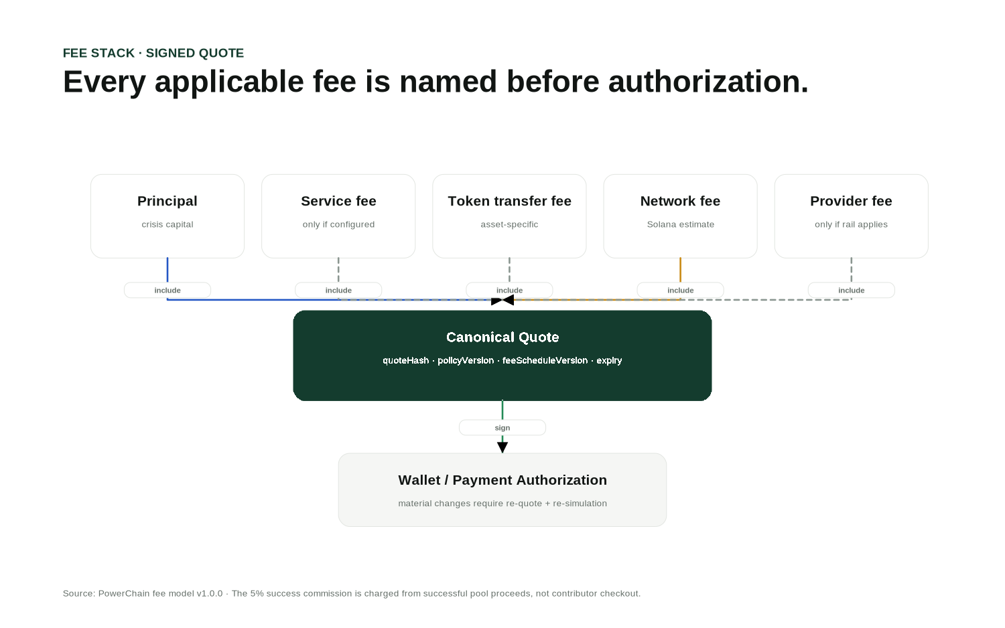
Figure 4. Material fee and policy fields are bound into the canonical quote.
The contributor checkout shows principal and each applicable service, token-transfer, network or provider fee separately. The 5% successful-funding commission is not a contributor checkout charge: where a capital-pool policy enables it, it is charged from successful pool proceeds only after the authoritative success threshold is satisfied.

Successful-funding commission
Destination | Share of successful pool proceeds
Community Treasury | 2 percentage points
Ecosystem & Development | 3 percentage points
Total | 5 percentage points
ATOMIC SETTLEMENT
Where the asset/network supports it, the 2% and 3% legs should be signed in one transaction and reconciled before the commission record becomes CONFIRMED.

PWRC 1.0

PowerChain Network Utility
PWRC is the shared utility asset for PowerChain access, AI/API consumption, participation, reviewed incentives and economic governance. A PWRC balance does not confer crisis-treasury or emergency authority.
Utility category | Examples
ACCESS | Entitlements and service tiers.
COMPUTE | AI workloads and bounded agent utility budgets.
SERVICES | Reports, data products and selected platform services.
PARTICIPATION | Programs and ecosystem coordination.
GOVERNANCE | Economic governance; not emergency treasury authority.
INCENTIVES | Evidence-backed community/ecosystem rewards.
REPUTATION | One input to eligibility/trust, never the sole score.
NETWORK | API and machine-service metering.

Power Units
Power Units are an internal metering abstraction. The reference planning conversion is configurable; service pricing can change without altering token decimals or crisis-capital accounting.

TOKEN FACTORY

One factory with safer issuer profiles
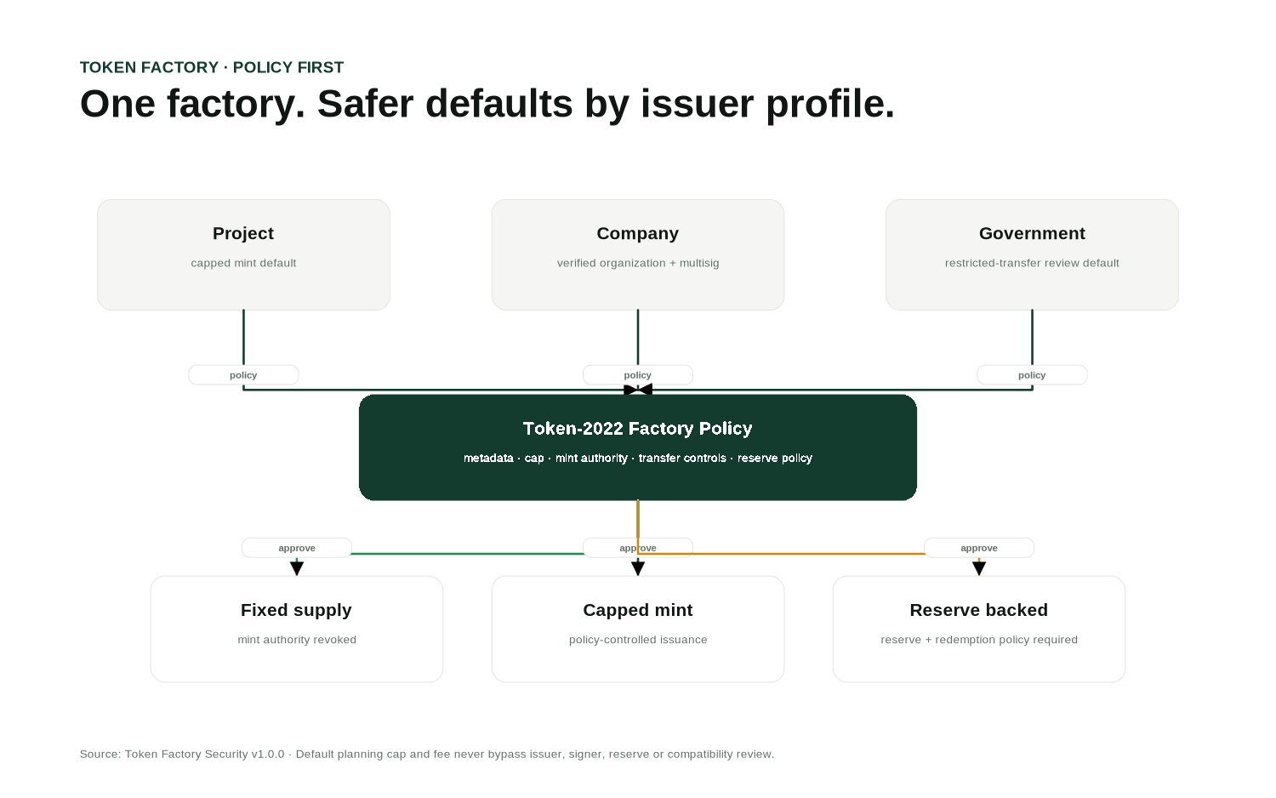
Figure 5. Project, company and government assets share the same factory but use different policy defaults.
Profile | Safer default posture
PROJECT | Capped mint, verified issuer, purpose/metadata disclosure.
COMPANY | Verified organization, multisig/HSM policy, explicit treasury/mint separation.
GOVERNMENT | Restricted-transfer review by default and stronger change control.
RESERVE BACKED | Reserve asset, ratio, attestation, redemption and controlled mint/burn policy required.
MINT SECRET BOUNDARY
The backend should prepare and verify Token-2022 transactions, but it should not receive or persist the mint private key. A one-billion-unit value is a planning cap, not an automatic mint.

CROSS-CHAIN

Provider-specific routes fail closed
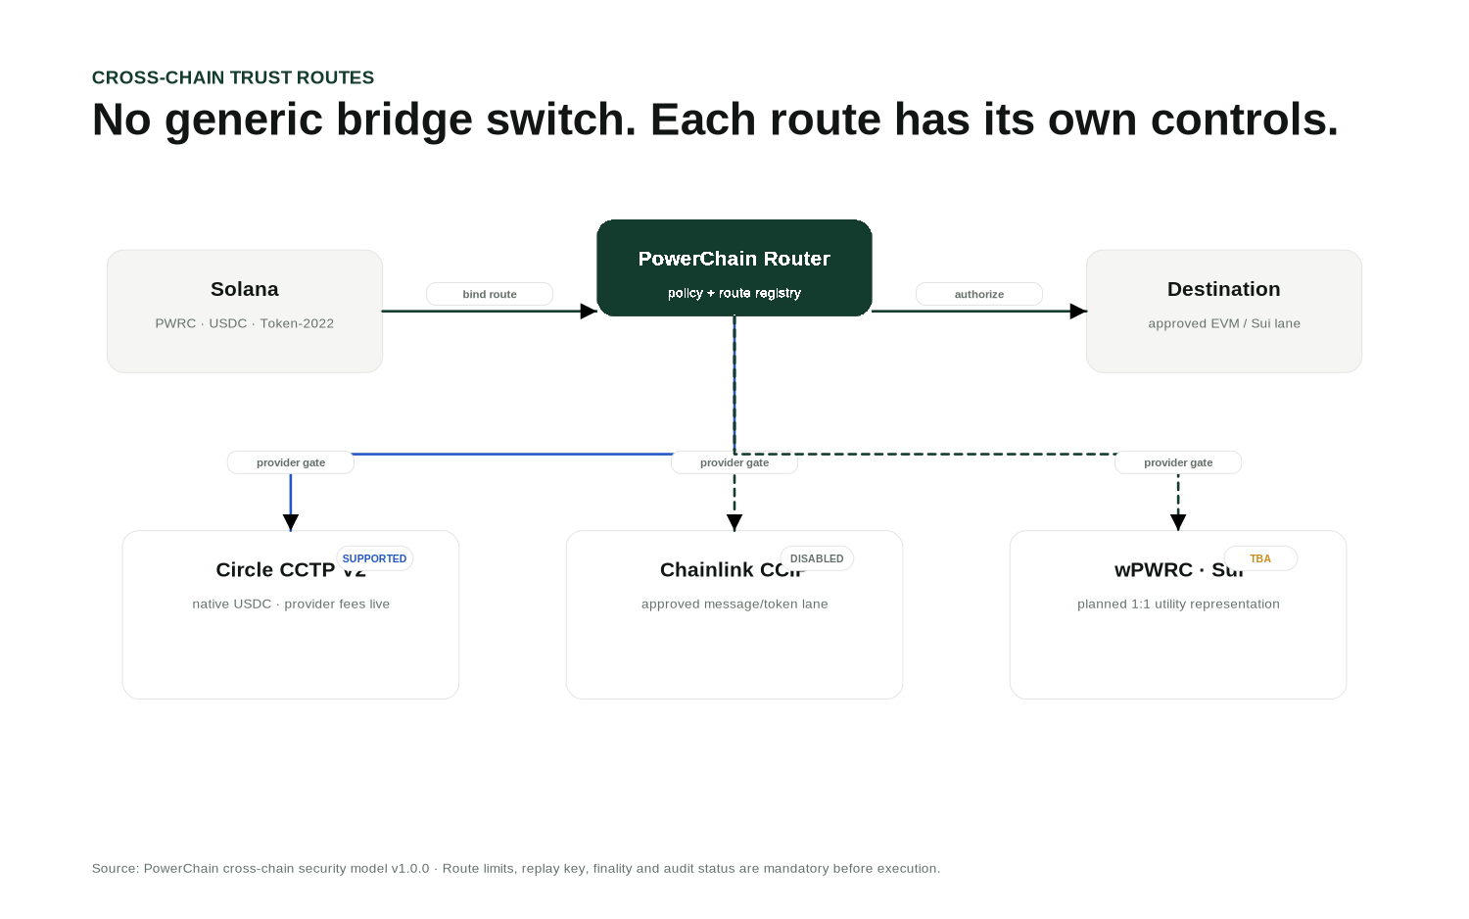
Figure 6. CCTP, CCIP and wPWRC use different trust and reconciliation models.
Route | Purpose | Activation rule
CCTP V2 | Native USDC cross-chain movement. | Domains/version/fees/status verified at execution time.
CCIP | Approved messaging/token lanes. | Router/pool/lane, allowlists, rate limits and audit required.
wPWRC / Sui | Planned 1:1 PWRC utility representation. | TBA until two-way bridge audit, custody and supply reconciliation are complete.

Conservation invariant
Outstanding wPWRC must never exceed verified backing PWRC. Any backing deficit or unknown source-chain state should pause new wrapped minting until reconciliation resolves the discrepancy.

SECURITY CONTROL PLANE

Identity, policy and signer authority remain separate
Authentication is not authorization. Token ownership is not authorization. AI output is not authorization.
Layer | Control
Identity | Authenticated user/wallet/service identity with replay-resistant challenge/session handling.
Organization | Tenant and verified organization membership.
Role / permission | Least-privilege operating scope and separation of duties.
Policy version | Machine-readable limits, allowed purpose/recipient/asset/network and approvals.
Risk | Explainable rules/anomaly signals; high-risk paths may hold/review.
Approval | Human or governance threshold appropriate to the action.
Signer | Wallet, multisig, HSM/MPC or approved signing infrastructure.
Reconciliation | Authoritative blockchain/provider verification before state advances.
HARD INVARIANT
No AI agent, client response, PWRC balance or static configuration can bypass treasury policy or cryptographic signing.

COMMUNITY REWARDS

Bounded rewards for verified contribution
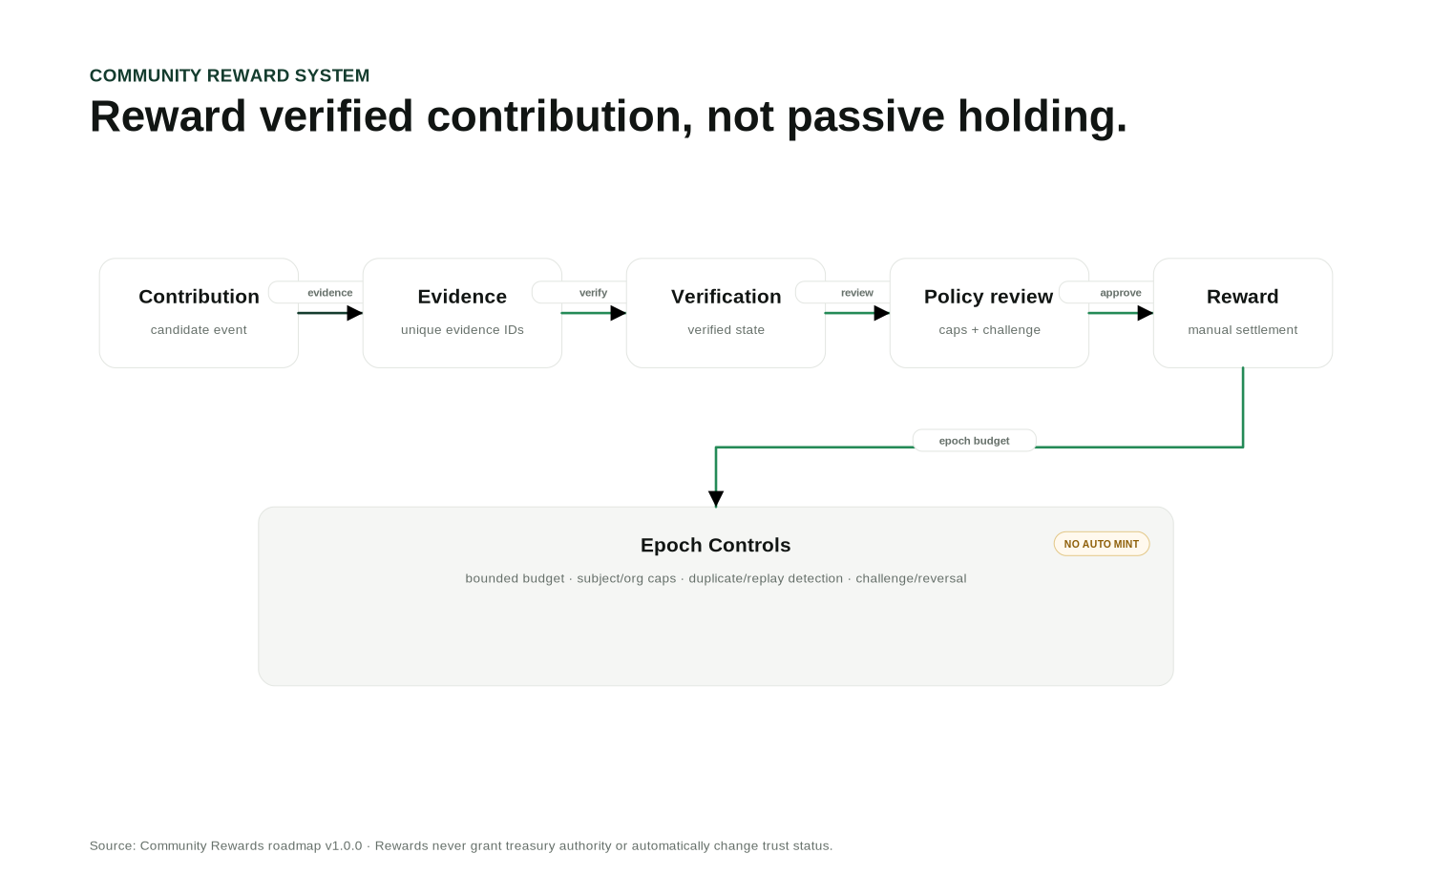
Figure 7. Rewards are evidence- and policy-reviewed, not passive-holding emissions.

Epoch budget model
- budget per epoch;
- per-subject and per-organization caps;
- evidence IDs and duplicate/replay checks;
- conflict-of-interest and anomaly review;
- challenge/reversal procedure;
- separate reward and crisis-capital ledgers.
AUTHORITY BOUNDARY
Reward eligibility does not grant treasury authority, procurement access, verifier status or an automatic reputation upgrade.

EVIDENCE & IMPACT

A transaction is not an outcome
PowerChain closes the lifecycle with field evidence, verification and outcome records. Sensitive raw evidence remains private/off-chain by default; public transparency uses approved metadata, hashes, attestations and human-readable records.
Stage | Control
Upload intent | Organization/crisis/subject binding, MIME/size policy and visibility class.
Storage | Private evidence bucket by default; public media uses a separate class.
Provenance | Server verifies stored object hash before evidence becomes AVAILABLE.
Verification | Verifier/policy records VERIFIED, PARTIAL, PENDING, CONFLICTING, EXPIRED or REJECTED.
Attestation | Optional on-chain hash/reference without publishing private content.
Impact | Outcome records link back to allocation, procurement, delivery and evidence.
Passport | Public or contributor-facing trace from source to verified impact.

UX / UI

Public simplicity, operator control, auditor evidence
Audience | Primary experience
Public | What happened? Can I trust this? Where is capital going? What has been verified?
Contributor | Amount, purpose, asset, network, fee stack, destination, authorization and receipt.
Operator | Alerts, approvals, blocked capital, procurement exceptions and verification backlog.
Treasury | Balances by state, allocations, escrow, releases, signers and reconciliation.
Auditor | Source, policy, approval, transaction, recipient, document, evidence and impact chain.

Visual language
- White / light gray / near-black / dark forest green.
- No neon or decorative crypto effects.
- Color plus text/icon for every status.
- Source and freshness labels on live data.
- Technical transaction details are available but not forced into the primary public flow.
- Mobile prioritizes understand -> trust -> fund -> track -> impact.

CANONICAL DEMO FIXTURE

Nepal Flood Response - demo only
DEMO DATA
The figures on this page are product fixtures. They are not real fundraising totals, verified humanitarian claims or live field outcomes.
Metric | Demo value
Raised | $4.28M
Allocated | $3.71M
Verified Impact | $2.94M
In Escrow | $770K
Verification rate | 72%

Purpose breakdown
Purpose | Demo allocation
Water | $1.20M
Medical | $1.70M
Shelter | $900K
Logistics | $480K
Mainnet/public production pages must either display authoritative live data with source identity/freshness or show an explicit unavailable/degraded state. Demo fixtures must never silently substitute for live crisis data.

DATA / ORACLES

Freshness and provenance are first-class
Pricing and external data observations carry provider identity, source, publish timestamp, fetch timestamp, freshness and status. The system must not invent a price or treat an external report as a verified crisis fact.
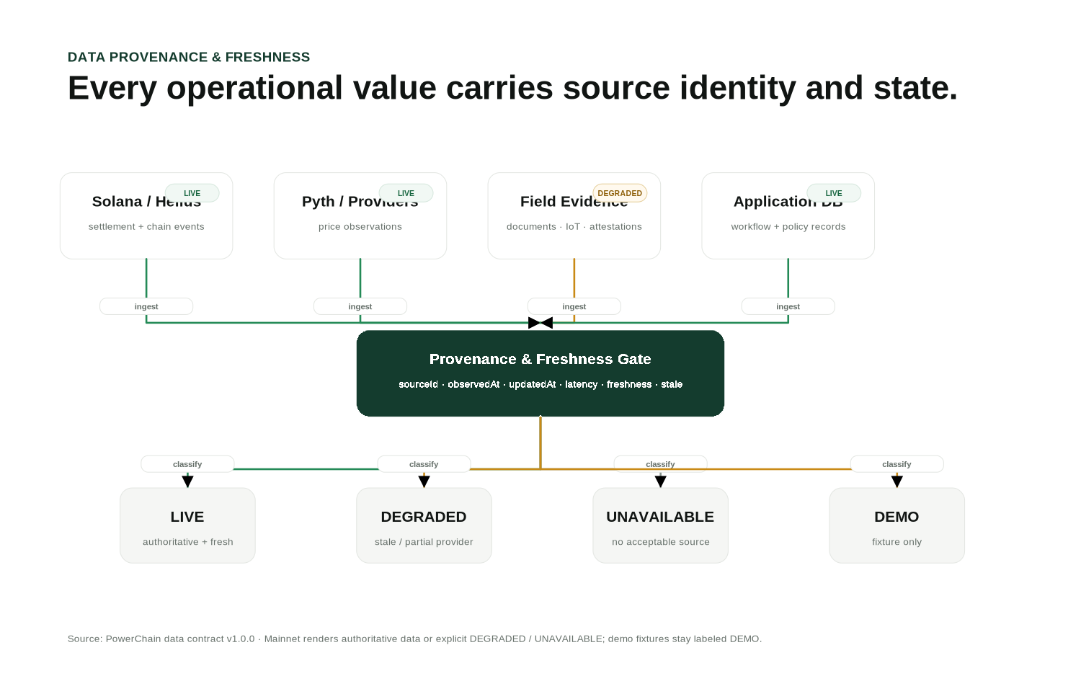
Figure 8. Provider observations pass through provenance and freshness gates before they can be labeled live, degraded, stale or unavailable.
Provider / layer | Role
Pyth | Primary market-price observation where configured; freshness/confidence enforced.
Birdeye | Corroboration or degraded fallback according to policy.
Chainlink | Provider-specific data/CCIP boundary where configured.
Helius | Solana RPC/API/webhook event infrastructure; webhook events are normalized/idempotent.
PowerChain backend | Policy evaluation, reconciliation, evidence metadata, risk and operational state.

Provider state
Use LIVE, DEGRADED, STALE, DISABLED, TBA or UNAVAILABLE. Static configuration alone does not justify a LIVE label, and unavailable data must never be rendered as a numeric zero.

VISUAL DATA SYSTEM

Lines, arrows and charts carry operational meaning
The architecture and chart system uses one semantic grammar across website, dashboard, docs and exports. Connectors are not decorative: their style communicates execution, optionality, review, degradation and source confidence.
Visual primitive | Required semantics
Node state | Operational state of the entity itself: live, verified, degraded, paused, TBA or unavailable.
Edge state | Independent transition state such as authorize, submit, confirm, release, evidence, reconcile, optional or blocked.
Arrowhead | Direction of authority, data or capital movement. Every process connector terminates explicitly.
Dashed connector | Optional, degraded, disabled or planned route - never a normal confirmed execution path.
Line chart | Latest value, previous-point delta, source identity, update/observation time and point-quality flags.
Point quality | VERIFIED, ESTIMATED, STALE or MISSING; missing data is not plotted as zero.
Source label | Provider plus freshness/latency where relevant. Demo/static values must be visibly labeled.
Accessible fallback | Charts and architecture maps expose a text/table representation for keyboard and screen-reader users.

Mainnet rendering rule
SOURCE BEFORE STYLE
Mainnet UI may render an operational value only when an authoritative source and acceptable freshness are available. Otherwise show an explicit DEGRADED, STALE or UNAVAILABLE state. Demo fixtures remain labeled DEMO.

Mobile behavior
Complex left-to-right flows collapse into vertical sequences on narrow screens. Edge labels remain adjacent to the transition they describe, and state is communicated with text/icon plus color rather than color alone.

PRODUCTION READINESS

Fail closed before mainnet
Gate | Required evidence
Dependencies | Pinned runtime/package manager, committed lockfile and clean frozen install.
Database | Prisma validation/migrations, RLS/storage review, backup/restore test.
Programs | Anchor build/tests, deployment IDs, authority/custody policy and independent review.
Financial | Treasury policy, transaction simulation, exact reconciliation and fee disclosure.
Cross-chain | Provider configuration, limits, replay protection, monitoring, incident runbook and audit status.
Token factory | Issuer approval, metadata, signer flow, reserve review and extension compatibility.
AI | Model/tool permission evaluation, prompt-injection testing and audit trail.
Operations | Monitoring, DR, event replay, degraded/offline modes and on-call procedures.
UNKNOWN EXECUTION
If the final blockchain/provider result cannot be established, preserve EXECUTION_UNKNOWN and reconcile later. Never convert uncertainty into success.

STRATEGIC ROADMAP

Activation sequence - version remains 1.0.0

01 Core financial close
Audit/deploy core Solana programs, real treasury registry, USDC/Solana Pay and authoritative reconciliation.

02 Evidence close
Production storage/RLS, verifier workflow, impact passport and public transparency.

03 PWRC utility close
Power Units, enterprise utility accounts, AI/API budgets and usage receipts.

04 Token factory close
Issuer policy, secure mint signing, reserve-backed controls and Token-2022 compatibility matrix.

05 Cross-chain close
CCTP production routes, audited CCIP lanes and only then wPWRC/Sui activation.

06 Community reward pilot
Epoch budgets, evidence policy, anti-gaming, review and reversals.

07 Partnership network
Scoped partner credentials, verified organizations and integration contracts.

08 Operational SLOs
RPC/webhook/queue/reconciliation/evidence backlog targets and incident dashboards.

CONCLUSION & REFERENCES

Speed without uncontrolled authority
The architectural goal is not to put donations on a blockchain. It is to make emergency capital traceable, policy-controlled and verifiable from crisis identity to real-world outcome.
POWERCHAIN PROMISE
Move capital where it matters. Control how it is used. Prove what it achieved.

Core invariant
PWRC powers the network around the response. Stable assets fund the response. Identity and policy control authority. Cryptographic signers authorize value movement. Evidence proves real-world outcomes.

Primary technical references
Solana Tokenization: https://solana.com/docs/tokenization
Solana Confidential Transfer integration: https://solana.com/docs/tokens/extensions/confidential-transfer/integration-guide
Circle CCTP: https://developers.circle.com/cctp
Chainlink CCIP: https://docs.chain.link/ccip
Pyth Network: https://docs.pyth.network/
Helius: https://www.helius.dev/docs
Technical status, supported routes, package IDs, mint addresses, fees, provider capabilities and audit/deployment state must be verified against the running environment. This whitepaper is not financial, legal, investment or tax advice.

