Decoupled Power Flow
User Guide

Draft
September 15, 2008
Table of contents

1 Introduction 2
1.1 Objectives 2
1.2 Requirements 2
1.3 Dimensions 3
2 Input Parameters 4
2.1 Control Parameters 4
3 Program Execution and Outputs 5
3.1 Program Output 6
4 Five Bus System 7
5 PALCO System 10
6 Power Flow Equations 11
7 Solution by Triangular Decompostion 14
8 LINKNET – A Structure for Computer Representation of Networks 21
8.1 Introduction 21
8.2 The LINKNET Structure 22
8.3 Using LINKNET to Build a Network Spanning Tree 27
8.4 Conclusions 30

Introduction

Objectives
This document is the User Guide for the Decoupled Power Flow Version 1.0.
The Decoupled Power Flow has the following objectives:
- To provide a relatively simple set of code for solving the sparse matrix decoupled power flow equations
- To provide a template so that professional software developers can build production scalable software in robust languages including C++ and Java
- To provide a model so that power system researchers have a tool to use.
- For use in training power system operators

Requirements
The Decoupled Power Flow runs under Microsoft EXCEL 2003. It uses Visual Basic MACROs to perform the power system simulation. EXCEL Worksheets are used for program input and program output.
The program input formats follow the conventions used by the PSSE Excel based data exchange formats.

Dimensions
The program is currently dimensioned to handle a maximum of:
- 1000 Buses
- 1000 Generators
- 1000 Loads
- 200 Shunts
- 200 Transformers
These dimensions can be readily increased.
The data storage structures have been increased for other applications to handle the Eastern US and Western US interconnected system models.
For bus dimensions above 64,000 all the integers have to be increased to Long.

Input Parameters
The program input data is entered on the following Worksheets:
- Control – Control and dimension parameters
- Buses – Bus data in PSSE format
- Lines – Branch data in PSSE format
- Machines – Machine data in PSSE format
- Loads – Load data in PSSE format
- Transformers – Transformer data in PSSE format
- Switched Shunts – Shunt data in PSSE format.

Control Parameters
The following parameters in the Control worksheet are used for controlling the initialization, overall progress and output of the solution.
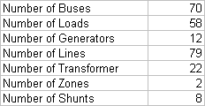

All bus numbers do not have to be used.

Program Execution and Outputs
The DPF Program can be run by selecting the “buses” Macro.

Program Output
The Flows worksheet shows MW and MVAR flows at the end of every line and then evey transformer.
The Solution worksheet shows the bus angles, bus voltages and MW and MVAR mismatch for each bus at the end of the solution.
Always check the mismatches to make sure a solution has converged.
The Output worksheet shows the LINKNET structure along with the self and mutual admittance terms prior the matrix factorization.
The Factor worksheet shows the LINKNET structure along with the self and mutual admittance terms for the B and B prime matrices after the matrix factorization.
The solved bus angles and bus voltages are updated in their respective columns of the buses worksheet.

Five Bus System
A 5 bus 7 branch network is shown below,
This example is ideal for debugging the program.
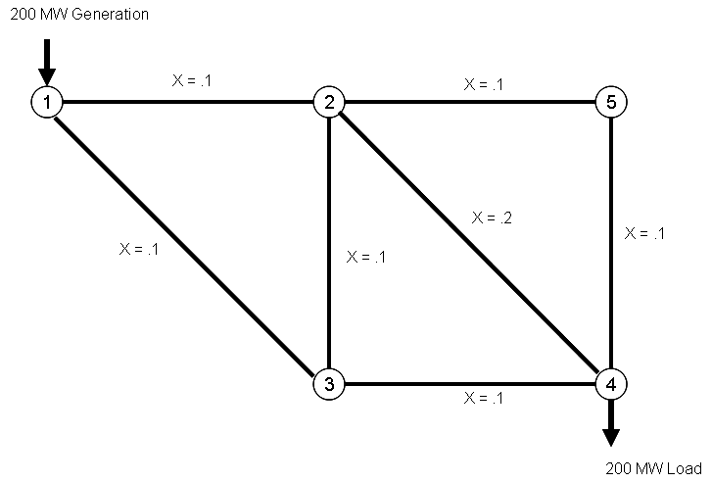

Figure 1: Bus injections and branch reactances

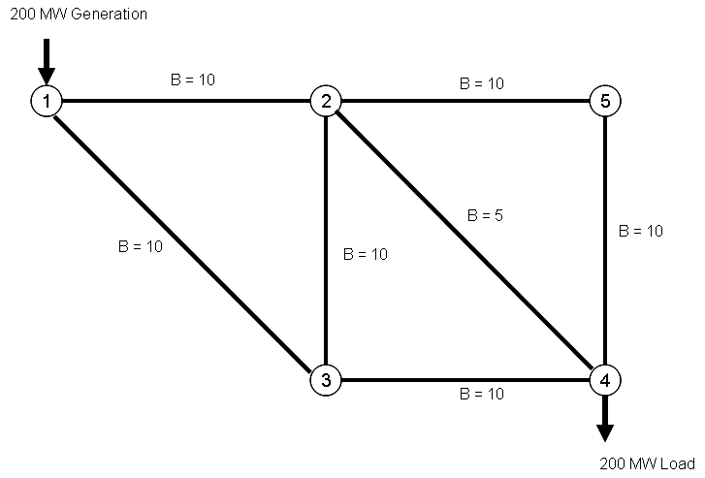

Figure 2: Bus injections and branch admittances

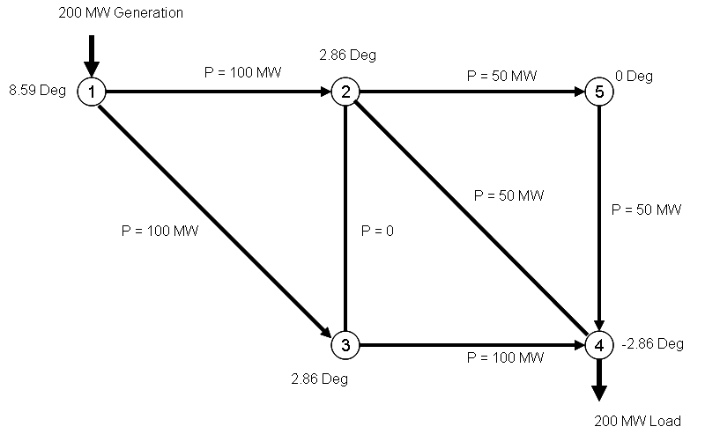

Figure 3: Bus angles and branch flow solution

The network has a certain amount of symmetry which aids debugging.
The flow on line 1 - 2 balances the flow on line 1 – 3. There is zero flow in line 2 -3.

PALCO System

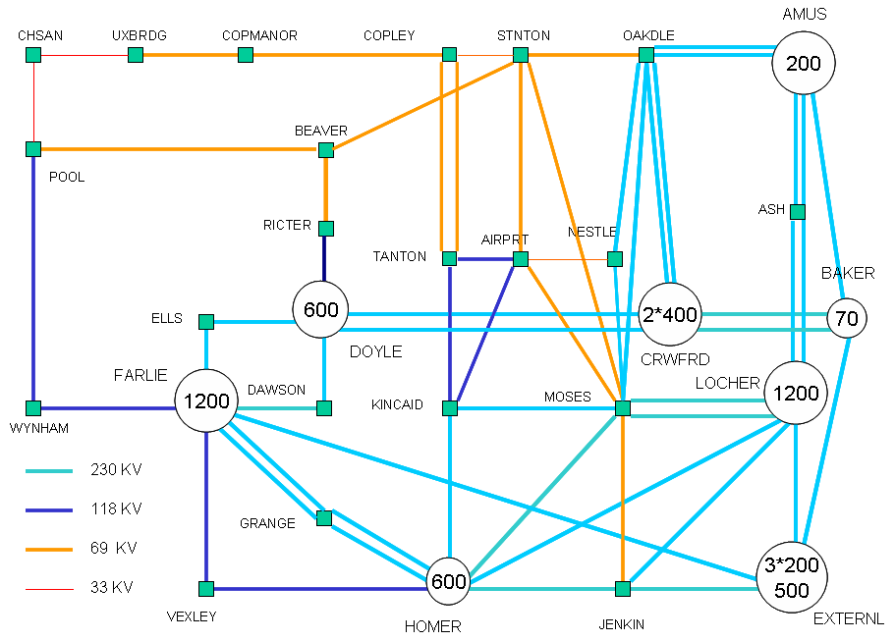

Power Flow Equations
This section develops the equation for the linearized or D.C. loadflow approximation.

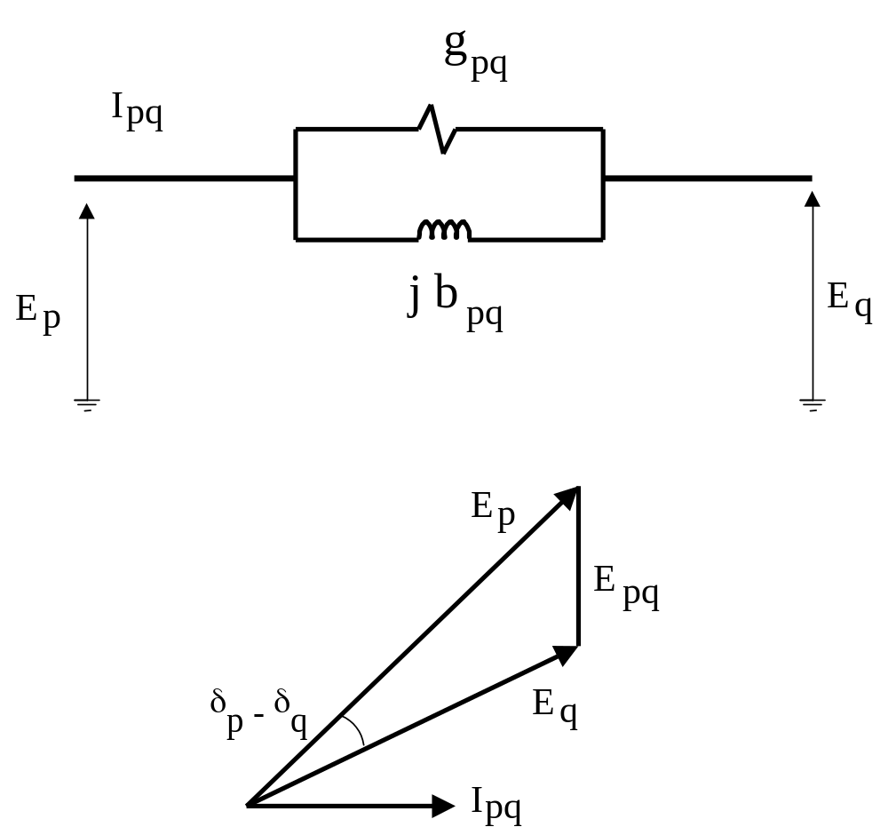

Figure 9-1: Branch Complex Voltage and Current Relationships

The power flow in branch pq of Figure 9-1 can be exactly expressed as:

(1) Ppq = Ep . R [ Ipq ]
where R [ Ipq ] is defined as the component of Ipq in phase with Ep. From the vector diagram in Figure 9.1 we derive
(2) R[ Ipq ] = (Ep - Eq cos (δp - δq) gpq - Eq sin(δp - δq) bpq
Thus substituting (2) into (1):
(3) Ppq = Ep(Ep – Eq cos (δp - δq) ) gpq - Ep Eq sin(δp - δq) bpq
The terms in (3) are the components of power flow through the branch conductance and branch susceptance respectively. For the susceptance term we approximate:
(4) sin(δp - δq) = δp - δq
and for the conductance term we approximate:

- cos (δp - δq) = 1
The effect of the error in the later approximation is reduced by the high X/R ratios of modern transmission systems. Substituting (4) and (5) into (3) we obtain a linearized relationship between the branch power and the bus angles,

(6) Ppq = Ep(Ep – Eq ) gpq - Ep Eq bpq (δp - δq)

If the equation defining the power balance at each bus is considered we obtain

(7) PN = MN + BNN δ

where we define MN(p), the net conductive flow from bus p as
(8) MN(p) = ΣqEp Eq bpq
(9) BNN (p,p) = - Σq Ep Eq bpq
(10) BNN (p,q) = Ep Eq bpq

Equation (7) expresses the bus powers PN linearly in terms of the bus angles δ and is commonly known as the D.C. loadflow equation. In its most common form the term MN is neglected but improved accuracy can be obtained by its inclusion. For convenience we hereafter consider the MN terms to be lumped with the load powers and thus equation (7) becomes:
(11) PN = BNN δ

Solution by Triangular Decompostion

We consider the solution of the nodal admittance equations I = Y.E by the well known method of triangular decomposition. The equations can be expanded,

(1) 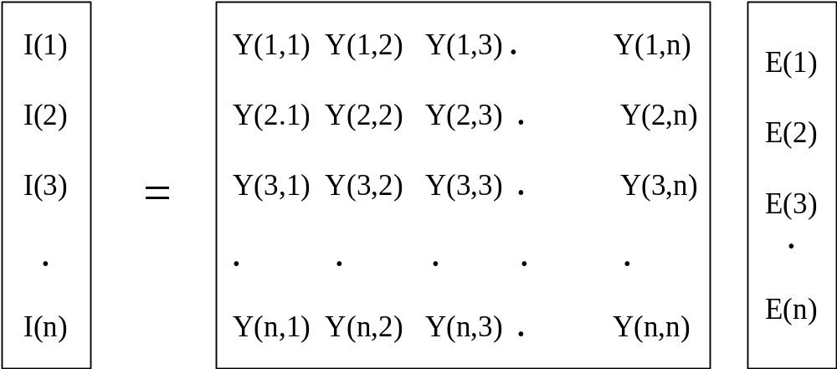

Eliminating E1 from all rows except the first we obtain:

(2) 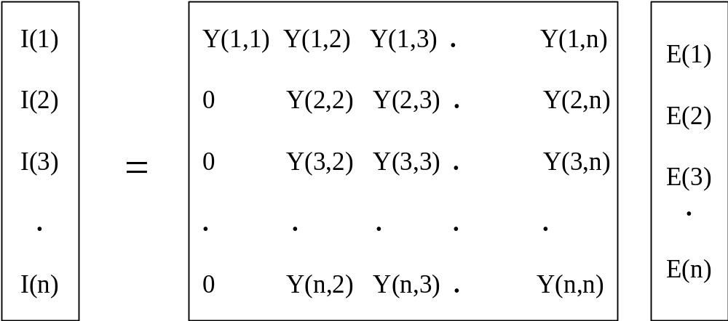

Where,
(3) I(j)2 = I(j)1 – Y(j,1)1/Y(1,1)1 * I(1)1 for 1 < j <= n
and
(4) Y(j,k)2 = Y(j,k)1 – Y(j,1)1 * Y(1,k)1/Y(1,1)1 for 1 < j <= n,
1 < k <= n.

Similarly, eliminating E(2) from all rows except the first and second we obtain,

(5) 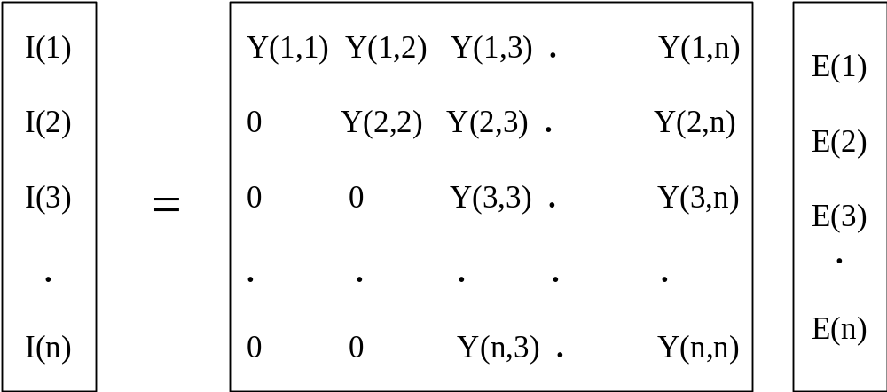

where,
(6) I(j)3 = I(j)2 – Y(j,2)2/Y(2,2)2 * I(2)2 for 2 < j <= n
and
(7) Y(j,k)3 = Y(j,k)2 – Y(j,2)2 * Y(2,k)2/Y(2,2)2 for 2 < j <= n
2 < k <= n.
Proceeding in this manner, after n-1 eliminations we finally obtain,

(8) 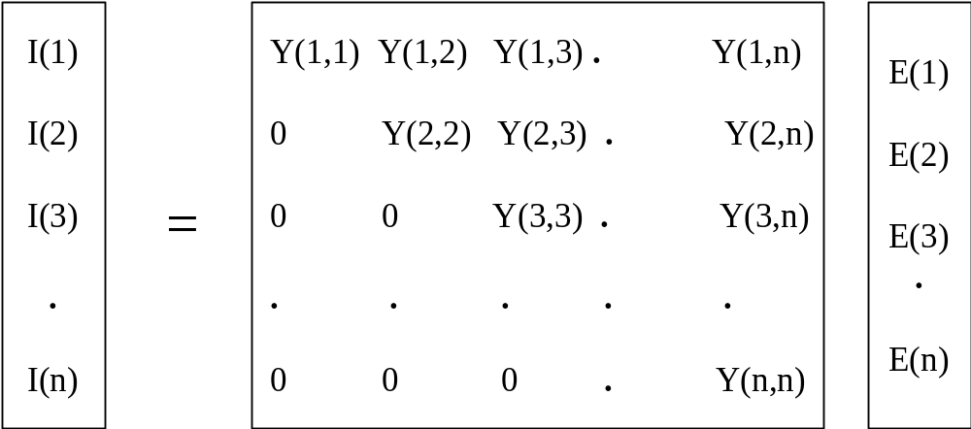

The node voltages can now be calculated by back substitution. The voltage on node n is calculated from,
- E(n) = I(n,n)n/Y(n,n)n
and the voltages on successive nodes, i = n-1,n-2, ....1, are calculated from,
- E(i) = [ I(i)i – Sum j=i+1,n Y(i,j) * E(j) ] / Y(i,i)i
The situation often arises in which voltage solutions are to be obtained for different node currents but the same admittance matrix. Upon the elimination of E(i) the node currents are reduced by,
(11) I(j)i+1 = I(j)i – Y(j,i)i / Y(i,i)i * I(i)i for i < j <= n
Y(j,i)i are the elements in the lower triangle which are eliminated. However, because the Y matrix is symmetric,

(12) Y(i,j)i = Y(j,i)i
and
(13) I(j)i+1 = I(j)i – Y(i,j)i /Y(i,i)i * I(i)i for i < j <= n.

In (13) the forward reduction of the node currents is performed using the elements which are retained in the upper triangle. Thus repeat solutions for different sets of node currents can be easily obtained.
In developing the solution algorithm it is convenient to consider the triangularization as a series of network reductions. To illustrate this assume that part way through the triangularization columns 1,2,.....i-1 have been processed. The equations are therefore:

(14) 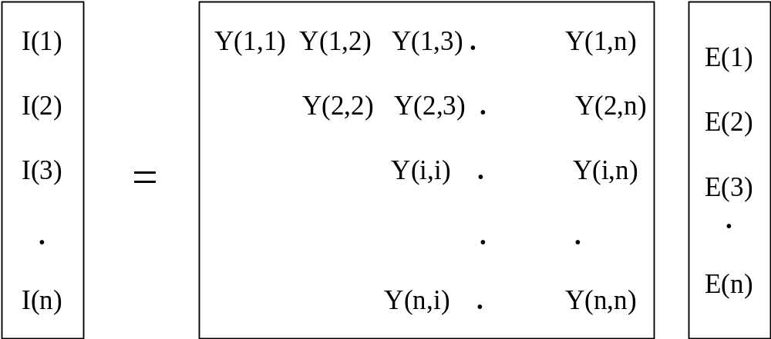

Extracting rows i, i+1, ...., n we obtain,

(15) 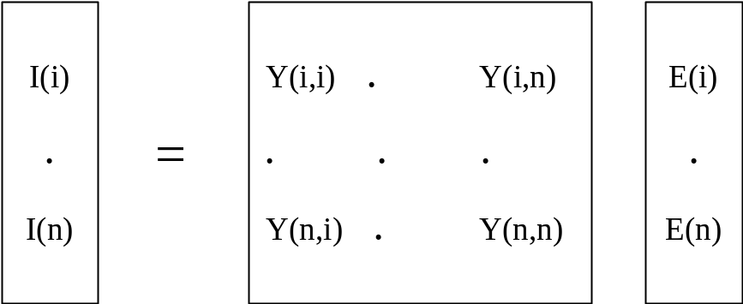

We can consider equation (15) to represent an admittance equivalent of the original network as viewed from nodes i, i+1, ....,n. The branches in this network correspond to the non-zero admittances in the matrix. The next triangularization operation which processes column i in (14) corresponds to eliminating node i from this network as shown in Figure 8-1. The sub-network of branches which are connected to node i is replaced by an equivalent network as viewed from the adjacent nodes. This requires the following changes to be made:

i) The injected current on each node j adjacent to node i is modified by,

-Y(j,i)i / Y(i,i)i * I(i)i

ii) The self admittance of each node j adjacent to node i is modified by,

Y(j,i)i * Y(i,j)i / Y(i,i)i

iii) The mutual admittance between each pair of nodes j and k which are adjacent to node i is modified by,

-Y(j,i)i * Y(i,k)i / Y(i,i)i

If the mutual admittance was previously zero then a new branch is introduced into the equivalent network.

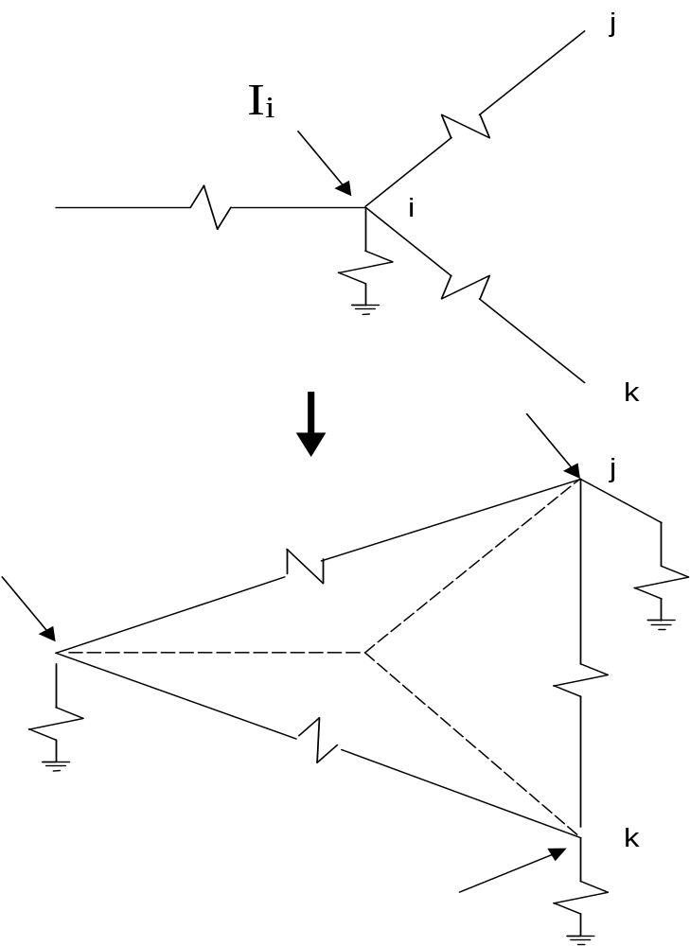

Figure 8-1: Elimination of Node i from the Equivalent Admittance Matrix

LINKNET – A Structure for Computer Representation of Networks

Introduction
In the development of any algorithm which deals with a network, the programmer must decide on how the network information should be stored in computer memory. The decision is particularly important for the analysis of large sparse networks, which occur in power system studies. Often, it will largely determine the computer memory requirements and it may also significantly affect the processing efficiency of the algorithm.
In the past a wide variety of methods has been used to store power system network information. Examples of the more common methods are single line entry tables, double entry line tables and compressed storage of node connection or node admittance matrices. Most of the structures have been developed for particular types of network algorithm and have a limited range of applications. However, for a wide variety of network problems there are a number of common features which are desirable in a storage structure. These can be summarized as:

- Use of a small amount of computer memory.
- Processing of network information should be facilitated; e.g. the branches and nodes connected to any given node should be easily scanned.
- The structure should easily reflect network changes; e.g. the addition or removal of branches.
- The structure should be basically simple and easy to program.
The LINKNET structure has been designed as a general purpose structure for representing networks in a computer. It incorporates each of the desirable features which are listed in a balanced manner. The structure derives its name from linked-lists, which it applies to obtain some of these features. The usefulness of the LINKNET structure has been demonstrated by its application in the programming of a wide variety of network algorithms. It has also been applied to other diverse problems such as game playing and minimum cost path finding.
The LINKNET structure is described along with some basic functions for processing the network information. The application of the LINKNET structure is then demonstrated by building a network spanning tree.

The LINKNET Structure

The LINKNET structure can be implemented in a high level language such as FORTRAN, C, C++ and JAVA.
We assume that the nodes and branches in the network are numbered either manually or by the computer. The properties of the network are divided into node attributes and branch attributes and topological relationships. The node and branch attributes are stored in a fairly standard fashion. For each node or branch attribute a one-dimensional array is allocated and each position in the array is identified with the node or branch with the corresponding number.
The topological properties of the network are represented by specifying the connections between the nodes and the branches. Firstly we assume that the ends of each branch are numbered as follows; ends of branch 1 are numbered 1 and 2, ends of branch 2 are numbered 3 and 4 etc. Thus, the branch end numbers may be derived from a branch number as;
END = 2*BRANCH-1
and,
END = 2*BRANCH
Conversely, a branch number may be derived from either of its end numbers using:
BRANCH = (END+1)/2
The integer round off is used to obtain the two to one mapping between branch ends and branches.
The topology of the network can now be defined by constructing a linked list of the branch ends which are connected to each node. This is illustrated in Figure 8-1. For each node we define a pointer:

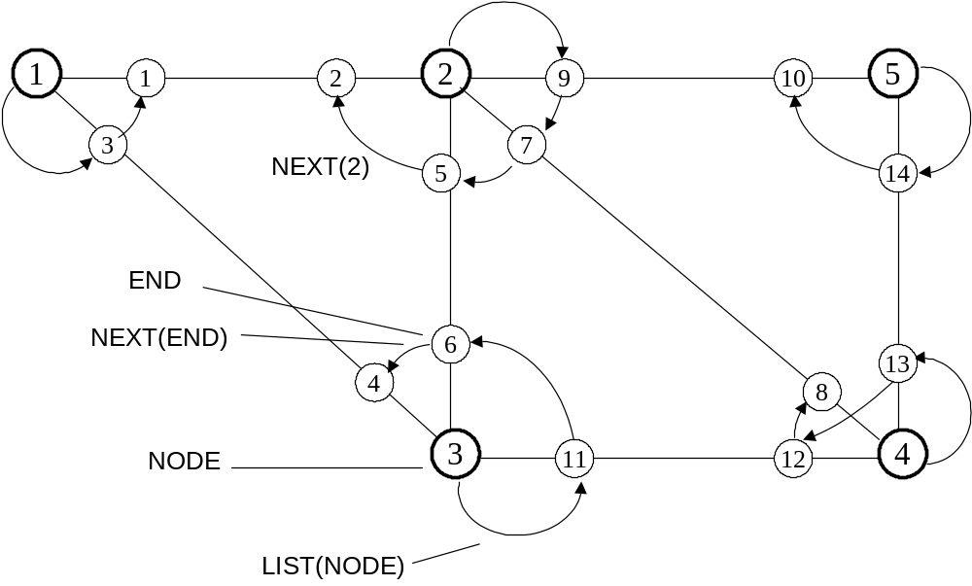

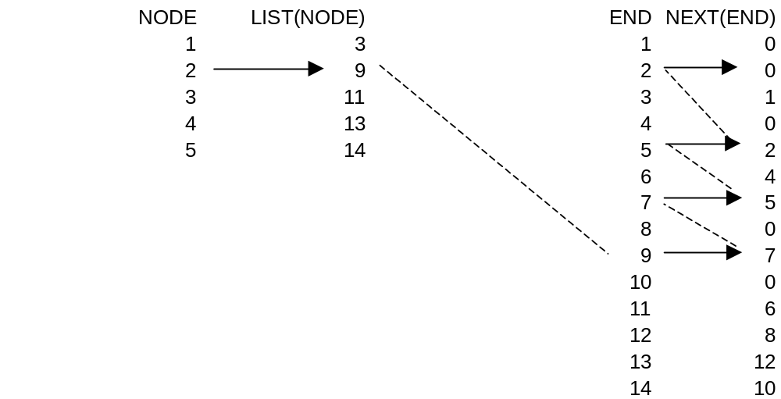
Figure 8-1: The LIST(NODE) and NEXT(END) Pointers

LIST(NODE) = The first branch end on the list from NODE. For each branch end we define a pointer NEXT(END) = The next branch end on the list after END. The last branch end on the list for each node is indicated when NEXT(END) = 0. The LIST(NODE) and NEXT(END) pointers are sufficient to defined network topology uniquely. They allow branches connected to any node to be directly obtained using the procedure:
Initialize, END = LIST(NODE)
then set, BRANCH =(END+1)/2
and END = NEXT(END) until NEXT(END) = 0.
In network computations it is often necessary to obtain the nodes which are connected to a given node. This operation is facilitated by defining an additional pointer for each branch end:
FAR(END) = The node at the far or opposite end of the branch. The FAR(END) pointers are illustrated in Figure 8-2. The nodes connected to any given node can now be obtained using the procedure:
Initialize, END = LIST(NODEA)
then set, NODEB = FAR(END)
and END = NEXT(END) until NEXT(END) = 0.
The successive values of NODEB will be the nodes that are connected to NODEA.
It may also be required to obtain the nodes at the ends of a given branch. These can be obtained as follows:
ENDA = 2*BRANCH-1
ENDB = 2*BRANCH
NODEA = FAR(ENDB)
NODEB = FAR(ENDA)
The pointers LIST(NODE), NEXT(END) and FAR(END) form the framework of the LINKNET structure. As illustrated by the preceding examples they enable various network scanning operations to be performed very easily.
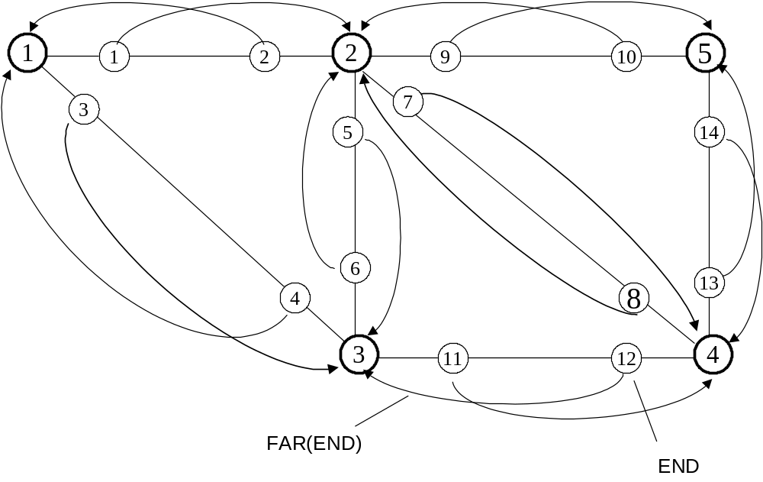
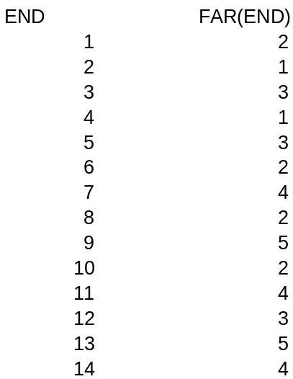
Figure 8-2: The FAR(END) Pointers
Another important attribute of the LINKNET structure is the ease with which the structure can be modified to reflect the addition or removal of network branches. This is in fact one of the main features that distinguishes the LINKNET structure from more conventional structures such as double entry line tables. In Figure 8-3 a flow diagram illustrates how the LINKNET structure can be built simply be adding each branch in turn to the network.

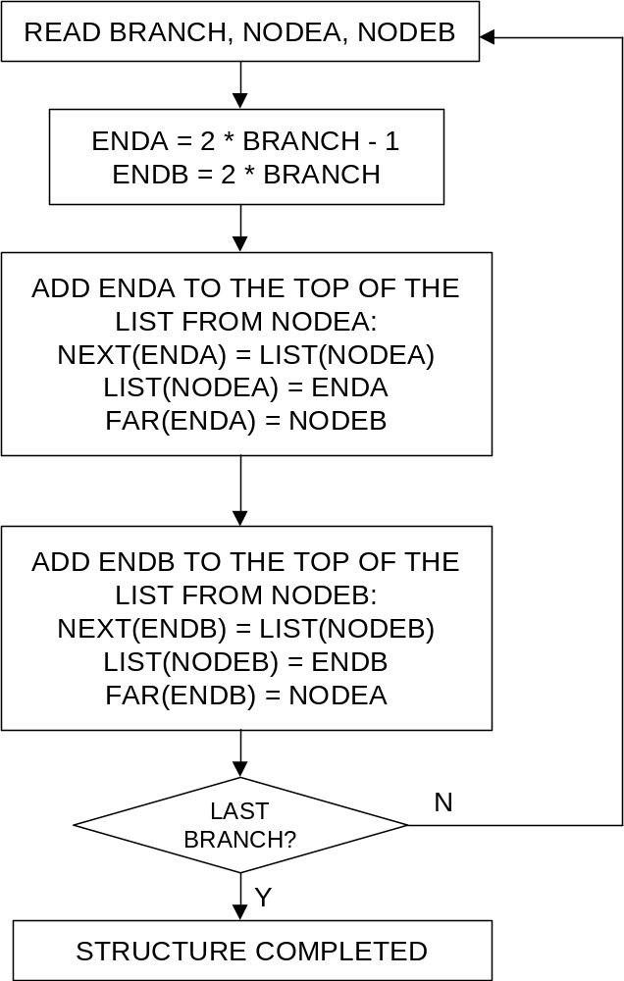

Figure 8-3: Construction of the LINKNET Structure

Using LINKNET to Build a Network Spanning Tree

To illustrate the application of the LINKNET structure we consider the problem of building a tree that spans all the connected nodes and branches in a network. The program will separate the network branches into tree branches and link branches.
The network information is read in one branch at a time and stored within the LINKNET structure in the manner that was shown in Figure 8-3.
The network tree, is a subset of the network branches just sufficient in number to connect all the network nodes. The branches in the tree are termed “Tree Branches” and the remaining branches are termed “Link Branches” or links.
To set up a tree within the LINKNET representation of the network the algorithm “expands” out from a root node and labels the branches as “Tree Branches” and the nodes at the ends of these branches as “Tree Nodes”. Subsequent expansions occur from the nodes that are members of the tree, and if any branch leads to a node already in the tree then this branch is labeled as a “Link Branch” rather than a “Tree Branch”. The algorithm terminates after all nodes have been expanded once. A flow diagram of the program to set up the tree within the LINKNET structure is shown in Figure 8-4. Figure 8-5 shows the resulting network tree when the algorithm is applied to a simple network.
The spanning tree algorithm is generally quite useful. Topology Processor uses the spanning tree algorithm to:

- Find all the equipment connected to a Topological Node
- Find all the topological nodes and equipment in an electrical island
- Find all the breakers that must be opened to isolated a multi-terminal transmission line
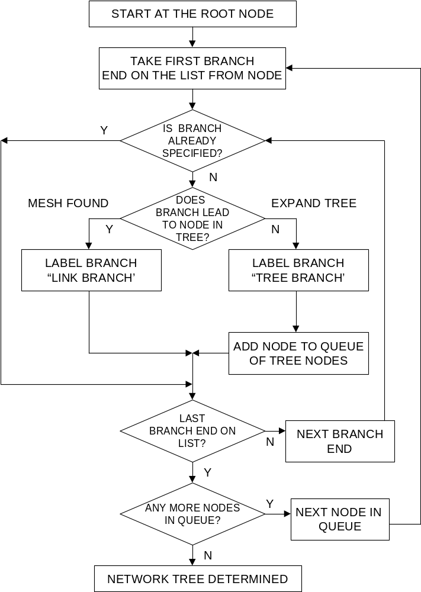

Figure 8-4: Flow Diagram of Program to Set up Network Tree

.
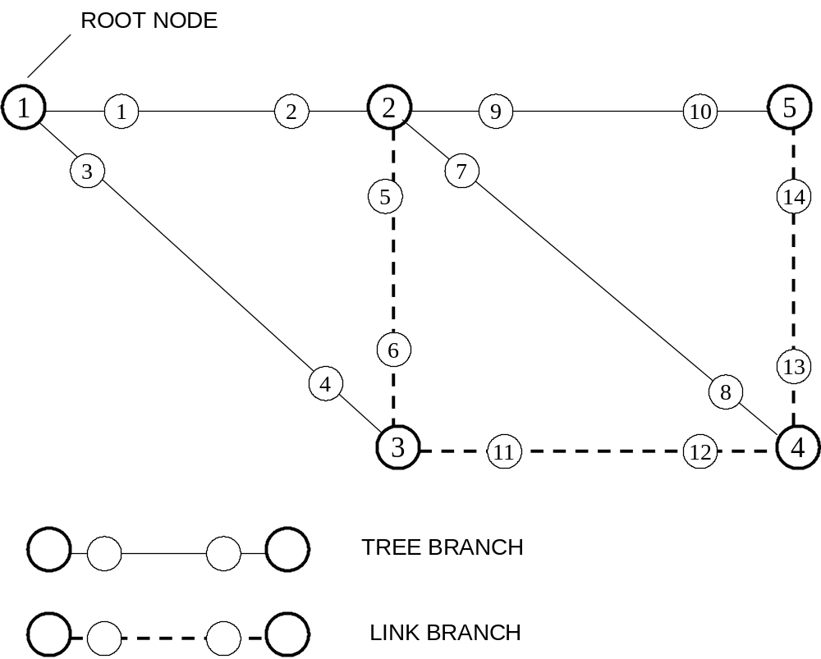

Figure 8-5: Network Spanning Tree

Conclusions

This chapter has described LINKNET, a general purpose structure for the computer representation of networks. The application of the structure has been illustrated by building a network spanning tree. The LINKNET structure has been a valuable tool in the development of the network programs that have been required for the studies in this thesis. The programs which have been written using LINKNET include; a program for triangularizing network matrices, an unbalanced short circuit program, a program for building bus impedance matrices, a nodal iterative loadflow program, a loss coefficient program, a linearized loadlflow, a transient stability program and a coherency based network reduction program.

