**CMPE-110 Introduction to Computer Engineering**

Homework 2

*Due September 25, 2018 to* ***Dropbox*** *in mycourses.rit.edu.*

1. Answer the following questions based on the truth table shown below.
2. (20%) Write a Boolean expression and the corresponding logic schematic diagram that describes the output Z with input signals A, B, and C.
3. (20%) Describe which 74XX SSI chips and how many logic gates in each chip you will use to implement Z. (Implementation that is minimized with a 1-sentence concise and correct justification will receive a 10% bonus.)

|  |  |  |  |
| --- | --- | --- | --- |
| A | B | C | Z |
| 0 | 0 | 0 | 0 |
| 0 | 0 | 1 | 1 |
| 0 | 1 | 0 | 0 |
| 0 | 1 | 1 | 0 |
| 1 | 0 | 0 | 0 |
| 1 | 0 | 1 | 1 |
| 1 | 1 | 0 | 0 |
| 1 | 1 | 1 | 1 |

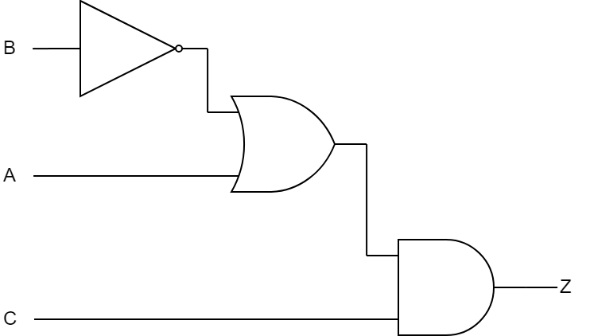a).

|  |  |  |  |  |
| --- | --- | --- | --- | --- |
|  | $$\overline{AB}$$ | $$\overline{\text{A}}\text{B}$$ | $$AB$$ | $$\text{A}\overline{\text{B}}$$ |
| $$C$$ | 1 | 0 | 1 | 1 |
| $$\overline{C}$$ | 0 | 0 | 0 | 0 |

$\text{C}\overline{\text{B}}\text{+CA}$ =Z

$$\text{Z=C(}\overline{\text{B}}\text{+A)}$$

b). Two 7400 utilizing 6 gates to utilize the same chip type to help reduce overall cost.

1. (30%) Convert 323.37510 to a) Binary and b) Hexadecimal.

a). 10100011.0110

b). 143.6

1. (30%) Find the representation of -4410 under the 2’s Complement system. Use the minimum number of bits to represent this value to obtain full credit.

10100