# How to Write a Computer Engineering Lab Report

<https://www.reddit.com/r/rit/comments/5tqgx0/any_advice_for_computer_engineering_lab_reports/?utm>

## Cover Sheet

Every computer engineering lab report will require a cover sheet. Please make sure the course number is correct and you write your TA’s full name correctly.



Above is an embedded document. Right click it, go to Document object and open to get the template.

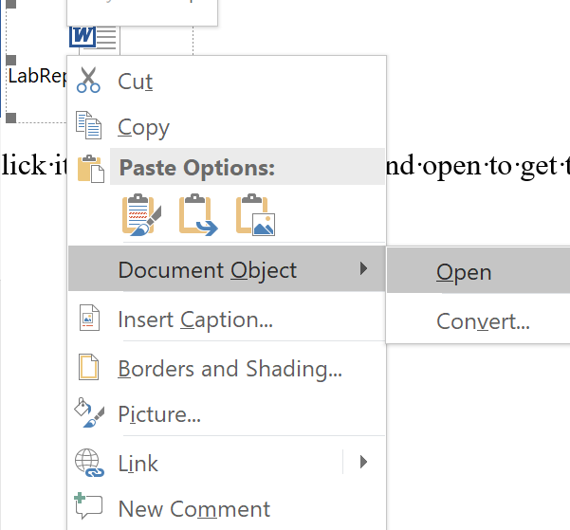

Figure - How to get the Cover Sheet from this document

## Abstract

* Summarize what you did
* Did you use any specific tools/algorithm/techniques?
* What is your result?
  + In one sentence
  + If there is a specific number, please state it (ex: 12 V)
  + Did the experiment work?

## Design Methodology/Procedure

* For this section describe what you did
* If the lab requires a procedure, you will write step by step what you did. If the lab requires a design methodology, you will just tell the reader what you did. (no steps)
* How did you design certain components? Why did you design it like that?
* You may use a Figures to describe your design

## Results and Analysis

* For this section, you will tell the reader what happened.
* What did your measuring tools say?
* What did your simulation give you?
* What does your data mean?
* Does your hardware data reflect your simulation data?

## Conclusion

* Summarize what happened (like the abstract, without copying word by word)
* Results (in one sentence)
* What concept/skill did you learn?
* If you can do this experiment one more time, what would you do differently.
* Can you apply what you learn into future works?

## Appendix

In some classes you will need an appendix. The appendix is used for Figures/Charts that is massive to put in your report, ex: source code for a design.

## Figures/Tables/Equations

* When you put a figure/table/equation please introduce them beforehand. You may also want to explain the figure/table/equation after.
* When referencing these components, call them by what it is and then a number
  + Examples
    - Figure 3
    - Table 2
    - Equation1
* Do not make subcategories (No Figure 1.2)
* If your figure has a black background, please invert the image. (We care about the environment)
* Everything must be centered with appropriate captions
* Figure
  + This includes your graphs/circuit diagrams/flow charts/UMLs/etc
  + Everything must be computer generated, no photographs
  + Label on the bottom
  + Example

Figure : A Triangle

* Tables
  + Labels on top
  + Format to table to be reasonable to read
  + The table must be within 1 page. If your table will run over to a new page, put the entire table on a new page.
  + Example

Table : Some Table

|  |  |
| --- | --- |
| A | B |
| 5 | 8 |
| 6 | 9 |
| 7 | 0 |

* Equation
  + Labels at the right
  + Example

$x=\frac{-b±\sqrt{b^{2}-4ac}}{2a}$ (1)

## Writing Style and Format

* Justify your document
* Use Font 11/12
* 1-inch margin
* No double space
* Please number your page
* Write everything in third person passive voice
  + Do not write I/me
  + Do not address your TA – we do not exist
* Do not use the word lab
  + Lab means the place
* Add signoff sheet to the back