AI Models for Materials Discovery - Performance Summary
Generated 2026-08-28 by build_summary.py. Rows are ordered by reported accuracy (descending), then by error (ascending) - not chronologically. Blank cells mean the value was not published in a machine-readable form; every blank is itemised in NEEDS_DATA.md.

How to read this document
Two tables, two very different evidentiary standards:
- Table 1 comes from the Matbench Discovery leaderboard, where every model is evaluated on the same held-out test set with the same DFT reference. These numbers are directly comparable.
- Table 2 comes from the daily digest, i.e. whatever the literature published this week. Each study uses its own test set and its own definition of error, so those numbers are not comparable to each other. Treat Table 2 as a lead list, not a ranking.

Headline numbers
- 65 models tracked, 64 with comparable accuracy figures.
- Highest stability-classification accuracy: EquFlashV2 at 97.8% (F1 0.929).
- Lowest energy error: EquFlashV2 at 18 meV/atom.
- 46 studies parsed from the digest; 2 reported a numeric performance figure in the abstract.

Figures
Performance clusters: accuracy vs error
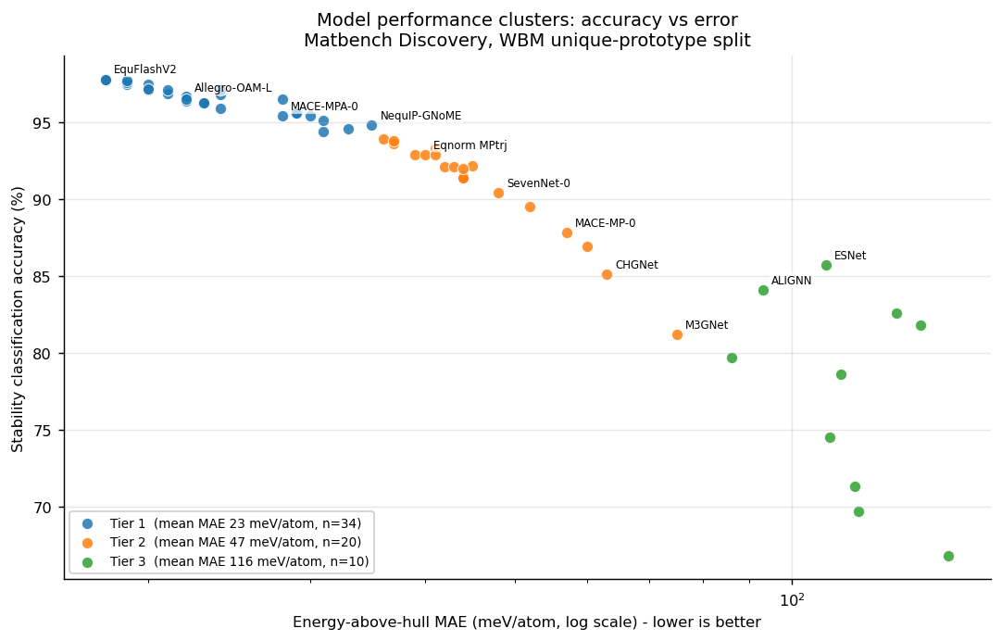
Trend: error frontier over time
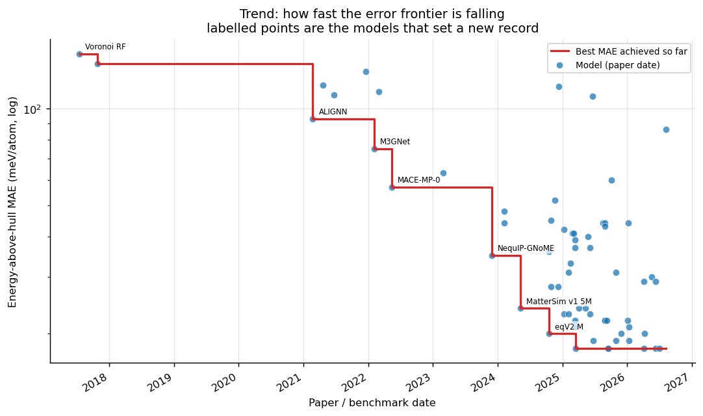
Architecture families and their mean error
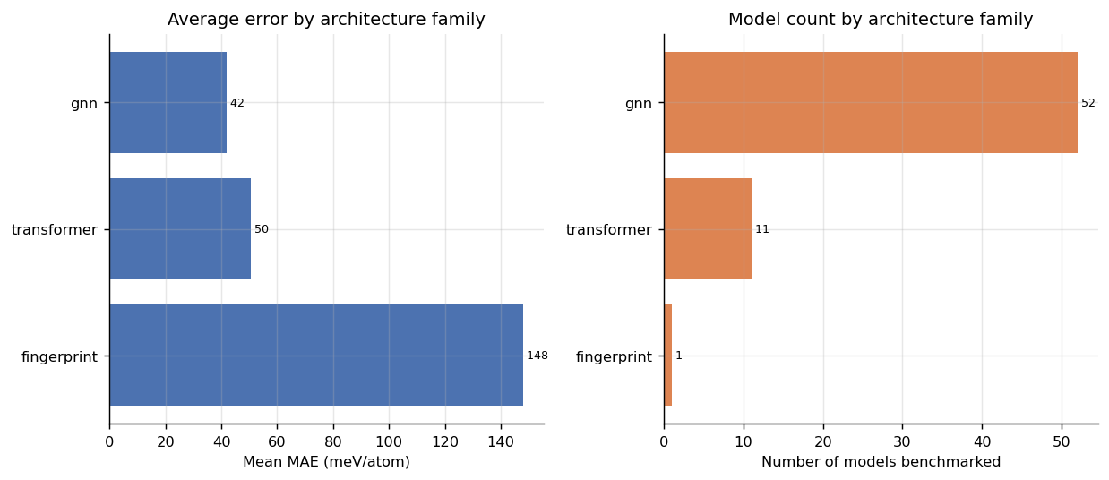
Energy accuracy vs thermal transport accuracy
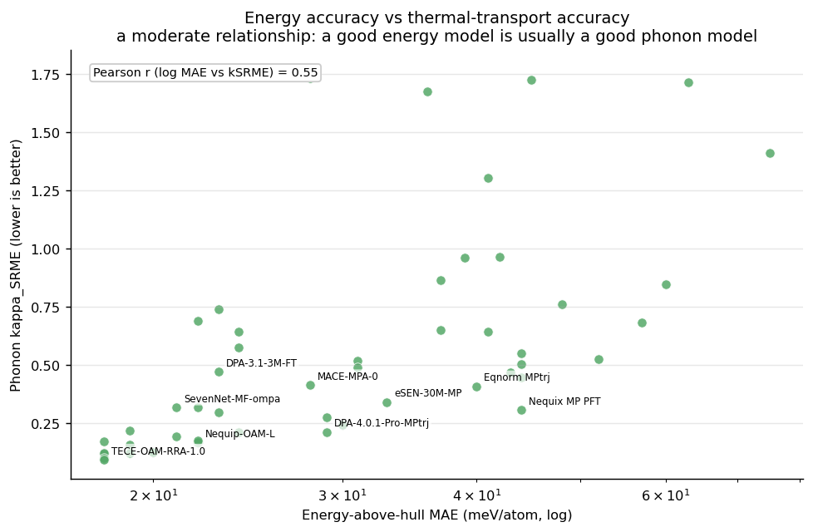
Model mentions in the incoming literature
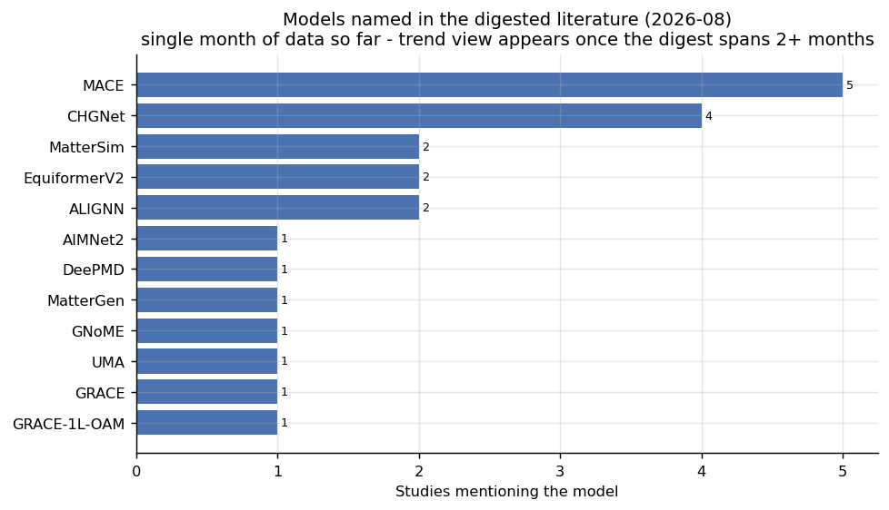

Table 1 - Benchmarked models, ranked by accuracy
Source: Matbench Discovery (CC-BY-4.0). Test set: WBM unique prototypes, ~215k inorganic crystals, scored against the Materials Project PBE convex hull. kSRME is the phonon thermal-conductivity error (lower is better); it is blank for models that were never evaluated on it.
# | Model | Acc. (%) | MAE (meV/atom) | RMSE (meV/atom) | F1 | R2 | kSRME | Tier | Architecture | Params | Calculation method / reference | Materials tested | Training set | Date | DOI
1 | EquFlashV2 | 97.8 | 18 | 66 | 0.929 | 0.873 | 0.094 | 1 | gnn | 44.9M | DFT PBE(+U), Materials Project settings; DFT single-point + relaxation: energy, forces, stress | WBM (unique prototypes), inorganic crystals vs MP convex hull | MPtrj, OMat24, sAlex | 2026-06-11 | link
2 | EquiformerV3+DeNS-OAM | 97.8 | 18 | 67 | 0.931 | 0.868 | 0.118 | 1 | transformer | 30.3M | DFT PBE(+U), Materials Project settings; DFT single-point + relaxation: energy, forces, stress | WBM (unique prototypes), inorganic crystals vs MP convex hull | MPtrj, OMat24, sAlex | 2026-04-07 | 10.48550/arXiv.2604.09130
3 | TACE-OAM-RRA-Preview | 97.8 | 18 | 68 | 0.928 | 0.866 | 0.101 | 1 | gnn | 213.7M | DFT PBE(+U), Materials Project settings; DFT single-point + relaxation: energy, forces, stress | WBM (unique prototypes), inorganic crystals vs MP convex hull | MPtrj, OMat24, sAlex | 2025-09-18 | 10.57967/hf/7458
4 | TECE-OAM-RRA-1.0 | 97.8 | 18 | 66 | 0.929 | 0.871 | 0.093 | 1 | gnn | 221.9M | DFT PBE(+U), Materials Project settings; DFT single-point + relaxation: energy, forces, stress | WBM (unique prototypes), inorganic crystals vs MP convex hull | MPtrj, OMat24, sAlex | 2025-09-18 | 10.57967/hf/7458
5 | eSEN-30M-OAM | 97.7 | 18 | 67 | 0.925 | 0.866 | 0.17 | 1 | gnn | 30.2M | DFT PBE(+U), Materials Project settings; DFT single-point + relaxation: energy, forces, stress | WBM (unique prototypes), inorganic crystals vs MP convex hull | MPtrj, OMat24, sAlex | 2025-03-17 | 10.48550/arXiv.2502.12147
6 | GRACE-3L-OAM-L | 97.7 | 18 | 65 | 0.925 | 0.875 | 0.121 | 1 | gnn | 42.1M | DFT PBE(+U), Materials Project settings; S2EF | WBM (unique prototypes), inorganic crystals vs MP convex hull | MPtrj, OMat24, sAlex | 2026-07-02 | 10.1038/s41524-026-01979-1
7 | PET-OAM-XL | 97.7 | 19 | 68 | 0.924 | 0.864 | 0.119 | 1 | transformer | 730.0M | DFT PBE(+U), Materials Project settings; DFT single-point + relaxation: energy, forces, stress | WBM (unique prototypes), inorganic crystals vs MP convex hull | MPtrj, OMat24, sAlex | 2026-01-10 | 10.1038/s41467-025-65662-7
8 | MatRIS-10M-OAM | 97.6 | 19 | 66 | 0.921 | 0.871 | 0.218 | 1 | gnn | 10.4M | DFT PBE(+U), Materials Project settings; DFT energy, forces, stress, magmoms | WBM (unique prototypes), inorganic crystals vs MP convex hull | MPtrj, OMat24, sAlex | 2025-10-29 | 10.48550/arXiv.2603.02002
9 | EquFlash | 97.5 | 19 | 66 | 0.919 | 0.871 | 0.158 | 1 | gnn | 28.7M | DFT PBE(+U), Materials Project settings; DFT single-point + relaxation: energy, forces, stress | WBM (unique prototypes), inorganic crystals vs MP convex hull | MPtrj, OMat24, sAlex | 2025-06-23 | link
10 | eqV2 M | 97.5 | 20 | 72 | 0.917 | 0.848 | 1.771 | 1 | transformer | 86.6M | DFT PBE(+U), Materials Project settings; DFT single-point + relaxation: energy, forces, stress | WBM (unique prototypes), inorganic crystals vs MP convex hull | MPtrj, OMat24 | 2024-10-18 | 10.48550/arXiv.2410.12771
11 | TACE-OAM-L | 97.2 | 20 | 67 | 0.91 | 0.868 | 0.126 | 1 | gnn | 82.9M | DFT PBE(+U), Materials Project settings; DFT single-point + relaxation: energy, forces, stress | WBM (unique prototypes), inorganic crystals vs MP convex hull | MPtrj, OMat24, sAlex | 2026-04-09 | 10.57967/hf/7458
12 | Nequip-OAM-XL | 97.1 | 20 | 66 | 0.906 | 0.872 | 0.125 | 1 | gnn | 32.1M | DFT PBE(+U), Materials Project settings; DFT single-point + relaxation: energy, forces, stress | WBM (unique prototypes), inorganic crystals vs MP convex hull | MPtrj, OMat24, sAlex | 2025-11-30 | 10.5281/zenodo.16980200
13 | SevenNet-Omni-i12 | 97.1 | 21 | 67 | 0.906 | 0.868 | 0.192 | 1 | gnn | 54.9M | DFT (see training set); DFT single-point + relaxation: energy, forces, stress | WBM (unique prototypes), inorganic crystals vs MP convex hull | COSMOSDataset | 2026-01-12 | 10.48550/arXiv.2510.11241
14 | ORB v3 | 97.1 | 24 | 78 | 0.905 | 0.821 | 0.21 | 1 | transformer | 25.5M | DFT PBE(+U), Materials Project settings; DFT single-point + relaxation: energy, forces, stress | WBM (unique prototypes), inorganic crystals vs MP convex hull | MPtrj, Alex, OMat24 | 2025-04-05 | 10.48550/arXiv.2504.06231
15 | SevenNet-MF-ompa | 96.9 | 21 | 67 | 0.901 | 0.867 | 0.317 | 1 | gnn | 25.7M | DFT PBE(+U), Materials Project settings; DFT single-point + relaxation: energy, forces, stress | WBM (unique prototypes), inorganic crystals vs MP convex hull | MPtrj, OMat24, sAlex | 2025-03-13 | 10.1021/jacs.4c14455
16 | AlphaNet-v1-OAM | 96.8 | 24 | 76 | 0.901 | 0.831 | 0.643 | 1 | gnn | 4.7M | DFT PBE(+U), Materials Project settings; DFT single-point + relaxation: energy, forces, stress | WBM (unique prototypes), inorganic crystals vs MP convex hull | MPtrj, OMat24, sAlex | 2025-05-12 | 10.48550/arXiv.2501.07155
17 | Nequip-OAM-L | 96.7 | 22 | 68 | 0.893 | 0.865 | 0.166 | 1 | gnn | 9.6M | DFT PBE(+U), Materials Project settings; DFT single-point + relaxation: energy, forces, stress | WBM (unique prototypes), inorganic crystals vs MP convex hull | MPtrj, OMat24, sAlex | 2025-08-28 | 10.5281/zenodo.16980200
18 | Allegro-OAM-L | 96.6 | 22 | 67 | 0.895 | 0.868 | 0.319 | 1 | gnn | 9.7M | DFT PBE(+U), Materials Project settings; DFT single-point + relaxation: energy, forces, stress | WBM (unique prototypes), inorganic crystals vs MP convex hull | MPtrj, OMat24, sAlex | 2025-08-28 | 10.5281/zenodo.16980200
19 | DPA3-v2-OpenLAM | 96.6 | 22 | 67 | 0.89 | 0.869 | 0.688 | 1 | gnn | 7.0M | DFT (see training set); DFT single-point + relaxation: energy, forces, stress | WBM (unique prototypes), inorganic crystals vs MP convex hull | OpenLAM | 2025-03-14 | 10.1038/s41524-026-02146-2
20 | TACE-v1-OAM-M | 96.5 | 22 | 68 | 0.889 | 0.865 | 0.173 | 1 | gnn | 18.8M | DFT PBE(+U), Materials Project settings; DFT single-point + relaxation: energy, forces, stress | WBM (unique prototypes), inorganic crystals vs MP convex hull | MPtrj, OMat24, sAlex | 2026-01-06 | 10.57967/hf/7458
21 | ORB v2 MPA | 96.5 | 28 | 77 | 0.88 | 0.824 | 1.734 | 1 | transformer | 25.2M | DFT PBE(+U), Materials Project settings; DFT single-point + relaxation: energy, forces, stress | WBM (unique prototypes), inorganic crystals vs MP convex hull | MPtrj, Alex | 2024-10-29 | 10.48550/arXiv.2410.22570
22 | GRACE-2L-OAM-L | 96.4 | 22 | 68 | 0.883 | 0.862 | 0.169 | 1 | gnn | 26.4M | DFT PBE(+U), Materials Project settings; S2EF | WBM (unique prototypes), inorganic crystals vs MP convex hull | MPtrj, OMat24, sAlex | 2025-09-09 | 10.48550/arXiv.2508.17936
23 | DPA-3.1-3M-FT | 96.3 | 23 | 67 | 0.884 | 0.869 | 0.469 | 1 | gnn | 3.3M | DFT (see training set); DFT single-point + relaxation: energy, forces, stress | WBM (unique prototypes), inorganic crystals vs MP convex hull | OpenLAM | 2025-06-05 | 10.1038/s41524-026-02146-2
24 | DPA3-v1-OpenLAM | 96.3 | 23 | 67 | 0.883 | 0.869 | 0.741 | 1 | gnn | 8.2M | DFT (see training set); DFT single-point + relaxation: energy, forces, stress | WBM (unique prototypes), inorganic crystals vs MP convex hull | OpenLAM | 2025-01-10 | 10.1038/s41524-026-02146-2
25 | GRACE-2L-OAM | 96.3 | 23 | 68 | 0.88 | 0.862 | 0.294 | 1 | gnn | 12.6M | DFT PBE(+U), Materials Project settings; S2EF | WBM (unique prototypes), inorganic crystals vs MP convex hull | MPtrj, OMat24, sAlex | 2025-02-06 | 10.1103/PhysRevX.14.021036
26 | MatterSim v1 5M | 95.9 | 24 | 68 | 0.862 | 0.863 | 0.575 | 1 | gnn | 4.5M | DFT (see training set); DFT single-point + relaxation: energy, forces, stress | WBM (unique prototypes), inorganic crystals vs MP convex hull | MatterSim | 2024-05-08 | 10.48550/arXiv.2405.04967
27 | DPA-4.0.1-Pro-MPtrj | 95.6 | 29 | 74 | 0.857 | 0.836 | 0.211 | 1 | gnn | 22.8M | DFT PBE(+U), Materials Project settings; DFT single-point + relaxation: energy, forces, stress | WBM (unique prototypes), inorganic crystals vs MP convex hull | MPtrj | 2026-06-11 | 10.48550/arXiv.2606.02419
28 | EquiformerV3+DeNS-MP | 95.6 | 29 | 74 | 0.863 | 0.84 | 0.275 | 1 | transformer | 30.3M | DFT PBE(+U), Materials Project settings; DFT single-point + relaxation: energy, forces, stress | WBM (unique prototypes), inorganic crystals vs MP convex hull | MPtrj | 2026-04-07 | 10.48550/arXiv.2604.09130
29 | MACE-MPA-0 | 95.4 | 28 | 73 | 0.852 | 0.842 | 0.412 | 1 | gnn | 9.1M | DFT PBE(+U), Materials Project settings; DFT single-point + relaxation: energy, forces, stress | WBM (unique prototypes), inorganic crystals vs MP convex hull | MPtrj, sAlex | 2024-12-09 | 10.48550/arXiv.2401.00096
30 | DPA-4.0-Pro-MPtrj | 95.4 | 30 | 78 | 0.85 | 0.823 | 0.241 | 1 | gnn | 32.7M | DFT PBE(+U), Materials Project settings; DFT single-point + relaxation: energy, forces, stress | WBM (unique prototypes), inorganic crystals vs MP convex hull | MPtrj | 2026-05-20 | 10.48550/arXiv.2606.02419
31 | MatRIS-10M-MP | 95.1 | 31 | 77 | 0.847 | 0.824 | 0.489 | 1 | gnn | 10.4M | DFT PBE(+U), Materials Project settings; DFT energy, forces, stress, magmoms | WBM (unique prototypes), inorganic crystals vs MP convex hull | MPtrj | 2025-10-29 | 10.48550/arXiv.2603.02002
32 | NequIP-GNoME | 94.8 | 35 | 85 | 0.829 | 0.785 |  | 1 | gnn | 16.2M | DFT (see training set); DFT single-point + relaxation: energy, forces, stress | WBM (unique prototypes), inorganic crystals vs MP convex hull | GNoME | 2023-11-29 | 10.1038/s41586-023-06735-9
33 | eSEN-30M-MP | 94.6 | 33 | 78 | 0.831 | 0.822 | 0.34 | 1 | gnn | 30.1M | DFT PBE(+U), Materials Project settings; DFT single-point + relaxation: energy, forces, stress | WBM (unique prototypes), inorganic crystals vs MP convex hull | MPtrj | 2025-02-17 | 10.48550/arXiv.2502.12147
34 | GRACE-1L-OAM | 94.4 | 31 | 73 | 0.824 | 0.842 | 0.517 | 1 | gnn | 3.4M | DFT PBE(+U), Materials Project settings; S2EF | WBM (unique prototypes), inorganic crystals vs MP convex hull | MPtrj, OMat24, sAlex | 2025-02-06 | 10.1103/PhysRevX.14.021036
35 | eqV2 S DeNS | 93.9 | 36 | 85 | 0.815 | 0.788 | 1.676 | 2 | transformer | 31.2M | DFT PBE(+U), Materials Project settings; DFT single-point + relaxation: energy, forces, stress | WBM (unique prototypes), inorganic crystals vs MP convex hull | MPtrj | 2024-10-18 | 10.48550/arXiv.2410.12771
36 | MatRIS v0.5.0 MPtrj | 93.8 | 37 | 82 | 0.809 | 0.803 | 0.865 | 2 | gnn | 5.8M | DFT PBE(+U), Materials Project settings; DFT energy, forces, stress, magmoms | WBM (unique prototypes), inorganic crystals vs MP convex hull | MPtrj | 2025-03-13 | 10.48550/arXiv.2603.02002
37 | DPA-3.1-MPtrj | 93.6 | 37 | 80 | 0.803 | 0.812 | 0.65 | 2 | gnn | 4.8M | DFT PBE(+U), Materials Project settings; DFT single-point + relaxation: energy, forces, stress | WBM (unique prototypes), inorganic crystals vs MP convex hull | MPtrj | 2025-06-05 | 10.1038/s41524-026-02146-2
38 | AlphaNet-v1-MPtrj | 93.3 | 41 | 93 | 0.799 | 0.745 | 1.305 | 2 | gnn | 16.2M | DFT PBE(+U), Materials Project settings; DFT single-point + relaxation: energy, forces, stress | WBM (unique prototypes), inorganic crystals vs MP convex hull | MPtrj | 2025-03-05 | 10.48550/arXiv.2501.07155
39 | DPA3-v2-MPtrj | 92.9 | 39 | 81 | 0.786 | 0.804 | 0.96 | 2 | gnn | 4.9M | DFT PBE(+U), Materials Project settings; DFT single-point + relaxation: energy, forces, stress | WBM (unique prototypes), inorganic crystals vs MP convex hull | MPtrj | 2025-03-14 | 10.1038/s41524-026-02146-2
40 | Eqnorm MPtrj | 92.9 | 40 | 83 | 0.786 | 0.799 | 0.408 | 2 | gnn | 1.3M | DFT PBE(+U), Materials Project settings; DFT single-point + relaxation: energy, forces, stress | WBM (unique prototypes), inorganic crystals vs MP convex hull | MPtrj | 2025-05-26 | link
41 | HIENet | 92.9 | 41 | 84 | 0.777 | 0.793 | 0.642 | 2 | gnn | 7.5M | DFT PBE(+U), Materials Project settings; DFT single-point + relaxation: energy, forces, stress | WBM (unique prototypes), inorganic crystals vs MP convex hull | MPtrj | 2025-02-25 | 10.48550/arXiv.2503.05771
42 | ORB v2 MPtrj | 92.2 | 45 | 91 | 0.765 | 0.756 | 1.726 | 2 | transformer | 25.2M | DFT PBE(+U), Materials Project settings; DFT single-point + relaxation: energy, forces, stress | WBM (unique prototypes), inorganic crystals vs MP convex hull | MPtrj | 2024-10-29 | 10.48550/arXiv.2410.22570
43 | DPA3-v1-MPtrj | 92.1 | 42 | 83 | 0.765 | 0.798 | 0.965 | 2 | gnn | 3.4M | DFT PBE(+U), Materials Project settings; DFT single-point + relaxation: energy, forces, stress | WBM (unique prototypes), inorganic crystals vs MP convex hull | MPtrj | 2025-01-10 | 10.1038/s41524-026-02146-2
44 | Nequip-MP-L | 92.1 | 43 | 84 | 0.761 | 0.791 | 0.466 | 2 | gnn | 9.6M | DFT PBE(+U), Materials Project settings; DFT single-point + relaxation: energy, forces, stress | WBM (unique prototypes), inorganic crystals vs MP convex hull | MPtrj | 2025-08-28 | 10.5281/zenodo.16980200
45 | SevenNet-l3i5 | 92 | 44 | 87 | 0.76 | 0.776 | 0.55 | 2 | gnn | 1.2M | DFT PBE(+U), Materials Project settings; DFT single-point + relaxation: energy, forces, stress | WBM (unique prototypes), inorganic crystals vs MP convex hull | MPtrj | 2024-02-06 | 10.1021/acs.jctc.4c00190
46 | Allegro-MP-L | 91.5 | 44 | 87 | 0.751 | 0.778 | 0.504 | 2 | gnn | 18.7M | DFT PBE(+U), Materials Project settings; DFT single-point + relaxation: energy, forces, stress | WBM (unique prototypes), inorganic crystals vs MP convex hull | MPtrj | 2025-08-28 | 10.5281/zenodo.16980200
47 | Nequix MP PFT | 91.4 | 44 | 85 | 0.748 | 0.784 | 0.307 | 2 | gnn | 708k | DFT PBE(+U), Materials Project settings; DFT single-point + relaxation: energy, forces, stress | WBM (unique prototypes), inorganic crystals vs MP convex hull | MPtrj, MDR-MP PBE ω_q | 2026-01-08 | 10.48550/arXiv.2601.07742
48 | Nequix MP | 91.4 | 44 | 86 | 0.751 | 0.782 | 0.446 | 2 | gnn | 708k | DFT PBE(+U), Materials Project settings; DFT single-point + relaxation: energy, forces, stress | WBM (unique prototypes), inorganic crystals vs MP convex hull | MPtrj | 2025-08-17 | 10.48550/arXiv.2508.16067
49 | SevenNet-0 | 90.4 | 48 | 92 | 0.724 | 0.75 | 0.762 | 2 | gnn | 842k | DFT PBE(+U), Materials Project settings; DFT single-point + relaxation: energy, forces, stress | WBM (unique prototypes), inorganic crystals vs MP convex hull | MPtrj | 2024-02-06 | 10.1021/acs.jctc.4c00190
50 | GRACE-2L-MPtrj | 89.5 | 52 | 94 | 0.691 | 0.741 | 0.525 | 2 | gnn | 15.3M | DFT PBE(+U), Materials Project settings; S2EF | WBM (unique prototypes), inorganic crystals vs MP convex hull | MPtrj | 2024-11-21 | 10.1103/PhysRevX.14.021036
51 | MACE-MP-0 | 87.8 | 57 | 101 | 0.669 | 0.697 | 0.682 | 2 | gnn | 4.7M | DFT PBE(+U), Materials Project settings; DFT single-point + relaxation: energy, forces, stress | WBM (unique prototypes), inorganic crystals vs MP convex hull | MPtrj | 2022-05-13 | 10.48550/arXiv.2401.00096
52 | BAM-MP-core | 86.9 | 60 | 99 | 0.623 | 0.712 | 0.848 | 2 | gnn | 17.0M | DFT PBE(+U), Materials Project settings; DFT single-point + relaxation: energy, forces, stress | WBM (unique prototypes), inorganic crystals vs MP convex hull | MPtrj | 2025-10-03 | 10.48550/arXiv.2510.03046
53 | ESNet | 85.7 | 109 | 194 | 0.572 | -0.114 |  | 3 | transformer | 5.4M | DFT (see training set); relaxed structure to relaxed energy | WBM (unique prototypes), inorganic crystals vs MP convex hull | MP 2022 | 2025-06-20 | 10.21203/rs.3.rs-5979703/v1
54 | CHGNet | 85.1 | 63 | 103 | 0.613 | 0.689 | 1.717 | 2 | gnn | 413k | DFT PBE(+U), Materials Project settings; DFT energy, forces, stress, magmoms | WBM (unique prototypes), inorganic crystals vs MP convex hull | MPtrj | 2023-03-01 | 10.48550/arXiv.2302.14231
55 | ALIGNN | 84.1 | 93 | 154 | 0.567 | 0.297 |  | 3 | gnn | 4.0M | DFT (see training set); relaxed structure to relaxed energy | WBM (unique prototypes), inorganic crystals vs MP convex hull | MP 2022 | 2021-02-22 | 10.1038/s41524-021-00650-1
56 | MEGNet | 82.6 | 130 | 206 | 0.51 | -0.248 |  | 3 | gnn | 168k | DFT (see training set); relaxed structure to relaxed energy | WBM (unique prototypes), inorganic crystals vs MP convex hull | MP Graphs | 2021-12-18 | 10.1021/acs.chemmater.9b01294
57 | CGCNN | 81.8 | 138 | 233 | 0.507 | -0.603 |  | 3 | gnn | 128k | DFT (see training set); relaxed structure to relaxed energy | WBM (unique prototypes), inorganic crystals vs MP convex hull | MP 2022 | 2017-10-27 | 10.1103/PhysRevLett.120.145301
58 | M3GNet | 81.2 | 75 | 118 | 0.569 | 0.585 | 1.409 | 2 | gnn | 228k | DFT PBE(+U), MPF2021; DFT single-point + relaxation: energy, forces, stress | WBM (unique prototypes), inorganic crystals vs MP convex hull | MPF | 2022-02-05 | 10.1038/s43588-022-00349-3
59 | EMA-GNN | 79.7 | 86 | 141 | 0.558 | 0.412 |  | 3 | gnn | 2.2M | DFT (see training set); relaxed structure to relaxed energy | WBM (unique prototypes), inorganic crystals vs MP convex hull | MP 2022 | 2026-08-08 | 10.6084/m9.figshare.33111509
60 | CGCNN+P | 78.6 | 113 | 182 | 0.5 | 0.019 |  | 3 | gnn | 128k | DFT (see training set); structure to relaxed energy | WBM (unique prototypes), inorganic crystals vs MP convex hull | MP 2022 | 2022-02-28 | 10.1038/s41524-022-00891-8
61 | Wrenformer | 74.5 | 110 | 186 | 0.466 | -0.018 |  | 3 | transformer | 5.2M | DFT (see training set); relaxed prototype to relaxed energy | WBM (unique prototypes), inorganic crystals vs MP convex hull | MP 2022 | 2021-06-21 | 10.1126/sciadv.abn4117
62 | AlchemBERT | 71.3 | 117 | 175 | 0.421 | 0.096 |  | 3 | transformer | 110.0M | DFT (see training set); relaxed structure to relaxed energy | WBM (unique prototypes), inorganic crystals vs MP convex hull | MP 2022 | 2024-12-11 | 10.26434/chemrxiv-2024-r4dnl
63 | BOWSR | 69.7 | 118 | 167 | 0.423 | 0.151 |  | 3 | gnn, bayesian_optimization | 168k | DFT (see training set); relaxed structure to relaxed energy | WBM (unique prototypes), inorganic crystals vs MP convex hull | MP Graphs | 2021-04-20 | 10.1016/j.mattod.2021.08.012
64 | Voronoi RF | 66.8 | 148 | 212 | 0.333 | -0.329 |  | 3 | fingerprint, random_forest | 26.2M | DFT (see training set); relaxed structure to relaxed energy | WBM (unique prototypes), inorganic crystals vs MP convex hull | MP 2022 | 2017-07-14 | 10.1103/PhysRevB.96.024104
65 | ALIGNN FF |  |  |  |  |  |  |  | gnn |  | DFT PBE(+U), Materials Project settings; DFT single-point + relaxation: energy, forces, stress |  | MPtrj | 2022-09-16 | 10.1039/D2DD00096B

Table 2 - Studies from the daily digest
Extracted automatically from titles and abstracts. Ordered by the numeric figure found (accuracy %, or 100 - error %, or R2/F1 x 100), then blanks. Caveat: abstracts state a numeric performance figure only about 10% of the time, so most metric cells are blank by necessity, not by oversight.
# | Sort value | Study | Models named | Materials / systems | Calculation method | Metrics found | Date | DOI
1 | 98.4 | Integrating Multi-Task Surrogate Modelling with Reinforcement Learning for Autonomous CO2 Reduction Catalyst Discovery: A Proof-of-Concept Framework |  | catalyst, alloy, CO2 | DFT | R2 0.984; R2 0.974; R2 0.559 | 2026-08-17 | 10.26434/chemrxiv.15007484/v1
2 | 92 | Interatomic Potential Prediction Based on Charge Equilibration and Equivariant Transformer |  |  | MLIP | MAE 8 % | 2026-08-24 | 10.70267/cai.26v3n4.3545
3 |  | Materials Discovery and Design |  | polymer |  |  | 2026-08-14 | 10.1002/9783527852048.ch9
4 |  | Electrostatic Phenomenology Benchmarks for Machine-Learned Interatomic Potentials in Electrochemistry: Beyond the Energy-Force Metric |  |  | MLIP |  | 2026-08-14 | link
5 |  | Universal Thermodynamic Interatomic Potentials for Crystalline Materials | UMA |  | MD, MLIP, free energy |  | 2026-08-14 | link
6 |  | Data-Efficient Construction of Material-Specific Machine-Learning Interatomic Potentials from Ab Initio Molecular Dynamics Trajectories | GRACE-1L-OAM, SevenNet-0, MACE-MP-0, MatterSim |  | DFT, AIMD, MD, MLIP |  | 2026-08-14 | link
7 |  | Neural Networks Accelerate Ab Initio Multiple Spawning Simulations: A Case Study of Using Machine Learning Potentials for Excited State Dynamics |  | molecule / organic | DFT, MLIP |  | 2026-08-14 | 10.26434/chemrxiv.15007443/v1
8 |  | Graph neural network prediction of temperature-dependent hydrogen diffusion and thermal conductivity tensors of tungsten containing helium bubbles and |  |  | MD |  | 2026-08-16 | link
9 |  | Unlocking Multi-Component Bulk-Materials Molecular Dynamics with a Small-Footprint Machine Learning Interatomic Potential |  |  | MD, MLIP |  | 2026-08-17 | link
10 |  | Conservation-Resolved Error Decomposition: A Benchmark Axis for Electronic-Structure Methods and Machine-Learned Interatomic Potentials | MACE | OFF23 | hybrid DFT, MLIP |  | 2026-08-17 | 10.26434/chemrxiv.15007478/v1
11 |  | G2RINS: A Generative String-and-Graph Polymer Representation to Assist Computational Materials Discovery |  | polymer | MD |  | 2026-08-17 | 10.26434/chemrxiv.15007504/v1
12 |  | GRACE-OFF: A machine-learned interatomic potential for organic liquids using the GRACE architecture | GRACE, MACE |  | MLIP |  | 2026-08-18 | 10.26434/chemrxiv.15001529/v2
13 |  | Optimization of active learning strategies for infrared spectra prediction in catalysis |  | catalyst, molecule / organic | DFT, AIMD, MD, MLIP |  | 2026-08-18 | 10.26434/chemrxiv.15007549/v1
14 |  | How AI Coding Agents Can Unlock Materials Simulation with NVIDIA ALCHEMI Toolkit | ALCHEMI |  |  |  | 2026-08-18 | link
15 |  | HIP: Hessian Interatomic Potentials | EquiformerV2 | molecule / organic | MLIP |  | 2026-08-19 | 10.5281/zenodo.22003592
16 |  | HIP: Hessian Interatomic Potentials | EquiformerV2 | molecule / organic | MLIP |  | 2026-08-19 | 10.5281/zenodo.22003591
17 |  | Local Symmetry Breaking and Correlated Fluctuations in Quantum Materials from Atomistic Foundation Models |  | superconductor | DFT, AIMD, MD, phonons, MLIP |  | 2026-08-19 | 10.26434/chemrxiv.15001387/v2
18 |  | Dynamic Ensembles of Phosphine-Stabilized Gold Nanoclusters |  |  | MD, MLIP |  | 2026-08-19 | link
19 |  | Exploring celecoxib polymorph landscape using AIMNet2 machine learning interatomic potential | AIMNet2 |  | DFT, MLIP |  | 2026-08-20 | 10.17615/xd5h-sd62
20 |  | Machine Learning Guided Discovery of Corundum High Entropy Oxides |  | oxide | MLIP |  | 2026-08-20 | link
21 |  | Machine Learning Guided Discovery of Corundum High Entropy Oxides |  | oxide | MLIP |  | 2026-08-20 | 10.48550/arxiv.2608.20596
22 |  | Data-Efficient and Fast Machine Learning Molecular Dynamics through Integrated Active Learning and Knowledge Distillation | DeePMD, MACE |  | DFT, MD, MLIP |  | 2026-08-21 | 10.1021/acs.jctc.6c00917
23 |  | Vibrational, structural, and chemical fingerprints of ion diffusion in crystalline solids |  | solid electrolyte | MD, MLIP, free energy |  | 2026-08-21 | link
24 |  | Vibrational, structural, and chemical fingerprints of ion diffusion in crystalline solids |  | solid electrolyte | MD, MLIP, free energy |  | 2026-08-21 | 10.48550/arxiv.2608.21624
25 |  | Machine Learning to Foundation Models: Artificial Intelligence for Nanophotonic Modeling and Scientific Discovery |  |  | MLIP |  | 2026-08-21 | 10.48550/arxiv.2608.21612
26 |  | The CHGNet uMLIP model fine-tuned for 2Hc-WS2 | CHGNet | WS2, MoS2 | DFT, MLIP |  | 2026-08-22 | 10.5281/zenodo.22059540
27 |  | FastMD | ALIGNN, CHGNet |  | MD, MLIP |  | 2026-08-22 | 10.5281/zenodo.22051980
28 |  | FastMD | ALIGNN, CHGNet |  | MD, MLIP |  | 2026-08-22 | 10.5281/zenodo.22051979
29 |  | Equivariance as a Substitutable Resource: A Unified Scaling Law for Machine-Learned Interatomic Potentials | MACE | molecule / organic | MLIP |  | 2026-08-23 | 10.5281/zenodo.22063928
30 |  | Equivariance as a Substitutable Resource: A Unified Scaling Law for Machine-Learned Interatomic Potentials | MACE | molecule / organic | MLIP |  | 2026-08-23 | 10.5281/zenodo.22063807
31 |  | Bayesian Neural Networks versus deep ensembles for uncertainty quantification in machine learning interatomic potentials |  | molecule / organic | MLIP |  | 2026-08-24 | 10.1088/2632-2153/ae9de8
32 |  | Y-Mn-B Magnetic Materials: A DFT and Machine Learning Dataset |  | magnetic material, Y3MnB7, YMnB4 | DFT, phonons, MLIP |  | 2026-08-24 | 10.5281/zenodo.22084773
33 |  | Y-Mn-B Magnetic Materials: A DFT and Machine Learning Dataset |  | magnetic material, Y3MnB7, YMnB4 | DFT, phonons, MLIP |  | 2026-08-24 | 10.5281/zenodo.22084774
34 |  | Attention-based composition learning for thermodynamic and electronic property prediction in inorganic materials |  |  | DFT |  | 2026-08-25 | 10.1016/j.nxmate.2026.103265
35 |  | PhononBench:A Large-Scale Phonon-Based Benchmark for Dynamical Stability in Crystal Generation | MatterSim, MatterGen |  | phonons |  | 2026-08-26 | 10.1088/3050-287x/ae9ee4
36 |  | Enhancing materials discovery with valence-constrained design in generative modeling |  |  |  |  | 2026-08-26 | 10.1038/s43588-026-01037-2
37 |  | Insights into Lithium Diffusion in Crystalline and Amorphous Solid Electrolytes with Machine Learning Interatomic Potentials |  | solid electrolyte, Li-ion battery, glass / amorphous, Li3YCl6, Li7P3S11 | MD, MLIP |  | 2026-08-26 | 10.26434/chemrxiv.15007863/v1
38 |  | A computed thermoelectric feature database for 50,992 GNoME materials | CHGNet, GNoME | thermoelectric | DFT, MLIP | MAE 0.036 eV/atom | 2026-08-26 | 10.26434/chemrxiv.15007873/v1
39 |  | High-throughput Discovery of Magnetic Rare Earth Transition Metal Alloys |  | alloy | DFT, MLIP |  | 2026-08-26 | link
40 |  | High-throughput Discovery of Magnetic Rare Earth Transition Metal Alloys |  | alloy, magnetic material | DFT, MLIP |  | 2026-08-26 | 10.48550/arxiv.2608.25270
41 |  | A Hierarchical Synergistic Deep Learning Framework Integrating Composition, Structure, and Ionic Transport for Solid-State Electrolyte Discovery |  | solid electrolyte |  |  | 2026-08-26 | link
42 |  | Realistic Simulations of Energy Materials Using Foundation Models and Electrode-Potential Learning | SevenNet |  | DFT, MLIP |  | 2026-08-26 | 10.26434/chemrxiv.15007895/v1
43 |  | Comparative study of ensemble-based uncertainty quantification methods for neural network interatomic potentials |  |  | DFT, phonons, MLIP |  | 2026-08-27 | 10.1088/2632-2153/ae9fb4
44 |  | Carbon Nanotube-Induced Magnetic Shielding Effects on 129Xe NMR from Equivariant Neural Networks |  |  | MD, MLIP |  | 2026-08-27 | 10.26434/chemrxiv.15007956/v1
45 |  | Benchmarking of Fast and Interpretable UF Machine Learning Potentials |  |  | DFT, MD, MLIP |  | 2026-08-27 | link
46 |  | Packora: Systematic Design for Generative Molecular Crystal Structure Prediction |  |  |  |  | 2026-08-27 | link

Provenance and honest limitations
- Why two sources. MAE/RMSE values are published in full-text tables, not abstracts. Testing 12 digest DOIs, only 1 exposed a usable numeric metric in its abstract. A table built solely from abstracts would be almost entirely blank, so the leaderboard supplies the comparable numbers and the digest supplies the leading edge.
- Accuracy here means stability classification accuracy (is this structure on or below the convex hull?), not a chemical accuracy claim.
- Tiers come from k-means (k=3) on [MAE, accuracy, F1, R2], ordered by mean MAE. Tier 1 is best. They are a descriptive grouping, not a ranking endorsed by the benchmark authors.
- Table 2 extraction is regex-based. It will miss models it has never heard of and can mis-attribute a number to the wrong quantity. Verify anything you intend to cite.
- Values you enter in manual_data.json override everything above and survive future runs.

