ODHS MPU6050 i2c connection

*read from the who am I register of the gyroscope(mpu6050) using I2C*

in i2c generally sequential write and read is supported as it is in the case if mpu6050.

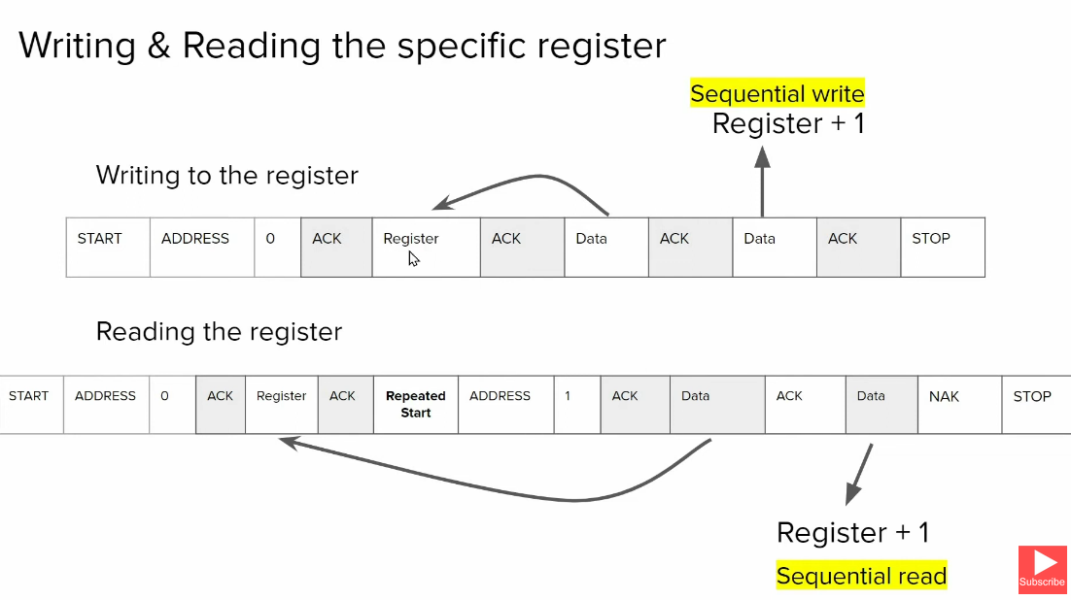

To write to a specific register:-

* start bit
* address of slave
* R/W bit (=0 to write)
* Get Ack from slave
* Send 1st register address to be written to
* Send data (the data is written to the said register)
* If any following data is sent, it is sequentially written onto register+i th register
* Stop bit

To read data from a register:-

* Start bit
* Address of slave
* R/W bit =0
* Get ack from slave
* Send 1st register address to be read
* Ack from slav
* Then resend start bit
* Address of the slave followed by R/W bit =1 (to read mode)
* Slave send ack and sends the data on that register
* If master sends back ACK then the slave sends the data in register +1 . this keeps happening till when master keeps sending ack
* To stop the conversation, master send a NAK followed by stop bit

In STM32cudeIDE select STM32F407VGT6 and create an EMPTY project

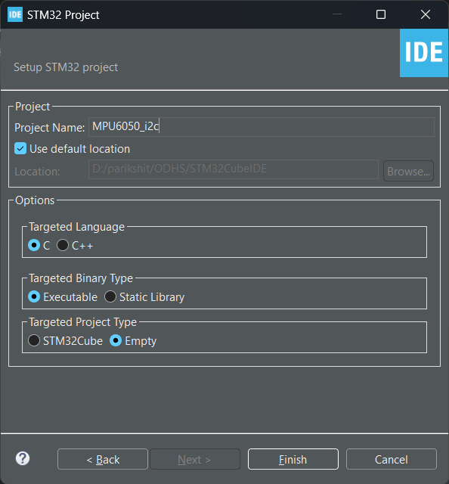

TO add CPAL Files

add the CPAL files (headers into inc and .c into src)

Link:- <https://docs.google.com/document/d/1XgmuZdV3H02oNoKyO8WgNbg7TIMane0wnFkh-nzFZkI/edit>

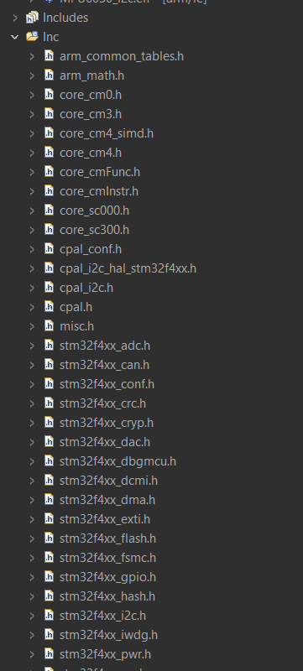

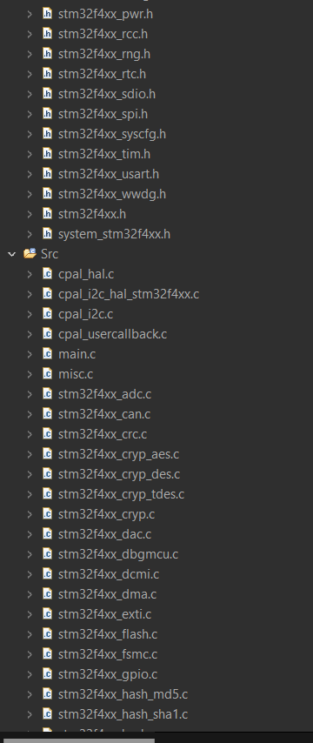

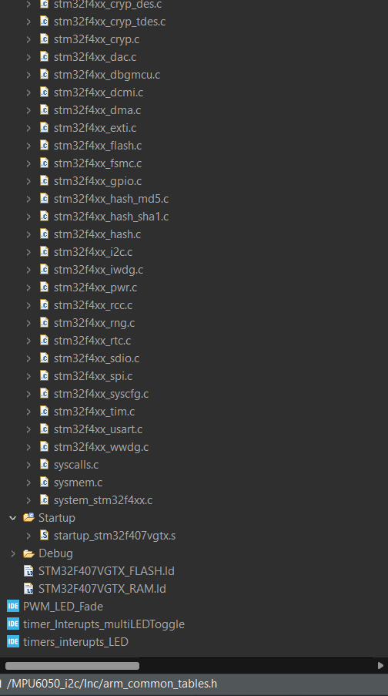

As MPU6050 can work upto a max clock speed of 400khz

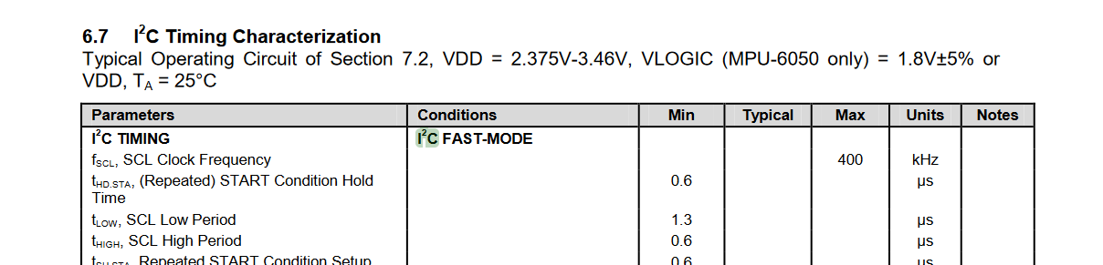

The clock speed is left as default of 100000 Hz i.e. 100KHz

And speed mode as standard mode

The address of MPU6050 is :-

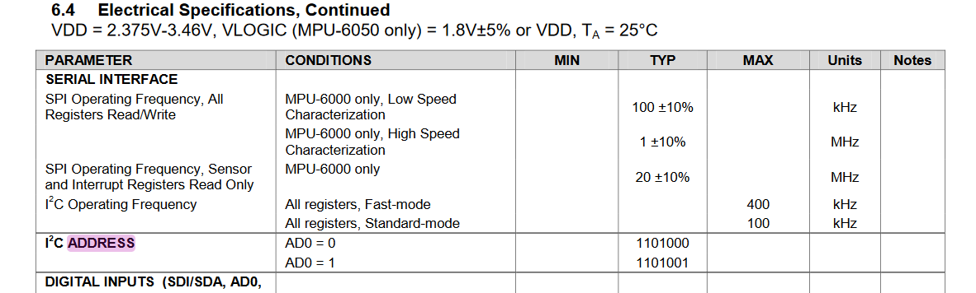

If AD0=0 address= 1101000 (using this)

If AD0=1 address= 1101001

references:-

<https://www.youtube.com/playlist?list=PLmXXQ1iFwiyKKURU4wAeGT_d1HsIe1YCY>

datasheet:-

<https://invensense.tdk.com/wp-content/uploads/2015/02/MPU-6000-Datasheet1.pdf>

register map:-

<https://invensense.tdk.com/wp-content/uploads/2015/02/MPU-6000-Register-Map1.pdf>