CS472W Software Engineering – Spring 2011

Group Project
Deliverable #2: Specification Document
Group Name: ___Powerstorm____________________________________________
Member #1: ___________________________________________________
Member #2: ___________________________________________________
Member #3: ___________________________________________________
Member #4: ___________________________________________________
Due Date: 03 Apr 2012 Received: ___________________________

Requirements:
- (5 points) Introduction
  - Overview of project
  - Specification Techniques used
  - CASE tools used (and how)
- (15 points) Constraints
  - Cost
  - Time
  - Requirements of: Parallel operation, Portability, Reliability, Performance
  - Others?
- (10 points) Acceptance Criteria
  - Test Scenarios
  - Passing requirements
- (30 points) Specification
  - Here use as many techniques as necessary to specify project
  - Grading will be based on: completeness, correctness and ambiguity
- (10 points) Schedule
  - When should each feature be designed?
  - When should each feature be implemented?
  - What will the beta dates be? What will be implemented for each beta?
  - Who will design and implement that feature?
  - When will testing that feature be accomplished?
- (10 points) End game
  - Who has ownership of the product when the semester ends
  - How long will you be willing to assist in maintenance?
  - How will you be contacted?
- (10 points) Testing
  - Discussion of walkthrough or inspection of specification
  - Discussion of changes due to testing
  - Discussion of traceability to requirements document
- (10 points) Discarded Strategies
  - What were they?
  - Why were they discarded?
PowerStorm
Justin Blackwood, Josiah Donor, Nathan TeGrotenhuis, Ethan Elmenhurst, Kristin Beltz

Introduction:

This is a system for providing real-time energy usage tracking for residence halls located on the Whitworth University campus. The goal is to encourage energy conservation among students by creating greater awareness. This project will focus on updating the existing website interface, improving database queries and data storage, testing the data received from the meters, and caching data for faster load time.

The specification techniques used in this document will include informal specification, UML diagrams, and a use case diagram. The informal specification will be used to describe the concepts behind the project that cannot be expressed effectively in a diagram. The UML diagrams will provide a basic structure for the classes in our program. The use case diagram will help grasp a better understanding of the possible navigation through the website.

The CASE tools that are used include Microsoft Word, Visio, and Google Docs. The word processor is used to write and compile specifications. Visio is used to create UML and use case diagrams. Google Docs is used to share our specification file to be edited by multiple team members.

Constraints:

In terms of resources required to implement our project, we are limited by the client being Whitworth and by the length of the semester. Since our client is Whitworth, there isn’t a whole lot of money being thrown around, so we must attempt to use either no money or as little as possible. Since this is for a class, the reality is that we will all go our separate ways once the semester ends, so the amount of time we can invest is limited.

Our primary focuses for constraints are informed by the purpose of PowerStorm: to increase awareness of power usage among students. Because of this, the site needs to be portable so we are not putting obstacles in the way of people accessing the information. If students can pull it up on their phone, their computer, and see it on a display in their dorm, chances are increased that the message will actually get through because students access information from a variety of mediums.

We need the site to be fast, so that students aren’t sitting and waiting for the page to load (currently some pages take upwards of 15 seconds to load). In this fast-paced world, a website needs to be speedy, meaning that it takes less than a second to load the graphs, or else short attention spans will kick in and nobody will stay on the site long enough to extract helpful information. Acceptable performance requirements are defined later in the document. The site also needs to be reliable, since it will be running for extended periods on displays in dorms. It needs to not crash if run for days and weeks at a time.

Since the dorm displays will probably be run off some sort of mini-PC (currently exploring Beagle Boards), we are constrained in terms of how graphically intensive the site can be. The graphics processing power of these barebones computers is pretty limited, so the site has to be stripped down graphically to account for this limitation.

Acceptance Criteria:

Since performance is a very important constraint for the usability of the web page, we need to ensure that the pages load acceptably fast. Currently the worst load time is on the order of 10000ms. This is not acceptable. We expect to gain a significant speed up from caching and database optimizations. To demonstrate performance improvement we will write tests to measure page load times for each user scenario. Our maximum acceptable load time is 200ms.

One of the bottlenecks on the page load time is querying the database. Adding indexes should improve performance. We will test the query times to measure the speedup we can get by adding indexes to the database. An acceptable speed of the database will be whatever is sufficient to reduce page load times to an acceptable range.

Another thing really slowing down page load times is rendering of graphs. To fix this we are going to render graphs server side, store the rendered graphs as an object in the database so they are ready to serve on a request. All the graphs for each dorm and timespan need to be refreshed right after the energy use data is updated.

A challenge in our project is that the data coming from the energy monitors is very error prone, giving obviously erroneous values such as 0kWH or 1000000kWH. We want to find the source of the errors to see if we can fix the bug. If we are unsuccessful at fixing the source of the errors, we will measure the frequency of errors. If the frequency is acceptably low we will detect errors and correct them by interpolating reasonable guesses. We will validate the database to ensure that no erroneous data is displayed to the user since this is unacceptable.

The user experience must be well tested. No possible user actions should lead to 404 pages. CSS should be tested by careful examination of pages rendered in every major browser, and on a sample of tablets and smart phones. We will also have 3rd parties in addition to the client use the site and give feedback on the design and usability. We will not care about outdated browser versions.

We are going to add data collection daemons to obtain data that we think will help us find correlations to energy usage and help us find a way of setting energy use goals for the dorms. The scope of the current project is to gather public data from online sources. The acceptance criteria is that the collection daemons do not hog resources needed for displaying data and they must be very reliable.

Reliability for the website is very important. We are aiming for constant uptime so the displays are running in the dorms. Therefore all unhandled exceptions or errors are unacceptable.

Specification:

Some structure is already in place as part of our client’s work. For example, the process of reading data from the meters, loading it into Powerstorm’s database, and giving it to the application is already established in ReadingGatherer.cs. Also, the basic structure of the web application is in place, including the home page, basic display for the dorms, and the advanced tabs. Our tasks are to update the website interface, and to add a service programs and enhance the performance of the application.

The UML diagram below displays the database structure. It contains a table that represents all of the energy meters, with an identifying ‘IP’ field, the building in which the meter is placed (which will correspond to an entry in the Buildings table), and the model of the meter. The Buildings table contains the name of the building, number of occupants, total capacity, area, and type of building (dorm, administrative, etc). The Electricity Readings table contains the date of the reading, the meter id (which corresponds to an entry in the Meters table), and the amount of power in the reading. Also, a lower priority task in our project will include establishing a weather table which will help to correlate power usage to the weather to help set reasonable goals for reducing energy usage. Also, some data currently in the tables will be used for expanded analysis (for example, how the day of the week, hour of the day, and number of people in the dorm impacts usage).

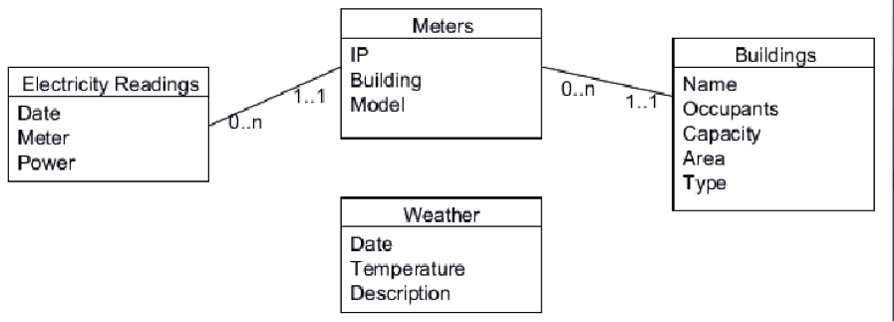

The UML below shows the services that we will implement for the project. The C# daemon will control the services, gathering and cleaning the data every fifteen minutes. The class “ReadingGatherer” is already implemented. The “ReadingGatherer” class is responsible for connecting to the external database containing meter data in order to pull to our own database. The other features listed below will be added.

The “DataCleaner” class will contain methods to compare the most recently received data value to the previous data values. If the new value is completely unreasonable compared to the others, it will be omitted. This will also contain a method to test the data retrieved from the database. It will also keep track of how often specific errors occur in the meters.

The “PerformanceService” class will contain methods to test the data that is received for its validity and existence. Also, it will keep track of how long queries are taking to complete. In addition, it will cache the data read from the database in an attempt to improve the website’s performance.

The “WeatherService” class represents a deamon that will connect to the NOAA weather database and retrieve information about temperature, hours of daylight, and cloud cover. The purpose of obtaining this data is to see if any of these variables correlate to energy usage, but the weather service does not analyze the data, only obtain it and store it in the database. It will also verify the data to ensure security and quality of the data. Note: This class will not be implemented in our final product because Nate ended up working on vastly improving the performance of the graphs on the website, a much more important task.

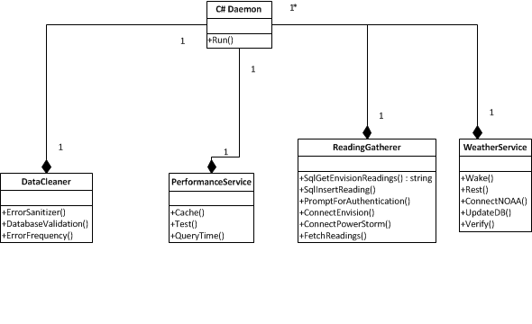
The diagram below (created by the client) is a basic use case for how various parts of the project interact. The meters connect to a database server which loads the data into SQL Server and runs the data through a daemon on the application server which moves it into a MySql database. The meters also connect to an automated logic web control interface which connects to the daemon in the application server to put the data into the MySql database as well. The application server also contains the Rails application, which is accessed by the client browser. The user will then access the project through the browser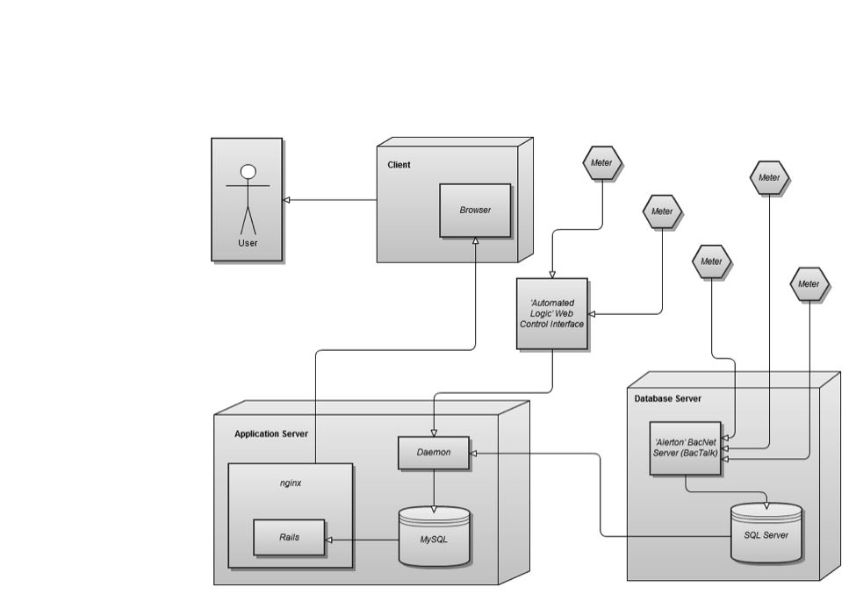

Finally, the use case diagram below describes the possible actions that can be taken on the project’s website. The application’s home page has a map of the campus. Users can mouse over the specific buildings and view data. From the home page, they can go to the about page which provides a brief description about the application or the contact page which provides our client’s contact information. Also, the user has the ability to click on a building from the home page. This takes the user to the building’s energy usage page. This displays a graph of the electricity usage which shows daily usage. Also, it will provide the current usage and equivalent dollar amounts. It will also provide a comparison other than kilowatts, like how long a car could run on the current electricity usage. On the bottom of the page, a graph that compares historical usage numbers to current usage will be displayed. From the building page, the user can go back to the previous page, or go to an advanced page.

On the advanced page users may view detailed data about electricity usage. The user is given four tabs of data from which to choose: Reduction Percentages (how much the energy usage has reduced since a specific time), Today’s Usage (current usage, total day’s usage, use/squarefoot, use/occupant, and greenhouse gas emissions), Month’s Usage (same data as Today’s usage), Year’s (same data), and All-Time Usage (same data as well). Based on which tab is selected, the graph will change to display the historical data.
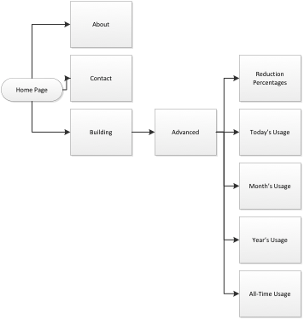

Below is the final version of our UML diagram. The C# daemon was put into the ReadingGatherer class. The CachingService ended up not being necessary because the performance of the graphs was improved through better queries and implementation of the graphs themselves. WeatherService was removed due to time constraints as well as higher priority items. Much of the project is also in Ruby and Javascript, which is not included in a UML diagram.

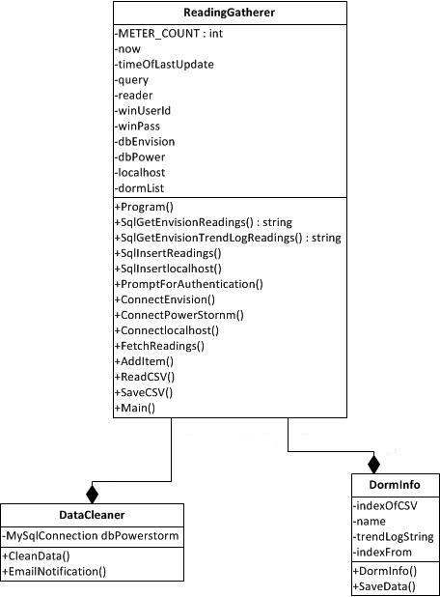
Schedule:

The charts below outline our expected implementation timeline. Our beta date is April 24, 2012. At this point, we hope to have fixed the data and GUI so that it is in a better working state than currently. Also, we hope to have written the DataCleaner and PerformanceService class, which will help to make the application run faster and have more reasonable data. We will have made some additions to the GUI, but those will still be in progress.

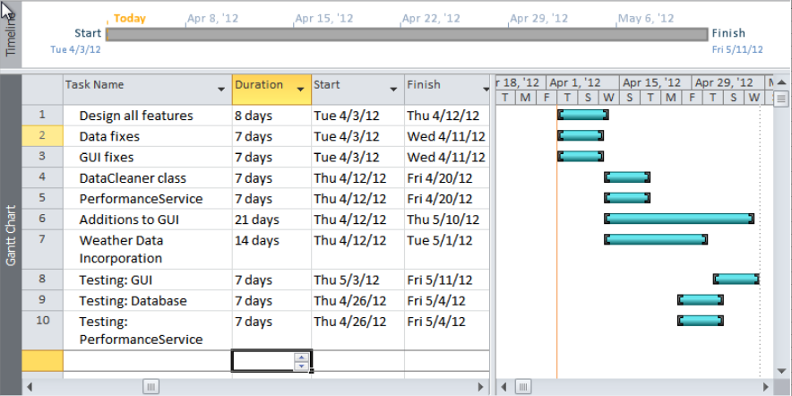

Josiah - GUI additions
Justin - PerformanceService (including caching)
Nathan - Weather data and testing
Ethan - Data fixing and validation
Kristin - DataCleaner, GUI testing, and GUI

Our beta day turned out to be May 1st. In this beta we presented our improvements in the user interface, our bug fixes in the ReadingGatherer that allowed the data to be accurately read and displayed, and our improvements in the performance of the graphs.

Josiah worked on updating the GUI, including removing the navigation bar slider, condensing the about/contact pages, and adding an indicator of what dorm is being viewed.

Justin rewrote the ReadingGatherer to work with the new time intervals, so that the data was actually read and displayed correctly. He also worked on the advanced page graphs.

Nathan played a large role in reading the data more efficiently and displaying it on the graphs almost instantaneously; it went from taking several seconds to load the graphs to about one second.

Ethan worked on the DataCleaner; he wrote the SQL queries and helped to test the algorithm on the current data.

Kristin also worked on the DataCleaner, setting up the structure and converting Ethan’s logic into code that would execute properly. She also wrote the email notification process.

End Game:

We have been communicating with Patrick who will take ownership of the product when we are finished. The current project lead on Whitworth’s side is Jake Landsiedel who is the environmental specialist in facility services. However there are ongoing efforts to find someone who will take over for the long-term. Our team can be contacted at our Whitworth emails and will be available after the semester ends. In addition, Patrick will still be interested in the project even when he has graduated.

Testing:

We reviewed the specification as a group, specifically each of the necessary tasks. We had to add a class to the UML diagram that had been left out. We also reviewed the tasks with our client. In addition, we decided that we needed more description of the classes in the specification section, so the paragraphs were broken out and more details were added.

In the requirements document, we were unsure of the exact goals and features of the project. We listed out the basic tasks that we need to accomplish, and many of those stayed the same in this document. However, due to our better understanding, we added a number of other features to the project in this document.

Discarded Strategies:

We wanted to make predictions based on weather data to set a goal. This feature has a high difficulty and a low priority so it is not in our current plan.

We had an idea to have dorms compete against one another on a periodic basis to achieve energy savings. The essential problem with this idea is that different dorms have very different energy use conditions such as number of students, insulation, age and efficiency of electrical hardware and different energy use meters.

We originally thought that the data used to creating the charts would be cached by storing the data for the charts: daily, monthly, yearly and all time usage. Instead we will create the charts and store them so they do not have to be rebuilt on every page load.

The client was using the google charts api to create and display graphs. But we expect a performance improvement by using jscharts because it doesn’t have to send the data to google and wait for google’s servers to deliver the chart.

