CS472W Software Engineering – Spring 2012

**Deliverable #1: Requirements Document**

**Group Name: Power Storm**

Member #1: Josiah Donor

Member #2: Ethan Elmenhurst

Member #3: Justin Blackwood

Member #4: Kristin Beltz

Member #5: Nathan TeGrotenhuis

**Requirements:**

Overview of project: This is a system for providing real-time energy usage tracking for residence halls located on Whitworth University campus. The goal is to encourage energy conservation among students by creating greater awareness and for the project to reach a state in which it can be successfully implemented in the dorms which will help increase energy awareness.

Client named: Patrick Yoho and Whitworth University

Competitor Analysis: Itron Inc. has smart meters (Open Way Technology) that allow for data transmission from the power meters directly into the house. The house owner can view cost of energy usage and schedule heating and power usage around peak demand for electricity.

**Client Requirements:**

Initially, the application had a basic structure in place that included the ability to click on a building and view energy data. However, the process to display the data had a number of errors, and the loading of the graph was very inefficient.

Client interview: We met with Patrick on March 6th to go over his list of ideal areas for development. He has developed a rough idea of what tasks he would like us to accomplish and created a list of features for us. We discussed in detail what was included in the more important steps of that list, writing down comments. In addition, we created a list of questions with which to interview him.

Q: What is the best way for us to update the code and get access to the servers?

A: We can set up a fork in the GitHub repository and make changes on that.

Q: What specific bugs are there to fix in the project?

A: The graph data does not correspond to the other data displayed on the site. The data is very inconsistent and the analysis in the program does not display accurately. Also the bar graph at the bottom does not work.

Q: What do you want the immediate improvements on the interface to look like?

A: The charts should be expanded to better fill the screen, the graph should shift from a daily to monthly view, the bar graph should change color based on current and past averages, and the chart units need to be updated. Also, it would be good if the data was displayed in a way that is more easily understood (i.e. in terms of how many cars the energy could run, cost, etc).

Q: Should there be a chart to show usage based on the hour of the day?

A: It currently does show some hourly increments, but it should be more detailed.

Q: What tasks need to be started immediately?

A: The drivers for the Beagleboard need to be compiled. This will allow the analog circuit to control the LED.

Q: What type of error notification do you want?

A: A check to ensure that the new data makes sense compared to the old data. If there are inconsistencies in the data, an email will be sent to the administrator.

Client Scenarios:

The client would like the project to reach a state in which it can be implemented in the dorm. This would result in showing students the current electricity usage and a comparison to the past usage. The goal of this is to increase awareness in the dorms in an effort to reduce electricity costs. In this scenario, just one screen for the dorm would be shown.

The lighting scheme goes along with the dorm scenario; it provides a different way of giving feedback to the students. It is more of an emotional feedback because results are achieved based on a response to the lights; the LED light colors change depending on how much electricity is wasted.

The moving graph and colored LED is intended to attract attention to the monitor so that people passing through the space will notice their energy usage. The inclusion of both the LED and the informational screen will help answer the research question of whether informational or emotive feedback is better for improving behavior. Is numerical data necessary to persuade students to use less energy?

Students might also access the website on their personal computers. It is conceivable that students would be interested in energy performance of the dorm they live in compared to others.

In another scenario, administrators in facilities services would use the website to monitor electricity usage in various dorms. This would include detailed statistics about different dorms. This helps to give an overall sense of the electricity usage, potentially to identify problem areas or excess energy usage. They can look at the aggregate data of energy usage after the system is rolled out to evaluate its effectiveness at reducing energy usage.

Specific Requirements:

1. One of the highest priority tasks is to build a pulse width modulation driver for the beagleboard. This is used to simulate an analog signal by quickly turning off and on a digital I/O. Source code for the driver is available online, but it needs to be cross compiled for the beagleboard.
2. The next task is to write a program for the beagleboard to change light colors based on current usage compared to a past average. This will incorporate the PWM driver; the circuit to control the LED lights is built, but it needs code to run.
3. The wireless networking driver for the beagleboard needs to be compiled as well. This will give the monitors a connection to the internet so they can display current data.
4. The interface for the website needs to be updated. It should include more accurate charts and better units. The graphs should switch between daily and monthly views automatically. The data should be displayed in such a way to help students better understand their electricity usage. Finally, the bar graph should change color based on current and past averages so that the students can easily see how the current usage compares to the past.
5. The database queries need to be optimized; there is a lag time between when the website loads and the data is displayed.
6. A system of error checking should be implemented so that the administrator is notified of errors within the data.

These were the top priority requirements; our client also gave us other ideas for future improvement if we have time at the end.

Once we got started on our project, many of the requirements changed. The client completed a number of our initial requirements himself, so we had to adapt our project to what else needed to be done within the application. The following are the requirements that we executed.

1. The user interface is to be improved. This will include removing the existing navigation bar slider, condensing the about/contact pages into the bottom of the home page, and adding an indicator of what dorm’s electricity is currently being viewed.
2. Once in a while, the meter data spikes unexpectedly. A process will be written to detect outliers, flag them in the database, correct them based off of a linear regression algorithm, and send an email notification.
3. There are numerous errors in the reading of the data which need to be fixed. Since the time intervals for meter readings were changed and the electricity reading attributes were changed, the ReadingGatherer class needed to be altered.
4. The graphs on all pages (dorm and advanced) need to be made more accurate and efficient (originally the data was incorrect and the graphs took several seconds to display any data).

Cost/Benefit Analysis:

1. This is a fairly challenging task because we have to work with new hardware and have to figure out how to successfully compile the drivers, so the effort will be 75. This is a high priority to the client because if it doesn’t work he can’t implement the project in dorms, so the benefit to the product is 85. The ratio is .88.
2. This is slightly more challenging, and is based on our success in the previous task, so the effort is 85. It is also very important to the project because he want the ability to change the light colors, so its benefit is 95. The ratio is .895.
3. This is a very challenging task; preliminary research says that it might not be possible, so the effort will be 95. This isn’t as necessary because he can connect the system using Ethernet, so the priority is 50. The ratio is 1.9.
4. This is slightly less challenging than compiling the drivers, but still involves a large number of tasks, so the effort is 60. This is a large part of the project and could significantly affect how successful it is in influencing the students, so the benefit is 95. The ratio is .63.
5. This depends on the database, but it shouldn’t be too difficult, just time consuming, so the effort is 55. It isn’t vital to the project but would help with efficiency, so the benefit is 40. The ratio is 1.375.
6. This is an issue of validating data which isn’t too challenging, so the effort is 30. It won’t provide a lot of benefit to the project, however, it just provides information to the administrator, so the benefit is 20. The ratio is 1.5.

Ranked in order from lowest to highest cost/benefit ratio (meaning the most benefit for the least cost), our requirements come out in the following order: 4, 1, 2, 5, 6, and 3.

Cost/Benefit Analysis for updated requirements:

1. This is a relatively simple task since it involves editing pre-existing Ruby and Javascript, and if it is not accomplished it will not cause the project to fail. The cost and benefit therefore are each 50, for a ratio of 1.
2. This is a more complicated task because it requires advanced database querying as well as setting up email notifications. However, it is not extremely vital to the project because outliers are not very frequent (about 30 in 15000 according to one test). The cost is 70 and the benefit is 60 for a ratio of 1.167.
3. Fixing the ReaderGatherer was a must because it got to a point where the application was not functioning. Since the basic structure is already established, rewriting it is not too challenging. The cost is a 40 and the benefit is a 90, for a ratio of .44.
4. Making the graphs accurate and efficient is of a high priority because otherwise the page is very frustrated and meaningless. It is a fairly challenging task however. The cost is 80, and the benefit is 95, for a ratio of .842.

Ranked in order from lowest to highest ratio (meaning the most benefit for the least cost), our requirements come out in the following order: 3, 4, 1, 2.

**Feasibility:**

Competitive: This is a unique project, although there are other technologies that do something similar. Those are targeted to the niche market of the home, whereas ours is using a dorm or a larger community. This is not something that has a significant amount of competition. It is also targeted for Whitworth specifically, so it won’t be competing in a wider market.

Technical: We need more knowledge in Beagleboards, compiling drivers, Linux knowledge, Ruby, virtual machines on servers, and SQL query optimization. The expertise varies among the group members. The client has provided us with a list of resources to read and learn about some of these technologies.

Economic: The average cost/benefit ratio for this project is 1.2. This indicates that there may be more cost than benefit to the tasks in the project. However, this is to be expected because we are working on doing various tasks for a client who has a pre-established project. Some of the tasks are things that he hasn’t been able to find out how to accomplish, so they will be very challenging. Also, there are a number of bugs and inconsistencies already in the project, so we will have to fix those in the process of adding our own features.

**Lifecycle model:**

Our project will implement the iterative lifecycle model. Considerable work has already been done on the project and we will use this work as our first iteration. Much of our work will involve fixing existing features. Each different build, or added feature, will be delivered to the client in increments. Since we have good access to our client and he has been very responsive we think the iterative model suits our relationship.

Our project is not a waterfall model because so much of it is already designed and completed and much of our work is fixing bugs, but we will add new features that are in an early stage of design. Though we are adding features to a project that already exists, we do not consider the current work as a rapid prototype because the user interface is well designed and implemented with a database back-end and some sophisticated functionality.

**User interface:**

As previously mentioned, the user interface already exists. This is the main screen that allows the user to select a dorm about which to get data.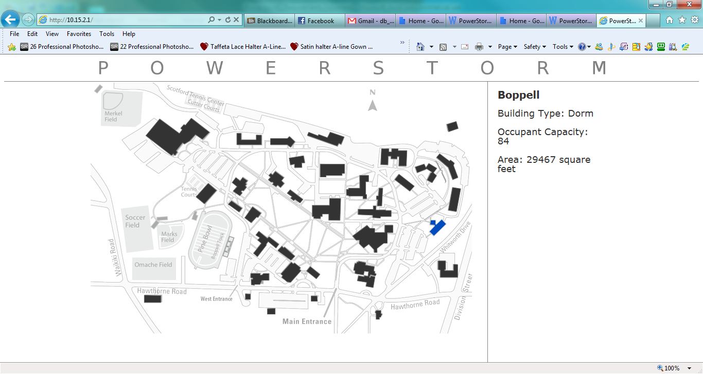

This is a screenshot of the current user interface that is displayed for a dorm, with some drawings on top of future improvements we intend to make. Some of our planned changes are present in the graphics. The graph in the middle is larger than the current chart that is displayed. The bar chart on the bottom is new. It will be a way of comparing historical to current data. It will be colored based on how well the dorm is doing in comparison to history. The data sections on the left and right will also automatically scroll through different metrics.

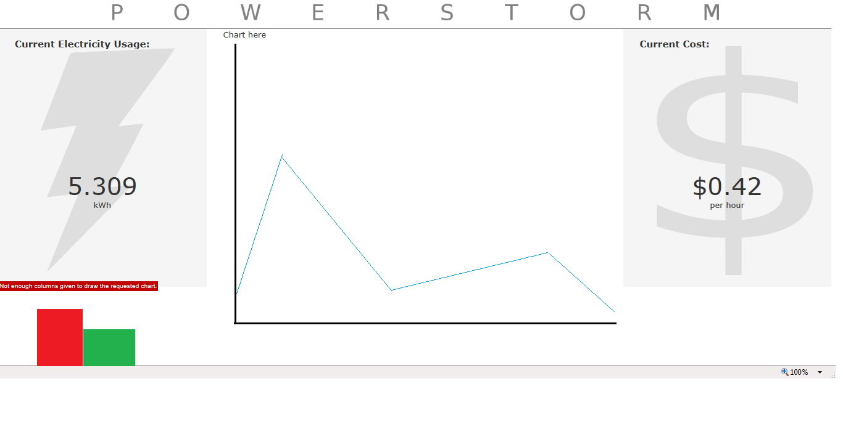

**Testing:**

Each of the specific requirements can be directly linked to a task that the client defined in his documentation for our team. The requirements are precisely what the client requested and provide the potential for expansion based on our progress on the project. This is a unique scenario because the client is someone who will also be actively involved on updating the project as well. He knows exactly what tasks he wants to be accomplished and has made those clear to us. Every member of the team will review the requirements document extensively as well.

**Presentation of Requirements to Client:**

The requirements outlined in this document are specifically as requested by the client. They precisely match his needs because they are the items of top priority for his project. The user interface was designed by the client, and proposed additions to the interface are per his request as well. We expect that as we make progress on the project that we will have new requirement ideas for the client.