**Day 3: FSD –TASK**

1. Use the rest countries APi to display all the countries flags in the country.

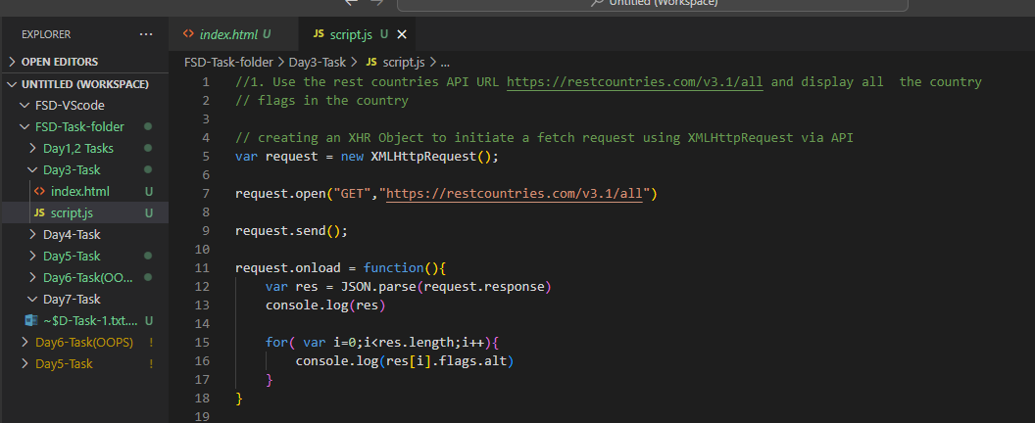

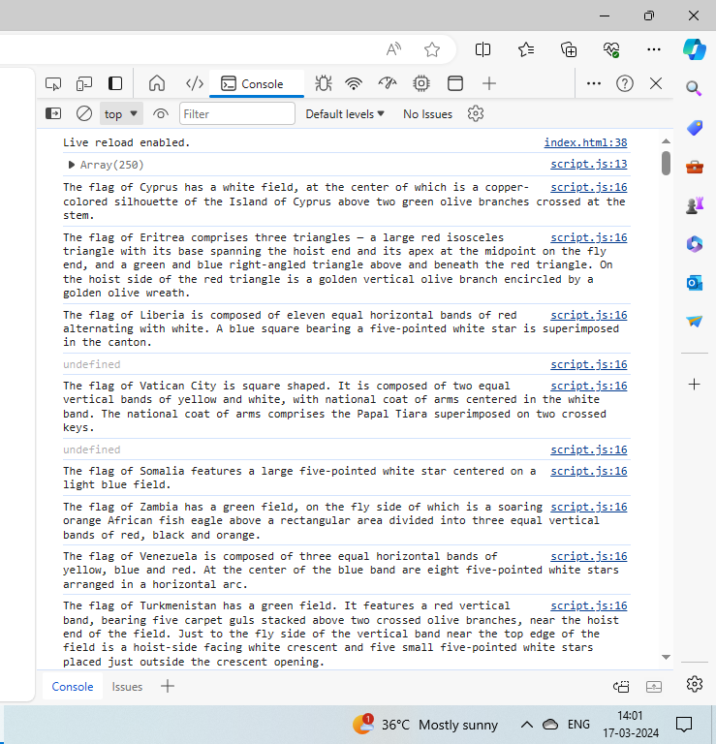

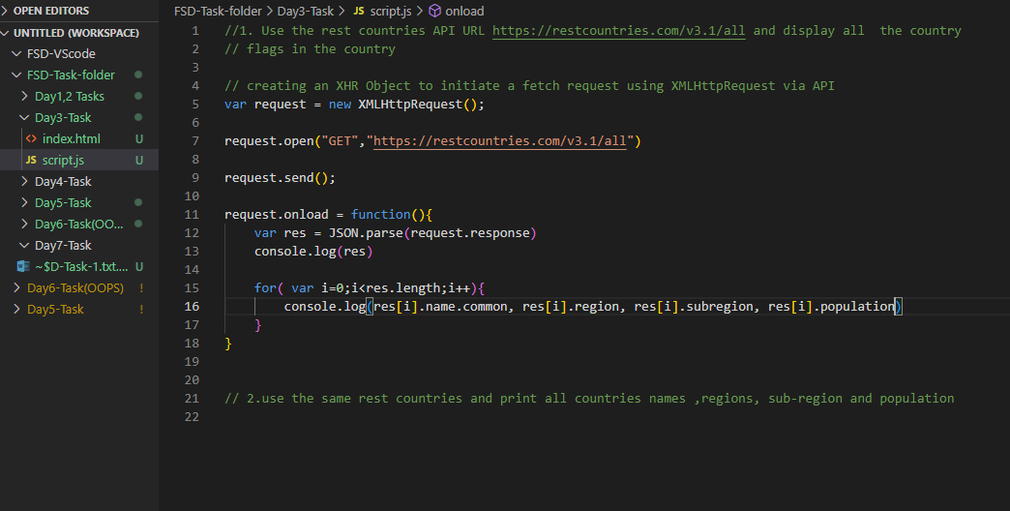

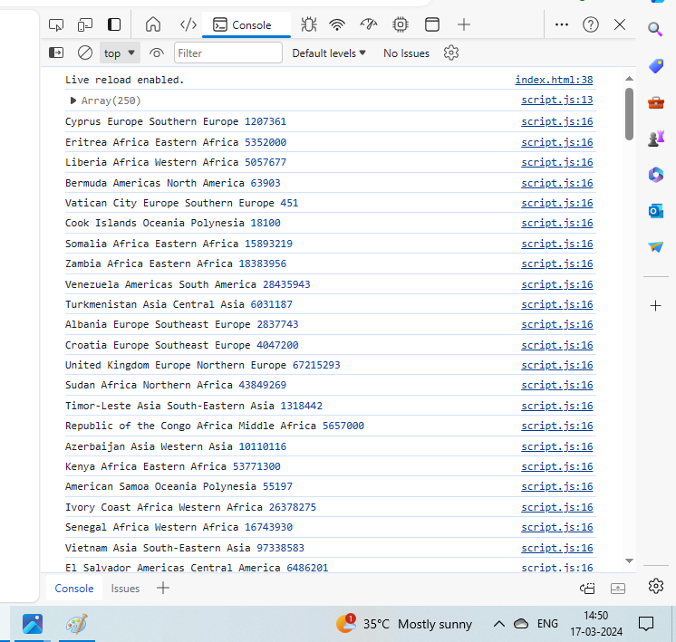

**3.How to compare to two JSON having same properties without order?**

var obj1 = {name: “Aadhya”, age: 10}

var obj2 = {age: 10, name: “Aadhya”}

This can be done by **Lodash** JavaScript library.

console.log(_.isEqual(obj1,obj2))

<script type="text/JavaScript" src = “https://cdn.jsdelivr.net/npm/lodash@4.17.20/lodash.min.js”></script>