Contents
Contents 2
1 Project Goals and Related Documents 4
Project Targets 4
Assumptions 4
Related Documents 4
2 High Level Architecture Implementation 5
2.1 Various NVMe Fabric System Configuration Examples (with respect to the NVMe drivers) 5
3 Various Design Features 8
3.1 Parameter Values and States Exposed by the Drivers in the Filesystem 8
3.2 API and .h files 10
3.3 configuration file 10
3.4 Discovery Sequence and Fabric Agnostic Commands Related to Discovery 11
3.5 Shutdown Sequence and Fabric Agnostic Commands Related to Shutdown 14
3.6 lsnvme 14

Revision History

Revision Number | Description | Name | Revision Date
0.1 | Started; semi-formally capturing all the 'stuff' being thrown around | jpf | March 3, 2015
0.2

Project Goals and Related Documents

Project Targets
- Primary goal is to push an nvme-fabric solution upstream into the mainline Linux kernel.
- The starting kernel target is the 3.19.0 and will be sync'ed with the mainline upstream on occasion.
- Initial fabric target is the RDMA solution found in the Linux kernel source, but a second fabric will be targeted to test the flexibility and maintainability of the code solution (what this second solution will be is TBD)
- Secondary goal is to backport the fabric solution to older kernels.

Assumptions
- For the initial design goal, there is a 1-to-1 mapping between an NVMe fabric target and physical NVMe device controller.
- For the initial design goal, there is a 1-to-1 mapping between an NVMe host fabric and NVMe target fabric.

Future Patches/Revisions After Initial Submission
- Backport initial solution to work with 3.18 and earlier kernels (bio block, not blk-mq being used starting in blk-mq).
- OmniPath, PCIe fabric drivers
- optimization on more comprehensive 'target end-to-end fastpath'
- Active-Active multipath from the fabric host. Multipath in this case is a fabric host being able to talk to a fabric target through two separate ports (but this phased in on a future release).
- lsnvme

Related Documents
- 1.2 NVMe specification, November 3, 2014
- NVMe Org proposal “Fabrics TP 002”

High Level Architecture Implementation

Various NVMe Fabric System Configuration Examples (with respect to the NVMe drivers)

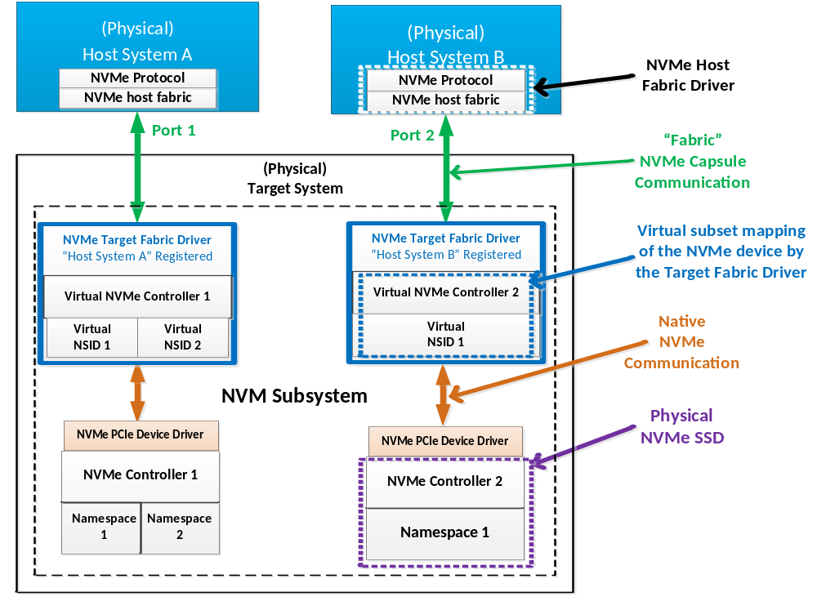
Figure 1: Basic NVMe Fabric System Setup in Which a Single Host Connects to a Single Target Through its Own Port Connection

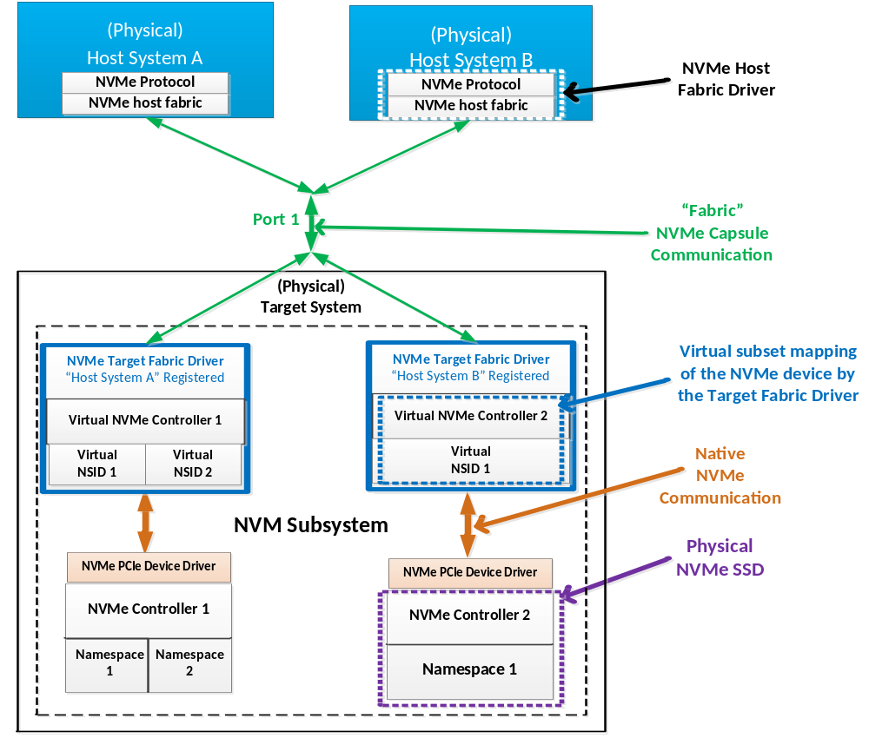
Figure 2: A NVMe Fabric System Setup in Which a Single Host Connects to a Single Target Through a Shared Port Connection of the Target System.

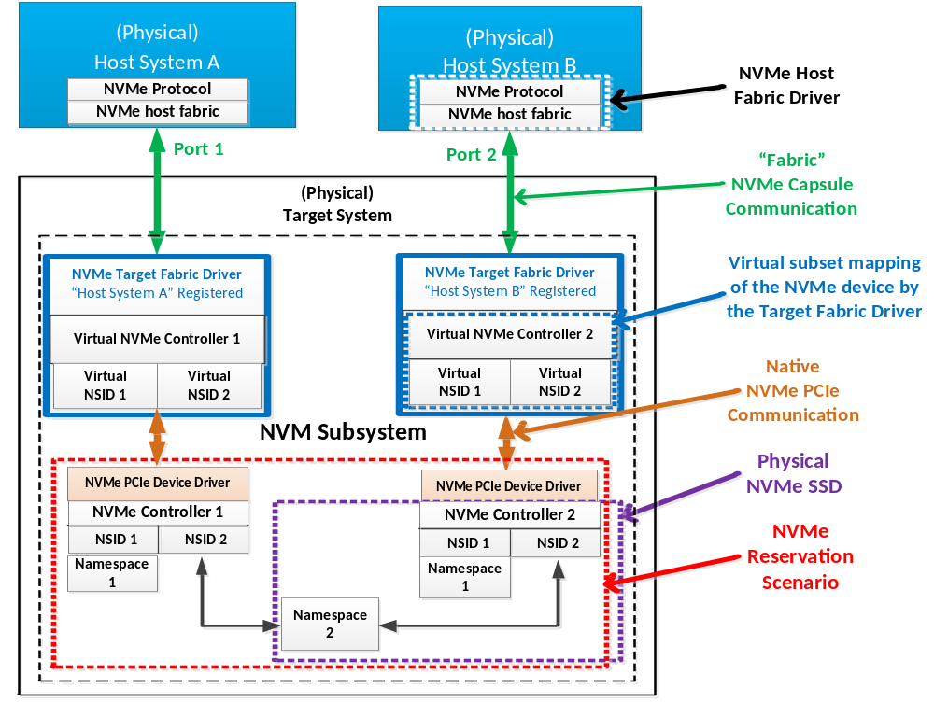
Figure 3: A NVMe Fabric System Setup in Which a Single Host is Attached to a Single Target in Which the Targets are Managing an NVM Subsystem with a NVMe Reservation Configuration

Various Design Features

Parameter Values and States Exposed by the Drivers in the Filesystem
Each driver module in Linux can have a number of parameters and values found by traversing the filesystem:

[jpfreyen@jpfreyen-mobl5 keyboard]$ pwd
/sys/module/keyboard
[jpfreyen@jpfreyen-mobl5 keyboard]$ ls
parameters uevent
[jpfreyen@jpfreyen-mobl5 keyboard]$ cd parameters/
[jpfreyen@jpfreyen-mobl5 parameters]$ ls *
brl_nbchords brl_timeout
[jpfreyen@jpfreyen-mobl5 parameters]$ cat brl_timeout
300
[jpfreyen@jpfreyen-mobl5 parameters]$

This is a list of the parameters and values to be dumped out to the filesystem for tools, statistics, and analysis.

Host Driver
- hostname: qualified unique name based on iSCSI RFC 7143 (https://tools.ietf.org/html/rfc7143#page-232). Default name if one is not provided is: TBD...
- fabric: Type of fabric being used. This will either be a string in human-readable form (“pcie”, “rdma”, etc) or the values of an enum describing the types (0 for pcie fabric, 1 for rdma fabric).
- timeout: Number of seconds the host should try and wait for a successful response with an NVMe device until it fails during discovery. If this is 0, timeout is disabled and will fail immediately on first attempt.
- admin_timeout: Number of seconds host should wait for a NVMe admin command response until it times out. If this is 0, timeout is disabled and host will fail immediately upon first detection of trouble.
- io_timeout: Number of seconds host should wait for a NVMe IO command response until it times out. If this is 0, timeout is disable and host will fail immediately upon first detection of trouble.
- legacymode: If 0, the host fabric driver is in a 3.19 and higher Linux kernel using the blk_mq struct introduced into the 3.19 kernel. If 1, the host fabric driver is in a 3.18 and below Linux kernel solution using the bio struct.
- num_ioq: Number of NVMe IO queues established with the NVMe target fabric. This is a read-only field and can not be overwritten by any Linux command-line tricks (example: echo 1 > num_ioq won't work)
- discover_addr: The discovery IP4 address being used to discover the NVMe target devices.
- num_controllers: Number of controllers reported by the NVMe target.
- num_namespaces: Number of namespaces reported by the NVMe target.

Target Driver
- targetname- qualified unique name based on iSCSI RFC 7143 (https://tools.ietf.org/html/rfc7143#page-232). Default name if a name is not provided for it is: TBD...
- fabric- Type of fabric being used. This will either be a string in human-readable form (“pcie”, “rdma”, etc) or the values of an enum describing the types (0 for pcie fabric, 1 for rdma fabric).
- timeout- Number of seconds the target should wait for a response from an NVMe device. If this parameter is 0, then the NVMe fabric target shall never timeout.
- legacymode- If 0, the host fabric driver is in a 3.19 and higher Linux kernel using the blk_mq struct introduced into the 3.19 kernel. If 1, the host fabric driver is in a 3.18 and below Linux kernel solution using the bio struct.
- nvmsubsystem1...nvmsubsystem[n]- One entry is added to sysfs for each NVM subsystem discovered by the NVMe fabric target which contains the name of the NVM discovered.
- num_controllers- Number of controllers discovered by the NVMe fabric target.
- num_namespaces- Number of namespaces discovered by the NVMe fabric target.

debugfs
debugfs can be used to expose more internal driver signals and values for debugging and validation purposes. (This is a strong hint to use this Linux kernel feature for the drivers). Some of the parameters mentioned above may be exposed via debugfs (like nvmsubsystem1 for example), this is TDB...

Some proposed debug variables:
- state: discover, running, shutdown

API and .h files
For NVMe host function prototypes and defines, please see nvme-common.h and nvme-fabrics.h.

For NVMe target function prototypes and defines, please see nvme-common.h, nvme-fabrics.h and nvme-target.h(??).

configuration file
Both the NVMe host and the NVMe target can use a configuration file to know things like what hosts can configure to targets and what IP addresses should be used.

NVMe Target Configuration File
Target looks at a file that contains:
- list of NVMe Fabric hostnames that will be allowed to connect to it.
- list of the subsystem names on the target machine
- for each nvme controller in that subsystem there will be a port address for that controller
- a tuple will be listed, (x,y) first parameter the type of fabric being used by the controller, second parameter the port addresses
- if x == RDMA, y == IP4 or IP6 address
- if x == ROCE, y == MAC address
- if x == INFINIBAND, y == Infiniband address (GUID)
- if x == FIBRECHANNEL, y == wwn (world wide name) or wwpn (world wide port name)

A possible example of a target configuration file:

# authorized hostnames allowed to connect to target
hostname eui.020000023B040506
hostname org.nvmexpress.bonzai

# list of subsystem names on the target machine
subsystem org.nvmexpress.nexus
subsystem org.nvmexpress.nebula

# Each controller is connected with it's own port address.
# Note the unique controller identifiers are part of the NVMe Identify
# data structure that is returned. See figure 37 of the 1.2 spec.
controller 1 NVME_FABRIC_RDMA 192.168.1.3
controller 2 NVME_FABRIC_RDMA 192.168.15.3

NVMe Host Configuration File
Host has a configuration file that contains:
- it's name
- the fabric it is supposed to use for the system
- the IP address used for the discovery sequence (the fabric host stops using this address once the discovery sequence is complete).

If no hostname or IP address is defined, the hostname will default to the following name and IP address:

TBD TBD

Possible example host configuration file:

# name of this host and the IP address that will be used on discovery
hostname org.nvmexpress.bonzai NVME_FABRIC_RDMA 192.16.2.6

Discovery Sequence and Fabric Agnostic Commands Related to Discovery
The following is the initial discovery sequence proposal. This sequence is the initialization/startup of an entire NVMe fabric system. Note this sequence depends on the use of newly defined fabric agnostic commands:

NVMF_LOGIN(HOSTNAME): Used by host to issue a login request to fabric target. Target sends 'OK' or 'FAIL' in return ('FAIL' can occur if hostname does not match with the list of hostnames the target maintains for legal connection).

NVMF_DISCOVER(HOSTNAME): Used by host to initiate a fabric target discovery of NVMe resources. If successful, the target will send a number representing the number of bytes that will be sent on a NVMF_REQ_CTRL_ADDR(HOSTNAME) command. Otherwise the target sends 0 back on error (like hostname did not match, for example). If the target is using default values instead of the target configuration file, then the byte size returned by the target is TBD.

NVMF_REQ_CTRL_ADDR(HOSTNAME): Host requests a list of all the NVMe controllers and their network addresses discovered by the NVMe fabric target. Specifically, the host is retrieving this part of the target configuration file:

controller 1 NVME_FABRIC_RDMA 192.168.1.3

If the target is using default configuration and not a configuration file, the fabric target sends a transmission of the network address values in the format of the target configuration file. Target sends an empty packet of size 0 on error (like the hostname did not match the list of legal hostnames defined in the target fabric configuration file). The host will fail this command if the fabric specified by the target does not match the fabric specified in the host (via its configuration file or default case if there is no configuration file).

NVMF_CONNECT(HOSTNAME, NETWORK ADDRESS): Host authentication login to an NVMe controller discovered by the fabric target. NVMe controller resource on the target machine will send OK or FAIL back to the host.

Discover system initialization sequence:

- Host fabric driver registers itself with the Linux kernel through a sysfs init function.
- host will read the config file for it's name and IP address. If either are not there, host will use default name and IP address.
- Host takes IP address from configuration file and does address/route resolution (validate the IP address). If there is an error, host will fall back and try the default IP address.
- Host creates a queue structure for initial communication connection to target
- If this is RDMA, host creates a queue-pair (sq/rq) and separately, a completion queue
- Host establishes connection to target (and will fail if time it takes to establish connection exceeds any timeout parameter value).
- Target accepts initial connection
- Host sends NVMF_LOGIN(HOSTNAME) command. Target responds OK or FAIL.
- Host sends NVMF_DISCOVER(HOSTNAME). Target sends back appropriate response (see definition of command above).
- Host will post a receive with big enough memory space to contain the network address list of all the controllers discovered by the fabric target.
- Host sends NVMF_REQ_CTRL_ADDR(HOSTNAME). Target sends back a list of all the controllers and their network addresses.
- Host logs out from the NVMF_LOGIN(HOST) command. Host tears down whatever queue structure used for the initial connection.
- This initial connection cannot be reused because this is a specific connection not related to NVMe command capsule formats that will be defined in the NVMe standard).

- (Setting up Admin/FabricCmd queue): For each network fabric address that is related to a controller on the target, the host:
- Host creates a queue pair (fabric-specific) for the NVMe Admin queue.
- Host sends NVMF_CONNECT(HOSTNAME, NETWORK ADDRESS) to controller.

===== Note at this point forward NVMe command capsules are used ======

- Host may need to read a CC or other controller register values the target exposes via NVMe register read commands (NVMe Express Committee proposal).
- Host sends NVMe Identify Controller (via cmd capsule).
- Host sends N NVMe Identify Namespace commands (via cmd capsule) where N is the nn (Number of Namespaces) value returned from NVMe Identify Controller data structure.
- Host sends NVMe Set Features: Set Interrupt Coalescing and turns this off (set to all 0's).
- Host sends NVMe Set Features: Set number of Queues, where # of queues = # of cpu cores on the fabric host machine.
- Question: Not sure how this will work for multiple controllers...would host need to divvy up the number of cpu cores and make each subset of cpu cores dedicated to a single controller, or are all cpu cores shared by all controllers?
- Host sends NVMe Create Submission Queues, with number of queues to be created based on the returned value of NVMe Set Features: Number of Queues.
- Host sends NVMe Create Completion Queues, with number of queues to be created based on the returned value of NVMe Set Features: Number of Queues.
- call setcapacity() linux kernel function and call add_disk() for each namespace to create and expose an actual drive on the host.

Shutdown Sequence and Fabric Agnostic Commands Related to Shutdown
A proper shutdown sequence is needed to bring the system into a stable state with minimum opportunity of data loss or corruption.

NVMF_DISCONNECT(HOSTNAME, NETWORK ADDRESS): Host disconnects itself from an NVMe controller resource exposed by the fabric target. What else does this do, like tear down NVMe queues??

This sequence is as follows: TBD

lsnvme
lsnvme uses information in sysfs to list NVMe devices (nvme-fabrics or PCIe specific devices) currently attached to the system. This command would be just like the Linux command-line lsscsi. Some initial things this command could list out:
- default (no command-line options): List out all nvme devices attached to the system, their iSCSI RFC 7143-like name (if available), and their sizes.
- -f, --fabric: List out the type of fabric (or transport) being used by each NVMe device attached to the system.
- -H, --hosts: List out the hosts attached to this system
- -T, --targets: List out the targets attached to the system.
- -s, --size: When printing out capacity, print in easier, human readable form (in GB??).
- -V, --version: Lists out version information of lsnvme then quits.

