**POTPOURRI**

Web architecture is a conceptual structure. The World Wide Web (WWW, W3, the Web) is an interconnected system of public web pages accessible through the Internet. The Internet is a global network of networks. The following four-part series looks inside a modern web browser.

(Press and hold ctrl and then click any hyperlink to open that link in a new tab)

[Inside look at modern web browser (part 1)](https://developer.chrome.com/blog/inside-browser-part1/)

[Inside look at modern web browser (part 2)](https://developer.chrome.com/blog/inside-browser-part2/)

[Inside look at modern web browser (part 3)](https://developer.chrome.com/blog/inside-browser-part3/)

[Inside look at modern web browser (part 4)](https://developer.chrome.com/blog/inside-browser-part4)

**Web Security**

**Browser architecture, writing secure code.**

[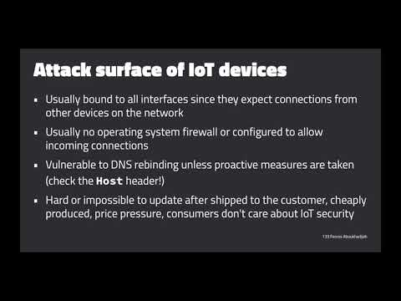](https://www.youtube.com/embed/5aguccOpGes?list=PL1y1iaEtjSYiiSGVlL1cHsXN_kvJOOhu-)

(Stanford, Feross Aboukhadijeh)

[Statistics](https://ia600106.us.archive.org/3/items/ucberkeley_webcast_itunesu_354822870/05.%202009-09-10%20-%20Lecture%205%3A%20Correlation%252fMore%20Correlation.mp4)

(UC Berkeley, Fletcher Hank Ibser)

[Multivariable Calculus](https://ia801003.us.archive.org/24/items/ucberkeley_webcast_itunesu_354823115/30.%202009-12-08%20-%20Lecture%2030.mp4)

(UC Berkeley, Edward Frenkel)

**Physics**

**Vibrations and Waves.**

[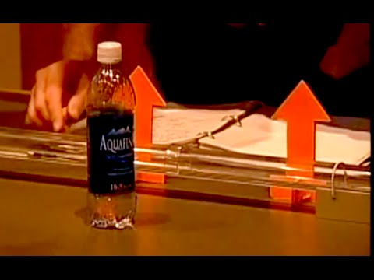](https://www.youtube.com/embed/hElGpHTo-80?feature=oembed)

(MIT, Walter Lewin)

**Electronic Feedback Systems**

**Model Train Speed Control.**

**[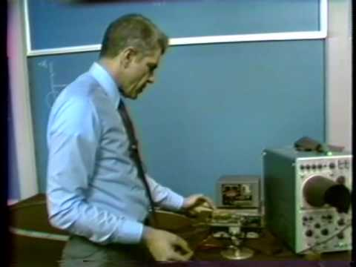](https://www.youtube.com/embed/uHtKGf4AymM?list=PLUl4u3cNGP62in17jH_DiJMkCGNM6Xni-)**

(MIT, James K. Roberge)

**Quantum Physics**

**Experimental Facts of Life.**

[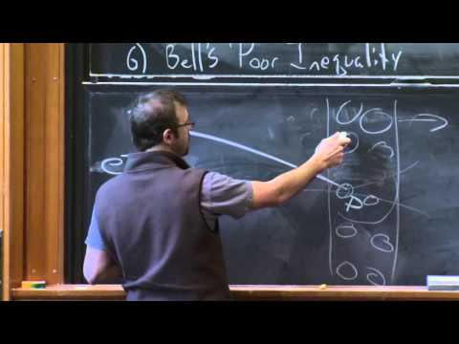](https://www.youtube.com/embed/U6fI3brP8V4?feature=oembed)

(MIT, Allan Adams)