Solutions to The smallest 2d Ising model

- Since we have N=4 spins, each of which can have 2 values (up and down), we have a total number of 2^{N} = 2⁴ = 16 distinct microstates. Note that this number is completely independent of how the spins are arranged (how many neighbors, how many dimensions….).

- These 16 microstates, tabulated with their magnetization, absolute value of magnetization, and energy, are:

++ +- -+ ++ ++ ++ -+ -- +- +- -+ -+ +- -- -- --
++ ++ ++ -+ +- -- -+ ++ +- -+ +- -- -- +- -+ --

M 4 2 2 2 2 0 0 0 0 0 0 -2 -2 -2 -2 -4
|M| 4 2 2 2 2 0 0 0 0 0 0 2 2 2 2 4

E -8J 0 0 0 0 0 0 0 0 8J 8J 0 0 0 0 -8J

Thus we see that there are 3 energy levels: E = -8J with degeneracy 2 (the ground states), E =0 with degeneracy 12, and E = 8J with degeneracy 2. Note that for each microstate, there are 8 distinct bonds to consider in periodic boundary conditions (4 internal, and 4 through periodic images).

- The partition function, Q, is thus the sum of the Boltzmann factors:
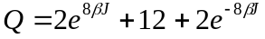.

- The average absolute value of the magnetization <|M|> is the weighted average of |M| over all the microstates of the ensemble. The weights are simply the Boltzmann factors divided by Q, thus:
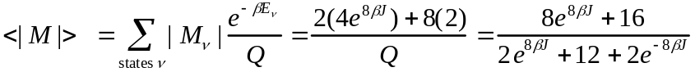

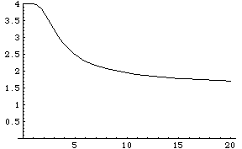
A plot of <|M|> versus T k_{B}/J (from Mathematica) is shown here:

Contrast this with Figure 5.2 in the reading from Chandler’s Introduction to Modern Statistical Mechanics, showing <|M|> vs. T for an infinite Ising magnet. For the infinite case, <|M|> drops to zero sharply at a specific temperature, the critical temperature T_{c}. In contrast, for our 2x2 system, the decrease in <|M|> is smooth, even though there is a characteristic temperature range around T = 3-5 J/k_{B} where most of the decrease in <|M|> occurs. Thus we don’t have a “sharp phase transition”, as this can only occur in the infinite system, where we have a divergence in the domain size at the critical point. Furthermore, at high temperatures, <|M|> -> 3/2, rather than zero as in the infinite system case, since as T -> infinity, all the Boltzmann factors approach one, and all the microstates are equally probable, and <|M|> is a uniform average over all 16 microstates, giving a non-zero value for <|M|>. At T=0, we find that <|M|>=4, consistent with the fact that at zero temperature, the system is found in the ground states with lowest energy, both of which have |M| = 4.

- As can be seen from the table above, there are 5 values of M: -4, -2, 0, 2, 4.

- For each value of M, we sum the Boltzmann factors for microstates having that value of M to get Q(M) (from which we get A(M) = -k_{B}T lnQ(M) ). Thus, we find:

++ +- -+ ++ ++ ++ -+ -- +- +- -+ -+ +- -- -- --
++ ++ ++ -+ +- -- -+ ++ +- -+ +- -- -- +- -+ --

M 4 2 2 2 2 0 0 0 0 0 0 -2 -2 -2 -2 -4
|M| 4 2 2 2 2 0 0 0 0 0 0 2 2 2 2 4

E -8J 0 0 0 0 0 0 0 0 8J 8J 0 0 0 0 -8J

Q(M)=
exp(8βJ) 4 4 + 2 exp(-8βJ) 4 exp(8βJ)

A(M)=
-8J -k_{B}T ln 4 -k_{B}T ln[4 + 2 exp(-8βJ)] -k_{B}T ln 4 -8J

Notice that for A(M=-4) = -8J = E(M=-4), since there is only one microstate with M=-4, and hence S(M=-4) = k_{B} ln(1) = 0, i.e., A = E - T S = E here. For M = -2, A = -T S, since E = 0, and S = k_{B} ln(4). For M = 0, we have 6 microstates, 2 of which have a higher energy than the other 4. Thus A here will be a complex function of T, since both energy and entropy contribute. (For M>0, the same reasoning as above applies.)

- At T = 0, A(M) = -8J, 0, 0, 0, -8J.
The lowest value of A occurs at M = -4 and M = 4.
As T -> infinity, A(M) -> -8J, - k_{B}T ln 4, - k_{B}T ln 6, - k_{B}T ln 4, -8J
The lowest value of A occurs at M = 0 (in the limit of large T).

In other words, at T = 0, energy dominates, and the lowest energy states have the lowest free energy. At high temperatures, entropy dominates, and the 6 microstates making up the M = 0 level dominate. This can be seen in the following graph plotting A(M) versus M:

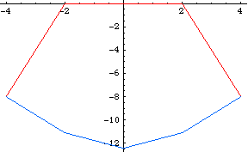
Here the red curve corresponds to T = 0, and the blue curve corresponds to T = 8 J/k_{B}. As T increase beyond 8, the blue curve continues to drop. (For the figure, J=1.)

- From the table of values for A(M) above, we see that A(M=0) is always less than A(M=-2) or A(M=2). Thus the minimum switches from M=-4 or M=4 at low temperatures to M=0 at high temperatures. This switch occurs at

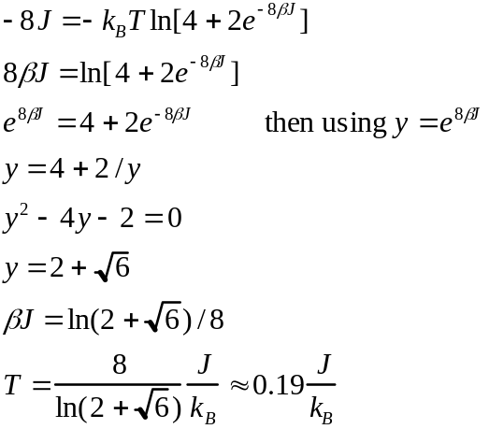
The critical temperature for the infinite Ising magnet is T_{c} = 2.269 J/k_{B}. Thus, the finite 2x2 system favors zero magnetization at much lower temperatures than the infinite system.

- The energy of coupling to an external field is E_{field} = -MμH. This is just linear in M, and adds to the energies above. Since A = E - TS, it also adds directly (linearly) to the free energy A as well. (This can also be verified by directly substituting the new energies into the equation for A(M) .) In particular, we find

A(M)=
-8J-4μΗ -k_{B}Tln(4)-2μΗ -k_{B}Tln[4+2exp(-8βJ)] -k_{B}Tln(4)+2μΗ -8J+4μΗ

In this case, the curve for A(M) shifts slightly in the direction that the field favors, e.g. causing the minimum at M=4 to be lower than that at M=-4 (for μΗ <0). Nonetheless, at high enough T, the lowest minimum will occur at M=0.

