# Kronig-Penney Model

## Objectives:

* To draw vs. curves, with a, b, U0 as parameters.
* To draw E-k diagrams, both extended and folded.

# Procedure:

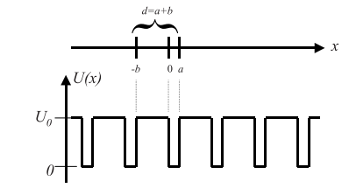

The curves are obtained by solving the following equation:

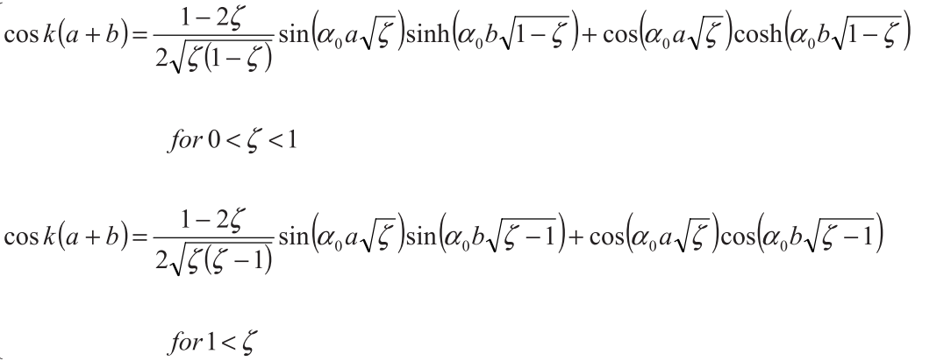

Where,

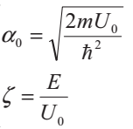

## Results:

### For U0=1 eV, a=3 Å, b=6 Å :

#### vs. :



#### E-k diagram (reduced zone):



#### E-k diagram (extended zone):



### For U0=1.5 eV, a=3 Å, b=6 Å :

#### vs. :



#### E-k diagram (reduced zone):



#### E-k diagram (extended zone):



### For U0=1 eV, a=1.5 Å, b=6 Å :

#### vs. :



#### E-k diagram (reduced zone):



#### E-k diagram (extended zone):



### For U0=1 eV, a=3 Å, b=4 Å :

#### vs. :



#### E-k diagram (reduced zone):



#### E-k diagram (extended zone):



## Conclusions:

### General Observations:

* Band width increases and band-gap decreases with higher energy.
* Effective mass decreases for higher energy bands and E-k relationship becomes from parabolic to v-shaped (or inverted v-shaped).

### Observations made by varying parameters:

* Increasing height of the potential wells U0 causes increase in band-gap and decrease in band-width for all bands. Effective masses also increase.
* Decreasing width of the potential wells a causes increase in band-width for lower energy bands. It also increases band-gap for higher energy bands (that are otherwise close together). Effective mass in lower energy bands decreases.
* Decreasing the separation among potential wells b causes increase in band-width for lower energy bands (in this case the first band). However, it decreases band-gap for higher energy bands .Effective mass in lower energy bands decreases.