The Sentimen Evaluation of Customer Review in Las Vegas City Restaurants

Pozy Pak Ya

October 22, 2015

This is an R Markdown document. Markdown is a simple formatting syntax for authoring HTML, PDF, and MS Word documents. For more details on using R Markdown see <http://rmarkdown.rstudio.com>.

When you click the **Knit** button a document will be generated that includes both content as well as the output of any embedded R code chunks within the document. You can embed an R code chunk like this:

summary(cars)

## speed dist   
## Min. : 4.0 Min. : 2.00   
## 1st Qu.:12.0 1st Qu.: 26.00   
## Median :15.0 Median : 36.00   
## Mean :15.4 Mean : 42.98   
## 3rd Qu.:19.0 3rd Qu.: 56.00   
## Max. :25.0 Max. :120.00

summary(airquality)

## Ozone Solar.R Wind Temp   
## Min. : 1.00 Min. : 7.0 Min. : 1.700 Min. :56.00   
## 1st Qu.: 18.00 1st Qu.:115.8 1st Qu.: 7.400 1st Qu.:72.00   
## Median : 31.50 Median :205.0 Median : 9.700 Median :79.00   
## Mean : 42.13 Mean :185.9 Mean : 9.958 Mean :77.88   
## 3rd Qu.: 63.25 3rd Qu.:258.8 3rd Qu.:11.500 3rd Qu.:85.00   
## Max. :168.00 Max. :334.0 Max. :20.700 Max. :97.00   
## NA's :37 NA's :7   
## Month Day   
## Min. :5.000 Min. : 1.0   
## 1st Qu.:6.000 1st Qu.: 8.0   
## Median :7.000 Median :16.0   
## Mean :6.993 Mean :15.8   
## 3rd Qu.:8.000 3rd Qu.:23.0   
## Max. :9.000 Max. :31.0   
##

You can also embed plots, for example:

## Warning: package 'png' was built under R version 3.2.2

## png   
## 2

## png   
## 2

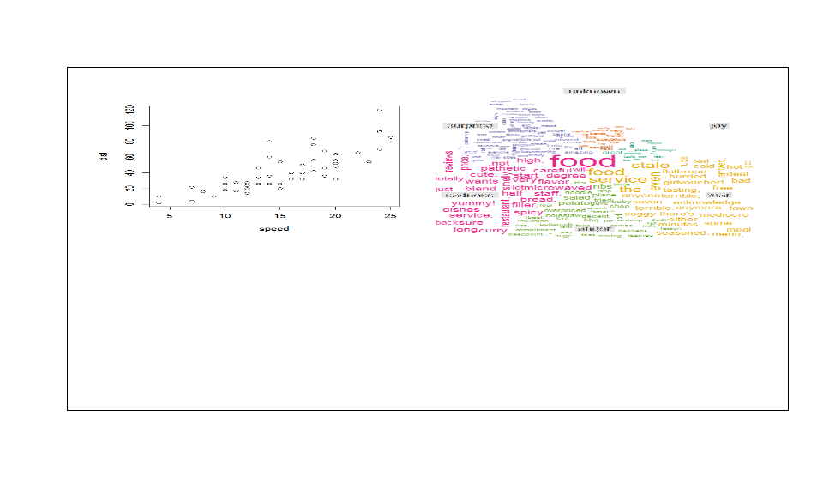

Note that the echo = FALSE parameter was added to the code chunk to prevent printing of the R code that generated the plot.