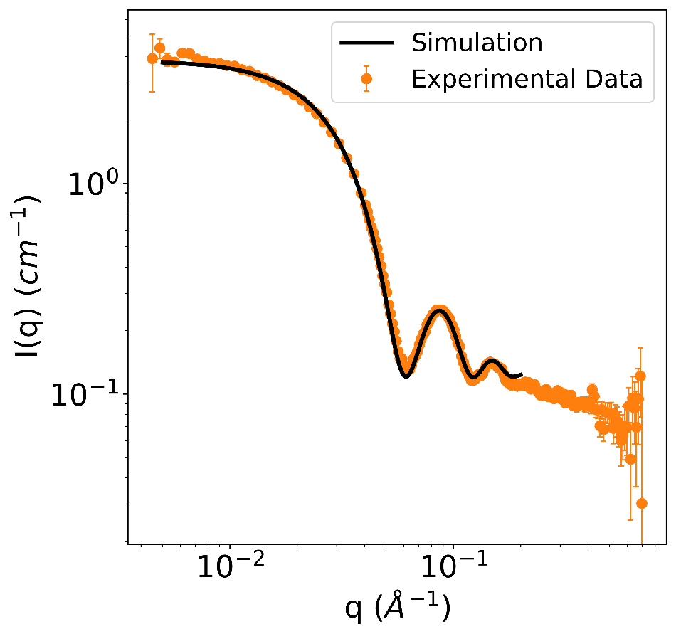
Figure 1. Experimental data for the dissolved HuHF crystals and the simulated data from the atomic coordinates of the ferritin cage structure.

The experimental scattering from the dissolved HuHF crystals is compared with the simulated ferritin cage structure. The simulated SANS data of the dissolved crystals was obtained by first extracting all the atom positions of the ferratin cage structure from its PDB file. The scattering length density of all the atoms in the cage were assumed to be $2×{10}^{-6}Å^{-2}$ while the deuterium oxide solvent was $6.35×{10}^{-6}Å^{-2}$. The scattering curve was then calculated using a Monte Carlo approximation of the Debye scattering equation [1]. The scattering curve was then multiplied by a scale parameter of $2.2×{10}^{-6}$ and added to a constant background term of $1.2×{10}^{-1}$ to account for the incoherent scattering of hydrogen atoms in the protein. The resulting simulated scattering curve was then plotted with the experimental one as shown in Figure 1, showing good agreement.

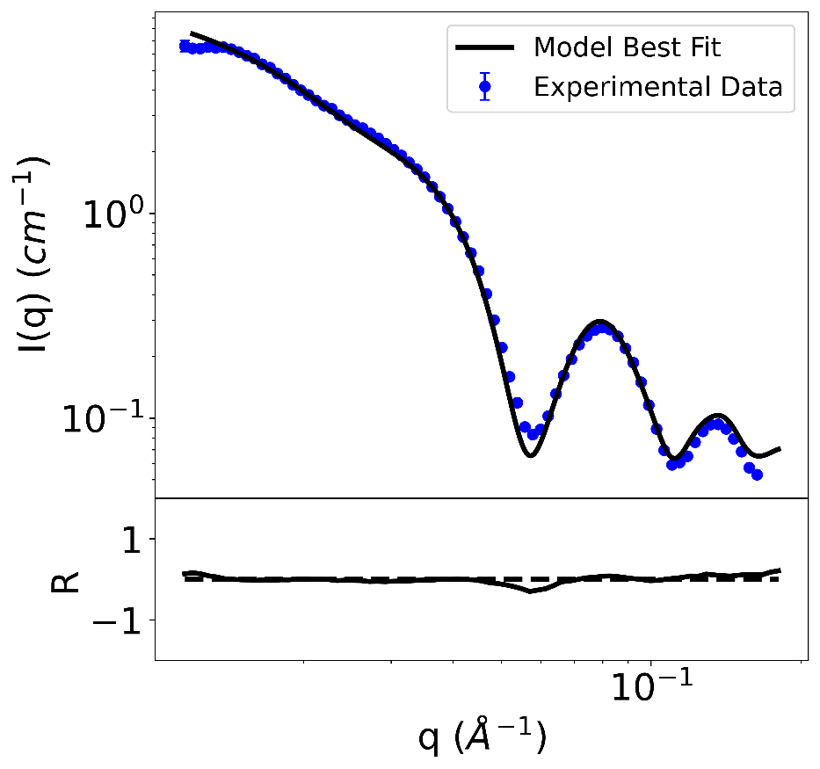
Figure 2. Experimental data for the dissolved HuHF-PIX and the fitted data of the model of the ferritin cage dimer.
To fit the experimental data of the HuHF-PIX dissolved in deuterium oxide, a model consisting of the ferratin cage monomer and a ferratin cage dimer was used. The atomic coordinates of the ferritin cage were retrieved from the PDB file, and dimers were generated by duplicating the cage and placing the copy at a separation distance, determined by a fitting parameter, away from the original structure. Additional fitting parameters include the proportion of dimers in the solution, the incoherent background, and the scale parameter. Next, initial guesses for these fit parameters were applied to create the dimer model, and its scattering curve was simulated using the same Monte Carlo approximation of the Debye Equation. This results in two scattering curves, one for the ferritin cage monomer and one for the dimer. The curves were then scaled so that the invariant of the dimer was two times the invariant of the monomer, and a weighted sum was calculated based on the fit parameter for the proportion of dimers in the solution. The resulting curve was then compared to the experimental one using the log mean-squared error and the similarity score was sent to a fitting algorithm to determine the next set of fit parameters. After several iterations, the best fit parameters were determined to be a ferritin separation distance of 16.5 nm, a dimer proportion of 36%, a background of 0.031 and a scale parameter of $3.3×{10}^{-6}$. The fitted scattering curve shows good agreement with the experimental one as shown in Figure 2.

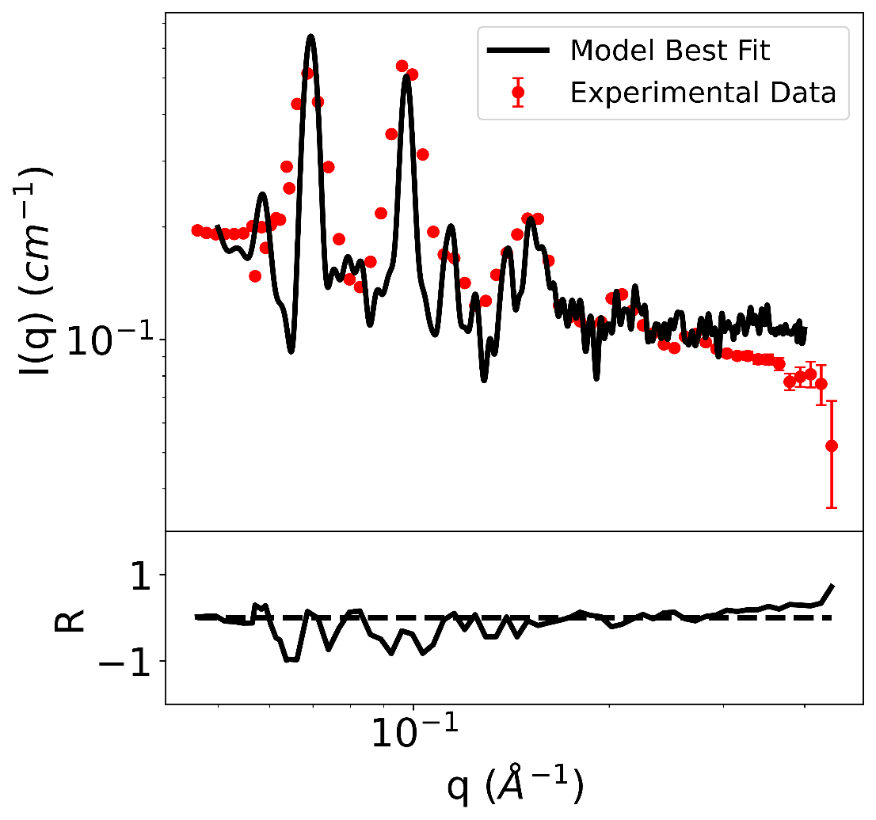
Figure 3. Experimental data of HuHF-PIX and the fitted data of the model of the ferritin crystal in an FCC structure.
To fit the experimental data of HuHF-PIX, a model of ferritin cages arranged in an FCC lattice was constructed, the corresponding scattering curve was simulated and incorporated into a fitting algorithm using the same procedure described in Figure 2. From the fit, the best fit parameters were determined to be an FCC lattice constant of 18.1 nm (d = 12.8 nm), a background of 0.10 and a scale parameter of $4.8×{10}^{-4}$. As shown in Figure 3, there is a reasonable agreement between the simulated data and the experiment in terms of the peak positions and height. The differences in peak broadness and the presence of smaller peaks could be explained by the thermal fluctuations and imperfections in the crystal, that were not accounted for in the model.

References
[1] Huat Thart Chiang, Zhiyin Zhang, Kiran Vaddi, Akif Tezcan, Lilo Pozzo. “Efficient analysis of small-angle scattering curves for large biomolecular assemblies using Monte Carlo methods”. Journal of Applied Crystallography. (2025). 58, 963-975

