Installing Iris dependencies on Ubuntu

Table of Contents
Numpy 2
Scipy 3
Udunits2 4
netcdf4-python 4
netcdf4 4
Pyke 5
gribapi 5
Jasper 5
matplotlib 6
python image library 6
basemap 6
graphviz 7
nose 7
shapely 7
Iris 7
Todo 7

This is a record of how I installed the Iris dependency packages on Ubuntu.

All packages were built from downloaded source (urls provided),
no pre-built binaries were downloaded.

Everything was installed to /usr/local/

Numpy
Numpy is not available from the Ubuntu Sotware Centre, despite being listed at this web page http://packages.ubuntu.com/precise/python/

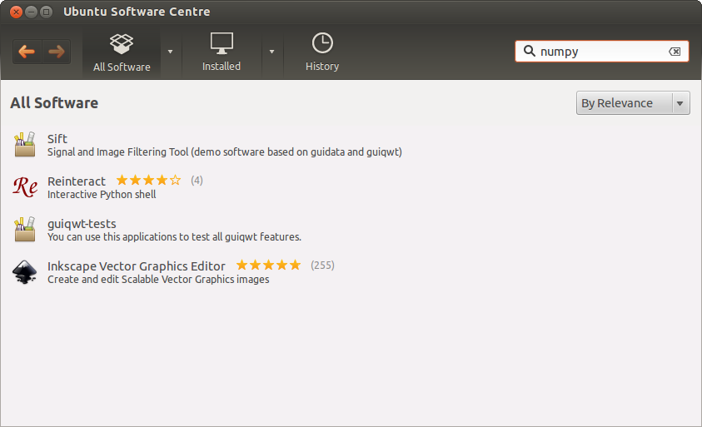
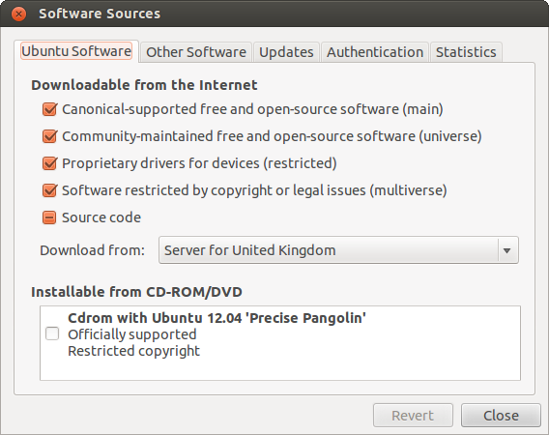
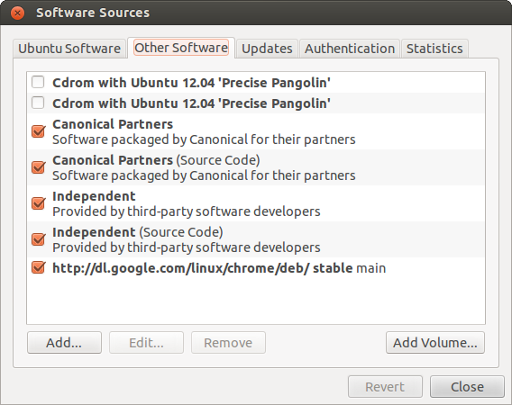
So I installed it like this:

sudo apt-get install python-numpy

Scipy
Again, not available despite being listed on that website.
This fails unless you open a new terminal.

sudo apt-get install python-scipy

Udunits2
This is not even listed on the website so I downloaded it from here http://www.unidata.ucar.edu/downloads/udunits/index.jsp

I unpacked it straight from the browser and entered the folder.

cd udunits-2.1.24/
./configure
make
make check
sudo make install

which informed me the libraries had been installed to /usr/local/lib

netcdf4-python
This is not listed on the website, just python-netcdf, which I assume is not the same.

netcdf4
It requires netcdf4 to be installed first, but before we can build it we need HDF5 from here http://www.hdfgroup.org/ftp/HDF5/current/src/

cd hdf5-1.8.9/
./configure --prefix=/usr/local
make
sudo make install

Now we can build netcdf4, which I downloaded from here ftp://ftp.unidata.ucar.edu/pub/netcdf/

cd netcdf-4.2.1/
./configure --enable -netcdf4
make
sudo make install

and finally netcdf4-python itself, from here http://code.google.com/p/netcdf4-python/downloads/list

cd netCDF4-1.0/
sudo python setup.py install

Pyke
http://sourceforge.net/projects/pyke/

cd pyke-1.1.1/
sudo python setup.py install

gribapi
These flags are needed for 64-bit machines first

export CFLAGS="-fPIC -m64"
export CPPFLAGS="-fPIC -m64"
export YFLAGS="-fPIC -m64"
export FFLAGS="-fPIC -m64"
export FCFLAGS="-fPIC -m64"
export LDFLAGS="-fPIC -m64"

Jasper
I want to be able to process jpeg2000 grib files so I built jasper first.
http://www.ece.uvic.ca/~frodo/jasper/#download

cd jasper-1.900.1/
./configure
make
sudo make install

Now the grib api itself, including the python interface
http://www.ecmwf.int/products/data/software/download/grib_api.html

cd grib_api-1.9.16/
./configure --with-jasper=/usr/local/lib --disable-fortran --enable-python
make
make check
sudo make install
cd python
sudo python setup.py install

I only include the make check step because so much went wrong for me installing this package.

matplotlib

sudo apt-get install python matplotlib

python image library
http://www.pythonware.com/products/pil/

cd Imaging-1.1.7
sudo python setup.py install

basemap
http://sourceforge.net/projects/matplotlib/files/matplotlib-toolkits/

cd basemap-1.0.4
cd geos-3.3.3/
./configure
make
sudo make install
cd ..
sudo python setup.py install

It's worth testing from python at this point with from mpl_toolkits.basemap import Basemap

graphviz
http://www.graphviz.org/Download.php/

cd graphviz-2.28.0
./configure
make
sudo make install

nose
http://pypi.python.org/pypi/nose/

cd nose-1.1.2
sudo python setup.py install

shapely
http://pypi.python.org/pypi/Shapely/#downloads

cd Shapely-1.2.15
sudo python setup.py install

Iris
We can't build Iris without setuptools:

sudo apt-get install python-setuptools

And now the happy moment is upon us:
https://github.com/scitools/iris

cd Iris
python setup.py build
python setup.py test
sudo python setup.py install

Iris develoment

(TBC)

In order for python to run the checked-out branches, rather than the version I downloaded and installed to /usr/local, we have to add our working folder to the front of the PYTHONPATH

In my unix login script:

export PYPTHONPATH=/home/Byron/git/Iris:$PYTHONPATH

Also, we need to build a few things in our working copy when we make a new branch:

python setup.py build_ext

Todo

What about the patches we use at UKMO?
The grib_set_double patch is obviated by the latest grib api.
What about the -ve ft patch, and the pathes for the other packages?

Test I can read a PP file

