Fall 2023 DATA 220 Mathematical Methods for Data Analytics

Homework – 4

Name :- Prayag Nikul Purani

SJSU Id :- 017416737

**Problem 4:**

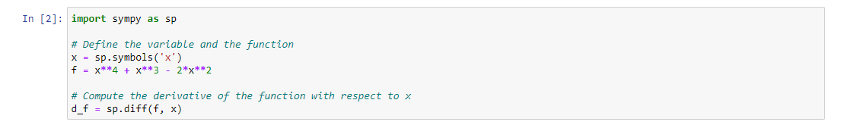

Creating the equation using sympy and the difference the equation

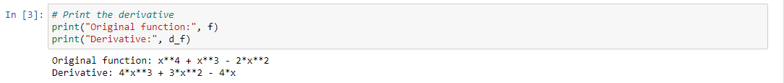

Displaying the both equation

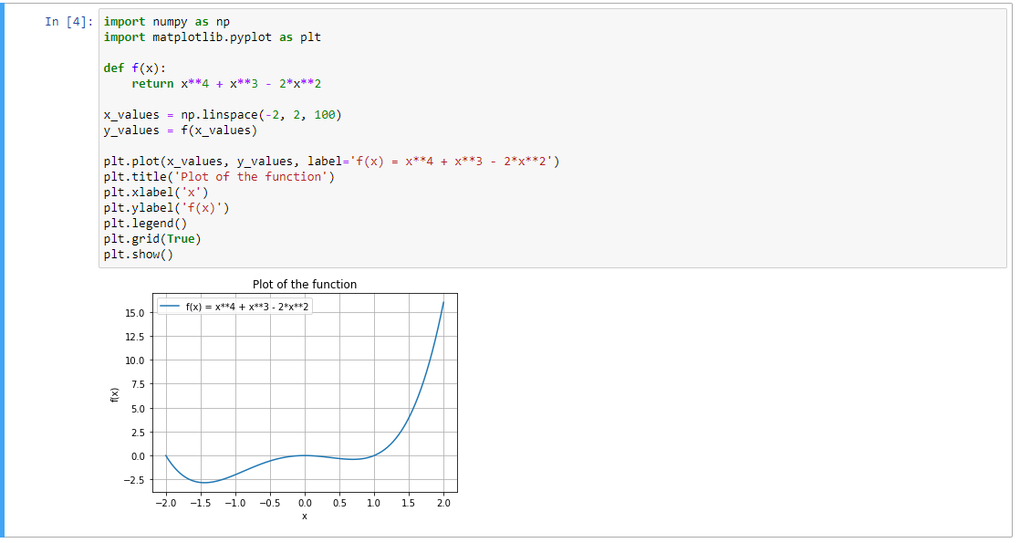

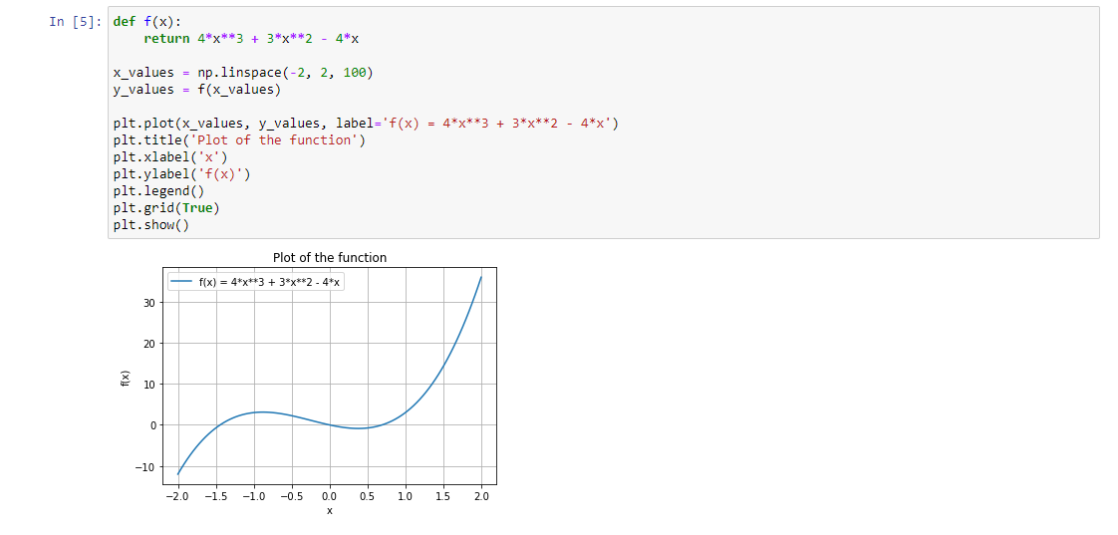

The graph of both equation so we can see how will the function will behave while.

a.

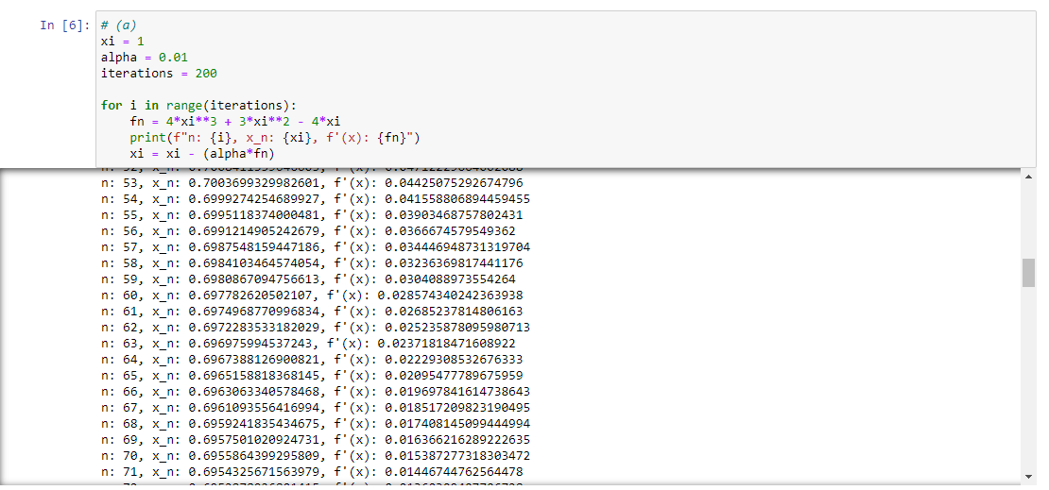

n: 195, x_n: 0.6930017182375595, f'(x): 7.4016973798940455e-06

n: 196, x_n: 0.6930016442205857, f'(x): 6.963440950080724e-06

n: 197, x_n: 0.6930015745861763, f'(x): 6.551133910459583e-06

n: 198, x_n: 0.6930015090748372, f'(x): 6.163239771872497e-06

n: 199, x_n: 0.6930014474424394, f'(x): 5.798313022609136e-06

so we can see that the function is approaching near the zero at x = ~0.69300144 but it is a local minimum that is the reason why we have plot the graph of the function before so come to the conclusion.

b.

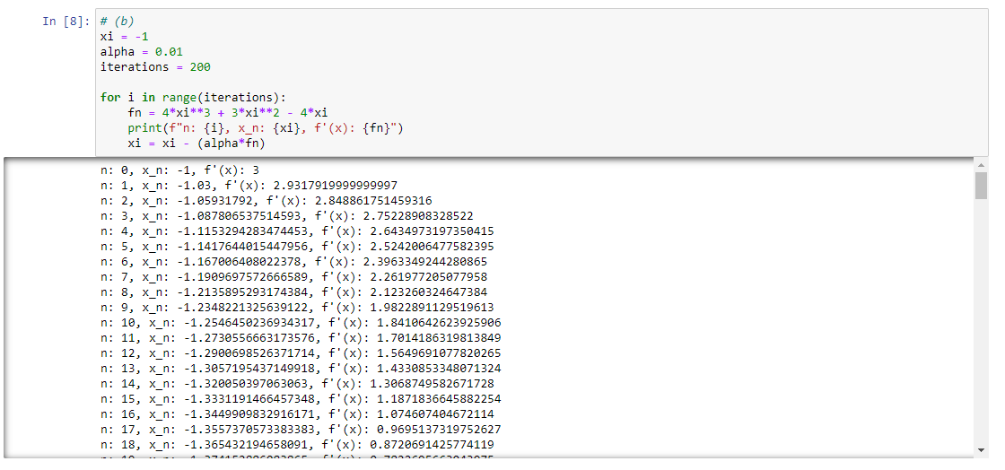

n: 195, x_n: -1.443000468158064, f'(x): 8.170886189873272e-11

n: 196, x_n: -1.443000468158881, f'(x): 7.16360304409136e-11

n: 197, x_n: -1.4430004681595974, f'(x): 6.280487241383526e-11

n: 198, x_n: -1.4430004681602253, f'(x): 5.5062621129309264e-11

n: 199, x_n: -1.443000468160776, f'(x): 4.8272497110701806e-11

So, if the starting point is -1 then the function will reach the global minima and that’s the reason why the starting point very important.

c. So, if we start from x=1 the decent function will reach the minima which local minima but if we start from x= -1 we will reach the global minima and this is the reason why the graph, step-size, starting point are very important factor in the gradient decent function.

**Problem 5:**

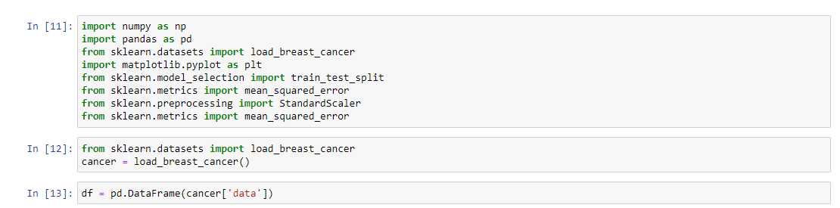

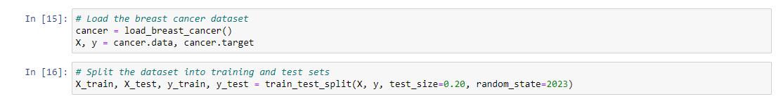

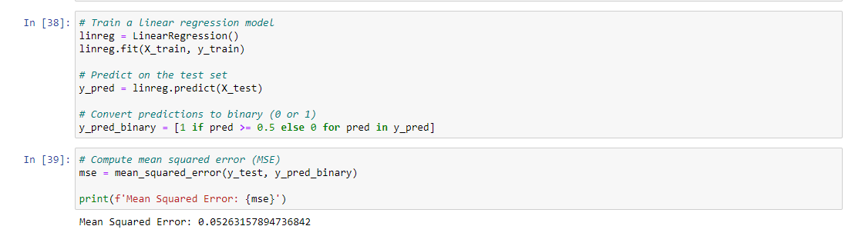

a.

Use the breast cancer dataset for the following tasks: import load_breast_cancer cancer = load_breast_cancer() from sklearn.datasets Allow us to examine the first five observations of the data (𝑋), which correspond to the target variable (𝑦) and thirty characteristics, respectively: Divide the dataset into 80:20 training and test sets, using test_size = 0.20 and random_seed = 2023. The training dataset must be used to train the linear regression model, and the test dataset must be used to calculate the MSE. Apply the optimization technique of gradient descent to do multiple linear regression. For this, you cannot utilize any direct packages. The usual normal distribution should be used to create the starting values of the parameters (intercepts and coefficients). Assign a starting learning rate of 0.001 and a maximum of 100 iterations.

MSE =

🡪

🡪

. .

. .

. .

. .

b.

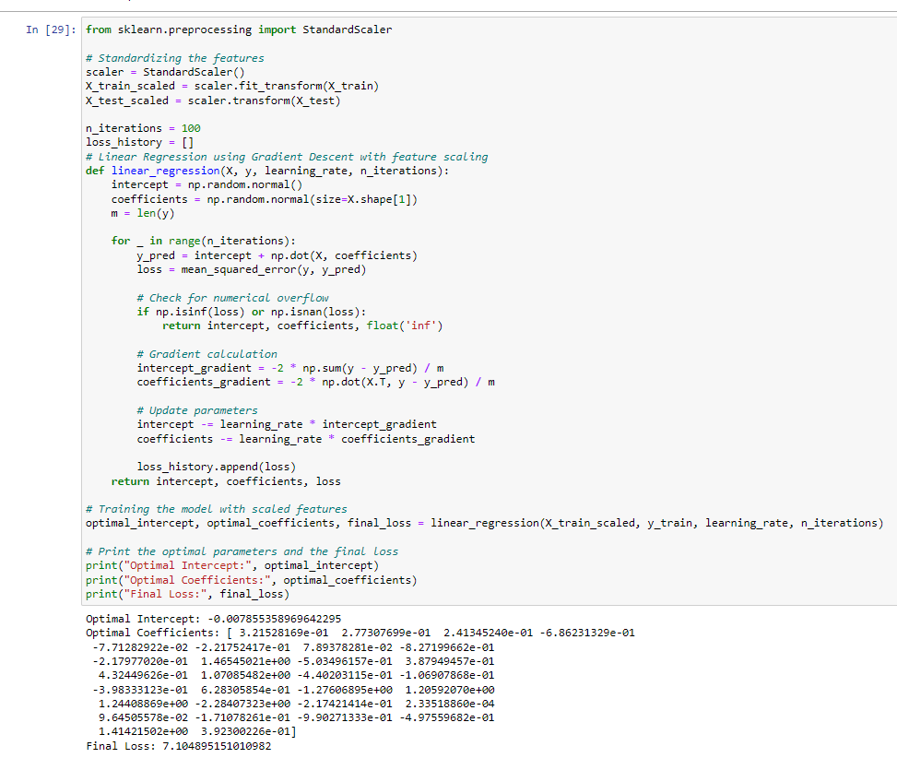

c.

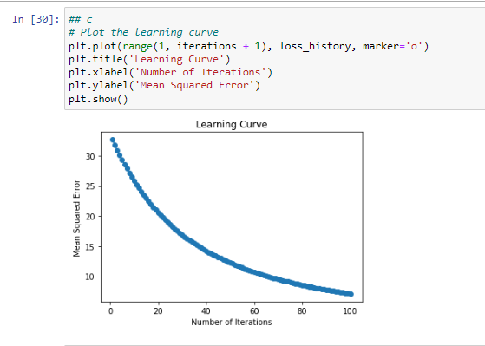

d.

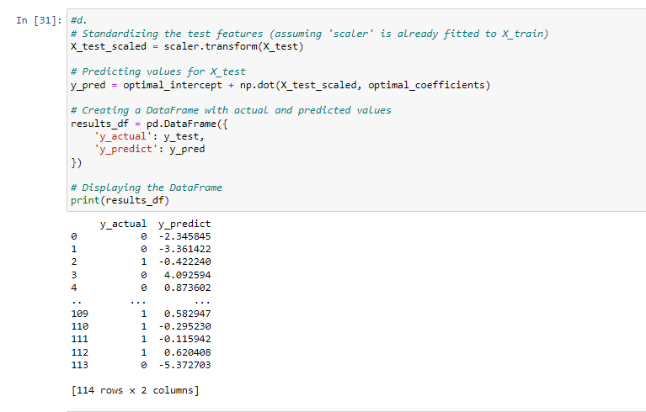

e.

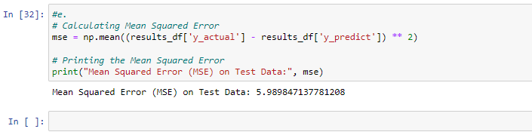

**References: -**

<https://problemsolvingwithpython.com/10-Symbolic-Math/10.06-Solving-Equations/>

<https://www.geeksforgeeks.org/solve-linear-equations-using-eval-in-python/>

<https://www.tutorialspoint.com/how-to-plot-a-function-defined-with-def-in-python-matplotlib>

<https://www.geeksforgeeks.org/python-output-formatting/>

<https://stackoverflow.com/questions/658763/how-to-suppress-scientific-notation-when-printing-float-values>