GCP Batch Data Pipeline
github.com/pp139515/GCP-Batch-Data-Pipeline
This is an end-to-end ETL pipeline built on Google Cloud Platform. It processes NYC Yellow Taxi trip data by pulling raw files from Cloud Storage, transforming and aggregating them with Python, and loading the results into BigQuery. Apache Airflow schedules and orchestrates the whole process inside Docker containers on a daily basis.

What This Project Does
The pipeline moves data through three steps each time it runs. Raw Parquet files are downloaded from a Cloud Storage bucket, cleaned and aggregated into a daily summary using Python and pandas, and then loaded into BigQuery. A SQL view sits on top of the loaded table for downstream analysis and revenue ranking.
The three steps run as tasks inside an Airflow DAG. Transform will not start until Extract finishes successfully, and Load will not run unless Transform completes cleanly. If any step fails, the pipeline stops and logs the error.

Airflow DAG
All three tasks ran successfully in the most recent pipeline execution. The graph view below shows each step completing in order.

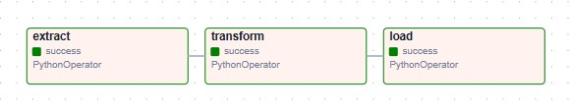
Airflow Graph view showing extract, transform, and load tasks all completing successfully

Architecture
Data flows through the pipeline in a fixed sequence. Cloud Storage acts as the raw data landing zone. Python handles the extraction, cleaning, and aggregation. BigQuery stores the final output. A SQL view adds an analytical layer on top.

Cloud Storage (raw Parquet files, organized by batch date)
|
| extract.py connects to GCS and downloads files
|
| transform.py cleans, filters, and aggregates in Python
|
| load.py writes transformed results to BigQuery
|
BigQuery pipeline_data.daily_summary (loaded table)
|
| SQL view
|
pipeline_data.top_revenue_days (days ranked by revenue)

Tech Stack

Tool | Purpose
Google Cloud Storage | Raw data landing zone, equivalent to AWS S3
Google BigQuery | Data warehouse for storing and querying results
Python / pandas / pyarrow | Core ETL logic: extraction, transformation, aggregation
Apache Airflow 2.9 | Pipeline orchestration and daily scheduling
Docker / Docker Compose | Local Airflow environment
SQL | Analytical view built on top of the loaded BigQuery table

Project Structure

gcp-batch-data-pipeline/
dags/
pipeline_dag.py Airflow DAG definition
scripts/
extract.py Downloads Parquet files from GCS
transform.py Cleans, filters, and aggregates data
load.py Loads transformed data into BigQuery
screenshots/ Pipeline output screenshots
docker-compose.yaml Airflow local setup
.gitignore

BigQuery Output
The pipeline produces a daily_summary table and a top_revenue_days view inside the pipeline_data dataset. The table below shows all three objects created in BigQuery after a successful pipeline run.

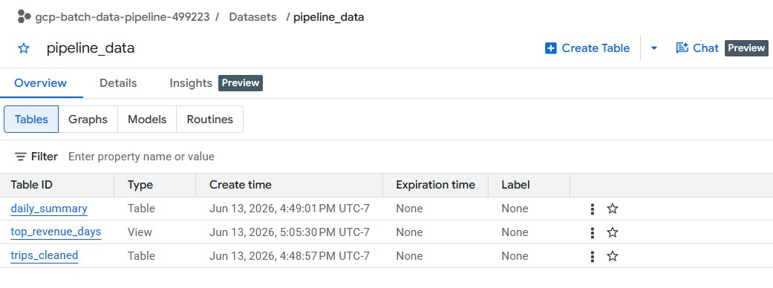
BigQuery pipeline_data dataset showing daily_summary table, top_revenue_days view, and trips_cleaned table

The query below shows the daily_summary data as it appears in BigQuery after loading. Each row represents one day of aggregated trip data.

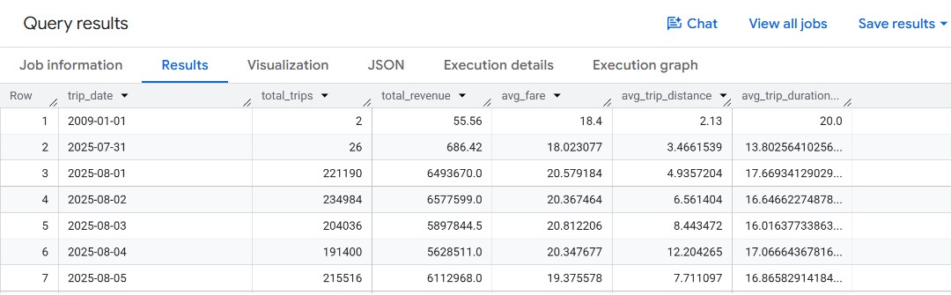
BigQuery query results showing daily trip counts, total revenue, average fare, and average distance

How Each Step Works

Extract
extract.py connects to GCP using a service account, lists all .parquet files under the raw/ prefix in the Cloud Storage bucket, and downloads them to a local data folder. Files are organized by batch date so the pipeline can be extended to incremental processing later if needed.

Transform
This is where the core ETL logic lives. Rather than loading all three months of data into memory at once, the script processes each file individually. For each file it:
- Reads only the six required columns using Parquet's columnar format, skipping the other thirteen
- Casts numeric columns from float64 to float32, which cuts memory usage roughly in half
- Removes duplicate rows, null fare amounts, negative fares, and zero-distance trips
- Calculates trip duration in minutes from the pickup and dropoff timestamps
- Aggregates to a daily summary covering total trips, total revenue, average fare, average distance, and average trip duration
- Releases the file from memory before loading the next one

The per-file approach was a deliberate fix after the original version hit an out-of-memory error at around 6.4GB of resident memory inside the container when loading all 11 million rows at once. Processing files one at a time keeps peak memory usage to roughly a third of that.

Load
load.py reads the aggregated daily summary and loads it into a BigQuery table using the google-cloud-bigquery Python SDK. It uses WRITE_TRUNCATE which replaces the table contents on each run. A production version would use incremental loads with date-partitioned BigQuery tables.

SQL View
After the data lands in BigQuery, a SQL view adds a simple analytical layer that ranks days by total revenue. The view does not store data separately and also filters out a small number of rows with bad timestamps from the source data.

CREATE OR REPLACE VIEW pipeline_data.top_revenue_days AS
SELECT
trip_date,
total_trips,
total_revenue,
RANK() OVER (ORDER BY total_revenue DESC) AS revenue_rank
FROM pipeline_data.daily_summary
WHERE trip_date BETWEEN '2025-08-01' AND '2025-10-31';

Airflow Orchestration
The three scripts run as tasks in a single Airflow DAG with explicit dependencies. Extract runs first, transform only starts after extract succeeds, and load only runs after transform completes cleanly.

extract >> transform >> load

Airflow provides a visual graph view in the browser where each task turns green on success or red on failure, with full logs available for each run. The DAG runs on a @daily schedule and can also be triggered manually from the UI.

Dataset
NYC Yellow Taxi Trip Records covering August through October 2025, sourced from the NYC TLC Trip Record Data portal. The raw dataset contains approximately 11 million rows across the three months. Each row represents one taxi trip and includes pickup and dropoff timestamps, fare amounts, trip distances, and location IDs.

Design Decisions
Why Python for transformation instead of SQL inside BigQuery?
The transformation logic including type casting, deduplication, duration calculation, and aggregation all runs in Python before the data reaches BigQuery. This keeps the logic portable and easier to unit test. The SQL view handles only the final analytical layer where SQL is the most natural tool.

Why process files one at a time in transform.py?
Loading all three months into a single DataFrame hit the container memory limit at around 6.4GB. Processing each file individually and releasing it before loading the next solved this within the existing Docker Desktop constraints. It also reflects how real pipelines handle large rolling batches where each arrival is processed independently.

Why local Docker instead of Cloud Composer?
Cloud Composer (managed Airflow on GCP) costs around $300 per month at minimum. Running Airflow locally in Docker demonstrates the same orchestration concepts while still connecting to real GCP services for storage and warehousing.

Why WRITE_TRUNCATE instead of incremental loads?
The pipeline is designed as a full batch refresh where each run replaces the previous output. This is appropriate for a dataset where the full history fits in a single run. The natural next step would be switching to partitioned BigQuery tables with WRITE_APPEND and processing only new date partitions on each run.

Setup and Local Run

Prerequisites
- Python 3.9 or higher
- Docker Desktop
- A GCP project with Cloud Storage and BigQuery APIs enabled
- A service account with Storage Admin, BigQuery Data Editor, and BigQuery Job User roles

1. Clone the repo
git clone https://github.com/pp139515/GCP-Batch-Data-Pipeline.git
cd GCP-Batch-Data-Pipeline

2. Set up Python environment
python -m venv venv
source venv/Scripts/activate
pip install google-cloud-storage google-cloud-bigquery pandas pyarrow python-dotenv

3. Configure environment variables
Create a .env file in the project root with the following values:
GOOGLE_APPLICATION_CREDENTIALS=/path/to/service-account-key.json
GCP_PROJECT_ID=your-project-id
GCS_BUCKET_NAME=your-bucket-name
BQ_DATASET=pipeline_data

4. Upload raw data to GCS
Upload Parquet files to your bucket organized by date prefix. For example: raw/2025-08-01/yellow_tripdata_2025-08.parquet

5. Run scripts manually (optional)
python scripts/extract.py
python scripts/transform.py
python scripts/load.py

6. Start Airflow
echo "AIRFLOW_UID=50000" >> .env
docker compose up airflow-init
docker compose up -d

Once the containers are running, open http://localhost:8080 in your browser and log in with airflow as both the username and password. Find the gcp_batch_pipeline DAG, toggle it on, and trigger a run. The Graph view shows each task turning green as it completes successfully.

