**Web Technologies**

**Mini Project**

**Online Bookstore**

**Developed by:**

**TE-B**

**(Computer)**

**Name SAP ID**

**Ankita Naikdalal 60004120070**

**Prerna Parmeshwaran 60004120073**

**Contents**

Topics Page no.

1. Purpose 3

1.1 Introduction 3

1.2 Scope 3

1.3 Document Overview 3

2. Overall Description

2.1 Functional Requirements 4

2.2 Non-Functional Requirements 4

2.3 Description of the software/ 5

technologies used

2.4 Modelling Diagrams 6

2.5 Database and its schema 8

2.6 Snapshots 10

The Bookie Joint

Web-Tech Mini Project

**Purpose**

**Introduction**

The topic of our mini project is a website for a bookstore. Our bookstore is created with an aim to provide people easy access to a wide range of books spanning various categories. Customers can check out various books, their prices and their descriptions. A person can place an order for his favourite books by filling a simple order form online. The website also contains information about our bookstore’s physical location and contact information.

**Scope**

Our website is designed for in general for people who want to buy books from our bookstore online. On the back-end we have implemented database connectivity which maintains information about the orders placed for the books. After filling the order form with required customer details, the user gets a confirmation that an order for his specified book is placed.

**Document** **Overview**

The following report of the project contains the overall description of our website, its various features and how it was implemented during the various phases of the project.

**Overall Description**

**Functional Requirements**

* **Simple Navigation:** The website will have a simple and user-friendly interface. The links will be easy to understand and will be indicated using various styles and effects. There will be no broken links and the user can navigate to any page from his current page.
* **User-friendly** **interface:** The user interface will be attractive and self-explainable. The language used will be English with no jargons used.
* **Form Validation:** The user will have to fill a form to place an order for books. We have used JavaScript validation to check if all the fields have been filled correctly.

**Non-Functional Requirements**

* **Support:**

**Browser:** Google Chrome, Internet Explorer, Mozilla Firefox

**Operating System:** Any Windows OS, XP and higher

* **Software used:** Notepad ++, Sublime Text 2,Xammp,Google Chrome browser
* **Languages used:** HTML, JavaScript, PHP, CSS, MySQL
* **Requirements:** Mouse, Keyboard

**Description of the software/technologies used**

* **HTML:** HTML stands for Hypertext Markup Language. It is popularly used to design web pages. HTML is mainly used to define the content of a web page, as its styling capacity is rather limited. These files are typed in a text editor and are saved with the extension .html. HTML pages can be viewed in web browsers such as Google Chrome, Mozilla Firefox etc.
* **CSS:** CSS stands for cascading style sheets. It is used to change the look and formatting of web pages. CSS can be applied to any kind of XHTML files. The main aim of CSS is to separate the document content from the document presentation.
* **JavaScript:** JavaScript is a dynamic computer language which allows client side scripts to interact with the user and control the browser.
* **PHP:** PHP is a server side scripting language used in web development. It is usually used to design web pages with dynamic content and also for the implementation of the back end, such as databases.
* **MySQL:** MySQL is a widely used relational database management software.
* **Sublime Text:** Sublime Text is a cross platform text and source code editor. It supports languages such as HTML, CSS, PHP, JavaScript, Python etc.
* **XAMPP:** XAMPP is a free and open-source cross-platform web server solution stack package. It consists of the Apache HTTP Server, MYSql database and interpreters for scripts written in PHP and Perl.

**Modelling Diagrams**

1. Class Diagram

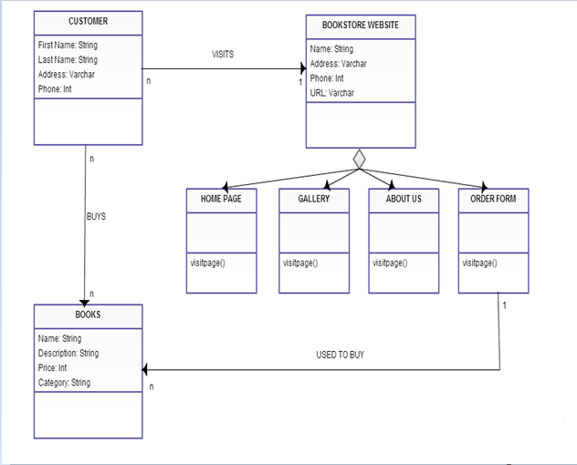

Description

The above class diagram describes the various classes in the system. The customer visits the bookstore’s website to view and buy books. The website has a home page, a gallery, an about us page and a form used to place order for books. The customer can buy books from various categories such as fiction, non-fiction, cooking and kid’s books. The customer must fill an order form to place an order for a book. Thus thee diagram shows the functioning of the system.

1. Use Case Diagram

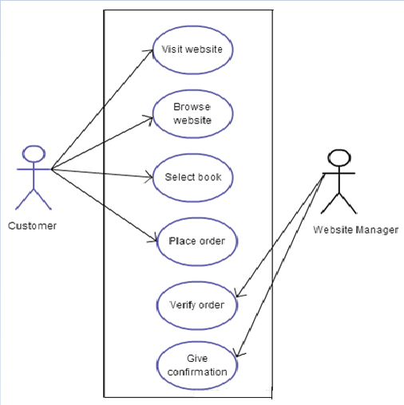

Description

The above use case diagram is for a scenario where a customer places an order for a book. Firstly, he visits the website and browses through all the books. Then he selects a particular book and fills an order form to place his order. The web admin then verifies all the details in his form. If the details are correct he confirms the order and gives a confirmation to the customer.

**Database Schema**

For this website, a database is created to store the various orders placed for books by a customer.

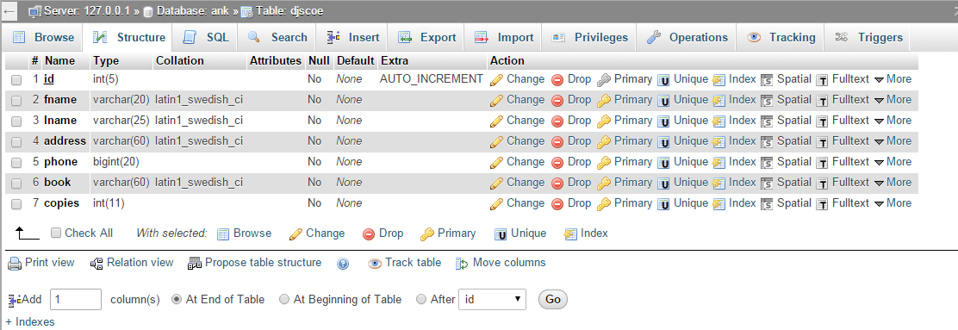

The structure of the table made is shown above. A table for storing orders is created in the database to store the customer details and book orders.

Attributes:

1. ID: This attribute gives the customer number. It is an integer datatype and its value is incremented automatically as a new order is placed. It is the primary key for the table.
2. Fname: This attribute stores the first name of the customer. It is a varchar datatype.
3. Lname: This attribute stores the last name of the customer. It is a varchar datatype.
4. Address: This attribute stores the address of the customer. It is a varchar datatype.
5. Phone: This attribute stores the contact number of the customer. It is a big integer datatype.
6. Book: This attribute stores the name of the book selected by the customer. It is a varchar datatype.
7. Copies: This attribute stores the number of book copies requested by the customer. It is an integer datatype.

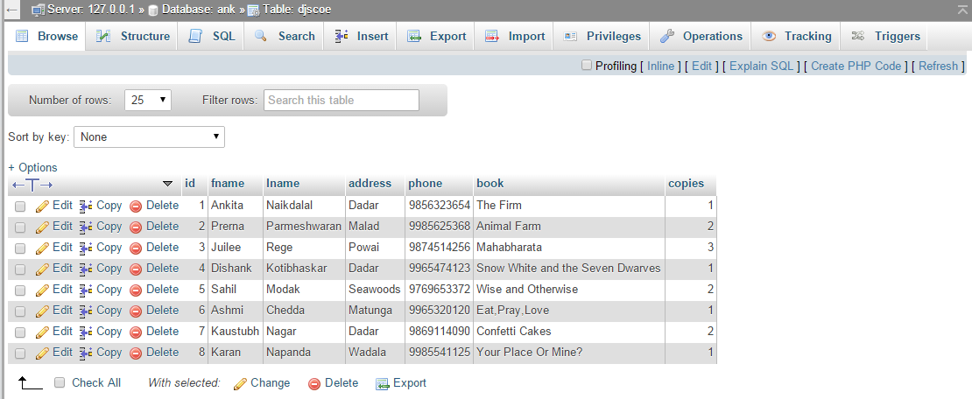

On filling the order form, the customer details and book preferences are successfully stored in the database as shown in the image above. The database thus contains all the necessary and valid information filled by the customer so as to place an order for a book online.

**Snapshots**

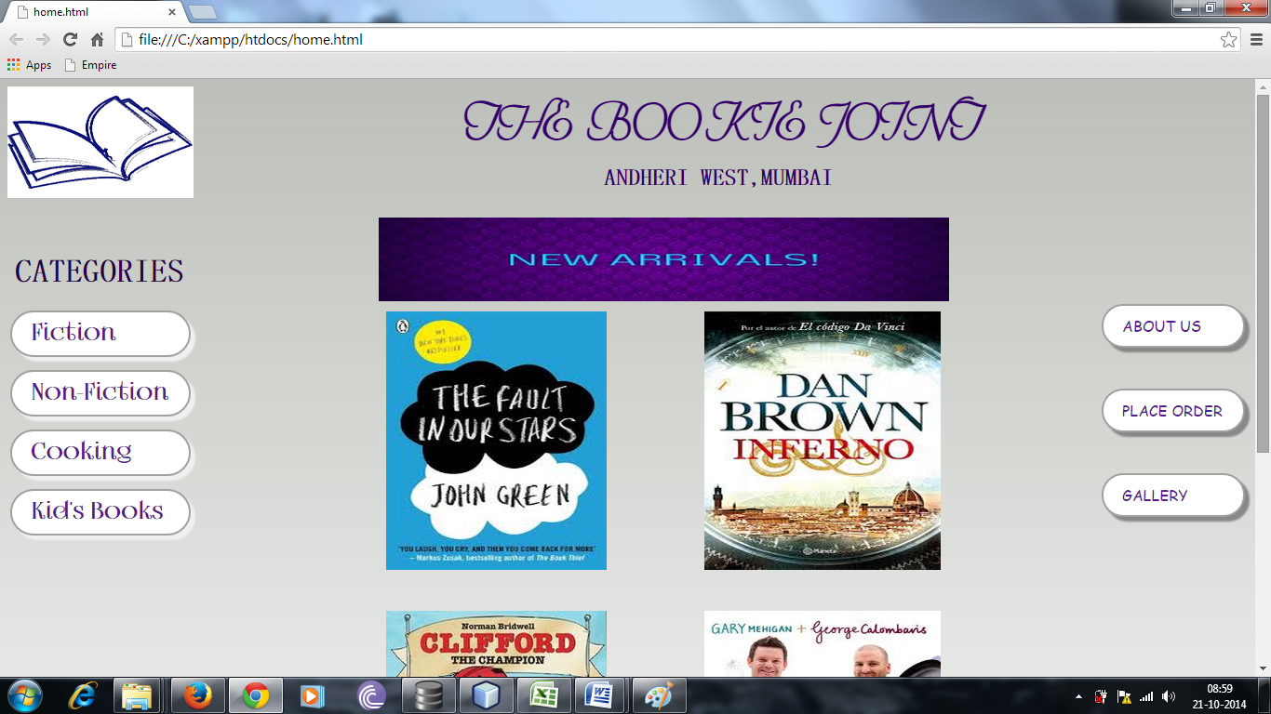



This is the home page for our website. It specifies the name and address, and each link present redirects the user to the relevant web page.

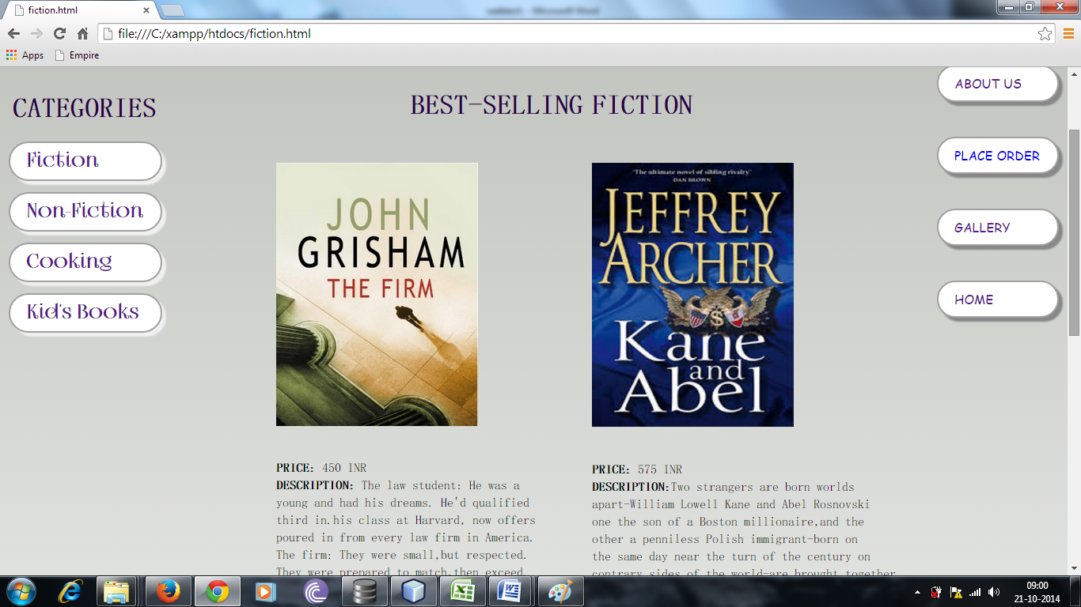

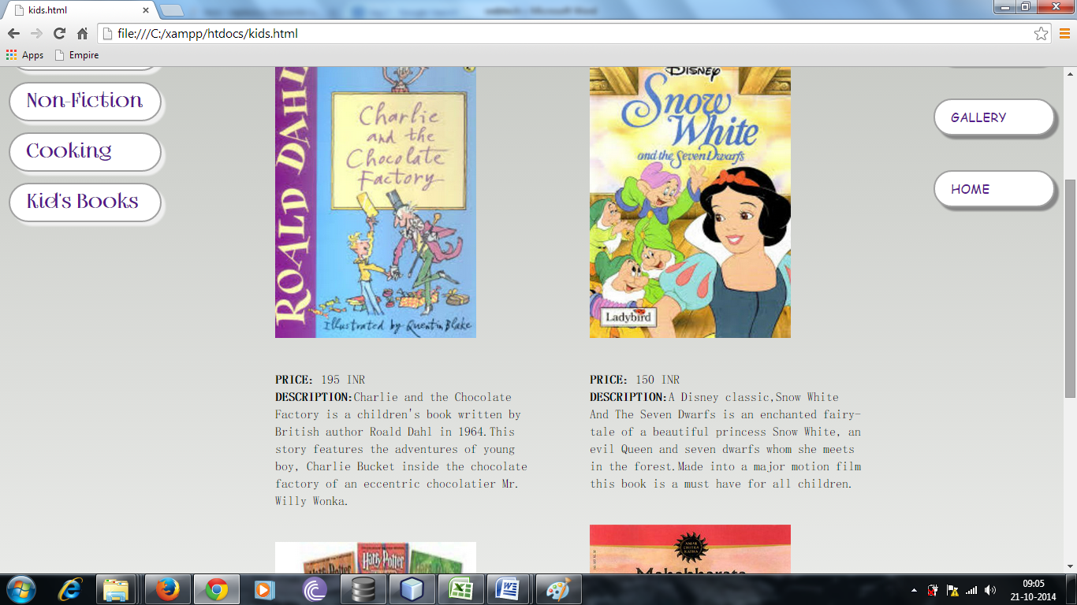

These pages represent the books available in the categories named “Fiction” and “Kid’s Books”. The image containing the name is accompanied by the price and a brief description of the book. There are four such categories and there is one web page for each.

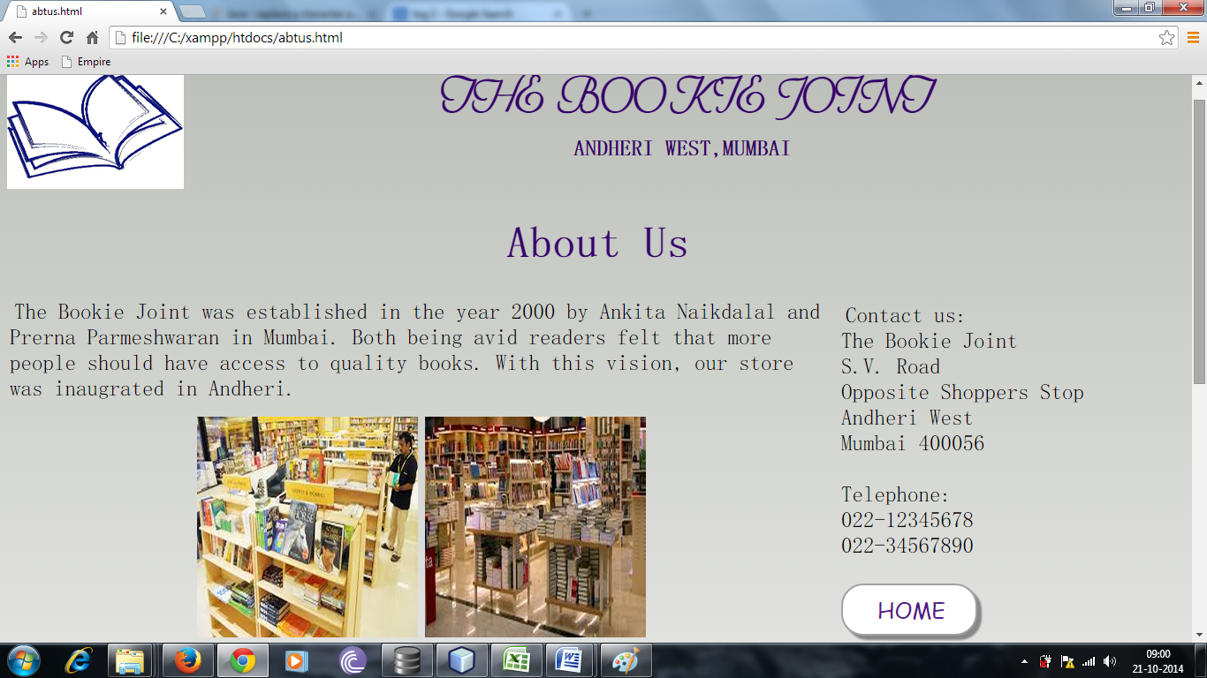

The page above shows the “About Us” section of our project.

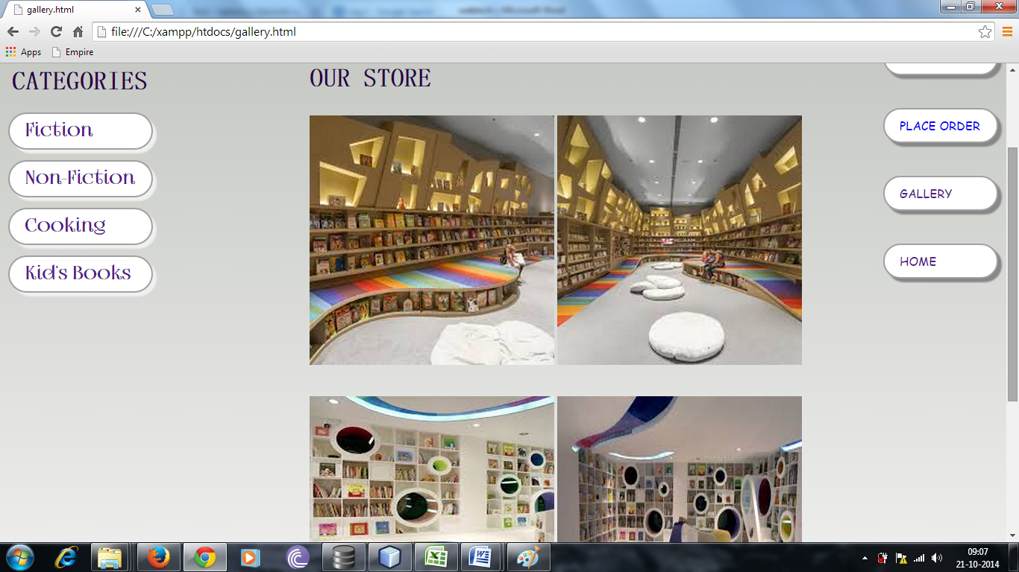

This page shows the “Gallery” section of the website.

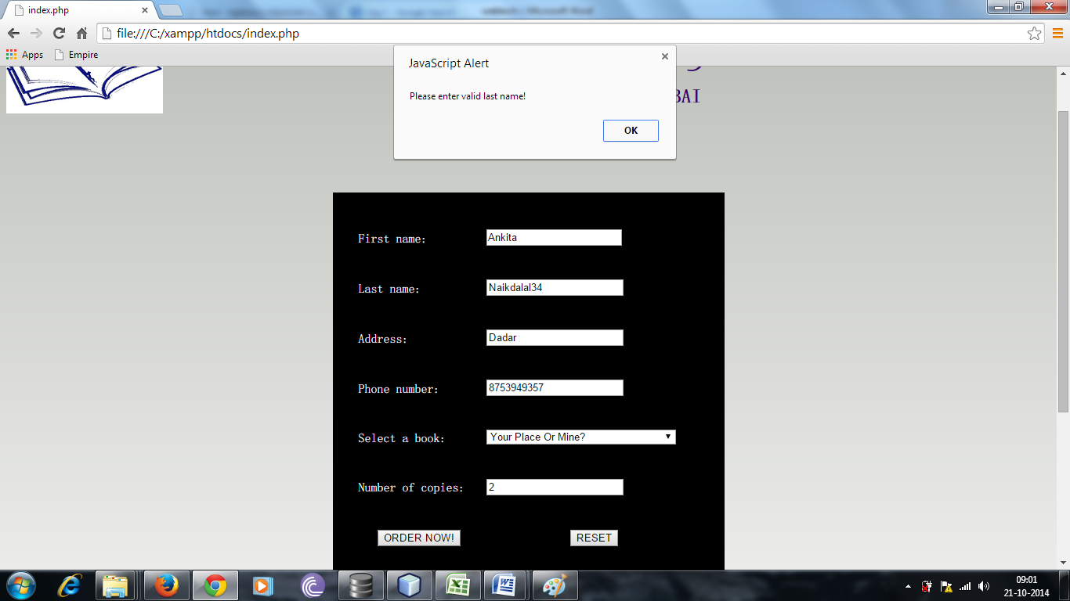

This is the order form that is to be filled by the customer while placing an online order.

The form has been validated such that all fields are selected, the input in each field is in the correct format and the customer cannot place a wholesale order (i.e. more than 3 books) online.