1) - Abra o terminal e rode o comando: sudo apt-get update.

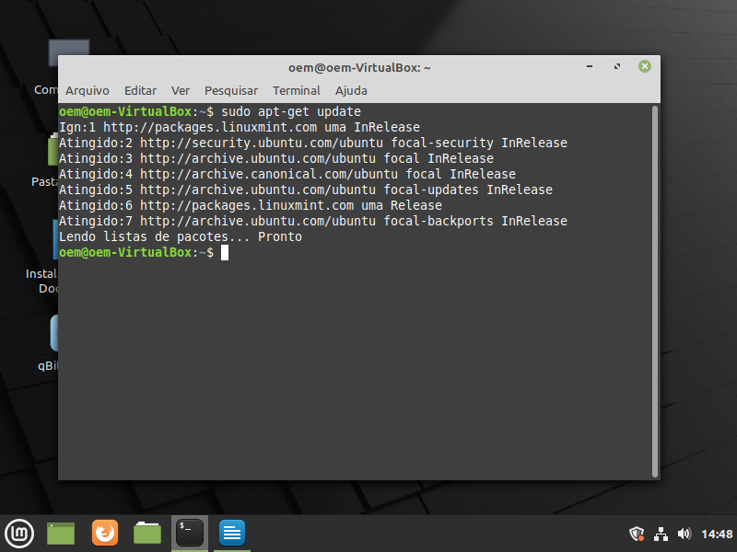

2) - rode os seguintes comandos:

sudo apt-get install \
ca-certificates \
curl \
gnupg \
lsb-release

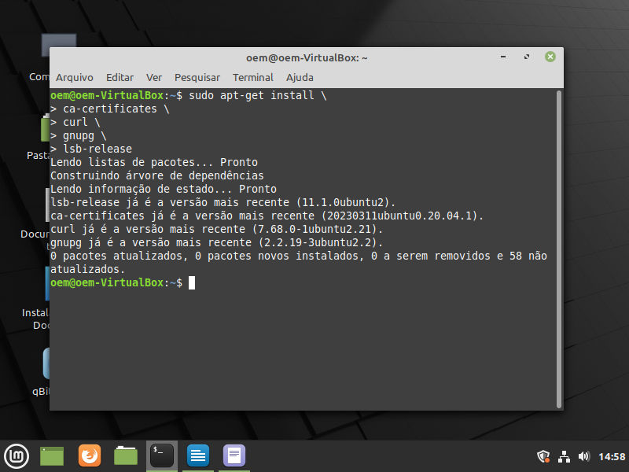

3) – rode o comando :

sudo apt install -y apt-transport-https ca-certificates curl software-properties-common gnupg lsb-release

4) – rode os comandos:

curl -fsSL https://download.docker.com/linux/ubuntu/gpg | sudo gpg --dearmor -o /usr/share/keyrings/docker-archive-keyring.gpg
sudo chmod a+r /usr/share/keyrings/docker-archive-keyring.gpg

echo "deb [arch=$(dpkg --print-architecture) signed-by=/usr/share/keyrings/docker-archive-keyring.gpg] https://download.docker.com/linux/ubuntu "$(. /etc/os-release && echo "$UBUNTU_CODENAME")" stable" | sudo tee /etc/apt/sources.list.d/docker.list > /dev/null

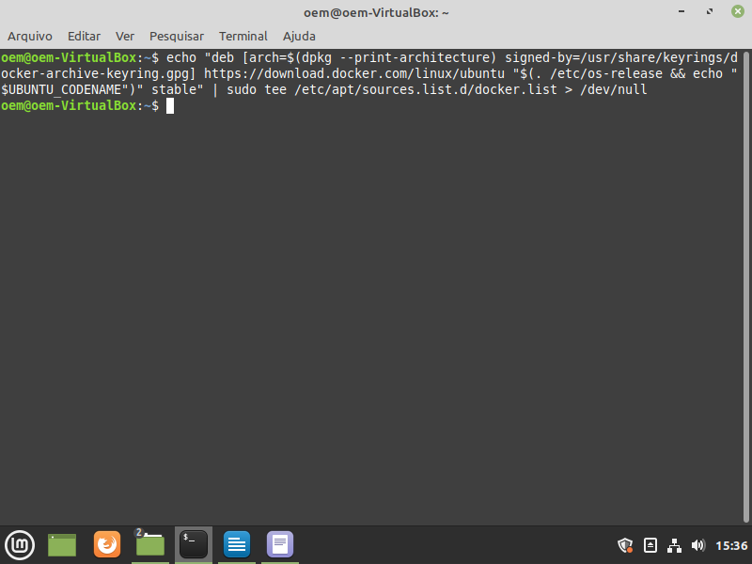

5) – rode o comando:

sudo apt update && sudo apt install -y docker-ce docker-ce-cli containerd.io docker-buildx-plugin docker-compose-plugin

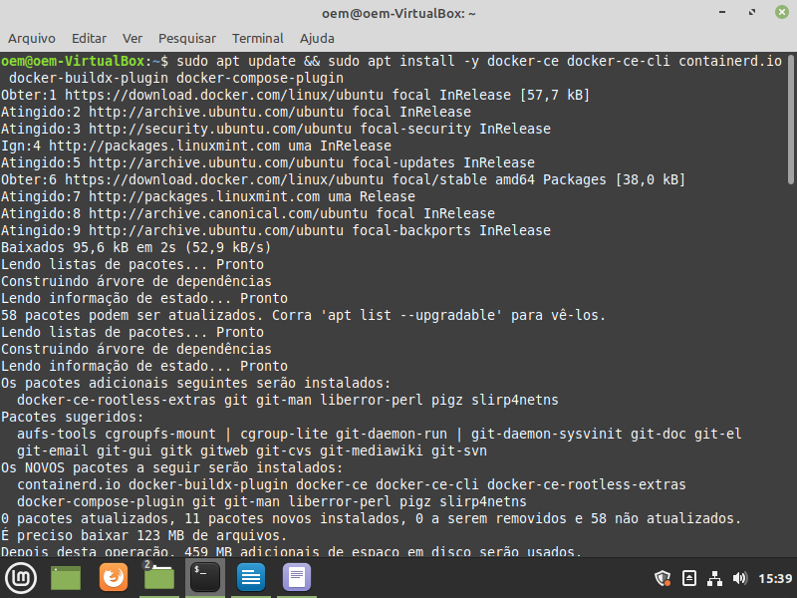

6) por fim rode o comando:

sudo docker info

