**BA: Project Management Techniques and Tools**

**PROJECT CLOSE**

**PROJECT EXECUTION AND CONTROL**

**PROJECT DEFINITION AND PLANNING**

**PROJECT CONCEPTION AND INITIATION**

**STAGE 1: PROJECT CONCEPTION AND INITIATION**

**Understanding the Business Objective for a Project**

Why It’s Important

* Many new Business Analysts jump straight into requirements without clarifying the business objective.
* This mistake can cause wasted time, money, and effort—producing solutions that don’t solve the actual business problem.
* The objective must be understood before stakeholder analysis or requirement gathering.

Lesson Learned

* A project can meet requirements but still fail if it doesn’t solve the business problem.
* Always clarify the objective at the very beginning.

Three Key Questions to Ask at the Start

1. What is the purpose of the project?

* Why was it approved? Why is budget being spent?

1. What are the goals and objectives?

* What problem must be solved?
* Where is the return on investment?

1. What does success look like, and how will it be measured?
   * Define success criteria and metrics (e.g., reduce customer response time from 72 hrs to <24 hrs).

**Why is a Business Case used?**  
A **Business Case** is a decision-making tool that outlines a problem or opportunity, possible solutions, costs, benefits, and a recommended action. It’s primarily used to convince decision-makers and secure funding or approval for projects.

**When is a Business Case used?**  
It is used **before starting a project** to convince decision-makers and to get approval or funding.

**Who creates a Business Case?**  
Business Cases are usually created by executives, managers, or business analysts. In some organizations, analysts are responsible not only for creating Business Cases but also for guiding the approved projects through to completion.

* Understand the problem or opportunity clearly.
* Identify who is affected and gather high-level requirements.
* Collect data to show the return on investment.
* Do a quick “sanity check” with decision-makers to see if solving the problem is even worth pursuing.

**PHASE 1: INITIAL ANALYSIS**

* List all possible options, including doing nothing.
* For each solution, evaluate: benefits, costs, timetable, return on investment, and risks.
* Assume decision-makers are seeing it for the first time.
* Clearly explain the problem before showing solutions.
* Present your recommendation and ROI.
* Mention stakeholder supporters to build credibility.
* End with a strong summary of benefits and ROI.

**PHASE 2: DETERMINE POTENTIAL SOLUTION**

**PHASE 3: WRITE THE BUSINESS CASE**

**PHASE 4: REVIEW BUSINESS CASE**

**PHASE 5: PRESENT BUSINESS CASE**

* Ensure the problem statement is strong and justifies action.
* Include all valid solutions, not just your preferred one.
* Double-check calculations.
* Objectively analyze your recommendation.
* Fix grammar/spelling and have someone else review it.
* Gain early support from 1–2 key stakeholders.

Most companies use a standard template, but the key sections include:

* Executive Summary (written last, but placed first).
* Problem Statement.
* Analysis and findings.
* Solution options with cost-benefit analysis.
* Recommendation of the best solution.

**Project Charter Basics**

* Introduces the project.
* Explains why the project is needed and what it should accomplish.
* Aligns stakeholders and decision-makers.
* Gains approval and usually budget to move forward.
* It should be short (no more than 5 pages), high-level, and easy to read.

**What is a Project Charter?**

A Project Charter is a short, high-level document that:

**Key Sections of a Project Charter**

| **Section** | **Details** |
| --- | --- |
| **1. Background Information** | * Why the project exists. * What problem it solves or opportunity it addresses. |
| **2. Scope** | * Defines boundaries of the project. * Describes high-level deliverables and who will use them. |
| **3. Objectives** | * Measurable goals that prove project success. |
| **4. Governance** | * Key people: Project Sponsor, Project Manager, and major stakeholders. |
| **5. Schedule** | * A simple, high-level timeline with key milestones (not detailed). |
| **6. Budget** | * Estimated costs: one-time (equipment, software). * Ongoing costs (support, resources). |
| **7. CARD (Constraints, Assumptions, Risks, Dependencies)** | * **Constraints**: challenges like time zones or approvals. * **Assumptions**: things you expect to be true (e.g., resources available on time) * **Risks**: potential problems that could cause failure. * **Dependencies**: other projects or technology that must be completed first. |

**How to Create a Project Charter**

1. Meet with the key project team (governance group).
2. Facilitate discussions on background, scope, budget, risks, etc.
3. Draft the Project Charter based on inputs.
4. Share with the team for feedback and corrections.
5. Finalize and distribute it as the “guide” for the project.

**IDENTIFY AND MANAGE STAKEHOLDERS**

**The Stakeholder Map and It’s Purpose**

The stakeholder map is a visual representation of stakeholders that are affected by activities and project.

**What is a Stakeholder?**

Stakeholders are people or groups affected by a project, either directly or indirectly.

Examples include:

1. **Project team** (Project Manager, Business Analyst, IT, business staff)
2. **Customers** (internal or external end users)
3. **Suppliers** (impacted by changes in processes or agreements)
4. **Employees** (executives, managers, and staff using project outputs)
5. **City/Community** (if the project is public-facing, e.g., building a library)
6. **Professional organizations** (unions, government agencies, regulators like FDA)
7. **Impacted individuals** (those affected, e.g., landowners in construction projects)
8. **Support teams** (IT, designers, maintainers after project completion)

**Why Identify Stakeholders?**

1. More ideas and input → better solutions, reduced risks.
2. Varied perspectives → users, managers, executives, and customers see things differently.
3. Gain buy-in → stakeholders feel ownership, making adoption easier.
4. Increase credibility → shows the project team cares, listens, and minimizes negative impact.

**How to Identify Stakeholders**

1. Solo brainstorming – Walk through the project scope and ask:

* Who benefits?
* Who is directly involved?
* Whose jobs may change?
* Any government or organizational bodies?
* Who are the influencers (execs, board)?
* Who has interest in the outcome (community, public)?

1. Team brainstorming – Share your initial list with the project team and add more together.
2. Ask stakeholders directly – Once you have a list, talk to them. Ask:

* “Who else could be impacted by this project?”
* This often uncovers hidden groups you didn’t think of.

**What is the R.A.C.I. Matrix?**

The R.A.C.I. Matrix is a project tool that defines stakeholder responsibilities. It prevents confusion, power struggles, and tasks being forgotten by clearly setting expectations before the project starts.

**Why Use It?**

* Avoids power struggles between managers or teams.
* Prevents tasks from being ignored (no finger pointing).
* Sets clear roles and responsibilities.
* 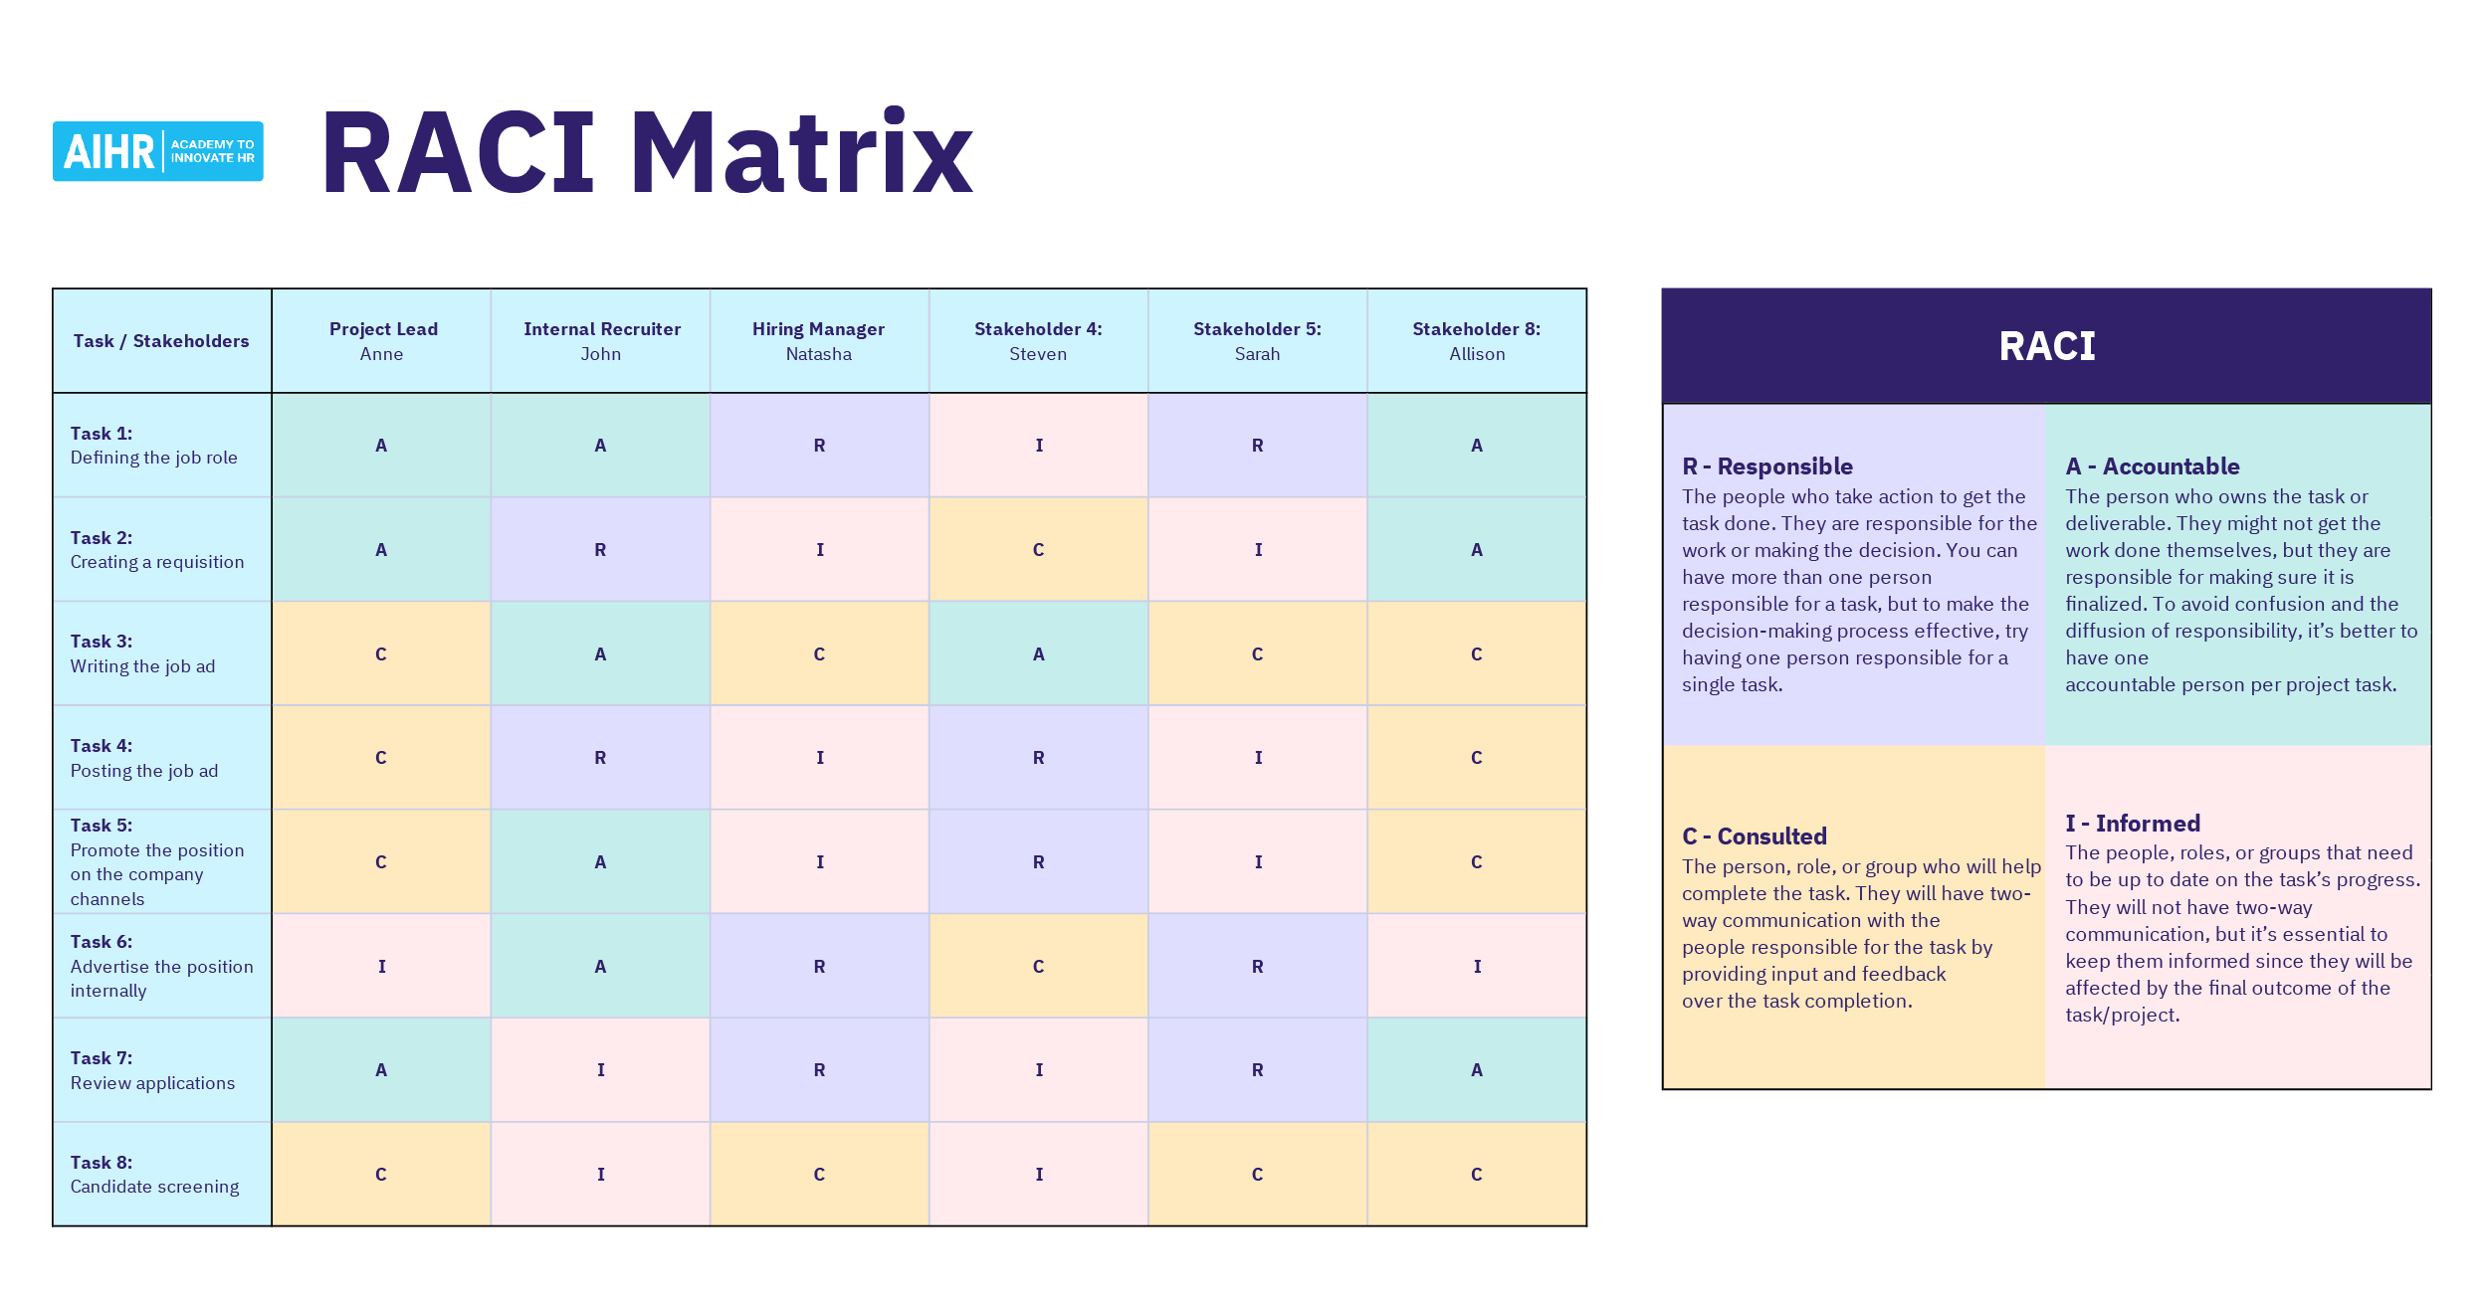Keeps projects on track, on time, and on budget.

| **Letter** | **Role** | **Meaning** | **Example** |
| --- | --- | --- | --- |
| **R** | Responsible | The person or team that **does the actual work**. | Developer writing code, Tester running tests |
| **A** | Accountable | The person who **approves the work** and is **answerable if things go wrong**. | Project Manager, Department Head |
| **C** | Consulted | People who provide **input, advice, or expertise**, but don’t make decisions. | Subject Matter Experts, Business Analysts |
| **I** | Informed | People who need to be **kept updated on progress** or results. | Executives, End Users, Sponsors |

**STAGE 2: PROJECT DEFINITION AND PLANNING**

It’s the process of developing a plan for how the project will be successfully carried out. In short, you’re answering the question: *How do we make this project succeed, and what steps do we need to take to get there?*

| **Step** | **What It Means** | **Why It’s Important** |
| --- | --- | --- |
| **1. Project Schedule** | Create a timeline with tasks and milestones. | Keeps the project on track and avoids delays. |
| **2. Communication Plan** | Decide how updates will be shared (meetings, reports, status updates). | Ensures everyone stays informed and aligned. |
| **3. Assumptions & Risks** | Identify what you expect to be true (assumptions) and what could go wrong (risks). | Helps prepare for challenges before they happen. |
| **4. Quality Plan** | Plan how testing and quality checks will be done. | Ensures the final deliverable meets expectations. |
| **5. Go-Live Plan** | Prepare for the moment the project deliverable is used in real life. | Ensures a smooth transition and adoption by users. |

**Project Schedule Basics**

| **Topic** | **Explanation** | **Why It Matters** |
| --- | --- | --- |
| What is a Project Schedule? | A timetable that shows the project start and end dates, milestones, activities, deliverables, and task owners. | Provides structure and clarity for the entire project. |
| Why Create One? | 1. Sets realistic expectations for stakeholders.  2. Shows the steps, milestones, and timeline instead of just the end date.  3. Reduces chances of cost and time overruns.  4. Keeps the project from stalling by setting due dates.  5. Clarifies task assignments so team members know their responsibilities. | Keeps projects on track, avoids delays, and ensures accountability. |

**Create a Project Schedule**

Build the timeline, then review for gaps/issues. Put all the tasks, durations, resources, and milestones together into a timeline. Review it for gaps or risks and adjust so the schedule is achievable and clear to everyone.

Check resource availability & limitations. Check for factors that could limit the project, like resource availability, budget, or dependencies on other tasks. Addressing constraints early helps prevent surprises later.

Estimate how long each task will take. Estimate how long each task will take. Accurate time estimates help shape a realistic project timeline and avoid rushing or unnecessary delays.

Identify key “flags” or checkpoints. Set key checkpoints in the project where progress can be reviewed.

Who will do each activity? Identify the people, teams, or tools responsible for each activity. This makes ownership clear and prevents confusion about who should be doing what.

Break down the deliverables into smaller, manageable tasks. Then arrange these tasks in the order they should happen. Sequencing prevents missed steps and keeps the workflow logical.

Clearly define what the project needs to accomplish. Deliverables are the end products or outcomes whether it’s a report, a piece of software, or even a working doorknob. This step ensures everyone knows what “done” looks like.

**OUTLINE RESOURCE AVAILABILITY AND CONSTRAINTS**

**DETERMINE AND DOCUMENT ACTIVITY ROTATIONS**

**ASSIGN AVAILABLE RESOURCES TO ACTIVITIES**

**DEFINE ACTIVITIES AND ORGANIZE INTO SEQUENCE**

**SET AND ANALYZE SCHEDULE**

**DEFINE MILESTONES**

**UNDERSTAND DELIVERABLES**

**Developing a Communication Plan**

What is Communication Planning?

It’s about setting the rules for how, when, and with whom you’ll communicate during a project.  
It helps:

* Define communication needs clearly.
* Show why the project matters.
* Gain stakeholder and team buy-in.
* Give stakeholders a chance to share feedback.

**The 3 Main Communication Types to Plan**

| **Communication Type** | **Audience** | **Purpose** | **Method** | **Frequency** | **Responsible** |
| --- | --- | --- | --- | --- | --- |
| **1. Kickoff Meeting** | Full project team (sponsors, QA, leads) | Collaboration, alignment, and setting expectations | Meeting (in-person/online) | Once | Project Manager |
| **2. Project Status Reports** | Full project team + sponsors | Update on schedule, budget, resources, risks | Written email | Weekly (may vary) | Project Manager |
| **3. Meeting Notes** | Meeting attendees + Project Lead (sometimes sponsor) | Document decisions, next steps, and accountability | Email after meeting | After every meeting | Project Manager |

**Identifying Assumption and Risks**

**Assumptions Risk**

Something you *expect* will happen during the project, but it’s not guaranteed.

An uncertain event or condition that, if it happens, negatively affects the project (cost, schedule, quality, adoption, etc.).

**Final Key Steps for Both Assumptions & Risks**

1. **Identify** → Spot them early.
2. **Validate** → Check if they are facts or not.
3. **Communicate** → Share openly with the team and stakeholders.
4. **Take Action** → Plan mitigation steps or adjustments.

| **Category** | **How to Identify** | **What to Do** |
| --- | --- | --- |
| **Assumptions** | Project Plan Walkthroughs: review activities step by step and listen for assumptions.  Question Everything: ask if it’s a fact or just an assumption; validate the source. | * Document assumptions clearly. * Share in status meetings and reports. * Ask: *If wrong, what’s the worst outcome?* * If impact is serious → validate with managers/stakeholders. * If it can’t be validated → treat it as a **risk**. |
| **Risks** | Identify early in planning.  Look for common problem areas:  **Schedule** – unrealistic timelines, dependency delays.  **Customer** – new requirements, unengaged sponsor.  **Requirements** – poorly defined, unclear needs. | * Document and share risks. * Try to eliminate or mitigate (reduce impact). * Example: adjust schedule or add resources to handle delays. |

**Determining a Quality Plan**

A Quality Plan ensures your project meets the required standards and runs smoothly.  
It covers quality requirements, standards, and assurance mechanisms.

There are **three main parts**:

**Testing & Quality Assurance**

**Training Requirements**

**Defect Management**

* Define responsibilities → Who will test the system.
* Set quality objectives → How reliable/bug-free the system must be (differs by project type).
  + Example:
  + CRM bugs = inconvenience.
  + Healthcare software bugs = life-threatening.
* Choose a testing approach → Unit testing, system testing, user acceptance testing, etc.
* Ensure timelines and resources are in place for thorough testing.

Training occurs at different stages:

* **Project Team Training (start of project):**
  + Needed to understand tools, software, or methodologies.
* **Staff/User Training (end of project):**
  + Sessions to teach end users how to use the system or deliverable.
  + Plan for number of sessions, attendees, locations, and delivery method (online/onsite).
* **Ongoing/Mid-project Training (if required):**
  + Sometimes additional training is needed if the project introduces new processes midway.
* Bugs and defects are inevitable during testing.
* Plan for:
  + **What counts as a defect** (criteria).
  + **Where defects will be documented** (system, SharePoint, Excel, etc.).
  + **Who manages defects** (Project Manager, designated team, administrator).
* Best practice → Use tools accessible to all testers for logging and tracking.

**Documenting a Go Live Plan**

Planning for go-live applies to all projects, not just systems or products. The details may differ, but you always need to plan how the deliverable will be rolled out, how people will use it, and how you’ll support them—whether it’s a complex system or just a research document.

**Planning for Go-Live: 3 Key Areas**

| **Key Area** | **What It Means** | **Options / Actions** |
| --- | --- | --- |
| **1. Rolling Out to Users** | Decide how and when users will start using the new system or product. | * **Big Bang**: Everyone switches at once. Simple but risky because any big issue affects all users. * **Phased Rollout**: Release the system in stages. Users may work with both old and new systems during transition. Safer and lets you fix issues along the way. * **Pilot Rollout**: A small group (like one department) uses the system first, helps uncover bugs, and smooths out issues before a wider rollout. |
| **2. Supporting Users During Go-Live** | Make sure users have help when problems happen during the rollout. | * Give users a simple process for reporting bugs (forms, tickets, emails). * Assign clear contacts for urgent issues that block work. * Have support staff onsite or available via hotline/bridge. * Hold short check-in meetings (daily or more often at first) to gather feedback and address urgent issues. |
| **3. Transitioning to Long-Term Support** | Plan when and how the project team hands over the system/product to the support team. | * Create handover documents (procedure manuals, system design docs, troubleshooting guides). * Train the support team to handle day-to-day issues. * Define escalation contacts for problems the support team can’t solve. * Set a timeline for when the project team steps back. |

*That’s the essence of planning for a go-live: deciding how the rollout will happen, how users will be supported, and how the system will transition to long-term ownership.*

**STAGE 3: PROJECT EXECUTION AND CONTROL**

This phase is about carrying out the project to achieve the agreed deliverables while continuously monitoring progress, risks, costs, and scope. It ensures the project stays on track and aligned with objectives.

**Seven Steps to a Successful Project Kickoff**

1. **Introduce Yourself**

* Share who you are, your role, and your responsibility in the project.
* Be personable and enthusiastic to set a positive tone.

1. **Team Introductions**

* Each member introduces themselves and their role.
* Helps build trust and avoids confusion later.

1. **Define the Project Purpose, Goals, and Deliverables**

* Walk through the Project Charter.
* Clarify *why* the project exists and *what success looks like*.

1. **Review the Project Schedule**

* Go over key activities, milestones, responsibilities, and dependencies.
* Ensure everyone understands timing and handoffs.

1. **Discuss Risks and Assumptions**

* Review known risks and assumptions identified in planning.
* Capture any new ones raised during discussion.

1. **Review the Communication Plan**

* Clarify how the team will communicate: meetings, emails, video calls, or in-person.
* Set expectations for frequency, attendees, and reporting.

1. **Ask for Feedback**

* Encourage concerns, risks, and scheduling conflicts to be shared.
* Make adjustments where reasonable.
* Reinforce collaboration and flexibility.

**Executing a Project Kickoff**

**Setting Up for a Project Kickoff**

Before the meeting, the Project Manager should:

1. **Schedule it at the beginning** – should happen before project execution begins.
2. **Plan the length** – usually 1 hour (longer only for large/complex projects).
3. **Invite the full project team** – includes sponsor, SMEs, QA testers, trainers, and all key contributors (but not end users).
4. **Send out an agenda** – give people a clear idea of what will be discussed.
5. **Distribute project documents early** – send the Project Charter, schedule, quality plan, communication plan, and go-live plan for review.
6. **Ensure pre-reading is done** – remind participants to review documents ahead of time so the meeting is productive.

A **Project Kickoff** is the first official meeting that brings the entire project team together. Its purpose is to set expectations, introduce team members, review objectives, and create excitement to begin execution.

It is meant to be an **enthusiastic, motivating session** where everyone leaves aligned and ready to start.

**Monitor and Mitigating Risk**

**Why It Matters**

* Risks that are not monitored can **become real problems**.
* A single overlooked risk can **impact schedule, cost, and quality**.
* Consistent risk management keeps the project on track and improves chances of success.

Risk management is one of the most critical responsibilities during Project Execution. Even though the process may sound simple, ignoring risks can completely derail a project causing missed deadlines, budget overruns, or outright failure.

**Core Activities**

1. **Identify** – Continually scan for risks at all stages of the project.
2. **Evaluate** – Assess the potential impact and likelihood of each risk.
3. **Communicate** – Make sure the project team and stakeholders are aware of risks.
4. **Mitigate (or Eliminate)** – Take proactive action to reduce or remove risks before they cause harm.

**Conducting Status Meetings**

Status meetings are essential for keeping the project on track. They provide updates, align activities, set expectations, and surface issues so they can be addressed early.

**Best Practices for Status Meetings**

* **Start on time** – Don’t delay for latecomers. Respect everyone’s time.
* **Hold the team accountable** – Track progress and escalate issues if tasks aren’t completed.
* **Keep it short** – Aim for 1 hour maximum; resolve detailed issues in smaller breakout meetings.
* **Focus on critical items** – Discuss only project-wide concerns, not minor details.
* **Remove roadblocks** – Use the meeting to identify and address obstacles.
* **End early if possible** – Don’t waste time. Adjourn when the agenda is complete.

**Static Agenda for Status Meetings**

Every meeting should follow a consistent structure to ensure nothing is missed.

1. **Roll Call** – Record who is present (in-person, online, or via phone).
2. **New Risks/Issues** – Discuss anything new affecting progress (e.g., delays, absences).
3. **Review Current Activities** – Check progress, confirm deadlines, identify roadblocks.
4. **Critical Activities** – Highlight tasks that unlock or impact other tasks.
5. **Q&A / Discussion** – Allow the team to raise questions or clarify.
6. **Takeaways & Next Steps** – Assign owners, due dates, and responsibilities.
7. **Conclude Meeting** – Wrap up with enthusiasm and clarity.
8. **Send Meeting Notes** – Share outcomes with all attendees (and absentees).

**Change Management Process**

Change Management ensures projects stay flexible while controlling the impact of changes on scope, schedule, cost, and resources.

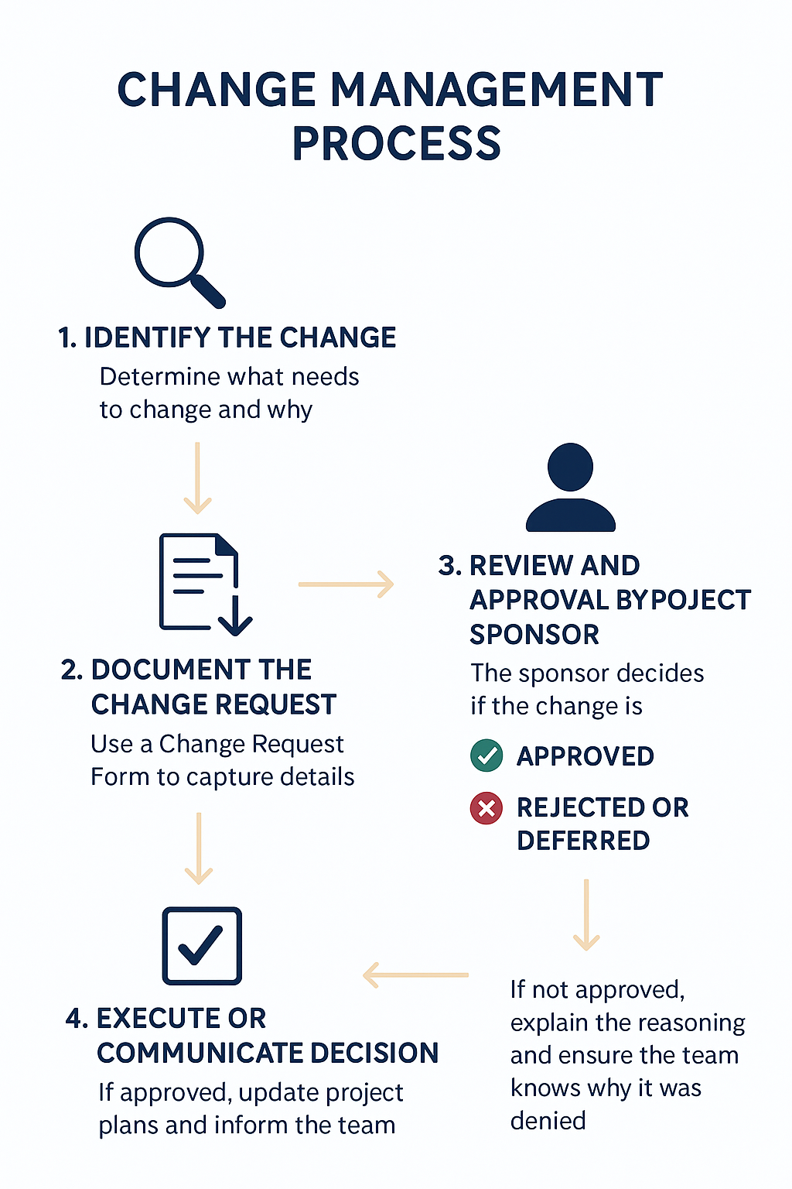**Steps in the Process**

**Steps in the Process**

1. **Identify the Change**

* Determine what needs to change and why.
* Example: A new feature request or a shift in requirements.

1. **Document the Change Request**

* Use a **Change Request Form** to capture details:
* Reason for change
* Priority level
* Impact on scope, schedule, cost, and resources

1. **Review and Approval by Project Sponsor**

* The sponsor decides if the change is:
* **Approved** – implement adjustments to scope, schedule, budget, and activities
* **Rejected or Deferred** – change is denied or postponed for a future phase

1. **Execute or Communicate Decision**

* If **approved**: update project plans and inform the team
* If **not approved**: explain the reasoning and ensure the team knows why it was denied

**Making Adjustments in a Project**

**1. Expect Change**

* No matter how well you plan, changes will happen (issues, hurdles, team changes, new business needs).
* Stay flexible—your project plan is not set in stone.

**2. Stay Balanced**

* Don’t reject every change, but don’t say yes to everything either.
* Always ask: *Will this change help or hurt the project?*
* Major decisions should go to the **Project Sponsor**, not you alone.

**3. Hold People Accountable**

* If tasks are not done on time, address it.
* First, talk directly to the person.
* If needed, escalate to their manager.
* Critical deadlines cannot just “slide.”

**4. Build Relationships**

* You don’t need to be everyone’s best friend, but treat people with respect.
* Recognize good work, give praise, and also hold people accountable when necessary.
* Strong relationships keep the project team motivated and moving forward.

**STAGE 4: Project Close**

Closing a project is more than just ending tasks and releasing resources. It’s about ensuring success, capturing lessons, and transitioning deliverables effectively.

**Key Steps in Closing a Project**

| **Step** | **What It Means** | **Why It Matters** |
| --- | --- | --- |
| 1. Confirm the Project Is Truly Done | Review KPIs, business objectives, and success metrics defined at the start. Check if they were met or exceeded. | Ensures the project achieved its intended purpose and delivered value. |
| 2. Conduct a Project Review | Gather the project team to discuss what went well, what didn’t, and how things can improve. Focus on solutions, not blame. | Helps improve processes and avoid repeating mistakes in future projects. |
| 3. Executing the Project Transition | Hand over systems, documents, or products to support teams or designated owners who will maintain them. | Ensures continuity and sustainability beyond the project team’s involvement. |

**Completing a Project**

Project completion doesn’t simply mean the requirements are done; it requires a verification process to confirm the project truly meets its objectives.

This process is usually documented in a simple Word or Excel file created by the Project Manager, containing project details like title, manager, sponsor, objectives, and rationale.

Verification focuses on several key aspects:

* **Budget, Schedule, and Quality:** Did the project stay within the planned budget and timeline, and meet quality standards? Successes should be highlighted briefly, while failures or overruns (like extra costs for licensing or added resources) should be explained in more detail.
* **Issues and Risks**: Open problems, such as bugs or risks like slow user adoption, should be recorded so they are visible after project closure.
* **Customer Satisfaction**: A high-level view of how satisfied the sponsor, users, and management are with the results. This feedback helps determine whether the project met expectations.

The level of detail depends on the organization and project, but the goal is to acknowledge what went well, what went wrong, and what lessons can be applied in the future.

**Conducting a Project Review:**

A project review has two main phases: gathering feedback from customers and then reviewing it with the project team. The purpose is to identify what went well, what didn’t, and how future projects can improve, while also addressing lingering customer concerns.

**Best Practices:**

Survey Questions (examples):

1. How successful was the project overall?
2. What went right? (up to 3 things)
3. What obstacles did you face? (up to 3 things)
4. What needs improvement or should have been done differently?
5. Any other comments?

* Keep meetings collaborative—one meeting is ideal, but for large groups, multiple sessions may be needed.
* Send a survey ahead of time to capture immediate feedback while the project is still fresh. This ensures better input, especially from those less likely to speak up in meetings.
* Always send an agenda in advance so participants know what to expect and come prepared.

**The Review Meeting:**

* Focus on both positives and negatives but avoid confrontation or finger-pointing.
* Facilitate constructive discussion based on survey results.
* Take notes on successes as well as areas for improvement.

**Post-Meeting Review:**

* Analyze results to identify avoidable vs. unique issues.
* Document lessons learned and proposed changes for future projects.
* Share findings with the sponsor, who can help drive organizational improvements.
* Reflect personally as Project Manager on mistakes and adjust for future planning.

A project review isn’t just about closing a project—it’s about learning. If lessons aren’t analyzed and applied, mistakes will keep repeating. By capturing feedback, documenting lessons, and creating an action plan, future projects can be more successful.

**Executing a Project Transition**

A project doesn’t end with delivery—it must be transitioned to a new owner, usually a support team, manager, or director who will handle future maintenance, support, and enhancements. Simply “dumping” documentation on them is ineffective and unfair. Instead, a structured transition process ensures smooth handover and continued success.

Four Key Steps in a Project Transition:

1. **Bundle Documentation**: Organize final product documentation (not schedules or internal project files) in an accessible location such as SharePoint or cloud storage. Structure folders clearly so the support team can find what they need.
2. **Provide Training**: Walk the support team through the system, key features, known risks, and how to resolve issues. Avoid a “dump and run”—help them understand the system.
3. **Review Common Questions/Issues**: Share the most frequent user questions or minor problems encountered during early use. This prepares the support team for typical support calls and helps them respond effectively.
4. **Execute the Transition**: Conduct a transition meeting to hand over documentation, train the team, and answer questions. Follow up a few days later to address new concerns.