**CSE 700 - INDEPENDENT STUDY**

**Dr. Jing Gao**

**By**

**Prasanna Pai**

**50132731**

**ppai2@buffalo.edu**

**SOCIAL NETWORKING FOR EMERGENCY AWARENESS**

Project Description:

The project of SOCIAL NETWORKING FOR EMERGENCY AWARENESS uses natural language processing techniques and machine learning algorithms to extract situation awareness information from Twitter and Facebook messages generated during various disasters and cries. These techniques are then analyzed for social networking patterns and clustered depending on their similarities and plotted on Google Maps for location of the messages which are then used by other people to track the victims. The architecture can clearly provide situation awareness using on-the-ground information from various Social Media networks which will help establish timely situation awareness and evacuation.

Tools used:

Python Twitter Streaming API, JSON, GeoJSON, JQuery, Leaflet.js, OpenStreetMap API

Process:

1. Extracted the relevant tweets for emergency situations like ‘flood’ or ‘earthquake’ from Twitter using Streaming API in the form of JSON
2. The tweets were extracted in such a way that the situational tweets were followed by the reaction tweets from the people about their experiences in those situations.
3. These tweets are then scanned for location coordinates. The location coordinates in the tweets are present in coordinates tag and location tag. The location tag is usually the location of the user whereas the coordinates tag contain the location coordinates of the tweet if the geo feature has been enabled by the user.
4. These coordinates were then harvested using GeoJSON feature to extract only the coordinates of the tweets present in the JSON data.
5. These coordinates were then mapped using the OpenStreetMap API by using Leaflet.js to position the exact location of the situation or the person tweeting about the situation.

Screenshots of the project:

JSON extraction from Twitter Streaming API

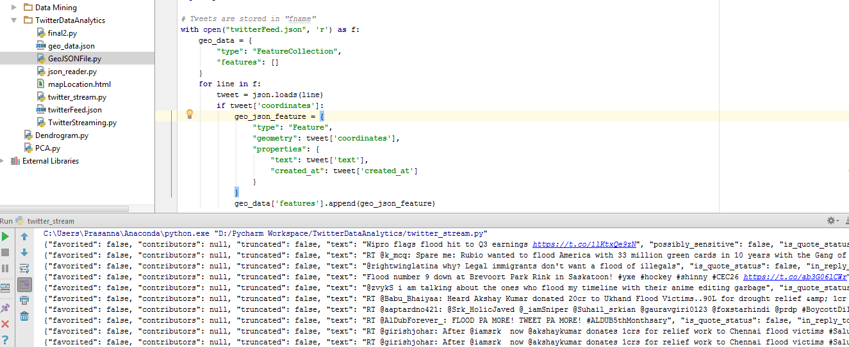

JSON Parsing for location coordinates

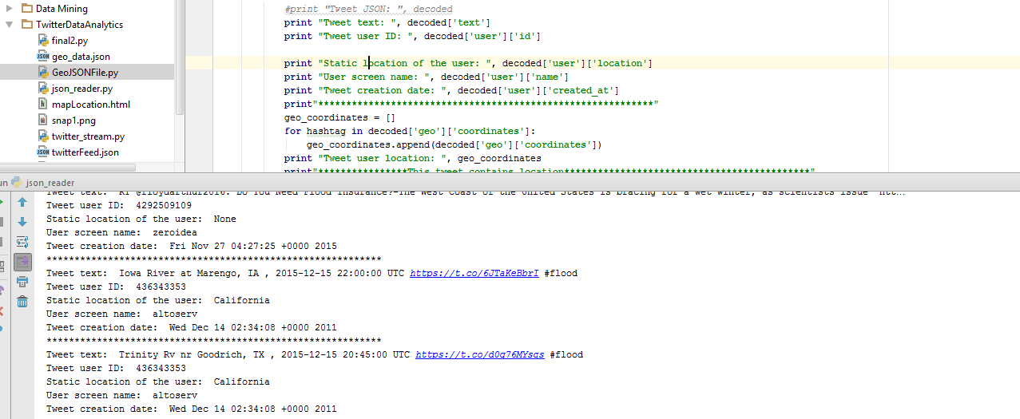

GeoJSON to extract the location coordinates of the tweets

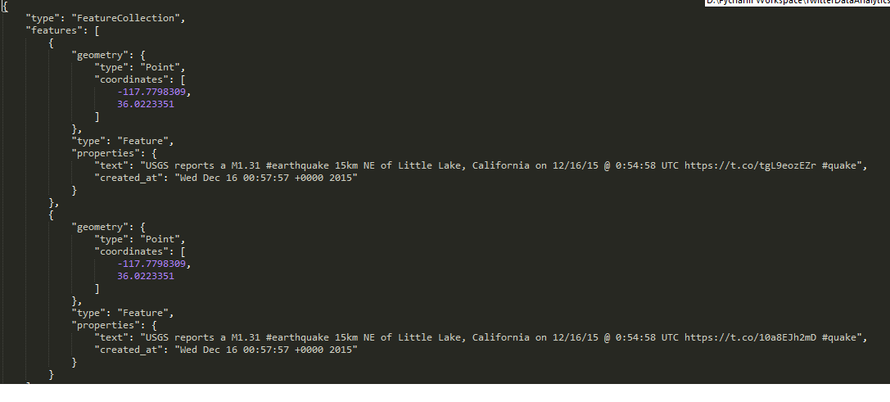

Location plotted on Maps using OpenStreetMap API and Leaflet.js

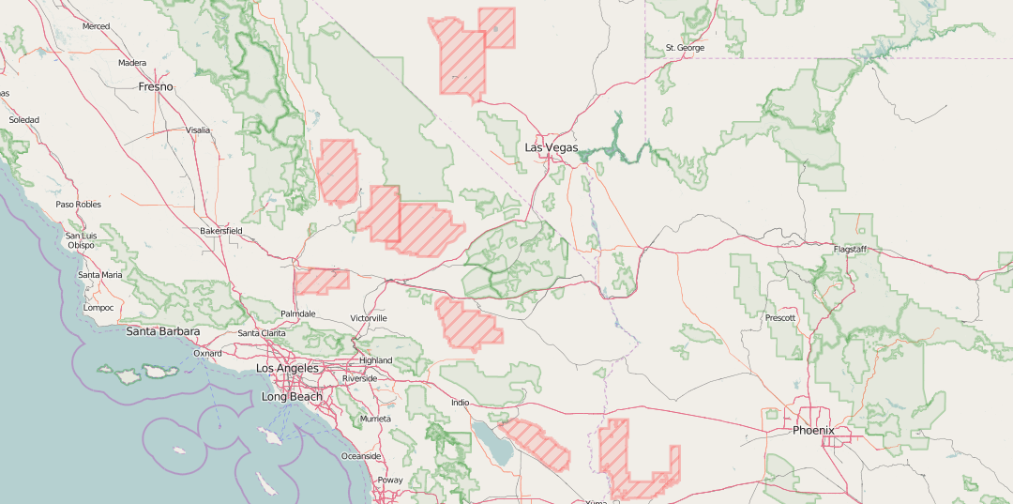

Challenges faced in the project:

1. Difficult to map location of the tweets since geo feature is null or disabled in most of the devices
2. Huge volumes of data and higher configuration devices needed to monitor the emergency situation and store the data
3. Location parameter is null in most of the tweets which makes it difficult to track the user or the tweet

Scope of the project:

1. Can be used to monitor real time situations like earthquakes and floods
2. Efficient and quick in getting the reaction tweets which makes it easier to determine the severity of the situation
3. Accuracy of the data in tweets can be a reliable factor