I. Used software:

-MySQL

-Eclipse IDE for Webdevelopers and JavaScript

-Apache Tomcat v 8.0

II. Run instruction:

1. Using MySQL run Employees.sq script to create schema „demo” within which table "empolyees" with columns

"id", "last_name", "first_name", "email". Created table should look like as on the picture „Table_Employees.jpg

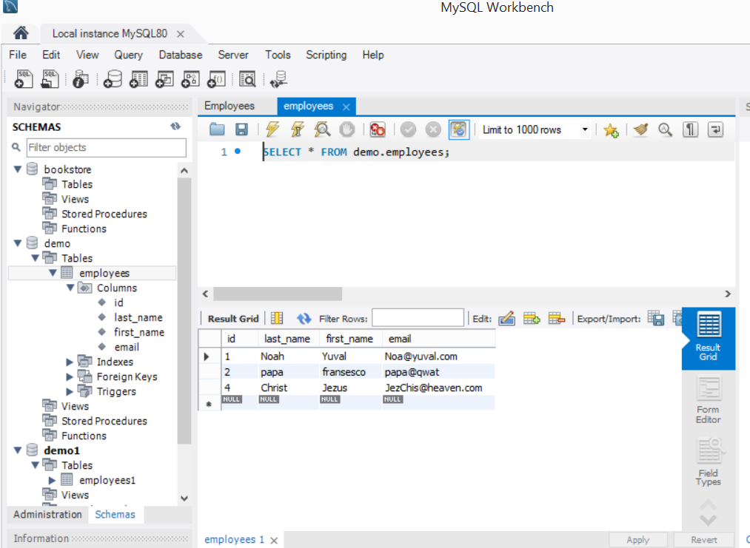

4. Use eclipse IDE to open "WebApp" project.

With the structure presented on the following

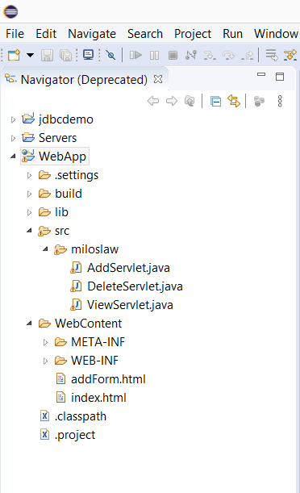 picture.

5. Right click on "WebApp" project within Eclipse IDE choose "Run as"->"Run on Server". Use Tomcat server to run the app. Page looks as follows:

