1. Thermodynamic Laws
   1. Zeroth (0th) Law

**“If two systems are in thermal equilibrium with a third system, they are in thermal equilibrium with each other”**

Introduces the thermodynamic intensive variable of temperature (*T*)

* 1. First (1st) Law

**“When energy passes, as work, as heat, or with matter, into or out from a system, the system's internal energy changes in accord with the law of conservation of energy”**

Conservation and conversion of energy

Defines extensive thermodynamic state variable of internal energy (*U*)

* 1. Second (2nd) Law

**“In a natural thermodynamic process, the sum of the entropies of the interacting thermodynamic systems increases”**

Defines the extensive thermodynamic state variable of entropy (*S*)

* 1. Third (3rd) Law

**“The entropy of a system approaches a constant value as the temperature approaches absolute zero”**

For systems in internal equilibrium, sets the zero of entropy at minimum in temperature (0K) and at the minimum in internal energy.

1. Mathematical Transforms
   1. Total Derivative
   2. Inverse Relation Among Partial Derivatives
   3. Ratio Relation for Partials
   4. Relation for Partials with Three Variables
   5. Chain Rule
   6. Exact Equation Criteria
   7. Legendre Transformations
   8. Stirling’s Approximation
   9. Other Approximations
2. State Functions
   1. Volume

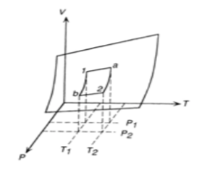

Figure 1: Reference figure borrowed from Laughlin’s notes for the equilibrium states of a fixed quantity of gas in V-P-T space, shown to lie on a surface

1. Processes
   1. Constraints
2. Third Law
3. Relevant Examples