Thermodynamic Laws

**0th**: **“If two systems are in thermal equilibrium with a third system, they are in thermal equilibrium with each other”** Introduces the thermodynamic intensive variable of temperature (*T*)

**1st**: **“When energy passes, as work, as heat, or with matter, into or out from a system, the system's internal energy changes in accord with the law of conservation of energy”** Conservation and conversion of energy: Defines extensive thermodynamic state variable of internal energy (*U*)

**2nd**: **“In a natural thermodynamic process, the sum of the entropies of the interacting thermodynamic systems increases”** Defines the extensive thermodynamic state variable of entropy (*S*)

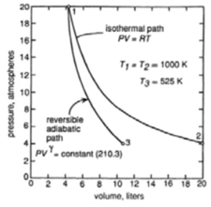**3rd**: **“The entropy of a system approaches a constant value as the temperature approaches absolute zero”** For systems in internal equilibrium, sets the zero of entropy at minimum in temperature (0K) and at the minimum in internal energy.

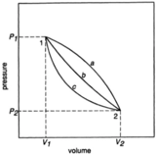Mathematical Transforms

;;

;

;

State Functions

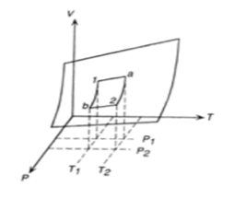

Processes: Constraints

Heat Capacity (*C*) - ratio of thermal energy added to or withdrawn from a system (of fixed composition) to the resultant change in the temperature of the system

Heat Capacity is path dependent:

also: and CP > CV

per mole:

|  |  |  |
| --- | --- | --- |
|  | CV | CP |
| 1 |  |  |
| 2 |  |  |

More exactly:

The two expressions for the difference in heat capacities are equal if

This is true for an ideal gas in which U’ is not a function of V’, that is U’=U’(T)

Reversible Adiabatic

since

thus:

Isothermal Reversible Expansion

An *isothermal* process is one of constant internal energy during which the work done by the system equals the thermal energy absorbed by the system

A decrease in pressure results in the work done by the *reversible isothermal process* (area under curve) exceeds that done by the *reversible adiabatic process*. This difference is from the *isothermal process* making the system absorb thermal energy in order to maintain constant temperature, whereas *adiabatic process* block thermal energy into system.

Other diagram shows 3 process paths for a fixed quality of gas from state 1 to state 2

and valid in isothermal expansion

The transfer of thermal energy (*q*) and the performance of work (*w*) are processes which occur on the system and are not intrinsic to the system and are not properties of the system. When performed on or by the system they do however change the properties of the system. In the case of a *cyclic process* the change in U is zero

In the reversible adiabatic expansion, where (*U2-U1)=-w*, the process since the process was adiabatic (*q=0*), thus the path of the process was specified and ΔU could be calculated

U’ is an extensive state variable, a simple system consisting of a given amount of substance of fixed composition, the value of U’ is fixed once any two independent variables are fixed. If temperature and volume are chosen, then:

DeHoff calls & coefficient relations

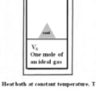Reversible Isothermal Expansion with Entropy (*q/T*)

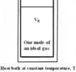(+) *w* since work done by system; (+) q since thermal energy into the system

; The entropy of the gas increases