Github path: <https://github.com/ppanan11/eMart>

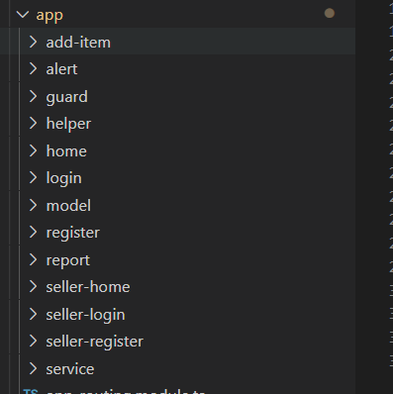

Jasmine test: app.component.spec.ts

import {TestBed, async} from '@angular/core/testing';

import {RouterTestingModule} from '@angular/router/testing';

import {AppComponent} from './app.component';

import { HttpClientModule, HttpClient } from '@angular/common/http';

fdescribe('AppComponent', () => {

  beforeEach(async(() => {

    TestBed.configureTestingModule({

      imports: [

        RouterTestingModule,HttpClientModule

      ],

      declarations: [

        AppComponent

      ],

      providers:[HttpClient]

    }).compileComponents();

  }));

  it('should create the app', () => {

    const fixture = TestBed.createComponent(AppComponent);

    const app = fixture.componentInstance;

    expect(app).toBeTruthy();

  });

  it(`should have as title 'eMart'`, () => {

    const fixture = TestBed.createComponent(AppComponent);

    const app = fixture.componentInstance;

    expect(app.title).toEqual('eMart');

  });

});

