**Source code :**

|  |
| --- |
| # Create a dataset for 10 students  > student_data <- data.frame(  + Attendance = c(75, 88, 92, 60, 85, 70, 95, 80, 65, 90),  + CGPA = c(7.0, 8.5, 9.0, 6.0, 8.2, 6.8, 9.5, 7.8, 6.5, 8.9)  + )  >  > # View the data  > print(student_data)  Attendance CGPA  1 75 7.0  2 88 8.5  3 92 9.0  4 60 6.0  5 85 8.2  6 70 6.8  7 95 9.5  8 80 7.8  9 65 6.5  10 90 8.9  >  > # Plot attendance vs CGPA  > plot(student_data$Attendance, student_data$CGPA,  + main = "Student Attendance vs CGPA",  + xlab = "Attendance (%)",  + ylab = "CGPA",  + pch = 19, col = "darkgreen")  >  > # Add regression line  > abline(lm(CGPA ~ Attendance, data = student_data), col = "red", lwd = 2)  >  > # 1. Boxplot for Attendance and CGPA  > boxplot(student_data$Attendance, student_data$CGPA,  + names = c("Attendance", "CGPA"),  + main = "Boxplot of Attendance and CGPA",  + col = c("lightblue", "lightgreen"))  > hist(student_data$Attendance,  + main = "Histogram of Attendance",  + xlab = "Attendance (%)",  + col = "lightblue",  + border = "white")  > plot(student_data$Attendance, student_data$CGPA,  + main = "Scatterplot: Attendance vs CGPA",  + xlab = "Attendance (%)",  + ylab = "CGPA",  + pch = 19, col = "blue")  > attendance_groups <- cut(student_data$Attendance,  + breaks = c(0, 65, 75, 85, 100),  + labels = c("Low (<65%)", "Moderate (65-75%)", "High (75-85%)", "Very High (>85%)"),  + right = FALSE)  >  > attendance_table <- table(attendance_groups)  >  > pie(attendance_table,  + main = "Pie Chart of Attendance Groups",  + col = c("red", "orange", "yellow", "green")) |
|  |
| |  | | --- | | > | |

Aditya

**Output :**

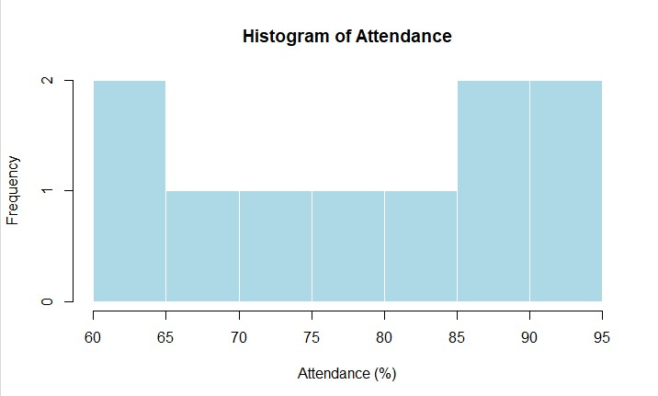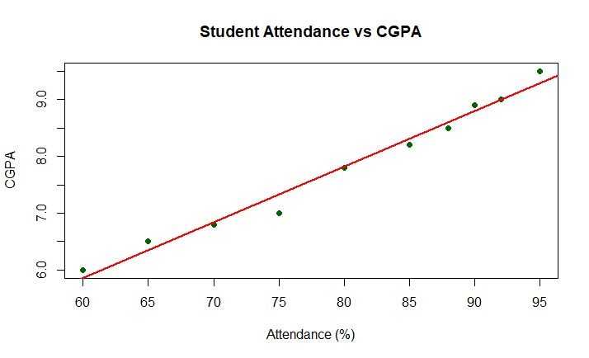

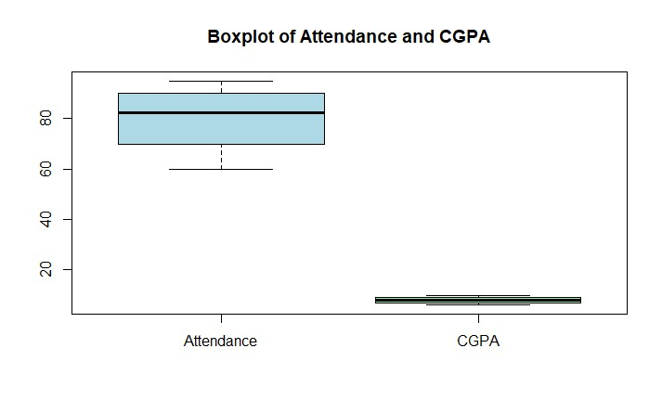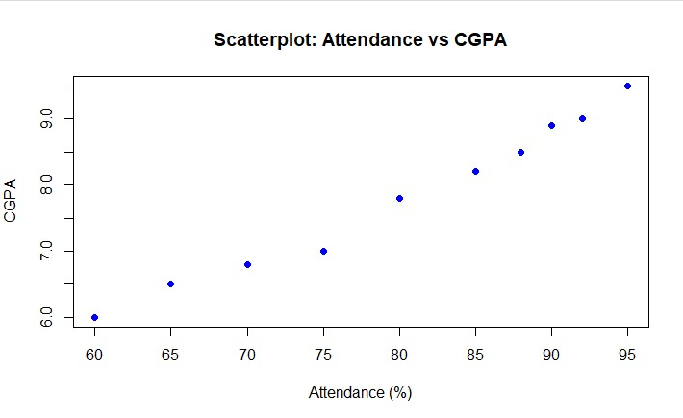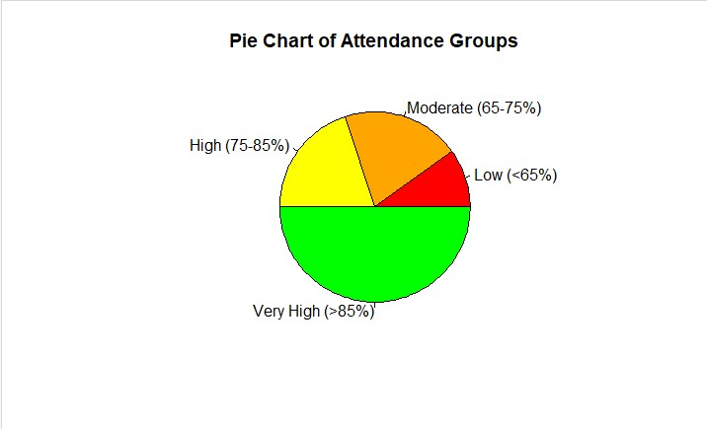

Conclusion :