Bonding Agent Effects on Plain-Bar Pull-Out in Low-Strength Concrete and Peak-Load Behavior of Cast-In GFRP Bars
Efectos de los agentes de adherencia en la extracción de barras lisas en concreto de baja resistencia y comportamiento de carga máxima de barras de PRFV embebidas
Piyarat Paoleng¹, Siriphat Maneekeaw¹, Sirisak Kongsomsaksakul¹, Krairoj Mahannopkul¹, Ittipon Meepon^{1,*}
¹ Department of Teacher Training in Civil Engineering, Faculty of Technical Education, King Mongkut’s University of Technology North Bangkok, Bangkok 10800, Thailand
* Corresponding author: Ittipon Meepon, ittipon.m@fte.kmutnb.ac.th
ORCID: P. Paoleng 0009-0008-5332-1007; S. Maneekeaw 0009-0002-0435-2866; S. Kongsomsaksakul 0009-0001-2352-5550; K. Mahannopkul 0000-0002-6207-0958; I. Meepon 0000-0001-5353-3511
Afiliación: Departamento de Formación de Profesores en Ingeniería Civil, Facultad de Educación Técnica, Universidad Tecnológica King Mongkut del Norte de Bangkok, Bangkok 10800, Tailandia.

Abstract
This study reports 180 pull-out tests on post-installed plain steel bars and cast-in glass fibre-reinforced polymer (GFRP) bars in 150 mm concrete cubes with a bonded length of 140 mm. Three nominal concrete-strength levels (4.9, 14.7 and 23.5 MPa) and three bar diameters (6, 9 and 12 mm) were investigated, with five specimens per group. Plain bars installed using epoxy, non-shrink grout and cement mortar had pooled mean bond stresses of 1.88, 0.43 and 0.021 MPa, respectively. Bonding agent showed the largest partial effect in the exploratory factorial analysis (partial η² = 0.73). At the 14.7 MPa nominal level, GFRP group mean peak loads were 20.8–21.7 kN across diameters; the pooled load did not show a detectable increase at the 23.5 MPa level. These observations apply to the tested configuration and do not establish diameter independence. Companion-cube strengths were 5.8, 13.4 and 17.9 MPa, and nominal strength was confounded with mixture preparation and curing. The results provide comparative experimental observations rather than design capacities.
Keywords: bond strength; pull-out test; plain steel bars; bonding agents; GFRP bars

Resumen
Este estudio presenta 180 ensayos de extracción de barras lisas de acero instaladas posteriormente y barras de polímero reforzado con fibra de vidrio (PRFV) embebidas en cubos de concreto de 150 mm, con una longitud adherida de 140 mm. Se investigaron tres niveles nominales de resistencia (4,9, 14,7 y 23,5 MPa) y diámetros de 6, 9 y 12 mm, con cinco especímenes por grupo. Las tensiones medias de adherencia de las barras lisas con epoxi, lechada sin retracción y mortero fueron 1,88, 0,43 y 0,021 MPa. El agente presentó el mayor efecto parcial en el análisis exploratorio (η² parcial = 0,73). Para PRFV, las cargas medias a 14,7 MPa fueron 20,8–21,7 kN; no se detectó un aumento conjunto a 23,5 MPa. Esto no demuestra independencia respecto al diámetro. Las resistencias medidas fueron 5,8, 13,4 y 17,9 MPa; los niveles nominales se confundieron con la preparación y el curado. Los resultados son observaciones comparativas, no capacidades de diseño.
Palabras clave: resistencia de adherencia; ensayo de extracción; barras lisas de acero; agentes de adherencia; barras de PRFV
[ตรวจสอบ 1: เอกสารแนบต่างจาก v7 เชิงโครงสร้าง AI จึงใช้ v7 เป็นฐานและปรับเฉพาะถ้อยคำ โดย: (ก) คงการอ้างอิงแบบตัวเลข [n] (เอกสารแนบใช้ผู้แต่ง–ปี; AI แปลงให้ตรงกับรายการอ้างอิงเดิมแล้ว และตัดงานของ Jafari 2025 กับ Tang 2021 ออกจากรายการเพราะไม่ถูกอ้างถึงในถ้อยคำใหม่); (ข) คงตารางเปรียบเทียบรายคู่, ตาราง stability, ตารางสมมติฐาน และ Appendix B ไว้ในเนื้อหา (เอกสารแนบย้ายเป็น Supplementary Table S4, S3, S1 และ S2 → ในเอกสารนี้คือ Table 7, 9, 13 และ Table B1); (ค) คงรูป Fig. 3–5 และ 7–9 ที่เอกสารแนบไม่มี โดยเพิ่มการอ้างรูปในข้อความ; (ง) เพิ่มชื่อเรื่อง บทคัดย่อ คำสำคัญ และสังกัดภาษาสเปนตามเอกสารแนบ (AI ไม่ได้ตรวจคำแปล) และใส่ hyphen ในชื่อเรื่องภาษาอังกฤษ (Plain-Bar, Low-Strength, Peak-Load, Cast-In). คำถาม: ต้องการเปลี่ยนข้อใดให้เป็นแบบเอกสารแนบ]

1. Introduction
Bond transfers load between reinforcement and concrete through adhesion, friction and, for ribbed bars, mechanical interlock [1, 2]. Plain round bars rely principally on adhesion and friction [3]. Their behaviour therefore differs from the ribbed bars underpinning conventional development-length provisions [4, 5]; models specifically addressing plain bars remain relevant [6].
Low concrete strength and construction deficiencies have been documented in existing buildings [7–10]. Repair frequently involves bars installed in drilled holes. Bonding-agent selection requires evidence applicable to the concrete, reinforcement and installation procedure being used.
Studies of post-installed reinforcement have compared chemical adhesives and cementitious binders [11–16]. Grout research also covers ducts, sleeves and anchoring systems [17–24]. These configurations provide useful context but cannot directly predict the resistance of plain bars installed in weak, unconfined concrete cubes.
The present programme compares epoxy, non-shrink grout and ordinary cement mortar using one installation protocol for plain round bars below 25 MPa nominal concrete strength. The literature search was targeted rather than systematic; no claim of an exhaustive research gap is made.
GFRP bond depends on bar surface, concrete and specimen geometry [25–33]. FRP design expressions account for cover, diameter and embedment [34, 35], but their applicability to the present low-strength, long-embedment configuration requires caution.
The objectives were to compare bonding agents for post-installed plain bars, describe associations with nominal concrete-strength level and diameter, screen possible limits imposed by bar capacity, and characterize cast-in GFRP peak loads and apparent bond stresses. Cross-system comparisons are descriptive because installation methods differ.

2. Experimental programme

2.1 Test matrix and provenance of the data
Two bar systems were tested under one protocol (Table 1, Fig. 1). Plain round steel bars of 6, 9, and 12 mm (RB6, RB9, RB12) were post-installed in drilled holes with epoxy, non-shrink grout, or cement mortar, and GFRP bars of 6, 9, and 12 mm were cast into the concrete. Each bar was pulled from a 150 mm concrete cube with a bonded length l_{e} = 140 mm. Nominal concrete strengths were 4.9, 14.7, and 23.5 MPa (50, 150, and 240 ksc). Five specimens per group gave 135 plain-bar specimens (3 diameters × 3 agents × 3 strengths × 5) and 45 GFRP specimens (3 diameters × 3 strengths × 5), 180 in all.
Plain bars were post-installed, whereas GFRP bars were cast in without a bonding agent; this difference prevents isolation of a bar-material effect. Groups are labelled by nominal grades rather than measured strengths. The statistical analyses were conducted retrospectively after inspection of the experimental dataset; therefore, the inferential results should be interpreted as exploratory rather than confirmatory.
Table 1. Test matrix.
Series | Bar | Diameters (mm) | Installation | Bonding agent | Nominal f′_{c} (MPa) | Groups × n | Specimens
RB | Plain round steel | 6, 9, 12 | Post-installed | Epoxy, non-shrink grout, cement mortar | 4.9, 14.7, 23.5 | 27 × 5 | 135
GFRP | GFRP bar | 6, 9, 12 | Cast-in | None | 4.9, 14.7, 23.5 | 9 × 5 | 45
Total |  |  |  |  |  | 36 groups | 180

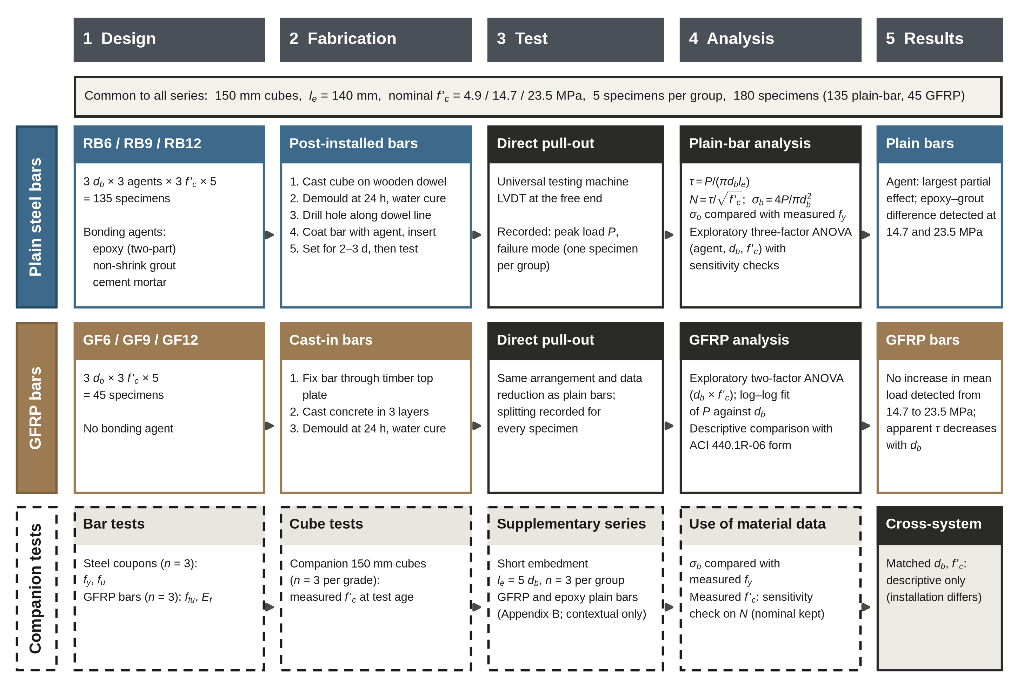
Fig. 1. Experimental programme and analysis workflow. The main series contains 180 specimens. Material tests and the supplementary short-embedment series are separate.
[ตรวจสอบ 2: ตามโน้ตเรื่อง overclaim ใน Fig. 1: เปลี่ยนหัวคอลัมน์ “Findings” เป็น “Results”; “Agent governs; epoxy gap opens from 14.7 MPa” เป็น “Agent: largest partial effect; epoxy–grout difference detected at 14.7 and 23.5 MPa”; “Load plateau above 14.7 MPa; apparent τ falls with db” เป็น “No increase in mean load detected from 14.7 to 23.5 MPa; apparent τ decreases with db”; “Three-factor/Two-factor ANOVA” เป็น “Exploratory …”; “ACI 440.1R-06 form” เป็น “Descriptive comparison with ACI 440.1R-06 form”; ชุดเสริมระบุ “contextual only”. คำถาม: มีตำแหน่งอื่นในรูปที่ยังดู overclaim หรือไม่]

2.2 Materials
Plain steel bars were designated SR24 in the source report, which cites TIS 20-2527. Nominal diameters were used. Table 2 reports three tensile coupons per diameter; the coupon batch relationship and steel test standard were not documented.
Table 2. Tensile properties of the SR24 plain round bars from coupon tests.
Bar | d_{b} (mm) | Nominal area (mm²) | n | Yield strength f_{y}, mean (SD) (MPa) | Tensile strength f_{u}, mean (SD) (MPa) | f_{u} / f_{y} | Elongation (%)
RB6 | 6 | 28.3 | 3 | 352 (8) | 448 (6) | 1.27 | 26
RB9 | 9 | 63.6 | 3 | 326 (6) | 441 (5) | 1.35 | 28
RB12 | 12 | 113.1 | 3 | 305 (7) | 436 (6) | 1.43 | 30

GFRP bars of 6, 9 and 12 mm were tested using a steel-tube grip filled with non-shrink grout. Tensile properties from three bars per diameter were reported following ASTM D7205/D7205M [36] (Table 3). Surface treatment and fibre content were not documented.
Table 3. Tensile properties of the GFRP bars (n = 3 per diameter). Maximum observed loads are those reported in Section 3.6.
Bar | d_{b} (mm) | Area (mm²) | f_{fu}, mean (SD) (MPa) | E_{f} (GPa) | ε_{fu} (%) | F_{fu} (kN) | Max observed P (kN) | Max P / F_{fu}
GF6 | 6 | 28.3 | 1040 (36) | 46.5 | 2.24 | 29.4 | 22.23 | 0.76
GF9 | 9 | 63.6 | 905 (31) | 45.8 | 1.98 | 57.6 | 24.18 | 0.42
GF12 | 12 | 113.1 | 812 (28) | 45.1 | 1.80 | 91.8 | 25.76 | 0.28

Concrete was prepared from commercial pre-blended dry mix. The weakest mixture included an equal mass of coarse sand (2.00–4.75 mm); the two higher nominal levels used undiluted dry mix and differed in recorded curing period (Table 4). Companion-cube results and recorded test ages are in Table 5. GFRP cubes used 5–6 L of water per bag of dry mix; the bag mass was not documented.
Table 4. Concrete mixtures used for the plain-bar series, as recorded in the source project (batch masses).
Nominal strength | Dry-mix concrete (kg) | Water (kg) | Coarse sand (kg) | Curing period (d)
4.9 MPa (50 ksc) | 150 | 50 | 150 | 5
14.7 MPa (150 ksc) | 300 | 48 | – | 7
23.5 MPa (240 ksc) | 300 | 48 | – | 14

Table 5. Compressive strength of companion 150 mm cubes at the age of the pull-out test.
Nominal grade (MPa) | Mixture | Curing (d) | Age at test (d) | n | Measured f′_{c}, mean (SD) (MPa) | CV (%) | Measured / nominal
4.9 (50 ksc) | Dry mix + equal mass of sand | 5 | 8 | 3 | 5.8 (0.6) | 10.3 | 1.18
14.7 (150 ksc) | Dry mix | 7 | 10 | 3 | 13.4 (1.0) | 7.5 | 0.91
23.5 (240 ksc) | Dry mix | 14 | 17 | 3 | 17.9 (1.3) | 7.3 | 0.76

The agents were a two-component epoxy paste, ready-mixed non-shrink cementitious grout and bagged cement mortar. The source quotes manufacturer-declared grout strengths above 300 and 850 ksc (approximately 29 and 83 MPa); these are not independent measurements. Product identifiers, mixing ratios and the age associated with the second grout value were not documented.

2.3 Specimen preparation
Concrete was placed in three layers in oiled 150 mm moulds, with 25 roddings per layer. For plain bars, a wooden dowel marked the hole position and was withdrawn after about one hour. Cubes were demoulded after 24 h, drilled, and fitted with bars dipped in freshly mixed agent. Records indicate two to three days between installation and testing (Fig. 2). Hole diameter, cleaning and complete filling procedures were not documented.
GFRP bars were held centrally by perforated timber plates during casting. Cubes were demoulded after 24 h and water-cured for the same periods as the plain-bar cubes (Tables 4 and 5).
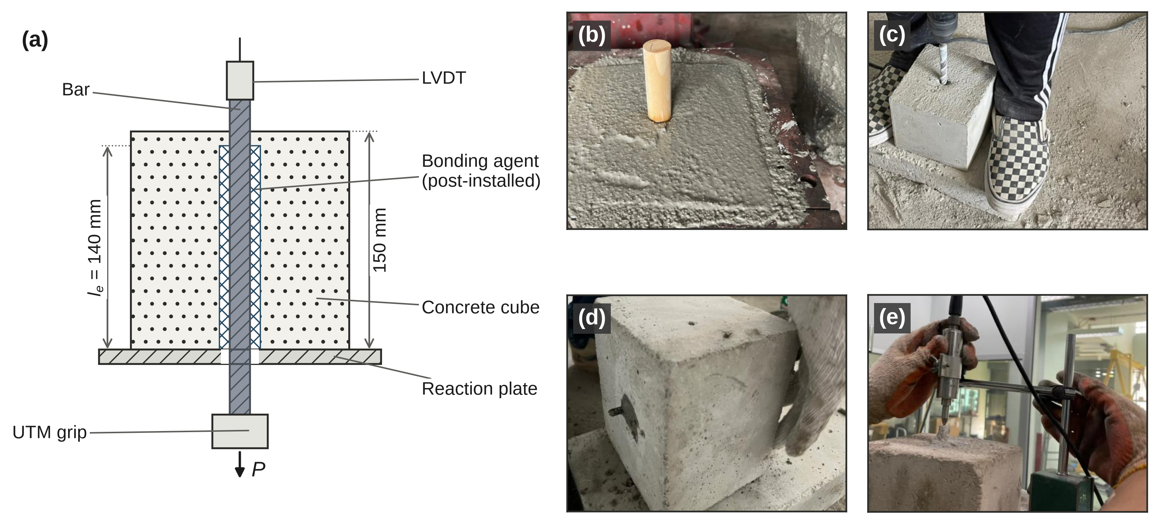
Fig. 2. Specimen and test arrangement. (a) Schematic with 140 mm bonded length in a 150 mm cube. (b) Dowel positioning. (c) Drilling. (d) Installed bar. (e) Free-end LVDT. Photographs are from the source project. GFRP specimens had no bonding-agent annulus.

2.4 Pull-out test
A universal testing machine applied direct pull-out while the cube reacted against a plate; free-end slip was recorded by an LVDT. The source adopted ASTM C234 [37]. Peak load P was the response analysed. Loading rate, instrument resolution and calibration records were not documented. Failure mode was recorded for one representative specimen per plain-bar group and all GFRP specimens. The separate 27-specimen short-embedment series (Appendix B, Table B1) is provided as supplementary contextual evidence.
ASTM C234 was withdrawn in 2000. The present geometry also differs from ACI 440.3R-04 Annex B.3 [38]. With l_{e}/d_{b} = 11.7–23.3, reported bond stress is an apparent average over a long embedment and is not a local interface strength.

2.5 Data reduction
Average bond stress was computed using peak load P in newtons and nominal diameter d_{b} and embedment l_{e} in millimetres, giving τ in MPa:
$τ=\frac{P}{πd_{b}l_{e}}$ (1)
and a strength-normalised value N was obtained by dividing by the square root of the nominal concrete strength (MPa units),
$N=\frac{τ}{\sqrt{{f'}_{c}}}$ (2)
The nominal stress in the bar at peak load was also computed,
$σ_{b}=\frac{4P}{π{d_{b}}^{2}}$ (3)
Bar stress was compared with coupon yield strength (Table 2) as a screening measure. This comparison does not establish whether an individual embedded bar yielded. Recorded zero loads were retained as zero in the reported analyses; they indicate zero recorded resistance, not proven absence of physical bond.
For the GFRP series, measured N was compared with the bond-strength expression of ACI 440.1R-06 [34] in the form quoted by Shbeeb et al. [35],
$\frac{τ}{\sqrt{{f'}_{c}}}=0.33 + 0.025\left(\frac{c}{d_{b}}\right)+ 8.3\left(\frac{d_{b}}{l_{e}}\right)$ (4)
Cover was assumed as c = (150 − d_{b})/2. The uncapped expression is used only for a descriptive comparison; c/d_{b} capped at 3.5 is also reported as a sensitivity calculation. This comparison is not a code-compliance assessment.

2.6 Statistical analysis
The source analysis reports a three-factor ANOVA for plain-bar bond stress (agent, diameter and nominal strength; n = 135), using Type III tests and sum-to-zero coding. Partial eta squared (η_{p}²) is a model-specific partial effect size, not the percentage of total physical variation explained. Reported sensitivity checks include Freedman–Lane permutations (4,000), HC3 Wald tests, square-root, log(τ + 0.1) and rank transformations, specimen subsets and exclusion of a splitting representative (Table 9). Pairwise comparisons used Welch tests with Hedges’ g and selected Mann–Whitney tests; trends used Spearman and Kruskal–Wallis tests, and zero-recorded-load proportions used Fisher’s exact test.
The source reports two-way ANOVA for GFRP responses (diameter × nominal strength; 36 error degrees of freedom). Diameter scaling was fitted in log–log form:
$P=k{d_{b}}^{b}$ (5)
For GFRP, fits were made within each nominal strength; for positive-load plain-bar observations, nominal strength was included as a fixed effect. Exponents of 1 and 2 represent idealized perimeter and area scaling, respectively; an exponent near zero describes weak diameter dependence within the fitted range. No multiplicity correction was applied. The source states that Python (NumPy, SciPy) and specimen-level data were used.
[ตรวจสอบ 3: ประโยคจากเอกสารแนบที่เป็นข้อเท็จจริงใหม่ ไม่มีใน v7 และ AI ยืนยันไม่ได้ — โปรดตรวจ: (หัวข้อ 2.2) “Product identifiers, mixing ratios and the age associated with the second grout value were not documented”; (หัวข้อ 2.3) “Hole diameter, cleaning and complete filling procedures were not documented”; (หัวข้อ 2.4) “Loading rate, instrument resolution and calibration records were not documented”; (หัวข้อ 4.8) “Raw load records, zero-value provenance and analysis code are required to reproduce the statistical claims” และ “calibration … undocumented”; (หัวข้อ 4.6) ประโยคและอ้างอิง ASTM D7913/D7913M-26 (AI ตรวจแล้วว่ามาตรฐานนี้มีจริง: Standard test method for bond strength of FRP matrix composite bars to concrete by pullout testing; ไม่ใส่ DOI เพราะยืนยันไม่ได้); และสำนวน “The source analysis reports …” (หัวข้อ 2.6) ซึ่งอาจทำให้เข้าใจว่าการวิเคราะห์ไม่ใช่ของผู้เขียนเอง. คำถาม: ยืนยันข้อความเหล่านี้หรือไม่]
[ตรวจสอบ 4: ประโยคเชิง “ต้องตรวจกับบันทึกต้นทาง” ในเอกสารแนบที่ไม่ได้นำมาใส่ในเนื้อหา เพราะเป็นงานที่ยังต้องทำไม่ใช่ข้อความในบทความ และบางข้อขัดกับข้อเท็จจริงที่คุณยืนยันแล้ว: (1) “bag mass and series-specific batch equivalence require source verification” → เขียนเป็น “the bag mass was not documented” และใช้ Table 5 กับทั้งสองชุดตามที่ยืนยัน; (2) “relation between curing periods and ages in Table 5 should be verified…” → ใช้ “same periods as the plain-bar cubes”; (3) “detection threshold and handling of unrecorded or failed tests require verification” → ตัดออก; (4) “exchangeability … requires assessment from the underlying records” → “which was not assessed”; (5) “Low within-group variability … requires comparison with original instrument records” → ระบุค่า CV และให้ตรวจกับบันทึกโหลด (เหมือน v7); (6) “raw data are needed to verify the reported inferential results” → “repeating the N analyses with measured strengths requires specimen-level data”. คำถาม: ยืนยันการเปลี่ยนถ้อยคำเหล่านี้]

3. Results

3.1 Effect of the bonding agent
Pooled mean bond stresses were 1.88 ± 1.64 MPa for epoxy, 0.43 ± 0.44 MPa for grout and 0.021 ± 0.055 MPa for mortar (mean ± SD; n = 45 per agent; Table 6 and Fig. 3). Epoxy exceeded grout by 1.45 MPa (Welch p < 0.001, g = 1.19), and grout exceeded mortar by 0.41 MPa (p < 0.001, g = 1.28; Table 7). Maximum recorded stresses were 5.75, 1.58 and 0.27 MPa, respectively. Group-level values are given in Table A1.
Zero recorded loads occurred in 6/45 epoxy, 16/45 grout and 36/45 mortar specimens (Fig. 4c). Exploratory Fisher comparisons gave p = 0.03 for epoxy versus grout and p < 0.001 for grout versus mortar.
Table 6. Bond stress τ (MPa) of the plain-bar series by bonding agent and nominal concrete strength, mean (SD).
Agent | 4.9 MPa | 14.7 MPa | 23.5 MPa | All strengths | Zero load, of 45 | Highest τ
Epoxy | 1.00 (1.37) | 1.50 (0.86) | 3.13 (1.78) | 1.88 (1.64) | 6 | 5.75
Non-shrink grout | 0.55 (0.54) | 0.37 (0.50) | 0.37 (0.23) | 0.43 (0.44) | 16 | 1.58
Cement mortar | 0.00 (0.00) | 0.04 (0.08) | 0.03 (0.04) | 0.02 (0.05) | 36 | 0.27
Each strength cell pools the three diameters (n = 15); the last columns pool all 45 specimens per agent. Zero-load specimens are included as zeros.

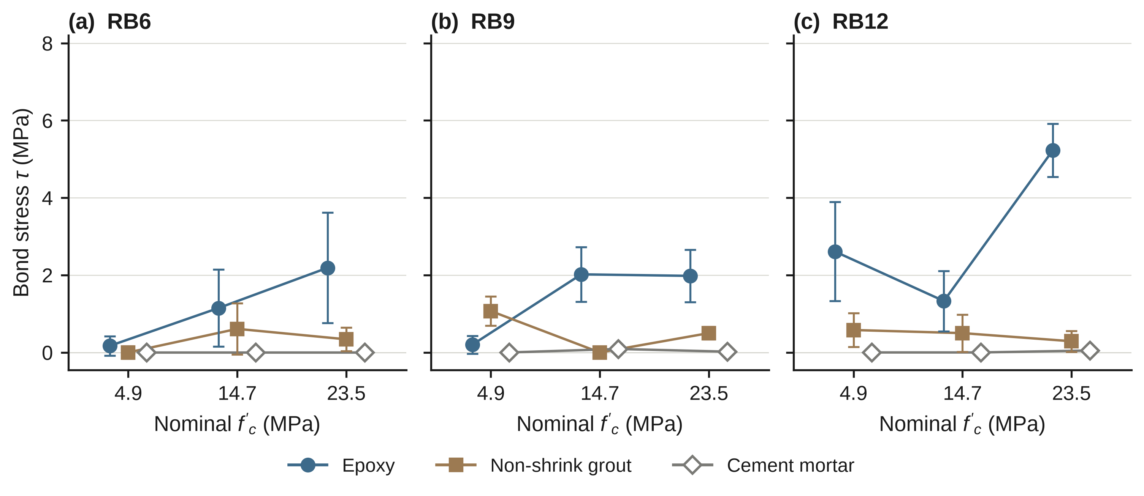
Fig. 3. Bond stress τ of the plain-bar series against nominal concrete strength for (a) RB6, (b) RB9, and (c) RB12. Symbols are group means ± 1 SD (n = 5); error bars are omitted for cement mortar, whose SD is below 0.1 MPa and smaller than the symbol.
Table 7. Pairwise contrasts between bonding agents in the plain-bar series.
Contrast (first minus second) | n per group | Mean difference (MPa) | Welch t | p | Hedges’ g | Mann–Whitney p
Epoxy − grout, all strengths | 45 | 1.45 | 5.71 | < 0.001 | 1.19 | < 0.001
Epoxy − mortar, all strengths | 45 | 1.86 | 7.58 | < 0.001 | 1.58 | < 0.001
Grout − mortar, all strengths | 45 | 0.41 | 6.14 | < 0.001 | 1.28 | < 0.001
Epoxy − grout at 4.9 MPa | 15 | 0.45 | 1.18 | 0.25 | 0.42 | 0.97
Epoxy − grout at 14.7 MPa | 15 | 1.13 | 4.41 | < 0.001 | 1.57 | < 0.001
Epoxy − grout at 23.5 MPa | 15 | 2.76 | 5.95 | < 0.001 | 2.11 | < 0.001
Grout − mortar at 4.9 MPa | 15 | 0.55 | 3.94 | 0.001 | 1.40 | < 0.001
Grout − mortar at 14.7 MPa | 15 | 0.33 | 2.54 | 0.02 | 0.90 | 0.08
Grout − mortar at 23.5 MPa | 15 | 0.34 | 5.71 | < 0.001 | 2.03 | < 0.001
No multiplicity correction was applied. The epoxy–grout contrast at 4.9 MPa is the only one in the table whose Welch and Mann–Whitney tests both detect no difference.

3.2 Dependence on concrete strength and stability of the result
The agent × nominal-strength interaction was F(4, 108) = 23.2 (p < 0.001; η_{p}² = 0.46; Fig. 4a). Epoxy means increased from 1.00 to 1.50 and 3.13 MPa; grout means were 0.55, 0.37 and 0.37 MPa. At 4.9 MPa, no difference was detected between epoxy and grout (Welch p = 0.25; Mann–Whitney p = 0.97). At 14.7 and 23.5 MPa, differences were 1.13 and 2.76 MPa (both Welch p < 0.001).
Table 8. Three-factor ANOVA of bond stress τ for the plain-bar series (n = 135 specimens; Type III, effects coding).
Effect | df | F | p | η_{p}²
Agent | 2, 108 | 149.3 | < 0.001 | 0.734
Diameter | 2, 108 | 20.1 | < 0.001 | 0.271
Nominal f′_{c} | 2, 108 | 19.5 | < 0.001 | 0.265
Agent × diameter | 4, 108 | 18.0 | < 0.001 | 0.400
Agent × f′_{c} | 4, 108 | 23.2 | < 0.001 | 0.462
Diameter × f′_{c} | 4, 108 | 5.9 | < 0.001 | 0.179
Agent × diameter × f′_{c} | 8, 108 | 8.7 | < 0.001 | 0.391

Agent had the largest partial effect (η_{p}² = 0.73), followed by diameter (0.27) and nominal strength (0.26). Interactions, including the three-way term, indicate that main effects cannot be interpreted independently of combinations (Table 8).
The reported sensitivity checks retained the agent × strength association, but do not exclude all consequences of zero-heavy data or heteroscedasticity. Agent × diameter was non-significant after rank transformation (p = 0.14; Table 9). Permutation validity also depends on exchangeability of the specimens, which was not assessed.
Table 9. Stability of the two agent interactions.
Analysis | n | Agent × strength | p | Agent × diameter | p
Primary model (all specimens) | 135 | F(4, 108) = 23.2 | < 0.001 | F(4, 108) = 18.0 | < 0.001
Freedman–Lane permutation (4,000 permutations) | 135 | F = 23.2 | 0.00025 | F = 18.0 | 0.00025
HC3 Wald test | 135 | χ²(4) = 39.5 | < 0.001 | χ²(4) = 33.4 | < 0.001
Square-root transform of τ | 135 | F(4, 108) = 11.3 | < 0.001 | F(4, 108) = 6.9 | < 0.001
log(τ + 0.1) transform | 135 | F(4, 108) = 8.3 | < 0.001 | F(4, 108) = 3.8 | 0.007
Rank transform of τ | 135 | F(4, 108) = 5.5 | < 0.001 | F(4, 108) = 1.8 | 0.14
First four specimens of each group | 108 | F(4, 81) = 14.3 | < 0.001 | F(4, 81) = 11.5 | < 0.001
Split-group representative specimen excluded | 134 | F(4, 107) = 22.8 | < 0.001 | F(4, 107) = 17.7 | < 0.001
Epoxy and grout only | 90 | F(2, 84) = 9.9 | < 0.001 | – | –
Epoxy and grout only, zero-load specimens excluded | 68 | F(2, 62) = 9.7 | < 0.001 | – | –
The smallest attainable permutation p value with 4,000 permutations is 0.00025.

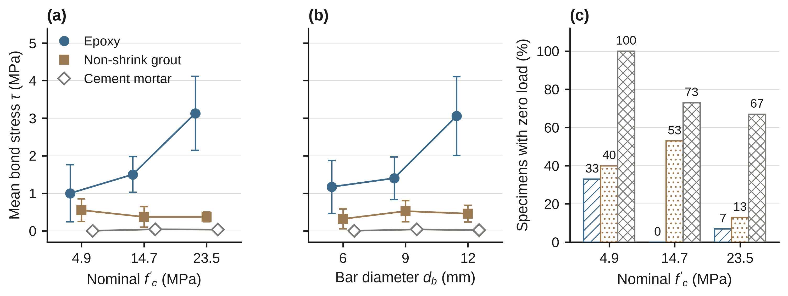
Fig. 4. Dependence of bond stress on agent, strength, and diameter in the plain-bar series. (a) Mean τ with 95% confidence intervals by agent and nominal strength (n = 15 per point). (b) Mean τ with 95% confidence intervals by agent and bar diameter (n = 15 per point). (c) Share of specimens that recorded zero load, by agent and strength (n = 15 per bar). Bar colour and hatching in (c) follow the agent legend in (a): epoxy, oblique lines; grout, dots; mortar, cross-hatching.

3.3 Effect of strength and diameter within each agent
Epoxy bond stress increased across nominal levels (Fig. 4a; Spearman ρ = 0.51, p < 0.001; Kruskal–Wallis p = 0.003). Grout showed no detectable trend (ρ = −0.07, p = 0.64). Mortar means remained 0.00–0.04 MPa despite a weak rank association (ρ = 0.34, p = 0.02).
Epoxy means were 1.17, 1.40 and 3.06 MPa for RB6, RB9 and RB12 (ρ = 0.46, p = 0.002; Figs. 4b and 5a). Diameter trends were not detected for grout (p = 0.28) or mortar (p = 0.06). Epoxy group means varied non-monotonically across some nominal levels, so the pooled diameter association should not be treated as universal.
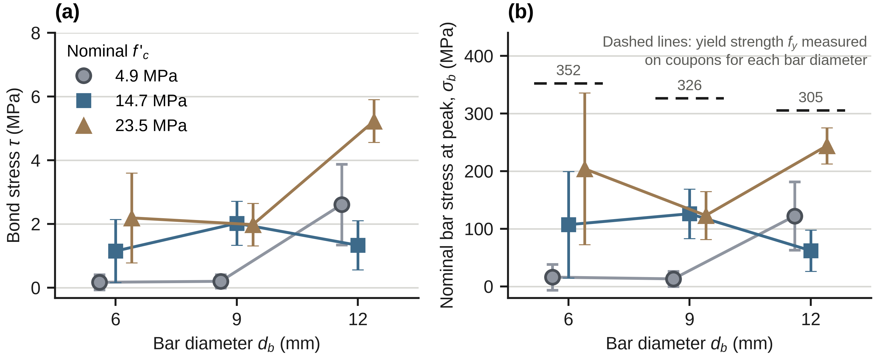
Fig. 5. Epoxy-anchored plain bars. (a) Bond stress τ and (b) nominal bar stress at peak load σ_{b} against bar diameter for each nominal strength (mean ± 1 SD, n = 5). The dashed lines in (b) are the yield strengths f_{y} measured on coupons of each bar diameter (352, 326, and 305 MPa for RB6, RB9, and RB12; Table 2).

3.4 Bar stress at peak load and scaling of capacity with diameter
No epoxy group mean bar stress reached coupon yield strength (Fig. 5b). The highest RB6 specimen reached 350 MPa (99% of f_{y}); the strongest RB12 specimen reached approximately 268 MPa (88%). RB12 at 23.5 MPa averaged 27.6 kN, approximately 80% of its coupon-based yield load. Grout and mortar maximum bar stresses were 138 and 17 MPa. Coupon comparisons indicate possible bar-capacity influence but do not verify yielding.
Positive-load epoxy observations gave a diameter exponent b = 2.12 (95% half-width 0.90; n = 39). Grout gave b = 0.38 (half-width 0.84; n = 29), compatible with both zero and one. These fits are conditional on excluding zero-load observations.

3.5 Failure modes
Representative plain-bar records (Fig. 6a) indicated pull-out in all nine epoxy groups; grout showed interface slip in six groups, slip with splitting in one and slip-out with zero recorded load in two. Mortar showed zero-recorded-load slip-out in five groups and slip within mortar in four. These are representative-specimen counts, not failure frequencies for all 135 specimens.
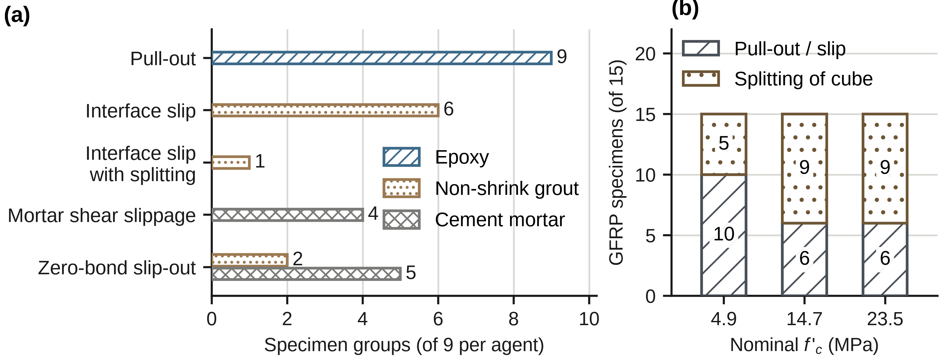
Fig. 6. Failure modes. (a) Mode recorded for each of the nine groups per agent in the plain-bar series (one representative specimen per group). (b) GFRP specimens (n = 15 per strength) that failed by splitting of the cube or by pull-out and slip.

3.6 GFRP bars
GFRP mean peak loads were 11.1, 14.5 and 15.3 kN at 4.9 MPa; 21.4, 20.8 and 21.7 kN at 14.7 MPa; and 17.9, 19.1 and 23.8 kN at 23.5 MPa (Table 10). Diameter exponents were 0.47 ± 0.10, 0.01 ± 0.10 and 0.41 ± 0.29 (95% half-widths; Fig. 7a). At 14.7 MPa, no diameter effect was detected (p = 0.45); this does not establish equivalence. Within-group coefficients of variation were 2.0–7.2% at 4.9 and 14.7 MPa and 5.3–18.9% at 23.5 MPa; the very low values in some groups should be checked against the original load records.
Table 10. Cast-in GFRP bars: peak load and derived bond measures (n = 5 per group).
d_{b} (mm) | Nominal f′_{c} (MPa) | P mean (SD), kN | CV of P (%) | P range (kN) | τ mean (MPa) | N mean | Splitting, of 5
6 | 4.9 | 11.1 (0.2) | 2.0 | 10.9–11.3 | 4.21 | 1.90 | 0
6 | 14.7 | 21.4 (0.7) | 3.2 | 20.4–22.2 | 8.11 | 2.11 | 3
6 | 23.5 | 17.9 (2.6) | 14.3 | 14.3–20.4 | 6.77 | 1.40 | 3
9 | 4.9 | 14.5 (0.4) | 2.9 | 14.1–15.0 | 3.66 | 1.65 | 2
9 | 14.7 | 20.8 (0.7) | 3.4 | 19.9–21.7 | 5.26 | 1.37 | 3
9 | 23.5 | 19.1 (3.6) | 18.9 | 14.9–24.2 | 4.82 | 0.99 | 3
12 | 4.9 | 15.3 (0.6) | 4.1 | 14.4–16.1 | 2.90 | 1.31 | 3
12 | 14.7 | 21.7 (1.6) | 7.2 | 19.9–23.4 | 4.11 | 1.07 | 3
12 | 23.5 | 23.8 (1.3) | 5.3 | 22.6–25.8 | 4.51 | 0.93 | 3
τ = P/(πd_{b}l_{e}) with nominal diameters; N = τ/√f′_{c}.

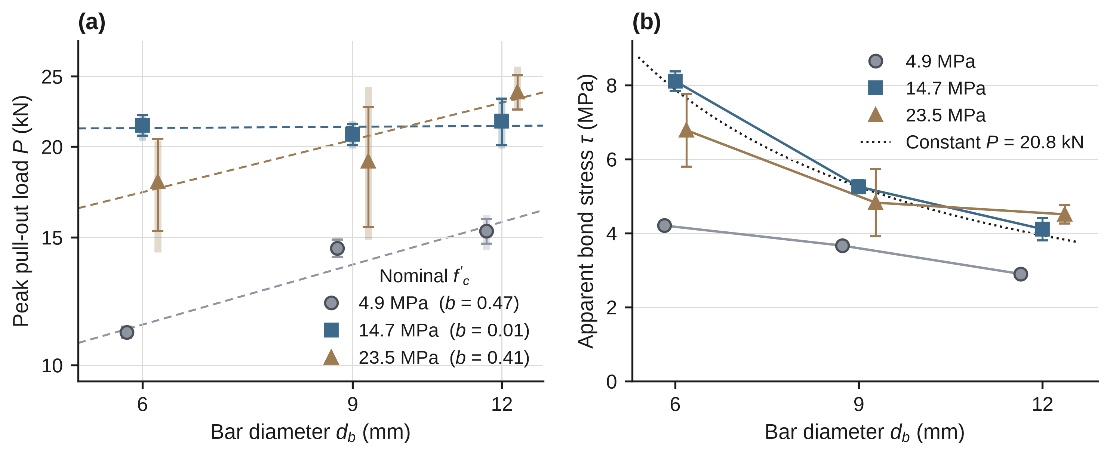
Fig. 7. Effect of diameter on GFRP pull-out capacity. (a) Peak load against bar diameter on logarithmic axes; symbols are group means ± 1 SD, translucent vertical bars are the minimum–maximum range of the five specimens, and dashed lines are the fitted power laws with exponent b in the legend (b = 1 for uniform interface stress, b = 0 for a diameter-independent capacity). (b) Apparent bond stress; the dotted curve is the stress that a constant load equal to the pooled mean peak load at 14.7 and 23.5 MPa would give.
At the two higher nominal levels, pooled peak load was 20.8 ± 2.7 kN (n = 30). Means were 21.3 and 20.3 kN (Welch p = 0.30, g = −0.38; Fig. 8a), an absence of a detected increase rather than evidence of equality. Diameter-specific changes differed in direction.
Two-way ANOVA reported diameter, nominal-level and interaction effects (Table 11). At 14.7 MPa, apparent stresses decreased from 8.11 to 5.26 and 4.11 MPa with increasing diameter (Fig. 7b). Splitting occurred in 23/45 GFRP specimens (Fig. 6b). Upper-level peak loads were 20.6 kN with splitting and 21.1 kN without (p = 0.72). Maximum nominal bar stresses were 786, 380 and 228 MPa for 6, 9 and 12 mm, or 76%, 42% and 28% of mean tensile strength.
Table 11. Two-way ANOVA of the GFRP series (n = 45).
 |  | Peak load P |  | Bond stress τ |  | Normalised bond N
Effect | df | F | η_{p}² | F | η_{p}² | F | η_{p}²
Diameter d_{b} | 2, 36 | 16.5 | 0.478 | 110.6 | 0.860 | 175.9 | 0.907
Nominal f′_{c} | 2, 36 | 92.7 | 0.837 | 91.9 | 0.836 | 102.6 | 0.851
d_{b} × f′_{c} | 4, 36 | 5.2 | 0.365 | 12.3 | 0.578 | 13.8 | 0.604
All p < 0.001 except d_{b} × f′_{c} for P (p = 0.002).

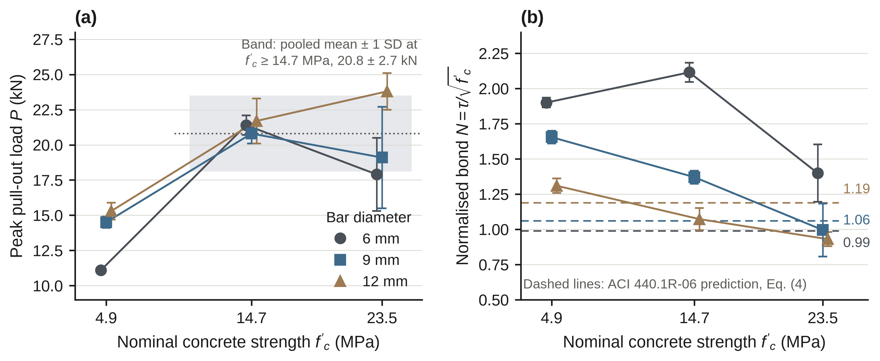
Fig. 8. Effect of nominal concrete strength on GFRP bars. (a) Peak load against strength for each diameter; the shaded band is the pooled mean ± 1 SD at 14.7 and 23.5 MPa (20.8 ± 2.7 kN). (b) Normalised bond N against strength; dashed lines are ACI 440.1R-06 predictions without a cover limit (Section 2.5).

3.7 Comparison with the ACI 440.1R-06 expression
Uncapped predicted N values were 0.99, 1.06 and 1.19 for 6, 9 and 12 mm. Measured-to-predicted ratios ranged from 0.79 to 2.15 (Table 12 and Fig. 8b). Capping c/d_{b} at 3.5 gives approximately 0.77, 0.95 and 1.13. These comparisons describe an older expression applied outside the present test configuration; they do not validate or invalidate a design provision.
Table 12. Measured normalised bond of the GFRP bars against the ACI 440.1R-06 expression (Eq. 4; no cap on c/d_{b}).
 |  |  | Measured N |  |  | Measured / predicted
d_{b} (mm) | c/d_{b} | Predicted N | 4.9 MPa | 14.7 MPa | 23.5 MPa | 4.9 MPa | 14.7 MPa | 23.5 MPa
6 | 12.0 | 0.99 | 1.90 | 2.11 | 1.40 | 1.93 | 2.15 | 1.42
9 | 7.8 | 1.06 | 1.65 | 1.37 | 0.99 | 1.56 | 1.30 | 0.94
12 | 5.8 | 1.19 | 1.31 | 1.07 | 0.93 | 1.10 | 0.90 | 0.79
c = (150 − d_{b})/2 (assumed); l_{e} = 140 mm; measured N is the group mean (n = 5).

3.8 Normalised bond across systems
GFRP mean loads exceeded epoxy plain-bar means in eight of nine matched diameter–nominal-level groups (Fig. 9b); Fig. 9a compares normalised bond N across the four systems. The exception was 12 mm at 23.5 MPa (23.8 versus 27.6 kN). Different installation procedures prevent interpretation as an intrinsic ranking of reinforcement materials.
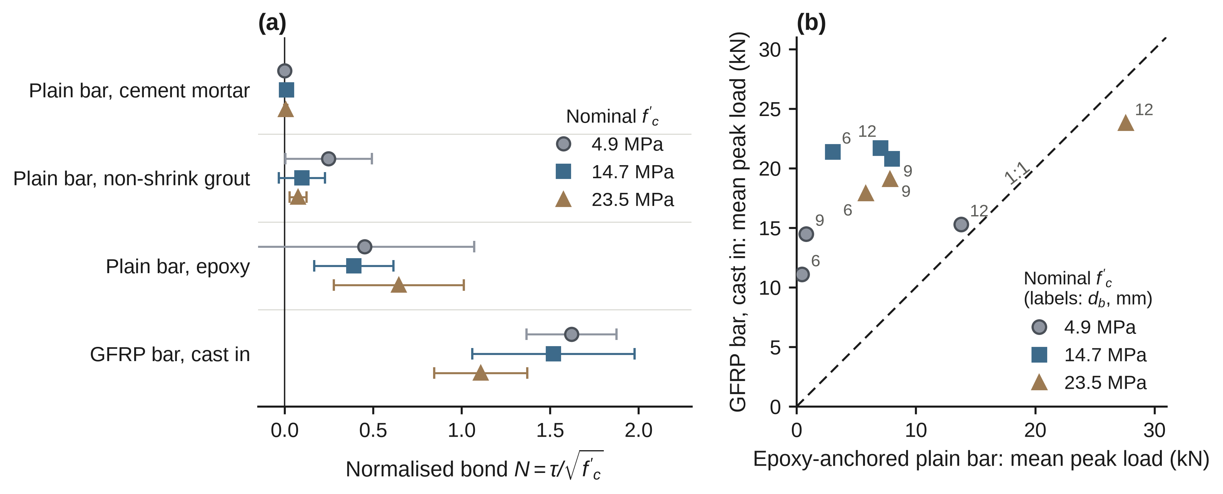
Fig. 9. Comparison of the plain-bar and GFRP series. (a) Normalised bond N = τ/√f′_{c} for each system (mean ± 1 SD, n = 15 per point). (b) Mean peak load of the GFRP bars against that of epoxy-anchored plain bars at the same diameter (point labels, mm) and nominal strength; the dashed line is 1:1. GFRP bars were cast in and plain bars post-installed, so the comparison is descriptive.

4. Discussion

4.1 Bonding agent and installation effects
The exploratory analysis associates bonding agent with the largest partial effect. Adhesion and friction offer plausible explanations for epoxy performance [3, 11], but the programme did not examine fracture surfaces or isolate interface mechanisms. Representative failure observations therefore support interpretation rather than prove a mechanism.
Dipping bars before insertion may interact with agent viscosity and hole condition. Unrecorded clearance, cleaning and filling prevent separation of product effects from installation effects. The findings apply to this procedure; they should not be extended directly to grouted ducts or sleeves [18, 19].

4.2 Nominal strengths, curing, and the strength trend
Epoxy results are consistent with a positive association across nominal concrete levels, but these levels also differ in curing or sand dilution. Comparisons with ribbed-bar studies [12] therefore provide context rather than calibration.
Companion strengths were 5.8, 13.4 and 17.9 MPa, rather than 4.9, 14.7 and 23.5 MPa. The measured upper-level strength ratio is 1.34 instead of 1.60. Using measured strengths would multiply nominally normalized N by approximately 0.92, 1.05 and 1.15. This sensitivity changes the GFRP strength trend but not its diameter ordering. The original nominal normalization is retained for traceability; repeating the N analyses with the measured strengths requires specimen-level data. Curing may itself influence bond [39].

4.3 Diameter, hole clearance, and the limit set by the bar
Unrecorded hole clearance, changing l_{e}/d_{b} and high bar stress may all contribute to epoxy diameter associations. The data do not isolate these influences. Apparent average stress should not be treated as a diameter-independent material property.
For RB12 epoxy at 23.5 MPa, mean bar stress was below coupon yield strength and the representative failure was pull-out. This supports an apparent pull-out response but does not establish the local interface strength or exclude bar-capacity influence in individual specimens.

4.4 What limits the capacity of GFRP bars in weak concrete
At 14.7 MPa, GFRP group mean loads were relatively stable across the investigated diameters; at 23.5 MPa they were less uniform. Non-significant contrasts do not establish a capacity ceiling. Potential explanations include concrete splitting, batch and curing differences, grip behaviour and bar properties; Table 13 retains these hypotheses without selecting a proven mechanism.
Table 13. Possible explanations for the similar peak loads of GFRP bars at 14.7 and 23.5 MPa.
Explanation | What the data show | Status
1. Nominal strengths differ from actual strengths | The 14.7 and 23.5 MPa mixtures differ in curing period only. Companion cubes gave 13.4 and 17.9 MPa (0.91 and 0.76 of nominal; Table 5), a strength ratio of 1.34 instead of 1.60, which would still raise the expected peak load by about 16% (square-root scaling) against an observed change of −5%. | Partly supported: actual strengths differ from nominal, but the measured ratio still predicts a rise
2. A cube or splitting ceiling | Splitting occurred in 9 of 15 specimens at both 14.7 and 23.5 MPa, but peak load did not depend on failure mode (p = 0.72). | Not excluded; a ceiling set by concrete tensile strength would fall under explanation 1
3. Batch, age, or curing effects | Cubes came from separate batches; the curing period (5, 7, and 14 d) and the age at test (8, 10, and 17 d) of the 4.9, 14.7, and 23.5 MPa grades are given in Table 5, but the casting dates are not documented. | Cannot be tested from the records
4. Random scatter alone | The change from 14.7 to 23.5 MPa was −1.05 kN (Welch p = 0.30, g = −0.38), so the similarity of the means is an absence of a detectable rise. | Compatible with the data
5. A limit at the grip | Individual peaks reached 25.8 kN (12 mm, 23.5 MPa), so one fixed grip ceiling near 21 kN is unlikely; a diameter-specific limit cannot be excluded. | Unlikely as a single ceiling; grip details needed
6. Bar tensile capacity | Nominal stress at the maximum load was 786, 380, and 228 MPa for the 6, 9, and 12 mm bars; this is 76%, 42%, and 28% of the tensile strength of the bars (Table 3). | Unlikely for all three diameters: bar rupture was not reached (highest 76%, 6 mm bar)

The observed decrease in apparent stress with diameter follows partly from dividing a relatively stable load by a larger perimeter. Transfer to other diameters or concrete conditions requires additional testing.

4.5 GFRP bars against the design expression
The ACI expression did not reproduce the observed diameter ordering in this configuration. Interpretation is limited by long embedment, low measured strengths, undocumented bar surface and assumed cover. The comparison is contextual and does not support a new design rule.

4.6 Test method and bonded length
The withdrawn test procedure and long embedment differ from beam-end, beam and adhesive-anchor qualification methods [37, 38, 40–43]. Average bond stress may differ from local maxima. Internal comparisons are useful, but these values cannot be transferred directly to development-length or anchor-design checks. ASTM D7913/D7913M-26 specifically addresses FRP-to-concrete pull-out testing [44]; compliance with it is not claimed for the archived specimens.

4.7 Implications for practice
Under the tested installation conditions, cement mortar gave low recorded resistance and frequent zero loads. Epoxy performed better at the two higher nominal levels, but some weakest-level specimens also recorded zero. These observations support project-specific qualification of the complete bar–agent–concrete system. They do not justify prescribing an agent or an anchorage design without suitable verification.

4.8 Limitations
The principal limitations are five specimens per group, retrospective analyses without multiplicity adjustment, zero-heavy and unequal-variance data, and incomplete source records. Nominal concrete grade is confounded with curing and mixture preparation. Plain-bar failure modes represent one specimen per group. Hole dimensions, cleaning, loading rate, calibration and GFRP surface treatment are undocumented. Raw load records, zero-value provenance and analysis code are required to reproduce the statistical claims. Cast-in GFRP and post-installed steel cannot isolate a material effect. Supplementary short-embedment specimens have incomplete preparation and age records and provide contextual evidence only.

5. Conclusions
For this 180-specimen programme and its recorded conditions:
(1) Epoxy, grout and mortar had pooled mean apparent bond stresses of 1.88, 0.43 and 0.021 MPa. Agent showed the largest partial effect in the exploratory model (η_{p}² = 0.73). Epoxy–grout differences were detected at the two higher nominal levels, but not at 4.9 MPa.
(2) Zero recorded loads occurred in 6/45 epoxy, 16/45 grout and 36/45 mortar specimens. These records require interpretation in relation to instrument resolution and test documentation.
(3) Epoxy stress increased across nominal levels and showed a pooled diameter association. Curing, mixture preparation and installation differences limit causal interpretation.
(4) GFRP mean peak loads were 20.8–21.7 kN across 6–12 mm at 14.7 MPa nominal strength. No pooled increase was detected at 23.5 MPa. Apparent bond stress decreased with diameter, but the data do not establish diameter independence or identify a unique limiting mechanism. All results are comparative observations, not design capacities.

Declarations
CRediT authorship contribution statement. Piyarat Paoleng: conceptualization, methodology, formal analysis, writing – original draft. Siriphat Maneekeaw: methodology, validation, writing – review and editing. Sirisak Kongsomsaksakul: investigation, data curation, writing – review and editing. Krairoj Mahannopkul: formal analysis, visualization, writing – review and editing. Ittipon Meepon: conceptualization, supervision, project administration, writing – review and editing.
Funding. The authors received no external funding for this work.
Declaration of competing interest. The authors declare no competing interests.
Data availability. The group means and standard deviations on which the analyses are based are reported in Tables 6, 10, A1, and B1; further data can be requested from the corresponding author.
[ตรวจสอบ 5: เอกสารแนบเขียน “Summary data are provided in the main tables, Appendix A and supplementary tables. Requests for specimen-level data, original instrument records and analysis scripts should be directed to the corresponding author” แต่ก่อนหน้านี้คุณตอบว่าไม่มีไฟล์ข้อมูลรายตัวอย่าง จึงคงข้อความของ v7 ที่คุณยืนยันแล้ว. คำถาม: ต้องการใช้ข้อความของเอกสารแนบแทนหรือไม่ (ถ้ามีไฟล์รายตัวอย่างจริง โปรดส่งมาเพื่อคำนวณ N ด้วย f′c ที่วัดได้ใหม่)]
Use of AI-assisted tools.
During revision, the authors used ChatGPT (OpenAI) for language editing, structural condensation, consistency checking, translation and identification of potentially overstated interpretations. The tool was not used in this revision to generate or modify experimental measurements or to reproduce statistical analyses. The authors remain responsible for the accuracy, provenance and interpretation of all data and analyses. Claude (Anthropic) was used to reorganise the tables, to redraw Figs. 1, 5 and 6 from the reported group means and standard deviations, to recompute derived ratios from reported group means (bar-stress ratios and the sensitivity of N to the measured strengths), and to edit the text; it was not used to generate experimental measurements.
[ตรวจสอบ 6: ใช้ข้อความตามเอกสารแนบ (ChatGPT) และเพิ่มประโยคเกี่ยวกับ Claude (Anthropic) เพราะการจัดตาราง วาดรูป คำนวณอัตราส่วนจากค่าเฉลี่ยกลุ่ม และเรียบเรียงข้อความในงานรอบนี้ใช้ Claude จริง ข้อความ AI-use ต้องครบถ้วนและผู้เขียนเป็นผู้รับผิดชอบ. คำถาม: ยืนยันหรือปรับถ้อยคำของประโยคนี้ (และตรวจว่าประโยค “not used … to reproduce statistical analyses” ตรงกับความจริงของผู้เขียน)]
Acknowledgements.
The authors thank the Department of Teacher Training in Civil Engineering, Faculty of Technical Education, King Mongkut's University of Technology North Bangkok, for laboratory testing equipment.

References
[1] Zheng, Y., Fan, C., Ma, J. et al. Review of research on bond–slip of reinforced concrete structures. Construction and Building Materials, 2023, 385, 131437. DOI: 10.1016/j.conbuildmat.2023.131437.
[2] Vembu, P.R.S. and Ammasi, A.K. A comprehensive review on the factors affecting bond strength in concrete. Buildings, 2023, 13 (3), 577. DOI: 10.3390/buildings13030577.
[3] Xing, G., Zhou, C., Wu, T. and Liu, B. Experimental study on bond behavior between plain reinforcing bars and concrete. Advances in Materials Science and Engineering, 2015, 2015, 604280. DOI: 10.1155/2015/604280.
[4] Darwin, D., Zuo, J., Tholen, M.L. and Idun, E.K. Development length criteria for conventional and high relative rib area reinforcing bars. ACI Structural Journal, 1996, 93 (3), pp. 347–359. DOI: 10.14359/9694.
[5] ACI Committee 318. ACI 318-08: Building code requirements for structural concrete and commentary. Farmington Hills, MI: American Concrete Institute, 2008.
[6] Opabola, E.A. Bond strength and development length models for straight plain longitudinal reinforcement in tension. ACI Structural Journal, 2022, 119 (6), pp. 165–175. DOI: 10.14359/51736111.
[7] Marshall, J.D., Lang, A.F., Baldridge, S.M. et al. Recipe for disaster: construction methods, materials, and building performance in the January 2010 Haiti earthquake. Earthquake Spectra, 2011, 27 (S1), pp. S323–S343. DOI: 10.1193/1.3637031.
[8] Yepez, F. and Yepez, O. Role of construction materials in the collapse of R/C buildings after Mw 7.8 Pedernales – Ecuador earthquake, April 2016. Case Studies in Structural Engineering, 2017, 7, pp. 24–31. DOI: 10.1016/j.csse.2016.12.001.
[9] Tutu, K.A., Odei, D.A., Baniba, P. et al. Concrete quality issues in multistory building construction in Ghana: cases from Kumasi metropolis. Case Studies in Construction Materials, 2022, 17, e01425. DOI: 10.1016/j.cscm.2022.e01425.
[10] Yuva, Y. Low-strength concrete properties in existing structures using NDT and core test results. Journal of Building Engineering, 2023, 76, 107281. DOI: 10.1016/j.jobe.2023.107281.
[11] Tayeh, B.A., EL dada, Z.M., Shihada, S. et al. Pull-out behavior of post installed rebar connections using chemical adhesives and cement based binders. Journal of King Saud University – Engineering Sciences, 2019, 31 (4), pp. 332–339. DOI: 10.1016/j.jksues.2017.11.005.
[12] Ahmed, K.S., Shahjalal, Md., Siddique, T.A. et al. Bond strength of post-installed high strength deformed rebar in concrete. Case Studies in Construction Materials, 2021, 15, e00581. DOI: 10.1016/j.cscm.2021.e00581.
[13] Fayed, S., Alkharisi, M.K., Bayoumi, E.A. et al. Bond of ribbed and threaded steel reinforcement bars post-installed in concrete considering bonded length and adhesive type. Scientific Reports, 2026, 16, 10762. DOI: 10.1038/s41598-026-42964-4.
[14] Multani, A.S. and Gupta, P.K. Bond strength analysis of post-installed rebar with chemical adhesive in concrete mixed with marble powder and glass fiber. Journal of Adhesion Science and Technology, 2024, 38 (7), pp. 1014–1042. DOI: 10.1080/01694243.2023.2245590.
[15] Hussein, D.A. and Sarkawt, S.A. Experimental investigation of post-installed anchors' behavior under axial tensile force. Polytechnic Journal, 2024, 13 (1), 22. DOI: 10.59341/2707-7799.1835.
[16] Rosca, B. and Corobceanu, V. Mix design approach of supplementary cementitious materials Portland cement-based mortars for anchoring post-installed reinforcement bars into hardened concrete. Procedia Manufacturing, 2020, 46, pp. 186–193. DOI: 10.1016/j.promfg.2020.03.028.
[17] Darwin, D. and Zavaregh, S.S. Bond strength of grouted reinforcing bars. ACI Structural Journal, 1996, 93 (4), pp. 486–495. DOI: 10.14359/9707.
[18] Raynor, D.J., Lehman, D.E. and Stanton, J.F. Bond-slip response of reinforcing bars grouted in ducts. ACI Structural Journal, 2002, 99 (5), pp. 568–576. DOI: 10.14359/12296.
[19] Ahn, B.-I., Kim, H.-K. and Park, B.-M. Confining effect of mortar grouted splice sleeve on reinforcing bar. Journal of the Korea Concrete Institute, 2003, 15 (1), pp. 102–109. DOI: 10.4334/jkci.2003.15.1.102.
[20] Jia, J., Zhao, N., Bai, Y. et al. Bond-slip model for rebar mounted to high-strength grouting material. Journal of Building Engineering, 2023, 74, 106794. DOI: 10.1016/j.jobe.2023.106794.
[21] Zhang, W., Jia, Y., Cen, Q. et al. Bond–slip constitutive relationship at the interface between reinforcing steel and grout in fully grouted sleeve couplers. Buildings, 2026, 16 (11), 2098. DOI: 10.3390/buildings16112098.
[22] Liu, D., Liu, C., Zhang, H. et al. Optimizing machine learning with SSA and PSO for anchor bolt–grout bond strength prediction. Materials, 2026, 19 (5), 906. DOI: 10.3390/ma19050906.
[23] Itoh, T., Ueda, R., Son, B. et al. Anchorage and bond strength of SBPDN bar embedded in high-strength grout mortar. Materials, 2026, 19 (1), 2. DOI: 10.3390/ma19010002.
[24] Jia, Q. and Zhang, T. Microbial cement grout anchoring steel reinforcement pull-out test. Scientific Reports, 2024, 14, 1559. DOI: 10.1038/s41598-024-52196-z.
[25] Achillides, Z. and Pilakoutas, K. Bond behavior of fiber reinforced polymer bars under direct pullout conditions. Journal of Composites for Construction, 2004, 8 (2), pp. 173–181. DOI: 10.1061/(ASCE)1090-0268(2004)8:2(173).
[26] Baena, M., Torres, L., Turon, A. and Barris, C. Experimental study of bond behaviour between concrete and FRP bars using a pull-out test. Composites Part B: Engineering, 2009, 40 (8), pp. 784–797. DOI: 10.1016/j.compositesb.2009.07.003.
[27] Wambeke, B.W. and Shield, C.K. Development length of glass fiber-reinforced polymer bars in concrete. ACI Structural Journal, 2006, 103 (1), pp. 11–17. DOI: 10.14359/15081.
[28] Sólyom, S. and Balázs, G.L. Bond of FRP bars with different surface characteristics. Construction and Building Materials, 2020, 264, 119839. DOI: 10.1016/j.conbuildmat.2020.119839.
[29] Yan, F., Lin, Z. and Yang, M. Bond mechanism and bond strength of GFRP bars to concrete: a review. Composites Part B: Engineering, 2016, 98, pp. 56–69. DOI: 10.1016/j.compositesb.2016.04.068.
[30] Ekrami Kakhki, S.A. and Kheyroddin, A. Bond behavior of fiber reinforced polymer bars in concrete: a review. International Journal of Concrete Structures and Materials, 2025, 19, 120. DOI: 10.1186/s40069-025-00859-0.
[31] Okelo, R. and Yuan, R.L. Bond strength of fiber reinforced polymer rebars in normal strength concrete. Journal of Composites for Construction, 2005, 9 (3), pp. 203–213. DOI: 10.1061/(ASCE)1090-0268(2005)9:3(203).
[32] Islam, S., Afefy, H.M., Sennah, K. et al. Bond characteristics of straight- and headed-end, ribbed-surface, GFRP bars embedded in high-strength concrete. Construction and Building Materials, 2015, 83, pp. 283–298. DOI: 10.1016/j.conbuildmat.2015.03.025.
[33] Shakiba, M., Hosseini, S.M., Bazli, M. et al. Enhancement of the bond behaviour between sand coated GFRP bar and normal concrete using innovative composite anchor heads. Materials and Structures, 2022, 55 (9), 236. DOI: 10.1617/s11527-022-02074-9.
[34] ACI Committee 440. ACI 440.1R-06: Guide for the design and construction of structural concrete reinforced with fiber-reinforced polymer (FRP) bars. Farmington Hills, MI: American Concrete Institute, 2006.
[35] Shbeeb, N.I., Katash, A.A., Oguzmert, M. et al. Estimation of the bond strength of fiber-reinforced polymer bars in concrete using artificial intelligence systems. Buildings, 2024, 14 (2), 369. DOI: 10.3390/buildings14020369.
[36] ASTM International. ASTM D7205/D7205M-21: Standard test method for tensile properties of fiber reinforced polymer matrix composite bars. West Conshohocken, PA: ASTM International, 2021.
[37] ASTM International. ASTM C234-91a: Standard test method for comparing concretes on the basis of the bond developed with reinforcing steel (withdrawn 2000). West Conshohocken, PA: ASTM International, 1991.
[38] ACI Committee 440. ACI 440.3R-04: Guide test methods for fiber-reinforced polymers (FRPs) for reinforcing or strengthening concrete structures. Farmington Hills, MI: American Concrete Institute, 2004.
[39] Fu, X. and Chung, D.D.L. Decrease of the bond strength between steel rebar and concrete with increasing curing age. Cement and Concrete Research, 1998, 28 (2), pp. 167–169. DOI: 10.1016/S0008-8846(97)00216-0.
[40] Rahimi, M., Davoodi, M.R., Nematzadeh, M. et al. A comparative study between beam and pull-out tests on bond behavior of ribbed GFRP bar in concrete conforming to RILEM standards. Archives of Civil and Mechanical Engineering, 2025, 25, 37. DOI: 10.1007/s43452-024-01095-1.
[41] Ekrami Kakhki, S.A. and Kheyroddin, A. Experimental investigation of bond behavior of steel, GFRP, and CFRP reinforcement in self-compacting and fiber-reinforced concrete using RILEM beam tests. Scientific Reports, 2026, 16, 19085. DOI: 10.1038/s41598-026-49366-6.
[42] ASTM International. ASTM A944-10 (Reapproved 2015): Standard test method for comparing bond strength of steel reinforcing bars to concrete using beam-end specimens. West Conshohocken, PA: ASTM International, 2015.
[43] ACI Committee 355. ACI CODE-355.4-19 (Reapproved 2021): Qualification of post-installed adhesive anchors in concrete and commentary. Farmington Hills, MI: American Concrete Institute, 2021.
[44] ASTM International. ASTM D7913/D7913M-26: Standard test method for bond strength of fiber-reinforced polymer matrix composite bars to concrete by pullout testing. West Conshohocken, PA: ASTM International, 2026.

Appendix A. Bond stress of the plain-bar series by group
Table A1. Mean bond stress τ (SD) in MPa for each plain-bar group (n = 5).
Bar | Agent | τ at 4.9 MPa | τ at 14.7 MPa | τ at 23.5 MPa
RB6 | Epoxy | 0.17 (0.24) [3] | 1.15 (0.99) | 2.19 (1.41) [1]
RB6 | Non-shrink grout | 0.00 (0.00) [5] | 0.61 (0.64) [2] | 0.32 (0.29) [1]
RB6 | Cement mortar | 0.00 (0.00) [5] | 0.00 (0.00) [5] | 0.00 (0.00) [5]
RB9 | Epoxy | 0.20 (0.21) [2] | 2.02 (0.69) | 1.98 (0.67)
RB9 | Non-shrink grout | 1.07 (0.36) | 0.00 (0.00) [5] | 0.50 (0.11)
RB9 | Cement mortar | 0.00 (0.00) [5] | 0.10 (0.13) [3] | 0.02 (0.03) [3]
RB12 | Epoxy | 2.61 (1.27) | 1.33 (0.77) | 5.23 (0.67)
RB12 | Non-shrink grout | 0.57 (0.41) [1] | 0.50 (0.45) [1] | 0.29 (0.24) [1]
RB12 | Cement mortar | 0.00 (0.00) [5] | 0.01 (0.02) [3] | 0.05 (0.05) [2]
The number in square brackets is the count of zero-load specimens in the group (of 5), shown only when greater than zero.

Appendix B. Supplementary pull-out series with a bonded length of five bar diameters
Table B1 lists a supplementary set of pull-out tests with a bonded length l_{e} = 5d_{b} (30, 45, and 60 mm for the 6, 9, and 12 mm bars; n = 3 per group): GFRP bars at 14.7 and 23.5 MPa and epoxy-anchored plain bars at 23.5 MPa. The apparent bond stress τ was 9.1–12.6 MPa for the GFRP bars and 5.9–6.8 MPa for the epoxy-anchored plain bars, and in each of the nine groups it was higher than the corresponding group mean at l_{e} = 140 mm (Table 10 for GFRP and Table A1 for the plain bars). For the GFRP bars τ decreased with diameter at both strengths (10.9, 9.8, and 9.1 MPa at 14.7 MPa; 12.6, 11.4, and 10.6 MPa at 23.5 MPa). All groups failed by pull-out except the 12 mm GFRP groups, in which 1 of 3 specimens at 14.7 MPa and 2 of 3 at 23.5 MPa split. These 27 specimens are not part of the 180 specimens analysed in the main text and are presented as contextual evidence only. The cube size, specimen preparation, age at test, and concrete strength of this series are not documented in the source, and the nominal grades are used as labels.
Table B1. Supplementary pull-out series with bonded length l_{e} = 5d_{b}.
Specimen | d_{b} (mm) | l_{e} (mm) | Nominal  f′_{c} (MPa) | n | Peak load P (kN) | τ = P/(π d_{b} l_{e}) (MPa) | Slip at peak (mm) | Failure mode
GF6 | 6 | 30 | 14.7 | 3 | 6.2 | 10.9 | 0.85 | Pull-out
GF9 | 9 | 45 | 14.7 | 3 | 12.5 | 9.8 | 1.10 | Pull-out
GF12 | 12 | 60 | 14.7 | 3 | 20.6 | 9.1 | 1.32 | Pull-out (2), splitting (1)
GF6 | 6 | 30 | 23.5 | 3 | 7.1 | 12.6 | 0.92 | Pull-out
GF9 | 9 | 45 | 23.5 | 3 | 14.5 | 11.4 | 1.21 | Pull-out
GF12 | 12 | 60 | 23.5 | 3 | 24.0 | 10.6 | 1.48 | Splitting (2), pull-out (1)
RB6 epoxy | 6 | 30 | 23.5 | 3 | 3.3 | 5.9 | 0.64 | Pull-out
RB9 epoxy | 9 | 45 | 23.5 | 3 | 8.1 | 6.4 | 0.77 | Pull-out
RB12 epoxy | 12 | 60 | 23.5 | 3 | 15.4 | 6.8 | 0.86 | Pull-out

