Numerical Assessment of Stiffness-Modification Measures for a Short Meter-Gauge Railway Bridge Transition Zone
Version 2 draft for Iranian Journal of Science and Technology, Transactions of Civil Engineering · Oct 7, 2026 · @ปิยรัตน์ เปาเล้ง [AI2-01 ภาษา – ควรแก้ (เล็ก): ทั้งฉบับสะกดแบบอังกฤษ (behaviour, analysed, modelled, optimised, discretisation) แต่ใช้ “meter-gauge” (แบบอเมริกัน) 10 ครั้ง รวมในชื่อเรื่อง — เลือกแบบเดียว ถ้าใช้อังกฤษให้เป็น “metre-gauge” (ในรูป Fig. 1 มีคำว่า “meter gauge” ด้วย) และตรวจนโยบายภาษาของวารสาร (AI ยังยืนยันไม่ได้)]
Piyarat Paoleng¹, Siriphat Maneekeaw¹, Sirisak Kongsomsaksakul¹, Krairoj Mahannopkul¹, Ittipon Meepon¹* [CONFIRM-1]
¹ Department of Teacher Training in Civil Engineering, Faculty of Technical Education, King Mongkut's University of Technology North Bangkok, Bangkok 10800, Thailand
* Corresponding author: Ittipon Meepon, ittipon.m@fte.kmutnb.ac.th
Author | E-mail | ORCID
Piyarat Paoleng | piyarat.p@fte.kmutnb.ac.th | https://orcid.org/0009-0008-5332-1007
Siriphat Maneekeaw | siriphat.m@fte.kmutnb.ac.th | https://orcid.org/0009-0002-0435-2866
Sirisak Kongsomsaksakul | sirisak.k@fte.kmutnb.ac.th | https://orcid.org/0009-0001-2352-5550
Krairoj Mahannopkul | krairoj.m@fte.kmutnb.ac.th | https://orcid.org/0000-0002-6207-0958
Ittipon Meepon | ittipon.m@fte.kmutnb.ac.th | https://orcid.org/0000-0001-5353-3511

Abstract
Stiffness discontinuity between ballasted track and a bridge amplifies the wheel–rail contact force and accelerates track deterioration, yet short transition zones on meter-gauge lines have received little attention. This study assesses stiffness-modification measures for a short meter-gauge bridge transition zone using a three-dimensional finite element model in ABAQUS and a multibody vehicle–track model in Universal Mechanism. Five models were compared: an unmodified track (M1); stepped polyurethane (PU)-injected ballast, 30, 20, and 10 cm thick over three 5 m zones (M2); and the same PU scheme combined with an auxiliary rail (M3), enlarged sleepers (M4), or both (M5). The static track stiffness was calibrated to 44 kN/mm on the ballasted track and 264 kN/mm on the bridge, and the peak vertical wheel–rail contact force was computed at 60–120 km/h. The peak forces are lower than the static wheel load and serve only to compare the models. Stepped PU raised the peak approach-side stiffness (the highest value along the approach) to 62 kN/mm, and the combined schemes raised it to 72–77 kN/mm, which lowered the ratio of bridge to peak approach stiffness from 6.0 to 3.4–4.3. At 120 km/h, the peak contact force of 69.17 kN in M1 fell by 17.3% (M2) and by 22.6–23.7% (M3–M5). Stepped PU alone provided 73% of the largest reduction, and the other measures added 5.3 to 6.4 percentage points. The model was calibrated and checked for internal consistency but not validated against field data, so the results support comparative screening rather than absolute prediction. [AI2-02 บทคัดย่อ – ตัวเลือก: ตอนนี้ 248 คำ ใกล้เพดาน 250 ตามที่ Drafting notes ระบุ (AI ยืนยันเพดานจากเว็บไซต์วารสารไม่ได้ เพราะเข้า springer.com ไม่ได้ในรอบนี้) ถ้าแก้เพิ่ม ให้ตัดตัวเลขรอง เช่น % ของ M3–M5 ก่อน และนับคำใหม่ทุกครั้ง]
Keywords: Railway transition zone; Track stiffness; Polyurethane-injected ballast; Auxiliary rail; Enlarged sleeper; Wheel–rail contact force

1 Introduction
Railway bridges and culverts interrupt the continuous ballasted track with a considerably stiffer support, and the junction between the two is a recurring maintenance problem. Wheels that cross this change in support stiffness generate additional dynamic loads, which accelerate ballast settlement and degradation, weaken sleeper support, and crack track components (Li and Davis 2005; Read and Li 2006; Sañudo et al. 2016a; Sol-Sánchez and D'Angelo 2017). Field studies at bridge approaches have linked the resulting differential movement to track geometry deterioration under heavy traffic (Li et al. 2010; Mishra et al. 2012; Shi et al. 2013), and numerical studies show that differential settlement in turn amplifies the dynamic train–track interaction, so that the two effects reinforce each other (Paixão et al. 2021), and long-term models have been developed to predict the resulting settlement (Wang and Markine 2018b). Variations in track stiffness raise the wheel–rail contact force (Lundqvist et al. 2006; Dahlberg 2010; Giannakos and Tsoukantas 2012), and standard texts on track mechanics treat track stiffness as a primary determinant of dynamic wheel–rail loading (Esveld 2001; Indraratna et al. 2011).
Transition design therefore aims at a gradual change in vertical stiffness between the two structures, and many measures have been proposed (Sañudo et al. 2016a; Indraratna et al. 2019). Auxiliary rails, also called additional rails, increase the flexural stiffness of the rail system. A field study of a slab-to-ballast transition showed that additional rails combined with an approach slab spread the rise in rail deflection over two stages (Heydari-Noghabi et al. 2018), three-dimensional train–track models showed that auxiliary rails reduced the variation of rail deflection (Heydari-Noghabi et al. 2017), and an approach slab with auxiliary rails produced a three-stage stiffness grading that was validated against field data (Heydari-Noghabi et al. 2023). Chumyen et al. (2022) found that widely spaced auxiliary rails were more effective than closely spaced rails, although soil improvement increased the stiffness more than the rails did. The stiffness of baseplate fastening systems has also been examined at stiffness transitions (Ngamkhanong et al. 2020).
Sleeper-based measures act on the support under the rail. Under-sleeper pads reduce ballast stress and settlement but may increase rail bending stress (Myskowski et al. 2023); in a field investigation at bridge approaches they reduced rail, sleeper, and deck accelerations by 35%, 24%, and 66% (Mottahed et al. 2019), and numerical work showed that their stiffness and position must be designed to avoid new abrupt stiffness steps (Paixão et al. 2018). Support positions have been optimised in ballast-to-slab transitions (Sañudo et al. 2016b, 2017). Reduced sleeper spacing and enlarged sleeper base area were compared in a long-term settlement model of a transition zone (Nasrollahi and Nielsen 2024), a discrete-element study found that the maximum settlement intensity was up to 3.5 times lower under a wide sleeper (Nabochenko et al. 2024), and sleeper arrangements alone were reported to be unable to remove the transition effect completely (Jain et al. 2024b).
Bonding or injecting the ballast with polyurethane (PU) is a further way to raise the stiffness locally. Laboratory tests showed that PU reinforcement raised the track stiffness by 40–50% after 500,000 load cycles (Woodward et al. 2014a), and a finite element study of a transition indicated that PU geocomposites controlled ballast migration and hanging sleepers (Woodward et al. 2014b). Ballast bonding has been trialled at bridge ends (Kaewunruen 2014), and elastomeric PU has been examined as a ballast treatment under cyclic loading (Gundavaram and Hussaini 2023). A life-cycle comparison of eight mitigation techniques suggested that soft baseplates suit short spans, whereas ballast bonding and embankment treatment suit long spans and extreme temperatures (Setsobhonkul et al. 2017).
Because a single measure rarely produces a smooth gradient, recent work has turned to the design of the stiffness profile itself. Sajjad et al. (2023) optimised multistep stiffness values with a beam-on-elastic-foundation model and verified them by finite element analysis, Chumyen et al. (2023) compared earthwork designs with different stiffness tapers in three-dimensional dynamic simulations, and Jain et al. (2024a) compared approach slabs, transition wedges, and a new transition structure with an energy criterion. The numerical models range from two-dimensional formulations (Zakeri and Ghorbani 2011), through genetic-algorithm optimisation of rail-pad stiffness and sleeper spacing (Aggestam and Nielsen 2019), to finite element and train–track interaction analyses of bridge approaches and other transitions (Varandas et al. 2011; Paixão et al. 2016; Real et al. 2016; Wang and Markine 2018a; Punetha et al. 2021; Punetha and Nimbalkar 2023). Transition layouts have also been compared with finite element models (Shan et al. 2013), and material parameters with finite-infinite element models (Shan et al. 2017).
The State Railway of Thailand operates a meter-gauge network, and the double-track lines under construction cross many drainage structures, culverts, and bridges [CONFIRM-2]. Transition-zone studies in this setting remain limited. In this paper, a short transition zone is one in which the stiffness is modified over only 15 m (three zones of 5 m) next to a simply supported concrete bridge, for a meter-gauge track carrying a 20-t axle load at 60–120 km/h. Because track stiffness, axle load, and bridge construction differ between networks, results obtained for other track types cannot be transferred directly to this case. [AI2-03 Intro – ควรแก้ (เล็ก): ประโยคนิยาม “short transition zone” แทรกกลางย่อหน้าที่เล่าเรื่อง SRT และมาตรฐานไทย ทำให้ลำดับความคิดสะดุด — ย้ายไปต้นย่อหน้าถัดไปหรือก่อนวัตถุประสงค์ (ค่า 15 m, 20-t, 60–120 km/h ตรงกับ Sect. 2.3 แล้ว)] Sommanawat and Niyompanitpattana (2024) compared three European design methods for bridge–embankment transitions by finite element analysis with reference to Thai infrastructure standards, and the Office of Transport and Traffic Policy and Planning has issued a standard for railway track transition zones (OTP 2018). The authors reviewed transition-zone behaviour and improvement techniques (Paoleng et al. 2018a) and reported a preliminary dynamic analysis of a short transition zone (Paoleng et al. 2018b) [CONFIRM-14]. Raising the permitted speed on existing short-span ballasted bridges has also been examined recently (Mousavi et al. 2025), which makes the behaviour at the bridge ends relevant to speed upgrading. In the literature reviewed here, these measures were mostly examined one at a time or together with approach slabs or soil improvement, and the share of the force reduction that stepped PU provides alone, compared with that of an auxiliary rail and enlarged sleepers added to it, was not identified for meter-gauge track. This study therefore asks how much of the reduction in peak wheel–rail contact force is provided by stepped PU alone and how much by the two supplementary measures at speeds of 60–120 km/h. [AI2-04 Intro – ควรแก้: คำถามวิจัยถามว่า PU “provides alone” กี่ส่วนเทียบกับมาตรการเสริม แต่ AR/ES ไม่ได้ทดสอบแยกจาก PU และผลไม่เป็น additive (Sect. 3.4) ตัวเลข 73% จึงขึ้นกับลำดับ “PU ก่อน แล้วเติม AR/ES” — ปรับถ้อยคำเป็น “the reduction obtained with stepped PU alone relative to that with all three measures” เพื่อไม่ให้อ่านเป็นการแบ่งสัดส่วนเชิงสาเหตุ]
The objectives of this study are (i) to build and calibrate a three-dimensional finite element model of a short meter-gauge track–bridge system in which the bridge is about six times stiffer than the ballasted approach, and to check its internal consistency; (ii) to quantify the stiffness ratios produced by stepped PU-injected ballast used alone and combined with an auxiliary rail, enlarged sleepers, or both; and (iii) to compare the peak wheel–rail contact forces of the resulting five configurations at speeds of 60–120 km/h with a multibody vehicle–track model, and to determine how much of the reduction stepped PU provides alone.

2 Methods

2.1 Research workflow
The study followed the seven-step workflow in Fig. 1. A three-dimensional finite element (FE) model of the unmodified track–bridge system (M1) was built in ABAQUS, then checked and calibrated (Sect. 2.4). Four modified models (M2–M5) were then built, and the vertical track stiffness along each model was evaluated under a 20-t axle load. The resulting stiffness profile served as the track input to a multibody vehicle–track model in Universal Mechanism (UM), and the peak wheel–rail contact force at 60, 80, 100, and 120 km/h was compared between the models.
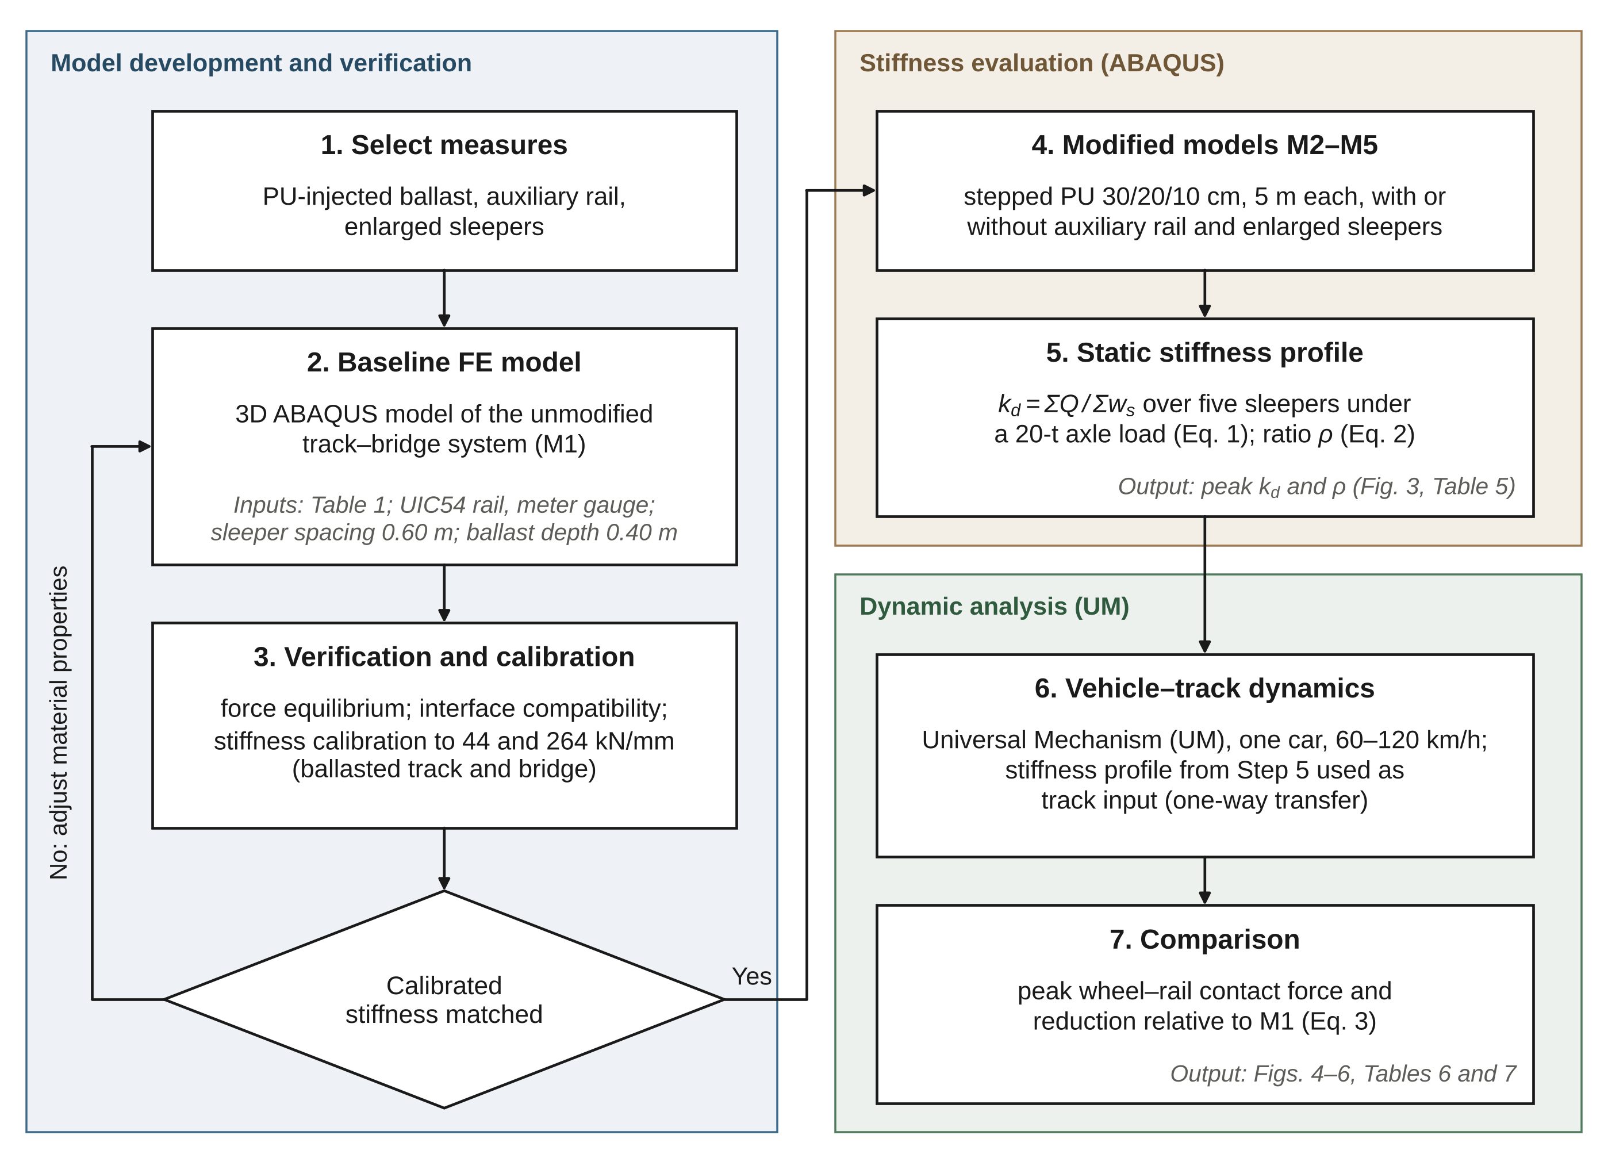
Fig. 1 Research workflow of the study. k_{d} denotes the static track stiffness, and M1–M5 are the five track configurations defined in Table 2.

2.2 Track–bridge model
The baseline model represents a meter-gauge (1.000 m) ballasted track with UIC54 rails, concrete sleepers at 0.60 m spacing, and a ballast layer 0.40 m deep over a sub-ballast layer. The track continues onto a simply supported concrete bridge. On the bridge, the sleepers rest directly on the concrete deck without a ballast layer (Fig. 2). The analysed length was 70 m, made up of a bridge section of approximately 22 m and ballasted approach sections on both sides [CONFIRM-3]. The measures were applied on the approach shown in Fig. 2, from which the vehicle entered the bridge. The components were assigned linear elastic properties (Table 1) based on in-service data provided by the State Railway of Thailand [CONFIRM-2]. The remaining geometric details (sleeper dimensions, sub-ballast thickness, and the support of the model) and the discretisation (element types, mesh size, boundary conditions, load application points, and interface constraints) are contained in the model files, which are available from the corresponding author on request. [AI2-05 Sect. 2.2 – ควรแก้: ผู้ตรวจไม่เห็นไฟล์โมเดล การเขียนว่า “อยู่ในไฟล์โมเดล” จึงเหมือนข้อมูลหาย ควรเขียนอย่างน้อย 3–4 ประโยค (ชนิดเอลิเมนต์/ขนาด mesh ใต้ราง–หมอน, เงื่อนไขขอบล่างและปลาย, จุดให้แรง, ชนิด tie/contact) และใส่ขนาดหมอนกับความหนา sub-ballast ใน Table 1 หรือตารางเล็ก ๆ — ถ้าไม่มีข้อมูลจริงจากไฟล์ ไม่ควรเติมเอง] A mesh-convergence study is not reported (Sect. 4.4). [AI2-06 Sect. 2.2 – ตัวเลือก: ประโยคนี้ซ้ำกับ Sect. 2.4 และ 4.4 — สำหรับ Q3 ไม่จำเป็นต้องมี mesh-convergence เป็นเงื่อนไข (ดุลยพินิจของ AI ไม่ใช่ข้อกำหนดที่ยืนยันจากวารสาร) ควรคงไว้ครั้งเดียวใน 4.4 เพื่อไม่ให้ Methods ฟังดูแก้ตัว] [CONFIRM-5] The bridge modulus in Table 1 is an effective value obtained during the stiffness calibration (Sect. 2.4) [CONFIRM-4].
Table 1 Material properties used in the finite element model
Component | Density (kg/m³) | Young's modulus, E | Poisson's ratio, ν
Rail (UIC54) | 7580 | 200 GPa | 0.30
Rail pad | 950 | 400 MPa | 0.30
Concrete sleeper | 2500 | 36.41 GPa | 0.17
Ballast | 1600 | 100 MPa | 0.20
PU-injected ballast | 2000 | 360 MPa | 0.33
Sub-ballast | 2200 | 40 MPa | 0.35
Bridge | 2400 | 395 MPa [CONFIRM-4] | 0.20
Note. The values of E are material moduli; the value for the rail pad is the Young’s modulus of the pad material and not an equivalent stiffness. The origin of the PU values is not documented, and no separate material data are tabulated for the auxiliary rail, the enlarged sleepers, or the support below the sub-ballast (Sect. 4.4). [AI2-07 Table 1 – ควรแก้: (1) หมายเหตุเขียนว่า “ที่มาของค่า PU ไม่มีเอกสาร” ในตัวบทที่จะตีพิมพ์ ทำให้ผลหลักดูไม่มีฐาน — ระบุตรง ๆ ว่าเป็นค่าสมมติ/ค่าทดสอบ/อ้างอิงใด และเหตุผล (E_PU = 3.6 × E_ballast); (2) แถว Bridge: E = 395 MPa คู่กับความหนาแน่น 2400 kg/m³ ของคอนกรีต ผู้อ่านจะสงสัย — เพิ่มหมายเหตุว่าเป็นค่าสมมูลที่ปรับให้ได้ 264 kN/mm (ถ้ารวมผลของที่รองรับ ให้บอกด้วย) ไม่ใช่โมดูลัสของคอนกรีต (CONFIRM-4)]

2.3 Stiffness-modification schemes
Five configurations were analysed (Table 2). They form a sequence in which stepped PU, the primary measure, is applied first and the auxiliary rail and the enlarged sleepers are added to it, so the study quantifies what the two supplementary measures add to a PU-treated approach and does not isolate their separate effects (Sect. 4.4). The PU scheme injects the ballast layer in three consecutive zones, each 5 m long, with thicknesses of 30, 20, and 10 cm, and the PU-injected ballast was modelled as a homogeneous material with E = 360 MPa (Table 1). The zones are arranged so that the PU thickness decreases with distance from the bridge (Fig. 2) [CONFIRM-7]. In each zone, the PU replaces the upper part of the ballast layer, measured from the underside of the sleepers, and the rest of the layer is unmodified ballast (Fig. 2). In M3 to M5, the auxiliary rail and the enlarged sleepers were added along part of the PU zone [CONFIRM-6]. Their dimensions and material data are defined in the model files, and only their position relative to the PU zones is shown schematically in Fig. 2. [AI2-08 Sect. 2.3 – ควรแก้ (สำคัญ): M3–M5 ต่างจาก M2 เพียงสองมาตรการนี้ แต่ผู้อ่านไม่ทราบขนาด ความยาว หรือวัสดุเลย (บอกเพียง “อยู่ในไฟล์โมเดล”) ทำซ้ำผลหลักไม่ได้ — ให้อย่างน้อย: ความยาวและหน้าตัดของ auxiliary rail, ขนาดหมอนปกติเทียบหมอน enlarged, จำนวนหมอนที่ครอบคลุม (source กล่าวถึง 4–5 หมอน; CONFIRM-6) แล้วแก้ Fig. 2 ให้ตรงกัน (รูปตอนนี้แสดงช่วง ≈ 10 m แบบ indicative)]
Table 2 Track configurations
Model | PU-injected ballast (30/20/10 cm) | Auxiliary rail | Enlarged sleepers
M1 | No | No | No
M2 | Yes | No | No
M3 | Yes | Yes | No
M4 | Yes | No | Yes
M5 | Yes | Yes | Yes
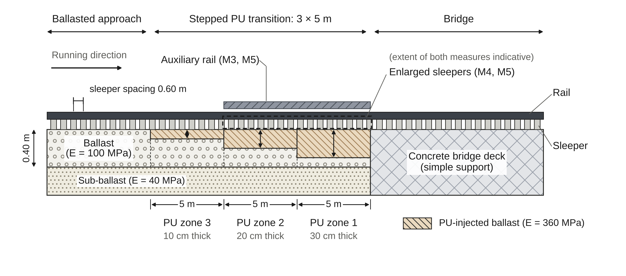
Fig. 2 Schematic longitudinal section of the modified track (not to scale). The extent of the auxiliary rail and the enlarged sleepers is indicative. The PU occupies the upper part of the ballast layer, and the running direction is from the ballasted approach toward the bridge.

2.4 Verification and stiffness calibration
The model was verified, that is, checked for whether it solves the intended problem correctly, with three checks. First, the applied vertical load (98,164.8 N) was compared with the sum of the support reactions at five sleepers (force equilibrium). Second, the settlement beneath the sleepers was compared with that at the PU surface, and the settlement beneath the PU with that at the top of the ballast layer, at measurement points along the rail in three PU test models (PU widths of 3.0, 2.7, and 1.9 m at a thickness of 30 cm) (interface compatibility). Third, the properties of the bridge and ballasted sections were adjusted by trial and error until the static track stiffness matched the targets of 264 kN/mm on the bridge and 44 kN/mm on the ballasted track [CONFIRM-16]. The targets were taken as given, and the adjusted parameters, their ranges, and the acceptance tolerance are not documented here (Sect. 4.4). [AI2-09 Sect. 2.4 – ควรแก้: ค่าเป้าหมาย 44 และ 264 kN/mm เป็นฐานของทั้งบทความ ควรบอกที่มาในหนึ่งประโยค (ต้นฉบับระบุว่า “per reference research” — ถ้ามีเอกสารจริงให้ใส่อ้างอิง; CONFIRM-16) บอกว่าปรับพารามิเตอร์ตัวใด (ประโยคก่อนหน้าระบุเพียง “properties of the bridge and ballasted sections”) และเกณฑ์ที่ยอมรับ — ข้อมูลสั้น ๆ ดีกว่าการเขียนว่า “not documented”] The equilibrium check and the stiffness calibration are assumed to refer to the unmodified model, and the interface check to three separate PU test models, so M2 to M5 were not verified individually [CONFIRM-5]. Validation against field measurements of the modelled structures was not possible because none were available, and the target stiffnesses were used for calibration, so they cannot also serve as validation data. The checks of force equilibrium and interface compatibility test the internal consistency of a linear elastic model and are not evidence of agreement with measured behaviour. A mesh-convergence study and a comparison with an analytical solution are not reported.
The track stiffness was calculated as the average spring constant under the rail (Eq. 1):
$k_{d}=\frac{\sum{Q}}{\sum_{s=1}^{5}{w_{s}}}$ (1)
where ΣQ is the sum of the vertical loads applied to the rail and w_{s} is the settlement of sleeper s, summed over five consecutive sleepers (s = 1 to 5). [AI2-10 Eq. (1) – ควรแก้ (เล็ก): “ΣQ” ยังตีความได้หลายแบบ — ระบุตรง ๆ ว่า ΣQ = 98.164 kN (แรงล้อเดียว เท่ากับผลรวมปฏิกิริยา 5 หมอนใน Table 3) และตรวจเลขให้ตรงกัน: Sect. 2.4 ใช้ 98,164.8 N (= 98.165 kN เมื่อปัดเศษ) แต่ประโยคถัดไปเขียน 98.164 kN (CONFIRM-9)] A wheel load of 98.164 kN, approximately half of a 20-t axle load, was applied, and the sleeper spacing was 0.60 m. The calculation was repeated at successive positions along the track to obtain the stiffness profile [CONFIRM-9]. The stiffness is reported in kN/mm [CONFIRM-17]. The five-sleeper window was adopted for all models, and its effect on k_{d} was not examined (Sect. 4.4).
To express the size of the stiffness contrast, the stiffness ratio between the bridge and the peak approach-side stiffness of each model was defined as (Eq. 2):
$ρ_{i}=\frac{k_{bridge}}{k_{approach,i}}$ (2)
where k_{bridge} is the bridge stiffness (264 kN/mm) and k_{approach,i} is the peak approach-side static stiffness of model i (i = 1 to 5 for M1 to M5), that is, the highest value of k_{d} along the approach track. The position of this peak is not reported, so ρ describes the overall stiffness contrast and not the stiffness gradient at the junction.

2.5 Vehicle–track dynamic analysis
Wheel–rail contact forces were computed with the multibody software Universal Mechanism (UM). A single power car of a type developed for use in Thailand, with an axle load of 20 t, travelled over the track at 60, 80, 100, and 120 km/h [CONFIRM-10]. The vehicle mass and the arrangement of axles and bogies are not reported here. [AI2-11 Sect. 2.5 – ควรแก้ (สำคัญ): “a type developed for use in Thailand” ไม่เฉพาะเจาะจงพอ — ระบุประเภท (หัวรถจักรหรือรถดีเซลราง), มวล, จำนวนเพลา–โบกี้ และแหล่งข้อมูล (Drafting notes ข้อ 10 ระบุว่าแหล่งคือ Songsak 2018 ซึ่งไม่อยู่ใน reference list — ถ้าใช้เป็นแหล่งข้อมูลรถ ให้ใส่ในเอกสารอ้างอิง)] The vertical track stiffness profile obtained from ABAQUS for each of M1 to M5 was used as the track input, and the maximum vertical wheel–rail contact force near the bridge end where the vehicle enters the bridge was extracted at each speed. The static stiffness was transferred to the multibody model in one direction only, and the track mass and damping, the rail irregularities, the wheel–rail contact model, and the exact definition of the peak value are contained in the model files and are not reported here, so the dynamic results can be reproduced only from those files. [AI2-12 Sect. 2.5 – ควรแก้: ผู้อ่านต้องรู้อย่างน้อยว่าโปรไฟล์ k_d ถูกแปลงเป็นสปริง/หน่วงใต้รางอย่างไร และ “peak force” คือค่าสูงสุดของแรงต่อล้อ (ล้อใด ช่วงใด) — เขียนสั้น ๆ 2–3 ประโยค ส่วนรายละเอียดอื่น (มวลราง, damping, ความไม่เรียบของราง) ใส่ตารางพารามิเตอร์หรือ Supplementary ได้ และควรตัดวลี “reproduced only from those files” เพราะบอกว่าอ่านบทความอย่างเดียวทำซ้ำไม่ได้] This peak value is the response used for all comparisons. Its magnitude is lower than the static wheel load of a 20-t axle (Sect. 3.3), so it is used only to compare the models with one another [CONFIRM-10]. [AI2-13 Sect. 2.5 – ต้องแก้: แรงสัมผัสสูงสุด 49–69 kN ต่ำกว่าแรงล้อสถิต 98.2 kN เป็นสิ่งที่ผู้อ่านสายวิศวกรรมสะดุดทันที แม้ใช้เชิงเปรียบเทียบ — ควรมีอย่างน้อยหนึ่งประโยคบอกว่าปริมาณที่รายงานคืออะไรและทำไมจึงต่ำกว่าสถิต (เช่น นิยาม output ใน UM หรือมวลรถที่ใช้) ถ้าหาสาเหตุไม่ได้ ให้คงการระบุเป็นข้อจำกัดอย่างชัดเจนตามที่ทำใน Abstract และ Sect. 3.3 แล้ว (ผู้ตรวจอาจยังถามความถูกต้องของแบบจำลอง)] The reduction in peak force achieved by a modified model i relative to M1 at the same speed was calculated as (Eq. 3):
$R_{i}=\frac{F_{M1}−F_{i}}{F_{M1}}×100$ (3)
where F is the peak wheel–rail contact force and the subscript i denotes the model.

2.6 Use of generative AI tools
The authors used Claude (Anthropic) to assist with drafting and language editing of the text and with writing the Python scripts used to prepare the schematic figures (Figs. 1 and 2) and the data figures (Figs. 3 to 6) from the numerical values in Tables 5 to 7. The ABAQUS and UM analyses and their numerical results come from the authors' own work. The authors reviewed and edited all text and figures and take full responsibility for the content [CONFIRM-11].

3 Results

3.1 Model verification
Force equilibrium was satisfied. The reported sum of the sleeper reactions equalled the applied load of 98,164.8 N, with a residual below 0.1 N (Table 3). The sleeper beneath the load carried 92,023.1 N, or 93.7% of the load, and the two neighbouring sleepers carried 3,634.2 N each. The two outer sleepers showed small reactions of opposite sign (−563.3 N each). The load was therefore concentrated on the loaded sleeper, and the reasons for this concentration and for the small negative reactions were not investigated (Sect. 4.4).
Table 3 Reaction forces at the five sleepers beneath the loaded rail seat
Sleeper position | Reaction force (N)
1 | −563.3
2 | 3,634.2
3 | 92,023.1
4 | 3,634.2
5 | −563.3
Sum of reactions (as reported) | 98,164.8
Applied load | 98,164.8
Residual | < 0.1
Note. Values are given as reported by ABAQUS to 0.1 N. The rounded reactions add up to 98,164.9 N, which differs from the reported sum by 0.1 N because of rounding.
Interface compatibility was also satisfied. In all three PU test models, the settlement beneath the sleepers matched that at the PU surface, and the settlement beneath the PU matched that at the top of the ballast layer (Table 4). At the six sleeper-supported measurement points, the largest difference was 0.0022 mm, or 0.48% of the local settlement. The differences beneath the PU were zero in two models and 0.0004 mm in the third. These differences are negligible against settlements of 0.44 to 0.63 mm, so the interfaces transferred displacement without relative movement. If the interfaces were defined as tie constraints, this check confirms the implementation of the constraints and not the physical behaviour [CONFIRM-5]. The check therefore carries little weight as verification. [AI2-14 Sect. 3.1 – ควรแก้ (ถ้อยคำ): “carries little weight as verification” ในบท Results ฟังดูลดค่างานตัวเอง ใช้ถ้อยคำเป็นกลาง เช่น “This check confirms the implementation of the constraints only.” ย้ายการประเมินน้ำหนักไป Sect. 4.4 (มีอยู่แล้ว) และพิจารณาย่อประโยค “were not investigated” ในย่อหน้าแรกของ 3.1 ในทำนองเดียวกัน] The four measurement points outside the sleeper-supported length were excluded from this comparison.
Table 4 Interface compatibility in the three PU test models (six sleeper-supported measurement points)
PU width and thickness | Maximum sleeper-to-PU difference, mm (% of local settlement) | Maximum PU-to-ballast difference, mm (% of local settlement) | Maximum sleeper settlement (mm)
3.0 m, 30 cm | 0.0022 (0.48) | 0.0000 (0.00) | 0.460
2.7 m, 30 cm | 0.0011 (0.31) | 0.0000 (0.00) | 0.436
1.9 m, 30 cm | 0.0021 (0.33) | 0.0004 (0.07) | 0.631
Note. The load applied to the test models and the direction in which the PU width is measured follow the model files. [AI2-15 Table 4 – ควรแก้ (เล็ก): ระบุแรงที่ใช้และทิศทางของ “width” ในหนึ่งประโยคแทนการอ้างไฟล์โมเดล (ถ้าเป็น 98.164 kN และความกว้างตามขวาง ก็เขียนตรง ๆ)]
After calibration, the static stiffness of the unmodified model was 44 kN/mm on the ballasted track and 264 kN/mm on the bridge (Table 5), which equal the target values. Because the model properties were adjusted until these targets were met, the agreement shows that the calibration converged. It is not an independent validation [CONFIRM-16].

3.2 Track stiffness
The peak approach-side stiffness rose from 44 kN/mm in M1 to 62 kN/mm with stepped PU (M2), and to between 72 and 77 kN/mm when the auxiliary rail or the enlarged sleepers were added (M3 to M5; Table 5 and Fig. 3). Stepped PU alone therefore raised the peak stiffness by 40.9%, and M5, which combined all three measures, raised it by 75.0%. The stiffness ratio ρ fell from 6.00 in M1 to 4.26 in M2 and to between 3.43 and 3.67 in M3 to M5.
Stepped PU supplied most of the added stiffness. M2 accounted for 18 of the 33 kN/mm gained by M5, or about 55%. The auxiliary rail and the enlarged sleepers raised the stiffness of M2 by a further 10 kN/mm (M3) and 14 kN/mm (M4), and their combination (M5) by 15 kN/mm, which is only 1 kN/mm more than the enlarged sleepers alone. Even in M5 the bridge remained 3.4 times stiffer than the peak approach stiffness. Only the peak value of each stiffness profile is reported in this paper; the profiles along the track are not reproduced [CONFIRM-12]. As a result, this study does not show whether the stiffness changes smoothly along the transition, and its conclusions on stiffness are limited to the peak value and the ratio ρ. [AI2-16 Sect. 3.2 – ตัวเลือก (ลดระดับจากรอบแรก): โปรไฟล์ k_d ตามระยะจากสะพานจะทำให้บทความแน่นขึ้นมาก แต่สำหรับ Q3 ไม่จำเป็น — การเขียนข้อจำกัดไว้ชัดเจนเท่าที่ทำใน V2 ยอมรับได้ ถ้ามีข้อมูลจาก ABAQUS อยู่แล้ว การเพิ่มเป็นรูปใหม่ทำได้ (AI ไม่สร้างข้อมูลเอง)]
Table 5 Peak approach-side static stiffness and bridge-to-approach stiffness ratio (bridge stiffness = 264 kN/mm; unit as discussed in [CONFIRM-17])
Model | Peak approach-side stiffness, k_{d} (kN/mm) | Increase relative to M1 (%) | Stiffness ratio, ρ
M1 | 44 | not applicable | 6.00
M2 | 62 | 40.9 | 4.26
M3 | 72 | 63.6 | 3.67
M4 | 76 | 72.7 | 3.47
M5 | 77 | 75.0 | 3.43
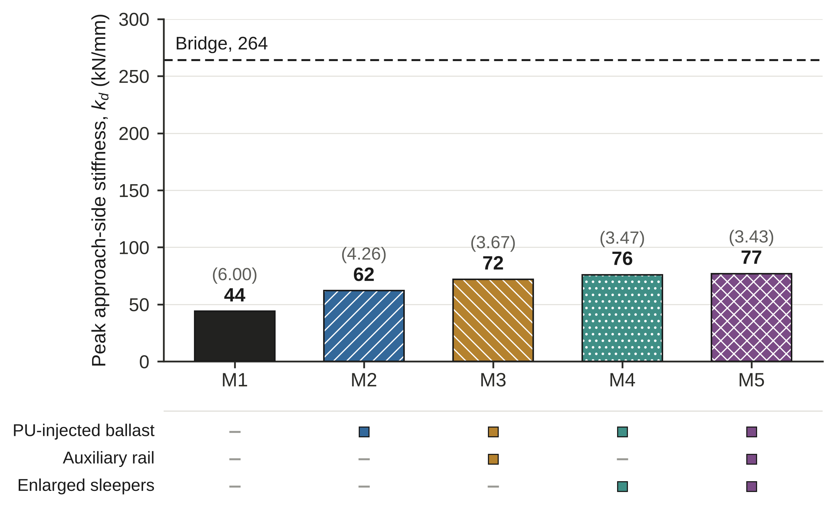
Fig. 3 Peak approach-side static stiffness of the five models. The dashed line marks the bridge stiffness (264 kN/mm), and the values in parentheses are the stiffness ratios ρ.

3.3 Peak wheel–rail contact force
In M1, the peak contact force increased from 55.00 kN at 60 km/h to 69.17 kN at 120 km/h, a rise of 25.8% (Table 6 and Fig. 4). The rise was smaller in every modified model, at 11.1% (M2), 7.8% (M3), 7.0% (M4), and 6.5% (M5). At 60 km/h, the forces of M2 to M5 were between 49.49 and 51.50 kN. At 120 km/h, M5 gave the lowest force (52.78 kN), followed by M3 (53.35 kN), M4 (53.56 kN), and M2 (57.21 kN). The forces averaged over the four speeds were 61.68 kN for M1, 54.84 kN for M2, and between 50.89 and 51.36 kN for M3 to M5.
The three combined schemes differed by no more than 0.8 kN (about 1.5%) at any speed. Differences of this size may lie within the numerical uncertainty of the model (for example, time step and mesh), which was not assessed, so the order among M3, M4, and M5 is not interpreted physically [CONFIRM-13]. The peak forces of 49 to 69 kN are lower than the static wheel load of 98.2 kN applied in the finite element model. The reported quantity is therefore treated as a comparative indicator of the response of the vehicle–track system and not as the total wheel load, and the absolute values should not be compared with design limits or measured forces. Only differences between models, which were obtained with the same vehicle, speeds, and output definition, are interpreted in the following sections [CONFIRM-10].
Table 6 Peak wheel–rail contact force (kN) of each model at four train speeds (used for comparison between models only)
Model | 60 km/h | 80 km/h | 100 km/h | 120 km/h | Mean | Rise from 60 to 120 km/h (%)
M1 | 55.00 | 58.11 | 64.45 | 69.17 | 61.68 | 25.8
M2 | 51.50 | 53.85 | 56.80 | 57.21 | 54.84 | 11.1
M3 | 49.49 | 50.75 | 51.02 | 53.35 | 51.15 | 7.8
M4 | 50.06 | 50.74 | 51.08 | 53.56 | 51.36 | 7.0
M5 | 49.55 | 50.15 | 51.08 | 52.78 | 50.89 | 6.5
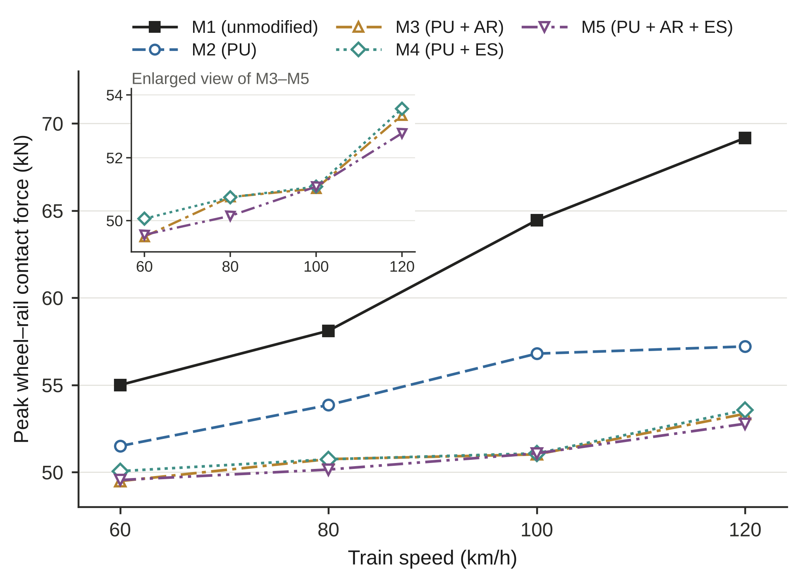
Fig. 4 Peak wheel–rail contact force against train speed for M1 to M5 (AR, auxiliary rail; ES, enlarged sleepers). The inset shows an enlarged view of M3–M5.

3.4 Reduction in peak contact force
All modified models reduced the peak force relative to M1 at every speed (Table 7 and Fig. 5). The reduction grew with speed, from 6.37% at 60 km/h to 17.29% at 120 km/h for M2, and from 9.90% to 23.69% for M5. Because the reduction is expressed relative to M1, and the force of M1 rose by 25.8% over the speed range whereas the forces of the modified models rose by 6.5 to 11.1%, the growth of the reduction with speed is a consequence of how the reduction is defined and of the data in Table 6. It does not by itself explain why the force of M1 rises faster with speed than that of the modified models. A larger stiffness contrast at the bridge end of M1 may contribute (interpretation, consistent with Sect. 4.1), but the mechanism was not investigated here.
At 120 km/h, stepped PU alone gave a reduction of 17.29%, which is 73% of the 23.69% obtained with all three measures. The auxiliary rail (M3), the enlarged sleepers (M4), and both together (M5) added 5.6, 5.3, and 6.4 percentage points, respectively, to the reduction of M2 at that speed. The three combined schemes differed from one another by no more than 1.2 percentage points at any speed, and by only 0.1 percentage points at 100 km/h. Their effects were not additive. At 120 km/h, the separate gains of M3 and M4 over M2 sum to 10.9 percentage points, whereas M5 gained 6.4 percentage points, and the ratio of the combined gain to the summed gains was about 0.5 to 0.6 at all four speeds.
Table 7 Reduction in peak contact force relative to M1 (%) at four train speeds
Model | 60 km/h | 80 km/h | 100 km/h | 120 km/h
M2 | 6.37 | 7.32 | 11.87 | 17.29
M3 | 10.02 | 12.66 | 20.84 | 22.87
M4 | 8.98 | 12.68 | 20.74 | 22.56
M5 | 9.90 | 13.69 | 20.75 | 23.69
Note. Reductions were calculated from the unrounded force values, so they can differ by 0.01 percentage points from values calculated from the rounded forces in Table 6.
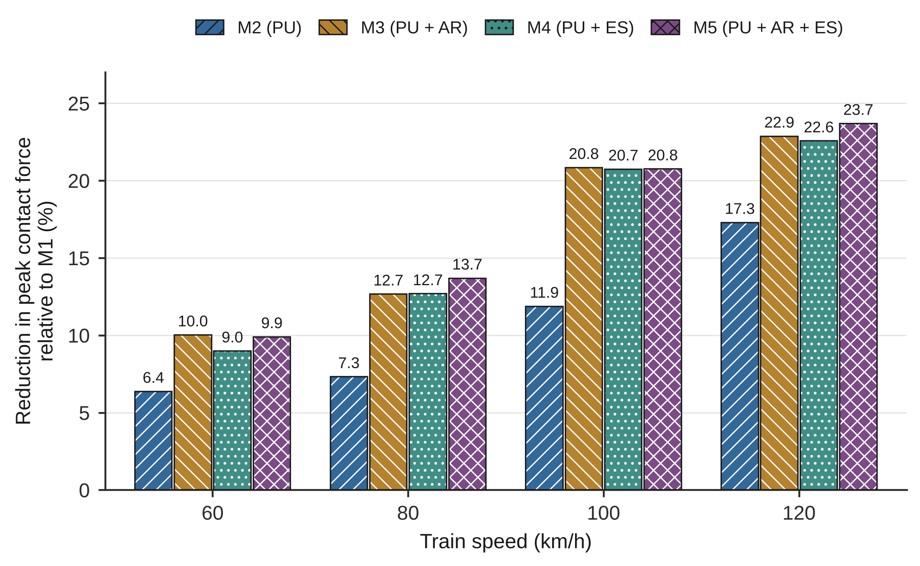
Fig. 5 Reduction in peak wheel–rail contact force relative to M1 at four train speeds (AR, auxiliary rail; ES, enlarged sleepers). The values above the bars are the reductions in percent, rounded to one decimal place (Table 7 gives two decimals).
The peak force at 120 km/h decreased as the peak approach-side stiffness increased (Fig. 6). Along the path M1, M2, M3, and M5, the force fell by 0.66 kN for each 1 kN/mm of added stiffness from M1 to M2, by 0.39 kN from M2 to M3, and by 0.11 kN from M3 to M5. These slopes depend on the path chosen: the step from M4 to M5 gave 0.78 kN per kN/mm, so a diminishing rate is not established for all paths. The relation was not strictly monotonic, because M4 (76 kN/mm) gave a force 0.21 kN higher than M3 (72 kN/mm), and differences of this size are comparable with the numerical uncertainty discussed in Sect. 3.3.
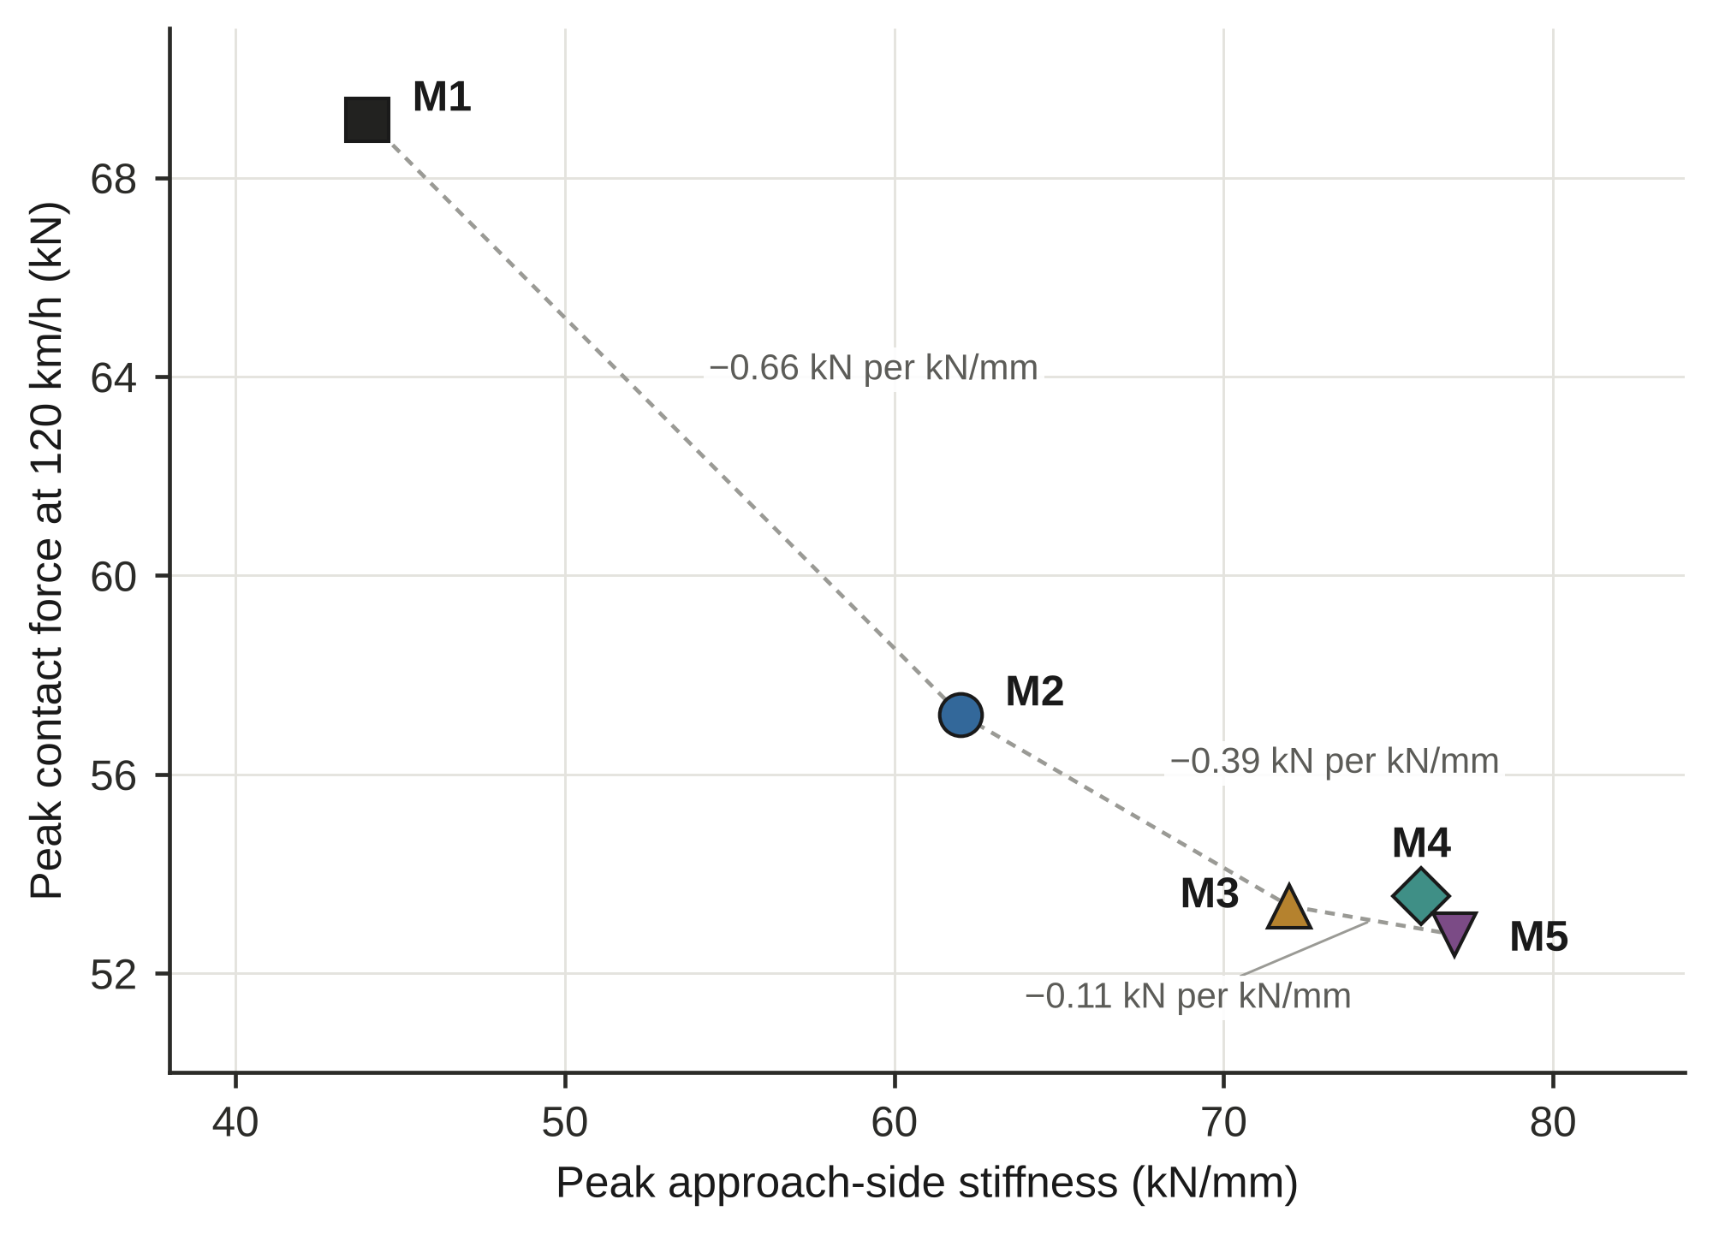
Fig. 6 Peak contact force at 120 km/h against the peak approach-side stiffness of M1 to M5. Dotted lines join M1, M2, M3 and M5, and the labels give the change in force per unit of added stiffness (kN per kN/mm) quoted in Sect. 3.4. M4 is not joined because its force is higher than that of M3.

4 Discussion

4.1 Interpretation of the results
Stepped PU, the first measure in the sequence from M1 to M5, produced the largest change. Replacing part of the ballast with PU (E = 360 MPa against 100 MPa for ballast; Table 1) in three zones of decreasing thickness raised the peak approach-side stiffness by 40.9% and lowered the stiffness ratio from 6.00 to 4.26 (Table 5). The peak force at 120 km/h fell by 17.29% (Table 7). Because the thickest PU zone lies next to the bridge [CONFIRM-7], the wheel meets a stiffer support before it reaches the bridge, and the reduction in force can be attributed to the smaller stiffness contrast at the bridge end. This explanation is an interpretation, because the stiffness profiles that would confirm it are not reproduced here. It applies to the running direction from the ballasted approach to the bridge (Fig. 2); the opposite direction and the exit side were not analysed (Sañudo et al. 2016b). [AI2-17 Sect. 4.1 – ควรแก้ (เล็ก): การอ้าง Sañudo et al. (2016b) ท้ายประโยค “…were not analysed” อ่านได้ว่างานนั้นไม่ได้วิเคราะห์ ควรแยกอ้าง เช่น “…were not analysed here; the influence of running direction has been studied by Sañudo et al. (2016b).” (อ้างตามชื่อเรื่องของงานนั้น AI ยังไม่ได้อ่านเนื้อหา)] Per unit of stiffness added, this first step (0.66 kN per kN/mm) was more effective than the further steps from M2 to M3, M4, or M5 (0.26 to 0.39 kN per kN/mm; Fig. 6). [AI2-18 Sect. 4.1 – ควรแก้ (เล็ก): ช่วง 0.26–0.39 อ่านจาก Fig. 6 ไม่ได้ (รูปแสดง 0.66/0.39/0.11 ตามเส้น M1→M2→M3→M5) ส่วน 0.26 = M2→M4 และ 0.30 = M2→M5 คำนวณจาก Tables 5–6 (AI คำนวณซ้ำแล้ว: 0.26, 0.30, 0.39) — เปลี่ยนเป็น “calculated from Tables 5 and 6” หรือเพิ่มในรูป]
The auxiliary rail and the enlarged sleepers added a smaller and overlapping benefit. They raised the stiffness of M2 by 10 to 15 kN/mm and the reduction at 120 km/h by 5.3 to 6.4 percentage points, but the gain of the combined scheme was only about 0.5 to 0.6 of the sum of the individual gains. This pattern can be attributed to both measures acting on the same stiffness deficit close to the bridge, so that the second measure works on a track that the first has already stiffened (interpretation). Once the stiffness ratio had fallen to about 3.7, further stiffening changed the force reduction by no more than 1.2 percentage points (Table 7). The force of this model and vehicle was therefore not sensitive to the stiffness ratio between 3.4 and 3.7. Only three configurations lie in this range, so the finding should not be generalised.
The benefit of every scheme grew with speed. The force in M1 rose by 25.8% between 60 and 120 km/h, whereas the forces of M2 to M5 rose by only 6.5 to 11.1% (Table 6). In this model, the benefit of the stiffness-modification schemes was therefore greatest at high speed, which is relevant where speeds are to be raised. Speed upgrading of short-span ballasted bridges has recently been examined (Mousavi et al. 2025), although that study did not address the stiffness transition at the bridge ends.

4.2 Comparison with previous studies
The 40.9% rise in peak stiffness with stepped PU is of the same order as the 40 to 50% rise in track stiffness that Woodward et al. (2014a) measured in laboratory tests of PU-reinforced ballast after 500,000 load cycles. The two values come from a static finite element model and from cyclic laboratory tests, respectively, and they are not directly comparable. Because the rise in this study depends directly on the PU modulus adopted (E = 360 MPa; Table 1), whose origin is not documented here, the agreement in magnitude does not show that this modulus is reasonable. The comparison is therefore an order-of-magnitude check and not a validation, and the sensitivity of the results to the PU modulus was not examined (Sect. 4.4).
The effect of the auxiliary rail agrees in direction with the three-dimensional train–track models of Heydari-Noghabi et al. (2017) and with the field-validated stiffness grading of Heydari-Noghabi et al. (2023), where auxiliary rails reduced the variation of rail deflection in the former and formed part of a three-stage stiffness grading in the latter. Chumyen et al. (2022) found that soil improvement raised the stiffness more than auxiliary rails did. In the present study, stepped PU likewise added more stiffness than the auxiliary rail did (18 kN/mm to M1 against 10 kN/mm to M2). The ranking is similar, but the two increments have different baselines and the extents of the measures differ between the studies, so the comparison is only qualitative.
The benefit of the enlarged sleepers (M4; 14 kN/mm and 5.3 percentage points over M2) agrees in direction with the lower maximum settlement intensity under a wide sleeper reported by Nabochenko et al. (2024), and it addresses the same parameter, the sleeper base area, that Nasrollahi and Nielsen (2024) examined in a long-term settlement model. Those studies addressed settlement, whereas the present work addresses contact force, so the agreement is limited to the direction of the effect. Jain et al. (2024b) reported that sleeper arrangements alone could not remove the transition effect. In the present study, the stiffness ratio remained between 3.4 and 3.7 in the combined schemes M3 to M5, which is consistent with that report, although every configuration here included stepped PU.
Paixão et al. (2018) showed numerically that the stiffness and position of under-sleeper pads must be designed to avoid new abrupt stiffness steps. The same caution applies to the 30, 20, and 10 cm PU steps, whose smoothness could not be checked here because only the peak stiffness is reported [CONFIRM-12]. The Thai standard for track transition zones (OTP 2018) was not used as an acceptance criterion, because the force magnitudes of the dynamic model could not be tied to a wheel-load limit (Sect. 3.3) [CONFIRM-10]. The analysis builds on the preliminary dynamic analysis of a short transition zone reported by Paoleng et al. (2018b), and the overlap between the two works is stated in the Statements and Declarations [CONFIRM-14].

4.3 Practical implications
Within the limits of the model, stepped PU injection accounts for most of the improvement in the sequence examined here, because it alone produced 73% of the largest reduction at 120 km/h and 54 to 64% at the lower speeds. The auxiliary rail and the enlarged sleepers were examined only as additions to stepped PU, so they are not ranked against it. They added 5.3 to 6.4 percentage points at 120 km/h, and the three combined schemes were within 1.2 percentage points of one another. The choice among them should therefore rest on cost, constructability, and maintenance rather than on contact force alone (recommendation). Setsobhonkul et al. (2017) compared mitigation techniques on a life-cycle basis, and the same approach would suit the present options.

4.4 Limitations and future work
The study has several limitations. First, the models were not validated against field measurements, so the results support comparative screening and not absolute prediction. The checks of force equilibrium and interface compatibility test only the internal consistency of the model, the origin of the calibration targets and the calibration procedure are not documented, and a mesh-convergence study and a comparison with an analytical solution are not reported. Second, the stiffness was obtained from static analyses of linear elastic models that exclude the nonlinearity of the ballast and hanging sleepers, and the bridge was represented by an effective modulus [CONFIRM-4] and a length that remains to be confirmed [CONFIRM-3]. The origin of the PU properties (E = 360 MPa) is not documented, and the sensitivity of the results to this modulus and to the length and thickness of the PU zones was not examined. The dimensions of the auxiliary rail and the enlarged sleepers, the transverse extent of the PU, and the support below the sub-ballast are not reported, and the load distribution among the sleepers (Table 3) and the effect of the five-sleeper window on k_{d} were not examined. Third, the dynamic analysis used one vehicle, four speeds, and the peak force only, and the absolute magnitude of the force could not be reconciled with the static wheel load [CONFIRM-10]. The static stiffness was transferred to the multibody model in one direction only, and the numerical uncertainty of the peak force (time step, mesh) was not assessed, so differences among M3, M4, and M5 should not be interpreted. Fourth, one PU layout and one auxiliary rail and sleeper design were assessed, only as additions to stepped PU, and the extent of the latter two is not fully defined [CONFIRM-6]. Only one running direction (from the ballasted approach to the bridge) was analysed, with the measures applied on one approach, and only the peak stiffness of each model is reported, so the smoothness of the stiffness transition along the track is not demonstrated. Fifth, settlement, ballast degradation, and the durability of PU under repeated loading were not modelled, although the long-term benefit of a transition measure depends on them (Li and Davis 2005; Sañudo et al. 2016a; Sol-Sánchez and D'Angelo 2017; Woodward et al. 2014a). [AI2-19 Sect. 4.4 – ควรแก้ (รูปแบบ): ย่อหน้ายาว 374 คำ รวมข้อจำกัดมากกว่า 20 ประเด็น — แยกเป็นข้อสั้น ๆ ตามความสำคัญ (ไม่มี validation/ที่มาของค่าเป้าหมาย; ค่าสมมูลของสะพานและ PU; นิยามแรงสัมผัส/ข้อมูลรถ; ทิศทางเดียว/รูปแบบเดียว; ไม่มี settlement) ส่วน mesh-convergence, หน้าต่างห้าหมอน, การกระจายแรงใน Table 3 เป็นข้อ ตัวเลือก สำหรับ Q3 ย่อเหลือครึ่งประโยคหรือตัดได้ (ดุลยพินิจของ AI)]
Future work should (i) measure track stiffness and the wheel–rail response at an instrumented meter-gauge bridge so that the models can be validated; (ii) report and optimise the stiffness profile, including the thickness and length of the PU zones, examine the sensitivity of the results to the PU modulus and to the running direction, and analyse the auxiliary rail and the enlarged sleepers without PU; and (iii) extend the analysis to settlement and life-cycle cost. These steps are needed before the results are used for design.

5 Conclusions
This study compared stepped polyurethane (PU)-injected ballast, an auxiliary rail, and enlarged sleepers at a short meter-gauge bridge transition zone with a three-dimensional finite element model and a multibody vehicle–track model. The following conclusions apply to the modelled geometry, vehicle, and speeds, and the models were not validated against field data.
- A three-dimensional finite element model of a short meter-gauge track–bridge system was calibrated to static stiffnesses of 44 kN/mm on the ballasted track and 264 kN/mm on the bridge, a ratio of 6.00, and its internal consistency was checked, but it was not validated against field data.
- Stepped PU (30, 20, and 10 cm in three 5 m zones) raised the peak approach-side stiffness by 40.9% to 62 kN/mm and lowered the stiffness ratio to 4.26. Adding the auxiliary rail, the enlarged sleepers, or both raised the stiffness to between 72 and 77 kN/mm and lowered the ratio to between 3.43 and 3.67.
- At 120 km/h, the peak contact force of 69.17 kN in the unmodified track fell by 17.29% with stepped PU, 22.87% with the auxiliary rail, 22.56% with the enlarged sleepers, and 23.69% with both. Stepped PU therefore supplied about 73% of the largest reduction, and the reductions grew with speed, for example from 6.37% at 60 km/h to 17.29% at 120 km/h with stepped PU alone.
- The auxiliary rail and the enlarged sleepers added 5.3 to 6.4 percentage points at 120 km/h, and their effects overlapped, so that the combined gain was only about 0.5 to 0.6 of the summed individual gains. The three combined schemes differed by no more than 1.2 percentage points, and the choice among them should rest on cost, constructability, and maintenance.

Statements and Declarations
Funding [To be completed by the authors. A statement such as "The authors received no specific funding for this work" may be used only if it is true] [CONFIRM-18].
Competing interests [To be completed by the authors] [CONFIRM-18].
Author contributions [To be completed by the authors using the CRediT taxonomy, with one entry per author] [CONFIRM-1].
Data availability The numerical results that support the findings of this study are given in Tables 3 to 7. The finite element and multibody model files are available from the corresponding author on reasonable request [CONFIRM-19].
Ethics approval and consent to participate Not applicable. The study involved no human participants or animals.
Prior publication Preliminary results on a short transition zone were reported in a conference paper (Paoleng et al. 2018b) and a journal article in Thai (Paoleng et al. 2018a). The overlap with the present manuscript and any permissions needed from the copyright holders are to be stated by the authors [CONFIRM-14].
Use of generative AI Described in Sect. 2.6.
Acknowledgements [To be completed by the authors, including any student or technical contributors [CONFIRM-1]].

References
Aggestam E, Nielsen J (2019) Multi-objective optimisation of transition zones between slab track and ballasted track using a genetic algorithm. J Sound Vib 446:91–112. https://doi.org/10.1016/j.jsv.2019.01.027
Chumyen P, Connolly DP, Woodward PK, Markine V (2022) The effect of soil improvement and auxiliary rails at railway track transition zones. Soil Dyn Earthq Eng 155:107200. https://doi.org/10.1016/j.soildyn.2022.107200
Chumyen P, Connolly DP, Woodward PK, Markine V (2023) A comparison of earthwork designs for railway transition zones. Constr Build Mater 395:132295. https://doi.org/10.1016/j.conbuildmat.2023.132295
Dahlberg T (2010) Railway track stiffness variations – consequences and countermeasures. Int J Civ Eng 8(1):1–12
Esveld C (2001) Modern railway track, 2nd edn. MRT-Productions, Zaltbommel
Giannakos K, Tsoukantas S (2012) Transition zone between ballastless and ballasted track: influence of changing stiffness on acting forces. Procedia Soc Behav Sci 48:3548–3557
Gundavaram D, Hussaini SKK (2023) Application of elastomeric polyurethane in performance improvement of rail ballast subjected to cyclic loading. J Mater Civ Eng 35(4):04023019. https://doi.org/10.1061/(ASCE)MT.1943-5533.0004679
Heydari-Noghabi H, Varandas JN, Esmaeili M, Zakeri J (2017) Investigating the influence of auxiliary rails on dynamic behavior of railway transition zone by a 3D train-track interaction model. Lat Am J Solids Struct 14(11):2000–2018. https://doi.org/10.1590/1679-78253906
Heydari-Noghabi H, Zakeri JA, Esmaeili M, Varandas JN (2018) Field study using additional rails and an approach slab as a transition zone from slab track to the ballasted track. Proc Inst Mech Eng F J Rail Rapid Transit 232(4):970–978. https://doi.org/10.1177/0954409717708527
Heydari-Noghabi H, Varandas JN, Zakeri JA, Esmaeili M (2023) Performance evaluation of a combined transition system in slab-ballasted railway track using a vehicle-track-substructure interaction model. KSCE J Civ Eng 27(9):3848–3860. https://doi.org/10.1007/s12205-023-1273-8
Indraratna B, Salim W, Rujikiatkamjorn C (2011) Advanced rail geotechnology – ballasted track. CRC Press, Boca Raton. https://doi.org/10.1201/b10861
Indraratna B, Sajjad MB, Ngo T, Gomes Correia A, Kelly R (2019) Improved performance of ballasted tracks at transition zones: a review of experimental and modelling approaches. Transp Geotech 21:100260. https://doi.org/10.1016/j.trgeo.2019.100260
Jain A, Metrikine AV, Steenbergen MJMM, van Dalen KN (2024a) Railway transition zones: evaluation of existing transition structures and a newly proposed transition structure. Int J Rail Transp 12(6):979–999. https://doi.org/10.1080/23248378.2023.2272668
Jain A, Metrikine AV, Steenbergen MJMM, van Dalen KN (2024b) Dynamic amplifications in railway transition zones: performance evaluation of sleeper configurations using energy criterion. Front Built Environ 10:1285131. https://doi.org/10.3389/fbuil.2024.1285131
Kaewunruen S (2014) Impact damage mechanism and mitigation by ballast bonding at railway bridge ends. Int J Railw Technol 3(4):1–22. https://doi.org/10.4203/ijrt.3.4.1
Li D, Davis D (2005) Transition of railroad bridge approaches. J Geotech Geoenviron Eng 131(11):1392–1398. https://doi.org/10.1061/(ASCE)1090-0241(2005)131:11(1392)
Li D, Otter D, Carr G (2010) Railway bridge approaches under heavy axle load traffic: problems, causes, and remedies. Proc Inst Mech Eng F J Rail Rapid Transit 224(5):383–390. https://doi.org/10.1243/09544097JRRT345
Lundqvist A, Larsson R, Dahlberg T (2006) Influence of railway track stiffness variations on wheel/rail contact force. In: Proceedings of the Workshop on Track for High-Speed Railways, University of Porto, 12–13 October 2006, pp 67–78
Mishra D, Tutumluer E, Stark TD, Hyslip JP, Chrismer SM, Tomas M (2012) Investigation of differential movement at railroad bridge approaches through geotechnical instrumentation. J Zhejiang Univ Sci A 13(11):814–824. https://doi.org/10.1631/jzus.A12ISGT7
Mottahed J, Zakeri JA, Mohammadzadeh S (2019) A field investigation on the effects of using USPs in transition zone from ballasted track to bridges. Int J Civ Eng 17(9):1421–1431. https://doi.org/10.1007/s40999-019-00440-3
Mousavi SD, Sadeghi J, Zakeri JA, Jahangiri M (2025) Improving train speed in existing short-span reinforced concrete railway bridges using ballasted pavement retrofitting method. Iran J Sci Technol Trans Civ Eng 49(4):3631–3645. https://doi.org/10.1007/s40996-024-01679-0
Myskowski B, de O. Lima A, Edwards JR (2023) Under tie (sleeper) pads – a state of the art review. Constr Build Mater 383:131239. https://doi.org/10.1016/j.conbuildmat.2023.131239
Nabochenko O, Sysyn M, Krumnow N, Fischer S (2024) Mechanism of cross-level settlements and void accumulation of wide and conventional sleepers in railway ballast. Railw Eng Sci 32(3):361–383. https://doi.org/10.1007/s40534-024-00329-5
Nasrollahi K, Nielsen J (2024) Influence of sleeper base area and spacing on long-term differential settlement in a railway track transition zone. Civil-Comp Conf 7:17.2. https://doi.org/10.4203/ccc.7.17.2
Ngamkhanong C, Ming QY, Li T, Kaewunruen S (2020) Dynamic train-track interactions over railway track stiffness transition zones using baseplate fastening systems. Eng Fail Anal 118:104866. https://doi.org/10.1016/j.engfailanal.2020.104866
Office of Transport and Traffic Policy and Planning (2018) Railway track transition zone standard (in Thai). Office of Transport and Traffic Policy and Planning, Bangkok [CONFIRM-20]
Paixão A, Fortunato E, Calçada R (2016) A contribution for integrated analysis of railway track performance at transition zones and other discontinuities. Constr Build Mater 111:699–709. https://doi.org/10.1016/j.conbuildmat.2016.02.126
Paixão A, Varandas JN, Fortunato E (2021) Dynamic behavior in transition zones and long-term railway track performance. Front Built Environ 7:658909. https://doi.org/10.3389/fbuil.2021.658909
Paixão A, Varandas JN, Fortunato E, Calçada R (2018) Numerical simulations to improve the use of under sleeper pads at transition zones to railway bridges. Eng Struct 164:169–182. https://doi.org/10.1016/j.engstruct.2018.03.005
Paoleng P, Parichatprecha R, Suthasupradit S (2018a) Behavior of railway transition zones and performance improvement techniques (in Thai). Naresuan Univ Eng J 13(1):74–87 [CONFIRM-20]
Paoleng P, Parichatprecha R, Suthasupradit S (2018b) Dynamic analysis of train-track interaction for performance improvement of short transition zone. In: Proceedings of the Fourth International Conference on Railway Technology (Railways 2018), Sitges, Spain, 3–7 September 2018 [CONFIRM-20]
Punetha P, Maharjan K, Nimbalkar S (2021) Finite element modeling of the dynamic response of critical zones in a ballasted railway track. Front Built Environ 7:660292. https://doi.org/10.3389/fbuil.2021.660292
Punetha P, Nimbalkar S (2023) Numerical investigation on dynamic behaviour of critical zones in railway tracks under moving train loads. Transp Geotech 41:101009. https://doi.org/10.1016/j.trgeo.2023.101009
Read D, Li D (2006) Design of track transitions. TCRP Research Results Digest 79. Transportation Research Board, Washington, DC. https://doi.org/10.17226/23228
Real T, Zamorano C, Hernández C, García JA, Real JI (2016) Static and dynamic behavior of transitions between different railway track typologies. KSCE J Civ Eng 20(4):1356–1364. https://doi.org/10.1007/s12205-015-0635-2
Sajjad MB, Indraratna B, Ngo T, Kelly R, Rujikiatkamjorn C (2023) A computational approach to smoothen the abrupt stiffness variation along railway transitions. J Geotech Geoenviron Eng 149(8):04023063. https://doi.org/10.1061/JGGEFK.GTENG-11294
Sañudo R, dell'Olio L, Casado JA, Carrascal IA, Diego S (2016a) Track transitions in railways: a review. Constr Build Mater 112:140–157. https://doi.org/10.1016/j.conbuildmat.2016.02.084
Sañudo R, Miranda M, Markine V, dell'Olio L (2016b) The influence of train running direction and track supports position on the behaviour of transition zones. Transp Res Procedia 18:281–288. https://doi.org/10.1016/j.trpro.2016.12.037
Sañudo R, Cerrada M, Alonso B, dell'Olio L (2017) Analysis of the influence of support positions in transition zones. A numerical analysis. Constr Build Mater 145:207–217. https://doi.org/10.1016/j.conbuildmat.2017.03.204
Setsobhonkul S, Kaewunruen S, Sussman JM (2017) Lifecycle assessments of railway bridge transitions exposed to extreme climate events. Front Built Environ 3:35. https://doi.org/10.3389/fbuil.2017.00035
Shan Y, Albers B, Savidis SA (2013) Influence of different transition zones on the dynamic response of track-subgrade systems. Comput Geotech 48:21–28. https://doi.org/10.1016/j.compgeo.2012.09.006
Shan Y, Shu Y, Zhou S (2017) Finite-infinite element coupled analysis on the influence of material parameters on the dynamic properties of transition zones. Constr Build Mater 148:548–558. https://doi.org/10.1016/j.conbuildmat.2017.05.071
Shi J, Burrow MPN, Chan AHC, Wang YJ (2013) Measurements and simulation of the dynamic responses of a bridge-embankment transition zone below a heavy haul railway line. Proc Inst Mech Eng F J Rail Rapid Transit 227(3):254–268. https://doi.org/10.1177/0954409712460979
Sol-Sánchez M, D'Angelo G (2017) Review of the design and maintenance technologies used to decelerate the deterioration of ballasted railway tracks. Constr Build Mater 157:402–415. https://doi.org/10.1016/j.conbuildmat.2017.09.007
Sommanawat W, Niyompanitpattana S (2024) Analysis and design approaches for the transition zone between bridges and embankments in railway tracks. Eng Technol Horiz 41(2):410210. https://doi.org/10.55003/ETH.410210
Varandas JN, Hölscher P, Silva MAG (2011) Dynamic behaviour of railway tracks on transitions zones. Comput Struct 89(13–14):1468–1479. https://doi.org/10.1016/j.compstruc.2011.02.013
Wang H, Markine V (2018a) Methodology for the comprehensive analysis of railway transition zones. Comput Geotech 99:64–79. https://doi.org/10.1016/j.compgeo.2018.03.001
Wang H, Markine V (2018b) Modelling of the long-term behaviour of transition zones: prediction of track settlement. Eng Struct 156:294–304. https://doi.org/10.1016/j.engstruct.2017.11.038
Woodward PK, Kennedy J, Laghrouche O, Connolly DP, Medero G (2014a) Study of railway track stiffness modification by polyurethane reinforcement of the ballast. Transp Geotech 1(4):214–224. https://doi.org/10.1016/j.trgeo.2014.06.005
Woodward P, Laghrouche O, El-Kacimi A (2014b) Railway track transition dynamics and reinforcement using polyurethane geocomposites. Geotech Eng 45(1):28–38. https://doi.org/10.14456/seagj.2014.42
Zakeri JA, Ghorbani V (2011) Investigation on dynamic behavior of railway track in transition zone. J Mech Sci Technol 25(2):287–292. https://doi.org/10.1007/s12206-010-1202-x [AI2-20 References – ตรวจสอบ: เลขบทความที่ V2 เพิ่ม (Gundavaram 04023019; Sajjad 04023063) AI ตรวจไม่ได้ในรอบนี้เพราะ crossref.org ถูกบล็อก (V2 ระบุว่าตรวจกับ Crossref แล้ว) — เปิด DOI ตรวจอีกครั้งตอนส่ง และตรวจรูปแบบอ้างอิงกับ Instructions for Authors ของวารสาร]

Drafting notes for the authors (delete this section before submission)
This section is not part of the manuscript. It separates what the source documents state, what the draft assumes, and what the authors must supply. Every tag [CONFIRM-n] in the text is defined below.

A. Items marked in the text
Tag | Type | Issue | Action needed
1 | Decision | The author list and order are a starting point (five KMUTNB authors). A student (Anan Khompa 2021) and Songsak and Rattapoohm contributed to the source work and are not listed. CRediT roles and acknowledgements are blank. | Decide authorship; complete the author contributions and acknowledgements.
2 | Source gap | The source of the State Railway of Thailand (SRT) network description and of the in-service material data in Table 1 is not identified. | Give the SRT document or the measurement source.
3 | Source conflict | The bridge length is 10 m in Sect. 3.2 and 3.4.1 of the source but about 22 m in Sect. 4.1 and in the stiffness chart. The total model length is 70 m. The draft uses about 22 m. | Confirm the bridge length in the ABAQUS model.
4 | Source conflict | A bridge modulus of 395 MPa is implausible for concrete. The draft treats it as an effective value from calibration. | Confirm the value and how the bridge was modelled.
5 | Source gap | Element types, mesh size, boundary conditions, load points and interface constraints are not in the source. | Supply them from the ABAQUS files and complete Sect. 2.2. Optional: Version 2 states that these details are in the model files and does not describe them.
6 | Source gap | The dimensions and extent of the auxiliary rail and the enlarged sleepers are not given (the source figures mention 4 and 5 sleepers). | Supply them and update Fig. 2.
7 | Assumption | The 30 cm PU zone is assumed to lie next to the bridge, with the thickness decreasing away from it. | Confirm from the model. Version 2 draws the PU in the upper part of the ballast layer, following the ABAQUS views in Figs. 3-17 to 3-19 of the source, and states that the sleepers rest directly on the bridge deck; confirm both.
8 | Source conflict | Verification Table 3-12 of the source (PU 3.0 m, 10 cm) is identical to Table 3-11 (PU 1.9 m, 30 cm). Only three distinct data sets are reported. | Provide the results of the 10 cm model, or confirm that it was not run. Version 2 no longer mentions the fourth table in the text.
9 | Source conflict and assumption | The worked stiffness example in the source uses a load sum of 122.64 kN, which does not match the 98.164 kN wheel load. Building the profile by moving the five-sleeper window along the track is an assumption. It is also unclear whether the load sum in Eq. 1 is one wheel load or five. | Confirm how the stiffness at each position was computed.
10 | Source gap | Vehicle parameters, track model, irregularities, contact model and the definition of the peak contact force are missing. The vehicle source (Songsak 2018) is not in the reference list, and the English designation of the Thai power car is unconfirmed. The peak forces of 49 to 69 kN are below the static wheel load of 98.2 kN, so they are used only as relative values, and the Thai standard limit (OTP 2018) is not applied. | Supply the Universal Mechanism input data and state what the force represents.
11 | Decision | Wording of the generative-AI disclosure (Sect. 2.6). | Confirm that it matches the actual use and the journal policy.
12 | Source gap | Only the peak stiffness of each model was available, so the draft reports stiffness ratios and not gradients. | Provide the stiffness profiles so that a profile figure can be added.
13 | Source conflict | In Sect. 4.5 of the source, the percentages for the auxiliary-rail and enlarged-sleeper models appear swapped relative to the force data in its own tables. The draft recomputed them from the force data with M3 as the auxiliary rail and M4 as the enlarged sleepers (22.87% and 22.56% at 120 km/h). | Confirm which model is which.
14 | Prior publication | Overlap with Paoleng et al. (2018a) and (2018b). Their content could not be compared with this draft. | Compare, disclose in the cover letter, and obtain permissions if text or figures are reused.
15 | Assumption | The statement that the combination has not been compared rests on a limited literature search. No IJSTCE paper on transition zones was found. Version 2 limits the statement to the literature reviewed in the Introduction. | Repeat a systematic search at submission.
16 | Source gap | The origin of the target stiffness values of 44 and 264 (stated as per reference research) is not identified. | Give the source or the measurement.
17 | Source conflict | The source gives stiffness in MPa, but the formula (load divided by settlement) implies kN/mm. The draft uses kN/mm. | Confirm the unit.
18 | Source gap | Funding and competing interests are unknown. | Complete the statements.
19 | Decision | The data availability statement is proposed wording. | Confirm or revise.
20 | Unverified | OTP (2018): the standard number (the code in the source is incomplete) and publisher details. Paoleng et al. (2018b): paper number, pages and DOI were not found. The co-author spellings in both Paoleng entries come from the source. | Check against the original documents.

B. Other differences between the source and the draft
Topic | What was found | Treatment in the draft
Effectiveness figures of the thesis (98%, 92 to 98%) | The basis of these figures is ambiguous. | Not used. All reductions are recomputed from the raw force values.
OTP limit of 60% | As read from the source, the force values in Fig. 4-19 are below 60% for every model including M1, which does not match the way Sect. 5.3 of the thesis uses the limit. | No compliance claim is made. Re-check before any claim is added.
Rail section | The source mentions both UIC54 and 100 lb/yd. | UIC54 is used.
Wheel load | 98.164 kN implies g = 9.8164 m/s²; standard gravity gives 98.07 kN (0.1% lower). | Source value kept.
Stiffness increases | The source gives 40.90% and 72.72%; recomputation gives 40.91% and 72.73%. | Recomputed values used.
Sum of reactions | The tabulated values add up to 98,164.9 N, and the source reports 98,164.8 N. | Both stated in Sect. 3.1.
Table 4 | The interface differences were computed by the drafter from the source settlement tables. | Marked here so that the authors can re-check them.
Source Sect. 5.3 and the thesis summary | Statements not supported by the M1 to M5 data set were not carried over. | Only claims that follow from Tables 5 to 7 are made.

C. Reference verification status (51 entries)
- 38 entries: the record page of the journal, publisher or repository was read (authors, year, volume, pages and DOI checked).
- 11 entries were checked only through secondary sources (reference lists or OpenAlex), and the DOI link should be opened once before submission. They are Giannakos and Tsoukantas (2012), Gundavaram and Hussaini (2023), Lundqvist et al. (2006), Mousavi et al. (2025), Ngamkhanong et al. (2020), Paixão et al. (2016), Shan et al. (2013), Shan et al. (2017), Varandas et al. (2011), Wang and Markine (2018a), and Zakeri and Ghorbani (2011). The abstracts of Gundavaram and Hussaini (2023), Mousavi et al. (2025) and Ngamkhanong et al. (2020) were not read by the drafter, so the authors should read them before submission. A separate check of the abstracts found that Mousavi et al. (2025) concerns deck and vehicle accelerations on short-span bridges and not the bridge ends. The DOI of Giannakos and Tsoukantas (2012) and the article numbers of Gundavaram and Hussaini (2023) and Sajjad et al. (2023) are missing from the list. The year of Mousavi et al. was set to 2025 after the publisher record (volume 49, issue 4, online 13 December 2024). In Version 2, nine of these 11 entries (all except Giannakos and Tsoukantas 2012 and Lundqvist et al. 2006) were re-checked against Crossref records, and authors, year, volume, pages and DOI agree with the list. Article numbers were added for Gundavaram and Hussaini (2023) and Sajjad et al. (2023). Giannakos and Tsoukantas (2012) and Lundqvist et al. (2006) could not be checked against a primary record, and OTP (2018) and Paoleng et al. (2018b) remain incomplete.
- 2 entries are incomplete (tag 20): OTP (2018) and Paoleng et al. (2018b).
- Esveld (2001) and Indraratna et al. (2011) are cited for general statements on track mechanics; page numbers should be added if the journal requires them.

D. Errors found in earlier working lists (do not reuse them)
Entry as written | Problem | Correct record
Zakeri 2026 | The DOI belongs to a 2011 paper. | Zakeri and Ghorbani (2011), J Mech Sci Technol 25(2).
Lu S. | Author name is wrong. | The paper is by Chen, Luo et al.
Jain 2024 (preprint) | Later published elsewhere. | J Vib Eng Technol (2025); not used.
Sajjad 2023 | Described as a PU study, but it is a computational study of stiffness smoothing. | Cited with the correct description.
de O. Lima | First author is wrong. | Myskowski et al. (2023).
Varandas 2021 | Wrong first author. | Paixão et al. (2021).
Geng 2020 | Wrong first author. | Park et al.
Wang 2020 (twist tolerance) | Wrong first author. | Hasan.
Paixão 2017 | Wrong first author. | Setsobhonkul et al. (2017).
Li 2026 | Wrong first author, and not relevant (settlement from GIS data). | Xie et al.; not used.
Dumitriu 2023; Wang 2021 (gauge widening) | Not relevant or of low relevance. | Not used.
The thesis bibliography also contains errors: Shi et al. is 2013 (volume 227), not 2012; Kaewunruen is 2014, not 2015; the Giannakos journal is Procedia Social and Behavioral Sciences; Kang is 2008, not 2014; Jenks is the program officer, and the authors of TCRP Research Results Digest 79 are Read and Li; Lundqvist et al. has a third author (Larsson) and is a Porto workshop paper. The RAILWAYS 2018 proceedings record and the Transportation Research Record volume for Stark (2016) could not be found.

E. Figures and files
- Figures 1 to 6 were drawn with Python (matplotlib) at 600 dpi, not with Canva or MATLAB. The manuscript does not name the plotting software. Fig. 1 can be redrawn in Canva, and the MATLAB script for Figs. 3 to 6 was written but could not be run in this environment. It must be run before MATLAB is claimed.
- The figures and scripts are delivered as separate files with this draft.

F. Checks that remain with the authors
- The current Scopus status and quartile of the journal, the publication charge or open-access option, and the Instructions for Authors (abstract length, reference style, figure format) at the time of submission.
- A similarity check against the thesis and the 2018 papers.
- The Springer route for free access, which was not re-checked. Before submission, remove all [CONFIRM-n] tags, the labels (interpretation) and (recommendation), the draft line under the title, the sentence on the fourth verification table in Sect. 3.1, and this section.

G. Checks run on this draft
- No question mark appears anywhere in the draft, and the title has no colon.
- The abstract has 248 words (journal limit 150 to 250 words). The draft has 51 references, and every one is cited and every citation has an entry. It has 6 figures, 7 tables and 3 equations, and all are cited in the text.
- All derived numbers in Tables 5 to 7 and in the text were recomputed from the raw force and stiffness values. One bound (1.1 percentage points) was corrected to 1.2.

H. Changes in Version 2
- Version 2 responds to 43 comments of the first review round (see the separate response table). Revised text is shown in bold red and should be set in normal type before submission.
- Fig. 1: the question mark in the decision box was removed. Fig. 2: redrawn with the PU in the upper part of the ballast layer (script included with the files).
- Equations 1 to 3 were converted to Word equations, as the journal asks for an equation editor.
- Items that remain with the authors: the origin of the PU properties and of the calibration targets, the dimensions of the auxiliary rail and the enlarged sleepers, mesh and boundary details, the vehicle data, the definition of the peak force, and the Springer policy on AI-assisted figures.
- Title, abstract, objectives, results, discussion and conclusions were compared for consistency of the model labels, speeds, units and values. A separate reviewer then rechecked all numbers and the use of the less well verified references. It found no wrong number. Its findings led to these changes: units added to the abstract; the verification wording narrowed to the models and checks actually run; the share of stepped PU stated per speed; the auxiliary rail and enlarged sleepers no longer ranked against PU, because they were never run without PU; the claim on speed dependence of M1 softened; and the descriptions of Varandas et al. (2011), Shan et al. (2013) and Wang and Markine (2018b) in the Introduction narrowed to what their titles and abstracts support.

