Mapping Artificial Intelligence Research in Vocational Education and Training Toward an AI-Aware Pedagogy of Occupational Competence
Siriphat Maneekeaw, Surawut Saekram, Phuwadon Yaiyindee, and Piyarat Paoleng
Department of Teacher Training in Civil Engineering, Faculty of Technical Education, King Mongkut’s University of Technology North Bangkok, Thailand

Abstract
Artificial intelligence is entering technical and vocational education and training faster than evidence about its educational value is accumulating, and it is unclear whether learners can still demonstrate occupational competence when artificial intelligence supports their work. Existing maps and reviews describe publication growth or the effectiveness of tools, but few separate records that study artificial intelligence directly from those that describe the digital and pedagogical conditions of vocational learning. This bibliometric-assisted critical review mapped the Scopus literature on artificial intelligence and digital foundations in vocational education, interpreted it through five pedagogical themes, and proposed a conceptual framework. A documented search retrieved 103 records, 13 were excluded after relevance screening, and 90 records published between 2019 and 1 July 2026 formed the corpus. Annual counts, country contributions (full counting) and a keyword co-occurrence map were produced with VOSviewer, and a critical synthesis read the map against selected sources. [ข้อสังเกต 1: ชื่อเรื่อง​ใช้ 'Mapping AI Research' แต่ corpus จริง​รวม​งาน​ด้าน digital/pedagogy ที่​ไม่​ได้​ศึกษา AI โดยตรง (Sec. 2.2, 4.10) ผู้อ่าน​อาจ​เข้าใจ​ว่า 90 records คือ​งาน​ด้าน AI ทั้งหมด ควร​ทบทวน​ว่า​ชื่อเรื่อง​สะท้อน​ขอบเขต​จริง​หรือไม่ (เช่น เติม 'digital foundations')]
Annual output rose from three records in 2023 to 14 in 2024, 26 in 2025 and 31 in the partial 2026 dataset. China (20 records), Indonesia (16) and Malaysia (14) were the most represented among 38 countries. The keyword map contained 60 items in seven clusters, which the synthesis organised into five themes covering artificial intelligence and data-driven learning systems, digital and technology-enhanced vocational learning, teacher competence, curriculum and workforce alignment, and assessment, literacy and ethics. Corpus membership, thematic relevance and evidence of effectiveness were distinct judgements, and publication growth alone did not indicate stronger evidence of learning. The proposed framework links teacher agency, competency-based curriculum alignment, technology-enhanced instructional design, authentic and artificial intelligence-aware assessment, and ethical artificial intelligence literacy. It is a conceptual synthesis that has not been validated empirically. Its central proposition is that artificial intelligence support should preserve opportunities for learners to practise and demonstrate occupational competence. [ข้อสังเกต 2: ถ้อยคำ​ของ central proposition ใน Abstract ('AI support should preserve opportunities...') ไม่​ตรง​กับ Conclusions ('AI should support opportunities to practise, explain and demonstrate... and should not replace supervised practical performance') ควร​ใช้​ถ้อยคำ​เดียวกัน เพราะ​เป็น​ข้อเสนอ​หลัก​ของ​บทความ]
Keywords: artificial intelligence; technical and vocational education and training; bibliometric analysis; teacher competence; digital pedagogy; authentic assessment; AI literacy

1. Introduction
Artificial intelligence (AI) now reaches vocational education as course recommenders, language-model assistants, automated assessment and curriculum analysis, yet the strength of the evidence behind these applications is uneven. A recent systematic review of 26 empirical studies of AI in vocational education and training found only five randomised experimental designs and a research emphasis on drill-and-practice and adaptive feedback, with approaches that build learner agency and critical reflection underrepresented (Deutscher et al., 2026). Single studies show the same pattern. Huang et al. (2025) built an assistance system for automotive electronics internships on a fine-tuned large language model and evaluated it technically, while stating that direct student trials were deliberately avoided (Figure 1a). A system can be accurate without anyone yet knowing whether apprentices who use it can perform the occupational task unaided.
In technical and vocational education and training (TVET), the educational question goes beyond whether learners can produce convincing digital outputs. It concerns whether they can perform occupational tasks, explain their decisions and show competence under conditions that resemble work. Competence has itself been examined critically as an organising concept of vocational education and training policy (Mulder et al., 2007), and AI adds a further difficulty, because polished outputs can now be produced with little visible effort. Holmes and Tuomi (2022) argue that enthusiasm for AI in education can rest on overestimates of what the technology can do and on a narrow view of what education is for. Assessment designers have reached a related position. Perkins et al. (2025) argue that permitted AI use should be matched to intended learning outcomes through assessment design, instead of relying on labels or detection alone.
The relevant literature is also spread across objects of inquiry that are easily confused. AI studies examine course recommendation (Hassan et al., 2024), feedback analysis in higher vocational English teaching (Ma, 2022), AI-supported curriculum analysis (Lima et al., 2026) and AI-enabled virtual mentorship in woodwork technology education (Okanya & Attah, 2026). A separate and older strand concerns information and communication technology (ICT) in TVET and the digital competence of vocational teachers (Cattaneo et al., 2022; Hassan et al., 2021; Lahn & Berntsen, 2023), often framed through technological pedagogical content knowledge (TPACK; Mishra & Koehler, 2006). A third strand examines assessment and AI literacy (Alexis & Pavlatou, 2026; Esposito et al., 2025; Hong, 2025). A keyword map places these strands side by side. A course recommender is nevertheless not the same intervention as a microcontroller training kit (Eliza et al., 2025; Hassan et al., 2024), and a teacher’s general digital competence is not the same as demonstrated competence in judging AI output (Cattaneo et al., 2022). [ข้อสังเกต 3: ประโยค 'A keyword map places these strands side by side' ไม่​ชัด​ว่า​หมายถึง​แผนที่​ของ​งาน​นี้ (Figure 5) หรือ​ของ​งาน​อื่น และ​ผล​ยัง​ไม่​ถูก​นำเสนอ​จนถึง Section 3 ควร​ระบุ 'Figure 5' หรือ​ย้าย​ไป​หลัง​นำเสนอ​ผล]
Earlier syntheses have mapped parts of this field. Hassan et al. (2021) reviewed ICT-enabled TVET systematically. Yuliansah et al. (2026b) mapped Scopus-indexed publications on AI-driven vocational teaching and learning, covering publication growth, geography, collaboration, keywords and emerging themes, and their review also discusses instructional design and evaluation. Reviews of adjacent topics, namely flipped classrooms in vocational education, mobile learning with competency-based education, and virtual simulation, supply further context (Rahayu et al., 2026; Wagino et al., 2026; Yindeemak et al., 2026). Deutscher et al. (2026) then examined the effectiveness evidence for AI-supported interventions. Three issues remain unresolved. The first is how AI-specific records should be read next to digital and pedagogical records that matter for vocational learning but do not study AI. The second is how teacher agency, curriculum alignment, instructional design, assessment and ethical AI literacy fit together in one account of vocational pedagogy. The third is what should count as credible evidence that a learner can perform an occupation when AI has been available during learning. [ข้อสังเกต 4: (1) ช่องว่าง 3 ข้อ​ยัง​ไม่​ถูก​แปลง​เป็น RQ ที่​ชัดเจน ข้อ​ที่ 3 (credible evidence) ปรากฏ​เพียง​โดยนัย​ใน objective (iv)-(v) ควร​จับคู่ gap กับ objective (2) ความต่าง​จาก Yuliansah et al. (2026b) ซึ่ง​เป็น Scopus mapping ที่​ใกล้เคียง​ที่สุด ควร​สรุป​เป็นตาราง​เปรียบเทียบ (ขอบเขต ช่วง​ปี จำนวน records ผล​หลัก) เพื่อ​ยืนยัน novelty ระดับ Q2]
Figure 1 shows why these issues matter. Panel a presents the architecture of the assistance system reported by Huang et al. (2025), a design whose evaluation concerns model performance. Panel b presents the competency-based education architecture proposed by Hong (2025) for building AI literacy among higher vocational students, a design organised around competency standards, learning pathways and assessment. Both would appear under the keywords artificial intelligence and vocational education, and both belong in a map of the literature, yet they support different kinds of claims.
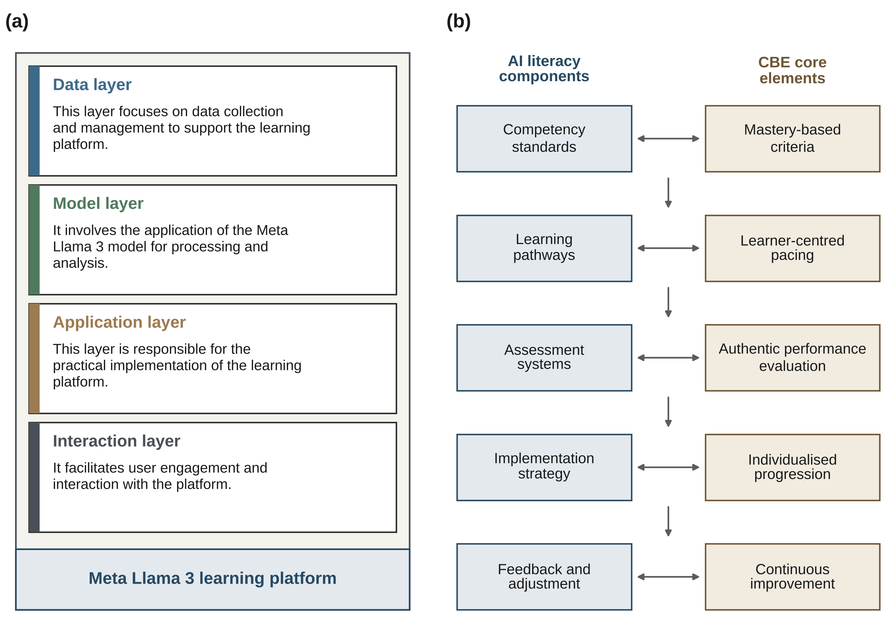

Figure 1. Two AI-in-TVET designs that share keywords but support different claims. (a) Architecture of the fine-tuned Llama 3 assistance system for automotive electronics internship learning, redrawn and adapted from Huang et al. (2025, Figure 1; https://doi.org/10.3390/systems13080668). (b) Architecture of the competency-based AI-literacy education system, redrawn and adapted from Hong (2025, Figure 1; https://doi.org/10.1038/s41598-025-15202-6). Both panels were redrawn for this article, and the labels follow the source figures. [ข้อสังเกต 5: ตรวจ​ก่อน​ส่ง: รูป (a) Huang et al. (2025) และ (b) Hong (2025) วาด​ใหม่​ตาม​เนื้อหา​และ​ป้าย​ของ​ต้นฉบับ แต่​ยัง​ไม่​ได้​ตรวจ​ยืนยัน license (เข้า​เว็บ​สำนักพิมพ์​ไม่​ได้​ขณะ​จัดทำ) โปรด​ตรวจ​ว่า​เป็น CC BY 4.0 หรือไม่ และ​เขียน credit ตามที่​กำหนด (เช่น 'Adapted from ... under CC BY 4.0') การ​วาด​ใหม่​ไม่​ได้​ทำให้​พ้น​ข้อ​กำหนดการ​อ้าง​ที่มา รูป (a) ต้นฉบับ​เป็น infographic รูป​กุญแจ จึง​วาด​เป็น 4 layer โดย​คง​ข้อความ​เดิม]
This article combines bibliometric mapping with critical synthesis and keeps the two layers apart. The descriptive base is a documented corpus of 90 Scopus records covering 2019 to the export date of 1 July 2026. The interpretive task is to connect that map to vocational teaching, teacher competence, curriculum alignment and assessment without inferring educational effectiveness from publication frequency or network position. The contribution claimed is specific and modest: an evidence-sensitive framework for AI-aware vocational pedagogy, together with an explicit separation between mapped records and claim-specific evidence. It is not a claim to provide the first or the most comprehensive map of AI in TVET. Deutscher et al. (2026) was published after the export date, so it is used only as later scholarly context and was not added to the 90-record corpus.
The objectives of this study were (i) to describe changes in publication output within the mapped literature from 2019 to the Scopus export date of 1 July 2026; (ii) to identify the countries most represented by author-affiliation metadata in the corpus; (iii) to characterise the keyword co-occurrence clusters of the mapped literature and relate them to the interpretive review themes; (iv) to synthesise what the literature indicates about the relationships among AI use, vocational pedagogy, teacher competence, curriculum alignment and assessment, given differences in evidential relevance; and (v) to develop a conceptual framework for AI-aware vocational pedagogy from this synthesis.

2. Materials and Methods

2.1 Review Design
The study uses a bibliometric-assisted critical review design with two analytical layers. The bibliometric layer describes the publication and keyword structure of a documented corpus. Methods of this kind describe how a literature is organised, not whether the practices it reports are effective (Donthu et al., 2021; van Eck & Waltman, 2010). The critical synthesis layer considers how selected, relevant sources inform vocational pedagogy. Grant and Booth (2009) describe the critical review as a review type that goes beyond description to include analysis and conceptual development, and the second layer follows that purpose. Figure 2 summarises the workflow. [ข้อสังเกต 6: ไม่​ระบุ​เกณฑ์​และ​กระบวนการ​เลือก 'selected, relevant sources' สำหรับ critical synthesis (ใคร​เลือก เกณฑ์​ใด จาก​กี่ records) Sec. 2.5 บอก​เพียง​ว่า reference list จำกัด​เฉพาะ​แหล่ง​ที่​ตรวจ​สอบผ่าน DOI ได้ ซึ่ง​เป็น​เกณฑ์​ด้าน​การ​ตรวจสอบ ไม่​ใช่​ด้าน​เนื้อหา อาจ​ถูก​มองว่า​มี selection bias]
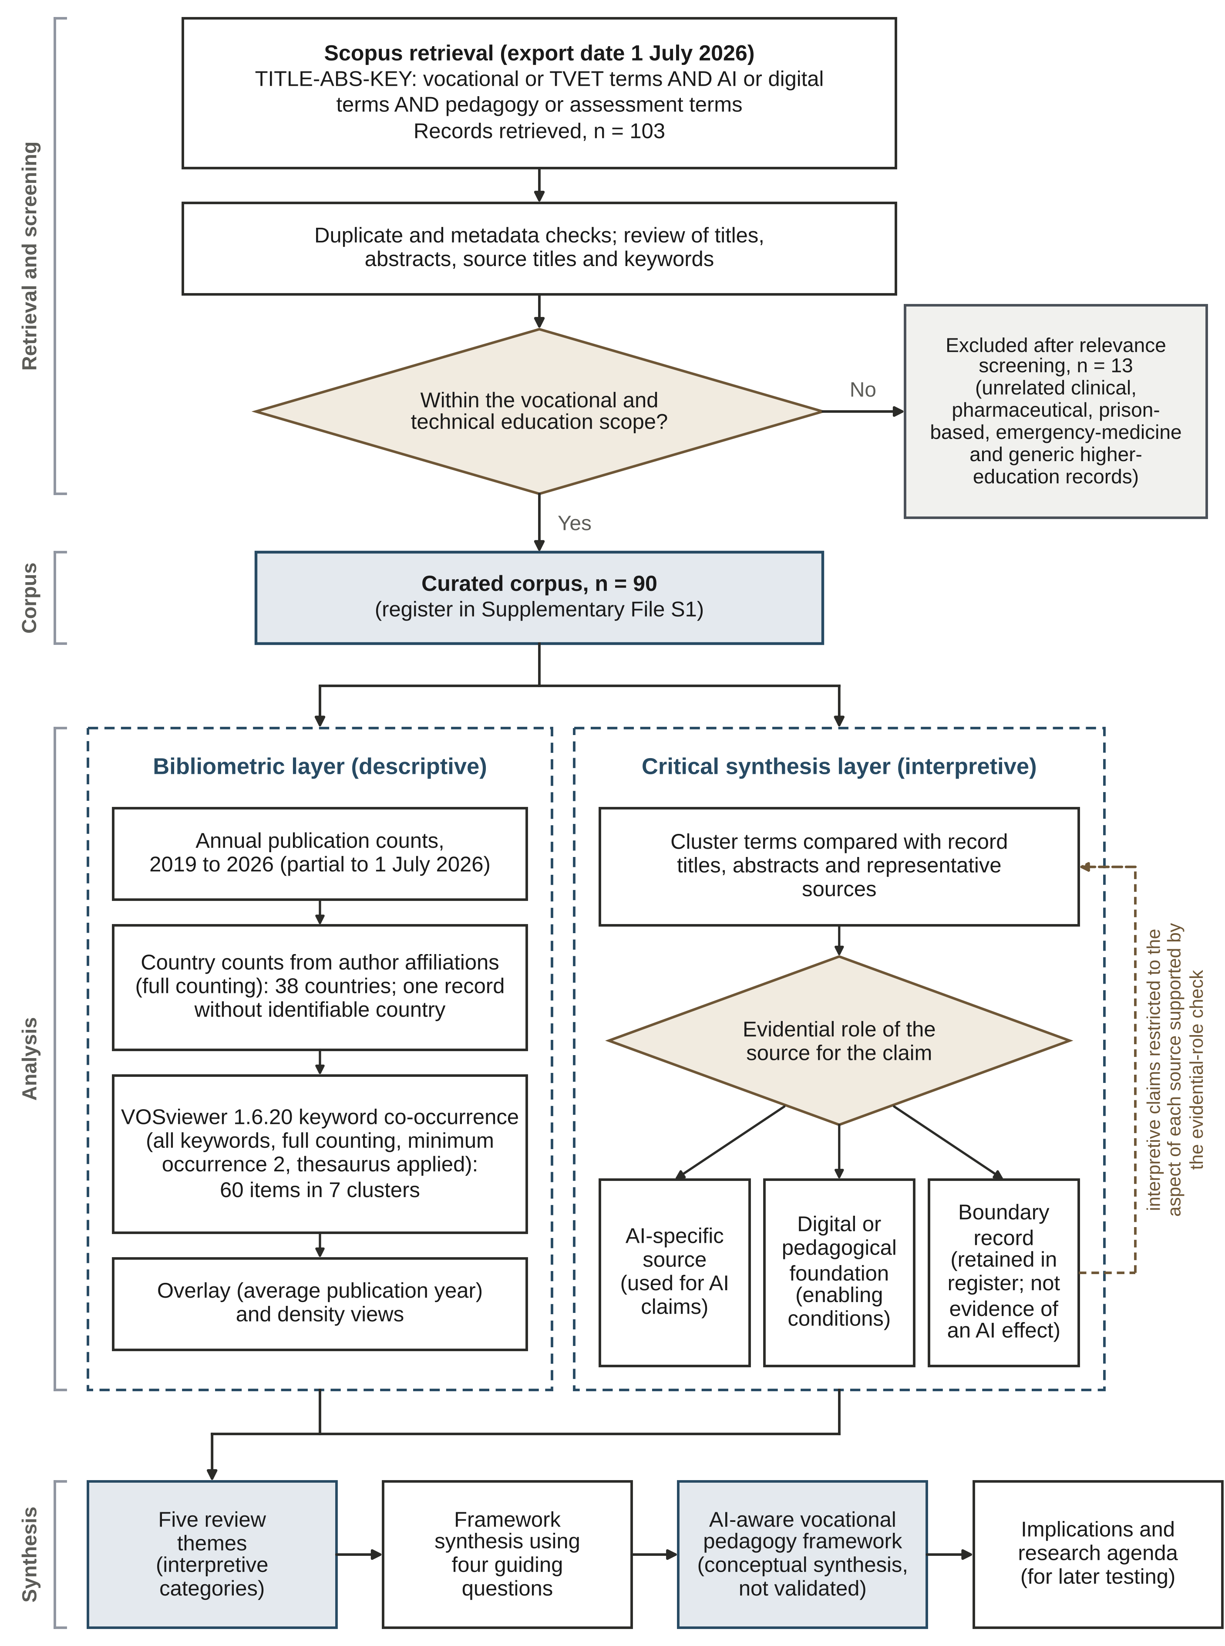
Figure 2. Workflow of the bibliometric-assisted critical review. TVET, technical and vocational education and training; AI, artificial intelligence. Solid arrows show the sequence of steps. The dashed arrow shows that interpretive claims were restricted to the aspect of each source supported by the evidential-role check. [ข้อสังเกต 7: ตรวจ​ก่อน​ส่ง: ลูกศร​ประ​ใน​รูป​เดิม​ออกจาก Boundary record เท่านั้น ใน V2 ปรับ​ให้​ออกจาก​กลุ่ม​บทบาท​ทั้ง​สาม​เพื่อให้​ตรง​กับ​คำอธิบาย​ใต้​รูป โปรด​ยืนยัน​ว่า​ตรง​เจตนา ตัวเลข 103/13/90 ตรง​กับ Table 1 แล้ว]
The two layers must stay distinct because the search combines AI terms with terms for digital competence and educational technology. A record can contribute to the descriptive map or to the discussion of enabling conditions without being evidence of an AI intervention. Interpretive use therefore depends on a source’s substantive focus, educational context and type of contribution, not on its inclusion in the mapped corpus.
This is not a meta-analysis, a systematic risk-of-bias appraisal or a test of a causal model. The expression “critical synthesis” denotes the interpretive examination used in this article, and it does not imply that a separate formal Critical Interpretive Synthesis protocol was implemented. No effect-size pooling, independent dual-screening agreement or inter-coder reliability statistic is reported. Recommendations and the proposed framework are presented as review-derived arguments, not as estimated intervention effects.

2.2 Data Source and Search Strategy
Scopus supplied the bibliographic metadata used for the mapping, including publication years, affiliation information, and author and index keywords. The documented export date is 1 July 2026. The analysis is restricted to that corpus and does not rest on an updated search, so the 2026 count is partial and the results are a snapshot of the mapped literature, not a complete annual or global inventory.
The working search strategy documented for the study is reproduced below. [ข้อสังเกต 8: ไม่​ระบุ​ตัว​กรอง​การ​ค้นหา (ช่วง​ปี ประเภท​เอกสาร ภาษา subject area) และ​ไม่​อธิบาย​ว่า​ทำไม corpus เริ่ม​ที่​ปี 2019 ทั้งที่ search string ไม่​มี​เงื่อนไข​ปี กลุ่ม​คำ​ที่ 3 ('pedagogy', 'assessment') กว้าง​มาก จึง​อธิบาย​ได้​ว่า​ทำไม​มี record นอกประเด็น AI ควร​รายงานตัว​กรอง​ให้​ครบ​เพื่อให้​ทำซ้ำ​ได้]
TITLE-ABS-KEY(
("vocational education" OR TVET OR "technical education" OR "vocational training")
AND
("artificial intelligence" OR "generative AI" OR ChatGPT OR "AI literacy" OR "machine learning" OR "deep learning" OR "learning analytics" OR "intelligent tutoring" OR "digital competence" OR "educational technology")
AND
("teacher competence" OR "teacher professional development" OR pedagogy OR "instructional design" OR "competency-based education" OR "outcomes-based education" OR assessment OR "authentic assessment")
)
The documented search and screening summary reports 103 retrieved records, 13 exclusions after relevance screening and a final mapping corpus of 90 records. Direct AI terms and broader digital terms define a deliberately mixed retrieval space. The original account describes duplicate and metadata checks followed by review of titles, abstracts, source titles and keywords. The summary counts are retained as documented. The search string above is reproduced from the original analysis and was not executed again for this manuscript, and exclusion decisions were not reconstructed. [ข้อสังเกต 9: (ประเด็นสำคัญ) คำ​ว่า 'original analysis/account' ปรากฏ​ซ้ำ​หลาย​จุด (Sec. 2.2-2.5, Tables 1-2, 6) แต่​ไม่​อธิบาย​ว่า​คือ​การ​วิเคราะห์​ใด ใคร​ทำ เมื่อใด ควร​ระบุ​ให้​ชัด และ​เนื่องจาก search string ไม่​ได้​รัน​ซ้ำ ควร​พิจารณา​รัน​ซ้ำ (ปัจจุบัน​เลย 1 July 2026 แล้ว) หรือ​อย่าง​น้อย​แนบ Scopus export และ search log เป็น Supplementary ผู้ประเมิน​มัก​ตั้งคำถาม​ประเด็น​นี้]

2.3 Eligibility and Screening
The documented eligibility scope covers vocational and technical education, vocational teacher development, workplace-oriented learning, digital competence, instructional design and assessment. Relevance to this scope is not equivalent to direct evidence about AI. For the critical synthesis, three evidential roles are distinguished. These are AI-specific sources; digital or pedagogical foundations; and boundary records whose relevance to an AI-pedagogy claim is limited or unresolved. The roles qualify interpretation, and they do not create a new statistical partition of the corpus. [ข้อสังเกต 10: มี​การ​แบ่ง evidential roles 3 แบบ แต่​ไม่​ระบุ​ว่า​ใคร​จัด​และ​ใช้​เกณฑ์​ใด และ​ไม่​รายงาน​จำนวน records ต่อ​บทบาท ทั้งที่​เป็น​ข้อโต้แย้ง​หลัก​ของ​บทความ ผู้อ่าน​ไม่​ทราบ​ว่า​จาก 90 records เป็น AI-specific กี่​ฉบับ ถ้า​มี​ข้อมูล​ใน Supplementary S1 ควร​รายงาน (ตาราง​สั้น​หรือ​ใส่​ใน Figure 2) ถ้า​ไม่​มี​ควร​อธิบาย​เหตุผล]
The original screening account reports excluding unrelated clinical, pharmaceutical, prison-based, emergency-medicine and generic higher-education records. A later claim-level check nevertheless identified boundary cases in the retained bibliography. These are made explicit in Supplementary File S1 instead of being removed silently from an already analysed corpus. One retained record lacks identifiable country metadata. It remains in the 90-record corpus but is excluded from country counting, so country shares in this article use 89 records as the denominator.
Table 1 reproduces the documented screening totals. Supplementary File S1 supplies a 90-record bibliographic register reconstructed from the manuscript, the original dominant allocations and evidence-use notes. It is not a substitute for the original Scopus export or the record-level screening log. [ข้อสังเกต 11: Table 1 (3 แถว) ซ้ำ​กับ​ตัวเลข 103 > 13 > 90 ใน Figure 2 และ Sec. 2.2 ควร​พิจารณา​ตัด​หรือ​รวม​เข้ากับ Figure 2 และ​ยัง​ไม่​ระบุ​จำนวน​ผู้​คัด​กรอง​ใน relevance screening]
Table 1. Search and screening summary for the mapped corpus.
Stage | Records
Initial Scopus retrieval | 103
Excluded after relevance screening | 13
Final curated corpus | 90
Note. Counts are reproduced as documented in the original analysis (export date 1 July 2026).

2.4 Data Preparation and Analysis
Annual counts were taken from the publication-year field in the original analysis. Countries were counted from author affiliations by full counting, so each country appearing in a document was credited once for that document. The reported distribution includes 38 countries and one record without identifiable country information. A multinational document may contribute to more than one country, so country totals need not equal the corpus size, and affiliation countries describe authorship participation, not necessarily the settings in which the research was conducted.
The documented VOSviewer analysis used version 1.6.20, all author and index keywords, full counting and a minimum occurrence threshold of two. The VOSviewer clustering technique builds on the unified approach to mapping and clustering of bibliometric networks described by Waltman et al. (2010). The original account reports use of a thesaurus to merge variants and remove generic indexing terms. The retained map contains 60 items in seven clusters. These settings and the original maps are preserved. No additional keyword cleaning, clustering run, threshold-sensitivity test or re-estimation is presented here. Table 2 reproduces the documented settings, and interpretations remain conditional on the underlying metadata and mapping choices (van Eck & Waltman, 2010). Proportions in Tables 3, 4 and 6 were calculated from the documented counts. The study used bibliographic metadata only and involved no human participants. [ข้อสังเกต 12: รายละเอียด VOSviewer ยัง​ไม่​พอ​สำหรับ​การ​ทำซ้ำ: ไม่​ระบุ normalisation (เช่น association strength), clustering resolution, minimum cluster size, จำนวน keyword ก่อน threshold = 2 (60 items คือ​หลัง threshold หรือ​หลัง thesaurus?) และ​ค่า​ตั้ง​ของ overlay/density ควร​แนบ thesaurus เป็น Supplementary เพราะ​มีผลต่อ cluster โดยตรง]
Table 2. VOSviewer keyword co-occurrence settings.
Parameter | Setting
Software | VOSviewer 1.6.20
Type of analysis | Co-occurrence
Unit of analysis | All keywords
Counting method | Full counting
Minimum keyword occurrence | 2
Thesaurus | Applied to merge variants and remove generic or non-substantive terms
Final keyword map | 60 items, 7 clusters

2.5 From Bibliometric Clusters to Review Themes
The seven keyword clusters serve as organisational prompts for the critical synthesis, not as evidence of seven validated pedagogical constructs. The documented interpretive process compared cluster terms with record titles, abstracts and representative sources. Cluster labels describe topical proximity, whereas the five review themes address broader questions about systems, learning environments, teachers, alignment and assessment. The themes are AI and data-driven learning systems; digital, immersive and technology-enhanced vocational learning; teacher competence and professional development; TVET, curriculum alignment and workforce competence; and assessment, learning outcomes, AI literacy and ethics. Theme prominence is not treated as a measure of evidence quality or effect magnitude. [ข้อสังเกต 13: การ​เปลี่ยน 7 clusters เป็น 5 themes ยัง​ไม่​โปร่งใส ไม่​มี​ตาราง​หรือ​รูป​แสดงว่า cluster ใด (Table 5) จัด​เข้า theme ใด ด้วย​เกณฑ์​อะไร ควร​เพิ่ม​ตาราง crosswalk cluster > theme (การ​จับคู่​ต้อง​เป็นการ​ตัดสิน​ของ​ผู้เขียน)]
Sources are used according to what they investigate. AI-focused studies can inform discussion of an AI application, research on general digital competence can inform readiness and teacher development, and work on practical learning can inform pedagogical context. A shared keyword does not establish an AI effect. The evidence-use check concerns citation placement, source relevance and interpretive boundaries. It is not a new screening exercise or an independent recoding, and no reviewer-agreement statistic is inferred. Source-specific qualifications and unresolved bibliographic checks are recorded in Supplementary File S1, and claims in the discussion are restricted to the aspect of each source that is relevant to the argument.
To keep the evidential trail transparent, the reference list is limited to sources directly used in the discussion whose bibliographic identity can be traced through DOI-linked scholarly records. The original 90-record register is preserved in Supplementary File S1, and its membership must not be confused with the subset cited to support interpretive claims. Foundational theory, bibliometric methodology and the later contextual review are distinguished from the July 2026 Scopus mapping corpus. Expanding the cited literature does not change the denominator, country counts, keyword network or original contribution-group allocations.

2.6 From Review Themes to Conceptual Framework
Framework synthesis uses four guiding statements. The first concerns the role proposed for AI in vocational learning. The second concerns who retains responsibility for professional judgement. The third concerns which curriculum and occupational expectations guide task design. The fourth concerns what evidence would allow an assessor to judge competence and responsible AI use. These statements connect the interpretive themes to practical design considerations, and they do not specify variables for a tested causal model.
The resulting framework has five components, named consistently throughout the article: teacher agency; competency-based curriculum alignment; technology-enhanced instructional design; authentic and AI-aware assessment; and ethical AI literacy. Teacher agency and ethical AI literacy are treated as cross-cutting considerations for curriculum, instruction and assessment. The framework is a conceptual synthesis, and its relationships, feasibility and consequences for competence development require empirical investigation. [ข้อสังเกต 14: 5 components ไม่​ตรง​กับ 5 themes: theme 'AI and data-driven learning systems' ไม่​มี component ของ​ตัวเอง และ 'ethical AI literacy' ถูก​แยกจาก theme assessment ควร​อธิบาย​ขั้นตอน derive (เช่น ตาราง theme > component พร้อม​เหตุผล) มิฉะนั้น​ประโยค 'derived from the review's argument' จะ​ถูก​มองว่า​อ้าง​วน​กลับ]

3. Results

3.1 Annual Publication Trend
The documented corpus contains 90 records. Annual counts range from two to five between 2019 and 2023, followed by 14 in 2024 and 26 in 2025, and the partial 2026 dataset contains 31 records at the export date (Table 3 and Figure 3). Calculated from these counts, 19 records (21.1%) date from 2019 to 2023 and 71 records (78.9%) from 2024 to the export date in 2026. The count for the partial 2026 year already exceeds the full-year count for 2025. These proportions describe a fixed corpus. They are not annualised growth estimates and they are not a census of all AI–TVET publications.
Table 3. Annual publication counts in the curated Scopus corpus.
Year | Documents | Share of corpus (%)
2019 | 2 | 2.2
2020 | 4 | 4.4
2021 | 5 | 5.6
2022 | 5 | 5.6
2023 | 3 | 3.3
2024 | 14 | 15.6
2025 | 26 | 28.9
2026 (partial to 1 July) | 31 | 34.4
Note. Counts are documented values (n = 90). Shares were calculated from those counts and rounded to one decimal place.
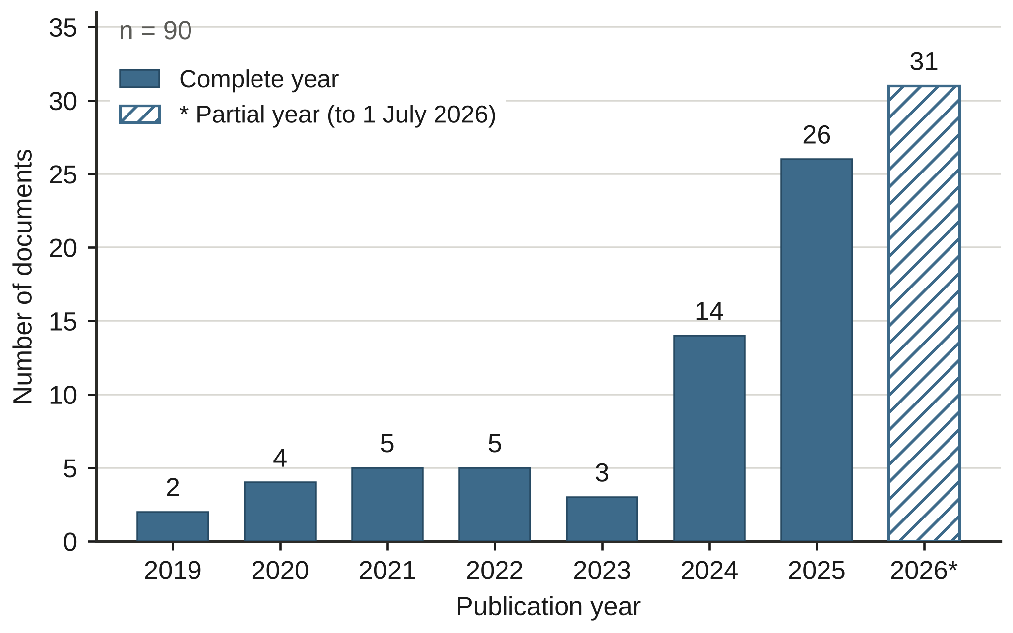
Figure 3. Annual publication trend in the curated corpus (2026 partial to 1 July 2026). Bars were replotted from the documented counts in Table 3, and the hatched bar marks the partial year.
The increase after 2023 is consistent with growing research attention within this corpus. The descriptive data do not establish that generative AI caused the increase, that AI adoption grew at the same rate, or that publication growth was accompanied by stronger educational evidence. The mixed scope of the corpus also rules out reading every record as an AI intervention study. The review by Deutscher et al. (2026), which found only five randomised experimental designs among 26 empirical studies, points the same way: output growth and causal evidence need not move together. The two datasets differ in design and cannot be compared numerically.

3.2 Country Contributions
Country-level full counting reports 38 countries and one record without identifiable country metadata. China has 20 document contributions (22.5% of the 89 records with country metadata), Indonesia 16 (18.0%) and Malaysia 14 (15.7%). Table 4 preserves the original ordering and counts for 20 selected countries, and Figure 4 reproduces the corresponding original bar chart. Countries with equal counts are tied and should not be read as substantively different ranks. Thailand appears in three records (3.4%), tied with Ukraine, Kazakhstan and Norway. Greece is one of the countries with a single document contribution, not necessarily the only country at that count. [ข้อสังเกต 15: (1) Figure 4 ใน V2 ถูก plot ใหม่​จาก​ตัวเลข​ใน Table 4 ประโยค 'Figure 4 reproduces the corresponding original bar chart' และ​คำ​ว่า 'original' ใน Sec. 3.1-3.2 จึง​ต้อง​ปรับ (2) Table 4 ระบุ '20 selected countries' แต่​ไม่​บอก​เกณฑ์​เลือก (มี 38 ประเทศ และ​อันดับ 20 = Greece ซึ่ง​เท่ากับ​อีก​หลาย​ประเทศ) (3) คอลัมน์ Rank ให้​อันดับ 6-9 กับ​ประเทศ​ที่​มี 3 เอกสาร​เท่ากัน ขัด​กับ​ข้อความ 'tied counts should not be read as different ranks' ควร​ใช้ tied rank (เช่น 6=)]
Table 4. Affiliation-based document contributions for 20 countries (full counting).
Rank | Country | Documents | Share of 89 records (%)
1 | China | 20 | 22.5
2 | Indonesia | 16 | 18.0
3 | Malaysia | 14 | 15.7
4 | Spain | 5 | 5.6
5 | Australia | 4 | 4.5
6 | Ukraine | 3 | 3.4
7 | Kazakhstan | 3 | 3.4
8 | Thailand | 3 | 3.4
9 | Norway | 3 | 3.4
10 | Slovenia | 2 | 2.2
11 | Nigeria | 2 | 2.2
12 | United Kingdom | 2 | 2.2
13 | Philippines | 2 | 2.2
14 | South Africa | 2 | 2.2
15 | Pakistan | 2 | 2.2
16 | Taiwan | 2 | 2.2
17 | Germany | 2 | 2.2
18 | Switzerland | 2 | 2.2
19 | Russia | 2 | 2.2
20 | Greece | 1 | 1.1
Note. Documents and ordering are documented values. Shares use the 89 records with country metadata as the denominator and do not sum to 100% because full counting can credit one document to several countries. Tied counts should be read as ties.
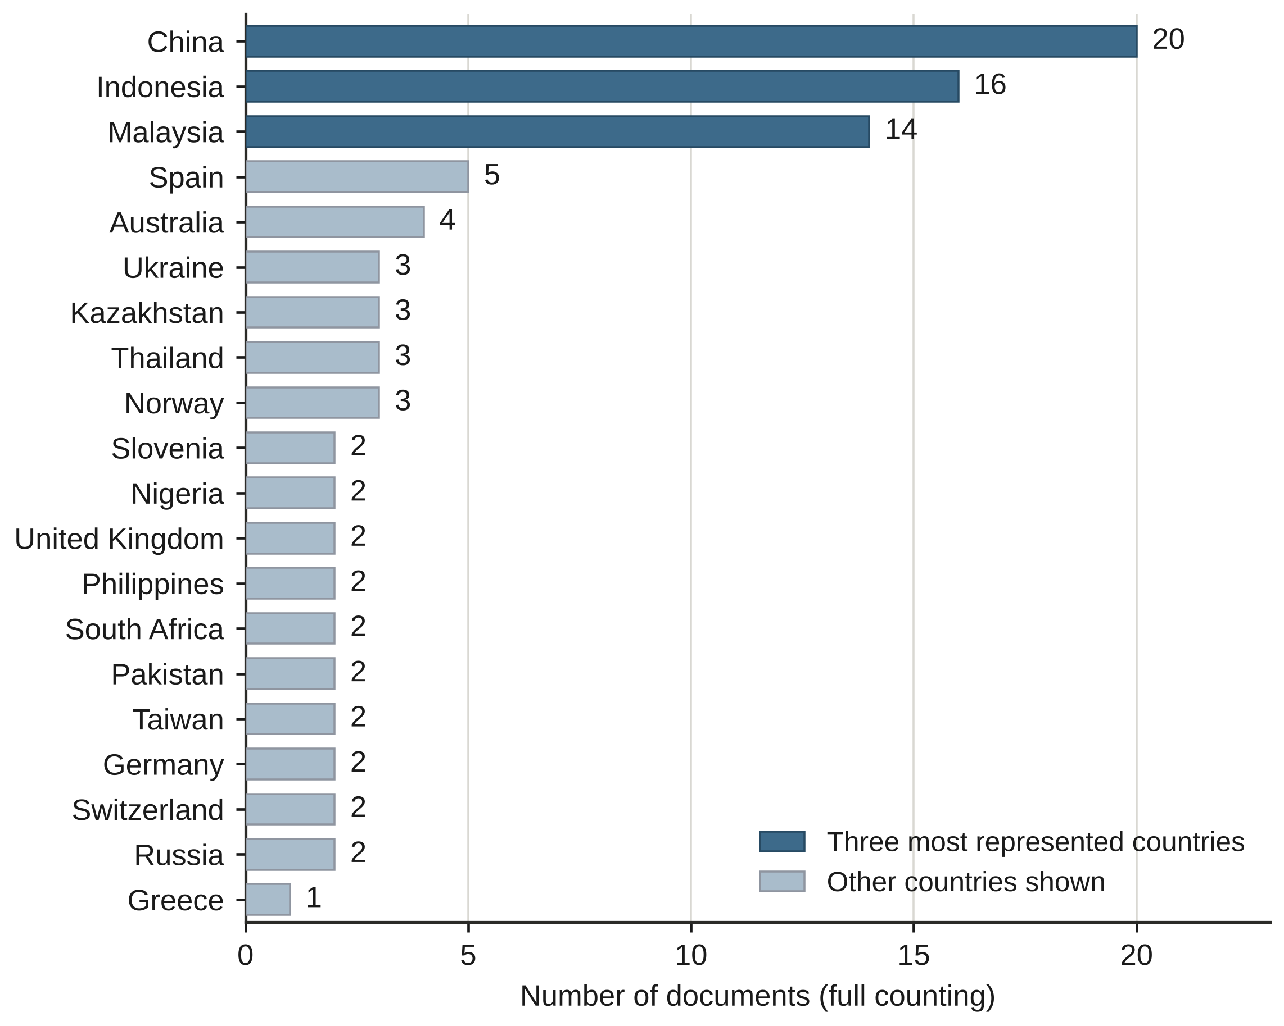
Figure 4. Country contributions based on author affiliations (full counting). Bars were replotted from the documented counts in Table 4, and the darker bars mark the three most represented countries.
Asian countries account for several of the largest affiliation-based contributions in the displayed distribution. This is a statement about authorship visibility in the corpus. It is not evidence that educational effectiveness is greater in those countries or that all reviewed learning settings are located there.

3.3 Keyword Co-occurrence Clusters
The retained VOSviewer map contains 60 keyword items in seven clusters. Table 5 preserves the original cluster labels and keyword descriptions. The labels organise topics related to vocational teaching, digital competence, learning environments, AI methods, curriculum, apprenticeship and workforce development. They should not be interpreted as independent causal dimensions or as quality-ranked bodies of evidence.
Table 5. Keyword co-occurrence clusters and thematic interpretation.
Cluster | Label | Main focus
1 | TVET Teaching and Teacher Digital Competence | Vocational education, TVET, teaching, teacher, digital competence, TPACK, technology integration
2 | Technology-Enhanced Vocational Learning | Educational technology, e-learning, vocational training, instructional design, student engagement, immersive learning
3 | AI Learning Systems, Feedback, and Assessment | Learning systems, deep learning, machine learning, feedback, assessment models, teaching quality
4 | Engineering and Technical Curriculum Quality | Engineering education, curricula, personnel training, quality assurance, ICT, TVET systems
5 | Advanced AI Methods in Higher Vocational Learning | Higher vocational education, federated learning, reinforcement learning, contrastive learning, personalized learning
6 | AI, Apprenticeship, Automation, and Motivation | Artificial intelligence, apprentices, automation, motivation, learning motivation
7 | Workforce Development and AI Literacy | Workforce development, AI literacy, behavioral research
Note. Cluster labels and keyword descriptions are reproduced from the original analysis. Clusters are organising prompts for the interpretive themes and are not independent causal dimensions.
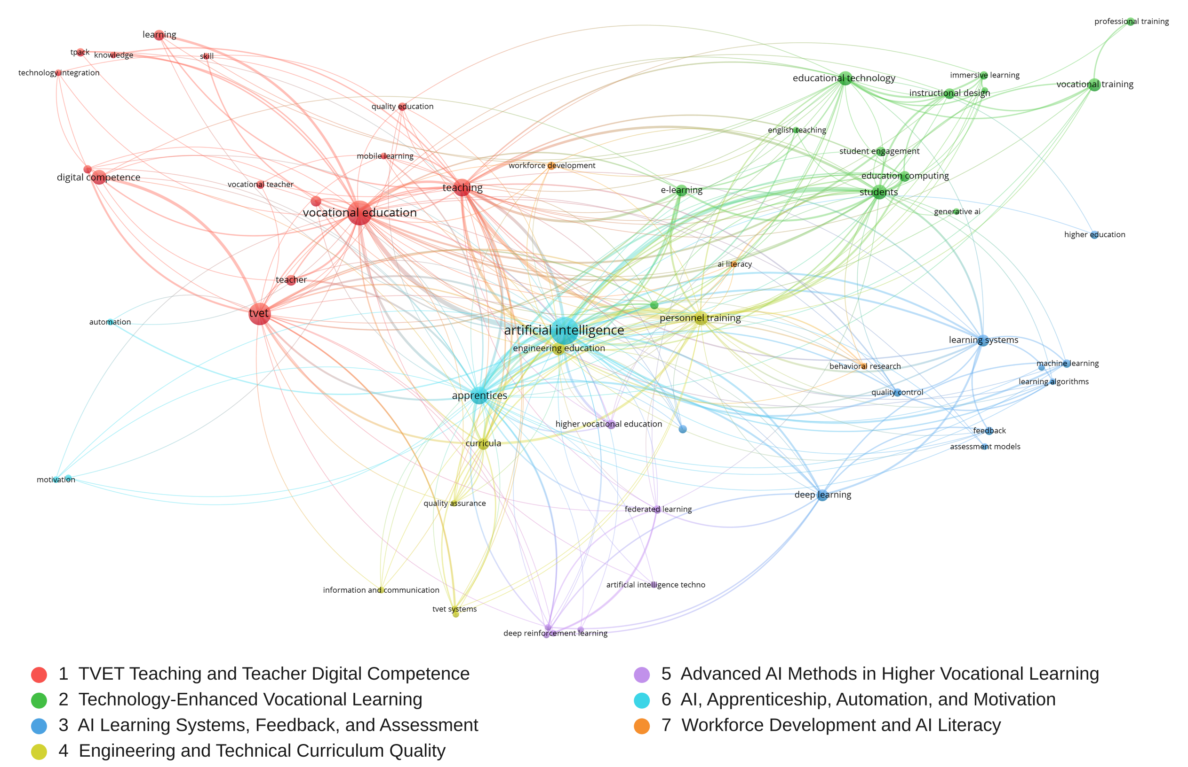
Figure 5. VOSviewer keyword co-occurrence network for the mapped corpus. Node colours correspond to the seven clusters in Table 5. Original VOSviewer output, cropped to the network extent.
The network places artificial intelligence and vocational education among the visually prominent terms, with TVET, teaching, digital competence, apprentices, learning systems and deep learning also visible in Figure 5. Generative AI and AI literacy appear as small nodes. Node size is a descriptive property of keyword occurrence, and item-level values are not reproduced here, so the map cannot show whether this reflects indexing practice, the minimum occurrence threshold of two, or the actual research focus of the corpus. Node prominence and proximity are descriptive properties of the map, not evidence that one topic improves learning more than another. The displayed connections provide an entry point for interpretation, which must still be grounded in the content of relevant sources. [ข้อสังเกต 16: (1) ใน Figure 5 ชื่อ keyword บางส่วน​ซ้อนทับ​กับ​เส้น​และ node และ​เป็น​ภาพ raster ควร export ใหม่​จาก​ไฟล์ VOSviewer เป็น SVG/PDF หรือ PNG ความ​ละเอียด​สูง (2) V2 เพิ่ม legend สี​ของ 7 clusters โดย​ตรวจ​เทียบ​สี node กับ​รายการ keyword ใน Table 5 แล้ว โปรด​ตรวจ​ซ้ำ​ใน VOSviewer (3) ข้อความ 'Generative AI and AI literacy appear as small nodes' ควร​มีค่า occurrence/link strength สนับสนุน]

3.4 Overlay and Density Visualisations
The original overlay view (Figure 6) displays average publication years associated with keywords, whereas the original density view (Figure 7) displays local concentrations of keyword occurrences. They describe the same network in complementary ways and are not additional tests of learning outcomes. Apparent recency or visual density does not establish that a topic is newly emerging, a research priority or an effective pedagogical practice. Detailed claims about keyword chronology require the underlying item-level values. [ข้อสังเกต 17: Figures 6-7 ไม่​มี colour scale ที่​เป็น​ตัวเลข ผู้อ่าน​ไม่​ทราบ​ว่า​สี​หมายถึง​ปี​หรือ​ระดับ​ความหนาแน่น​ใด V2 เติม​แถบ​สี​เชิง​คุณภาพ​เท่านั้น (earlier > later, lower > higher) เพราะ​ไม่​มีค่า​จริง ควร​ใช้​แถบ​สี​ตัวเลข​จาก VOSviewer (min-max ของ average publication year) และ​ระบุ​ค่า​ตั้ง​ของ overlay/density]
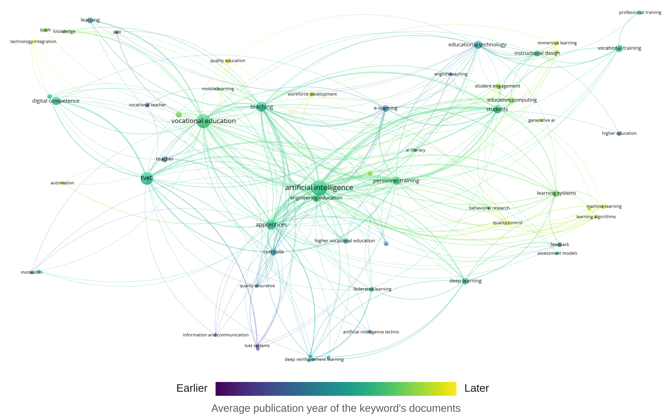
Figure 6. VOSviewer overlay visualisation of average publication year. Original VOSviewer output, cropped to the network extent. The colour bar is qualitative because item-level values are not reproduced.
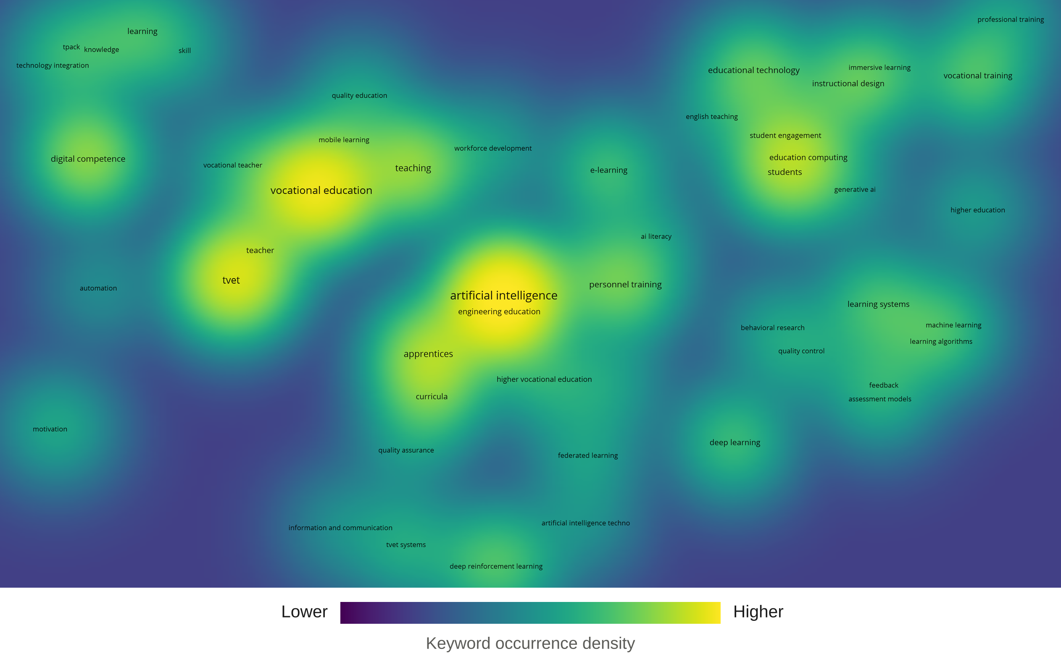
Figure 7. VOSviewer density visualisation of the keyword network. Original VOSviewer output, cropped to the network extent. The colour bar is qualitative because item-level values are not reproduced.

3.5 Corpus Profile
Table 6 retains the original dominant contribution-group counts for provenance. Each record has one original dominant allocation, and the six counts total 90. Teacher competence and professional development (29 records, 32.2%), AI and data-driven learning systems (25 records, 27.8%) and assessment, learning outcomes, AI literacy and ethics (23 records, 25.6%) account for 77 of the 90 allocations (85.6%). The five interpretive review themes, however, overlap conceptually and are not estimated by summing these groups. In particular, curriculum and workforce alignment can inform several themes even though only two records (2.2%) carry it as their dominant allocation. That figure is an artefact of single-label allocation and does not show that curriculum evidence is absent. Supplementary File S1 distinguishes the retained organisational assignments from the corrected, claim-specific use of individual sources. [ข้อสังเกต 18: ไม่​อธิบาย​ว่า​ใคร​และ​เกณฑ์​ใด​กำหนด 'dominant allocation' และ Table 6 มี 6 กลุ่ม ขณะที่ review themes มี 5 (กลุ่ม​ที่ 6 ไม่​ใช่ theme) ควร​อธิบาย​ความสัมพันธ์​ระหว่าง 6 กลุ่ม​กับ 5 themes ใน Note ของ Table 6]
Table 6. Dominant corpus contribution groups with illustrative supporting sources.
Contribution group | Records | Share (%) | Representative citations
AI and data-driven learning systems | 25 | 27.8 | Hassan et al., 2024; Huang et al., 2025; Lima et al., 2026; Ma, 2022
Digital, immersive, and technology-enhanced vocational learning | 9 | 10.0 | Radovan & Makovec Radovan, 2025; Wagino et al., 2026; Yindeemak et al., 2026; Younis, 2025
Teacher competence and professional development | 29 | 32.2 | Amenduni et al., 2022; Berntsen et al., 2026; Cattaneo et al., 2022; Md Hani et al., 2025
TVET, curriculum alignment, and workforce competence | 2 dominant; cross-cutting | 2.2 (dominant only) | Hassan et al., 2021; Silor & Silor, 2025; Lima et al., 2026; Golzad et al., 2026; Yan et al., 2025
Assessment, learning outcomes, AI literacy, and ethics | 23 | 25.6 | Alexis & Pavlatou, 2026; Budiman et al., 2025; Esposito et al., 2025; Perkins et al., 2025
Adjacent conceptual and workforce-policy records | 2 | 2.2 | S005 and S019 in Supplementary File S1 (boundary records only, not evidence of an AI effect)
Note. Original category labels and numerical allocations are retained, not revalidated or recoded. Shares were calculated from the documented counts (n = 90). The counts do not represent numbers of AI interventions or of studies demonstrating effectiveness. The two dominant curriculum and workforce records are part of the total of 90, and cross-cutting examples are not additional records.

4. Discussion

4.1 What the Map Shows and What It Does Not
The mapped literature is growing quickly, it is geographically concentrated in a few countries, and its keyword structure combines AI methods with a long-established digital-pedagogical vocabulary. These three descriptive patterns answer objectives (i) to (iii), but they do not answer the educational question that motivates the review. Publication growth after 2023 and the prominence of China, Indonesia and Malaysia describe where and how often authors write about AI in vocational settings. They say little about whether learners perform better in practice. The seven clusters make the same point from another direction. TVET teaching, digital competence, e-learning, deep learning, curricula and workforce development sit together in one network because the search strategy brought them together, not because they form a single body of evidence.
Three judgements therefore had to be kept apart throughout the synthesis. Corpus membership records that a document matched the search and screening. Thematic relevance records that a document informs a theme. Evidence of effectiveness records that a document tested whether a practice improved learning, and few records do so. This separation is the main analytical difference from earlier mapping work. Yuliansah et al. (2026b) mapped publication growth, geography, collaboration, keywords and themes in AI-driven vocational teaching and learning, and the present study adds an explicit evidential-role distinction and a framework built on it. The distinction also fits the finding of Deutscher et al. (2026) that the empirical base for AI in vocational education and training is thin and leans toward a general success narrative. A map cannot repair that thinness, but it can show readers where claims need more caution. [ข้อสังเกต 19: 'few records do so' และ 'main analytical difference from earlier mapping work' เป็น​ข้อกล่าวอ้าง​เชิง​ปริมาณ/novelty ที่​ยัง​ไม่​มี​ตัวเลข​รองรับ ควร​ระบุ​จำนวน​หรือ​สัดส่วน records ที่​ทดสอบ​ประสิทธิผล​จริง (จาก Supplementary S1) หรือ​ใช้​ถ้อยคำ​ที่​ไม่เชิง​ปริมาณ]
The practical consequence is a change in the question asked of any AI-supported vocational activity. The question stops being whether the tool works and becomes what the learner can do, explain and justify when the tool is absent or constrained. The framework in Section 4.8 is organised around that change.

4.2 AI and Data-Driven Learning Systems
Directly AI-focused work includes a deep-learning course recommender for TVET (Hassan et al., 2024), AI-supported feedback analysis and course recommendation in higher vocational English teaching (Ma, 2022), and a fine-tuned language-model assistance system for automotive electronics learning (Huang et al., 2025). These examples serve different educational functions and are not one uniform intervention. Curriculum analysis using AI is another function and should not be treated as equivalent to student-facing tutoring (Lima et al., 2026).
The pedagogical inference is conditional. An AI system may be useful when its outputs help a teacher or learner address a defined learning need, but a technically accurate recommendation is not in itself evidence of independent practical competence. Cao and Abdullah (2025) examine engagement and amotivation in an AI-enhanced higher vocational language-learning context, which cautions against collapsing participation, motivation and learning into a single outcome. The framework therefore asks what the tool supports and what evidence remains necessary, and it does not assume that technical sophistication guarantees educational benefit.
The application field is heterogeneous. A deep-learning model may recommend technical courses, while other systems generate feedback, analyse learner pathways or support assessment. Studies of technical-training prediction, AI-assisted knowledge mapping, mobile AI-based teaching evaluation, generative AI instructional design and AI-based assessment models illustrate these different functions (Li, 2025; Luo et al., 2024; J. Wang, 2026; Q. Wang, 2026a, 2026b). Their reported targets and evaluation designs differ, so they cannot be pooled as evidence of one learning outcome.
More occupation-specific accounts extend beyond classroom text generation. They include AI-enabled virtual mentorship for woodwork technology education and discussion of AI adoption in maritime curricula (Okanya & Attah, 2026; Reyes, 2026). AI-enhanced entrepreneurship education is a related but distinct vocational context (Tang et al., 2026). The relevance of these applications depends on whether the learning activities and assessment tasks can represent the decisions, tools and performance standards of the occupation concerned. Evidence about language-oriented systems also calls for caution. A qualitative study in Chinese higher vocational English-as-a-foreign-language education examines being engaged yet amotivated in AI-enhanced learning (Cao & Abdullah, 2025), and a broader study of AI-driven chatbots in language instruction provides technological context but does not by itself validate workplace skill acquisition in TVET (Fibriasari et al., 2025). Across these applications, engagement, prediction accuracy, instructional utility and demonstrated occupational competence should be reported as distinct constructs. [ข้อสังเกต 20: Cao and Abdullah (2025) ถูก​อธิบาย​ซ้ำ 2 ครั้ง​ใน Sec. 4.2 (ย่อ​หน้าที่ 2 และ​ย่อหน้า​นี้) ด้วย​ใจความ​เดียวกัน (engagement vs amotivation) ควร​รวม​หรือ​ตัด​อย่างใดอย่างหนึ่ง]

4.3 Digital, Immersive and Technology-Enhanced Vocational Learning
Digital foundations include blended learning, simulation, practical training resources and technologies that support vocational instruction. These do not all use AI. Eliza et al. (2025) study a microcontroller training kit, and Borden Lanza et al. (2025) develop an instrument for examining applied technology classrooms. Both are used here as contextual evidence about practical and digital learning, not as tests of AI effectiveness. Radovan and Makovec Radovan (2025) address blended activities and digital competence, and Grecu et al. (2025) examine VR-based technical training.
This distinction matters for instructional design. Adding AI to an existing digital environment creates a design question and not an automatic improvement. The criterion proposed in this review is whether the activity maintains meaningful practice, usable feedback and opportunities to explain or transfer learning. Interest in a tool, or immersion in a simulation, should not be substituted for evidence of occupational performance. A domain-sensitive conception of vocational technology integration, such as that developed by Younis (2025), is relevant to this design question without validating the framework proposed here.
Studies of distance teaching in technical and mathematical disciplines, microcontroller training resources and instructional models for vocational software engineering address conditions for effective technology-supported practice, without necessarily testing adaptive AI (Biziuk et al., 2021; Eliza et al., 2025; Nofriansyah et al., 2020). Research on blended learning and mobile competency-based instruction informs the design of digital vocational environments but does not furnish stand-alone estimates of AI effectiveness (Radovan & Makovec Radovan, 2025; Wagino et al., 2026).
Immersive learning requires careful specification of what is technologically distinctive. Experimental work on the cognitive demands of virtual-reality technical training and longitudinal research on skill transfer in virtual-reality settings show both the opportunities and the limits of immersion (Grecu et al., 2025; Jou & Hao, 2026). Reviews of virtual simulation and flipped-classroom practice provide a broader instructional background (Rahayu et al., 2026; Yindeemak et al., 2026). None of these should be characterised as an AI intervention merely because the learning environment is digital or simulated. At an institutional level, applied-technology classroom assessment, inclusive digital pedagogy in tertiary TVET and contextual technology-integration frameworks offer design and implementation perspectives (Borden Lanza et al., 2025; Mohd Jamil et al., 2024; Younis, 2025). Evidence on new literacies in TVET supports attention to transferable learner capabilities (Silor & Silor, 2025), but relevance to a specific AI-supported task still requires a defensible instructional and assessment link. [ข้อสังเกต 21: (ทั้ง Sec. 4.2-4.6) การ​อภิปราย​เป็น​ลิสต์​การ​อ้างอิง​ยาว​ตาม​ด้วย​ข้อ​สงวน​ที่​ซ้ำ​กัน ('does not establish', 'should not be read as') ทำให้​ข้อโต้แย้ง​หลัก​อ่าน​ยาก ควร​สรุป​แต่ละ theme เป็น 1-2 ประโยค​ว่า​หลักฐาน​ชี้​อะไร ย้าย​รายการ​อ้างอิง​ยาว​เข้า​ตาราง (เช่น​ขยาย Table 7) และ​ลด​ข้อ​สงวน​ที่​ซ้ำ​กับ Sec. 2.1 และ 4.7]

4.4 Teacher Competence and Professional Development
General digital competence and professional AI competence are connected but distinguishable. Cattaneo et al. (2022) examine vocational teachers’ digital competence, Amenduni et al. (2022) consider its role during emergency remote teaching, and Lahn and Berntsen (2023) synthesise frameworks for vocational teachers’ digital competences. Md Hani et al. (2025) contribute a TVET digital-competence framework related to educator satisfaction. None of these contributions should be read as evidence that a teacher can evaluate every AI-generated technical output.
Berntsen et al. (2026) provide a more directly AI-focused account of vocational teachers in information technology and media production, highlighting profession-specific practices, informal professional learning and tensions around assessment and ethics. The implication developed here is that teacher agency includes deciding when a tool is appropriate, checking its outputs against occupational knowledge and retaining responsibility for supervision and assessment. Professional development should therefore connect AI use to subject expertise and practical tasks, and should not focus only on tool demonstrations.
Studies in different national and institutional settings operationalise teacher readiness differently. Digital and mobile-tool use, graphic competence, TVET educator satisfaction, TPACK competence and synchronous teaching competence are addressed through different instruments and populations (Berková et al., 2024; Bitemirova et al., 2026; Md Hani et al., 2025; Regassa & Desissa, 2026; Wannapiroon et al., 2022). These findings are relevant to the enabling conditions for AI, but competence with conventional digital platforms should not be relabelled as validated AI competence.
Professional development is also shaped by policy and institutional capacity. Studies report vocational-teacher professionalisation, TVET lecturers’ experience of educational technologies, learning-management-system competence, generational differences in digital capability and training for distance-education readiness (Jaya et al., 2026; Jideani & Mpungose, 2026; Noor et al., 2024; Sanchez-Prieto et al., 2020; Shumeiko et al., 2024). More specialised work examines vocational educators’ programming-related digital competence, contextual influences on competence and the evaluation of TVET teachers’ digital capabilities (Subarno, 2026; Xin et al., 2024; Zubizarreta Pagaldai et al., 2026). The move from digital readiness to AI-aware pedagogical agency is visible in exploratory accounts of AI-related teaching knowledge, triadic teacher–AI–student relationships and vocational language teachers’ experiences with AI (Chen et al., 2026; Wong & Zeng, 2026; Xia et al., 2026). Teacher perspectives on AI in Indonesian vocational learning provide more directly situated evidence (Yuliansah et al., 2026a). The higher-education study by Chen et al. (2026) is used here as adjacent theoretical context, not as direct evidence from a TVET teaching population.

4.5 TVET, Curriculum Alignment and Workforce Competence
Curriculum alignment is treated as a cross-cutting criterion and not as a separately dominant body of evidence. Lima et al. (2026) use AI-supported analysis to examine automation and curricular competence indicators, Golzad et al. (2026) propose a conceptual account of AI-integrated building information modelling (BIM) education and process competencies, and Yan et al. (2025) address AI, competency assessment and curriculum transformation. These contributions differ in purpose and evidential status. They do not jointly establish that one AI implementation improves all occupational outcomes.
Constructive alignment provides an established rationale for relating intended learning outcomes, teaching activities and assessment (Biggs, 1996). Applied here as a design principle, it means that an AI-supported task should have a defensible connection to an occupational requirement and an assessment opportunity. A generated technical explanation may be a learning resource, but it is not a substitute for checking whether the learner can perform the relevant procedure and justify decisions. This is the review’s interpretive use of alignment, not a newly tested causal relationship.
Curriculum quality and workforce readiness also depend on learners’ entry-level capabilities and institutional support. Research on digital competence among commercial vocational trainees and TVET college students illustrates baseline variation that may constrain advanced AI-supported tasks (Findeisen & Wild, 2022; Mbambo & du Plessis, 2025). Such work belongs to the enabling-condition evidence base and is distinct from studies that evaluate AI-supported teaching systems. Curriculum-linked AI research includes analyses of automation-related competence indicators, proposals for AI-integrated BIM process competencies and AI-supported transformation of vocational assessment and curricula (Golzad et al., 2026; Lima et al., 2026; Yan et al., 2025), and a competency-based AI-literacy pathway for higher vocational learners adds a targeted competence-development perspective (Hong, 2025). These sources strengthen the case for stating learning outcomes explicitly, while leaving open which instructional sequence achieves durable workplace transfer. The longer literature on ICT-enabled TVET and on contextual vocational technology–pedagogy knowledge supplies scope and design considerations (Hassan et al., 2021; Younis, 2025), and studies of twenty-first-century vocational competencies indicate possible curriculum priorities (Silor & Silor, 2025). In the proposed framework these works justify an alignment requirement. They do not establish that introducing AI produces a measurable gain in competence.

4.6 Assessment, Learning Outcomes, AI Literacy and Ethics
Assessment requires clarity about what is being assessed, whether a learning process, an AI-produced artefact, conceptual understanding or practical performance. Budiman et al. (2025) address AI-driven learning evaluation, Alexis and Pavlatou (2026) focus on AI literacy through a vocational voice-recognition project, and Esposito et al. (2025) describe an AI-ethics module in technical training. These sources address complementary but non-equivalent aims. AI-literacy development and the evaluation of an assessment system cannot by themselves establish valid certification of an occupational skill.
Perkins et al. (2025) argue for assessment design aligned with intended outcomes and permitted AI use, rather than relying on labels or detection alone. The present review extends that design argument to practical vocational evidence. Demonstrations, oral explanation, process documentation and staged checks can be considered where they match the assessed competence. Gulikers et al. (2004) describe authentic assessment through five dimensions that include the task, its physical and social context and the criteria applied, which gives a way to judge how closely a vocational assessment resembles the occupation. These are proposed design choices and not outcomes tested by this review. Ethical AI literacy includes evaluating accuracy, recognising limitations and bias, protecting data and documenting assistance appropriately, and access and task conditions also need attention.
AI literacy and assessment readiness are related but separable constructs. Profiles of technical high-school students’ AI literacy, a competency-based vocational AI-literacy progression and instruments for evaluating vocational learners’ critical thinking articulate different intended outcomes (Avsec & Rupnik, 2025; Hong, 2025; Olmedo-Moreno et al., 2026). A digital-competence measurement study is a useful measurement antecedent but is not a test of AI literacy itself (Wild & Schulze Heuling, 2021). Assessment designs should also specify whether evidence comes from a portfolio, an observed performance, an algorithmic prediction or a learner explanation. Work on electronic development portfolios illustrates support for self-directed learning without presupposing AI (Beckers et al., 2019), whereas AI-based teaching-quality frameworks, generative instructional-design models and educational assessment systems address different AI-enabled design functions (J. Wang, 2026; Q. Wang, 2026a, 2026b). Vocational competency-assessment research adds an occupationally situated perspective (Yan et al., 2025).
Ethical implications extend beyond technical accuracy. Technical-training AI-ethics modules emphasise stakeholder involvement, broader cultural models of AI workforce preparation foreground contextual values, and vocational entrepreneurship education raises engagement and fairness considerations (Esposito et al., 2025; Feyijimi et al., 2026; Tang et al., 2026). The workforce model is used as wider conceptual context and not as empirical validation of TVET assessment. For classroom practice, disclosure of permitted AI assistance and direct assessment of the learner’s own reasoning remain necessary design judgements, not outcomes proven by this review (Perkins et al., 2025).

4.7 Evidence Boundaries and Corpus Boundary Records
Table 7 condenses the evidential boundary of each theme, using only the roles that the cited sources themselves occupy in this review. The pattern across the table is consistent. Each theme informs a defined design question, and none of the themes taken alone establishes that learners can perform occupational tasks without AI support.
Table 7. Evidence boundaries of the five review themes (interpretive, not quantitative).
Theme | What the cited examples report | What they can inform | What they do not establish alone
AI and data-driven learning systems | Recommendation, feedback analysis, language-model assistance, prediction and engagement (Cao & Abdullah, 2025; Hassan et al., 2024; Huang et al., 2025; Ma, 2022) | The feasibility and function of a defined AI tool | Independent practical competence of learners
Digital, immersive and technology-enhanced learning | Training-kit motivation, instrument development, blended activities and cognitive demands of virtual reality (Borden Lanza et al., 2025; Eliza et al., 2025; Grecu et al., 2025; Radovan & Makovec Radovan, 2025) | Conditions for practice and feedback in vocational settings | An effect of AI
Teacher competence and professional development | Digital-competence frameworks and surveys, and profession-specific AI practice (Berntsen et al., 2026; Cattaneo et al., 2022; Lahn & Berntsen, 2023; Md Hani et al., 2025) | Teacher readiness and the conditions for AI-aware agency | Teachers’ ability to judge AI output across technical tasks
TVET, curriculum alignment and workforce competence | AI-supported curriculum analysis, a conceptual BIM competence framework and competency assessment (Golzad et al., 2026; Lima et al., 2026; Yan et al., 2025) | Alignment requirements between outcomes, tasks and assessment | That one AI implementation improves all occupational outcomes
Assessment, AI literacy and ethics | AI-driven evaluation, AI-literacy projects, an ethics module and assessment-design commentary (Alexis & Pavlatou, 2026; Budiman et al., 2025; Esposito et al., 2025; Perkins et al., 2025) | The design of evidence and of permitted AI use | Valid certification of an occupational skill
Note. The columns restate the evidential roles that the cited sources occupy in this review. They are not a coding frequency table or a validation result.
Boundary records show why corpus membership and evidential relevance must remain separate. The preserved register includes a case-method vocational-training paper (S021), a microcontroller training-kit study (S022) and research on institutional building-condition assessment (S017). The first two can inform descriptions of practical-training contexts, whereas the third concerns facilities management and not the assessment of students’ learning. None is used as direct evidence that AI improves vocational competence. These records remain in the mapping register to preserve the documented bibliometric results, and their presence must not inflate claims of AI-specific effectiveness. Other adjacent educational or workforce-policy records are documented as boundary evidence in Supplementary File S1. [ข้อสังเกต 22: S017, S021, S022 ถูก​เรียก​ว่า boundary records แต่​ยังอยู่​ใน corpus ที่​ใช้​คำนวณ​ทุก​ตัวเลข (Figures 3-7, Tables 3-6) ผู้ประเมิน​อาจ​ถาม​ว่า​ทำไม​ไม่​ตัดออก​แล้ว​รัน​ใหม่ โดยเฉพาะ S017 ที่​เกี่ยวกับ facilities management ควร​อธิบาย​เหตุผล​เชิง​วิธี​วิทยา และ​ถ้า​ทำได้​ควร​รายงาน sensitivity เมื่อ​ตัด boundary records ออก]

4.8 An AI-Aware Vocational Pedagogy Framework
The proposed framework defines AI-aware vocational pedagogy as the purposeful use and critical evaluation of AI within competence-oriented vocational teaching, learning and assessment. It brings together five components derived from the review’s argument. Its contribution is to organise decisions about the relationship between tool use, occupational requirements and credible learning evidence, and it is not a validated measurement scale or a tested intervention. [ข้อสังเกต 23: framework ยัง​ไม่​ถูก​เปรียบเทียบ​กับ​กรอบ​ที่​เกี่ยวข้อง (เช่น TPACK/I-TPACK ซึ่ง​อ้าง​ถึง​บางส่วน​แล้ว, DigCompEdu, UNESCO AI competency framework for teachers สอง​รายการ​หลัง​เป็น​ข้อเสนอแนะ​ให้​ผู้เขียน​ตรวจสอบ​และ​ค้น​อ้างอิง​เอง ยัง​ไม่​ได้​ตรวจ​แหล่งที่มา) ควร​อธิบาย​ว่า​กรอบ​นี้​เพิ่ม​อะไร และ​เนื่องจาก​ยัง​ไม่ validate วารสาร Q2 หลาย​แห่ง​คาดหวัง expert review (เช่น Delphi/IOC) อย่าง​น้อย​หนึ่ง​รอบ หรือ​เหตุผล​ที่​ไม่​ทำ]
Figure 8 places teacher agency and ethical AI literacy as cross-cutting considerations around three coordinated pedagogical functions, namely curriculum alignment, instructional design and assessment. Connecting lines indicate conceptual relationships only. The intended aim at the centre is credible, workplace-relevant evidence of occupational competence, which is not a measured outcome of this review.
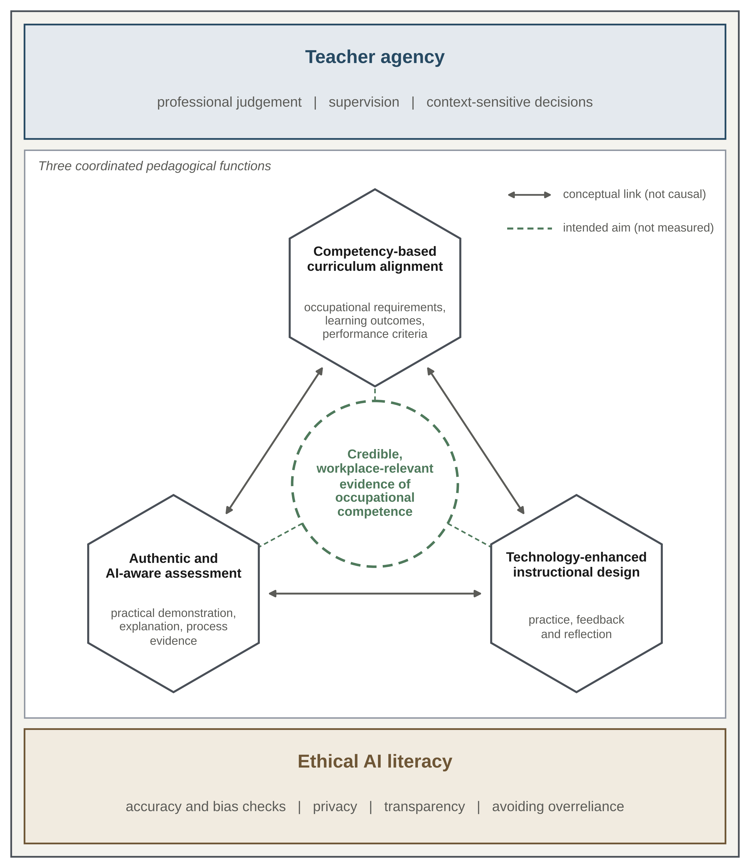
Figure 8. Review-derived AI-aware vocational pedagogy framework. Teacher agency and ethical AI literacy surround three coordinated pedagogical functions, and the dashed circle at the centre marks the intended aim. Links are conceptual and do not imply causal effects or validated learning outcomes. [ข้อสังเกต 24: V2 ออกแบบ​รูป​ใหม่​เป็น​ผัง​กรอบ​สี่เหลี่ยม​ล้อมรอบ (แทน​วงแหวน​เดิม) ให้​ตัวอักษร​เป็น​แนวนอน​และ​อ่าน​ง่าย​ขึ้น ข้อความ​ย่อย​ใน 3 hexagon ดึง​จาก​เนื้อหา Sec. 4.8 โปรด​ตรวจ​ว่า​ตรง​กับ​เจตนา]
The five components keep the same meanings across the methods, discussion and visual framework. Teacher agency concerns professional judgement, supervision and context-sensitive decisions about AI use. It is informed by work on vocational teachers’ digital and professional AI competence (Berntsen et al., 2026; Cattaneo et al., 2022; Lahn & Berntsen, 2023), and within the framework teachers remain responsible for deciding what requires direct supervision and what evidence is adequate for judging performance. Competency-based curriculum alignment connects occupational requirements, learning outcomes and performance criteria. Constructive alignment is the theoretical reference point (Biggs, 1996), AI-supported curriculum analysis provides a context-specific example (Lima et al., 2026), and the proposed function is to make the purpose of an AI-supported activity explicit before the tool is selected. Technology-enhanced instructional design concerns how a tool is integrated into practice, feedback and reflection. AI-assisted technical learning and vocational technology-integration frameworks provide relevant examples (Huang et al., 2025; Younis, 2025), and the proposed criterion is pedagogical usefulness for a defined task, not the novelty of the technology.
Authentic and AI-aware assessment concerns practical demonstration, explanation and process evidence under stated conditions of AI use. Perkins et al. (2025) inform the assessment-design rationale, and Gulikers et al. (2004) inform the judgement of authenticity. The vocational extension proposed here is to judge competence from an appropriate combination of performance and reasoning, and not from a polished output alone. Ethical AI literacy concerns accuracy and bias checks, privacy, transparency and avoiding overreliance. It draws on vocational AI-literacy and technical AI-ethics work (Alexis & Pavlatou, 2026; Esposito et al., 2025). Its cross-cutting position in Figure 8 means that these considerations apply to curriculum, instruction and assessment, and not only to a separate ethics lesson. The framework also speaks to the gaps identified in the empirical literature, in which approaches that build learner agency and critical reflection are underrepresented (Deutscher et al., 2026), because it gives teacher judgement and learner explanation a defined place in design.
Table 8 links each component to its source roles, to the design implication used in this review and to the outcome that later studies could examine. The last column is the research agenda. It states what a test of the framework would need to measure and does not report any result.
Table 8. Evidence-to-framework crosswalk and outcomes for later testing (conceptual, not quantitative).
Framework component | Relevant source role | Review-derived design implication | Outcome to examine in later studies
Teacher agency | Digital competence and profession-specific AI practice (Berntsen et al., 2026; Cattaneo et al., 2022) | Retain professional judgement over tool use, supervision and evidence of competence. | Defensibility of teachers’ decisions on permitted AI use, rated independently, and accuracy of their checks of AI output against occupational knowledge
Competency-based curriculum alignment | Constructive-alignment theory and AI-supported curriculum analysis (Biggs, 1996; Lima et al., 2026) | Link the activity to occupational outcomes and explicit performance criteria. | Traceability from each AI-supported task to an occupational requirement and a performance criterion
Technology-enhanced instructional design | An AI-assisted technical-learning system and a vocational technology-integration model (Huang et al., 2025; Younis, 2025) | Choose AI support for a defined practice, feedback or reflection function. | Presence of practice, usable feedback and reflection in the task design, and task performance with and without AI support
Authentic and AI-aware assessment | Design-oriented assessment commentary and authentic-assessment dimensions (Gulikers et al., 2004; Perkins et al., 2025) | Specify permitted assistance and collect task-appropriate performance and process evidence. | Assessor agreement, credibility of assessment evidence and transfer of performance to workplace-like tasks
Ethical AI literacy | Vocational AI-literacy and technical AI-ethics work (Alexis & Pavlatou, 2026; Esposito et al., 2025) | Embed critical checking, privacy, transparency and responsible use across tasks. | Learners’ accuracy and bias checking, disclosure of AI assistance and data-protection practice
Note. The first three columns are an interpretive crosswalk. The last column is a research agenda and reports no result.
The expanded evidence base supports keeping the conceptual claim deliberately modest. Work on teacher professionalisation, technical learning, AI literacy and assessment supplies complementary perspectives and not a single experimentally established pathway to occupational competence (Berntsen et al., 2026; Hong, 2025; Jou & Hao, 2026; Yan et al., 2025). The framework specifies decisions to investigate, not validated causal links.

4.9 Implications
For TVET teacher education, the framework can organise professional-learning tasks around occupational cases. Teachers could compare an AI-generated explanation with a recognised technical procedure, identify inaccuracies and decide what learners must demonstrate without assistance. This is a proposed use consistent with the emphasis on professional judgement, and its effectiveness has not been tested in this review.
For curriculum design, teams can use the alignment component to specify the competence being developed, identify an appropriate role for AI and decide what evidence will demonstrate the outcome. AI-related content should be linked to the occupational context and not added as a disconnected technology topic. The suitability of such decisions will vary by programme, occupation, available resources and assessment requirements.
For classroom and workshop practice, and as an illustrative application and not a study finding, a vocational laboratory task could permit AI assistance during preparation or reflection while reserving tool operation, safety-critical decisions and practical demonstration for supervised assessment. Learners could be required to explain which suggestions they accepted or rejected. The framework does not prescribe one universal boundary. It makes the need to justify task-specific boundaries explicit.
For assessment and research, future evaluation should distinguish perceived usefulness, AI literacy, task performance, transfer, assessor agreement and the credibility of assessment evidence. An appropriate next study could test whether the framework helps educators make more defensible design and assessment decisions, using clearly specified settings and outcome measures. Such work would evaluate the conceptual proposal and would not retroactively validate the bibliometric map.

4.10 Limitations
The corpus is restricted to one database and a documented export date, with incomplete 2026 coverage, and records published after 1 July 2026 are not included. The search includes both AI and broader digital-pedagogical terms, so the 90 records do not constitute 90 AI interventions or a comprehensive census of global AI–TVET research. The search string and the counts of retrieved and excluded records are reported as documented and were not executed again for this manuscript. Some retained records have weak or indirect relevance to AI-pedagogy claims, and their presence remains relevant to interpretation even when they are not used as direct evidence. The original contribution-group counts are organisational descriptors, not a validated thematic prevalence estimate. Keyword maps depend on source metadata, thesaurus decisions, thresholds and clustering settings, and no sensitivity analysis is reported. Affiliation-based full counting represents participation and can count one document for several countries. The register in Supplementary File S1 was reconstructed from the manuscript and cannot independently authenticate the executed query, historical index membership or all screening decisions. Selected publisher records were checked during revision, but a complete record-level verification and a risk-of-bias assessment were not undertaken. Finally, the conceptual framework has not been empirically validated and cannot support causal claims about learning gains. [ข้อสังเกต 25: 'Selected publisher records were checked during revision' ไม่​ชัด​ว่า​ตรวจ​กี่​รายการ เกณฑ์​ใด และ Limitations ยัง​ไม่​กล่าวถึง​ข้อจำกัด​ด้าน​ภาษา/ประเภท​เอกสาร (เพราะ​ไม่​ได้​รายงานตัว​กรอง) และ​การ​ไม่​มี dual-screening ซึ่ง​ปรากฏ​เฉพาะ​ใน Sec. 2.1]

5. Conclusions
This review combined a documented 90-record bibliometric map with a critical synthesis of AI-focused studies and the digital foundations of vocational learning. The conclusions follow the five objectives.
- (i) Publication output. Annual counts rose from three records in 2023 to 14 in 2024 and 26 in 2025, and the partial 2026 dataset already holds 31 records, so 71 of 90 records (78.9%) date from 2024 onwards. This describes the fixed corpus and does not show stronger educational evidence.
- (ii) Country contributions. China (20 of 89 records with country metadata, 22.5%), Indonesia (16, 18.0%) and Malaysia (14, 15.7%) were the most represented among 38 countries under full counting, and Thailand appeared in three records. Affiliation counts describe authorship participation and not research settings or effectiveness.
- (iii) Keyword structure. The keyword map contained 60 items in seven clusters, spanning TVET teaching and teacher digital competence, technology-enhanced learning, AI learning systems and assessment, curriculum quality, advanced AI methods, apprenticeship and motivation, and workforce development and AI literacy. The clusters served as organising prompts for five review themes and are not independent causal dimensions.
- (iv) Evidence synthesis. In the sources discussed, AI-specific studies mostly report system performance, feedback, engagement or design, digital and pedagogical studies supply enabling conditions, and teacher-competence studies concern readiness. None of these alone establishes that learners can perform occupational tasks without AI support. Corpus membership, thematic relevance and evidence of effectiveness are therefore distinct judgements. [ข้อสังเกต 26: 'mostly report' เป็น​ข้อสรุป​เชิง​ปริมาณ​โดยนัย​ที่​ยัง​ไม่​มี​ตัวเลข​รองรับ (ดู​ข้อสังเกต​ที่ Sec. 2.3) ควร​ระบุ​ว่า​อ้าง​จาก​กี่​แหล่ง หรือ​ใช้​ถ้อยคำ​ที่​ไม่​ระบุ​ปริมาณ]
- (v) Conceptual framework. The AI-aware vocational pedagogy framework links teacher agency, competency-based curriculum alignment, technology-enhanced instructional design, authentic and AI-aware assessment, and ethical AI literacy. It is a conceptual synthesis and has not been empirically validated.
The central proposition is that AI should support opportunities to practise, explain and demonstrate occupational competence and should not replace supervised practical performance. The proposition is offered for later testing in vocational settings, with the outcome measures listed in Table 8.

Declarations
Funding. This research received no external funding.
Conflict of interest. The authors declare no conflict of interest.
Data availability. Supplementary File S1 contains the reconstructed 90-record corpus register, original dominant allocations and evidence-use notes. The descriptive tables and original bibliometric figures are included in the manuscript. The register does not replace the original Scopus export, thesaurus, network files or record-level screening log. Access to the underlying Scopus metadata is subject to the database’s applicable terms. [ข้อสังเกต 27: อ้าง​ถึง Supplementary File S1 แต่​ไม่​ได้​แนบ​มา​กับ​ไฟล์​นี้ โปรด​แนบ​พร้อม​ต้นฉบับ และ​พิจารณา​นำ Scopus export (CSV) thesaurus และ​ไฟล์ VOSviewer ขึ้น repository เช่น Zenodo/OSF เพื่อให้​ทำซ้ำ​ได้ (ภายใต้​ข้อกำหนด​ของ Scopus)]
Ethics approval. Not applicable. This study used bibliographic metadata and did not involve human participants.
Author contributions. The authors confirm contribution to the paper as follows: Siriphat Maneekeaw: analysis and interpretation of results; review and editing. Surawut Saekram: review and editing. Phuwadon Yaiyindee: review and editing. Piyarat Paoleng: study conception and design; analysis and interpretation of results; draft manuscript preparation; supervision. Krairoj Mahannopkul: review and editing. All authors reviewed the results and approved the final version of the manuscript. [ข้อสังเกต 28: จัดเรียง​ตามลำดับ​ผู้เขียน​ใน byline โดย​คง​บทบาท​เดิม​ครบ​ทุก​ข้อ (ไม่​ได้​เพิ่ม​หรือ​เปลี่ยน​บทบาท​ของ​ใคร) พบ​ว่า Krairoj Mahannopkul อยู่​ใน​ข้อความ​นี้​แต่​ไม่​อยู่​ใน​รายชื่อ​ผู้เขียน​หน้า​แรก จึง​วาง​ไว้​ท้ายสุด โปรด​ยืนยัน​ว่า​ต้อง​เพิ่ม​เป็น​ผู้เขียน​หรือ​ตัดออก และ​หาก​วารสาร​กำหนด CRediT taxonomy ควร​ปรับ​ให้​ตรง​หมวด CRediT]
Use of AI-assisted tools. AI-assisted tools supported language editing, manuscript restructuring, citation-consistency checks, bibliographic verification support, and the drawing of the workflow diagram (Figure 2) and the conceptual framework diagram (Figure 8). Figures 2 and 8 are digitally typeset diagrams and do not depict empirical measurements. No bibliometric values or original bibliometric images were generated or altered. The authors retain responsibility for verifying the sources, methods, interpretations, declarations and final manuscript. [ข้อสังเกต 29: ต้อง​แก้​ให้​ตรง​กับ V2: Figure 1 ถู​กวาด​ใหม่ และ Figures 3-4 ถูก plot ใหม่​ด้วย AI จึง​ต้อง​เพิ่ม​ใน​รายการ ประโยค 'No bibliometric values or original bibliometric images were generated or altered' ไม่​ตรง​อีกต่อไป (Figures 3-4 replot จาก​ตัวเลข​เดิม, Figures 5-7 crop และ​เติม legend) ร่าง​เสนอ: 'Figures 1, 2, 3, 4 and 8 were redrawn or replotted with AI-assisted tools from documented values or source figures; no bibliometric values were changed. Figures 5-7 are the original VOSviewer outputs, cropped, with a legend added.' (ผู้เขียน​ต้อง​ตรวจ​และ​ยืนยัน​เอง)]
Supplementary material. Supplementary File S1 retains the complete original 90-record mapping register, including boundary records. The References section contains 64 DOI-traceable publications selected from that documented corpus and 10 DOI-backed sources for theory, bibliometric methodology or later scholarly context. No sources have been inserted into the original mapping dataset or its numerical results. [ข้อสังเกต 30: ตรวจ​แล้ว​ว่า​รายการ​อ้างอิง 74 รายการ​ตรง​กับ in-text citation ทั้งหมด (ไม่​พบ​รายการ​เกิน​หรือ​ขาด) และ​ตรง​กับ​ตัวเลข 64 + 10 ใน​ย่อหน้า​นี้ แต่​ยัง​ไม่​ได้​ตรวจ DOI และ​รายละเอียด​บรรณานุกรม​กับ​แหล่ง​ปฐมภูมิ (เข้า​เว็บ​สำนักพิมพ์​ไม่​ได้​ขณะ​จัดทำ) ควร​ตรวจ​อีก​ครั้งก่อน​ส่ง]

References
Alexis, N. G., & Pavlatou, E. A. (2026). Exploring AI literacy: Voice recognition project in vocational education. Digital, 6(1), Article 19. https://doi.org/10.3390/digital6010019
Amenduni, F., Rauseo, M., Antonietti, C., & Cattaneo, A. (2022). Challenges and opportunities perceived by Swiss vocational education and training (VET) teachers during emergency remote teaching: The role of teachers’ digital competence. Qwerty, 17(2), 47–66. https://doi.org/10.30557/QW000057
Avsec, S., & Rupnik, D. (2025). From transformative agency to AI literacy: Profiling Slovenian technical high school students through the Five Big Ideas lens. Systems, 13(7), Article 562. https://doi.org/10.3390/systems13070562
Beckers, J., Dolmans, D. H. J. M., & van Merriënboer, J. J. G. (2019). PERFLECT: Design and evaluation of an electronic development portfolio aimed at supporting self-directed learning. TechTrends, 63(4), 420–427. https://doi.org/10.1007/s11528-018-0354-x
Berková, K., Kubišová, A., Frendlovská, D., Krpálková Krelová, K., Krpálek, P., & Vacínová, T. (2024). The relation among vocational teachers’ use of digital and mobile tools and socio-demographic factors. International Journal of Interactive Mobile Technologies, 18(24), 82–99. https://doi.org/10.3991/ijim.v18i24.50867
Berntsen, S. K., Granborg, Ø., Karstensen, S., Lahn, L. C., & Aakernes, N. (2026). Vocational teachers as AI pioneers: A study of professional AI competence in the Norwegian vocational field of information technology and media production. International Journal for Research in Vocational Education and Training, 13(3), 424–442. https://doi.org/10.13152/IJRVET.13.3.5
Biggs, J. (1996). Enhancing teaching through constructive alignment. Higher Education, 32(3), 347–364. https://doi.org/10.1007/BF00138871
Bitemirova, S., Zholdasbekova, S., Konakbayeva, U., Karataev, G., Zhanbirshiyev, S., & Turalbayeva, A. (2026). Developing graphic digital competence in future vocational education teachers: From theory to practice. Frontiers in Education, 11, Article 1721205. https://doi.org/10.3389/feduc.2026.1721205
Biziuk, A., Biziuk, V., & Shakurova, T. (2021). Analysis of teaching elements on technical and mathematical disciplines in modern distance education. Technology Audit and Production Reserves, 4(2(60)), 28–32. https://doi.org/10.15587/2706-5448.2021.237455
Borden Lanza, Y. H., Lores-Gómez, B., & Usart Rodríguez, M. (2025). Aulas de tecnología aplicada y competencia digital en la formación profesional: Diseño, elaboración y validación de un instrumento de recogida de datos [Applied technology classrooms and digital competence in vocational education and training: Design, development and validation of a data collection instrument]. Aula Abierta, 54(2), 219–228. https://doi.org/10.17811/rifie.21353
Budiman, R. D. A., Surjono, H. D., Wagiran, Firdaus, M., Kurniati, T., Feladi, V., Oktarika, D., Hakiki, M., Sabir, A., Wiyoko, T., Kadir, A., Hamid, M. A., & Fadli, R. (2025). Effectiveness of AI-driven assessments in enhancing learning evaluation through predictive technology in vocational secondary school. International Journal of Information and Education Technology, 15(7), 1410–1417. https://doi.org/10.18178/ijiet.2025.15.7.2342
Cao, L., & Abdullah, A. (2025). EBA (engaged but amotivated) in AI-enhanced EFL learning: A qualitative study from a Chinese higher vocational context. Frontiers in Psychology, 16, Article 1643653. https://doi.org/10.3389/fpsyg.2025.1643653
Cattaneo, A. A. P., Antonietti, C., & Rauseo, M. (2022). How digitalised are vocational teachers? Assessing digital competence in vocational education and looking at its underlying factors. Computers & Education, 176, Article 104358. https://doi.org/10.1016/j.compedu.2021.104358
Chen, J., Loke, S.-P., & Teh, S. Y. (2026). From TPACK to I-TPACK: Exploring teachers’ perceptions and experiences with AI tools in pedagogical practice in Chinese higher education. Interactive Learning Environments. https://doi.org/10.1080/10494820.2026.2683204
Deutscher, V., Thomann, H., Zlatkin-Troitschanskaia, O., Weyland, U., Abele, S., Danek, A. H., Greiff, S., Rausch, A., Seeber, S., Seifried, J., & Winther, E. (2026). Artificial intelligence in vocational education and training: A systematic review of educational purposes, theoretical conceptualizations, and empirical effectiveness. Computers & Education: Artificial Intelligence, 11, Article 100628. https://doi.org/10.1016/j.caeai.2026.100628
Donthu, N., Kumar, S., Mukherjee, D., Pandey, N., & Lim, W. M. (2021). How to conduct a bibliometric analysis: An overview and guidelines. Journal of Business Research, 133, 285–296. https://doi.org/10.1016/j.jbusres.2021.04.070
Eliza, F., Candra, O., Mukhaiyar, R., Fadli, R., & Wibowo, Y. E. (2025). Development of a microcontroller training kit to increase student learning motivation. Engineering, Technology and Applied Science Research, 15(3), 22319–22326. https://doi.org/10.48084/etasr.10142
Esposito, G., Sanchez, M., Fratini, F., Iorio, E., Bertuccini, L., Cecchetti, S., Tirelli, V., & Giansanti, D. (2025). Embedding AI ethics in technical training: A multi-stakeholder pilot module emphasizing co-design and interdisciplinary collaboration at Rome Technopole. Education Sciences, 15(10), Article 1416. https://doi.org/10.3390/educsci15101416
Feyijimi, T. R., Dansu, V., Osunbunmi, I. O., Elesemoyo, I. O., Olayemi, M., Apata, O. E., & Oyeniran, D. O. (2026). Ubuntu-Ẹ̀kọ́ framework: A four-pillared critical-cultural-contextual-communal model for cultivating, educating and enhancing an AI-ready African workforce. Computers & Education Open, 10, Article 100372. https://doi.org/10.1016/j.caeo.2026.100372
Fibriasari, H., Waluyo, B. D., Putri, T. T. A., Soraya, T. R., & Harianja, N. (2025). Revolutionizing language learning: The power of AI-driven chatbots in enhancing engagement and proficiency. International Journal of Information and Education Technology, 15(10), 2058–2071. https://doi.org/10.18178/ijiet.2025.15.10.2405
Findeisen, S., & Wild, S. (2022). General digital competences of beginning trainees in commercial vocational education and training. Empirical Research in Vocational Education and Training, 14(1), Article 2. https://doi.org/10.1186/s40461-022-00130-w
Golzad, H., Khuong, L. N., & Banihashemi, S. (2026). AI-integrated BIM education: A conceptual framework for process competencies aligned with industry workforce demands. Journal of Science and Transport Technology, 6(1), 161–182. https://doi.org/10.58845/jstt.utt.2026.en.6.1.161-182
Grant, M. J., & Booth, A. (2009). A typology of reviews: An analysis of 14 review types and associated methodologies. Health Information & Libraries Journal, 26(2), 91–108. https://doi.org/10.1111/j.1471-1842.2009.00848.x
Grecu, V., Petruse, R. E., Chiliban, M.-B., & Tâlvan, E.-T. (2025). The cognitive cost of immersion: Experimental evidence from VR-based technical training. Applied Sciences, 15(23), Article 12534. https://doi.org/10.3390/app152312534
Gulikers, J. T. M., Bastiaens, T. J., & Kirschner, P. A. (2004). A five-dimensional framework for authentic assessment. Educational Technology Research and Development, 52(3), 67–86. https://doi.org/10.1007/BF02504676
Hassan, R. H., Hassan, M. T., Naseer, S., Khan, Z., & Jeon, M. (2021). ICT enabled TVET education: A systematic literature review. IEEE Access, 9, 81624–81650. https://doi.org/10.1109/ACCESS.2021.3085910
Hassan, R. H., Hassan, M. T., Sameem, M. S. I., & Rafique, M. A. (2024). Personality-aware course recommender system using deep learning for technical and vocational education and training. Information, 15(12), Article 803. https://doi.org/10.3390/info15120803
Holmes, W., & Tuomi, I. (2022). State of the art and practice in AI in education. European Journal of Education, 57(4), 542–570. https://doi.org/10.1111/ejed.12533
Hong, L. (2025). Development and validation of a competency-based ladder pathway for AI literacy enhancement among higher vocational students. Scientific Reports, 15(1), Article 29898. https://doi.org/10.1038/s41598-025-15202-6
Huang, Y.-C., Tsai, H.-J., Liang, H.-T., Chen, B.-S., Chu, T.-H., Ho, W.-S., Huang, W.-L., & Tseng, Y.-J. (2025). Development of an automotive electronics internship assistance system using a fine-tuned Llama 3 large language model. Systems, 13(8), Article 668. https://doi.org/10.3390/systems13080668
Jaya, D. J., Sudira, P., & Raharjo, N. E. (2026). Vocational teacher professionalisation as human resource development: Policy reflections from Indonesia. International Journal of Training Research. https://doi.org/10.1080/14480220.2026.2630821
Jideani, A., & Mpungose, C. B. (2026). Lecturers’ reflections on using educational technology resources in teaching at two South African TVET colleges. African Identities. https://doi.org/10.1080/14725843.2026.2643671
Jou, M., & Hao, Y. (2026). Dual empowerment in VR-based technical training: Longitudinal evidence of developmental dynamics in learning outcomes and skill transfer. Educational Technology Research and Development. https://doi.org/10.1007/s11423-026-10654-7
Lahn, L. C., & Berntsen, S. K. (2023). Frameworking vocational teachers’ digital competencies: An integrative literature review and synthesis. Nordic Journal of Comparative and International Education, 7(2). https://doi.org/10.7577/njcie.5322
Li, F. (2025). Prediction of technical training efficiency using deep learning and real-time feedback systems in engineering education. Australian Journal of Electrical and Electronics Engineering. https://doi.org/10.1080/1448837X.2025.2607836
Lima, Y. O. de, Silveira Braga, C. A., & Pereira, I. F. (2026). Estimating the impact of Industry 4.0 automation on curricular competence indicators in Brazilian vocational education and training: A mixed-methods AI-supported analysis. International Journal for Research in Vocational Education and Training, 13(2), 211–236. https://doi.org/10.13152/IJRVET.13.2.3
Luo, Z., Shao, X., & Ma, X. (2024). Enhancing learners’ performance in contest through knowledge mapping algorithm: The roles of artificial intelligence and blockchain in scoring and data integrity. Journal of Organizational and End User Computing, 36(1). https://doi.org/10.4018/JOEUC.336277
Ma, X. (2022). English teaching in artificial intelligence-based higher vocational education using machine learning techniques for students’ feedback analysis and course selection recommendation. Journal of Universal Computer Science, 28(9), 898–915. https://doi.org/10.3897/jucs.94160
Mbambo, G. P., & du Plessis, E. C. (2025). Evaluating technical vocational education and training college student’s digital skills versus throughput rate. Discover Education, 4(1), Article 6. https://doi.org/10.1007/s44217-025-00396-8
Md Hani, M. H., Ismail, A., Abdul Samad, S. F., Mohd Yusof, M. A., & Hafidzi, A. (2025). Enhancing High Aptitude TVET Technological Assistance (HATTA) framework of a digital competence model for TVET educator’s satisfaction by using linear regression approaches. Journal of Technical Education and Training, 17(1), 45–61. https://doi.org/10.30880/jtet.2025.17.01.004
Mishra, P., & Koehler, M. J. (2006). Technological pedagogical content knowledge: A framework for teacher knowledge. Teachers College Record, 108(6), 1017–1054. https://doi.org/10.1111/j.1467-9620.2006.00684.x
Mohd Jamil, M. R., Idris, N., Md Zalli, M. M., Nek Rakami, N. M. H., & Putra, Z. H. (2024). Transforming inclusive digital pedagogy in Malaysian tertiary TVET: Adapting to a new educational landscape. Journal of Technical Education and Training, 16(2), 161–170. https://doi.org/10.30880/JTET.2024.16.02.014
Mulder, M., Weigel, T., & Collins, K. (2007). The concept of competence in the development of vocational education and training in selected EU member states: A critical analysis. Journal of Vocational Education & Training, 59(1), 67–88. https://doi.org/10.1080/13636820601145630
Nofriansyah, D., Ganefri, & Ridwan. (2020). A new learning model of software engineering in vocational education. International Journal of Evaluation and Research in Education, 9(3), 572–582. https://doi.org/10.11591/ijere.v9i3.20482
Noor, A. N. F. M., Ismail, W. O. A. S. W., Mahmud, W. M. W., Halim, N. A., & Sobri, S. A. (2024). Teachers’ competency in utilizing Google Classroom as an LMS in vocational education. Pakistan Journal of Life and Social Sciences, 22(2), 7264–7280. https://doi.org/10.57239/PJLSS-2024-22.2.00548
Okanya, A. V., & Attah, O. K. (2026). Effectiveness of an AI-based virtual mentorship model on technical competency development in university-level woodwork technology education in Nigeria. Education + Training, 68(5), 724–745. https://doi.org/10.1108/ET-01-2026-0043
Olmedo-Moreno, E. M., de la Guardia, J. J. R.-D., Expósito-López, J., Chacón-Cuberos, R., & Parejo-Jiménez, N. (2026). Validating a critical thinking scale: An essential skill for vocational education students in the era of artificial intelligence. International Journal of Evaluation and Research in Education, 15(1), 303–314. https://doi.org/10.11591/ijere.v15i1.33693
Perkins, M., Roe, J., & Furze, L. (2025). How (not) to use the AI Assessment Scale. Journal of Applied Learning and Teaching, 8(2), 14–23. https://doi.org/10.37074/jalt.2025.8.2.15
Radovan, M., & Makovec Radovan, D. (2025). Mapping blended learning activities to students’ digital competence in VET. Multimodal Technologies and Interaction, 9(12), Article 118. https://doi.org/10.3390/mti9120118
Rahayu, W., Setyawan, H., Ganefri, & Effendi, H. (2026). Future trends and challenges of the flipped classroom model in vocational education: A bibliometric analysis. Journal of Information Technology Education: Innovations in Practice, 25, Article 6. https://doi.org/10.28945/5715
Regassa, M. S., & Desissa, T. D. (2026). TPACK competency status among TVET instructors in Sheger City, Ethiopia. Discover Sustainability, 7(1), Article 461. https://doi.org/10.1007/s43621-026-02871-0
Reyes, S. M. (2026). Status applications and prospects of AI integration in maritime education implications for curriculum planning. Discover Artificial Intelligence, 6(1), Article 556. https://doi.org/10.1007/s44163-026-01301-4
Sanchez-Prieto, J., Trujillo-Torres, J. M., Gómez-García, M., & Gómez-García, G. (2020). The generational digital gap within dual vocational education and training teachers. European Journal of Educational Research, 9(4), 1557–1567. https://doi.org/10.12973/EU-JER.9.4.1557
Shumeiko, T., Bezhina, V., Zhiyenbayeva, A., Bozhevolnaya, N., & Zubko, N. (2024). Improving the readiness of teachers for using distance technologies in supplementary technical education: A case study in Kazakhstan. International Journal of Innovative Research and Scientific Studies, 7(1), 92–106. https://doi.org/10.53894/ijirss.v7i1.2506
Silor, A. C., & Silor, F. S. C. (2025). Harnessing TVET for new literacies: An experimental study on enhancing 21st century competencies. International Journal of Learning, Teaching and Educational Research, 24(11), 144–160. https://doi.org/10.26803/ijlter.24.11.7
Subarno, A. (2026). Visual programming for digital competency development in vocational education and training teachers: A pilot feasibility study with implications for post-compulsory education. Research in Post-Compulsory Education, 31(2), 365–390. https://doi.org/10.1080/13596748.2026.2647629
Tang, Y., Qi, X., Gao, Y., & Sun, P. (2026). AI-enhanced entrepreneurship education in vocational colleges: The roles of strategic engagement, digital literacy, and perceived fairness. Frontiers in Psychology, 17, Article 1826836. https://doi.org/10.3389/fpsyg.2026.1826836
van Eck, N. J., & Waltman, L. (2010). Software survey: VOSviewer, a computer program for bibliometric mapping. Scientometrics, 84(2), 523–538. https://doi.org/10.1007/s11192-009-0146-3
Wagino, W., Tymofiiv, V., Polin, K., Hidayat, N., Muslim, M., & Koto, R. D. (2026). Mobile learning and competency-based education in TVET: A bibliometric synthesis. International Journal of Interactive Mobile Technologies, 20(8), 4–32. https://doi.org/10.3991/ijim.v20i08.61205
Waltman, L., van Eck, N. J., & Noyons, E. C. M. (2010). A unified approach to mapping and clustering of bibliometric networks. Journal of Informetrics, 4(4), 629–635. https://doi.org/10.1016/j.joi.2010.07.002
Wang, J. (2026). A framework for the integration of mobile technology and artificial intelligence with the aim of evaluating the quality of teaching in higher vocational education. International Journal of Interactive Mobile Technologies, 20(3), 4–17. https://doi.org/10.3991/ijim.v20i03.60251
Wang, Q. (2026a). Construction and application evaluation of a generative AI-assisted instructional design model for vocational education. Computer Applications in Engineering Education, 34(4), Article e70217. https://doi.org/10.1002/cae.70217
Wang, Q. (2026b). Construction and empirical analysis of an artificial intelligence-based educational assessment model. International Journal of Information and Communication Technology Education, 22(1). https://doi.org/10.4018/IJICTE.399169
Wannapiroon, P., Nilsook, P., Jitsupa, J., & Chaiyarak, S. (2022). Digital competences of vocational instructors with synchronous online learning in next normal education. International Journal of Instruction, 15(1), 293–310. https://doi.org/10.29333/iji.2022.15117a
Wild, S., & Schulze Heuling, L. (2021). Re-evaluation of the D21-digital-index assessment instrument for measuring higher-level digital competences. Studies in Educational Evaluation, 68, Article 100981. https://doi.org/10.1016/j.stueduc.2021.100981
Wong, S. P., & Zeng, X. (2026). Empowering sustainable futures: The teacher-AI-student triadic model in vocational education. Journal of Communication, Language and Culture, 6(1), 167–179. https://doi.org/10.33093/jclc.2026.6.1.9
Xia, Y., Siraj, S. B., & Halili, S. H. B. (2026). AI integration in vocational EFL in China: A qualitative pedagogical capability framework from teachers’ perspectives. International Journal of Environment, Engineering and Education, 8(2), 300–323. https://doi.org/10.55151/ijeedu.v8i2.499
Xin, Y., Tang, Y., & Mou, X. (2024). An empirical study on the evaluation and influencing factors of digital competence of Chinese teachers for TVET. PLOS ONE, 19(9), Article e0310187. https://doi.org/10.1371/journal.pone.0310187
Yan, J., Tian, H., Sun, X., & Song, L. (2025). Role of artificial intelligence in enhancing competency assessment and transforming curriculum in higher vocational education. Frontiers in Education, 10, Article 1551596. https://doi.org/10.3389/feduc.2025.1551596
Yindeemak, A., Pasmala, R., Chooppawa, P., Nammanee, M., Jantakoon, T., Wannapiroon, P., & Nilsook, P. (2026). Emerging trends in virtual simulation for education: A systematic review of technology-pedagogy alignment. International Journal of Technology in Education and Science, 10(2), 417–442. https://doi.org/10.46328/ijtes.6779
Younis, B. (2025). Developing and validating the contextual technology andragogy/pedagogy entrepreneurship work content knowledge model: A framework for vocational education. IEEE Transactions on Education, 68(1), 57–66. https://doi.org/10.1109/TE.2024.3449636
Yuliansah, Sholikah, M., & Sutirman. (2026a). Exploring artificial intelligence in vocational learning: Teachers’ perspective from Indonesia. IAES International Journal of Artificial Intelligence, 15(3), 2009–2023. https://doi.org/10.11591/ijai.v15.i3.pp2009-2023
Yuliansah, Y., Nugroho, M. A., & Sutirman, S. (2026b). AI-driven teaching and learning in vocational education: Current trends and future directions. TEM Journal, 15(2), 1665–1680. https://doi.org/10.18421/TEM152-60
Zubizarreta Pagaldai, A., Imaz Agirre, A., & Marín, V. I. (2026). Teachers’ digital competence in basic vocational education training in the Basque Autonomous Community: The impact of personal and context-related factors. Technology, Pedagogy and Education. https://doi.org/10.1080/1475939X.2026.2622351

