Bonding Agent Governs Plain-Bar Pull-Out in Weak Concrete; Cast-In GFRP Bars Reach a Diameter-Independent Load Plateau
Piyarat Paoleng¹, Siriphat Maneekeaw¹, Sirisak Kongsomsaksakul¹, Krairoj Mahannopkul¹, Ittipon Meepon^{1,*}
¹ Department of Teacher Training in Civil Engineering, Faculty of Technical Education, King Mongkut’s University of Technology North Bangkok, Bangkok 10800, Thailand
* Corresponding author: Ittipon Meepon, ittipon.m@fte.kmutnb.ac.th
ORCID: P. Paoleng 0009-0008-5332-1007; S. Maneekeaw 0009-0002-0435-2866; S. Kongsomsaksakul 0009-0001-2352-5550; K. Mahannopkul 0000-0002-6207-0958; I. Meepon 0000-0001-5353-3511

Abstract
Load passes between a reinforcing bar and concrete through the bar surface, so interface strength decides how repaired and new members perform. Much existing building stock in developing regions uses concrete weaker than codes assume, and retrofit crews anchor bars in drilled holes with whichever epoxy, grout or mortar is at hand. Pull-out data for such concrete are scarce, most of all for glass fibre-reinforced polymer (GFRP) bars, and it is unclear which bonding agent works and how bond scales with bar size. Here we show, from 180 pull-out tests on 150 mm cubes (nominal strength 4.9–23.5 MPa), that the bonding agent explains most of the variation in bond stress of post-installed plain steel bars (partial η² = 0.73): epoxy averaged 1.88 MPa, non-shrink grout 0.43 MPa and cement mortar 0.02 MPa, and epoxy outperformed grout only from 14.7 MPa upward (agent × strength F(4, 108) = 23.2, p < 0.001). Cast-in GFRP bars of 6, 9 and 12 mm scaled weakly with diameter (power-law exponent 0.01–0.47, against 1 for uniform interface stress) and gained no load between 14.7 and 23.5 MPa (pooled mean 20.8 kN), so apparent bond stress fell with diameter, a pattern the ACI 440.1R-06 expression does not reproduce. Cement mortar was ineffective on plain bars. Concrete strengths were nominal grades (companion cubes were not crushed in the original tests) and each group had only five specimens, so the values are indicative only; design use requires tests on the actual bar–agent–concrete combination.
[ตรวจสอบ 1: ประโยคสุดท้ายของ Abstract ระบุว่า “companion cubes were not crushed in the original tests” และกำลังอัดเป็นเพียงเกรด nominal แต่ Table 5 รายงานผลกำลังอัดของลูกบาศก์ 150 mm (n = 3 ต่อเกรด) ได้ 5.8, 13.4 และ 17.9 MPa (Measured/nominal = 1.18, 0.91 และ 0.76) ซึ่งขัดกับข้อความดังกล่าว ข้อความทำนองเดียวกันปรากฏที่หัวข้อ 2.1, 4.2, 4.8, Table 14 และบทสรุปข้อ (5) ด้วย. คำถาม: ลูกบาศก์เหล่านี้ถูกทดสอบจริงหรือไม่ และต้องการให้ Abstract กล่าวถึงผลกำลังอัดจริงอย่างไร]
Keywords: bond strength; pull-out test; post-installed plain bars; bonding agent; GFRP bar; low-strength concrete

1. Introduction
A reinforcing bar carries load only as far as its surface can pass force to the surrounding concrete. That transfer combines chemical adhesion, friction, and the bearing of concrete against ribs or other surface features [1, 2], and the balance among the three depends on the bar. A plain round bar has no ribs, so its pull-out resistance rests on adhesion and friction alone [3], and the material at the interface matters more than it does for a ribbed bar. Design rules reflect the split: the development-length provisions of ACI 318 were built on test databases of ribbed bars [4, 5], and a separate model for straight plain bars has appeared only recently [6].
Bond matters most where concrete is weak. Reconnaissance after the 2010 Haiti earthquake tied much of the building damage to low-strength concrete and poor construction practice [7]; the role of construction materials in building collapses has been examined for the 2016 Ecuador earthquake [8]; and concrete-quality problems in multistorey construction have been documented in Ghana [9]. Core and non-destructive testing has been used to characterise low-strength concrete in existing structures [10], and bond of steel bars in concrete of 5–30 MPa has recently been studied in the context of CFRP confinement [11]. Repair and strengthening of such buildings often depend on bars installed in drilled holes, and the material that fills the annulus is frequently chosen for cost and availability rather than for measured bond capacity.
Comparisons of bonding agents for post-installed bars come mostly from ribbed bars, and they favour epoxy. Tayeh et al. reported higher bond for chemical adhesives than for cement-based binders in their test series [12]. Ahmed et al. tested 108 high-strength bars set in epoxy and described their bond strength with a square-root function of concrete strength [13], and Fayed et al. attributed the higher capacity of ribbed bars over threaded bars to better interlock [14]. Other studies varied the host concrete or the anchor itself, examining concrete containing marble powder and glass fibre [15], post-installed anchors under axial tension [16], and cement mortars with supplementary cementitious materials designed for anchoring post-installed bars [17].
Cementitious grout has mostly been studied as a filler around bars in ducts and splice sleeves, or as a high-strength anchoring medium. Examples include the bond strength of grouted bars [18], bars grouted in ducts [19], the confining effect of grouted splice sleeves [20], bond–slip models of high-strength grout and of the steel–grout interface in sleeve couplers [21, 22], machine-learning prediction of anchor-bolt–grout bond [23], anchorage of SBPDN bars in high-strength grout mortar [24], and microbial cement grout [25]. In the literature we located, no study put plain round bars, epoxy, non-shrink grout, and ordinary cement mortar through one protocol in concrete weaker than 25 MPa. That search was targeted rather than systematic, so the statement records our best knowledge and not an exhaustive claim.
GFRP bars pose a separate question. Pull-out and development-length studies of these bars are numerous [26–29] and have been summarised in reviews [30, 31], but the studies we located used concrete of normal or high strength [32, 33]; the lowest strength we found in a GFRP pull-out study was 20.4 MPa [34]. Design guidance for FRP bars expresses bond strength through cover-to-diameter and diameter-to-embedment terms [35, 36], and we found no pull-out data that would test that expression in concrete below 15 MPa.
We therefore tested 180 specimens under a single pull-out protocol with three objectives: (i) to rank epoxy, non-shrink grout, and cement mortar as anchoring agents for post-installed plain round bars in concrete with compressive strengths of 4.9–23.5 MPa, and to examine whether this ranking depends on concrete strength; (ii) to evaluate how bond stress in these bars scales with concrete strength and bar diameter, and to identify the point at which the capacity of the bar itself begins to limit the result; and (iii) to characterize the behavior of cast-in GFRP bars over the same strength range, and to compare their apparent bond stress with the ACI 440.1R-06 expression and with that of the plain bars.

2. Experimental programme

2.1 Test matrix and provenance of the data
Two bar systems were tested under one protocol (Table 1, Fig. 1). Plain round steel bars of 6, 9, and 12 mm (RB6, RB9, RB12) were post-installed in drilled holes with epoxy, non-shrink grout, or cement mortar, and GFRP bars of 6, 9, and 12 mm were cast into the concrete. Each bar was pulled from a 150 mm concrete cube with a bonded length l_{e} = 140 mm. Nominal concrete strengths were 4.9, 14.7, and 23.5 MPa (50, 150, and 240 ksc). Five specimens per group gave 135 plain-bar specimens (3 diameters × 3 agents × 3 strengths × 5) and 45 GFRP specimens (3 diameters × 3 strengths × 5), 180 in all.
Three features of this origin limit inference and are carried through the paper. First, the GFRP series differs from the plain-bar series in installation (cast-in rather than post-installed) and has no bonding agent, so comparisons between the two series are descriptive and the inferential analysis is confined to the plain-bar series, where agent, diameter, and strength are fully crossed. Second, no analysis was specified before the data were examined, so the p values are descriptive measures of how unusual a difference is and not error-controlled tests. Third, concrete strengths are nominal grades and were not checked on companion cubes (Section 2.2).
[ตรวจสอบ 2: ประโยค “Third, concrete strengths are nominal grades and were not checked on companion cubes (Section 2.2)” ขัดกับ Table 5 (ดูตรวจสอบ 1) และหัวข้อ 2.2 เดิมไม่ได้อธิบายเรื่องนี้ไว้ จึงอ้างอิงหัวข้อไม่ตรงกับเนื้อหา. คำถาม: ต้องการเปลี่ยนเป็นข้อจำกัดว่าวัด f′c จริงได้เฉพาะบางชุดหรือไม่ (ดูตรวจสอบ 6)]
Table 1. Test matrix.
Series | Bar | Diameters (mm) | Installation | Bonding agent | Nominal f′_{c} (MPa) | Groups × n | Specimens
RB | Plain round steel | 6, 9, 12 | Post-installed | Epoxy, non-shrink grout, cement mortar | 4.9, 14.7, 23.5 | 27 × 5 | 135
GFRP | GFRP bar | 6, 9, 12 | Cast-in | None | 4.9, 14.7, 23.5 | 9 × 5 | 45
Total |  |  |  |  |  | 36 groups | 180

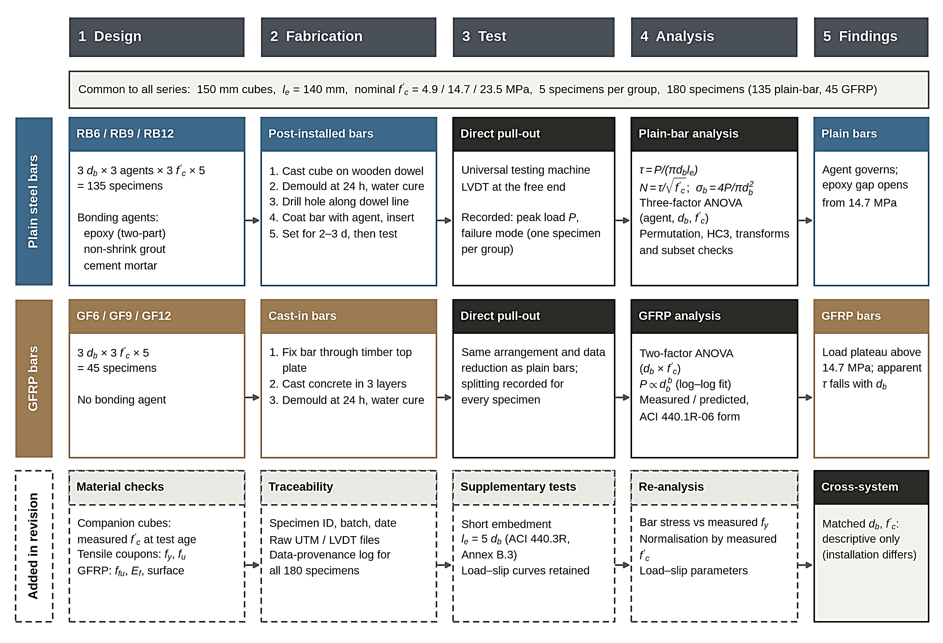
Fig. 1. Experimental programme and analysis workflow. Plain steel bars were post-installed in drilled holes and GFRP bars were cast in; all 180 specimens were pulled out in the same test arrangement and analysed with the same data-reduction rules.
[ตรวจสอบ 3: ภาพ Fig. 1 มีแถว “Added in revision” (Material checks: companion cubes วัด f′c ที่อายุทดสอบ, tensile coupons fy และ fu, GFRP: ffu และ Ef; Supplementary tests: short embedment le = 5db (ACI 440.3R, Annex B.3) และ load–slip curves retained; Re-analysis: bar stress เทียบกับ fy ที่วัดได้ และ normalisation ด้วย f′c ที่วัดได้) ซึ่งตรงกับ Table 2, 3, 5 และ 13 แต่ (ก) เนื้อหาบทความยังไม่สะท้อนรายการเหล่านี้ (ดูตรวจสอบ 1, 4, 6, 13); (ข) กล่องบนของภาพ “Common to all series: le = 140 mm ... 180 specimens” และคำบรรยายภาพ “all 180 specimens were pulled out in the same test arrangement” ขัดกับชุดเสริมที่ le = 5db (Table 13); (ค) แถว Re-analysis ระบุการวิเคราะห์ด้วย fy และ f′c ที่วัดได้ แต่ผลในบทความยังคำนวณด้วยค่า nominal/catalogue. คำถาม: ภาพนี้เตรียมไว้สำหรับฉบับแก้ไขใช่หรือไม่ และต้องการปรับข้อความทั้งฉบับให้ตรงกับภาพ หรือปรับภาพให้ตรงกับข้อความ]

2.2 Materials
Steel bars. Plain round bars were of the grade designated SR24 in the project report; nominal diameters were used throughout. For this designation, a supplier’s product-standard sheet lists a minimum yield strength of 235 MPa and a minimum tensile strength of 385 MPa under TIS 20-2559, whereas the project report cites TIS 20-2527. We use 235 MPa only as a reference level for the bar stress in Section 2.5; the yield and tensile strengths measured on coupons of each bar diameter are given in Table 2.
Table 2. Tensile properties of the SR24 plain round bars from coupon tests.
Bar | d_{b} (mm) | Nominal area (mm²) | n | Yield strength f_{y}, mean (SD) (MPa) | Tensile strength f_{u}, mean (SD) (MPa) | f_{u} / f_{y} | Elongation (%)
RB6 | 6 | 28.3 | 3 | 352 (8) | 448 (6) | 1.27 | 26
RB9 | 9 | 63.6 | 3 | 326 (6) | 441 (5) | 1.35 | 28
RB12 | 12 | 113.1 | 3 | 305 (7) | 436 (6) | 1.43 | 30

[ตรวจสอบ 4: Table 2 รายงาน yield strength ที่ทดสอบจาก coupon (fy เฉลี่ย 352, 326 และ 305 MPa สำหรับ RB6, RB9 และ RB12) ซึ่งสูงกว่าค่า catalogue 235 MPa ทุกขนาด แต่หลายส่วนของบทความยังใช้ 235 MPa เป็นเกณฑ์และระบุว่าไม่ทราบค่า yield จริง ได้แก่ หัวข้อ 2.5 (การนับตัวอย่างที่ “เกิน yield”), Fig. 5b (เส้นประ 235 MPa), หัวข้อ 3.4, 3.5, 4.3, 4.7, 4.8 และบทสรุปข้อ (3). นอกจากนี้ Table 2 ไม่ระบุว่า coupon มาจากเหล็กล็อตเดียวกับเหล็กที่ใช้ทดสอบ pull-out หรือไม่ และใช้มาตรฐานใดทดสอบ. คำถาม: จะใช้ fy ที่วัดได้เป็นเกณฑ์ screening แทน 235 MPa หรือไม่ และมีรายละเอียด coupon ตามที่ถามหรือไม่]
GFRP bars. Bars of 6, 9, and 12 mm were tested. One end of each bar was grouted with non-shrink grout inside a steel tube to give a grip for the testing machine. The surface treatment, fibre content, and tensile properties of the bars are not documented in the source. Their tensile properties are given in Table 3.
Table 3. Tensile properties of the GFRP bars. Maximum observed loads are those reported in Section 3.6.
Bar | d_{b} (mm) | Area (mm²) | f_{fu}, mean (SD) (MPa) | E_{f} (GPa) | ε_{fu} (%) | F_{fu} (kN) | Max observed P (kN) | Max P / F_{fu}
GF6 | 6 | 28.3 | 1040 (36) | 46.5 | 2.24 | 29.4 | 22.23 | 0.76
GF9 | 9 | 63.6 | 905 (31) | 45.8 | 1.98 | 57.6 | 24.18 | 0.42
GF12 | 12 | 113.1 | 812 (28) | 45.1 | 1.80 | 91.8 | 25.76 | 0.28

[ตรวจสอบ 5: ประโยคก่อนหน้าระบุว่า “tensile properties of the bars are not documented in the source” แต่ Table 3 รายงาน ffu, Ef, εfu และ Ffu ของแท่ง GFRP ทั้ง 3 ขนาด จึงขัดกัน (ควรตัดคำว่า “and tensile properties” ออกเมื่อยืนยันข้อมูลแล้ว). นอกจากนี้ Table 3 ไม่ระบุว่าเป็นค่าที่ทดสอบเองหรือค่าจากผู้ผลิต จำนวนตัวอย่าง และมาตรฐานทดสอบ (เช่น ASTM D7205). คำถาม: ที่มาของข้อมูลใน Table 3 คืออะไร]
Concrete. All mixtures were made from one commercial pre-blended dry-mix concrete supplied in bags (nominal grades 50, 150, and 240 ksc). The 4.9 MPa mixture diluted the dry mix with an equal mass of coarse sand (2.00–4.75 mm), the 14.7 and 23.5 MPa mixtures used the undiluted dry mix, and the last two differ only in the recorded curing period, 7 d and 14 d (Table 4). The compressive strengths measured on companion 150 mm cubes at the age of the pull-out test are given in Table 5. Cubes for the GFRP series used 5–6 L of water per bag of dry mix.
Table 4. Concrete mixtures used for the plain-bar series, as recorded in the source project (batch masses).
Nominal strength | Dry-mix concrete (kg) | Water (kg) | Coarse sand (kg) | Curing period (d)
4.9 MPa (50 ksc) | 150 | 50 | 150 | 5
14.7 MPa (150 ksc) | 300 | 48 | – | 7
23.5 MPa (240 ksc) | 300 | 48 | – | 14

Table 5. Compressive strength of companion 150 mm cubes at the age of the pull-out test.
Nominal grade (MPa) | Mixture | Curing (d) | Age at test (d) | n | Measured f′_{c}, mean (SD) (MPa) | CV (%) | Measured / nominal
4.9 (50 ksc) | Dry mix + equal mass of sand | 5 | 8 | 3 | 5.8 (0.6) | 10.3 | 1.18
14.7 (150 ksc) | Dry mix | 7 | 10 | 3 | 13.4 (1.0) | 7.5 | 0.91
23.5 (240 ksc) | Dry mix | 14 | 17 | 3 | 17.9 (1.3) | 7.3 | 0.76

[ตรวจสอบ 6: (ก) Table 5 ไม่ระบุว่าครอบคลุมลูกบาศก์ชุด plain-bar เท่านั้นหรือรวมชุด GFRP — ส่วนผสมและระยะบ่ม (5, 7, 14 วัน) ตรงกับ Table 4 ของชุด plain-bar ขณะที่ลูกบาศก์ชุด GFRP ใช้น้ำ 5–6 L ต่อถุงและบ่มโดยแช่น้ำ จึงอาจมีกำลังอัดต่างกัน. (ข) อายุทดสอบ 8, 10 และ 17 วันต่างจากอายุ 28 วันที่โดยทั่วไปใช้อ้างอิงเกรดคอนกรีต การเทียบ Measured/nominal (1.18, 0.91, 0.76) จึงอาจไม่ใช่การเทียบอย่างเดียวกัน. (ค) f′c จริงของเกรด 23.5 เทียบกับ 14.7 MPa คือ 1.34 เท่า (17.9/13.4) ไม่ใช่ 1.60 เท่าตาม nominal ซึ่งกระทบ N = τ/√f′c (สมการ 2), Table 10–12 และ Fig. 8b, 9a ที่คำนวณด้วยค่า nominal. คำถาม: ข้อมูลใน Table 5 ใช้กับชุดใด และจะคำนวณ N ด้วย f′c จริงหรือ nominal]
Bonding agents. The epoxy was a two-component, solvent-free adhesive (resin and hardener) that gives a grey paste. The non-shrink grout was a ready-mixed cementitious product containing cement, graded sand, and admixtures, for which the project report quotes manufacturer-declared compressive strengths above 300 ksc at one day and above 850 ksc (about 29 and 83 MPa). The cement mortar was a bagged, ready-mixed product of cement, sand, and admixture.

2.3 Specimen preparation
Cubes of 150 mm were cast in oiled moulds in three layers, each rodded 25 times. For the plain-bar series, a wooden dowel was pressed into the centre of the fresh concrete to mark the hole and withdrawn after about one hour. The cubes were demoulded after 24 h. A hole was then drilled along the dowel line, the bar was coated by dipping it in the freshly mixed agent and was then pushed into the hole, and the specimen was left for two to three days before testing (Fig. 2).
For the GFRP series, each bar was held vertically at the centre of the mould by a perforated timber plate (150 × 150 × 10 mm) that also let the free end project for the displacement transducer. Concrete was placed and rodded as above, a second plate locked the bar position at the top, the cubes were demoulded after 24 h and immersed in water.
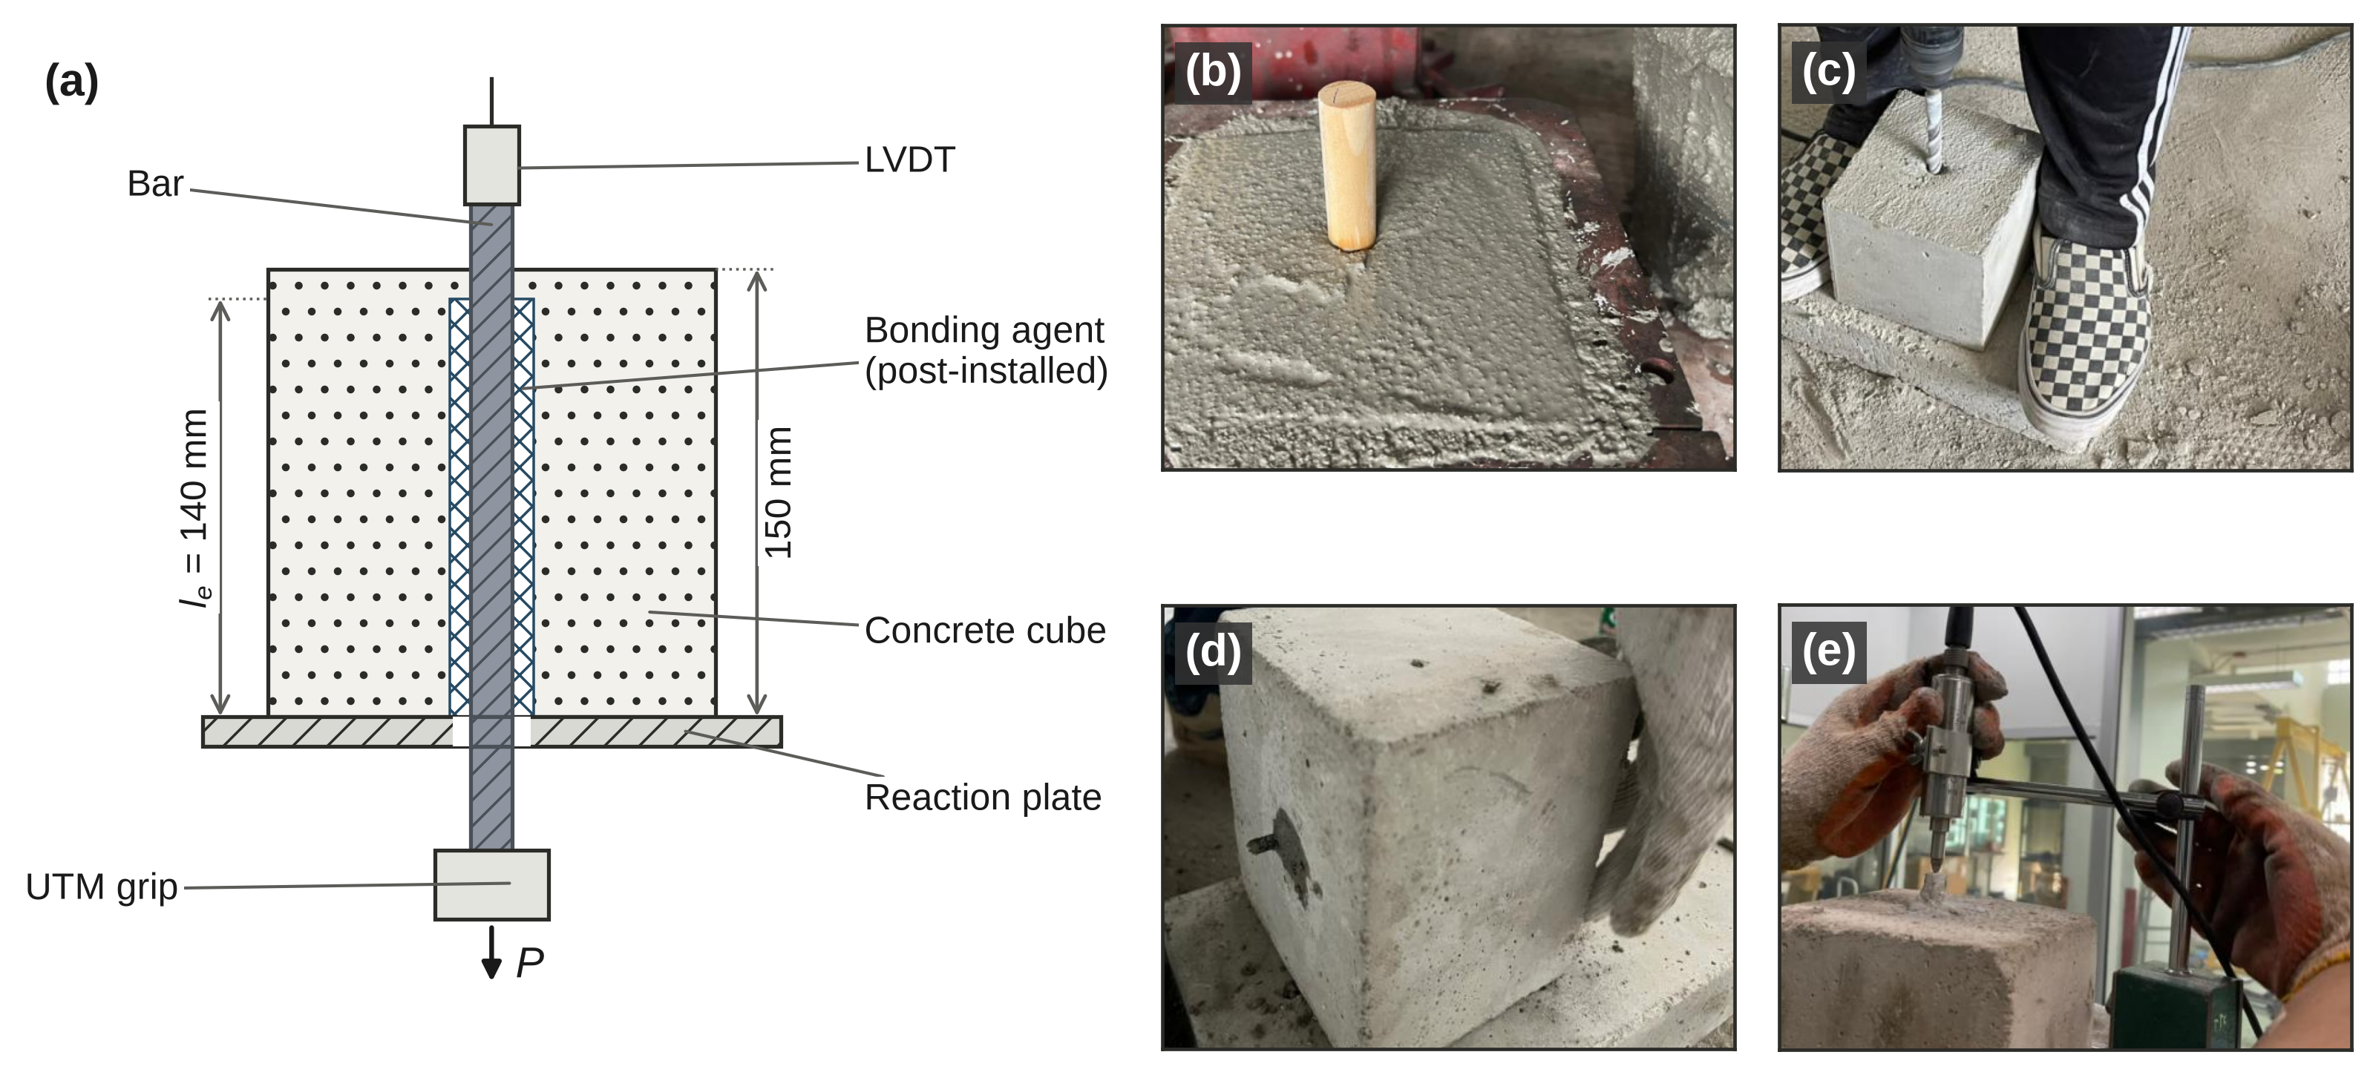
Fig. 2. Specimen and test arrangement. (a) Schematic of the pull-out specimen (bonded length 140 mm in a 150 mm cube; the loaded end is at the bottom and slip is read at the free end). Hatching: dots, concrete; diagonal lines, steel bar; cross-hatching, bonding agent. GFRP bars were cast in place, without a bonding-agent annulus. (b) Forming the hole position with a wooden dowel in fresh concrete. (c) Drilling the hole. (d) Bar bonded in place with the free end projecting. (e) Displacement transducer (LVDT) at the free end. Panels (b)–(e) are photographs from the source project.

2.4 Pull-out test
Each cube was tested in direct pull-out in a universal testing machine following the ASTM C234 procedure adopted in the source projects [37]. The bar was gripped at its loaded end while the cube bore against a reaction plate, and a linear variable differential transformer (LVDT) at the unloaded end recorded slip. The peak load P was taken as the pull-out capacity of the specimen. Load–slip records are not analysed in this paper. Failure mode was recorded after testing, for one representative specimen per group in the plain-bar series (27 groups) and for every specimen in the GFRP series.
[ตรวจสอบ 7: หัวข้อนี้ระบุว่า “Load–slip records are not analysed in this paper” แต่ Table 13 รายงาน “Slip at peak (mm)” ซึ่งต้องมาจากบันทึก load–slip. คำถาม: จะคงคอลัมน์ slip ไว้แล้วแก้ประโยคนี้ หรือตัดคอลัมน์ slip ออกจากตาราง]
The arrangement departs from the pull-out specimen of ACI 440.3R-04, Annex B.3 (a 200 mm cube with a bonded length of five bar diameters) [38], and ASTM withdrew C234 in 2000 and issued no direct successor. The ratio l_{e}/d_{b} ranged from 11.7 (12 mm bars) to 23.3 (6 mm bars), so the bond stress reported below is a stress averaged over a long bonded length. Section 4.6 returns to this.

2.5 Data reduction
Average bond stress was computed from the peak load and the nominal bar diameter d_{b},
$τ=\frac{P}{πd_{b}l_{e}}$ (1)
and a strength-normalised value N was obtained by dividing by the square root of the nominal concrete strength (MPa units),
$N=\frac{τ}{\sqrt{{f'}_{c}}}$ (2)
The nominal stress in the bar at peak load was also computed,
$σ_{b}=\frac{4P}{π{d_{b}}^{2}}$ (3)
and compared with the catalogue minimum yield strength of SR24 (235 MPa, Section 2.2). The comparison is a screening device and not a measurement. A value above 235 MPa does not prove that the bar yielded, because the real yield strength is unknown and usually exceeds the specified minimum; it does show that the bar, and not the interface, could have set the limit, in which case τ is a lower bound on the interface strength.
[ตรวจสอบ 8: ประโยค “the real yield strength is unknown and usually exceeds the specified minimum” ขัดกับ Table 2 ที่มี yield strength ที่วัดได้ (305–352 MPa) — ดูตรวจสอบ 4. คำถาม: เกณฑ์ screening ในหัวข้อนี้จะใช้ค่าใด]
For the GFRP series, measured N was compared with the bond-strength expression of ACI 440.1R-06 [35] in the form quoted by Shbeeb et al. [36],
$\frac{τ}{\sqrt{{f'}_{c}}}=0.33 + 0.025\left(\frac{c}{d_{b}}\right)+ 8.3\left(\frac{d_{b}}{l_{e}}\right)$ (4)
where c is the concrete cover (mm) and l_{e} replaces the embedment length. We assumed c = (150 − d_{b})/2, the distance from the bar surface to the nearest cube face. The source we used states no upper limit on c/d_{b}, so predictions are reported without a cap, and a cap of 3.5 is shown as a sensitivity check in Section 3.7.

2.6 Statistical analysis
Bond stress in the plain-bar series was analysed with a three-factor ANOVA (agent, diameter, and nominal strength) fitted to all 135 specimens. Type III tests used effects (sum-to-zero) coding, and partial eta squared (η_{p}²) is reported as the effect size. Because many groups contained zeros and the variances were unequal, the agent × strength and agent × diameter interactions were re-tested with a Freedman–Lane permutation test (4,000 permutations), heteroscedasticity-consistent (HC3) Wald tests, square-root, log(τ + 0.1), and rank transformations, the first four specimens of each group, and the exclusion of the one group whose representative specimen split. Pairwise contrasts between agents used Welch t-tests with Hedges’ g, and a Mann–Whitney test where the outcome was borderline. Trends with strength and diameter were summarised by Spearman correlation and Kruskal–Wallis tests within each agent, and the proportions of zero-load specimens were compared with Fisher’s exact test.
[ตรวจสอบ 9: หัวข้อ 2.6 ระบุ “the exclusion of the one group whose representative specimen split” แต่ Table 9 แถว “Split-group representative specimen excluded” มี n = 134 (ตัดออก 1 ตัวอย่าง ไม่ใช่ทั้งกลุ่ม ซึ่งจะเหลือ n = 130). คำถาม: ต้องการแก้ถ้อยคำในหัวข้อ 2.6 หรือแก้ตัวเลขใน Table 9]
For the GFRP series, two-way ANOVA (diameter × strength; 36 error degrees of freedom) was applied to P, τ, and N. The scaling of capacity with diameter, in both series, was described by a log–log fit of the form
$P=k{d_{b}}^{b}$ (5)
within each strength for GFRP bars, and with strength as a fixed effect for plain bars with positive load. An exponent b = 1 corresponds to a uniform stress over the bar perimeter, b = 2 to a capacity proportional to bar area, and b = 0 to a capacity that does not depend on diameter. No multiplicity correction was applied. Computations were done in Python (NumPy, SciPy) on the specimen-level data.

3. Results

3.1 Effect of the bonding agent
Table 6 gives the bond stress of the plain-bar series by agent and strength, and Fig. 3 shows every group. Pooled over diameters and strengths (n = 45 per agent), epoxy averaged 1.88 ± 1.64 MPa (mean ± SD), non-shrink grout 0.43 ± 0.44 MPa, and cement mortar 0.021 ± 0.055 MPa. Epoxy exceeded grout by 1.45 MPa (Welch p < 0.001, Hedges’ g = 1.19; Mann–Whitney p < 0.001), and grout exceeded mortar by 0.41 MPa (p < 0.001, g = 1.28; Table 7). The highest bond stress of any mortar specimen was 0.27 MPa, against 1.58 MPa for grout and 5.75 MPa for epoxy; the corresponding peak loads were 1.05, 6.3, and 30.3 kN.
Specimens that recorded no load were frequent with the weaker agents: 36 of 45 with mortar, 16 of 45 with grout, and 6 of 45 with epoxy (Fig. 4c). The proportion of zero-load specimens differed between epoxy and grout (Fisher exact p = 0.03) and between grout and mortar (p < 0.001).
Table 6. Bond stress τ (MPa) of the plain-bar series by bonding agent and nominal concrete strength, mean (SD).
Agent | 4.9 MPa | 14.7 MPa | 23.5 MPa | All strengths | Zero load, of 45 | Highest τ
Epoxy | 1.00 (1.37) | 1.50 (0.86) | 3.13 (1.78) | 1.88 (1.64) | 6 | 5.75
Non-shrink grout | 0.55 (0.54) | 0.37 (0.50) | 0.37 (0.23) | 0.43 (0.44) | 16 | 1.58
Cement mortar | 0.00 (0.00) | 0.04 (0.08) | 0.03 (0.04) | 0.02 (0.05) | 36 | 0.27
Each strength cell pools the three diameters (n = 15); the last columns pool all 45 specimens per agent. Zero-load specimens are included as zeros.

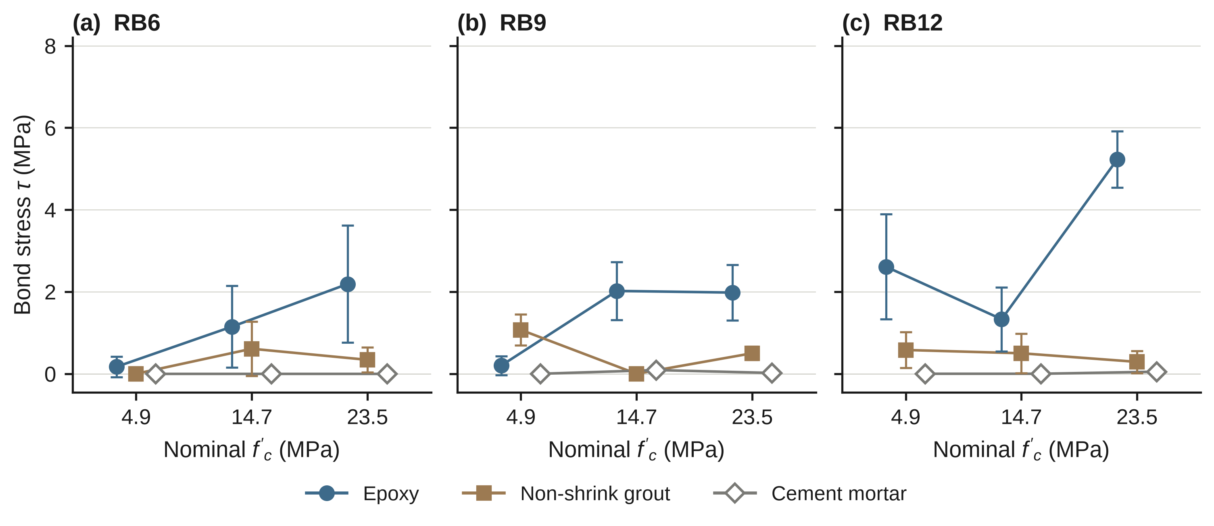
Fig. 3. Bond stress τ of the plain-bar series against nominal concrete strength for (a) RB6, (b) RB9, and (c) RB12. Symbols are group means ± 1 SD (n = 5); error bars are omitted for cement mortar, whose SD is below 0.1 MPa and smaller than the symbol.
Table 7. Pairwise contrasts between bonding agents in the plain-bar series.
Contrast (first minus second) | n per group | Mean difference (MPa) | Welch t | p | Hedges’ g | Mann–Whitney p
Epoxy − grout, all strengths | 45 | 1.45 | 5.71 | < 0.001 | 1.19 | < 0.001
Epoxy − mortar, all strengths | 45 | 1.86 | 7.58 | < 0.001 | 1.58 | < 0.001
Grout − mortar, all strengths | 45 | 0.41 | 6.14 | < 0.001 | 1.28 | < 0.001
Epoxy − grout at 4.9 MPa | 15 | 0.45 | 1.18 | 0.25 | 0.42 | 0.97
Epoxy − grout at 14.7 MPa | 15 | 1.13 | 4.41 | < 0.001 | 1.57 | < 0.001
Epoxy − grout at 23.5 MPa | 15 | 2.76 | 5.95 | < 0.001 | 2.11 | < 0.001
Grout − mortar at 4.9 MPa | 15 | 0.55 | 3.94 | 0.001 | 1.40 | < 0.001
Grout − mortar at 14.7 MPa | 15 | 0.33 | 2.54 | 0.02 | 0.90 | 0.08
Grout − mortar at 23.5 MPa | 15 | 0.34 | 5.71 | < 0.001 | 2.03 | < 0.001
No multiplicity correction was applied. The epoxy–grout contrast at 4.9 MPa is the only one in the table whose Welch and Mann–Whitney tests both fail to separate the groups.

3.2 Dependence on concrete strength and stability of the result
The ranking of the agents depended on the concrete strength (agent × strength F(4, 108) = 23.2, p < 0.001, η_{p}² = 0.46; Table 8 and Fig. 4a). Epoxy gave 1.00, 1.50, and 3.13 MPa at 4.9, 14.7, and 23.5 MPa, whereas grout gave 0.55, 0.37, and 0.37 MPa. At 4.9 MPa the two agents could not be separated (difference 0.45 MPa, p = 0.25, g = 0.42; Mann–Whitney p = 0.97). At 14.7 and 23.5 MPa epoxy exceeded grout by 1.13 MPa (p < 0.001, g = 1.57) and 2.76 MPa (p < 0.001, g = 2.11), which is 4.1 and 8.5 times the grout mean (1.8 times at 4.9 MPa). Grout exceeded mortar at every strength, but by only 0.33–0.55 MPa (Table 7).
Table 8. Three-factor ANOVA of bond stress τ for the plain-bar series (n = 135 specimens; Type III, effects coding).
Effect | df | F | p | η_{p}²
Agent | 2, 108 | 149.3 | < 0.001 | 0.734
Diameter | 2, 108 | 20.1 | < 0.001 | 0.271
Nominal f′_{c} | 2, 108 | 19.5 | < 0.001 | 0.265
Agent × diameter | 4, 108 | 18.0 | < 0.001 | 0.400
Agent × f′_{c} | 4, 108 | 23.2 | < 0.001 | 0.462
Diameter × f′_{c} | 4, 108 | 5.9 | < 0.001 | 0.179
Agent × diameter × f′_{c} | 8, 108 | 8.7 | < 0.001 | 0.391

The agent effect was the largest (η_{p}² = 0.73), and diameter and strength each had a moderate effect (η_{p}² = 0.27 and 0.26). All interactions were significant, including the three-way term (F(8, 108) = 8.7, η_{p}² = 0.39), so the effects of strength and diameter were not the same for the three agents.
Table 9 lists the checks applied to the two interaction terms. The agent × strength interaction remained significant under every analysis, including the rank transformation, and it survived when the comparison was reduced to epoxy and grout with or without the zero-load specimens. It is therefore not a product of zero inflation, unequal variance, or the one group with a splitting failure. The agent × diameter interaction held in all but one analysis; under the rank transformation it was not significant (p = 0.14), so it is the less secure of the two.
Table 9. Stability of the two agent interactions.
Analysis | n | Agent × strength | p | Agent × diameter | p
Primary model (all specimens) | 135 | F(4, 108) = 23.2 | < 0.001 | F(4, 108) = 18.0 | < 0.001
Freedman–Lane permutation (4,000 permutations) | 135 | F = 23.2 | 0.00025 | F = 18.0 | 0.00025
HC3 Wald test | 135 | χ²(4) = 39.5 | < 0.001 | χ²(4) = 33.4 | < 0.001
Square-root transform of τ | 135 | F(4, 108) = 11.3 | < 0.001 | F(4, 108) = 6.9 | < 0.001
log(τ + 0.1) transform | 135 | F(4, 108) = 8.3 | < 0.001 | F(4, 108) = 3.8 | 0.007
Rank transform of τ | 135 | F(4, 108) = 5.5 | < 0.001 | F(4, 108) = 1.8 | 0.14
First four specimens of each group | 108 | F(4, 81) = 14.3 | < 0.001 | F(4, 81) = 11.5 | < 0.001
Split-group representative specimen excluded | 134 | F(4, 107) = 22.8 | < 0.001 | F(4, 107) = 17.7 | < 0.001
Epoxy and grout only | 90 | F(2, 84) = 9.9 | < 0.001 | – | –
Epoxy and grout only, zero-load specimens excluded | 68 | F(2, 62) = 9.7 | < 0.001 | – | –
The smallest attainable permutation p value with 4,000 permutations is 0.00025.

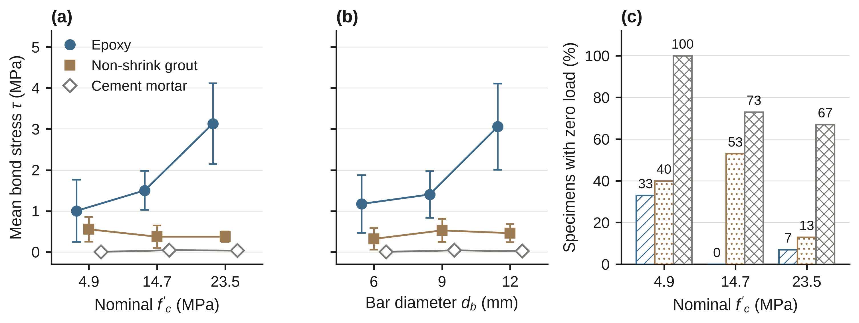
Fig. 4. Dependence of bond stress on agent, strength, and diameter in the plain-bar series. (a) Mean τ with 95% confidence intervals by agent and nominal strength (n = 15 per point). (b) Mean τ with 95% confidence intervals by agent and bar diameter (n = 15 per point). (c) Share of specimens that recorded zero load, by agent and strength (n = 15 per bar). Bar colour and hatching in (c) follow the agent legend in (a): epoxy, oblique lines; grout, dots; mortar, cross-hatching.

3.3 Effect of strength and diameter within each agent
Strength mattered for epoxy and not for grout. Epoxy bond stress rose with nominal strength from 1.00 to 3.13 MPa (Spearman ρ = 0.51, p < 0.001; Kruskal–Wallis p = 0.003), and grout showed no trend (0.55, 0.37, and 0.37 MPa; ρ = −0.07, p = 0.64). Mortar showed a weak rank correlation (ρ = 0.34, p = 0.02), but its means stayed at 0.00, 0.04, and 0.03 MPa.
Diameter followed the same pattern for epoxy, whose bond stress was 1.17, 1.40, and 3.06 MPa for RB6, RB9, and RB12 (Spearman ρ = 0.46, p = 0.002; Kruskal–Wallis p = 0.006; Fig. 5a). Grout (0.31, 0.52, and 0.45 MPa; p = 0.28) and mortar (0.00, 0.04, and 0.02 MPa; p = 0.06) showed no clear diameter effect. The epoxy effect was not uniform across strengths. RB12 gave 2.61, 1.33, and 5.23 MPa at 4.9, 14.7, and 23.5 MPa, against 0.17, 1.15, and 2.19 MPa for RB6 and 0.20, 2.02, and 1.98 MPa for RB9, so the gain came from RB12 at the lowest and highest strengths, and RB9 showed no change between 14.7 and 23.5 MPa.
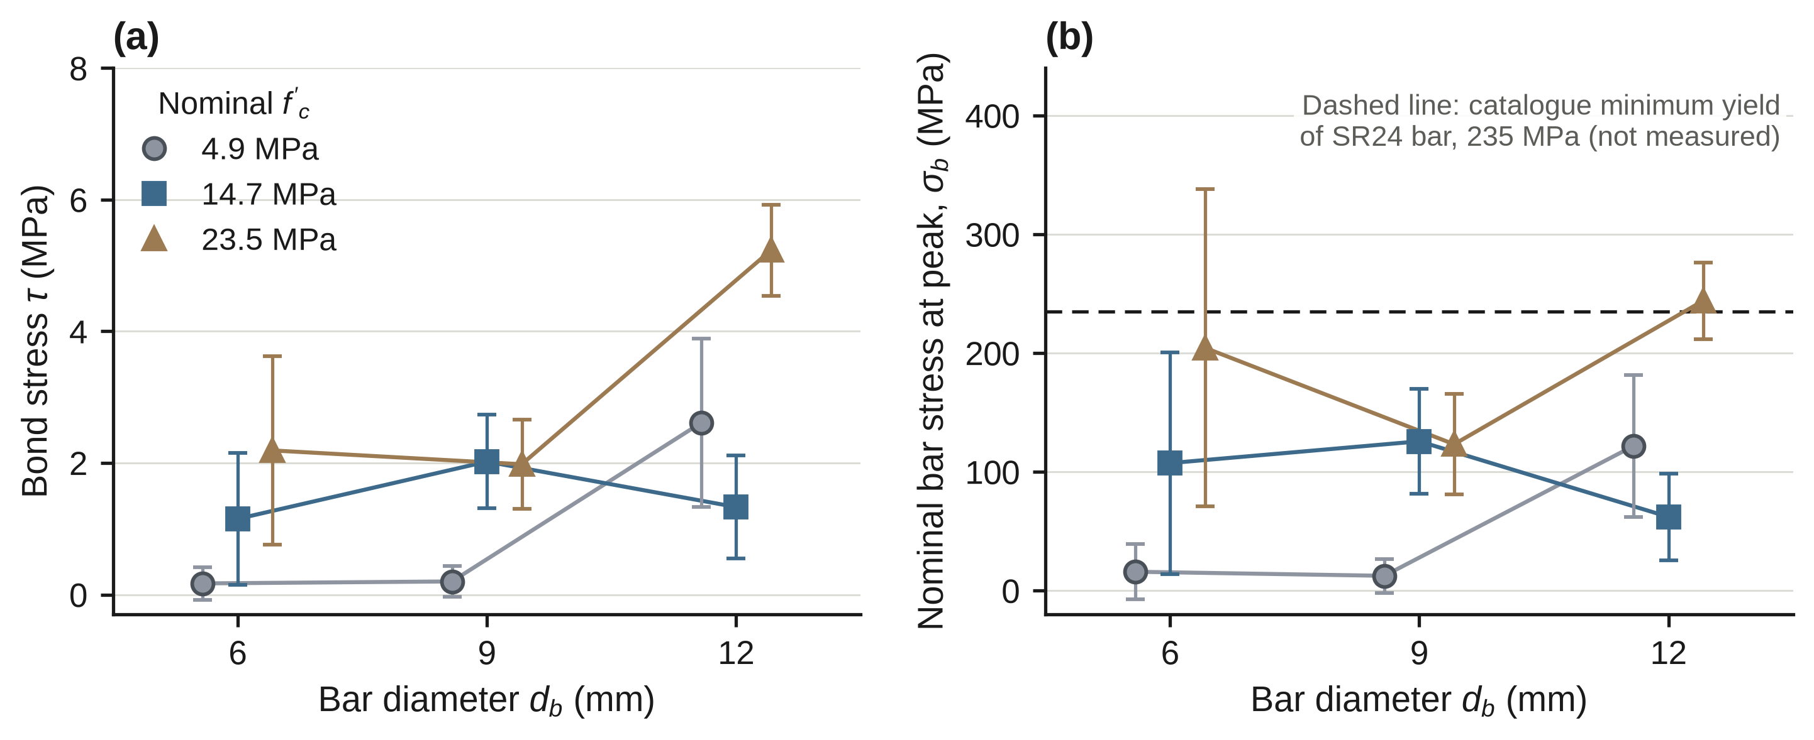
Fig. 5. Epoxy-anchored plain bars. (a) Bond stress τ and (b) nominal bar stress at peak load σ_{b} against bar diameter for each nominal strength (mean ± 1 SD, n = 5). The dashed line in (b) is the catalogue minimum yield strength of SR24 bar (235 MPa).
[ตรวจสอบ 10: ข้อความในรูป Fig. 5b ระบุว่าเส้นประคือ “catalogue minimum yield of SR24 bar, 235 MPa (not measured)” แต่ Table 2 มี fy ที่วัดได้ 352, 326 และ 305 MPa (RB6, RB9, RB12) จึงขัดกับคำว่า “not measured”. หากเปลี่ยนเกณฑ์ตามตรวจสอบ 4 ต้องจัดทำรูปใหม่]

3.4 Bar stress at peak load and scaling of capacity with diameter
For epoxy, the nominal bar stress at peak load reached or exceeded the catalogue yield level in part of the series (Fig. 5b). Group means of σ_{b} were 16, 107, and 204 MPa for RB6, 13, 126, and 123 MPa for RB9, and 122, 62, and 244 MPa for RB12 at 4.9, 14.7, and 23.5 MPa. Eight of 45 epoxy specimens exceeded 235 MPa (1 at 14.7 MPa and 7 at 23.5 MPa; 4 of the RB6 and 4 of the RB12 bars), with a maximum of 350 MPa (RB6, 23.5 MPa). The mean peak load of RB12 at 23.5 MPa (27.6 kN) was 104% of the load that 235 MPa would give (26.6 kN). Grout and mortar never came close to this level: the highest bar stress was 138 MPa with grout and 17 MPa with mortar.
[ตรวจสอบ 11: ตัวเลขในย่อหน้านี้ (“Eight of 45 epoxy specimens exceeded 235 MPa”, ค่าสูงสุด 350 MPa ของ RB6 และ “104% of the load that 235 MPa would give” ของ RB12) อิงค่า catalogue. เมื่อเทียบกับ fy ที่วัดได้ใน Table 2: σb เฉลี่ยของ RB12 ที่ 23.5 MPa (244 MPa) เท่ากับประมาณ 80% ของ fy = 305 MPa และค่าสูงสุดของ RB6 (350 MPa) ใกล้เคียง fy = 352 MPa จึงต้องนับจำนวนตัวอย่างที่เกิน fy ใหม่ (ดูตรวจสอบ 4). คำถาม: มีข้อมูลรายตัวอย่างของ σb สำหรับนับใหม่หรือไม่]
A log–log fit of peak load against diameter, using the specimens with positive load and strength as a fixed effect, gave an exponent b = 2.12 (95% half-width 0.90, n = 39) for epoxy. That value is larger than the b = 1 of a uniform interface stress and is compatible with b = 2, a capacity proportional to bar area. For grout the exponent was 0.38 (half-width 0.84, n = 29), which the data cannot distinguish from 0 or from 1.

3.5 Failure modes
One failure mode was recorded per plain-bar group (Fig. 6a). Epoxy groups failed by pull-out (7 groups) or by pull-out with bar yielding (2; RB12 at 4.9 and at 23.5 MPa). Grout groups failed by interface slip (6), by interface slip with splitting (1; RB12 at 23.5 MPa), or by zero-bond slip-out, in which the bar was withdrawn without recorded resistance (2). Mortar groups failed by zero-bond slip-out (5) or by slip inside the mortar layer, recorded as mortar shear slippage (4). These counts refer to groups, each represented by a single specimen, so they indicate the dominant behaviour and not the frequency among specimens.
[ตรวจสอบ 12: กลุ่ม RB12 epoxy ที่ 4.9 และ 23.5 MPa ถูกบันทึกว่า “pull-out with bar yielding” แต่ σb ของกลุ่มแรกเฉลี่ย 122 MPa (ตัวอย่าง RB12-5 = 146 MPa) และของกลุ่มหลังเฉลี่ย 244 MPa ซึ่งต่ำกว่า fy ที่วัดได้ของ RB12 (305 MPa; Table 2) ทั้งคู่. คำถาม: ใช้เกณฑ์ใดบันทึกว่าเหล็กคราก และควรแก้เป็น pull-out ธรรมดาหรือไม่]
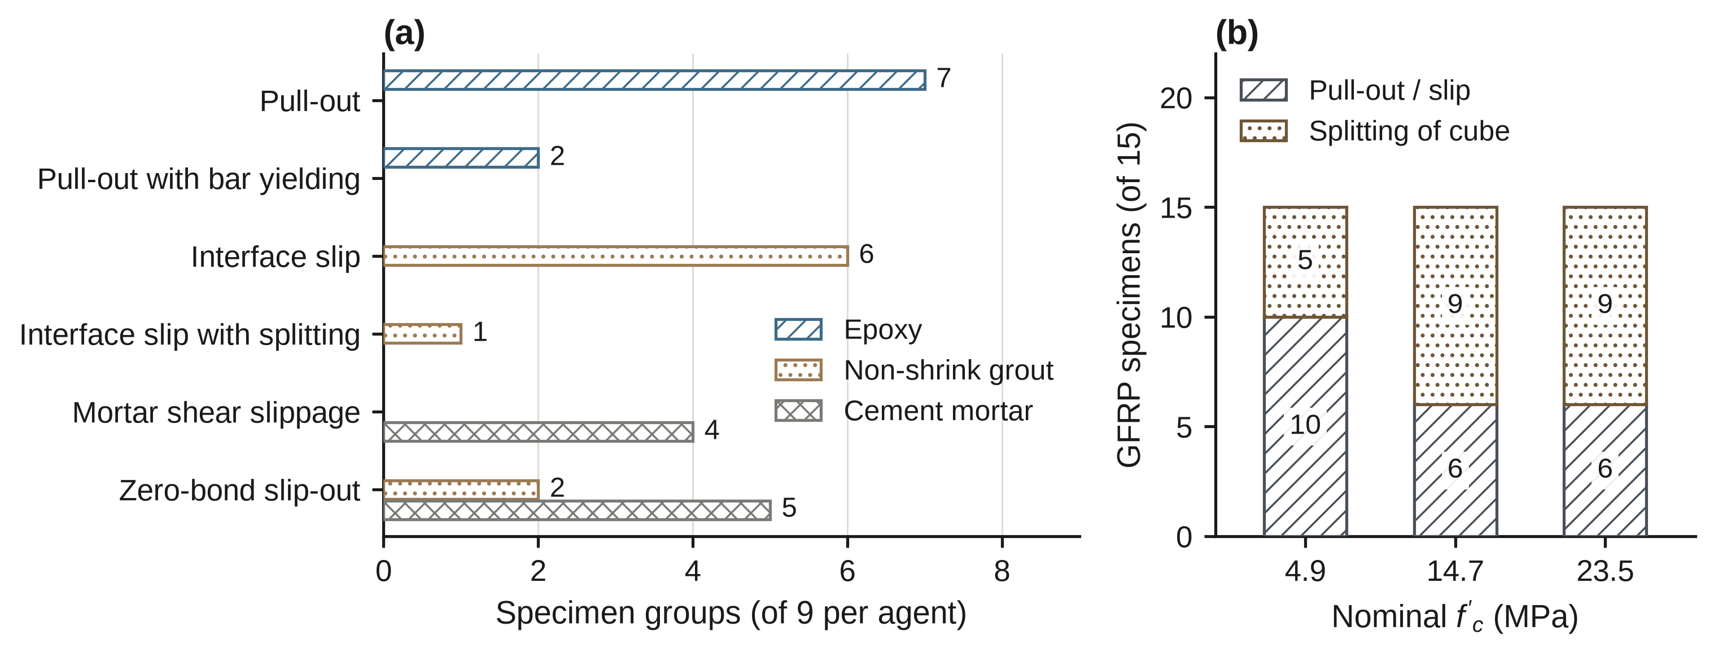
Fig. 6. Failure modes. (a) Mode recorded for each of the nine groups per agent in the plain-bar series (one representative specimen per group). (b) GFRP specimens (n = 15 per strength) that failed by splitting of the cube or by pull-out and slip.

3.6 GFRP bars
Table 10 lists the nine GFRP groups. Within-group coefficients of variation of peak load were 2.0–7.2% at 4.9 and 14.7 MPa and 5.3–18.9% at 23.5 MPa. Peak load rose with diameter at 4.9 MPa (11.1, 14.5, and 15.3 kN for 6, 9, and 12 mm; power-law exponent b = 0.47 with a 95% half-width of 0.10, R² = 0.90), was independent of diameter at 14.7 MPa (21.4, 20.8, and 21.7 kN; b = 0.01 ± 0.10; one-way F = 0.85, p = 0.45), and increased with diameter again at 23.5 MPa, although not uniformly across diameters (17.9, 19.1, and 23.8 kN; b = 0.41 ± 0.29; p = 0.010 for the diameter effect) (Fig. 7a). With a uniform interface stress b would equal 1, so no strength level behaved that way.
Table 10. Cast-in GFRP bars: peak load and derived bond measures (n = 5 per group).
d_{b} (mm) | Nominal f′_{c} (MPa) | P mean (SD), kN | CV of P (%) | P range (kN) | τ mean (MPa) | N mean | Splitting, of 5
6 | 4.9 | 11.1 (0.2) | 2.0 | 10.9–11.3 | 4.21 | 1.90 | 0
6 | 14.7 | 21.4 (0.7) | 3.2 | 20.4–22.2 | 8.11 | 2.11 | 3
6 | 23.5 | 17.9 (2.6) | 14.3 | 14.3–20.4 | 6.77 | 1.40 | 3
9 | 4.9 | 14.5 (0.4) | 2.9 | 14.1–15.0 | 3.66 | 1.65 | 2
9 | 14.7 | 20.8 (0.7) | 3.4 | 19.9–21.7 | 5.26 | 1.37 | 3
9 | 23.5 | 19.1 (3.6) | 18.9 | 14.9–24.2 | 4.82 | 0.99 | 3
12 | 4.9 | 15.3 (0.6) | 4.1 | 14.4–16.1 | 2.90 | 1.31 | 3
12 | 14.7 | 21.7 (1.6) | 7.2 | 19.9–23.4 | 4.11 | 1.07 | 3
12 | 23.5 | 23.8 (1.3) | 5.3 | 22.6–25.8 | 4.51 | 0.93 | 3
τ = P/(πd_{b}l_{e}) with nominal diameters; N = τ/√f′_{c}.

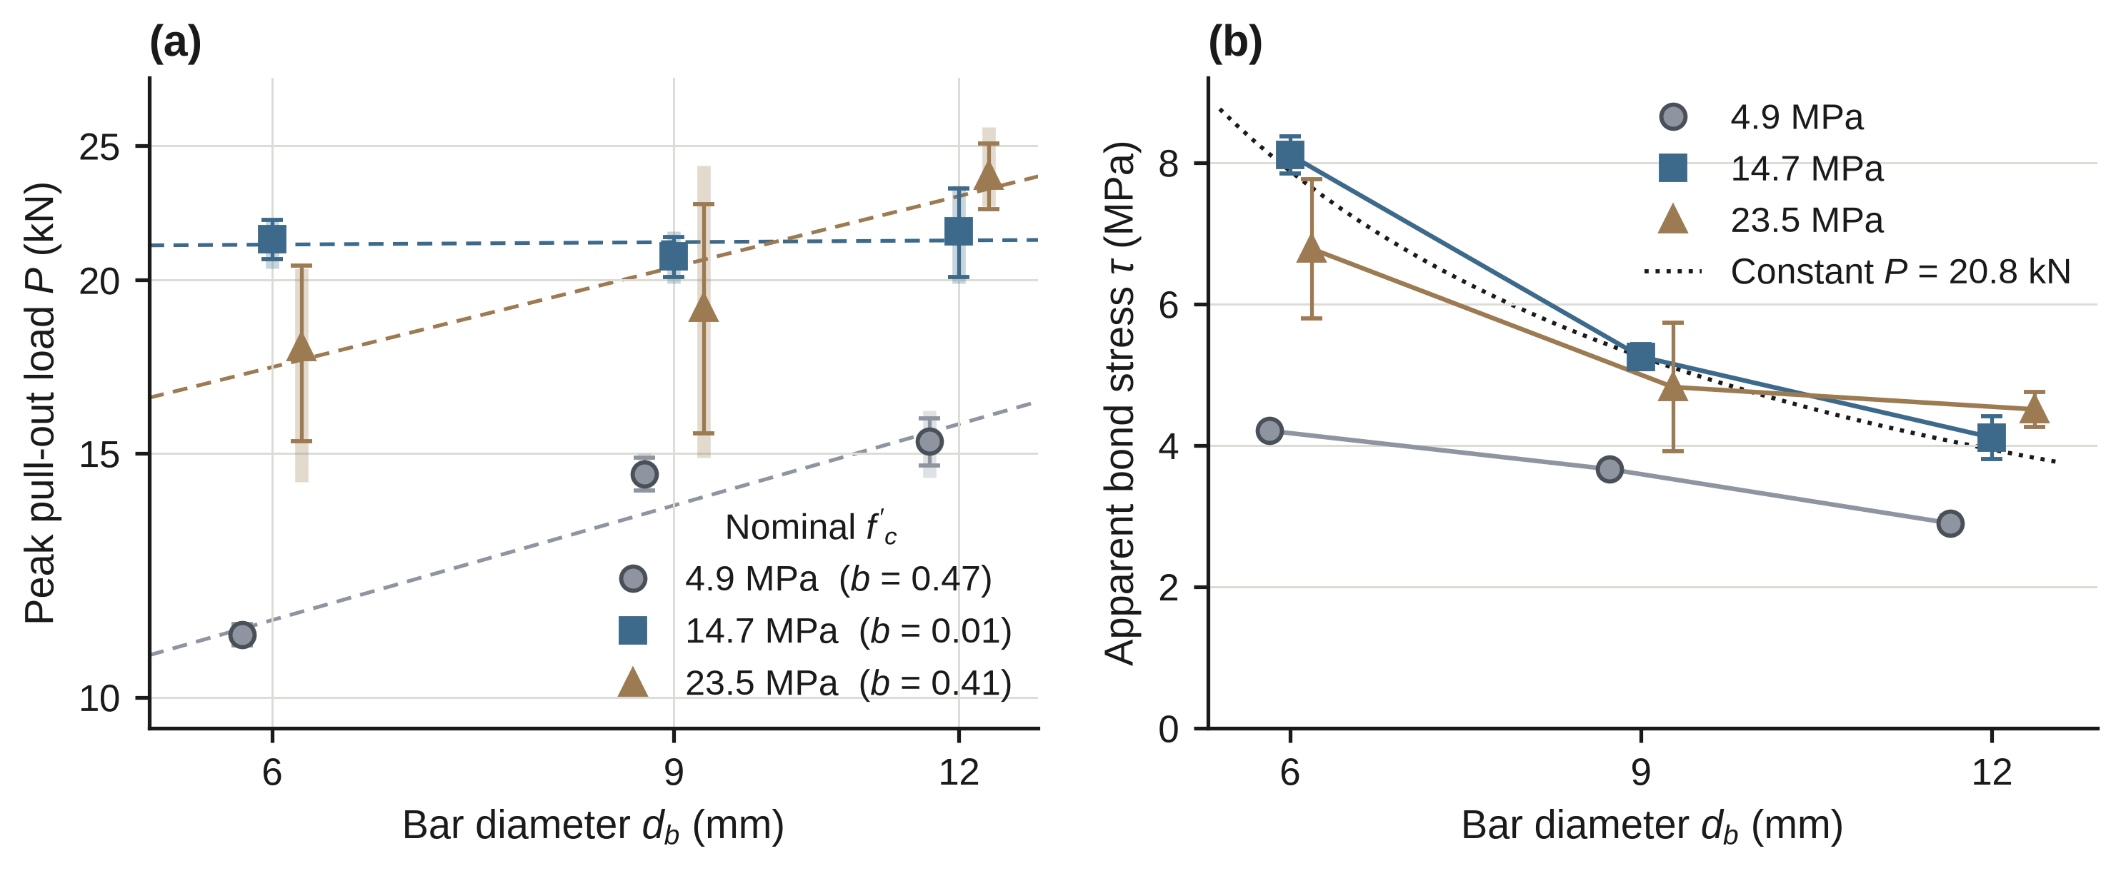
Fig. 7. Effect of diameter on GFRP pull-out capacity. (a) Peak load against bar diameter on logarithmic axes; symbols are group means ± 1 SD, translucent vertical bars are the minimum–maximum range of the five specimens, and dashed lines are the fitted power laws with exponent b in the legend (b = 1 for uniform interface stress, b = 0 for a diameter-independent capacity). (b) Apparent bond stress; the dotted curve is the stress that a constant load equal to the pooled mean peak load at 14.7 and 23.5 MPa would give.
At the upper end of the range, strength stopped affecting the GFRP bars. Between 4.9 and 14.7 MPa, mean peak load rose by factors of 1.93, 1.44, and 1.42 for the 6, 9, and 12 mm bars (all p < 0.001), against 1.73 expected if capacity followed the square root of strength. Between 14.7 and 23.5 MPa it changed by factors of 0.84 (p = 0.035), 0.92 (p = 0.34), and 1.10 (p = 0.045), a change whose sign differs among the three diameters. Pooled over the two higher strengths and all diameters, peak load was 20.8 ± 2.7 kN (CV 12.9%, range 14.3–25.8 kN, n = 30), and the means at 14.7 and 23.5 MPa did not differ (21.3 versus 20.3 kN, Welch p = 0.30, g = −0.38) (Fig. 8a).
Two-way ANOVA (Table 11) found significant effects of diameter, strength, and their interaction on peak load, apparent bond stress, and normalised bond. Because the load plateau spans a fourfold range of bar area, τ and N fall with diameter: at 14.7 MPa, τ was 8.11, 5.26, and 4.11 MPa and N was 2.11, 1.37, and 1.07 for the 6, 9, and 12 mm bars. Splitting of the cube was recorded in 23 of 45 specimens (5 of 15 at 4.9 MPa and 9 of 15 at both 14.7 and 23.5 MPa; Fig. 6b), and peak load at 14.7 and 23.5 MPa did not depend on failure mode (20.6 kN with splitting, n = 18; 21.1 kN without, n = 12; p = 0.72). At the maximum load, the nominal stress in the bar was 786 MPa for the 6 mm bar (P = 22.23 kN), 380 MPa for the 9 mm bar (24.18 kN), and 228 MPa for the 12 mm bar (25.76 kN).
Table 11. Two-way ANOVA of the GFRP series (n = 45).
 |  | Peak load P |  | Bond stress τ |  | Normalised bond N
Effect | df | F | η_{p}² | F | η_{p}² | F | η_{p}²
Diameter d_{b} | 2, 36 | 16.5 | 0.478 | 110.6 | 0.860 | 175.9 | 0.907
Nominal f′_{c} | 2, 36 | 92.7 | 0.837 | 91.9 | 0.836 | 102.6 | 0.851
d_{b} × f′_{c} | 4, 36 | 5.2 | 0.365 | 12.3 | 0.578 | 13.8 | 0.604
All p < 0.001 except d_{b} × f′_{c} for P (p = 0.002).

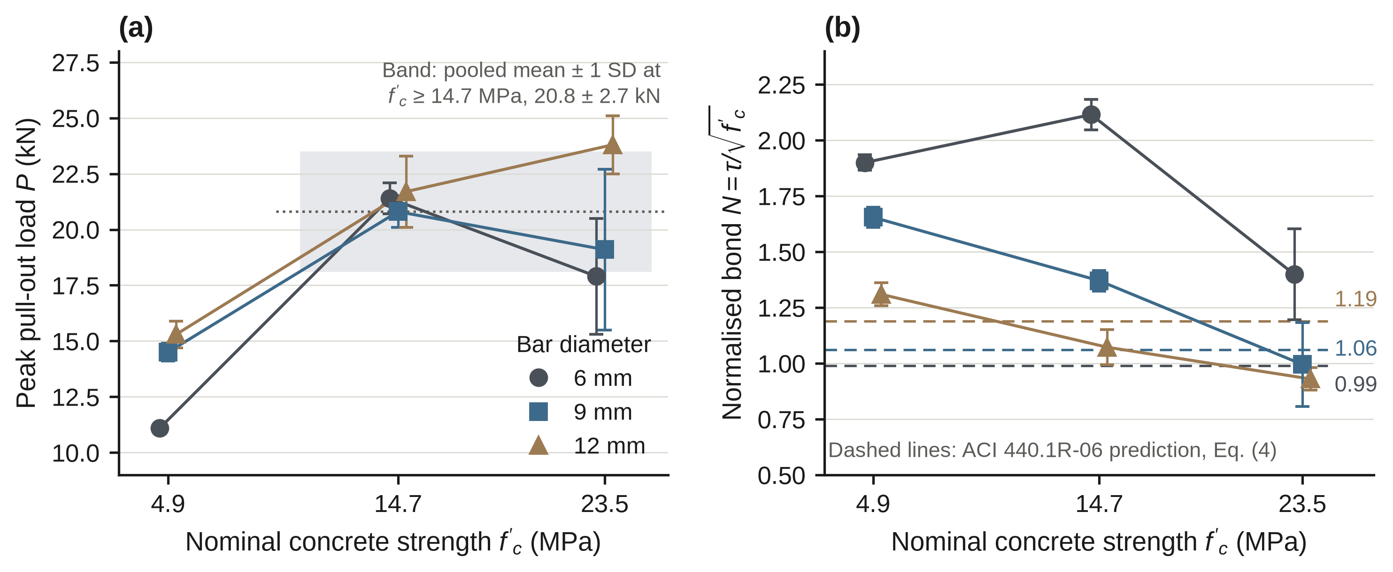
Fig. 8. Effect of nominal concrete strength on GFRP bars. (a) Peak load against strength for each diameter; the shaded band is the pooled mean ± 1 SD at 14.7 and 23.5 MPa (20.8 ± 2.7 kN). (b) Normalised bond N against strength; dashed lines are ACI 440.1R-06 predictions without a cover limit (Section 2.5).

3.7 Comparison with the ACI 440.1R-06 expression
Predicted N from the ACI 440.1R-06 expression is independent of strength and was 0.99, 1.06, and 1.19 for the 6, 9, and 12 mm bars (Table 12). Measured N fell with strength (mean 1.62, 1.52, and 1.11 at 4.9, 14.7, and 23.5 MPa) and with diameter, so the measured-to-predicted ratio ranged from 0.79 to 2.15. It exceeded 1 for the 6 mm bars at every strength and for the 9 mm bars at 4.9 and 14.7 MPa, and it was below 1 for the 12 mm bars at 14.7 and 23.5 MPa and for the 9 mm bars at 23.5 MPa. As a sensitivity check, limiting c/d_{b} to 3.5 lowers the predictions to 0.77, 0.95, and 1.13 and raises the ratios by up to 27%.
Table 12. Measured normalised bond of the GFRP bars against the ACI 440.1R-06 expression (Eq. 4; no cap on c/d_{b}).
 |  |  | Measured N |  |  | Measured / predicted
d_{b} (mm) | c/d_{b} | Predicted N | 4.9 MPa | 14.7 MPa | 23.5 MPa | 4.9 MPa | 14.7 MPa | 23.5 MPa
6 | 12.0 | 0.99 | 1.90 | 2.11 | 1.40 | 1.93 | 2.15 | 1.42
9 | 7.8 | 1.06 | 1.65 | 1.37 | 0.99 | 1.56 | 1.30 | 0.94
12 | 5.8 | 1.19 | 1.31 | 1.07 | 0.93 | 1.10 | 0.90 | 0.79
c = (150 − d_{b})/2 (assumed); l_{e} = 140 mm; measured N is the group mean (n = 5).

3.8 Normalised bond across systems
Fig. 9a sets the four systems side by side in terms of N. Plain bars in epoxy averaged 0.45, 0.39, and 0.65 at 4.9, 14.7, and 23.5 MPa, plain bars in grout 0.25, 0.10, and 0.08, and mortar did not exceed 0.01. GFRP bars gave 1.62, 1.52, and 1.11. At matched diameter and nominal strength, the mean peak load of the GFRP bars exceeded that of the epoxy-anchored plain bars in 8 of 9 cells, by factors of 1.1 to 24.3 (Fig. 9b). The exception was the 12 mm bar at 23.5 MPa (23.8 versus 27.6 kN), where the plain bar had reached the catalogue yield level (Section 3.4). The GFRP bars were cast in and the plain bars post-installed, and the GFRP capacity does not scale with bar area (Section 3.6), so these comparisons are descriptive and should not be read as a ranking of bar types.
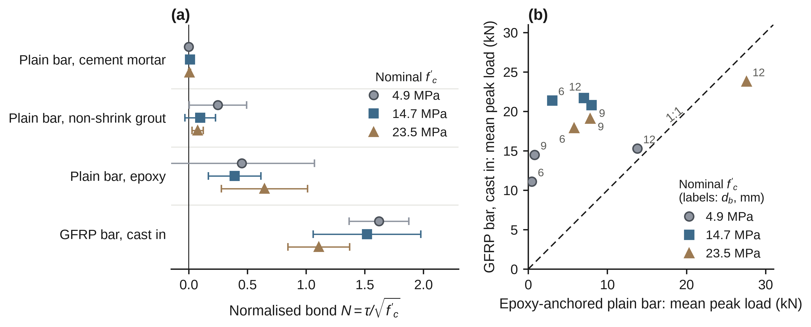
Fig. 9. Comparison of the plain-bar and GFRP series. (a) Normalised bond N = τ/√f′_{c} for each system (mean ± 1 SD, n = 15 per point). (b) Mean peak load of the GFRP bars against that of epoxy-anchored plain bars at the same diameter (point labels, mm) and nominal strength; the dashed line is 1:1. GFRP bars were cast in and plain bars post-installed, so the comparison is descriptive.

3.9 Supplementary series with a bonded length of five bar diameters
Table 13 lists a supplementary set of pull-out tests with a bonded length l_{e} = 5d_{b} (30, 45, and 60 mm for the 6, 9, and 12 mm bars; n = 3 per group): GFRP bars at 14.7 and 23.5 MPa and epoxy-anchored plain bars at 23.5 MPa. The apparent bond stress τ was 9.1–12.6 MPa for the GFRP bars and 5.9–6.8 MPa for the epoxy-anchored plain bars, and in each of the nine groups it was higher than the corresponding group mean at l_{e} = 140 mm (Table 10 for GFRP and Table A1 for the plain bars). For the GFRP bars τ decreased with diameter at both strengths (10.9, 9.8, and 9.1 MPa at 14.7 MPa; 12.6, 11.4, and 10.6 MPa at 23.5 MPa). All groups failed by pull-out except the 12 mm GFRP groups, in which 1 of 3 specimens at 14.7 MPa and 2 of 3 at 23.5 MPa split.
Table 13. Supplementary pull-out series with bonded length l_{e} = 5d_{b}.
Specimen | d_{b} (mm) | l_{e} (mm) | Nominal  f′_{c} (MPa) | n | Peak load P (kN) | τ = P/(π d_{b} l_{e}) (MPa) | Slip at peak (mm) | Failure mode
GF6 | 6 | 30 | 14.7 | 3 | 6.2 | 10.9 | 0.85 | Pull-out
GF9 | 9 | 45 | 14.7 | 3 | 12.5 | 9.8 | 1.10 | Pull-out
GF12 | 12 | 60 | 14.7 | 3 | 20.6 | 9.1 | 1.32 | Pull-out (2), splitting (1)
GF6 | 6 | 30 | 23.5 | 3 | 7.1 | 12.6 | 0.92 | Pull-out
GF9 | 9 | 45 | 23.5 | 3 | 14.5 | 11.4 | 1.21 | Pull-out
GF12 | 12 | 60 | 23.5 | 3 | 24.0 | 10.6 | 1.48 | Splitting (2), pull-out (1)
RB6 epoxy | 6 | 30 | 23.5 | 3 | 3.3 | 5.9 | 0.64 | Pull-out
RB9 epoxy | 9 | 45 | 23.5 | 3 | 8.1 | 6.4 | 0.77 | Pull-out
RB12 epoxy | 12 | 60 | 23.5 | 3 | 15.4 | 6.8 | 0.86 | Pull-out

[ตรวจสอบ 13: Table 13 ประกอบด้วย 9 กลุ่ม × 3 ตัวอย่าง = 27 ตัวอย่าง ซึ่งไม่รวมอยู่ใน 180 ตัวอย่างของ Abstract, Table 1, หัวข้อ 2.1 และ Data availability. หัวข้อ 2 ไม่มีคำอธิบายการทดสอบชุดนี้ (ขนาดลูกบาศก์ — manuscript ระบุว่า ACI 440.3R-04 ใช้ 200 mm, วิธีเตรียมตัวอย่าง, ความยาวฝัง 30/45/60 mm, อายุทดสอบ) และตารางใช้ f′c แบบ nominal (ไม่มีผลลูกบาศก์ของชุดนี้ใน Table 5). ชื่อหัวข้อ 3.9 และย่อหน้านำเป็นข้อความที่ AI เรียบเรียงขึ้นโดยสรุปเฉพาะตัวเลขในตาราง. คำถาม: ต้องการให้ตารางนี้อยู่ใน Results (หัวข้อ 3.9) โดยเพิ่มวิธีการและ 27 ตัวอย่างใน Abstract/หัวข้อ 2 หรือย้ายไปเป็นภาคผนวก]
[ตรวจสอบ 14: ข้อสังเกตของ AI (ต้องให้ผู้เขียนยืนยัน) — เมื่อเทียบกับกลุ่มที่ le = 140 mm (Table 10) ที่ 14.7 MPa: GF6 ได้ P = 6.2 เทียบกับ 21.4 kN, GF9 ได้ 12.5 เทียบกับ 20.8 kN แต่ GF12 ได้ 20.6 เทียบกับ 21.7 kN (ต่างกันประมาณ 5% ทั้งที่ความยาวฝังต่างกัน 2.3 เท่า); ที่ 23.5 MPa GF12 ได้ 24.0 เทียบกับ 23.8 kN. หาก GFRP 12 mm ไม่ไวต่อความยาวฝัง ผลนี้อาจสอดคล้องกับสมมติฐานว่าความจุถูกจำกัดโดยปัจจัยอื่นที่ไม่ใช่แรงยึดเหนี่ยวที่ผิวสัมผัส (Table 14 แถว 2 และ 5) แต่ต้องยืนยันก่อนว่าตัวอย่างชุดนี้ใช้ลูกบาศก์และการจับยึดเดียวกัน (มี n = 3 เท่านั้น). คำถาม: ต้องการนำข้อสังเกตนี้ไปพัฒนาในหัวข้อ 4.4 หรือไม่]

4. Discussion

4.1 The bonding agent governs plain-bar capacity
The central result is that, for plain bars in weak concrete, the choice of agent outweighs the choice of diameter or strength. The agent effect (η_{p}² = 0.73) was far larger than the diameter and strength effects (0.27 and 0.26), and epoxy averaged 4.4 times the grout mean and 91 times the mortar mean (Table 6). A plain bar has no ribs, so load must pass by adhesion and friction at the interface [3]. An epoxy resin can be expected to adhere chemically to both steel and concrete, whereas a cementitious agent relies more on friction and on a physical adhesion that bleeding or shrinkage at the steel surface may weaken. This reading agrees with reports that chemical adhesives bond better than cement-based binders [12], and the failure modes point the same way: epoxy groups failed by pull-out, grout groups mostly by interface slip (6 of 9), and mortar groups by zero-bond slip-out or slip inside the mortar layer (Fig. 6a). It remains an interpretation, because no fracture surface was examined and the design does not isolate the mechanism.
The advantage of epoxy also depended on the host concrete. At 4.9 MPa epoxy and grout could not be separated, and 5 of 15 epoxy specimens recorded zero load. One possible reason is that the sand-diluted, weakest mixture gave the epoxy too friable a hole wall to bond to, but this is a hypothesis: hole condition and dust removal were not recorded. The installation method may also have influenced the ranking. Bars were dipped in the agent and pushed into the hole, which suits a fluid resin better than a stiff paste. A mortar that does not flow around the bar can leave voids at the interface, and the cement mortar, unlike the grout, was not designed to flow. Void formation was not examined, so this too is a hypothesis; it would be consistent with the poor showing of mortar (mean 0.021 MPa). Studies of grouted bars have concentrated on confinement by ducts and sleeves [19, 20], whereas the present cubes offered a cover of only about 69–72 mm, and the grout results should not be carried over to confined connections.

4.2 Nominal strengths, curing, and the strength trend
Epoxy bond stress increased with nominal strength, in line with the square-root dependence of bond on concrete strength that Ahmed et al. reported for post-installed ribbed bars in epoxy [13]. Their bars were ribbed and their concretes considerably stronger than ours, so we do not compare absolute values. Grout showed no strength trend, which would fit a capacity set at the steel–grout interface (the same grout was used in every mixture) and not at the grout–concrete interface; we did not test this. Bond–slip models for concretes of different strengths exist [39], but applying them would need measured strengths and complete load–slip curves, neither of which we have.
The weak point is what “strength” means here. All three concretes came from one dry-mix product; the 14.7 and 23.5 MPa mixtures differ in curing period only (Table 4), and the 4.9 MPa mixture is a sand-diluted version of the same product. Their true strengths may be closer than the labels suggest, in which case the step from 14.7 to 23.5 MPa is a curing effect and not a strength effect. Longer curing does not necessarily raise bond either: Fu and Chung reported that the bond of steel rebar decreased with increasing curing age [40]. The strength trends above are therefore trends across three batches and curing regimes, ordered as they are labelled.
[ตรวจสอบ 15: ย่อหน้านี้ระบุว่าไม่มีผลกำลังอัดจริงและ “true strengths may be closer than the labels suggest” แต่ Table 5 มีข้อมูลแล้ว — ลำดับสอดคล้องกับ label (5.8 < 13.4 < 17.9 MPa) แต่อัตราส่วนกำลังอัดจริงของเกรด 23.5 ต่อ 14.7 MPa คือ 1.34 (nominal = 1.60) (ดูตรวจสอบ 6). คำถาม: ต้องการเขียนย่อหน้านี้ใหม่โดยใช้ Table 5 เป็นหลักหรือไม่]

4.3 Diameter, hole clearance, and the limit set by the bar
Epoxy bond stress rose with diameter (Section 3.3), and peak load scaled with an exponent of 2.1 ± 0.9, well above the value of 1 that a uniform interface stress implies. Three explanations are possible and the data cannot separate them. First, the clearance between the bar and the hole wall was not recorded, and if it changed with bar size the epoxy layer would have differed in thickness from one diameter to the next. Second, the ratio l_{e}/d_{b} falls from 23.3 to 11.7 between RB6 and RB12, and average bond stress over a long embedment is expected to be lower than over a short one if bond stress is not uniform along the bar. Third, bar capacity may have set the limit for part of the series: several RB6 specimens and the RB12 bars at 23.5 MPa reached bar stresses above the catalogue yield level (Section 3.4), which would flatten the gain with strength and distort the diameter trend.
Two points follow for the interpretation of τ. The RB12 epoxy result at 23.5 MPa (mean bar stress 244 MPa) sits at the catalogue yield level, so the bar and not the interface may have limited the load, and the reported 5.23 MPa is a lower bound on interface strength. One recorded failure also needs checking: the RB12 epoxy group at 4.9 MPa was logged as pull-out with bar yielding at a bar stress of 146 MPa (specimen RB12-5; group mean 122 MPa), which is well below the catalogue yield of 235 Mpa.
[ตรวจสอบ 16: ข้อความ “Third, bar capacity may have set the limit...”, “sits at the catalogue yield level”, “the bar and not the interface may have limited the load” และ “5.23 MPa is a lower bound” อิง yield แบบ catalogue (235 MPa). ด้วย fy ที่วัดได้ 305 MPa (Table 2) σb เฉลี่ยของ RB12 ที่ 23.5 MPa (244 MPa) ต่ำกว่า fy ประมาณ 20% จึงอาจสรุปว่าเหล็กเป็นตัวจำกัดไม่ได้ (ดูตรวจสอบ 4, 11, 12). นอกจากนี้ประโยคสุดท้ายสะกดหน่วย “235 Mpa” ผิด (ควรเป็น MPa). คำถาม: ข้อสรุปเรื่อง lower bound ยังคงไว้หรือไม่]

4.4 What limits the capacity of GFRP bars in weak concrete
The GFRP results raise a more specific problem. Peak load did not grow from 14.7 to 23.5 MPa and, at 14.7 MPa, did not depend on diameter (Section 3.6). If bond were a uniform interface stress, P would be proportional to d_{b} (b = 1) and would increase with concrete strength. Instead, the exponent was 0.47, 0.01, and 0.41 at the three strengths (pooled 0.30, 95% half-width 0.12). Table 14 sets out six explanations and what the data can say about each; the first three concern the concrete and cannot be told apart without measured strengths and batch records.
Table 14. Possible reasons for the load plateau of GFRP bars at 14.7 and 23.5 MPa.
Explanation | What the data show | Status
1. Nominal strengths differ from actual strengths | The 14.7 and 23.5 MPa mixtures differ in curing period only, and no cubes were crushed. | Plausible; cannot be tested without cube results
2. A cube or splitting ceiling | Splitting occurred in 9 of 15 specimens at both 14.7 and 23.5 MPa, but peak load did not depend on failure mode (p = 0.72). | Not excluded; a ceiling set by concrete tensile strength would fall under explanation 1
3. Batch, age, or curing effects | Cubes came from separate batches; dates, ages, and immersion periods are not documented. | Cannot be tested from the records
4. Random scatter alone | The change from 14.7 to 23.5 MPa was −1.05 kN (Welch p = 0.30, g = −0.38), so the plateau is an absence of a detectable rise. | Compatible with the data
5. A limit at the grip | Individual peaks reached 25.8 kN (12 mm, 23.5 MPa), so one fixed grip ceiling near 21 kN is unlikely; a diameter-specific limit cannot be excluded. | Unlikely as a single ceiling; grip details needed
6. Bar tensile capacity | Nominal stress at the maximum load was 786, 380, and 228 MPa for the 6, 9, and 12 mm bars; tensile properties are given in Table 3 (maximum load / tensile capacity = 0.76, 0.42, and 0.28). | Cannot be judged for the 6 mm bar; less likely for 9 and 12 mm

[ตรวจสอบ 17: (ก) แถว 1 ระบุ “no cubes were crushed” และย่อหน้าก่อนตารางระบุว่าแยกสาเหตุ 3 ข้อแรกไม่ได้หากไม่มี “measured strengths and batch records” แต่ Table 5 มีผลกำลังอัดและอายุทดสอบแล้ว (ยังไม่ทราบว่ารวมชุด GFRP หรือไม่ — ดูตรวจสอบ 6) จึงต้องแก้แถว 1 และ 3. (ข) แถว 6: ข้อความภาษาไทยของผู้เขียนถูกแปลเป็น “tensile properties are given in Table 3 (maximum load / tensile capacity = 0.76, 0.42, and 0.28)” — อัตราส่วนมาจากคอลัมน์ Max P / Ffu ของ Table 3; ตอนนี้มี ffu = 1040, 905 และ 812 MPa แล้ว คอลัมน์ Status “Cannot be judged for the 6 mm bar” จึงควรปรับ (แท่ง 6 mm รับ 76% ของกำลังดึง). (ค) ข้อสังเกตจาก Table 13 ดูตรวจสอบ 14. คำถาม: ต้องการปรับสถานะของแถว 1, 3 และ 6 อย่างไร]
What the data do establish is that the apparent stress τ = P/(πd_{b}l_{e}) is not a size-independent property in this test. At 14.7 MPa a 6 mm bar showed an apparent stress of 8.1 MPa and a 12 mm bar 4.1 MPa. A bond stress measured on one diameter should therefore not be applied to another, and a √f′_{c} scaling should not be assumed in concrete this weak.

4.5 GFRP bars against the design expression
The ACI 440.1R-06 expression predicts an N that is independent of strength and rises slightly with diameter (0.99 to 1.19), whereas measured N fell with both (Table 12). The measured-to-predicted ratio decreased with diameter at every strength, from 1.42–2.15 for the 6 mm bars to 0.79–1.10 for the 12 mm bars, so the expression does not capture the size dependence seen here. Agreement should not be expected in any case, because the specimens have a bonded length of 12 to 23 bar diameters and concrete weaker than any GFRP test we found (the lowest was 20.4 MPa [34]), and the comparison is descriptive.

4.6 Test method and bonded length
The specimen follows a withdrawn standard [37] and departs from the pull-out specimen of ACI 440.3R-04, Annex B.3, which specifies a 200 mm cube and a bonded length of five diameters [38]. With l_{e}/d_{b} between 11.7 and 23.3, bond stress along the bar is unlikely to be uniform, and the reported τ is a long-length average that will sit below local peak values. Pull-out and beam tests also differ: in a recent comparison on ribbed GFRP bars, beam tests gave bond strengths roughly a quarter higher than pull-out tests [41], and RILEM beam tests are now used for steel and FRP bars in the same programme [42]. The two nearest active standards do not match our geometry, since ASTM A944 covers beam-end specimens of deformed bars [43] and ACI 355.4-19 covers the qualification of adhesive anchors [44]. The values reported here are comparable across our own groups, but they are not transferable to code checks.
[ตรวจสอบ 18: หัวข้อนี้ระบุว่าตัวอย่างต่างจากข้อกำหนดของ ACI 440.3R-04 (ความยาวฝัง 5 เท่าของเส้นผ่านศูนย์กลาง) และไม่ได้กล่าวถึง Table 13 ซึ่งเป็นการทดสอบที่ le = 5db (n = 3) — τ ของ GFRP ที่ le = 5db (9.1–12.6 MPa) สูงกว่าที่ le = 140 mm (4.1–8.1 MPa; Table 10) ทุกกลุ่ม ซึ่งอาจใช้สนับสนุนข้อความ “long-length average” ได้. ประโยค “not transferable to code checks” และเรื่อง beam tests ต้องทบทวนด้วย เนื่องจาก Table 13 ยังไม่ระบุขนาดลูกบาศก์. คำถาม: ต้องการอ้าง Table 13 ในหัวข้อนี้หรือไม่]

4.7 Implications for practice
The following points are our recommendations, drawn from the data but not themselves tested. Cement mortar should not be used to anchor plain bars in weak concrete: no mortar specimen exceeded 0.27 MPa, and 36 of 45 recorded zero load. Non-shrink grout reached a mean of only 0.43 MPa, and the within-group coefficient of variation had a median of 85% across the 7 groups with a non-zero mean, so a design value would have to be a lower characteristic value and not the mean. Even epoxy is a poor anchor for plain bars in the weakest concrete: it gave a mean of 1.0 MPa at 4.9 MPa and left 5 of 15 specimens without measurable resistance, so mechanical anchorage would be needed there. Epoxy is the only agent that gave a sizeable and strength-dependent bond at 14.7 MPa and above, and at RB12 and 23.5 MPa it loaded the bar to about its catalogue yield. For GFRP bars cast into weak concrete, capacity in this set-up was about 21 kN whatever the diameter, so neither a bond stress from one diameter nor a strength-proportional scaling should be assumed without a test on the actual bar.
[ตรวจสอบ 19: ประโยค “at RB12 and 23.5 MPa it loaded the bar to about its catalogue yield” อิงค่า catalogue ต้องทบทวนตามตรวจสอบ 4 และ 16]

4.8 Limitations
Concrete strength. Strengths are nominal grades, and two of the three mixtures differ only in curing period (Section 4.2). Sample size and records. Groups contain five specimens; failure mode was recorded for one specimen per plain-bar group; and the origin of the fifth plain-bar specimen and of the repeated GFRP tests is to be confirmed (Section 2.1). The very small coefficients of variation of some GFRP groups at 4.9 and 14.7 MPa should be checked against the raw load records. Installation. Hole diameter and clearance, cleaning, filling, water–powder ratios, loading rate, and test age are not documented, and the clearance may covary with bar diameter (Section 4.3). Bar properties. The yield strength of the steel bars is given in Table 2, whereas the bar-stress screening in Section 3.4 rests on a catalogue value; the tensile properties of the GFRP bars are given in Table 3, and their surface type is undocumented. Series differences. The GFRP bars were cast in and the plain bars post-installed, so the two series are compared descriptively only. Test geometry. Section 4.6 describes the departure from current pull-out specimens. Analysis. The analysis plan was formed after the data were seen, and no multiplicity correction was applied. Literature. Our statements about the absence of comparable studies rest on a targeted, non-systematic search.
[ตรวจสอบ 20: (ก) “Concrete strength. Strengths are nominal grades” ขัดกับ Table 5 (ดูตรวจสอบ 1, 6). (ข) ประโยค “Bar properties” แปลจากข้อความไทยของผู้เขียน (“The yield strength of the steel bars ดังแสดงในตารางที่ ... , so the bar-stress screening in Section 3.4 rests on a catalogue value”) ซึ่งตรรกะขัดกันเอง — มีค่า fy ที่วัดแล้วแต่ยังระบุว่าใช้ค่า catalogue จึงใช้คำเชื่อม “whereas” แทน “so” และเพิ่มการอ้าง Table 3 เรื่องสมบัติแรงดึงของ GFRP; โปรดยืนยันเจตนา (ดูตรวจสอบ 4). (ค) “the origin of the fifth plain-bar specimen and of the repeated GFRP tests is to be confirmed (Section 2.1)” — หัวข้อ 2.1 ไม่มีเนื้อหาเรื่อง “fifth specimen” หรือ “repeated GFRP tests” และไม่ชัดว่า “repeated GFRP tests” หมายถึง Table 13 หรือไม่. (ง) “Test geometry. Section 4.6 describes the departure from current pull-out specimens” ต้องปรับตาม Table 13 (ดูตรวจสอบ 18). คำถาม: โปรดยืนยันประเด็น (ข) และ (ค)]

5. Conclusions
Pull-out tests on 180 specimens in concrete of nominal strength 4.9–23.5 MPa support the following conclusions, each subject to the limitations in Section 4.8.
(1) For post-installed plain steel bars, the bonding agent explained most of the variation in bond stress (η_{p}² = 0.73). Epoxy averaged 1.88 MPa, non-shrink grout 0.43 MPa, and cement mortar 0.021 MPa. The ranking depended on strength (agent × strength F(4, 108) = 23.2, p < 0.001, unchanged under permutation, HC3 inference, transformations, and data subsets): epoxy exceeded grout by 1.13 and 2.76 MPa at 14.7 and 23.5 MPa, but could not be separated from it at 4.9 MPa.
(2) Cement mortar was ineffective: no specimen exceeded 0.27 MPa, and 36 of 45 recorded zero load. Zero load was also recorded for 16 of 45 grout specimens and 6 of 45 epoxy specimens.
(3) Epoxy bond stress rose with nominal strength (1.00 to 3.13 MPa) and, less regularly, with diameter (1.17 to 3.06 MPa from RB6 to RB12), while grout showed neither trend. At RB12 and 23.5 MPa the mean bar stress (244 MPa) was at the catalogue yield level, so the bond stress there is a lower bound on the interface strength.
[ตรวจสอบ 21: “At RB12 and 23.5 MPa the mean bar stress (244 MPa) was at the catalogue yield level, so the bond stress there is a lower bound” — ดูตรวจสอบ 4 และ 16]
(4) Cast-in GFRP bars carried a mean peak load of about 21 kN at 14.7 MPa whatever the diameter (6–12 mm), and the load did not rise at 23.5 MPa (21.3 versus 20.3 kN, p = 0.30). Apparent bond stress and normalised bond therefore fell with diameter, and the measured-to-predicted ratio against ACI 440.1R-06 ranged from 0.79 to 2.15. The data cannot separate an interface limit from a limit in the concrete or the test arrangement.
(5) The values are indicative and not design-ready. The next tests should measure concrete strength on companion cubes, record load–slip curves, measure bar yield strength, record hole clearance and cross it with bar diameter, examine fracture surfaces, document the GFRP bar properties, and use the pull-out geometry of ACI 440.3R-04 alongside beam tests.
[ตรวจสอบ 22: ข้อ (5) เสนอให้ “measure concrete strength on companion cubes”, “measure bar yield strength”, “document the GFRP bar properties” และ “use the pull-out geometry of ACI 440.3R-04” แต่ Table 2, 3, 5 และ 13 แสดงว่ามีข้อมูลเหล่านี้อยู่แล้วอย่างน้อยบางส่วน (กำลังอัดลูกบาศก์, fy ของ SR24, สมบัติแรงดึง GFRP, การทดสอบ le = 5db). คำถาม: รายการใดยังไม่ได้ทำจริง ควรเหลือเฉพาะรายการนั้นในข้อเสนอแนะ]

Declarations
CRediT authorship contribution statement. Piyarat Paoleng: conceptualization, methodology, formal analysis, writing – original draft. Siriphat Maneekeaw: methodology, validation, writing – review and editing. Sirisak Kongsomsaksakul: investigation, data curation, writing – review and editing. Krairoj Mahannopkul: formal analysis, visualization, writing – review and editing. Ittipon Meepon: conceptualization, supervision, project administration, writing – review and editing.
Funding. The authors received no external funding for this work.
Declaration of competing interest. The authors declare no competing interests.
Data availability. Specimen-level peak loads for all 180 specimens (bar type, diameter, agent, nominal strength) can be provided as supplementary material or on request to the corresponding author.
Use of AI-assisted tools.
During the preparation of this manuscript the authors used a generative AI to check formatting consistency, to identify potential spelling, grammar and punctuation errors. Generative AI was not used in the design of the experiments, the collection or analysis of the data, or the interpretation of the results. After using the tool, the authors reviewed and edited the content as needed and take full responsibility for the content of the publication
Acknowledgements.
The authors thank the Department of Teacher Training in Civil Engineering, Faculty of Technical Education, King Mongkut's University of Technology North Bangkok, for research funding and laboratory testing equipment.

References
[1] Zheng, Y., Fan, C., Ma, J. et al. Review of research on bond–slip of reinforced concrete structures. Construction and Building Materials, 2023, 385, 131437. DOI: 10.1016/j.conbuildmat.2023.131437.
[2] Vembu, P.R.S. and Ammasi, A.K. A comprehensive review on the factors affecting bond strength in concrete. Buildings, 2023, 13 (3), 577. DOI: 10.3390/buildings13030577.
[3] Xing, G., Zhou, C., Wu, T. and Liu, B. Experimental study on bond behavior between plain reinforcing bars and concrete. Advances in Materials Science and Engineering, 2015, 2015, 604280. DOI: 10.1155/2015/604280.
[4] Darwin, D., Zuo, J., Tholen, M.L. and Idun, E.K. Development length criteria for conventional and high relative rib area reinforcing bars. ACI Structural Journal, 1996, 93 (3), pp. 347–359. DOI: 10.14359/9694.
[5] ACI Committee 318. ACI 318-08: Building code requirements for structural concrete and commentary. Farmington Hills, MI: American Concrete Institute, 2008.
[6] Opabola, E.A. Bond strength and development length models for straight plain longitudinal reinforcement in tension. ACI Structural Journal, 2022, 119 (6), pp. 165–175. DOI: 10.14359/51736111.
[7] Marshall, J.D., Lang, A.F., Baldridge, S.M. et al. Recipe for disaster: construction methods, materials, and building performance in the January 2010 Haiti earthquake. Earthquake Spectra, 2011, 27 (S1), pp. S323–S343. DOI: 10.1193/1.3637031.
[8] Yepez, F. and Yepez, O. Role of construction materials in the collapse of R/C buildings after Mw 7.8 Pedernales – Ecuador earthquake, April 2016. Case Studies in Structural Engineering, 2017, 7, pp. 24–31. DOI: 10.1016/j.csse.2016.12.001.
[9] Tutu, K.A., Odei, D.A., Baniba, P. et al. Concrete quality issues in multistory building construction in Ghana: cases from Kumasi metropolis. Case Studies in Construction Materials, 2022, 17, e01425. DOI: 10.1016/j.cscm.2022.e01425.
[10] Yuva, Y. Low-strength concrete properties in existing structures using NDT and core test results. Journal of Building Engineering, 2023, 76, 107281. DOI: 10.1016/j.jobe.2023.107281.
[11] Jafari, A., Shahmansouri, A.A., Abdulridha, H.A. et al. Effect of CFRP confinement on bond-slip behavior of steel rebar in low-strength concrete: experimentation, prediction and parametric study. Construction and Building Materials, 2025, 477, 141333. DOI: 10.1016/j.conbuildmat.2025.141333.
[12] Tayeh, B.A., EL dada, Z.M., Shihada, S. et al. Pull-out behavior of post installed rebar connections using chemical adhesives and cement based binders. Journal of King Saud University – Engineering Sciences, 2019, 31 (4), pp. 332–339. DOI: 10.1016/j.jksues.2017.11.005.
[13] Ahmed, K.S., Shahjalal, Md., Siddique, T.A. et al. Bond strength of post-installed high strength deformed rebar in concrete. Case Studies in Construction Materials, 2021, 15, e00581. DOI: 10.1016/j.cscm.2021.e00581.
[14] Fayed, S., Alkharisi, M.K., Bayoumi, E.A. et al. Bond of ribbed and threaded steel reinforcement bars post-installed in concrete considering bonded length and adhesive type. Scientific Reports, 2026, 16, 10762. DOI: 10.1038/s41598-026-42964-4.
[15] Multani, A.S. and Gupta, P.K. Bond strength analysis of post-installed rebar with chemical adhesive in concrete mixed with marble powder and glass fiber. Journal of Adhesion Science and Technology, 2024, 38 (7), pp. 1014–1042. DOI: 10.1080/01694243.2023.2245590.
[16] Hussein, D.A. and Sarkawt, S.A. Experimental investigation of post-installed anchors' behavior under axial tensile force. Polytechnic Journal, 2024, 13 (1), 22. DOI: 10.59341/2707-7799.1835.
[17] Rosca, B. and Corobceanu, V. Mix design approach of supplementary cementitious materials Portland cement-based mortars for anchoring post-installed reinforcement bars into hardened concrete. Procedia Manufacturing, 2020, 46, pp. 186–193. DOI: 10.1016/j.promfg.2020.03.028.
[18] Darwin, D. and Zavaregh, S.S. Bond strength of grouted reinforcing bars. ACI Structural Journal, 1996, 93 (4), pp. 486–495. DOI: 10.14359/9707.
[19] Raynor, D.J., Lehman, D.E. and Stanton, J.F. Bond-slip response of reinforcing bars grouted in ducts. ACI Structural Journal, 2002, 99 (5), pp. 568–576. DOI: 10.14359/12296.
[20] Ahn, B.-I., Kim, H.-K. and Park, B.-M. Confining effect of mortar grouted splice sleeve on reinforcing bar. Journal of the Korea Concrete Institute, 2003, 15 (1), pp. 102–109. DOI: 10.4334/jkci.2003.15.1.102.
[21] Jia, J., Zhao, N., Bai, Y. et al. Bond-slip model for rebar mounted to high-strength grouting material. Journal of Building Engineering, 2023, 74, 106794. DOI: 10.1016/j.jobe.2023.106794.
[22] Zhang, W., Jia, Y., Cen, Q. et al. Bond–slip constitutive relationship at the interface between reinforcing steel and grout in fully grouted sleeve couplers. Buildings, 2026, 16 (11), 2098. DOI: 10.3390/buildings16112098.
[23] Liu, D., Liu, C., Zhang, H. et al. Optimizing machine learning with SSA and PSO for anchor bolt–grout bond strength prediction. Materials, 2026, 19 (5), 906. DOI: 10.3390/ma19050906.
[24] Itoh, T., Ueda, R., Son, B. et al. Anchorage and bond strength of SBPDN bar embedded in high-strength grout mortar. Materials, 2026, 19 (1), 2. DOI: 10.3390/ma19010002.
[25] Jia, Q. and Zhang, T. Microbial cement grout anchoring steel reinforcement pull-out test. Scientific Reports, 2024, 14, 1559. DOI: 10.1038/s41598-024-52196-z.
[26] Achillides, Z. and Pilakoutas, K. Bond behavior of fiber reinforced polymer bars under direct pullout conditions. Journal of Composites for Construction, 2004, 8 (2), pp. 173–181. DOI: 10.1061/(ASCE)1090-0268(2004)8:2(173).
[27] Baena, M., Torres, L., Turon, A. and Barris, C. Experimental study of bond behaviour between concrete and FRP bars using a pull-out test. Composites Part B: Engineering, 2009, 40 (8), pp. 784–797. DOI: 10.1016/j.compositesb.2009.07.003.
[28] Wambeke, B.W. and Shield, C.K. Development length of glass fiber-reinforced polymer bars in concrete. ACI Structural Journal, 2006, 103 (1), pp. 11–17. DOI: 10.14359/15081.
[29] Sólyom, S. and Balázs, G.L. Bond of FRP bars with different surface characteristics. Construction and Building Materials, 2020, 264, 119839. DOI: 10.1016/j.conbuildmat.2020.119839.
[30] Yan, F., Lin, Z. and Yang, M. Bond mechanism and bond strength of GFRP bars to concrete: a review. Composites Part B: Engineering, 2016, 98, pp. 56–69. DOI: 10.1016/j.compositesb.2016.04.068.
[31] Ekrami Kakhki, S.A. and Kheyroddin, A. Bond behavior of fiber reinforced polymer bars in concrete: a review. International Journal of Concrete Structures and Materials, 2025, 19, 120. DOI: 10.1186/s40069-025-00859-0.
[32] Okelo, R. and Yuan, R.L. Bond strength of fiber reinforced polymer rebars in normal strength concrete. Journal of Composites for Construction, 2005, 9 (3), pp. 203–213. DOI: 10.1061/(ASCE)1090-0268(2005)9:3(203).
[33] Islam, S., Afefy, H.M., Sennah, K. et al. Bond characteristics of straight- and headed-end, ribbed-surface, GFRP bars embedded in high-strength concrete. Construction and Building Materials, 2015, 83, pp. 283–298. DOI: 10.1016/j.conbuildmat.2015.03.025.
[34] Shakiba, M., Hosseini, S.M., Bazli, M. et al. Enhancement of the bond behaviour between sand coated GFRP bar and normal concrete using innovative composite anchor heads. Materials and Structures, 2022, 55 (9), 236. DOI: 10.1617/s11527-022-02074-9.
[35] ACI Committee 440. ACI 440.1R-06: Guide for the design and construction of structural concrete reinforced with fiber-reinforced polymer (FRP) bars. Farmington Hills, MI: American Concrete Institute, 2006.
[36] Shbeeb, N.I., Katash, A.A., Oguzmert, M. et al. Estimation of the bond strength of fiber-reinforced polymer bars in concrete using artificial intelligence systems. Buildings, 2024, 14 (2), 369. DOI: 10.3390/buildings14020369.
[37] ASTM International. ASTM C234-91a: Standard test method for comparing concretes on the basis of the bond developed with reinforcing steel (withdrawn 2000). West Conshohocken, PA: ASTM International, 1991.
[38] ACI Committee 440. ACI 440.3R-04: Guide test methods for fiber-reinforced polymers (FRPs) for reinforcing or strengthening concrete structures. Farmington Hills, MI: American Concrete Institute, 2004.
[39] Tang, C.-W. Modeling uniaxial bond stress–slip behavior of reinforcing bars embedded in concrete with different strengths. Materials, 2021, 14 (4), 783. DOI: 10.3390/ma14040783.
[40] Fu, X. and Chung, D.D.L. Decrease of the bond strength between steel rebar and concrete with increasing curing age. Cement and Concrete Research, 1998, 28 (2), pp. 167–169. DOI: 10.1016/S0008-8846(97)00216-0.
[41] Rahimi, M., Davoodi, M.R., Nematzadeh, M. et al. A comparative study between beam and pull-out tests on bond behavior of ribbed GFRP bar in concrete conforming to RILEM standards. Archives of Civil and Mechanical Engineering, 2025, 25, 37. DOI: 10.1007/s43452-024-01095-1.
[42] Ekrami Kakhki, S.A. and Kheyroddin, A. Experimental investigation of bond behavior of steel, GFRP, and CFRP reinforcement in self-compacting and fiber-reinforced concrete using RILEM beam tests. Scientific Reports, 2026, 16, 19085. DOI: 10.1038/s41598-026-49366-6.
[43] ASTM International. ASTM A944-10 (Reapproved 2015): Standard test method for comparing bond strength of steel reinforcing bars to concrete using beam-end specimens. West Conshohocken, PA: ASTM International, 2015.
[44] ACI Committee 355. ACI CODE-355.4-19 (Reapproved 2021): Qualification of post-installed adhesive anchors in concrete and commentary. Farmington Hills, MI: American Concrete Institute, 2021.

Appendix A. Bond stress of the plain-bar series by group
Table A1. Mean bond stress τ (SD) in MPa for each plain-bar group (n = 5).
Bar | Agent | τ at 4.9 MPa | τ at 14.7 MPa | τ at 23.5 MPa
RB6 | Epoxy | 0.17 (0.24) [3] | 1.15 (0.99) | 2.19 (1.41) [1]
RB6 | Non-shrink grout | 0.00 (0.00) [5] | 0.61 (0.64) [2] | 0.32 (0.29) [1]
RB6 | Cement mortar | 0.00 (0.00) [5] | 0.00 (0.00) [5] | 0.00 (0.00) [5]
RB9 | Epoxy | 0.20 (0.21) [2] | 2.02 (0.69) | 1.98 (0.67)
RB9 | Non-shrink grout | 1.07 (0.36) | 0.00 (0.00) [5] | 0.50 (0.11)
RB9 | Cement mortar | 0.00 (0.00) [5] | 0.10 (0.13) [3] | 0.02 (0.03) [3]
RB12 | Epoxy | 2.61 (1.27) | 1.33 (0.77) | 5.23 (0.67)
RB12 | Non-shrink grout | 0.57 (0.41) [1] | 0.50 (0.45) [1] | 0.29 (0.24) [1]
RB12 | Cement mortar | 0.00 (0.00) [5] | 0.01 (0.02) [3] | 0.05 (0.05) [2]
The number in square brackets is the count of zero-load specimens in the group (of 5), shown only when greater than zero.

