Cost and Time Comparison of a BIM-to-FDM Printing Workflow and Manual Fabrication of a 1:60 Architectural Model of a Two-Storey House
Piyarat Paoleng¹, Siriphat Maneekeaw¹, Sirisak Kongsomsaksakul¹, Krairoj Mahannopkul¹, Ittipon Meepon^{1,*}
¹ Department of Teacher Training in Civil Engineering, Faculty of Technical Education, King Mongkut's University of Technology North Bangkok, Bangkok, Thailand
* Corresponding author: Ittipon Meepon, ittipon.m@fte.kmutnb.ac.th
ORCID: P. Paoleng 0009-0008-5332-1007; S. Maneekeaw 0009-0002-0435-2866; S. Kongsomsaksakul 0009-0001-2352-5550; K. Mahannopkul 0000-0002-6207-0958; I. Meepon 0000-0001-5353-3511
[Author list, order and corresponding author are taken from the authors' default list and must be confirmed before submission.]
Abstract
Physical architectural models remain a common medium for communicating building designs, yet few studies compare building information modelling (BIM) combined with desktop fused deposition modelling (FDM) against manual model-making using itemised cost and time records. This study documents a BIM-to-FDM workflow and compares it with manual fabrication of a 1:60 model of a two-storey reinforced-concrete house with approximately 315 m² of usable area. The BIM model was developed in Autodesk Revit, exported as a binary STL file, sliced in Ultimaker Cura, printed in separate parts on a desktop FDM printer and assembled with adhesive. The manual model was cut from Plaswood sheets and clear PVC using printed 1:60 plans. Costs were recorded as materials, labour (manual route) and printer service charge (printing route), together with fabrication duration. The manual route cost 7,220 THB and took 6 days, whereas the BIM-to-FDM route cost 10,000 THB and took 3 days. Printing therefore halved the fabrication time but increased the cost by 38.5%, largely because the printer service charge (8,800 THB) represented 88% of the printing-route cost. A sensitivity analysis based on the recorded values indicated that cost parity would occur at a service charge of 6,020 THB or at a daily wage of about 504 THB per person (at the 2026 Bangkok minimum wage of 400 THB per day the cost premium would be 23.2%), and that including the reported 1–2 days of Revit modelling would reduce the time saving to 17–33%. Door and window frames could not be printed with the printer used. Because the study covers one building, one printer and one team, the results are exploratory. They suggest that the economic case for BIM-to-FDM models depends mainly on how printer use is charged and on whether the BIM model is reused for other purposes.
Keywords: building information modelling; fused deposition modelling; architectural scale model; cost–time comparison; Autodesk Revit
1. Introduction
Building information modelling (BIM) represents a facility as a data-rich three-dimensional model from which drawings, quantities and other outputs can be generated (Eastman et al., 2011). Because a BIM model is already digital and geometric, it is a natural source for fabricating physical models, and several studies have examined links between BIM and additive manufacturing (Teizer et al., 2018; Wang & Skibniewski, 2019). Most of this literature concerns full-scale construction printing, which has been reviewed repeatedly (Paolini et al., 2019; Tay et al., 2017; Ning et al., 2021; Schuldt et al., 2021; Tuvayanond & Prasittisopin, 2023) and for which BIM-based workflows have been proposed (García-Alvarado et al., 2024). Cost comparisons have also been made at that scale, for example for material cost in Jordan using a Revit model (Allouzi et al., 2020).
Desktop fused deposition modelling (FDM) printers serve a different and smaller-scale need, namely producing architectural scale models for design review and teaching. A systematic review separates this use from concrete printing (Žujović et al., 2022). Earlier comparative work on physical modelling in architecture evaluated laser cutting, CNC milling and 3D printing (Globa et al., 2012), and a recent survey examined architecture students' acceptance of traditional, laser-cutting and 3D-printing techniques against criteria that included completion speed and cost (Mourad et al., 2025). Educational studies have also reported the use of 3D printers in architectural design studios and for teaching structural concepts (Boumaraf & İnceoğlu, 2020; Özeren et al., 2023; Dart & Lim, 2023).
The cost of a printed part depends on how machine, material, energy and labour are allocated. Classification reviews and cost frameworks for additive manufacturing and FDM are available (Kadir et al., 2020; Griffin et al., 2022; Hernandez Korner et al., 2024; Seregi & Ficzere, 2025), the energy requirements of additive processes have been quantified (Liu et al., 2018), and sustainability trade-offs have been discussed (Ford & Despeisse, 2016). Studies of low-cost open-source printers report payback periods from a few months to about two years, which shows that printer economics depend strongly on how the machine is used (Wittbrodt et al., 2013; Petersen & Pearce, 2017). Dimensional accuracy and geometric deviation of FDM parts have likewise been reviewed and measured (Equbal et al., 2024; Li et al., 2025; Petruse et al., 2024), which is relevant to small details on a 1:60 model.
In Thailand, BIM adoption has been examined in terms of drivers and barriers (Ngowtanasawan, 2017; Sierra & Rodboonpha, 2023), and a national conference study considered the cost-effectiveness of combining BIM and 3D printing in design and construction (Tapan et al., 2020). Within the literature screened for this study, we did not find an itemised per-model comparison of cost and time between a BIM-to-FDM route and manual fabrication of an architectural scale model that also tests how the conclusion changes with the accounting assumptions. The screening was not a systematic review, so this statement is limited to the sources consulted.
This study therefore (1) documents a BIM-to-FDM workflow for a two-storey house, (2) compares its cost and duration with manual fabrication of a model at the same scale, (3) tests how sensitive the comparison is to wage, printer service charge and BIM modelling time, and (4) records the practical limitations of the printed model. It is a single-case exploratory evaluation based on records from an undergraduate special project, and it is presented as such.
2. Methodology
2.1 Case and scope
The case was a two-storey reinforced-concrete house with three bedrooms, three bathrooms and approximately 315 m² of usable area, taken from an existing design of a Thai public-housing programme for which complete design information was available. Both routes produced a physical model at a scale of 1:60. The overall procedure is shown in Fig. 1.
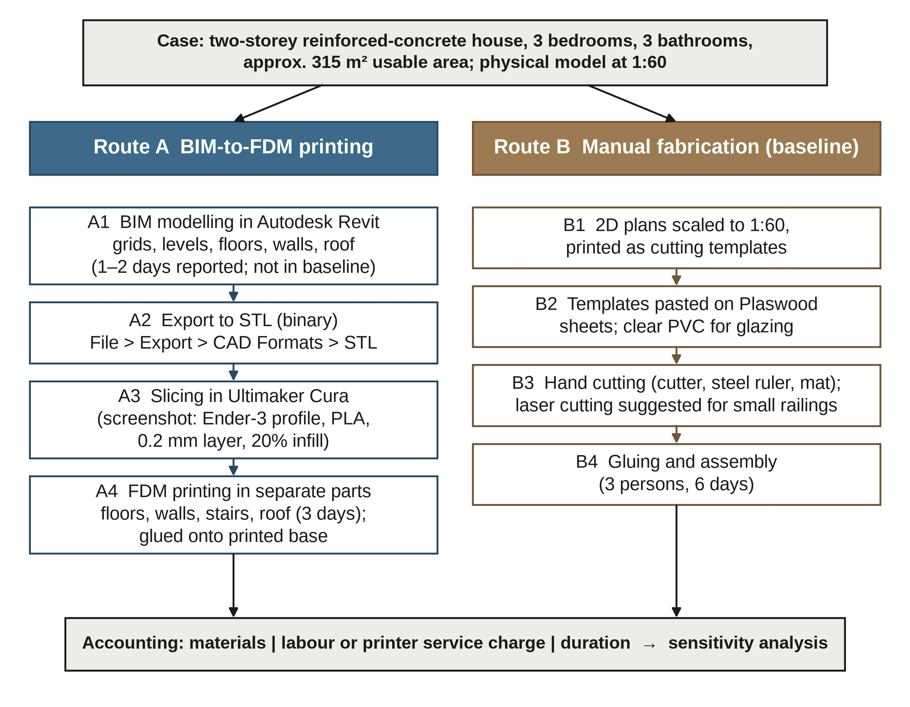
Fig. 1. Research procedure comparing the BIM-to-FDM route (A) with manual fabrication (B) for the same house at 1:60. The slicer settings in step A3 were read from the archived slicer screenshot (Fig. 3b).
2.2 BIM-to-FDM route
The building was modelled in Autodesk Revit starting from grids and levels, followed by columns, floors, walls, doors, windows and the roof, using the existing plans of the project. The team reported that modelling took one to two days, depending on the operator's proficiency; this time is shown in Fig. 1 but is not included in the baseline cost and duration, and its effect is examined in Section 3.3. Representative modelling steps are shown in Fig. 2. After checking the model, it was exported through File > Export > CAD Formats > STL using the binary option and a resolution chosen by the operator (Fig. 3a).
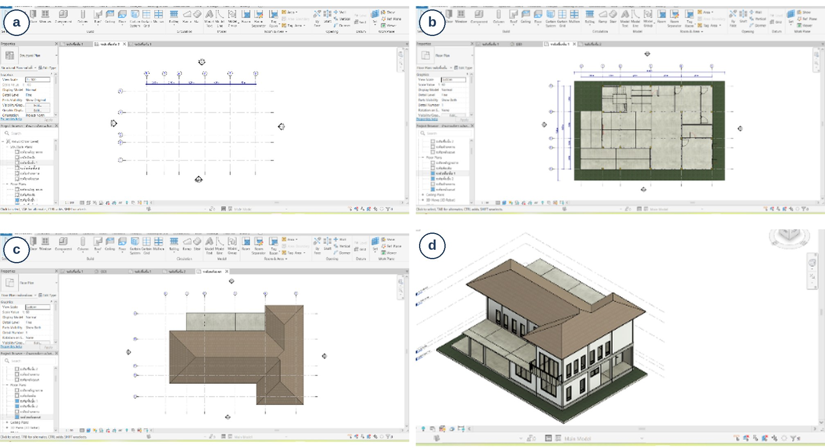
Fig. 2. BIM modelling in Autodesk Revit: (a) grids and levels; (b) floor and wall modelling over the imported plan; (c) roof; (d) completed three-dimensional model.
The STL file was opened in Ultimaker Cura (version 4.0.0 according to the project report), which slices the model into layers and generates printer instructions (Fig. 3b). Because the printer could not produce the whole building in one job, the model was divided into the first-floor slab, the second-floor slab, walls, doors and windows, stairs and roof. The slabs were printed first to serve as the base, followed by the walls, stairs and roof (Fig. 4). Printing used the FDM principle with a 0.4 mm nozzle. The archived slicer screenshot (Fig. 3b) displays a Creality Ender-3 machine profile, generic PLA, the “Draft 0.2 mm” quality profile and 20% infill, and the printer visible in Fig. 4a carries Ender branding. These parameters were read from a low-resolution screenshot and photograph. No other print parameters, such as print speed, part orientation, individual print times or filament mass, were recorded. The printed parts were joined with plastic adhesive onto the base.
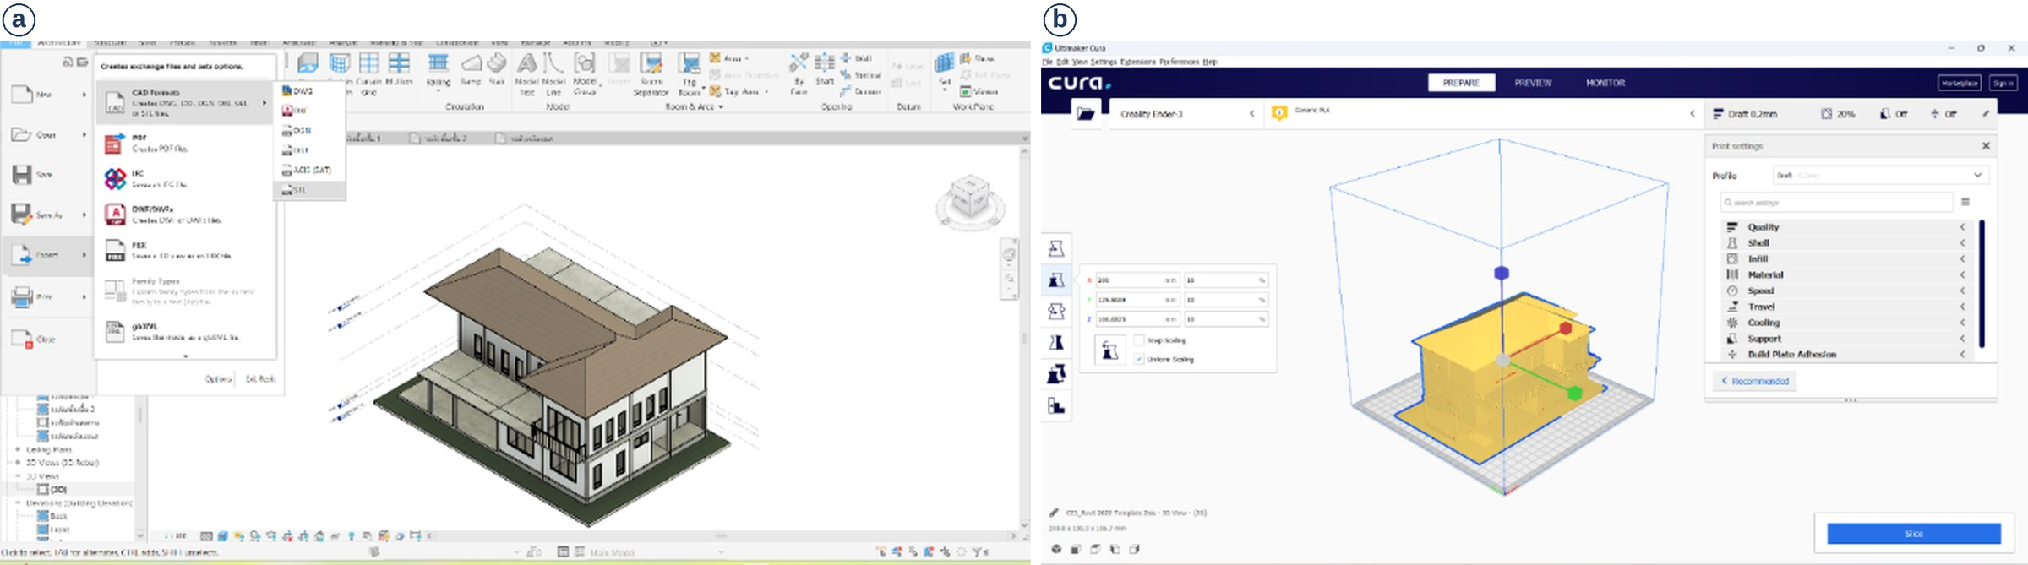
Fig. 3. From BIM model to printer instructions: (a) STL export from Revit; (b) slicing in Ultimaker Cura (parts highlighted in yellow lie within the build plate).
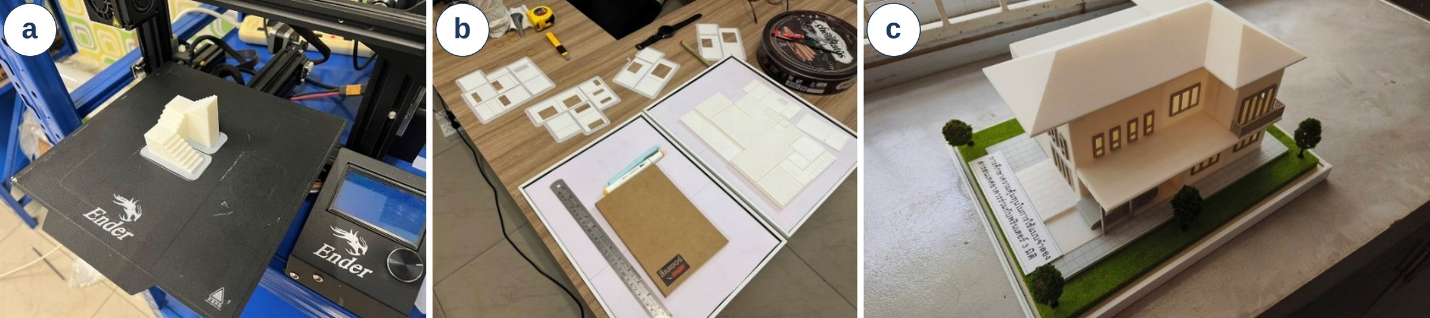
Fig. 4. FDM printing and assembly: (a) a printed part on the machine; (b) printed parts laid out before assembly; (c) the assembled 1:60 printed model.
2.3 Manual route
The baseline model was made from the two-dimensional plans scaled to 1:60 and printed on paper as cutting templates. The templates were pasted onto Plaswood sheets (PVC foam board), with clear PVC sheet used for glazed openings, and the parts were cut with a cutter, steel ruler and cutting mat. The team noted that small railings and fences are difficult to cut by hand and might require laser cutting. The first-floor and second-floor plans and the roof were assembled with general-purpose adhesive (Fig. 5). Three persons worked on the manual model.
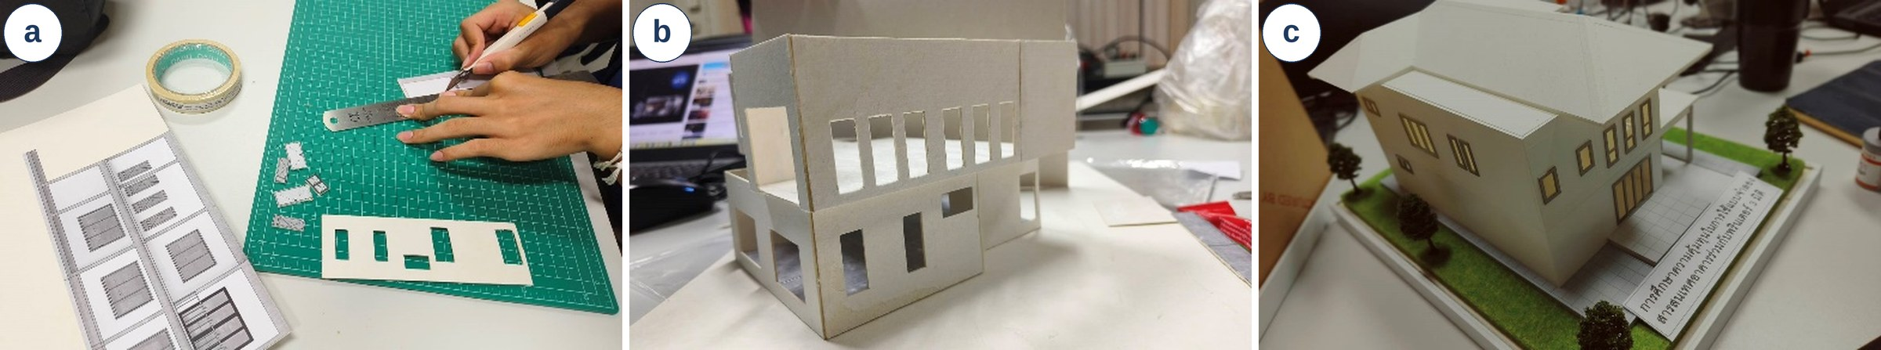
Fig. 5. Manual fabrication: (a) cutting Plaswood parts from printed templates; (b) partially assembled model; (c) the finished 1:60 manual model.
2.4 Cost and time accounting
Costs were recorded in Thai baht (THB) under three headings (Table 1). For the manual route, materials comprised Plaswood sheets, adhesive, cutter, cutting mat and ruler, and labour was calculated as the number of persons × number of days × daily wage. For the printing route, materials comprised filament and electricity, and a printer service charge was recorded for three days of printer use (the project report states 8,800 THB for the use of the 3D printer for three days). No labour cost was recorded for the printing route, so slicing, supervision, gluing and assembly effort is not represented. Duration was the elapsed number of days to complete each model. The project report states the daily wage as 350 THB in the calculation and 300 THB in the accompanying table text; 350 THB was used for the baseline and 300 THB is tested in Section 3.3. For context, Thai wage regulation distinguishes a statutory daily minimum wage, which in 2026 ranges from 337 to 400 THB depending on the province and is 400 THB in Bangkok (Wages Committee, 2026), from higher wage rates for trades that hold a national skill standard, for example 445, 595 and 685 THB per day for skill levels 1–3 of construction carpentry (Wages Committee, 2023). The recorded wages of 300 and 350 THB are retained for the baseline because they are the project's records; 350 THB lies within the 2026 provincial minimum-wage range but below the Bangkok rate, and 300 THB lies below it. The 2026 values are therefore used as an updated benchmark in Section 3.3 (scenarios S6 and S7). [Authors to confirm: these figures were taken from secondary summaries and must be verified against the primary notifications before submission.]
Table 1. Cost-accounting scheme used in this study.
Item | Manual route | BIM-to-FDM route
Materials | Plaswood, adhesive, cutter, mat, ruler | Filament and electricity
Labour / service | Labour: 3 persons × 6 days × 350 THB/day | Printer service charge for 3 days
Duration | Elapsed days to finish the model | Elapsed days to finish the model
Not included | Preparation of 2D plans | Revit modelling (reported 1–2 days); preparation of 2D plans
Note. Finishing items visible in Figs. 4c and 5c (base, lawn, trees, placard) are not itemised in the project records, and it is not stated whether they were included in the materials cost.
2.5 Sensitivity analysis
To test how the comparison depends on the recorded inputs, the baseline values were recombined arithmetically. No new measurements were made, and the results in Section 3.3 are therefore derived quantities rather than observations. Let m be the manual materials cost, n the number of persons, d the number of days, w the daily wage, f the filament and electricity cost, and s the printer service charge. The total costs are
C_{M} = m + n·d·w (1)
C_{P} = f + s (2)
The service charge and the daily wage at which the two routes cost the same are
s∗ = C_{M} − f, w∗ = (C_{P} − m) / (n·d) (3)
If t_{b} days of BIM modelling are added to the printing route, the relative reduction in total duration becomes
R = (T_{M} − T_{P} − t_{b}) / T_{M} (4)
where T_{M} and T_{P} are the recorded durations. The additional cost of printing per day saved is (C_{P} − C_{M}) / (T_{M} − T_{P}). For scenarios that include BIM modelling labour, one operator at the baseline wage was assumed; this is an illustrative assumption, not a recorded value.
3. Results and Discussion
3.1 Workflow outcomes
Both routes produced a complete model at 1:60 (Figs. 4c and 5c). The project team judged by visual inspection that the two models had a similar overall form and no apparent distortion; no dimensional measurement was taken, so this observation is qualitative. The main differences reported are summarised in Table 2. The printer could not print small details such as door and window frames, which were therefore not reproduced in the printed model, whereas the manual route allowed finer control of detail but required considerable care. The team also reported that some printed areas were less strong than desired, although the printed material was described as generally sturdy; strength was not tested.
Table 2. Qualitative observations reported by the project team.
Aspect | Manual route | BIM-to-FDM route
Overall form | Complete 1:60 model; no apparent distortion on visual inspection | Complete 1:60 model; no apparent distortion on visual inspection
Small details | Finer control of detail; requires care | Door and window frames not printed with the printer used
Structural robustness | Not reported | Generally sturdy; some printed areas weaker than desired (not tested)
Build constraints | None reported | Whole building not printable in one job; printed in parts and glued
Team aspects | Modification during assembly is easier; supports teamwork and learning | Shorter fabrication time (3 days versus 6 days)
Note. All entries are the project team's observations; none was quantified.
3.2 Cost and duration
Table 3 and Fig. 6 give the recorded costs and durations. The manual model cost 7,220 THB (920 THB materials and 6,300 THB labour) and took 6 days. The printed model cost 10,000 THB (1,200 THB filament and electricity, and 8,800 THB printer service charge) and took 3 days. Printing therefore reduced the duration by 3 days (50%) and increased the total cost by 2,780 THB (38.5%). Labour represented 87% of the manual cost, and the printer service charge represented 88% of the printing cost, so in both routes the result is governed by a single non-material item rather than by material cost. The additional cost of printing amounts to about 927 THB per day saved.
Table 3. Recorded cost and duration for the two routes (baseline).
Item | Manual route | BIM-to-FDM route | Difference
Materials (THB) | 920 | 1,200 | +280
Labour or printer service charge (THB) | 6,300 | 8,800 | +2,500
Total cost (THB) | 7,220 | 10,000 | +2,780 (+38.5%)
Duration (days) | 6 | 3 | −3 (−50%)
Additional cost per day saved (THB/day) | – | – | 926.7
Note. Baseline values as recorded by the project team; the difference column and the cost per day saved were calculated by the authors. Revit modelling time (reported as 1–2 days) is excluded.
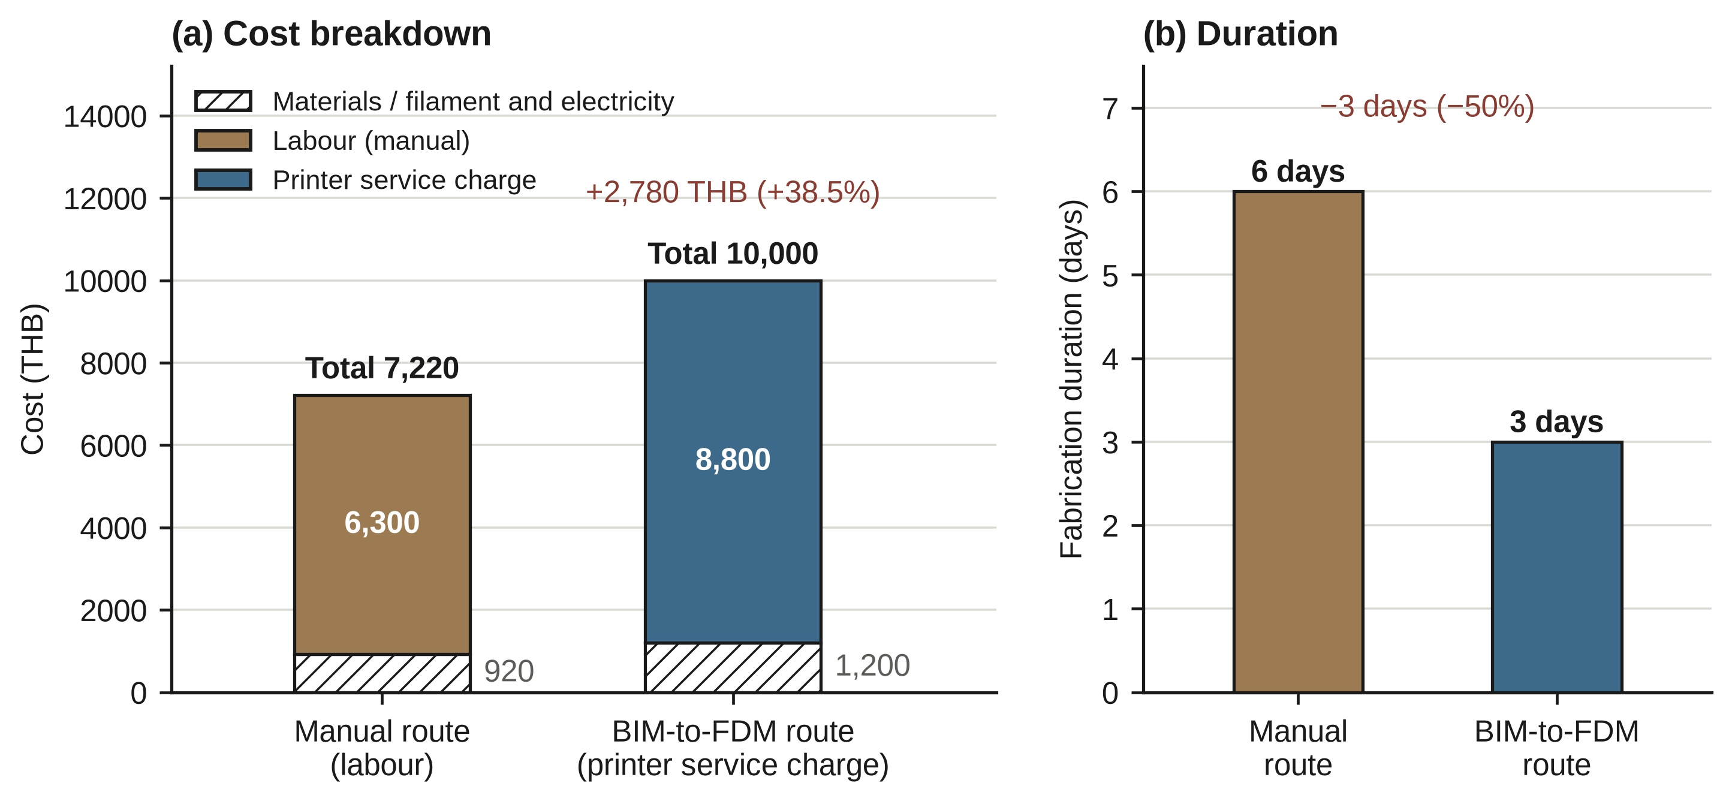
Fig. 6. Baseline comparison of (a) cost breakdown and (b) fabrication duration for the manual and BIM-to-FDM routes.
3.3 Sensitivity of the comparison
Table 4 and Fig. 7 show how the conclusion changes with the accounting assumptions. Cost parity would be reached if the printer service charge fell from 8,800 THB to 6,020 THB (a reduction of 31.6%), or if the daily wage were about 504 THB per person instead of 350 THB. Conversely, using the lower wage of 300 THB increases the premium of printing to 58.2%. The time saving is also sensitive to the treatment of BIM modelling: adding one or two days of Revit modelling to the printing route reduces the duration advantage from 50% to 33.3% or 16.7%, and adds 350–700 THB if one operator is assumed, raising the cost premium to 43.4–48.2%. Using the 2026 wage benchmarks, the premium of printing falls to 1,880 THB (23.2%) at the Bangkok minimum wage of 400 THB per day (S6) and to 1,070 THB (12.0%) at 445 THB per day, the skill level 1 carpentry rate (S7, illustrative because undergraduate model-making is not a certified trade); both remain below the break-even wage of about 504 THB, so printing is still more expensive at these wages. [Authors to verify the 2026 wage figures against the primary notifications (Wages Committee, 2023, 2026).]
Table 4. Sensitivity of the cost and duration comparison (derived from the recorded values).
Scenario | Manual cost (THB) | Printing cost (THB) | Cost difference | Duration of printing route (days) | Duration reduction
S0 Baseline | 7,220 | 10,000 | +2,780 (+38.5%) | 3 | 50.0%
S1 Daily wage 300 THB | 6,320 | 10,000 | +3,680 (+58.2%) | 3 | 50.0%
S2 Service charge 6,020 THB | 7,220 | 7,220 | 0 (0.0%) | 3 | 50.0%
S3 Daily wage 504.4 THB | 10,000 | 10,000 | 0 (0.0%) | 3 | 50.0%
S4 + 1 day Revit modelling | 7,220 | 10,350 | +3,130 (+43.4%) | 4 | 33.3%
S5 + 2 days Revit modelling | 7,220 | 10,700 | +3,480 (+48.2%) | 5 | 16.7%
S6 Daily wage 400 THB (2026 Bangkok minimum) | 8,120 | 10,000 | +1,880 (+23.2%) | 3 | 50.0%
S7 Daily wage 445 THB (2026 skill level 1, carpentry) | 8,930 | 10,000 | +1,070 (+12.0%) | 3 | 50.0%
Note. S2 and S3 are break-even points calculated with Eq. (3). S4 and S5 assume one operator at 350 THB/day for the added modelling days (illustrative assumption). Percentages are relative to the manual cost or duration. S6 and S7 use 2026 wage benchmarks (Wages Committee, 2023, 2026) with 3 persons × 6 days; the figures are to be verified against the primary notifications.
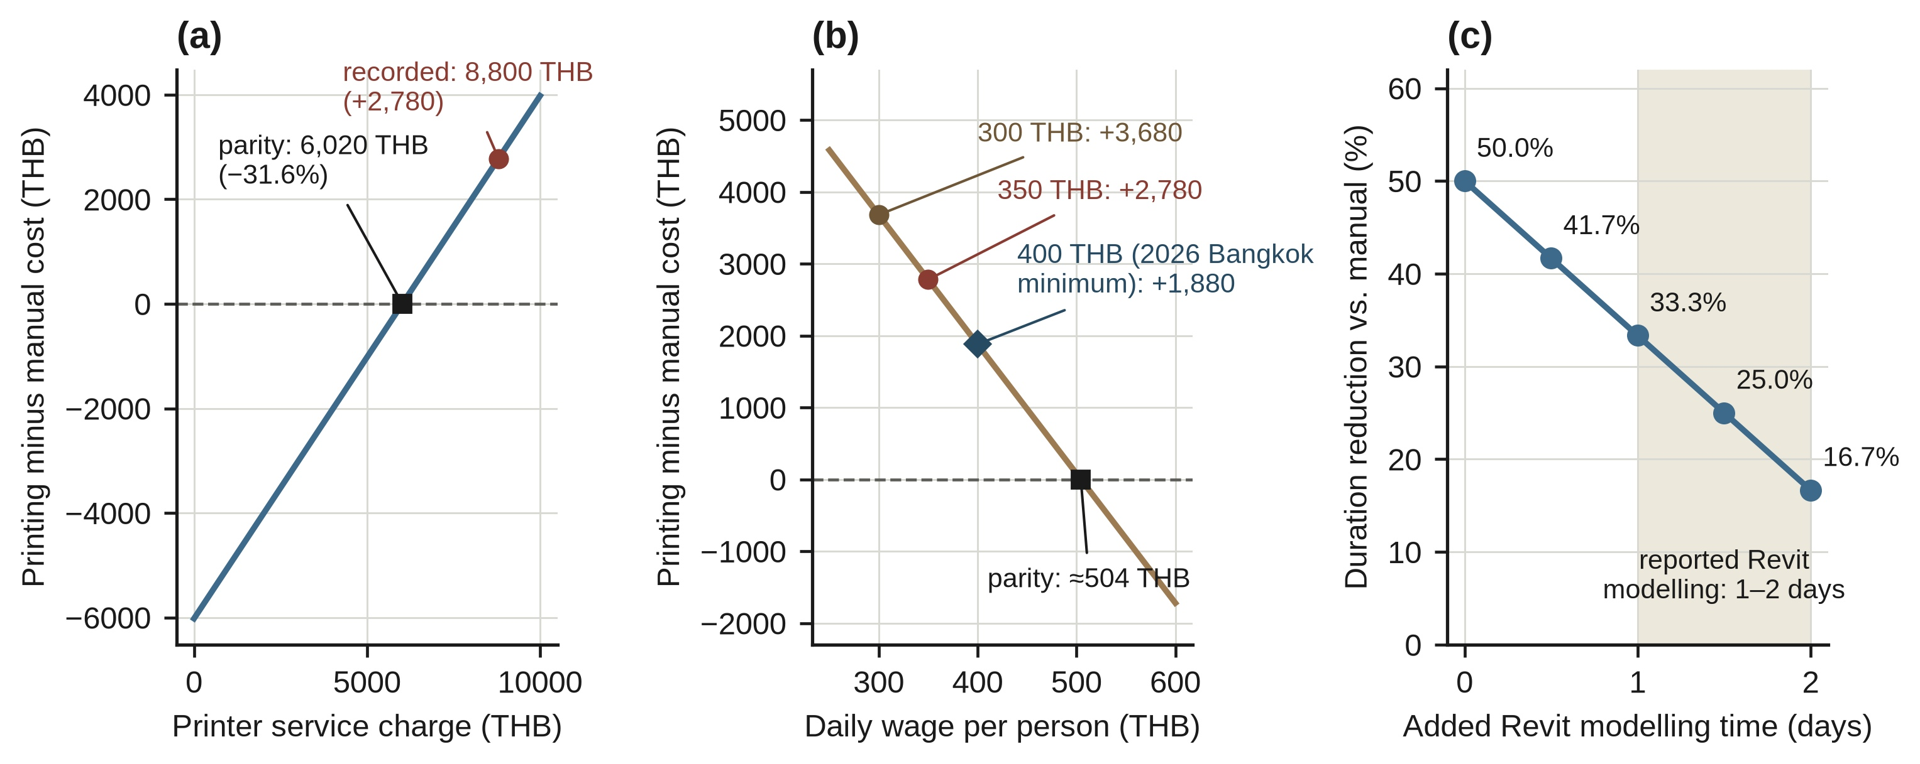
Fig. 7. Sensitivity of the comparison to (a) printer service charge, (b) daily wage and (c) Revit modelling time added to the printing route. Break-even points are 6,020 THB and about 504 THB per person per day. The 2026 Bangkok minimum wage (400 THB) is marked in (b).
Two interpretations follow, both of which are the authors' reading of the derived results rather than tested findings. First, the cost penalty of printing depends mainly on what the 8,800 THB service charge represents. If it recovers machine and operating costs, a department that already owns the printer and prints many models would face a lower marginal cost, which would be consistent with the payback analyses reported for low-cost printers (Wittbrodt et al., 2013; Petersen & Pearce, 2017). The present records cannot test this because the charge was not itemised. Second, the time saving is smaller when the full workflow is counted, but the BIM model is not consumed by printing. The team noted that the same model can support permit drawings and animations, so the modelling effort may be shared with other uses, in which case the baseline view in Fig. 6 is the more relevant one.
3.4 Positioning against related work
The cost–time trade-off found here follows the logic of earlier comparisons of fabrication technologies for physical models, in which laser cutting, CNC milling and 3D printing were compared on time, cost and labour (Globa et al., 2012). The present study differs in recording the actual costs and durations of one BIM-driven FDM model and one manual model, whereas the survey by Mourad et al. (2025) captured student perceptions of several techniques. A Thai conference study has addressed the cost-effectiveness of BIM with 3D printing in design and construction (Tapan et al., 2020). Because its cost accounting was not independently verified in the present work and may differ from that used here, no quantitative comparison with it is made. Educational studies suggest that printing offers benefits that this study does not measure, such as design iteration and learning outcomes (Boumaraf & İnceoğlu, 2020; Özeren et al., 2023; Dart & Lim, 2023). Table 5 summarises how the present study differs in scope and type of evidence from the studies discussed above. The comparison is qualitative, because the studies report different cost bases, units and settings and no common numerical basis exists.
Table 5. Qualitative comparison of the present study with related work cited in this paper.
Study | Focus and basis of comparison | Difference from the present study
Globa et al. (2012) | Laser cutting, CNC milling and 3D printing compared for physical models in architecture (time, cost, labour) | Present study adds a BIM-driven FDM route, itemised costs of one case and a sensitivity analysis of the accounting assumptions
Mourad et al. (2025) | Survey of architecture students on traditional, laser-cutting and 3D-printing model-making (speed and cost among the criteria) | Perception data in the cited survey; present study records actual costs and durations of one model per route
Allouzi et al. (2020) | Material cost of conventional construction versus 3D printing in Jordan, using a Revit model | Full-scale construction; present study concerns a 1:60 desktop-FDM model for design review and teaching
Tapan et al. (2020) | Cost-effectiveness of BIM with 3D printing in design and construction (Thai conference paper) | Cost accounting not verified here; no quantitative comparison is made
Wittbrodt et al. (2013); Petersen & Pearce (2017) | Payback and return on investment of low-cost open-source printers | Present study does not model printer ownership; the service charge is treated as one recorded, unitemised input
Boumaraf & İnceoğlu (2020); Özeren et al. (2023); Dart & Lim (2023) | Educational use of 3D printing in architecture and structural-engineering courses | Learning outcomes not measured here; present study quantifies cost and time only
Present study | One two-storey house at 1:60; BIM-to-FDM versus manual route; recorded cost and duration; sensitivity to wage, service charge and modelling time | Single case, exploratory; no accuracy or strength measurement
Note. Entries summarise the scope as described in the respective papers cited in the text; no numerical values from those papers are compared. Tapan et al. (2020) was not checked against the full text.
3.5 Practical implications
For educators and small practices that already have a BIM model, the results indicate that printing is attractive when schedule is the priority and the printer is available at a low marginal charge; at the recorded charge, each day saved cost roughly 927 THB more than manual work. Manual fabrication remains preferable when budget is the priority, when fine details such as frames and railings are essential, or when modification during assembly is expected. A hybrid approach, in which slabs and massing are printed and fine details are made by hand or laser cutting, is a reasonable option suggested by the team's observations, but it was not tested here.
3.6 Limitations
The findings should be interpreted with the following limitations. (1) The study covers one building, one desktop printer and one team, with no replication, so the ratios reported cannot be generalised. (2) The routes are not equal in scope: the manual model started from existing 2D plans, whereas the printing route required a 3D model. (3) The service charge was not itemised, no labour was recorded for the printing route, and the wage was stated as both 300 and 350 THB. (4) Costs and durations are totals taken from project records; labour time was not logged by task, and finishing items were not itemised. (5) Print parameters were only partly documented, and no dimensional accuracy or strength test was performed, although dimensional deviation of FDM parts is known to depend on process settings (Equbal et al., 2024; Li et al., 2025; Petruse et al., 2024). (6) Operator proficiency affects both modelling and hand-cutting time. (7) Original receipts, STL files and slicer logs were not retained, which limits independent reproduction of the figures. Future work should replicate the comparison across several buildings and printers, log labour by task, itemise the service charge, include modelling time, measure model accuracy, and test the hybrid approach.
4. Conclusions
This exploratory single-case study documented a BIM-to-FDM workflow for a two-storey house and compared it with manual fabrication of a 1:60 model. The conclusions are limited to this case.
- The BIM-to-FDM route halved the fabrication time (3 days versus 6 days) but cost 38.5% more (10,000 THB versus 7,220 THB).
- The cost difference was governed by the printer service charge, which accounted for 88% of the printing cost. Cost parity would occur at a service charge of 6,020 THB or a wage of about 504 THB per person per day. At the 2026 Bangkok minimum wage (400 THB per day) the cost premium would be 23.2%.
- Counting 1–2 days of Revit modelling reduces the time saving to 17–33%, but the BIM model can be reused for other purposes.
- The printer used could not reproduce door and window frames; the manual route gave finer detail at the price of more labour.
- Because the data come from one project with partly documented inputs, the results should be treated as a transparent case record and a framework for sensitivity analysis rather than as general cost or time ratios.
Acknowledgments
The authors thank the undergraduate project team of the Department of Teacher Training in Civil Engineering, Faculty of Technical Education, KMUTNB, who carried out the BIM modelling, printing and model-making that provided the data for this study. [Funding statement to be completed by the authors, for example “This research received no specific external funding” if correct.]
Conflict of Interest
[To be confirmed by all authors. Draft wording: The authors declare no conflict of interest.]
Author Contribution
[To be completed by the authors using CRediT roles: Conceptualization; Methodology; Investigation; Formal analysis; Writing – original draft; Writing – review and editing; Supervision. No assignment of roles has been made in this draft.]
Data Availability
The cost and duration values analysed are reported in Tables 1 to 4. [Authors to confirm: the original receipts, STL files and slicer logs were not retained by the project team.]
Declaration on the Use of Generative AI
[To be confirmed by the authors. Draft wording: Generative AI (Claude, Anthropic) was used to support English language editing, structuring and consistency checking of the manuscript. The authors reviewed and edited all content and take full responsibility for it.]
References
Allouzi, R., Al-Azhari, W., & Allouzi, R. (2020). Conventional construction and 3D printing: A comparison study on material cost in Jordan. Journal of Engineering, 2020, Article 1424682. https://doi.org/10.1155/2020/1424682
Boumaraf, H., & İnceoğlu, M. (2020). Integrating 3D printing technologies into architectural education as design tools. Emerging Science Journal, 4(2), 73–81. https://doi.org/10.28991/esj-2020-01211
Dart, S., & Lim, J. B. P. (2023). Three-dimensional printed models for teaching and learning structural engineering concepts. Journal of Civil Engineering Education, 149(2), Article 05022004. https://doi.org/10.1061/(asce)ei.2643-9115.0000078
Eastman, C., Teicholz, P., Sacks, R., & Liston, K. (2011). BIM handbook: A guide to building information modeling for owners, managers, designers, engineers and contractors (2nd ed.). John Wiley & Sons.
Equbal, A., Murmu, R., Kumar, V., & Equbal, M. A. (2024). A recent review on advancements in dimensional accuracy in fused deposition modeling (FDM) 3D printing. AIMS Materials Science, 11(5), 950–990. https://doi.org/10.3934/matersci.2024046
Ford, S., & Despeisse, M. (2016). Additive manufacturing and sustainability: An exploratory study of the advantages and challenges. Journal of Cleaner Production, 137, 1573–1587. https://doi.org/10.1016/j.jclepro.2016.04.150
García-Alvarado, R., Soza, P., Moroni, G., Pedreros, F., Avendaño, M., Banda, P., & Berríos, C. (2024). From BIM model to 3D construction printing: A framework proposal. Frontiers of Architectural Research, 13(4), 912–927. https://doi.org/10.1016/j.foar.2024.03.002
Globa, A., Donn, M., & Twose, S. (2012). Digital to physical: Comparative evaluation of three main CNC fabrication technologies adopted for physical modelling in architecture. International Journal of Architectural Computing, 10(4), 461–480. https://doi.org/10.1260/1478-0771.10.4.461
Griffin, C., Hale, J., & Jin, M. (2022). A framework for assessing investment costs of additive manufacturing. Progress in Additive Manufacturing, 7(5), 903–915. https://doi.org/10.1007/s40964-022-00260-3
Hernandez Korner, M. E., Lamban, M. P., Albajez, J. A., Santolaria, J., Ng Corrales, L. C., & Royo, J. (2024). Cost model framework for pieces additively manufactured in fused deposition modeling for low to medium batches. 3D Printing and Additive Manufacturing, 11(1), 287–298. https://doi.org/10.1089/3dp.2022.0044
Kadir, A. Z. A., Yusof, Y., & Wahab, M. S. (2020). Additive manufacturing cost estimation models—A classification review. The International Journal of Advanced Manufacturing Technology, 107(9), 4033–4053. https://doi.org/10.1007/s00170-020-05262-5
Li, Y., Molazem, A., Kuo, H.-I., Ahmadi, V., & Shastri, V. P. (2025). Comparative analysis of dimensional accuracy in PLA-based 3D printing: Effects of key printing parameters and related variables. Polymers, 17(12), Article 1698. https://doi.org/10.3390/polym17121698
Liu, Z., Jiang, Q., Ning, F., Kim, H., Cong, W., Xu, C., & Zhang, H.-C. (2018). Investigation of energy requirements and environmental performance for additive manufacturing processes. Sustainability, 10(10), Article 3606. https://doi.org/10.3390/su10103606
Mourad, R., Noori, F., & Abd Yashooa, N. (2025). Evaluating the efficiency of different model-making techniques in the academic architectural design schools. Journal of Design and Built Environment, 25(3), 1–17. https://doi.org/10.22452/jdbe.vol25no3.1
Ngowtanasawan, G. (2017). A causal model of BIM adoption in the Thai architectural and engineering design industry. Procedia Engineering, 180, 793–803. https://doi.org/10.1016/j.proeng.2017.04.240
Ning, X., Liu, T., Wu, C., & Wang, C. (2021). 3D printing in construction: Current status, implementation hindrances, and development agenda. Advances in Civil Engineering, 2021, Article 6665333. https://doi.org/10.1155/2021/6665333
Özeren, Ö., Özeren, E. B., Top, S. M., & Qurraie, B. S. (2023). Learning-by-doing using 3D printers: Digital fabrication studio experience in architectural education. Journal of Engineering Research, 11(3), Article 100135. https://doi.org/10.1016/j.jer.2023.100135
Paolini, A., Kollmannsberger, S., & Rank, E. (2019). Additive manufacturing in construction: A review on processes, applications, and digital planning methods. Additive Manufacturing, 30, Article 100894. https://doi.org/10.1016/j.addma.2019.100894
Petersen, E. E., & Pearce, J. (2017). Emergence of home manufacturing in the developed world: Return on investment for open-source 3-D printers. Technologies, 5(1), Article 7. https://doi.org/10.3390/technologies5010007
Petruse, R. E., Simion, C., & Bondrea, I. (2024). Geometrical and dimensional deviations of fused deposition modelling (FDM) additive-manufactured parts. Metrology, 4(3), Article 25. https://doi.org/10.3390/metrology4030025
Schuldt, S. J., Jagoda, J. A., Hoisington, A. J., & Delorit, J. D. (2021). A systematic review and analysis of the viability of 3D-printed construction in remote environments. Automation in Construction, 125, Article 103642. https://doi.org/10.1016/j.autcon.2021.103642
Seregi, B. L., & Ficzere, P. (2025). Refined cost calculation framework for FDM parts. Journal of Manufacturing and Materials Processing, 9(9), Article 321. https://doi.org/10.3390/jmmp9090321
Sierra, F., & Rodboonpha, C. (2023). Building information modelling implementation models in Thailand: Drivers, benefits, barriers, and lessons learned. Journal of Construction in Developing Countries, 28(2), 37–55. https://doi.org/10.21315/jcdc-05-22-0091
Tapan, A., et al. (2020). Increasing value using BIM and 3D printing in the design and construction process (Paper CEM06) [Conference paper, in Thai]. The 25th National Convention on Civil Engineering (NCCE25), Thailand. [Complete author list, proceedings details and URL from the conference site before submission]
Tay, Y. W. D., Panda, B., Paul, S. C., Noor Mohamed, N. A., Tan, M. J., & Leong, K. F. (2017). 3D printing trends in building and construction industry: A review. Virtual and Physical Prototyping, 12(3), 261–276. https://doi.org/10.1080/17452759.2017.1326724
Teizer, J., Blickle, A., King, T., Leitzbach, O., Guenther, D., Mattern, H., & König, M. (2018). BIM for 3D printing in construction. In A. Borrmann et al. (Eds.), Building information modeling (pp. 421–446). Springer. https://doi.org/10.1007/978-3-319-92862-3_26 [Expand editor list from the publisher page]
Tuvayanond, W., & Prasittisopin, L. (2023). Design for manufacture and assembly of digital fabrication and additive manufacturing in construction: A review. Buildings, 13(2), Article 429. https://doi.org/10.3390/buildings13020429
Wages Committee. (2023). Notification of the Wages Committee re: Wage rate according to skill standards (No. 13), dated 29 September 2023 [Official notification, in Thai]. Ministry of Labour, Thailand. [Royal Gazette citation and URL to be added from the primary source before submission]
Wages Committee. (2026). [Notification on the minimum wage rates in force in 2026] [Official notification, in Thai]. Ministry of Labour, Thailand. [Notification number, Royal Gazette citation, effective date and URL to be added from the primary source before submission]
Wang, K.-C., & Skibniewski, M. J. (2019). Feasibility study of integrating BIM and 3D printing to support building construction. In Proceedings of the Creative Construction Conference 2019 (pp. 845–850). Budapest University of Technology and Economics. https://doi.org/10.3311/ccc2019-116
Wittbrodt, B. T., Glover, A. G., Laureto, J., Anzalone, G. C., Oppliger, D., Irwin, J. L., & Pearce, J. M. (2013). Life-cycle economic analysis of distributed manufacturing with open-source 3-D printers. Mechatronics, 23(6), 713–726. https://doi.org/10.1016/j.mechatronics.2013.06.002
Žujović, M., Obradović, R., Rakonjac, I., & Milošević, J. (2022). 3D printing technologies in architectural design and construction: A systematic literature review. Buildings, 12(9), Article 1319. https://doi.org/10.3390/buildings12091319

