What Authentic Tasks, Teamwork and Digital Tools Can and Cannot Show About Competence in Architecture, Engineering and Construction Education
Manuscript type: critical integrative review | Version 2 (17 October 2026) [คำอธิบาย: ข้อความในวงเล็บพื้นเหลืองทั้งหมดเป็นความเห็นของผู้ช่วยวิจัย AI เพื่อให้ผู้เขียนพิจารณา ไม่ใช่เนื้อหาของต้นฉบับ — ตรวจและลบออกให้หมดก่อนส่งวารสาร] [ความเห็น: ใต้ชื่อเรื่องยังไม่มีรายชื่อผู้เขียน สังกัด และ corresponding author — เพิ่มตามรูปแบบของวารสารเป้าหมาย (หรือแยกเป็น title page หากวารสารใช้ double-blind) และลบบรรทัด 'Manuscript type … Version 2' ก่อนส่งจริง]

Abstract
Authentic projects, teamwork and digital technologies are widely used to prepare students for professional practice in architecture, engineering and construction (AEC), yet their educational value depends on distinguishing the opportunities that they offer from the evidence supporting claims about competence. Existing reviews provide useful classifications and design guidance; a further concern is what must be observed, judged and justified before a competence claim is warranted. This critical integrative review examined how learning configurations in AEC and construction-related vocational education relate to the assessment evidence reported and to the competence claims that this evidence can support. Framework synthesis was applied to a curated collection of 76 report records: 35 were analysed as core cases, 39 served as contextual or foundational literature, one fell outside the educational focus and one lacked a correctly matched full text. Expert-reviewed assessment summaries, targeted source checks and comparison of contrasting cases informed the analysis. The collection was not an exhaustive systematic-search sample, and its complete search and screening history could not be recovered.
Authenticity concerned the decisions and constraints within a task rather than its realism alone. Collaboration was informative when learners’ reasoning was observable, and technology offered both affordances and costs. Assessment design determined the scope of defensible interpretations, because learner responses, task learning, situated judgement, external alignment and transfer each required distinct evidence. These findings were integrated into the Learning Configuration–Evidence–Claim (LCEC) Framework, which treats the learning configuration, the assessment evidence and the competence claim as three linked but non-interchangeable units, and into three research propositions for future testing. LCEC is a provisional synthesis, not a validated causal model or a certification of professional readiness. Its practical contribution is to make explicit the observations and assumptions behind a competence claim. [ความเห็น: Abstract ยาวประมาณ 285 คำ (นับจากไฟล์ V1) ซึ่งอาจเกินเพดานของวารสารเป้าหมาย (โดยทั่วไปมักอยู่ราว 150–250 คำ แต่ยังไม่ได้ตรวจกับ Author Guidelines ของวารสารใด) — ลดรายละเอียดเชิงตัวเลขของ corpus (76/35/39/1/1) ให้เหลือเฉพาะ 76 รายงานและ 35 core cases ได้]
Keywords: engineering education; integrative review; authentic assessment; professional judgement; competence claims; vocational education

1 Introduction

1.1 Problem and context
Engineering problems demand more than the correct application of a formula. Students must select relevant information, reconcile conflicting representations, negotiate responsibilities and defend decisions that affect other people. In architecture, engineering and construction (AEC), these demands arise in coordinated design, site interpretation, resource planning and safety-sensitive work. Vocational education sharpens a related concern, namely whether learners can enact under the constraints of work what they can explain or produce in a course. Situated engineering learning provides a starting point by connecting knowledge with the tools, representations and forms of participation through which it is used (Brown et al., 1989; Johri & Olds, 2011; Lave & Wenger, 1991).
Collaborative building information modelling (BIM), virtual site visits, design-build workshops, peer assessment and project-based courses offer different ways of organising such activity. Recent reviews examine the instructional alignment of digital technologies, construction-management simulations and broader teaching frameworks (Hou et al., 2026; Jayathilaka et al., 2025; Lozano et al., 2025). Other contributions address studio instruction, critique and structural literacy (Ahmed et al., 2026; Ezennia & Agbonome, 2025; Fahmy, 2025). These bodies of work provide useful classifications and design guidance. A further concern is the inference from educational activity to competence, in particular what must be observed, judged and justified before a particular claim is warranted.
A realistic task offers an opportunity to learn, but its realism does not demonstrate learning. A team assignment can prompt interaction without requiring students to evaluate competing explanations. A usefulness survey concerns experience rather than the technical quality of the work, while a practitioner’s assessment of a classroom product is not an observation of a graduate at work. Conflating these forms of evidence gives a bounded educational finding an occupational meaning that the study may not support. The central problem is the fit between the scope of a competence claim and the reasons offered for accepting it—its evidential warrant.
Evidence from an adjacent field shows how this gap can appear in practice. Toyoda et al. (2022) categorised the outcomes measured in virtual-reality-based health and safety training for high-risk engineering industries according to Kirkpatrick’s four evaluation levels (Figure 1). Behaviour (Level 3) was evaluated by fewer authors than the reaction and learning levels, and no study measured results (Level 4). [ความเห็น: ประโยคใช้คำว่า 'fewer authors' แต่รูปแสดง 'frequency of usage' — ควรใช้หน่วยให้ตรงกับ Toyoda et al. (2022) (จำนวนการศึกษา หรือจำนวนครั้งที่ใช้แต่ละระดับ) และตรวจตัวเลข 36/36/6/0 กับตัวบทความต้นฉบับอีกครั้ง] Claims about workplace capability usually concern behaviour or results, the levels that were least often assessed in that review. [ความเห็น: 'usually concern behaviour or results' เป็นข้อสรุปเหมารวมที่ยังไม่มีแหล่งอ้างอิง — เพิ่มการอ้างอิงที่สนับสนุน หรือระบุให้ชัดว่าเป็นการตีความของผู้เขียน] This observation concerns one field and does not describe the collection reviewed here, but it illustrates the distance between what is measured and what is claimed.
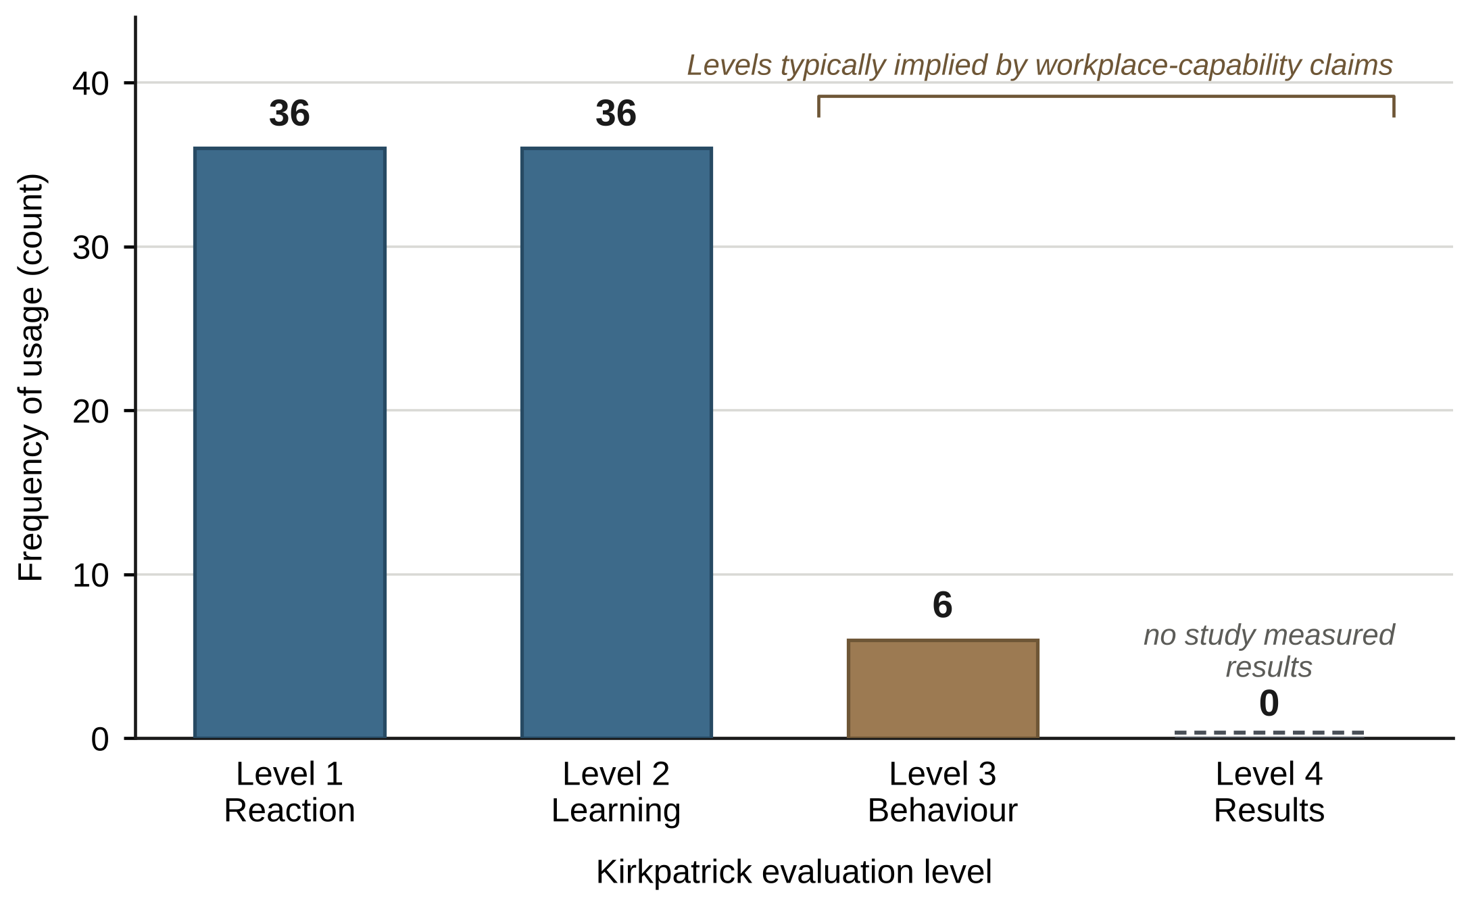
Figure 1. Distribution of the outcome(s) measured, based on Kirkpatrick’s training evaluation model, in virtual-reality-based health and safety training for high-risk engineering industries. Adapted from Toyoda et al. (2022, Fig. 7), which is published under a Creative Commons Attribution 4.0 licence (CC BY 4.0). The frequencies (36, 36, 6 and 0 for Levels 1–4) were read from the original figure and re-plotted; the level names and the bracket over Levels 3 and 4 were added by the present authors. [ความเห็น: ค่า 36/36/6/0 อ่านจากรูปต้นฉบับ (Toyoda et al., 2022, Fig. 7) โดยวัดพิกเซลเทียบเส้นกริด ยังไม่ได้เทียบกับตัวบทความโดยตรง (เข้าถึงบทความออนไลน์จากสภาพแวดล้อมนี้ไม่ได้) — โปรดตรวจกับต้นฉบับ รวมทั้งชื่อระดับ Reaction/Learning/Behaviour/Results และวงเล็บเหนือ Level 3–4 ซึ่งเป็นส่วนที่เพิ่มขึ้นมาใหม่]
Reviews in engineering education have called for contributions that organise knowledge rather than merely catalogue interventions (Borrego et al., 2014). Reporting transparency is integral to that contribution because readers need to evaluate how a synthesis was reached (Phillips et al., 2024). This review uses an existing collection whose complete search and screening history could not be recovered. It therefore offers a critical integrative review of a bounded corpus, not a claim to systematic coverage. Contrasting cases are used to examine relationships between design, evidence and interpretation; the collection’s size is not taken as evidence of representativeness.

1.2 Conceptual background
Situated learning treats professional knowledge as embedded in participation rather than as a possession transferred unchanged between settings. Activity theory similarly directs attention to tools, rules, divisions of labour and the purposes of collective work (Engeström, 2001; Lave & Wenger, 1991). These perspectives guide the present analysis towards what students do with representations and with other people. They do not imply that a classroom simulation reproduces professional practice: a simulated site may preserve spatial relationships while removing weather, client disagreement, accountability or the consequences of unsafe action.
Authenticity is consequently understood as a relationship among task, context, product and judgement, not simply visual fidelity. Authentic-assessment research distinguishes these dimensions, while authentic-learning design emphasises sustained activity and access to multiple perspectives (Gulikers et al., 2004; Herrington & Oliver, 2000; Villarroel et al., 2018). Constructive alignment requires intended outcomes, learning activities and assessment to elicit compatible performances (Biggs, 1996). Together, these perspectives distinguish representing a workplace from organising learning around the decisions that make work demanding.
Collaborative professional judgement is defined here as the joint evaluation of evidence, alternatives or artefacts against reasons and standards. It includes identifying a discrepancy, explaining its significance, challenging an interpretation and revising a proposal. Cooperative-learning theory helps explain interdependence, but group membership alone says little about the quality of that activity (Johnson & Johnson, 2009). Research on shared knowledge construction and unsuccessful groups shows why the interaction itself needs examination (Barron, 2003; Roschelle & Teasley, 1995). The ICAP framework likewise distinguishes forms of cognitive engagement rather than treating all visible participation as equivalent (Chi & Wylie, 2014).
Teamwork and professional judgement overlap, but are not interchangeable. Planning, mutual monitoring and coordination support collective work (Marks et al., 2001), and behaviourally anchored assessments describe contributions more precisely than overall satisfaction ratings (Ohland et al., 2012). Yet students may coordinate efficiently while accepting a flawed design without criticism. The review therefore examines both the organisation of responsibilities and whether interaction changes how evidence, quality or alternatives are judged. An episode of reasoned action can be informative where a message count is not. Collaboration is a property of some configurations, not a requirement imposed on every learning activity.
Competence is inferred from assessment evidence. That inference depends on the performance elicited, the basis on which it was judged and the proposed use of the result. Validity theory places these interpretations and uses, rather than an instrument’s label, at the centre of evaluation (Kane, 2013; Messick, 1995). A reliable confidence questionnaire can support an interpretation of confidence without providing evidence of safe construction performance. Conversely, a detailed qualitative account of a revised decision can support an interpretation of situated judgement without producing a standardised score.
Assessment can also contribute to learning. Formative assessment and evaluative judgement emphasise learners’ capacity to recognise quality, interpret criteria and use feedback (Sadler, 1989, 2010; Tai et al., 2018). Self-regulated learning and feedback literacy further specify how learners engage with these demands (Carless & Boud, 2018; Nicol & Macfarlane-Dick, 2006). Feedback becomes consequential when learners can act on it, not simply when they receive a comment or score (Boud & Molloy, 2013). This educational role must be distinguished from the use of assessment evidence to support a research conclusion. In LCEC, feedback practices belong to the learning configuration; the resulting records and judgements constitute evidence.
Professional competence is treated as an inference about a specified capability under stated conditions, rather than a fixed catalogue of future-ready skills. A course cannot establish performance in every future setting. Transfer research highlights learner characteristics, training design, the receiving environment and differences between learning and application contexts (Baldwin & Ford, 1988; Blume et al., 2010). A competence claim must therefore identify the task or setting, the learner or team to whom it applies, and the support under which performance was observed. These are requirements of the interpretation, not additional instructional ingredients.
This focus on warrant is not new to assessment or evidence synthesis. Gough (2021) examines the fitness for purpose of evidence claims, including the methods and evidence on which they rest. Fawns et al. (2026) distinguish product, process, performance and practice as assessment proxies. These contributions sharpen the present concern, which is how the constraints and arrangements of an engineering-learning activity shape the evidence available and how far that evidence justifies a claim. They provide conceptual comparisons, not additional core cases.

1.3 Approach and objectives
The review integrates these relationships in the Learning Configuration–Evidence–Claim (LCEC) Framework. The name denotes three analytical units: learning configuration (LC), assessment evidence (E) and competence claim (C). [ความเห็น: ชื่อ 'LCEC' มี 4 ตัวอักษรแต่มีเพียง 3 หน่วย (LC, E, C) จนต้องอธิบายซ้ำใน §3.8 — ผู้อ่านและผู้ประเมินอาจสับสน; พิจารณาเขียนเป็น 'LC–E–C Framework' หรือเปลี่ยนชื่อ แล้วใช้ให้สม่ำเสมอทั้งเอกสารและรูปที่ 4, 6, 7] LC concerns the conditions under which learning and performance occur; E concerns the observations and judgements available for interpretation; and C concerns the capability and context to which an interpretation applies. LCEC is the organising synthesis developed through this review, not an intervention tested in the included reports.
The review therefore had three objectives: (i) to describe how task conditions, social organisation, instructional support and tools are configured in AEC and construction-related vocational learning; (ii) to examine what assessment evidence the reports use and what interpretations of learning or competence that evidence can support; and (iii) to identify the recurring gaps between configurations, evidence and claims that inform an integrative framework and priorities for further research.

2 Materials and Methods

2.1 Review design and scope
We conducted a critical integrative review using framework synthesis, retrospectively examining a curated collection of reports. The integrative approach supports comparison across heterogeneous empirical and conceptual contributions, while requiring an explicit account of how evidence is selected, evaluated and synthesised (Snyder, 2019; Torraco, 2005; Whittemore & Knafl, 2005). Framework-synthesis guidance informed the use and revision of sensitising categories (Carroll et al., 2013). Here, “critical” refers to examining what a study’s evidence can support, including alternative explanations; it does not imply that the included work is uniformly deficient. The purpose is interpretive and theory-generating, rather than an estimate of intervention effects (Borrego et al., 2009; Grant & Booth, 2009).
The empirical collection retained its nominal publication window of 2016–2026, using issue year where available; this window is not a search-completion date. Reports concerned AEC, construction-related engineering education, or vocational learning relevant to construction and design. Core reports served as cases for analysing a specified learning activity or learner, educator or task process. Contextual reports supplied theoretical, institutional, curricular or methodological context. The distinction concerns analytical use, not a ranking of designs: a perception study can be a core case when it describes a particular learning configuration, or contextual literature when its principal contribution concerns broader readiness or implementation. Older theoretical and methodological sources were considered separately. Neither statistical representativeness nor theoretical saturation was a criterion claimed for the retained collection.
Figure 2 summarises the review procedure, from the retained collection to the synthesis outputs, and indicates where each step is documented in Supplementary Material S1.
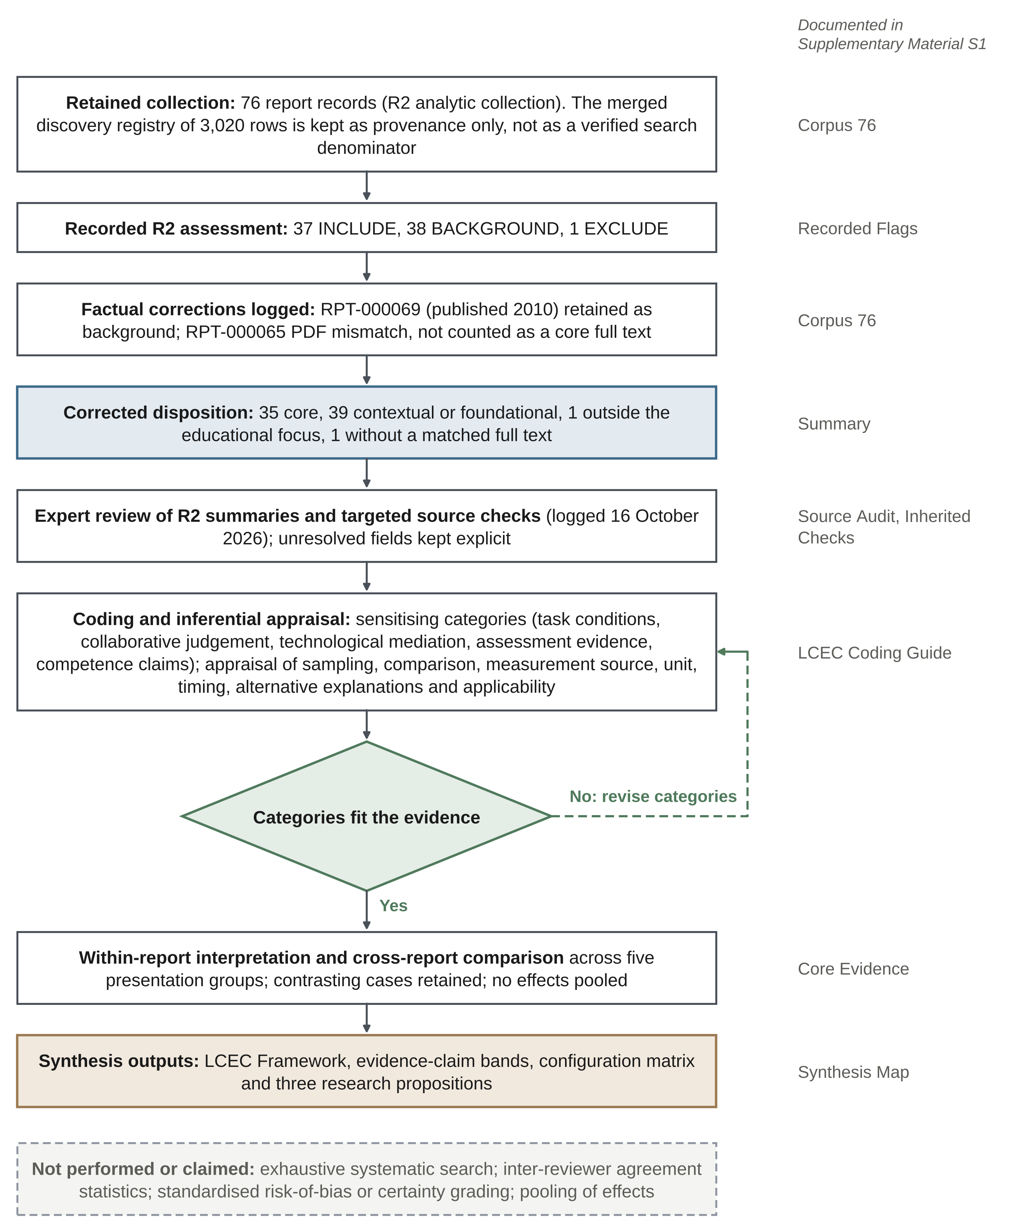
Figure 2. Procedure of the critical integrative review. Boxes record the principal steps, the diamond marks the iterative revision of sensitising categories, and grey labels give the sheet of Supplementary Material S1 in which each step is documented. The dashed box lists procedures that were not performed or claimed.

2.2 Corpus provenance and disposition
The retained project documentation described a merged discovery registry of 3,020 rows assembled from legacy exports labelled Scopus, ERIC and OpenAlex, alongside a local analytic collection of 76 report records. Source-specific queries, execution dates, duplicate removals and sequential screening decisions were not recoverable in full. The registry size is therefore reported for provenance, not as a verified systematic-search denominator. Three logged SciSpace discovery queries produced 30 candidate records; these outputs were not automatically added to the analytic collection. [ความเห็น: ไม่ชัดเจนว่า 30 รายการจาก SciSpace ถูกใช้อย่างไรในที่สุด (เป็น conceptual references ที่อ้างในบทความ? ถูกตัดออก?) — ระบุผลลัพธ์ให้ตรวจสอบย้อนกลับได้] The review does not reconstruct unrecorded database searches or screening counts.
The retained R2 assessment contained 76 unique report identifiers, with decisions of 37 INCLUDE, 38 BACKGROUND and one EXCLUDE. [ความเห็น: 'R2' ปรากฏครั้งแรกใน Fig. 2 และ §2.2 แต่นิยามอยู่ใน §2.3 — ควรนิยามตั้งแต่ครั้งแรก และอธิบายที่มาของ R2 ให้ชัด (ใคร/เครื่องมือใดเป็นผู้ประเมิน และ R1 คืออะไร) เพราะ Declarations ระบุว่ามี GPT/Codex ช่วยสรุปและเปรียบเทียบการลงรหัส] Two corrections affected the INCLUDE group. RPT-000069 was published in 2010, rather than the legacy year 2020, and was retained as foundational background. For RPT-000065, the documentation identified a PDF about construction-project success factors rather than the intended teamwork article; the record was not counted as a retrieved core full text. The corrected disposition was 35 core reports, 39 contextual or foundational reports, one outside the educational focus and one without a correctly matched full text in the retained records. Supplementary Material S1 preserves the report identifiers and distinguishes the original decisions from these corrections.
Figure 3 accounts for this bounded collection. PRISMA 2020 and PRISMA-S informed disclosure of recoverable and missing information, but neither the figure nor the review is presented as a completed PRISMA search and screening process (Page et al., 2021; Rethlefsen et al., 2021). The denominator is the 76 retained report records. Additional methodological and conceptual sources used to clarify the review design and position LCEC are cited separately; they are not additions to the 35-report core or the 76-record denominator.
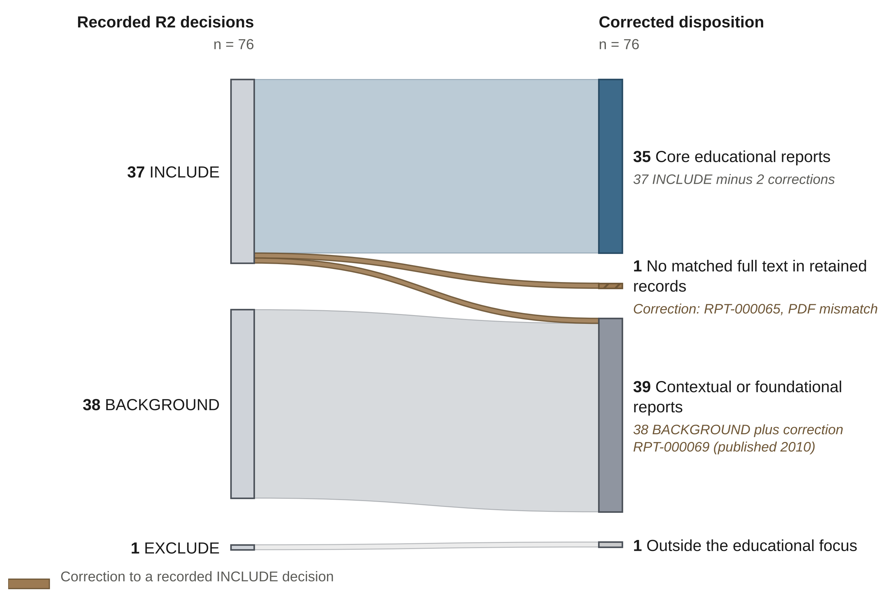
Figure 3. Disposition of the retained report collection (n = 76). The original R2 decisions (left) and the corrected disposition after subsequent factual corrections (right) are distinguished; band widths are proportional to the number of reports, and the two brown bands mark the corrections to INCLUDE decisions. Counts refer to reports, not verified independent studies; the historical 3,020-row discovery registry is not a verified search denominator, and this is not a PRISMA identification and screening flow. [ความเห็น: รูปนี้จับคู่ 'EXCLUDE 1' กับ 'Outside the educational focus 1' ตามผลรวมในข้อความ (37−2 = 35; 38+1 = 39; 1; 1 รวม 76) ซึ่งเป็นการอนุมานจากตัวเลขใน §2.2 ไม่ได้ระบุตรง ๆ — โปรดยืนยันว่าเป็นรายงานเดียวกัน]

2.3 Expert review and source checking
A human subject-matter expert reviewed and refined the R2 assessment summaries before they were incorporated into the synthesis. [ความเห็น: ควรระบุจำนวน คุณสมบัติ และความเป็นอิสระของผู้เชี่ยวชาญ (เป็นผู้เขียนหรือไม่) และขอบเขตของการ 'refined' (แก้ไขสัดส่วนเท่าใดของรายการ) เพราะเป็นหลักฐานหลักของความน่าเชื่อถือของการลงรหัส] R2 is the designation of the retained assessment record, not evidence of two independently documented human coding passes. A comparable independent R1 matrix was unavailable. Accordingly, no inter-reviewer kappa, percentage agreement or consensus-adjudication procedure is claimed. Expert review of the interpretations is distinguished from bibliographic matching and verification against the source reports.
Source checking distinguished bibliographic identity from the evidence supporting an interpretation. Targeted checks used available publisher texts, accepted manuscripts and institutional records, with the material consulted and the scope of each check recorded separately in Supplementary Material S1. Checks undertaken while preparing this version were logged on 16 October 2026. A publisher or DOI match does not establish that an outcome has been verified; an abstract check does not constitute full-text appraisal. Unresolved fields remain explicit. The core evidence matrix maps the synthesis to reports and claim boundaries, rather than representing an independent re-coding of every full text. Original screening decisions were not overwritten by subsequent editorial checks.

2.4 Coding and inferential appraisal
Initial sensitising categories distinguished task conditions, collaborative judgement, technological mediation, assessment evidence and competence claims. These categories preceded the present formulation and were revised through comparison with the evidence. They were subsequently organised into the three LCEC units: task conditions, social organisation, scaffolding and tools within LC; observations, criteria, assessors, units and timing within E; and the capability and contextual reach of the interpretation within C. This reorganisation clarifies analytical roles without changing the recorded eligibility decisions. LCEC was not prospectively registered or developed without prior exposure to the findings, and the historical flags were not automatically converted into new LCEC scores.
Appraisal focused on the inference a design could support: sampling and response, comparison or assignment, measurement source, unit of analysis, timing, alternative explanations and applicability. Self-reported experience, task knowledge, observed performance, artefact or interaction records, external judgement and subsequent application were distinguished. Missing information was not treated as evidence of no effect. Earlier confidence labels partly derived from component counts and keyword-based claim levels were discarded because framework coverage is not methodological quality. The present appraisal is design-sensitive but is not a completed standardised risk-of-bias or certainty assessment. MMAT guidance informs the need to match appraisal to design, not a claim that its checklist was administered in full (Hong et al., 2018). Table 1 illustrates the resulting claim-specific judgements.
Table 1. Claim-specific implications of inferential appraisal [ความเห็น: Table 1 เป็นผลการประเมินรายกรณี (ลักษณะเป็นผลลัพธ์) แต่อยู่ใน Methods — พิจารณาย้ายไป §3 หรือระบุเกณฑ์การเลือก 6 กรณีนี้ (รวม Coronado et al. ซึ่งเป็น contextual ไม่ใช่ core)]
Case | Evidence and design | Claim retained | Claim not established
Chenah and Boton (2026) | Survey evaluation of a collaborative BIM workflow | Perceived usefulness and design plausibility | An independently measured gain in technical competence
Sun et al. (2022) | Comparative plan-reading task; no statistically significant performance difference | A bounded comparison with presence and usability trade-offs | Equivalence or general superiority of VR
Setiawan et al. (2021) | Ex-post-facto collaborative and drawing-skill measures | Association between measured constructs | A causal collaboration effect
Andalib and Monsur (2024) | Exploratory mixed-method evaluation; small sample; no experimental comparison | Learning-mode preferences and implementation concerns | VR superiority
Wu et al. (2019) | Novice-expert comparison in a simulated review | Expert-referenced situated behaviour | Longitudinal transition to expertise
Coronado et al. (2021) | Retrospective alumni survey; 52 valid responses from a population of 545 graduates | Perceived long-term relevance | An 18-year prospective transfer effect
Note. Coronado et al. (2021) is contextual literature and is not included in the 35-report core. The cautions concern particular claims; they are not formal risk-of-bias grades.

2.5 Synthesis procedure and interpretive limits
Synthesis proceeded through within-report interpretation and cross-report comparison. For each core case, the matrix identifies the learning configuration, the evidence described, the interpretation retained and its principal boundary. Cases were then compared across the five presentation groups in Table 2, asking whether similar activities produced comparable evidence and whether different evidence types justified similar claims. Nonsignificant performance findings, preferences for nonimmersive representations, individual activities and qualitative process explanations were retained as contrasts. A nonsignificant comparison was not treated as equivalence; an observational association was not treated as an intervention effect. Separate report identifiers were not assumed to denote independent underlying samples.
The cross-case interpretation was consolidated into LCEC and linked to the objectives through the synthesis map in Supplementary Material S1. That map distinguishes report-level findings, the review’s interpretation and the resulting framework implication. It makes the reasoning inspectable without implying that the framework emerged wholly inductively or that independent analysts reached identical categories. No effects were pooled: comparable outcomes, variance estimates and independent units were not consistently established. The framework and configuration matrix neither estimate moderation or mediation nor establish necessary or sufficient conditions. Reporting safeguards follow the concerns raised by Phillips et al. (2024), without converting reporting completeness into a numerical certainty score.

2.6 Analytical standpoint
The review prioritises the educational interpretation of professional activity rather than the promotion of a technology. This standpoint foregrounds assessment and judgement, but may give less attention to enjoyment, belonging or exploratory making. Because initial categories preceded the synthesis, confirmation bias remains a concern. Contrasting cases, separation of core and contextual uses, and removal of component-based quality labels were used to constrain the interpretation. In particular, individual and non-digital activities prevent collaboration or technology from becoming defining requirements of LCEC. These safeguards do not eliminate subjectivity or compensate for incomplete search records.

3 Results

3.1 Corpus characteristics and the evidence available
The 35 core reports covered higher education, architecture and construction management, together with construction-related vocational and school learning. They included surveys, comparative tasks, qualitative cases, tutor interviews, prototype evaluations and course-design accounts. Table 2 groups them by their principal analytical use rather than treating them as a homogeneous set of intervention trials. Supplementary Material S1 identifies the reports assigned to each group. The unit counted is a report, not a verified independent study or participant, so the collection should not be read as a representative map of institutions, countries or learners. [ความเห็น: Results ยังไม่มีข้อมูลพรรณนาของ 35 core reports (ปี ประเทศ ระดับการศึกษา ประเภทงานวิจัย) ซึ่งผู้ประเมินมักคาดหวัง — แม้ไม่อ้างความเป็นตัวแทน ควรสรุปเป็นตารางสั้น ๆ หรือชี้ไปยัง S1 (ยังไม่ได้ตรวจ S1 จึงไม่ทราบว่ามีอยู่แล้วหรือไม่)]
Table 2. Analytical groupings of the core reports
Primary analytic focus | Reports | Evidence represented
BIM and collaborative workflows | 7 | Surveys, observation, project artefacts, reflection and action research
Representations and simulation | 9 | Prototype and modality evaluation, knowledge tasks and user experience
Projects, studios and workshops | 11 | Design accounts, interviews, qualitative cases and perceived learning
Assessment and instructional organisation | 5 | Peer assessment, digital artefacts, grading, tests and course implementation
Skill and reference comparisons | 3 | Role-group comparison, observational regression and novice-expert review
Note. Groups are mutually exclusive for presentation, not categories of design quality. Total = 35 reports. Linkage between reports and independent underlying studies was not established.
The retained component flags did not provide a sufficiently secure basis for estimating the prevalence of competence or transfer claims. They are preserved in Supplementary Material S1 for provenance, but are not treated as independently verified findings about the 35 reports. In particular, an individual digital game does not establish observed collaboration, and an innovative non-digital activity does not establish technological mediation. The results below therefore compare specified configurations, evidence types and interpretations. They do not infer the absence of transfer research from a missing positive flag.

3.2 Authenticity is produced through constraints and decisions
The core reports made professional problems available for learning in several ways. Workshops combined material experimentation with environmental analysis; community-linked projects connected design activity with recipients and sponsors; and heritage assignments required documentary, map and field interpretation (Chimwayange, 2025; Ruiz et al., 2018; Stoyanova Bond et al., 2026). Interviews with experienced construction-workshop tutors provided a different perspective on educational goals, learning environments and evaluation (Luyten et al., 2025). Across these accounts, authenticity rested on the information, constraints and consequences students had to consider, rather than on sophisticated equipment alone. [ความเห็น: ผู้อ่านแยกไม่ได้ว่างานที่อ้างใน §3.2–3.6 เป็น core (35) หรือ contextual (39) — พิจารณาทำเครื่องหมายใน References (เช่น *) หรือระบุในประโยคที่อ้าง เพื่อให้ตรวจสอบย้อนกลับได้]
Other activities introduced competing stakeholder interests or representations. A heritage atelier brought economic and cultural considerations into dialogue with teachers and stakeholders (Curto et al., 2021), while sustainable interior-design classes linked disciplinary assignments to environmental assessment tools (Celadyn, 2020). Mock arbitration assigned owner, contractor and panel roles around historical claim documents (Arneson & Ozbek, 2020). Such arrangements can give justification a meaningful role within a course. In the arbitration case, however, the evaluation concerned students’ reported legal understanding; realistic roles did not themselves establish assessed legal competence.
Producing a physical artefact does not resolve this evidential problem. The pavilion study examined students’ interpretations of construction, engagement, design and teamwork rather than independently establishing a performance gain (Gutai & Palaiologou, 2021). Course accounts integrating Conceive–Design–Implement–Operate (CDIO) projects or interactive construction-learning units likewise described promising arrangements without isolating intervention effects (Martí et al., 2017; Salazar & Ponton, 2024). Task authenticity and evidence of its educational consequences must therefore be examined separately.

3.3 Collaborative activity becomes informative when judgement is observable
Collaborative BIM reports illustrate how representations organise coordination. Chenah and Boton (2026) structured clash detection around communication, coordination and production, although their evaluation was predominantly survey-based. Nikolic et al. (2021) connected collaborative information management with continuous-improvement assessment. A seven-step BIM model compared project cohorts through design work and reflection, while a lean integrated-project-delivery course addressed coordinated design management (Basson & Smallwood, 2026; Pikas et al., 2026). These configurations inform an account of collective work, but do not isolate software use as the cause of competence development.
Behavioural evidence is informative when it specifies what participants did together. Sun et al. (2026) examined paired activity during an online construction-site visit using interaction records, instructor assessment and knowledge outcomes. Their account connects collaborative problem-solving with learning within a supported task. Instructor scaffolding was part of the configuration, not a background condition that could be separated from the platform by assumption. The reported relationship therefore supports a situated-process interpretation; it should not be read as an isolated causal effect of the communication tools or as evidence of later workplace performance.
A team-role comparison challenges the assumption that a particular group composition necessarily improves achievement. Academic performance did not differ significantly between balanced and imbalanced role groups, although some experience ratings did (García-Ramírez, 2025b). In an ex-post-facto analysis of 130 vocational learners, collaborative skill was associated with construction-drawing skill (Setiawan et al., 2021). Prior attainment or shared educational conditions remain plausible explanations for that association. The relevant questions concern the quality of joint action and the design supporting its interpretation, not simply whether students worked in teams.

3.4 Assessment determines what can be learned from an innovation
Assessment-focused reports make the distinction between an activity and its evidence particularly clear. An evidence-based peer-assessment approach linked technical software outputs with student evaluations (Javidan & Soltani, 2026). Such a design makes the basis of a judgement more visible, but the accuracy of peer ratings remains a separate question from participation or perceived usefulness. Digital explanation assignments asked students to produce media artefacts against stated criteria, making explanation and audience awareness available for assessment (Kamardeen & Samaratunga, 2020). Automated activity-on-node grading addressed scoring accuracy, feedback and the propagation of errors across course cohorts (Ren et al., 2021). These contributions concern how learning is made assessable; they cannot be collapsed into a single claim of professional readiness.
Other studies assessed bounded knowledge or examined implementation. Soil-mechanics laboratory teaching combined achievement tests with suitability and satisfaction measures (Saekram et al., 2023). [ความเห็น: ผู้เขียน Saekram et al. (2023) มีชื่อย่อ S. Saekram และ S. Maneekeaw ซึ่งตรงกับชื่อในรายชื่อผู้เขียนต้นฉบับนี้ (เทียบจากชื่อย่อเท่านั้น ยังไม่ยืนยัน) — หากเป็นบุคคลเดียวกัน ควรระบุว่าเป็น self-citation/งานของผู้เขียนเอง และพิจารณาในส่วน Limitations และ Conflict of interest] BIM-enabled cash-flow teaching used participatory action research to refine an exercise (Olowa et al., 2023). A flipped construction course combined quizzes, active spaces, group tasks, tutorials and case assessment (Mojtahedi et al., 2020). Such combinations can inform curriculum design, but concurrent changes make it difficult to attribute an outcome to one component. Similarly, a final-semester BIM project combined examples of student work with perceived skill and career development, rather than externally observed graduate performance (Wang et al., 2020).
Contextual studies concern related but distinct objects of assessment. Authentic-assessment competence among vocational construction teachers addresses assessor capability (Sutarto & Jaedun, 2018); research on pre-service vocational teachers’ digital competence concerns another participant population and measurement model (Roll & Ifenthaler, 2021). Institutional BIM maturity concerns the conditions for implementing teaching, not learner competence itself (Azevedo et al., 2026). Keeping these contributions separate from the core outcome accounting avoids conflating institutional, teacher and learner results.

3.5 Technology produces affordances and costs rather than a uniform advantage
A virtual reality (VR) site-visit comparison provides a useful check on technological optimism. Sun et al. (2022) compared plan-reading activity in a virtual collaborative space with delivery through Zoom, examining task performance alongside presence, fatigue and usability. The study’s reported nonsignificant performance comparison needs to be read separately from the experiential benefits and usability concerns. It does not establish equivalence, which would require an appropriate equivalence design. Nor does a more favourable experience, on its own, establish a learning advantage. These are different outcomes within the same educational configuration.
Other representational comparisons warrant similar care. In a co-created landscape VR study, students preferred 3D modelling within a sequence of learning modes; the authors noted a small sample and the absence of experimental data (Andalib & Monsur, 2024). A later landscape-construction study extended the comparison of instructional modes (Andalib et al., 2025). Physical prototypes and board games also offered ways of organising road-design learning without immersive technology (García-Ramírez, 2025a). These cases shift the question from which medium is newest to what each representation allows learners to inspect, manipulate and explain.
Technology can nevertheless make useful task evidence available. Construction-detailing research reported immediate learning gains in a BIM–VR comparison, while interactive building anatomy linked component manipulation with knowledge assessment (Elgewely et al., 2021; Park et al., 2016). A novice–expert accessibility-review comparison used think-aloud and behavioural data to provide an external reference for situated performance (Wu et al., 2019). It did not follow novices as they became experts. Another BIM-into-VR study evaluated characteristics through student survey responses, despite the term “performance” in its title (Alizadehsalehi et al., 2021). The assessment design, rather than title terminology, determines the defensible interpretation.
Augmented reality (AR) renovation activity exposed both realistic and unrealistic features of simulated construction (McCord et al., 2023). Interviews about site analysis during and after pandemic disruption showed how access to place affects the information available to designers (Yahia et al., 2023). An individual resource-management game made uncertainty and pacing available for discussion, without demonstrating peer collaboration or workplace transfer (Elenany & Ahmed, 2024). Contextual work on mixed-reality cognitive load and immersive construction learning adds reasons to examine attention, usability and instructional support (Ohueri et al., 2025; Tomori & Ogunseiju, 2025). Technology’s value is thus conditional on the actions it enables and the evidence used to assess their consequences.

3.6 Future relevance is not demonstrated transfer
Claims about future professional performance demand evidence beyond a course’s perceived relevance. Technology-acceptance and generative artificial intelligence (GenAI) surveys, scaffold models and transnational-programme evaluations address perceptions, implementation or engagement rather than a common occupational-performance outcome (Andrić et al., 2026; Gladovic, 2026; Hussain et al., 2026; Na et al., 2026; Rahardjo et al., 2026). Virtual-pedagogy and AI-studio discussions provide conceptual context, while BIM curriculum research examines perceived preparation (Karadağ, 2025; Nguyen & Adhikari, 2025; Salman et al., 2025). These purposes are legitimate. Their contribution should be assessed against those purposes, rather than extended to capabilities that were not observed.
The long-term project-based-learning survey illustrates why elapsed time alone is insufficient. Its 18-year course history and retrospective graduate accounts were not a prospective 18-year follow-up of the same learners. The study obtained 52 valid graduate responses from a population of 545 graduates, together with a comparison sample of work colleagues (Coronado et al., 2021). Sampling and retrospective recall limit what can be inferred about enduring benefits. Practitioner involvement in an older capstone report also provided curricular context, but that report was published in 2010, outside the core collection’s publication window (Fiegel & DeNatale, 2010). Neither programme duration nor practitioner participation substitutes for assessing application under changed conditions.

3.7 Integrative findings in relation to the objectives
Objective (i) is addressed by the variation in learning configurations rather than by a single preferred method. Material workshops, document-based disputes, shared digital models and individual simulations organise different decisions and forms of participation (Arneson & Ozbek, 2020; Elenany & Ahmed, 2024; Luyten et al., 2025). Authenticity depends on the constraints learners must address. Neither teamwork nor digital mediation is common to every relevant case; both therefore belong within the configuration rather than becoming universal requirements.
Objective (ii) concerns what is made visible. Surveys capture experience, tests capture bounded knowledge or performance, and interaction or revision records can expose aspects of judgement. These sources answer different questions even when they arise from similar activities (Chenah & Boton, 2026; Sun et al., 2022; Wu et al., 2019). Assessment must also identify its unit: a successful team product does not establish the independent capability of each member. The synthesis thus separates evidence from the task that generated it and from the interpretation placed upon it.
For objective (iii), the recurring issue is an insufficiently specified link, not a uniform absence of educational value. Task realism cannot replace evidence of learning; coordinated participation cannot replace evidence of reasoned judgement; and professional relevance cannot replace assessment under changed conditions (Coronado et al., 2021; Gutai & Palaiologou, 2021; Setiawan et al., 2021). LCEC integrates these distinctions as configuration, evidence and claim. The resulting research gaps concern observable reasoning, individual attribution, professional criteria, context change and assessment timing. Supplementary Material S1 traces each synthesis finding to its contributing cases and interpretive boundary.

3.8 The LCEC Framework
The synthesis identifies three objects that need to be related without being conflated (Figure 4). Learning configuration (LC) comprises task constraints, representations, the organisation of individual or joint action, instructional support and the tools available. Assessment evidence (E) comprises the products, performances and process records selected for examination, together with their criteria, assessors, units and timing. Competence claim (C) specifies the capability inferred, who demonstrated it and the conditions to which the inference applies. “LC” is a single unit within the name LCEC: the framework has three analytical units, not four stages.
The LC–E connection asks what an activity makes observable and how observations are sampled. A task may invite reasoning without recording it; a polished artefact may conceal how responsibilities were distributed. The E–C connection asks whether the observations and their interpretation are sufficient for the stated claim. Dialogue, annotated alternatives and linked revisions may support an interpretation of judgement where participation counts cannot. These links describe an argument about evidence, not a validated causal chain. A configuration may provide learning opportunities even when the research design cannot establish their effects.
Feedback illustrates why the units are connected but distinct. Feedback practices may reshape subsequent activity and therefore belong to LC. Records of feedback use and reasoned revision can also become E. Whether those records justify a claim about improved judgement remains a question for C. Technology can support access, shared representations or trace capture within LC, but does not constitute evidence of learning merely by being present. Collaboration is likewise conditional: an individual task can be analysed through LCEC when individual mastery is the relevant outcome.
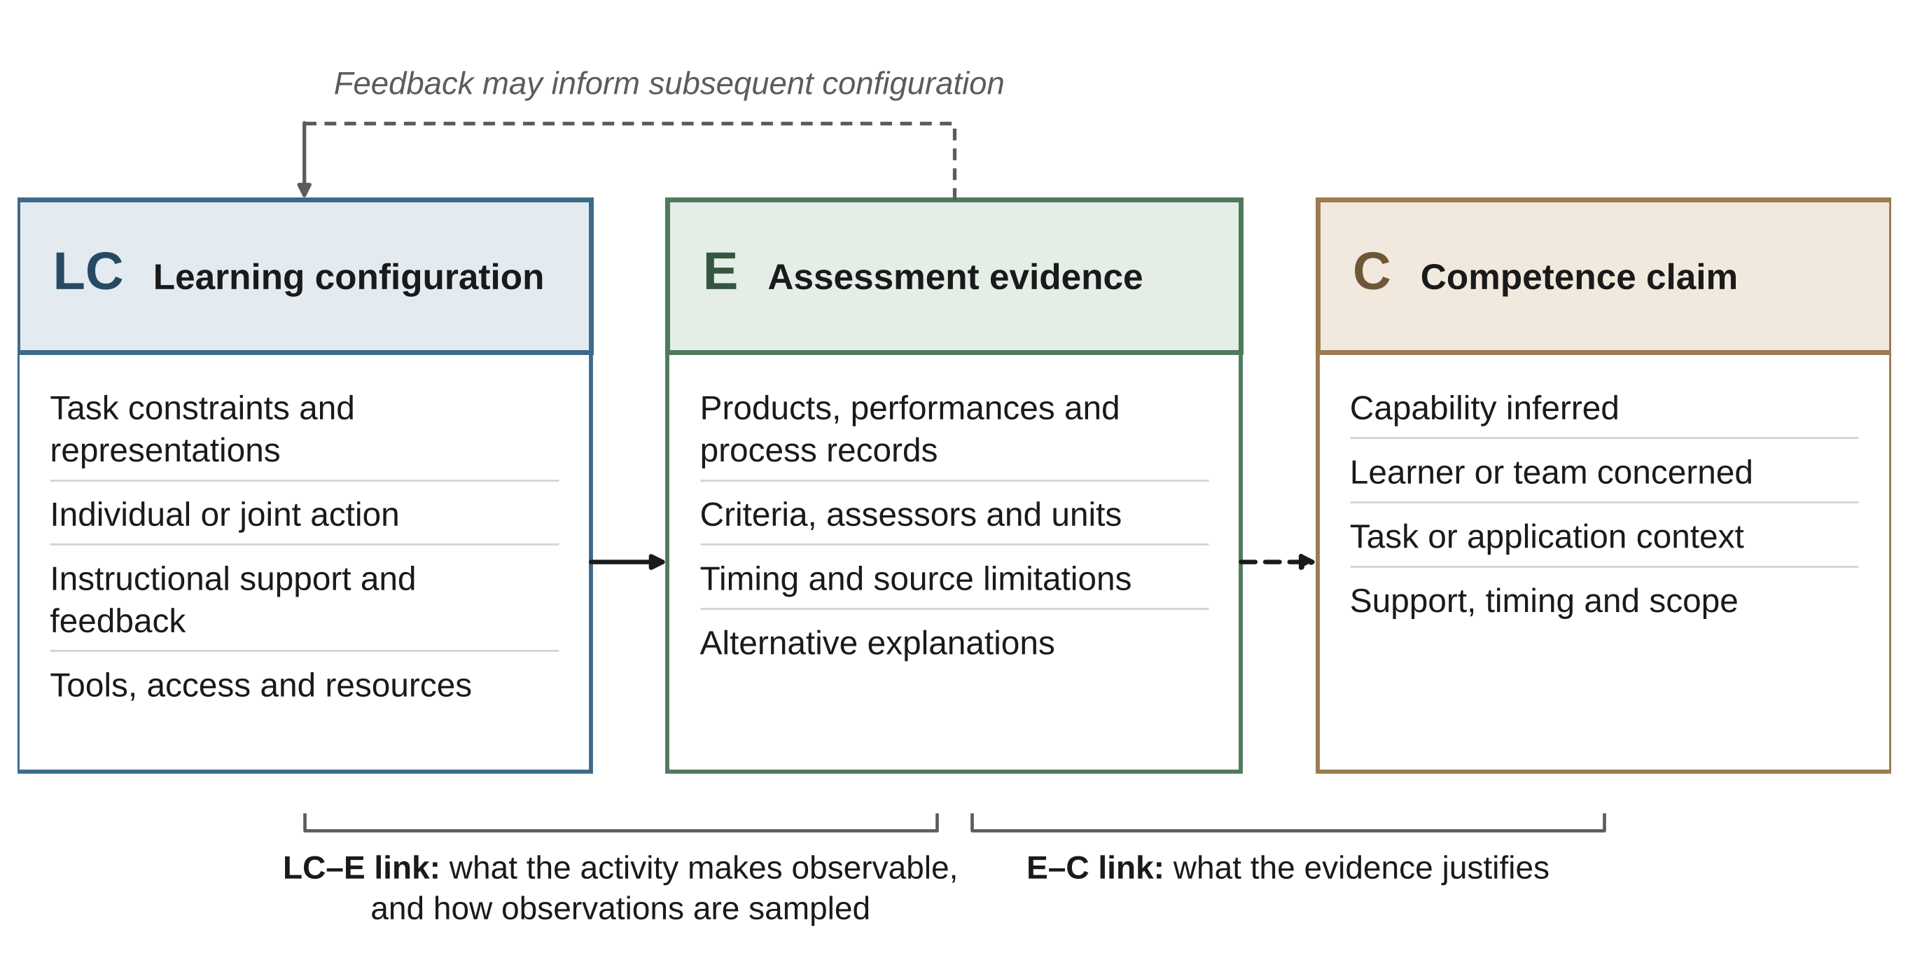
Figure 4. The Learning Configuration–Evidence–Claim (LCEC) Framework. LC, E and C are three analytical units. Connections denote evidence sampling and interpretive warrant, not demonstrated causal effects. Feedback may inform subsequent activity; collaboration and technology are conditional features of the configuration.

3.9 Evidence–claim bands and interpretive reach
Table 3 distinguishes five evidence-claim bands, and Table 4 identifies the checks required when an interpretation is extended. The bands draw on distinctions between reaction, learning and behaviour in training evaluation, including Toyoda et al. (2022), while making situated judgement and external alignment explicit. Numbers are labels, not scores or a compulsory progression. The bands are not nested: transfer can be assessed without an external assessor, and external judgement need not reveal a learner’s reasoning. Independence, support, context change and timing cut across the bands. A well-supported qualitative explanation can make an important contribution without claiming workplace transfer. Figure 5 summarises the bands and the missing links between them. [ความเห็น: Fig. 5, Table 3 และ Table 4 มีเนื้อหาซ้อนกันมาก (5 bands + missing links ชุดเดียวกัน; ตรวจเทียบแล้วตรงกัน) — พิจารณาคงรูป + ตารางอย่างละ 1 และย้าย Table 4 ไป Supplementary เพื่อลดความยาว]
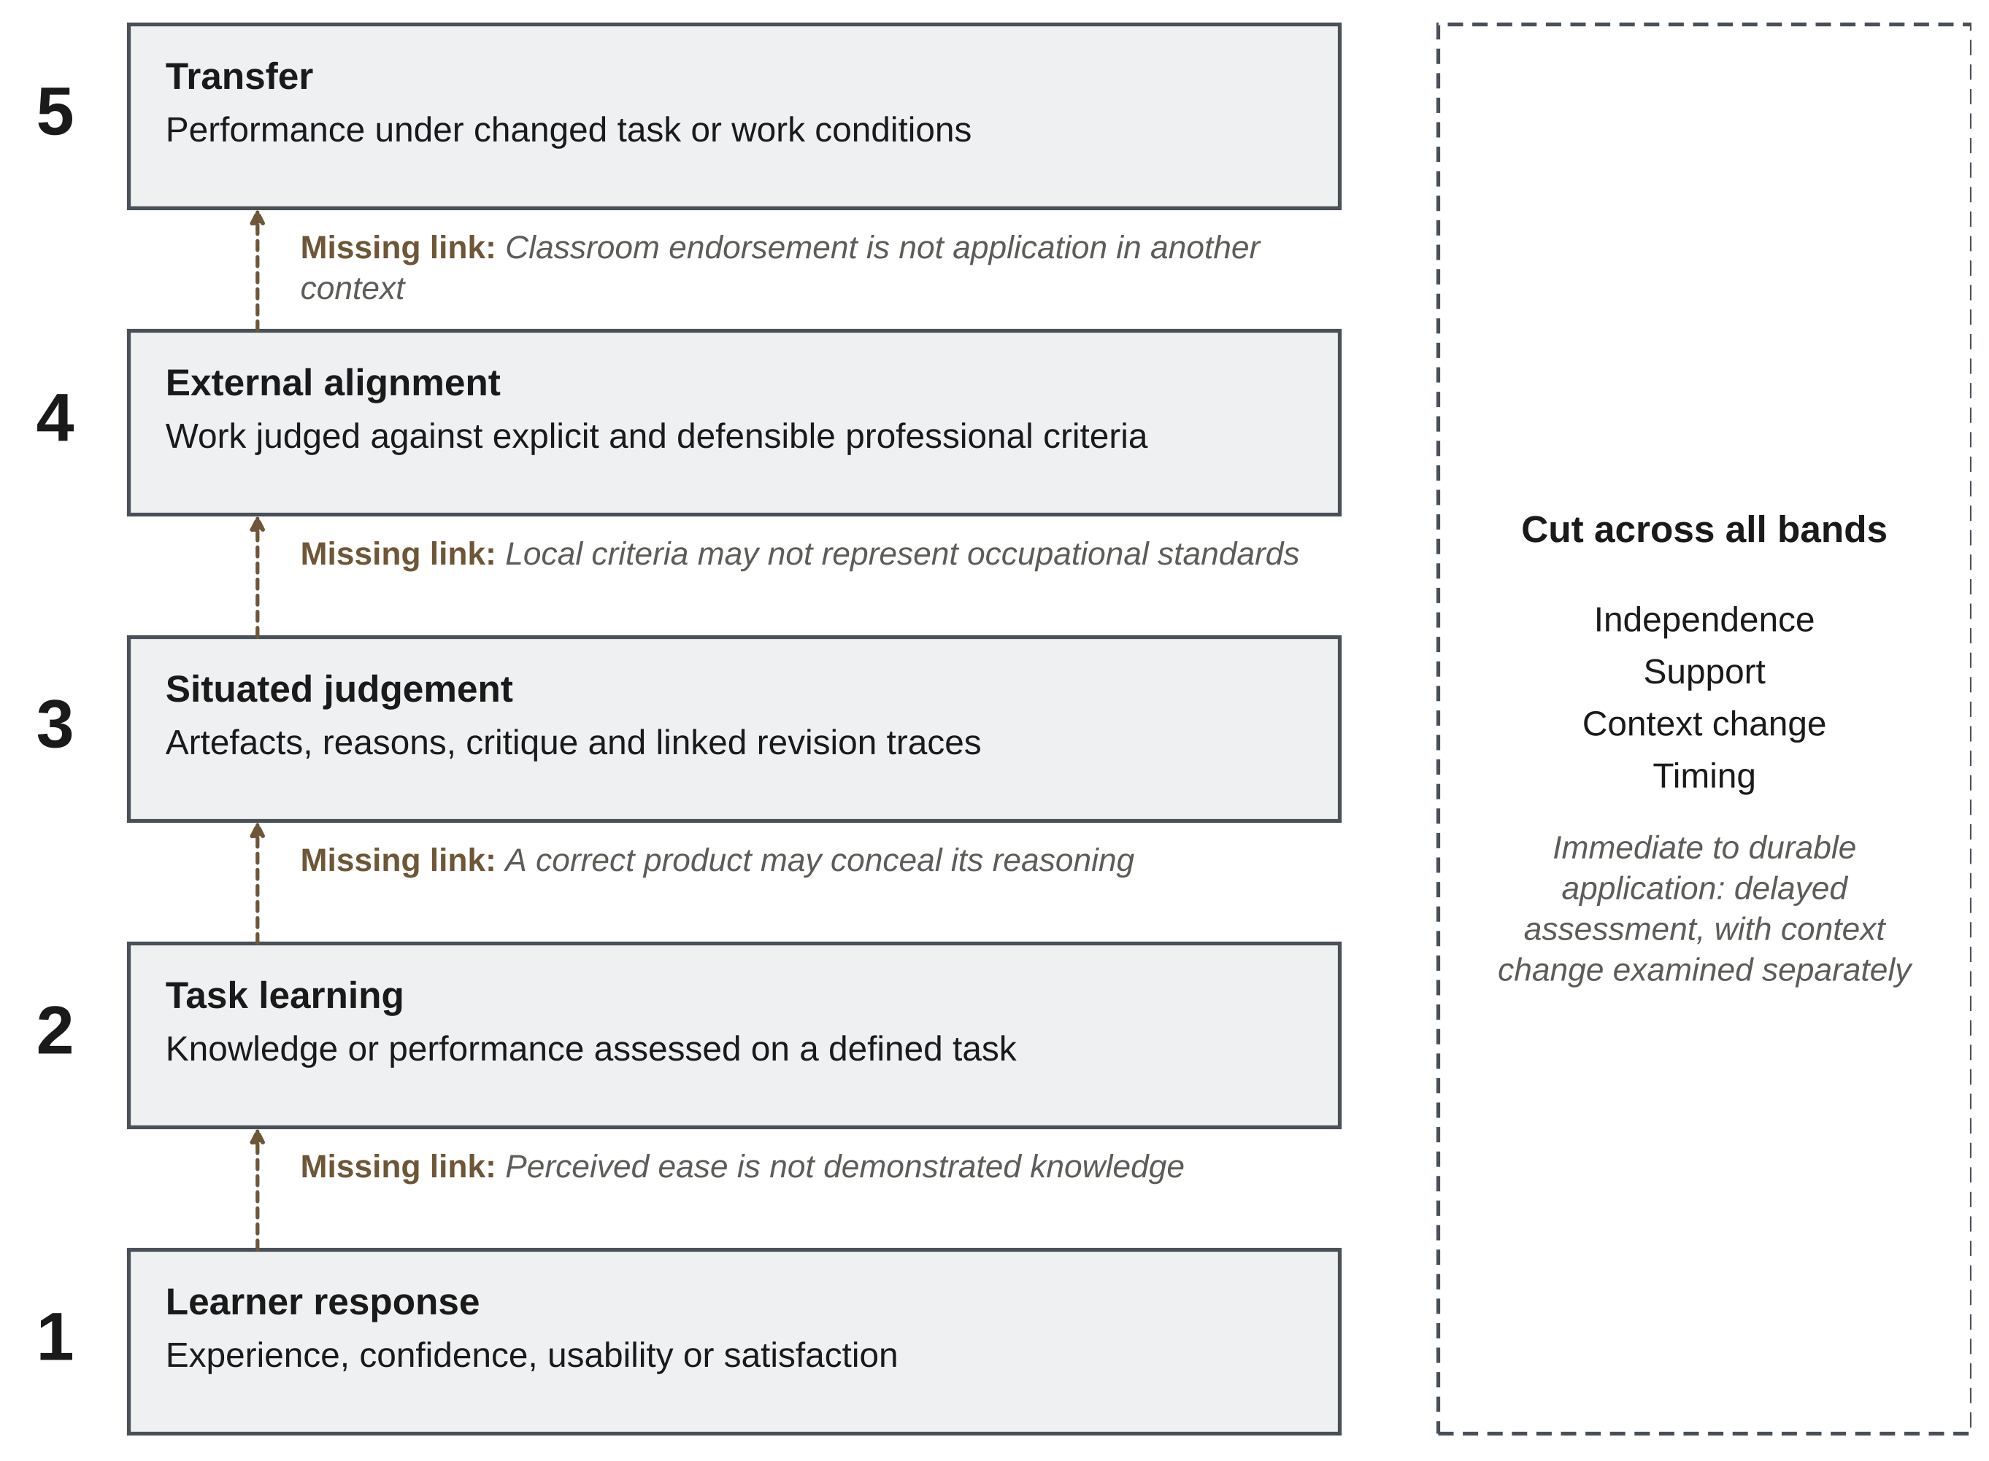
Figure 5. Evidence–claim bands and the missing links that must be addressed before an interpretation is extended. Numbers are labels, not scores. The bands are not nested and do not form a compulsory progression.
Table 3. Evidence-claim bands and the boundaries of interpretation
Claim band | Evidence needed | Boundary to retain
5 Transfer | Performance under changed task or work conditions | A delay alone does not establish transfer; changed-task transfer is not necessarily workplace transfer.
4 External alignment | Work judged against explicit and defensible professional criteria | Expert assessment of a classroom product is not observation of workplace behaviour.
3 Situated judgement | Artefacts, reasons, critique and linked revision traces | A final product alone may conceal how a judgement was reached.
2 Task learning | Knowledge or performance assessed on a defined task | Attainment is not necessarily a learning gain; immediate success is not occupational readiness.
1 Learner response | Experience, confidence, usability or satisfaction | Positive perceptions do not establish competence.
An employer’s rating of a classroom artefact can strengthen its alignment with professional criteria without showing independent performance at work. A delayed test may establish retention without assessing transfer; a new simulation may assess transfer to a changed task without reproducing workplace responsibility. A retrospective graduate survey concerns perceived relevance unless behaviour is assessed separately. Table 4 makes these distinctions explicit. Extending a claim requires additional observations and a justified link between them, rather than stronger terminology.
Table 4. Checks required when extending a competence interpretation
Interpretive extension | Missing link | Evidence to add | Competing explanation
Response to learning | Perceived ease is not demonstrated knowledge | Construct-specific assessment and a justified scoring interpretation | Novelty, confidence or prior ability
Task success to judgement | A correct product may conceal its reasoning | Decision rationales, critique and linked revision traces | Imitation or adoption of the instructor’s solution
Situated judgement to external alignment | Local criteria may not represent occupational standards | Calibrated external review against explicit professional criteria | A rubric rewarding course-specific conventions
External alignment to transfer | Classroom endorsement is not application in another context | Changed-task assessment with support and opportunity documented | Familiarity with the learning setting or receiving environment
Immediate to durable application | Elapsed time does not establish retention or transfer | Delayed assessment, with context change examined separately | Repeated testing, recall or intervening experience
Note. These checks support an argument about validity; they are neither validated cut-offs nor compulsory steps. Qualitative explanations can make a strong contribution without a transfer claim.

3.10 The configuration matrix
Table 5 aligns illustrative cases with the three LCEC units and a claim boundary. It compares what a configuration makes available, the evidence used and the interpretation retained. Unlike an effect synthesis examining statistical moderators, such as Yang et al. (2024), it supports descriptive comparison and proposition development. It establishes neither a best configuration nor necessary or sufficient conditions for competence. Shared instructors, assessment rules or institutional resources may account for features that occur together.
Table 5. Illustrative configurations, evidence and competence interpretations [ความเห็น: Table 5 แสดงเพียง 5 จาก 35 core cases — ควรระบุเกณฑ์ที่ใช้เลือก (เช่น ครอบคลุมทั้ง 5 กลุ่มใน Table 2) และชี้ว่าตารางเต็มอยู่ที่ S1 ส่วนใด]
Learning configuration (LC) / case | Assessment evidence (E) | Interpretation supported (C) | Boundary
Paired virtual-site task  Sun et al. (2026) | Interaction records, instructor assessment and task knowledge | Situated collaborative problem-solving in a supported task | Does not isolate a tool effect or establish workplace transfer.
Community-linked project  Chimwayange (2025) | Project account and evidence of participation and artefact development | A contextual account of learning and engagement | Not a comparative estimate of intervention effectiveness.
Individual resource simulation  Elenany and Ahmed (2024) | Prototype feedback from student, faculty and industry participants | A bounded account of resource-management learning opportunities | Individual play does not demonstrate peer collaboration.
Evidence-based peer review  Javidan and Soltani (2026) | Technical outputs and student evaluations | An account of how technical evidence can structure peer assessment | Accuracy and calibration of ratings require their own evidence.
Expert-referenced review  Wu et al. (2019) | Think-aloud and behavioural comparison | Differences in situated novice and expert review activity | Not a longitudinal transition to expertise or workplace transfer.
Note. LC denotes learning configuration; E denotes assessment evidence; C denotes the interpretation supported. These are descriptive cases, not estimated moderators or configurations shown to be necessary or sufficient. Core report identifiers and source-check scope are recorded in Supplementary Material S1.

3.11 Research propositions
Three propositions follow from the synthesis. They specify questions for future studies rather than relationships demonstrated by the present review. [ความเห็น: ควรระบุว่าแต่ละข้อเสนอสืบเนื่องจากผลใน §3.2–3.6 ส่วนใดโดยเฉพาะ (ตอนนี้บอกเพียงว่า 'follow from the synthesis') เพื่อให้ตรวจสอบย้อนกลับได้]
Proposition 1: Consequential conflicts and joint judgement. Tasks that require students to resolve conflicting representations are expected to elicit more substantively justified evaluation than tasks completed through parallel division of labour. A study could compare these arrangements while holding the technical problem, available time and assessment criteria as constant as possible. Candidate indicators include whether learners state a reason, evaluate an alternative, challenge a proposal and make a linked revision. Analyses should account for team-level dependence and distinguish the quality of an episode from its frequency.
Proposition 2: Documented revision and evaluative development. Feedback that requires a revision and an explanation of its rationale is expected to make evaluative development more assessable than a final artefact alone. A test would compare the interpretations supported by final products with those supported by linked feedback, revision and rationale records. Independently scored performance on a related task would help distinguish improved judgement from compliance with an instructor’s solution; agreement between assessors would address scoring consistency rather than establish transfer.
Proposition 3: External alignment and changed-context performance. Performance judged against explicit professional criteria is expected to provide information about subsequent changed-task performance that course-experience ratings alone do not provide. A study could collect experience ratings, calibrated external assessments and a separately scored changed-context task, accounting for prior attainment, support and opportunity to perform. External alignment, retention and transfer should remain separate outcomes. Neither predictive validity nor a causal pathway is established by the present synthesis.
Figure 6 sets out the three propositions as contrasts in configuration, the evidence to be collected and the interpretation to be tested.
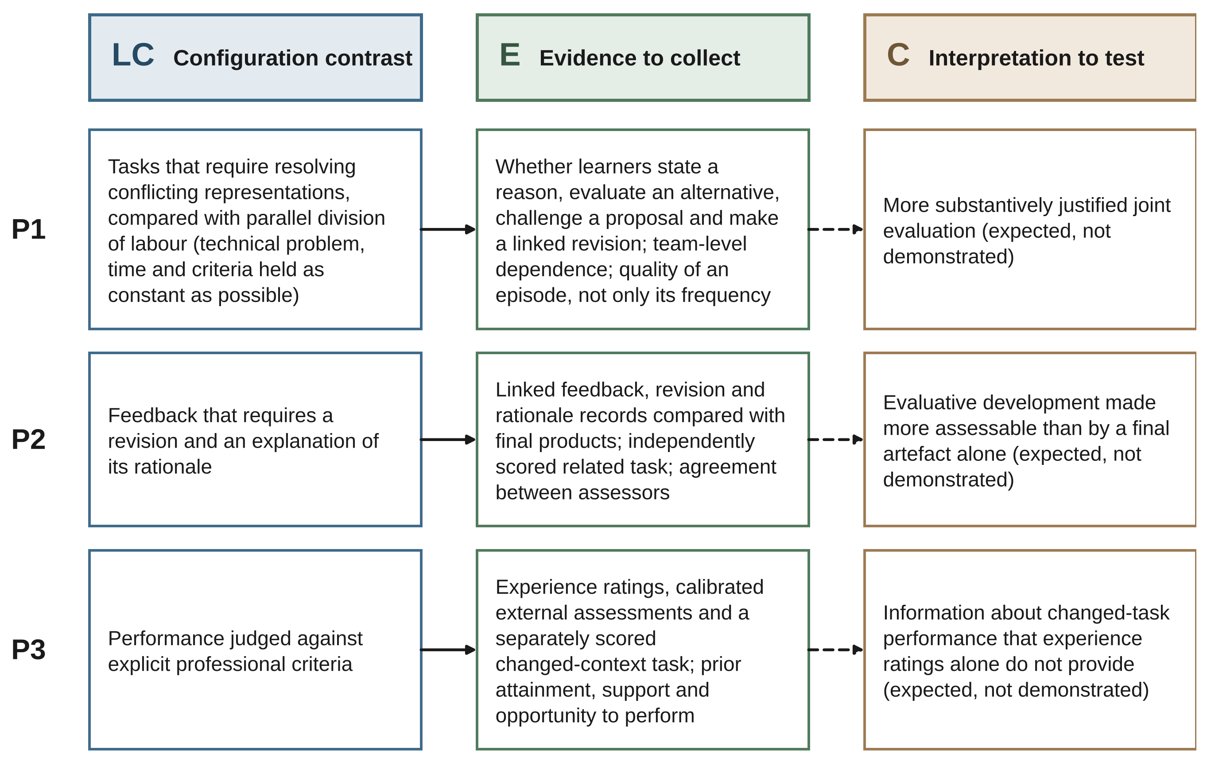
Figure 6. Research propositions derived from the synthesis. Each row links a contrast in learning configuration (LC) to the evidence (E) that would be collected and the interpretation (C) to be tested. The propositions are expectations for future studies, not demonstrated relationships.

3.12 Worked example from a design conflict to a competence claim
This example is a proposed application of LCEC, not an additional empirical result. Consider a team asked to resolve a conflict between a service route and a structural element under cost, access and construction-sequence constraints. These conditions, the assignment of responsibilities and the available support define LC. A shared BIM model may assist inspection and coordination, but annotated drawings could serve the same purpose if they make the conflict visible. Assigning team roles establishes a collaborative arrangement; it does not establish the quality of the team’s judgement. Figure 7 illustrates the example. [ความเห็น: Fig. 7 แสดง 5 claims (Team performance, Individual capability, Situated judgement, External alignment, Transfer) ซึ่งไม่ตรงกับ 5 bands ใน Table 3 (Team performance และ Individual capability ไม่ใช่ band) — ชี้แจงในเนื้อหา/คำบรรยายรูป หรือจัดให้สอดคล้องกัน เพื่อไม่ให้ผู้อ่านเข้าใจว่าเป็นชุดเดียวกัน]
To generate E, the assessment could retain annotated alternatives, a short recorded critique and linked versions of the design. Criteria would address technical reasoning, the treatment of constraints and the justification of the revision, rather than simply the absence of clashes in the final model. A correct group product supports a bounded interpretation of team performance. Attributing that capability to each student would require individual evidence, such as an independently explained decision or performance on a related task.
C would then be stated at the scope the evidence supports. Recorded critique and justified revision may support an interpretation of situated judgement. Calibrated practitioner assessment against explicit criteria may support external alignment. Transfer requires performance under changed task conditions with the level of support documented; workplace capability requires evidence appropriate to actual work. A delayed repetition of the original task addresses retention, not necessarily transfer. The example shows how one learning configuration can generate several kinds of evidence, each supporting a distinct claim.
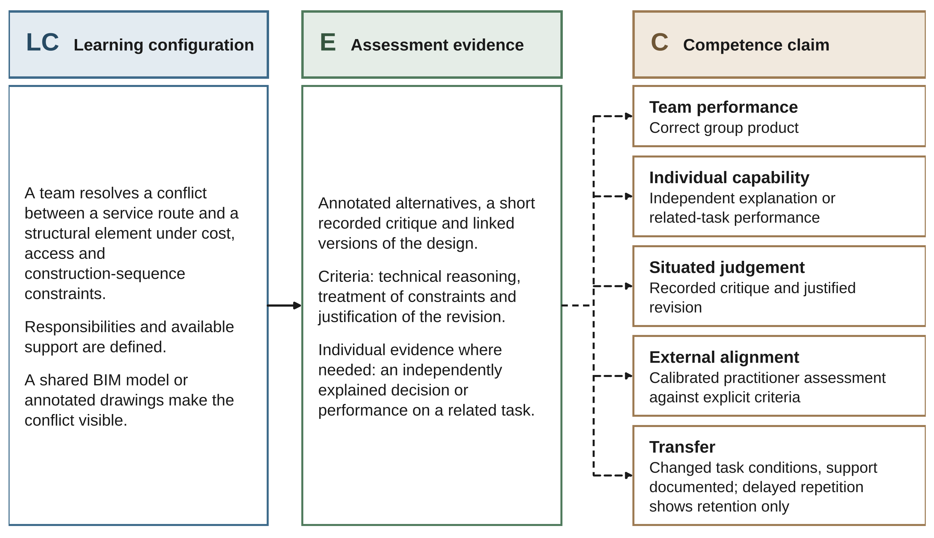
Figure 7. Worked example of LCEC applied to a design conflict between a service route and a structural element. One learning configuration can generate several kinds of evidence, and each supports a distinct claim. The example is a proposed application, not an additional empirical result.

4 Discussion

4.1 Contribution and positioning
The review’s contribution is the integration of learning configuration, assessment evidence and competence interpretation across contrasting AEC and construction-related vocational cases. It does not rest on the novelty of authentic tasks, collaboration or assessment. Separating the three units explains why similar educational activities may support different conclusions: the activity can be comparable while the evidence collected, the unit assessed or the claimed context differs. LCEC gives this distinction a practical structure for design, laboratory, capstone and vocational learning. [ความเห็น: 'practical structure' อาจเกินหลักฐาน เพราะ LCEC ยังไม่ได้ทดสอบกับผู้ใช้/ในสถานการณ์จริง (ขัดกับท่าทีของบทความที่ว่าเป็น provisional synthesis) — พิจารณา 'a proposed structure'] Extension beyond the reviewed settings remains an empirical question. [ความเห็น: ประโยคเชิงปฏิเสธ/ระมัดระวังซ้ำมากทั้งบทความ (นับคร่าว ๆ จากเนื้อหาก่อน References: 'rather than' ≈ 33, 'does not' ≈ 24, 'not establish' ≈ 17 ครั้ง) — ผู้ประเมินอาจมองว่าซ้ำและบั่นทอนข้อเสนอเชิงบวก; พิจารณารวม/ตัดประโยคปฏิเสธที่ซ้ำ โดยคงไว้เฉพาะใน Abstract, §2 และ §4.5]
Table 6 positions LCEC alongside established theory and related syntheses. Constructive alignment addresses coherence between outcomes, activity and assessment, while authenticity frameworks characterise the relationship between assessment and practice (Biggs, 1996; Gulikers et al., 2004). Validity theory already supplies the basis for evaluating interpretations and uses (Kane, 2013; Messick, 1995). Gough (2021) extends attention to the fitness for purpose of evidence claims, including the relevance and quality of the evidence and competing explanations. LCEC applies these concerns to the link between an educational configuration and the interpretation of the performance it makes observable; it does not propose a replacement theory of validity.
Related assessment work also limits what can reasonably be claimed as new. The 4Ps framework distinguishes product, process, performance and practice as proxies used in assessment (Fawns et al., 2026). LCEC is compatible with that distinction: its evidence unit can include any of those sources. Its particular emphasis is the relation of evidence to task constraints, social organisation and instructional support in AEC learning, followed by an explicit statement of claim scope. Reviews of digital instructional alignment and construction-management teaching address complementary questions about pedagogical functions and educational arrangements (Hou et al., 2026; Jayathilaka et al., 2025). The present synthesis contributes an applied cross-case interpretation, not superior coverage or a quantitative estimate of effectiveness.
Table 6. LCEC in relation to established theory and review frameworks
Foundation or framework | Primary concern | Relationship to LCEC
Constructive alignment  Biggs (1996) | Coherence of outcomes, activity and assessment | LC records the design; E–C asks what the resulting evidence justifies.
Authentic assessment  Gulikers et al. (2004) | Relations between assessment and professional practice | Task authenticity is retained within LC, separate from evidence of competence.
Validity theory  Kane (2013); Messick (1995) | Justification of interpretations and uses | Provides the basis of the E–C warrant; LCEC is an application, not a replacement.
Evidence-claim appraisal  Gough (2021) | Fitness for purpose, relevant evidence and alternative explanations | Situates claim-specific appraisal within the concrete conditions of engineering learning.
4Ps assessment framework  Fawns et al. (2026) | Product, process, performance and practice as assessment proxies | These sources can populate E; LCEC relates them to configuration and claim scope.
Digital and construction-teaching reviews  Hou et al. (2026); Jayathilaka et al. (2025) | Instructional functions, alignment and teaching arrangements | LCEC compares what arrangements make observable and what those observations support.
Training and practical-skills reviews  Toyoda et al. (2022); Yang et al. (2024) | Outcome distinctions, effects and contextual variation | Informs claim boundaries without attributing effect estimates or moderator tests to LCEC.
Note. Analytical purposes are compared, not the relative quality of the cited work. LCEC integrates and applies established ideas to a bounded educational corpus; the comparison does not establish theoretical superiority.
Technology is not indispensable within this structure. Research on active learning directs attention to what students do (Freeman et al., 2014), and work on cognitive demands and scaffolding also cautions against equating authenticity with minimal guidance (Hmelo-Silver et al., 2007; Kirschner et al., 2006). The design problem is to support demanding judgement while progressively giving learners responsibility for it. A digital platform is one possible means, not the defining feature of professional learning.

4.2 Behavioural depth and the role of feedback
The proposed mechanism becomes testable when judgement is specified at a suitable level of detail. [ความเห็น: คำว่า 'mechanism' สื่อถึงกลไกเชิงเหตุผล ขัดกับข้อความอื่นที่ระบุว่า LCEC ไม่ใช่ causal model (Abstract, §3.8, Fig. 4) — พิจารณาใช้ 'proposed interpretive account' หรือคำที่เป็นกลางกว่า] A learner may identify a clash without explaining its consequence; a team may agree quickly because one member’s view goes unchallenged. A revised artefact may reproduce the instructor’s answer rather than demonstrate improved reasoning. These alternatives motivate the analysis of episodes connecting a problem representation, a proposed explanation, an evaluative response and a subsequent action. Who initiates, questions and enacts a decision matters alongside the final outcome.
Peer assessment provides a useful setting for examining this process when both criteria and the basis of each judgement are visible. Its promise does not remove questions of expertise, fairness and calibration (Topping, 1998). Preparation for longer-term learning also requires students to evaluate work beyond the immediate assignment (Boud & Falchikov, 2006). In LCEC, feedback uptake and justified revision are potentially informative evidence, while self-report and artefacts each offer partial views. Convergence across sources may strengthen an interpretation; agreement among similar measures does not itself establish validity.
Immersive-learning research makes a related distinction between experience and learning. Cognitive load, presence and affect may change how an environment is experienced without producing a corresponding learning advantage (Makransky & Petersen, 2021; Sweller, 1988). Experimental work outside the core corpus reports greater presence alongside poorer learning and shows the importance of instructional choices (Makransky et al., 2019; Parong & Mayer, 2018). A review of immersive virtual reality applications in higher education likewise distinguishes technological affordances from educational design (Radianti et al., 2020). These sources inform the interpretation; their findings are not counted among the 35 core reports.

4.3 Appraisal must change the conclusion
The critical appraisal is visible in the conclusions retained from specific cases. Survey evaluation of collaborative BIM supports an account of experience and design rather than an independently measured competence gain (Chenah & Boton, 2026). Vocational regression supports association rather than causation (Setiawan et al., 2021). A novice–expert comparison provides a reference for situated performance rather than a developmental trajectory (Wu et al., 2019). The site-visit comparison requires performance and experience to be considered separately (Sun et al., 2022). These limits are part of the synthesis, not quality labels appended to an unchanged narrative.
This approach does not rank qualitative evidence below quantitative work because it lacks a control group. Tutor interviews can explain what makes a workshop educationally demanding, and learner accounts can illuminate the relation between an artefact and participation. The warrant depends on the fit between question, data and interpretation, including contextual detail and alternative readings (Walther et al., 2013). LCEC’s evidence-claim bands distinguish the kind and scope of an inference, not a universal hierarchy of methods.

4.4 Implications for educational design and research
For educators, the practical starting point is a professional decision that learners should be able to justify. Task representations, interdependence and assessment can then be chosen to make that reasoning visible. A document-based dispute, a physical workshop and a shared model may each serve this purpose. Digital infrastructure is warranted when it makes a specific contribution, such as revealing a hidden spatial relationship, preserving revisions or enabling critique of an otherwise inaccessible task. “Preparing the future workforce” is too broad to serve as an instructional specification.
For researchers, knowledge, judgement, collaboration and workplace application require linked but distinct operational definitions and appropriate units of analysis. Team performance cannot be treated as independent observations of individual students without accounting for that dependence. Cohort comparisons need to consider prior attainment, instructors, assessment rules and concurrent changes. Digital-trace studies must justify the relationship between an observable event and the construct inferred from it; a long sequence of clicks is not, by itself, an assessment of judgement.
Transfer and fairness remain demanding directions for further research. Studies could assess an underlying professional problem under deliberately changed representations or constraints, then follow learners into supervised work where feasible. They would need to document support, opportunities to perform and the receiving environment rather than attribute every difference to the course. Access and inclusion also deserve explicit attention. Research on minoritised construction students, safety in school construction courses and cross-disciplinary curriculum development highlights conditions that technology-centred accounts can overlook (Balogun et al., 2023; Gharipour & Trout, 2020; Love & Roy, 2023). The configuration and evidence records should therefore identify who can participate, whose judgement is recognised and what resources performance requires.
Contextual research on authentic construction activity reinforces the value of specifying task characteristics rather than treating realism as a sufficient explanation (Patil et al., 2025). The propositions in Section 3.11 can be examined through replicated course studies, process analyses and changed-context tasks. LCEC should also be tested where individual mastery is central, collaboration is unnecessary or digital access adds difficulty. Such cases would test the framework’s usefulness and boundaries, not represent incomplete implementation of a prescribed teaching model.

4.5 Limitations
Corpus selection is the principal limitation. The 76-report collection arose through a historical discovery process whose complete search and screening chain could not be reconstructed. The 35 core reports are not a representative sample, and the retained 2016–2026 publication window does not imply complete coverage through 2026. Availability and prior prioritisation may have favoured accessible, digitally prominent or positively framed work. Targeted source checking and supplementary conceptual references do not repair that selection history. The review cannot establish field-wide prevalence, publication bias, theoretical saturation or the absence of transfer research elsewhere.
Expert review of the R2 summaries was not independently documented duplicate full-text coding. Source checking during manuscript preparation varied in depth according to access, from bibliographic records and abstracts to selected full-text passages. Supplementary Material S1 distinguishes these levels and preserves unresolved fields. Thus, a report’s presence in the core matrix does not mean that every result or methodological detail has been independently verified. The retained summaries and incomplete coding archive limit the reproducibility and authority of the cross-case interpretation. [ความเห็น: Limitations ยังไม่กล่าวถึงบทบาทของเครื่องมือ AI ในการสรุป/เปรียบเทียบการลงรหัส (ตาม Declarations) — ควรเพิ่มประโยคเรื่องความเสี่ยงต่อข้อผิดพลาดจากการสรุปด้วย AI และวิธีตรวจสอบที่ทำจริง]
No standardised design-specific risk-of-bias or formal certainty assessment was completed. Claim-specific appraisal is useful for identifying overextended interpretations but is not a substitute for such procedures when estimating effects. Reports may share institutions, course histories or participants; independent study linkage was not established. LCEC also reflects prior theoretical commitments and was consolidated after exposure to the evidence. Its constructs, proposed judgement-episode coding and research propositions require independent critique and testing. It is a framework for examining competence claims, not for certifying that a course or graduate is professionally ready.

5 Conclusions
The three objectives of this review lead to the following conclusions. [ความเห็น: ข้อสรุป (i)–(iii) ซ้ำกับ §3.7 เกือบทั้งหมด — ย่อ §3.7 หรือให้ Conclusions เน้นนัยเชิงปฏิบัติ ข้อจำกัด และงานวิจัยต่อไป เพื่อลดความซ้ำ]
- Objective (i), learning configurations. The reviewed reports organised learning through varied configurations rather than a single preferred method. Material workshops, document-based disputes, shared digital models and individual simulations organised different decisions and forms of participation. Authenticity depended on the constraints and decisions that learners had to address, and neither teamwork nor digital mediation was common to every relevant case.
- Objective (ii), assessment evidence and interpretations. Surveys captured experience, tests captured bounded knowledge or performance, and interaction or revision records exposed aspects of judgement. Assessment design determined which interpretations could be supported: learner response, task learning, situated judgement, external alignment and transfer required distinct evidence, and a team product did not establish the independent capability of each member.
- Objective (iii), gaps and framework. The recurring gap was an insufficiently specified link between configuration, evidence and claim, not a uniform absence of educational value. The LCEC Framework integrates this distinction through three analytical units. The resulting research gaps concern observable reasoning, individual attribution, professional criteria, context change and assessment timing, and three propositions indicate how these gaps could be examined.
LCEC is a provisional synthesis of a bounded, non-exhaustive collection. It is not a validated causal model or a certification of professional readiness. For educational practice, it directs attention to consequential decisions, records of learners’ reasoning and claims bounded by the evidence; for research, it offers a concrete basis for examining what engineering-learning innovations enable and what their evidence can establish.

Declarations
Use of artificial intelligence. SciSpace supported supplementary literature discovery. GPT/Codex assisted evidence organisation, preliminary summaries, source examination, coding comparisons, framework development, figure preparation, substantive drafting, translation and language editing. Claude (Anthropic) assisted in restructuring Version 1 of the manuscript into Introduction, Materials and Methods, Results, Discussion and Conclusions sections, in language editing, in preparing figures and in checking bibliographic metadata against the Crossref registry. A human subject-matter expert reviewed and refined the R2 assessment. Human review and author responsibility are distinct from independent duplicate coding. The authors are responsible for the classifications, interpretations, references and submitted text. [ความเห็น: ข้อความระบุบทบาทของ Claude เฉพาะ 'Version 1' — ปรับให้ครอบคลุมงานรอบ V2 ตามจริง (ออกแบบรูปใหม่ ปรับ Declarations และให้ข้อเสนอแนะ) และเปิดเผยให้ตรงกับนโยบาย AI ของวารสารเป้าหมาย; ไม่ได้แก้ข้อความของผู้เขียนเอง]
Data availability. Supplementary Material S1 accompanies this manuscript. It contains the 76-report inventory, recorded screening decisions and flags, corrected dispositions, the 35-report core evidence matrix, an LCEC coding guide and crosswalk, a synthesis map, and source-check records identifying the scope of verification. Additional conceptual and methodological references are recorded separately from the retained corpus. The supplement is not a reconstructed comprehensive search dataset or a record of independent full-text coding of every report. Copyrighted source PDFs are not redistributed.
Acknowledgements. [ความเห็น: ต้นฉบับมีเฉพาะหัวข้อ ไม่มีเนื้อหา — ใส่ชื่อบุคคล/หน่วยงานที่ต้องการขอบคุณ (เช่น ผู้เชี่ยวชาญที่ทบทวน R2 หากไม่ได้เป็นผู้เขียน) หรือหากไม่มี ให้ใช้ 'The authors have no acknowledgements to declare.' หรือตัดหัวข้อออกตามที่วารสารกำหนด; ไม่ได้เติมข้อความแทนผู้เขียน]
Funding. This research received no external funding.
Conflict of interest. The authors declare no conflict of interest. [ความเห็น: หาก Saekram et al. (2023) เป็นงานของผู้เขียนเอง ควรพิจารณาเปิดเผยในข้อนี้ — ดูหมายเหตุที่ §3.4]
Author contributions. Study conception and design: Piyarat Paoleng. Analysis and interpretation of results: Siriphat Maneekeaw and Piyarat Paoleng. Draft manuscript preparation and supervision: Piyarat Paoleng. Review and editing: Siriphat Maneekeaw, Krairoj Mahannopkul, Phuwadon Yaiyindee and Surawut Saekram. All authors reviewed the results and approved the final version of the manuscript. [ความเห็น: (1) เรียบเรียงเป็นประโยคสั้นและใช้ 'Author contributions' ตามรูปแบบทั่วไป เนื้อหาและชื่อเดิมครบ — หากวารสารกำหนด CRediT taxonomy ให้เปลี่ยนตามนั้น; (2) AI statement ระบุว่า GPT/Codex ช่วย 'substantive drafting' แต่ข้อนี้ระบุว่า Piyarat Paoleng เป็นผู้เตรียมร่างต้นฉบับ — ควรปรับให้สอดคล้องกัน และตรวจนโยบาย AI ของวารสารเป้าหมาย]
Ethics statement. Not applicable. This review analysed published reports and involved no human participants, human data or animal subjects. [ความเห็น: รวม 'Ethics statement' สองข้อที่ซ้ำกันให้เหลือข้อเดียว และเปลี่ยน 'curriculum documents' (ในข้อความไฮไลต์เดิม) เป็น 'published reports' ให้ตรงกับ §2.2 และ Declarations — โปรดยืนยันว่าถูกต้อง (หากงานวิเคราะห์เอกสารหลักสูตรจริง ต้องแก้ Methods ด้วย)]

References
[ความเห็น: ตรวจเบื้องต้นแบบอัตโนมัติ (จับคู่ชื่อผู้เขียนแรก–ปี) พบว่า 110 รายการใน References ทุกรายการถูกอ้างในเนื้อหา และการอ้างในเนื้อหามีรายการใน References ครบ แต่ยังไม่ได้ตรวจความถูกต้องของ DOI/เล่ม/หน้า — ควรตรวจรูปแบบรายการที่ผิดปกติ เช่น Lozano et al. (2025) ไม่มีเล่ม/ฉบับ, Salman et al. (2025) 'sp(VII)', Fawns et al. (2026) advance online (อัปเดตเมื่อตีพิมพ์) และจัดรูปแบบตามวารสารเป้าหมาย]
Ahmed, Y., Farooqui, R. U., & Ahmed, S. M. (2026). Contemporary pedagogical techniques in studio instruction to enhance quality in construction management and built environment education programs in the United States. Buildings, 16(3), 603. https://doi.org/10.3390/buildings16030603
Alizadehsalehi, S., Hadavi, A., & Huang, J. C. (2021). Assessment of AEC students' performance using BIM-into-VR. Applied Sciences, 11(7), 3225. https://doi.org/10.3390/app11073225
Andalib, S. Y., & Monsur, M. (2024). Co-created virtual reality (VR) modules in landscape architecture education: A mixed methods study investigating the pedagogical effectiveness of VR. Education Sciences, 14(6), 553. https://doi.org/10.3390/educsci14060553
Andalib, S. Y., Monsur, M., Cook, C., Lemon, M., Zawarus, P., & Loon, L. (2025). Enhancing landscape architecture construction learning with extended reality (XR): Comparing interactive virtual reality (VR) with traditional learning methods. Education Sciences, 15(8), 992. https://doi.org/10.3390/educsci15080992
Andrić, J. M., Saeed, N., & Ammari Allahyari, T. M. (2026). Improving students' motivation, engagement and learning environment in a transnational civil engineering program. Education Sciences, 16(1), 61. https://doi.org/10.3390/educsci16010061
Arneson, E., & Ozbek, M. E. (2020). Mock arbitration as experiential legal education for construction management students. Journal of Legal Affairs and Dispute Resolution in Engineering and Construction, 12(2), Article 04520010. https://doi.org/10.1061/(asce)la.1943-4170.0000384
Azevedo, V. F. B. D., Lago, E. M. G., Griz, C. M. S., Gusmão, A. D., & Vasconcelos, B. M. (2026). Assessment of BIM maturity in civil engineering education: A diagnostic study applied to the Polytechnic School of the University of Pernambuco in the Brazilian context. Buildings, 16(1), 221. https://doi.org/10.3390/buildings16010221
Baldwin, T. T., & Ford, J. K. (1988). Transfer of training: A review and directions for future research. Personnel Psychology, 41(1), 63–105. https://doi.org/10.1111/j.1744-6570.1988.tb00632.x
Balogun, T. B., Awonuga, O. O., & Abowen-Dake, R. (2023). Investigating digital technological competencies amongst Black Asian minority ethnic construction students in the UK. Journal of Engineering, Design and Technology, 21(6), 1857–1882. https://doi.org/10.1108/jedt-08-2021-0449
Barron, B. (2003). When smart groups fail. Journal of the Learning Sciences, 12(3), 307–359. https://doi.org/10.1207/s15327809jls1203_1
Basson, J. P., & Smallwood, J. (2026). A seven-step BIM collaboration model for AEC education: Bridging disciplinary silos through BIM maturity level 3 implementation. Buildings, 16(7), 1282. https://doi.org/10.3390/buildings16071282
Biggs, J. (1996). Enhancing teaching through constructive alignment. Higher Education, 32(3), 347–364. https://doi.org/10.1007/bf00138871
Blume, B. D., Ford, J. K., Baldwin, T. T., & Huang, J. L. (2010). Transfer of training: A meta-analytic review. Journal of Management, 36(4), 1065–1105. https://doi.org/10.1177/0149206309352880
Borrego, M., Douglas, E. P., & Amelink, C. T. (2009). Quantitative, qualitative, and mixed research methods in engineering education. Journal of Engineering Education, 98(1), 53–66. https://doi.org/10.1002/j.2168-9830.2009.tb01005.x
Borrego, M., Foster, M. J., & Froyd, J. E. (2014). Systematic literature reviews in engineering education and other developing interdisciplinary fields. Journal of Engineering Education, 103(1), 45–76. https://doi.org/10.1002/jee.20038
Boud, D., & Falchikov, N. (2006). Aligning assessment with long-term learning. Assessment & Evaluation in Higher Education, 31(4), 399–413. https://doi.org/10.1080/02602930600679050
Boud, D., & Molloy, E. (2013). Rethinking models of feedback for learning: The challenge of design. Assessment & Evaluation in Higher Education, 38(6), 698–712. https://doi.org/10.1080/02602938.2012.691462
Brown, J. S., Collins, A., & Duguid, P. (1989). Situated cognition and the culture of learning. Educational Researcher, 18(1), 32–42. https://doi.org/10.3102/0013189x018001032
Carless, D., & Boud, D. (2018). The development of student feedback literacy: Enabling uptake of feedback. Assessment & Evaluation in Higher Education, 43(8), 1315–1325. https://doi.org/10.1080/02602938.2018.1463354
Carroll, C., Booth, A., Leaviss, J., & Rick, J. (2013). "Best fit" framework synthesis: Refining the method. BMC Medical Research Methodology, 13(1), 37. https://doi.org/10.1186/1471-2288-13-37
Celadyn, M. (2020). Integrative design classes for environmental sustainability of interior architectural design. Sustainability, 12(18), 7383. https://doi.org/10.3390/su12187383
Chenah, D. E., & Boton, C. (2026). Teaching collaborative BIM in higher education: A new pedagogical framework. Journal of Civil Engineering Education, 152(4), Article 05026003. https://doi.org/10.1061/jceecd.eieng-2356
Chi, M. T. H., & Wylie, R. (2014). The ICAP framework: Linking cognitive engagement to active learning outcomes. Educational Psychologist, 49(4), 219–243. https://doi.org/10.1080/00461520.2014.965823
Chimwayange, C. (2025). Promoting student engagement using project based learning as service-based skills development. International Journal of Technology and Design Education, 35(4), 1429–1446. https://doi.org/10.1007/s10798-024-09947-w
Coronado, J. M., Moyano, A., Romero, V., Ruiz, R., & Rodríguez, J. (2021). Student long-term perception of project-based learning in civil engineering education: An 18-year ex-post assessment. Sustainability, 13(4), 1949. https://doi.org/10.3390/su13041949
Curto, R., Barreca, A., Coscia, C., Ferrando, D. G., Fregonara, E., & Rolando, D. (2021). The active role of students, teachers, and stakeholders in managing economic and cultural value, urban and built heritage. Interdisciplinary Journal of Problem-Based Learning, 15(1). https://doi.org/10.14434/ijpbl.v15i1.29626
Elenany, Y., & Ahmed, V. (2024). A digital simulation game for resource management in construction projects. Electronic Journal of e-Learning, 22(10), 01–18. https://doi.org/10.34190/ejel.22.10.3495
Elgewely, M. H., Nadim, W., ElKassed, A., Yehiah, M., Talaat, M. A., & Abdennadher, S. (2021). Immersive construction detailing education: Building information modeling (BIM)-based virtual reality (VR). Open House International, 46(3), 359–375. https://doi.org/10.1108/ohi-02-2021-0032
Engeström, Y. (2001). Expansive learning at work: Toward an activity theoretical reconceptualization. Journal of Education and Work, 14(1), 133–156. https://doi.org/10.1080/13639080020028747
Ezennia, I. S., & Agbonome, P. C. (2025). Advances in design studio critique techniques: A narrative review on innovative critique models and lessons for improving architecture education. Discover Education, 4(1), 369. https://doi.org/10.1007/s44217-025-00824-9
Fahmy, A. (2025). A review on structural literacy in architectural education. Buildings, 15(23), 4312. https://doi.org/10.3390/buildings15234312
Fawns, T., Boud, D., & Dawson, P. (2026). Identifying what our students have learned: A framework for practical assessment validation. Assessment & Evaluation in Higher Education. Advance online publication. https://doi.org/10.1080/02602938.2026.2620053
Fiegel, G., & DeNatale, J. (2010). Collaborating with local practitioners to lead a capstone civil engineering design course. In 2010 Annual Conference & Exposition Proceedings (pp. 15.283.1–15.283.17). https://doi.org/10.18260/1-2--16226
Freeman, S., Eddy, S. L., McDonough, M., Smith, M. K., Okoroafor, N., Jordt, H., & Wenderoth, M. P. (2014). Active learning increases student performance in science, engineering, and mathematics. Proceedings of the National Academy of Sciences, 111(23), 8410–8415. https://doi.org/10.1073/pnas.1319030111
García-Ramírez, Y. (2025a). Enhancing civil engineering education through innovative STEM-based prototyping: A comparative study of physical models and board games in geometric road design. Humanities and Social Sciences Communications, 12(1), 686. https://doi.org/10.1057/s41599-025-05020-6
García-Ramírez, Y. (2025b). Impact of team role distribution on performance in civil engineering education: A TREO survey analysis. Edelweiss Applied Science and Technology, 9(3), 1403–1414. https://doi.org/10.55214/25768484.v9i3.5534
Gharipour, M., & Trout, A. L. (2020). Curriculum development in health and the built environment: Creating a multidisciplinary platform to enhance knowledge and engagement. Archnet-IJAR: International Journal of Architectural Research, 14(3), 439–452. https://doi.org/10.1108/arch-09-2019-0212
Gladovic, C. (2026). Hard hats, soft skills: A responsive scaffold model for construction management education. Construction Economics and Building, 26(1). https://doi.org/10.5130/b3db7q35
Gough, D. (2021). Appraising evidence claims. Review of Research in Education, 45(1), 1–26. https://doi.org/10.3102/0091732X20985072
Grant, M. J., & Booth, A. (2009). A typology of reviews: An analysis of 14 review types and associated methodologies. Health Information & Libraries Journal, 26(2), 91–108. https://doi.org/10.1111/j.1471-1842.2009.00848.x
Gulikers, J. T. M., Bastiaens, T. J., & Kirschner, P. A. (2004). A five-dimensional framework for authentic assessment. Educational Technology Research and Development, 52(3), 67–86. https://doi.org/10.1007/bf02504676
Gutai, M., & Palaiologou, G. (2021). Pavilions in architecture studio—Assessment of design-build approach in architecture education. Architecture, 1(1), 38–55. https://doi.org/10.3390/architecture1010005
Herrington, J., & Oliver, R. (2000). An instructional design framework for authentic learning environments. Educational Technology Research and Development, 48(3), 23–48. https://doi.org/10.1007/bf02319856
Hmelo-Silver, C. E., Duncan, R. G., & Chinn, C. A. (2007). Scaffolding and achievement in problem-based and inquiry learning: A response to Kirschner, Sweller, and Clark (2006). Educational Psychologist, 42(2), 99–107. https://doi.org/10.1080/00461520701263368
Hong, Q. N., Fàbregues, S., Bartlett, G., Boardman, F., Cargo, M., Dagenais, P., Gagnon, M. P., Griffiths, F., Nicolau, B., O'Cathain, A., Rousseau, M. C., Vedel, I., & Pluye, P. (2018). The mixed methods appraisal tool (MMAT) version 2018 for information professionals and researchers. Education for Information, 34(4), 285–291. https://doi.org/10.3233/efi-180221
Hou, X., Wang, Y., Xiao, B., Liu, H., & Mueller, S. T. (2026). Instructional applications and pedagogical alignment of digital technologies in construction education: A structured review. Advanced Engineering Informatics, 74, Article 104647. https://doi.org/10.1016/j.aei.2026.104647
Hussain, R., Anjum, S., Abraham, Y., Rambo-Hernandez, K., Akanmu, A., & Nnaji, C. (2026). Integrating computational thinking into immersive construction education: A framework for VR-based learning. Computer Applications in Engineering Education, 34(3), Article e70198. https://doi.org/10.1002/cae.70198
Javidan, F., & Soltani, A. (2026). Leveraging computer technology for authentic and impactful peer assessment in civil engineering education. Journal of Civil Engineering Education, 152(3), Article 05026001. https://doi.org/10.1061/jceecd.eieng-2334
Jayathilaka, R. D. W. W., Wijewickrama, M. K. C. S., & Edwards, D. J. (2025). Developing a holistic teaching and learning framework for construction management education: A systematic literature review. Engineering, Construction and Architectural Management, 32(13), 258–284. https://doi.org/10.1108/ecam-11-2024-1557
Johnson, D. W., & Johnson, R. T. (2009). An educational psychology success story: Social interdependence theory and cooperative learning. Educational Researcher, 38(5), 365–379. https://doi.org/10.3102/0013189x09339057
Johri, A., & Olds, B. M. (2011). Situated engineering learning: Bridging engineering education research and the learning sciences. Journal of Engineering Education, 100(1), 151–185. https://doi.org/10.1002/j.2168-9830.2011.tb00007.x
Kamardeen, I., & Samaratunga, M. (2020). DigiExplanation driven assignments for personalising learning in construction education. Construction Economics and Building, 20(3). https://doi.org/10.5130/ajceb.v20i3.7000
Kane, M. T. (2013). Validating the interpretations and uses of test scores. Journal of Educational Measurement, 50(1), 1–73. https://doi.org/10.1111/jedm.12000
Karadağ, D. (2025). AI in architectural education: Rethinking studio culture. PLANARCH - Design and Planning Research, 9(2), 243–253. https://doi.org/10.54864/planarch.1749891
Kirschner, P. A., Sweller, J., & Clark, R. E. (2006). Why minimal guidance during instruction does not work: An analysis of the failure of constructivist, discovery, problem-based, experiential, and inquiry-based teaching. Educational Psychologist, 41(2), 75–86. https://doi.org/10.1207/s15326985ep4102_1
Lave, J., & Wenger, E. (1991). Situated learning: Legitimate peripheral participation. Cambridge University Press. https://doi.org/10.1017/cbo9780511815355
Love, T. S., & Roy, K. R. (2023). A study of safety issues and accidents in secondary education construction courses within the United States. Sustainability, 15(14), Article 11028. https://doi.org/10.3390/su151411028
Lozano, M., Brioso, X., & Herrera, R. F. (2025). Simulations for teaching construction management: A systematic literature review. Engineering, Construction and Architectural Management, 1–38. https://doi.org/10.1108/ecam-11-2024-1587
Luyten, L., Vrouwe, I., & Acican, Ö. (2025). Pedagogical analysis of construction workshops in architecture programs to teach structure and construction. Architecture, Structures and Construction, 5(1), 31. https://doi.org/10.1007/s44150-025-00146-2
Makransky, G., & Petersen, G. B. (2021). The cognitive affective model of immersive learning (CAMIL): A theoretical research-based model of learning in immersive virtual reality. Educational Psychology Review, 33(3), 937–958. https://doi.org/10.1007/s10648-020-09586-2
Makransky, G., Terkildsen, T. S., & Mayer, R. E. (2019). Adding immersive virtual reality to a science lab simulation causes more presence but less learning. Learning and Instruction, 60, 225–236. https://doi.org/10.1016/j.learninstruc.2017.12.007
Marks, M. A., Mathieu, J. E., & Zaccaro, S. J. (2001). A temporally based framework and taxonomy of team processes. Academy of Management Review, 26(3), 356–376. https://doi.org/10.5465/amr.2001.4845785
Martí, N., Fonseca, D., Peña, E., Adroer, M., & Simón, D. (2017). Design of interactive and collaborative learning units using TICs in architectural construction education. Revista de la construcción, 16(1), 34–42. https://doi.org/10.7764/rdlc.16.1.33
McCord, K. H., Ayer, S. K., Wu, W., Perry, L. A., London, J. S., & Kopitske, J. (2023). Using augmented reality to simulate authentic learning building assessment and construction experiences. Journal of Architectural Engineering, 29(3), Article 04023023. https://doi.org/10.1061/jaeied.aeeng-1531
Messick, S. (1995). Validity of psychological assessment: Validation of inferences from persons' responses and performances as scientific inquiry into score meaning. American Psychologist, 50(9), 741–749. https://doi.org/10.1037/0003-066x.50.9.741
Mojtahedi, M., Kamardeen, I., Rahmat, H., & Ryan, C. (2020). Flipped classroom model for enhancing student learning in construction education. Journal of Civil Engineering Education, 146(2), Article 05019001. https://doi.org/10.1061/(asce)ei.2643-9115.0000004
Na, R., Aljagoub, D., Zhao, T., & Lin, X. (2026). Technology acceptance and perceived learning outcomes in construction surveying education: A comparative analysis using UTAUT and Bloom's taxonomy. Education Sciences, 16(1), 45. https://doi.org/10.3390/educsci16010045
Nguyen, T. D., & Adhikari, S. (2025). Bridging the gap: Enhancing BIM education for sustainable design through integrated curriculum and student perception analysis. Computers, 14(11), 463. https://doi.org/10.3390/computers14110463
Nicol, D. J., & Macfarlane-Dick, D. (2006). Formative assessment and self-regulated learning: A model and seven principles of good feedback practice. Studies in Higher Education, 31(2), 199–218. https://doi.org/10.1080/03075070600572090
Nikolic, D., Castronovo, F., & Leicht, R. (2021). Teaching BIM as a collaborative information management process through a continuous improvement assessment lens: A case study. Engineering, Construction and Architectural Management, 28(8), 2248–2269. https://doi.org/10.1108/ecam-11-2020-1000
Ohland, M. W., Loughry, M. L., Woehr, D. J., Bullard, L. G., Felder, R. M., Finelli, C. J., Layton, R. A., Pomeranz, H. R., & Schmucker, D. G. (2012). The comprehensive assessment of team member effectiveness: Development of a behaviorally anchored rating scale for self- and peer evaluation. Academy of Management Learning & Education, 11(4), 609–630. https://doi.org/10.5465/amle.2010.0177
Ohueri, C. C., Masrom, M. A. N., & Lohana, S. (2025). Advances in immersive virtual reality-based construction management student learning. Journal of Construction Engineering and Management, 151(1), Article 03124009. https://doi.org/10.1061/jcemd4.coeng-15345
Olowa, T., Witt, E., & Lill, I. (2023). Building information modelling (BIM) - enabled construction education: Teaching project cash flow concepts. International Journal of Construction Management, 23(9), 1494–1505. https://doi.org/10.1080/15623599.2021.1979300
Page, M. J., McKenzie, J. E., Bossuyt, P. M., Boutron, I., Hoffmann, T. C., Mulrow, C. D., Shamseer, L., Tetzlaff, J. M., Akl, E. A., Brennan, S. E., Chou, R., Glanville, J., Grimshaw, J. M., Hróbjartsson, A., Lalu, M. M., Li, T., Loder, E. W., Mayo-Wilson, E., McDonald, S., ... Moher, D. (2021). The PRISMA 2020 statement: An updated guideline for reporting systematic reviews. BMJ, 372, Article n71. https://doi.org/10.1136/bmj.n71
Park, C. S., Le, Q. T., Pedro, A., & Lim, C. R. (2016). Interactive building anatomy modeling for experiential building construction education. Journal of Professional Issues in Engineering Education and Practice, 142(3), Article 04015019. https://doi.org/10.1061/(asce)ei.1943-5541.0000268
Parong, J., & Mayer, R. E. (2018). Learning science in immersive virtual reality. Journal of Educational Psychology, 110(6), 785–797. https://doi.org/10.1037/edu0000241
Patil, K. R., Ayer, S. K., McCord, K. H., Perry, L. A., Wu, W., London, J. S., & Kline, A. R. (2025). Characteristics of authentic construction learning experiences to enable accurate consideration of cost-effective alternatives. Buildings, 15(14), 2446. https://doi.org/10.3390/buildings15142446
Phillips, M., Reed, J. B., Zwicky, D., & Van Epps, A. S. (2024). A scoping review of engineering education systematic reviews. Journal of Engineering Education, 113(4), 818–837. https://doi.org/10.1002/jee.20549
Pikas, E., Tetik, M., Seppänen, O., & Vendel, K. R. (2026). Advancing AECO education: A project-based lean IPD design process and design management course. International Journal of Construction Education and Research, 22(3), 416–448. https://doi.org/10.1080/15578771.2025.2534334
Radianti, J., Majchrzak, T. A., Fromm, J., & Wohlgenannt, I. (2020). A systematic review of immersive virtual reality applications for higher education: Design elements, lessons learned, and research agenda. Computers & Education, 147, Article 103778. https://doi.org/10.1016/j.compedu.2019.103778
Rahardjo, A. S., Navaratnam, S., Bandaranayake, S., & Zhang, G. (2026). Understanding generative artificial intelligence (GenAI) impact on the sustainability of civil engineering education and practice: A survey study on learning process. Digital Engineering, 8, Article 100093. https://doi.org/10.1016/j.dte.2026.100093
Ren, R., Zhang, J., & Jiang, Y. (2021). New automated activity-on-node calculation grading method for construction management education innovation. Journal of Civil Engineering Education, 147(3), Article 04021004. https://doi.org/10.1061/(asce)ei.2643-9115.0000043
Rethlefsen, M. L., Kirtley, S., Waffenschmidt, S., Ayala, A. P., Moher, D., Page, M. J., Koffel, J. B., & PRISMA-S Group. (2021). PRISMA-S: An extension to the PRISMA statement for reporting literature searches in systematic reviews. Systematic Reviews, 10(1), Article 39. https://doi.org/10.1186/s13643-020-01542-z
Roll, M. J. J., & Ifenthaler, D. (2021). Multidisciplinary digital competencies of pre-service vocational teachers. Empirical Research in Vocational Education and Training, 13(1), 7. https://doi.org/10.1186/s40461-021-00112-4
Roschelle, J., & Teasley, S. D. (1995). The construction of shared knowledge in collaborative problem solving. In C. O'Malley (Ed.), Computer supported collaborative learning (pp. 69–97). Springer. https://doi.org/10.1007/978-3-642-85098-1_5
Ruiz, R., Moyano, A., Romero de Ávila, V., Coronado, J. M., & Rodríguez, J. (2018). Heritage preservation training in civil engineering education: Modern roads restoration projects. Journal of Professional Issues in Engineering Education and Practice, 144(4), Article 05018008. https://doi.org/10.1061/(asce)ei.1943-5541.0000381
Sadler, D. R. (1989). Formative assessment and the design of instructional systems. Instructional Science, 18(2), 119–144. https://doi.org/10.1007/bf00117714
Sadler, D. R. (2010). Beyond feedback: Developing student capability in complex appraisal. Assessment & Evaluation in Higher Education, 35(5), 535–550. https://doi.org/10.1080/02602930903541015
Saekram, S., Pramongudomrat, P., Katawaethwarag, S., & Maneekeaw, S. (2023). A study of learning achievement using a flipped-classroom model combined with online cooperative learning in soil mechanics laboratory. Education Research International, 2023, Article 1534193. https://doi.org/10.1155/2023/1534193
Salazar, P. H. V., & Ponton, A. F. H. (2024). Integrating theory and practice through innovation in civil engineering education: A course based on project learning and the CDIO approach. Revista de Gestão Social e Ambiental, 18(4), Article e07151. https://doi.org/10.24857/rgsa.v18n4-168
Salman, M., Samadi, Z., Saquib, M., & Mohd Yusoff, Z. (2025). Essential components of framework for virtual pedagogy in architecture education. Journal of Design and Built Environment, sp(VII), 74–90. https://doi.org/10.22452/jdbe.spvii.6
Setiawan, A. H., Takaoka, R., Tamrin, A., Roemintoyo, Murtiono, E. S., & Trianingsih, L. (2021). Contribution of collaborative skill toward construction drawing skill for developing vocational course. Open Engineering, 11(1), 755–771. https://doi.org/10.1515/eng-2021-0073
Snyder, H. (2019). Literature review as a research methodology: An overview and guidelines. Journal of Business Research, 104, 333–339. https://doi.org/10.1016/j.jbusres.2019.07.039
Stoyanova Bond, M. S., Hokstad, L. M., & Finocchiaro, L. (2026). Experimental workshops at the Climate HubLAB: A case study on learning spaces for experiential learning through pedagogy and technology. Frontiers in Education, 11, Article 1719730. https://doi.org/10.3389/feduc.2026.1719730
Sun, Y., Albeaino, G., Gheisari, M., & Eiris, R. (2022). Online site visits using virtual collaborative spaces: A plan-reading activity on a digital building site. Advanced Engineering Informatics, 53, Article 101667. https://doi.org/10.1016/j.aei.2022.101667
Sun, Y., Bhadaniya, P., Eiris, R., & Gheisari, M. (2026). Online construction site visit: Studying construction students' collaborative problem-solving behaviors. Computers & Education: X Reality, 8, Article 100148. https://doi.org/10.1016/j.cexr.2026.100148
Sutarto, H. P., & Jaedun, M. P. D. (2018). Authentic assessment competence of building construction teachers in Indonesian vocational schools. Journal of Technical Education and Training, 10(1), 91–108. https://doi.org/10.30880/jtet.2018.10.01.008
Sweller, J. (1988). Cognitive load during problem solving: Effects on learning. Cognitive Science, 12(2), 257–285. https://doi.org/10.1207/s15516709cog1202_4
Tai, J., Ajjawi, R., Boud, D., Dawson, P., & Panadero, E. (2018). Developing evaluative judgement: Enabling students to make decisions about the quality of work. Higher Education, 76(3), 467–481. https://doi.org/10.1007/s10734-017-0220-3
Tomori, M., & Ogunseiju, O. (2025). Investigating the relationship between situational awareness and cognitive load in a mixed reality learning environment for construction education. Journal of Information Technology in Construction, 30, 1459–1477. https://doi.org/10.36680/j.itcon.2025.059
Topping, K. (1998). Peer assessment between students in colleges and universities. Review of Educational Research, 68(3), 249–276. https://doi.org/10.3102/00346543068003249
Torraco, R. J. (2005). Writing integrative literature reviews: Guidelines and examples. Human Resource Development Review, 4(3), 356–367. https://doi.org/10.1177/1534484305278283
Toyoda, R., Russo-Abegão, F., & Glassey, J. (2022). VR-based health and safety training in various high-risk engineering industries: A literature review. International Journal of Educational Technology in Higher Education, 19(1), 42. https://doi.org/10.1186/s41239-022-00349-3
Villarroel, V., Bloxham, S., Bruna, D., Bruna, C., & Herrera-Seda, C. (2018). Authentic assessment: Creating a blueprint for course design. Assessment & Evaluation in Higher Education, 43(5), 840–854. https://doi.org/10.1080/02602938.2017.1412396
Walther, J., Sochacka, N. W., & Kellam, N. N. (2013). Quality in interpretive engineering education research: Reflections on an example study. Journal of Engineering Education, 102(4), 626–659. https://doi.org/10.1002/jee.20029
Wang, L., Yan, X., Fan, B., Jin, R., Yang, T., & Kapogiannis, G. (2020). Incorporating BIM in the final semester undergraduate project of construction management—A case study in Fuzhou University. KSCE Journal of Civil Engineering, 24(8), 2403–2418. https://doi.org/10.1007/s12205-020-1971-4
Whittemore, R., & Knafl, K. (2005). The integrative review: Updated methodology. Journal of Advanced Nursing, 52(5), 546–553. https://doi.org/10.1111/j.1365-2648.2005.03621.x
Wu, W., Hartless, J., Tesei, A., Gunji, V., Ayer, S., & London, J. (2019). Design assessment in virtual and mixed reality environments: Comparison of novices and experts. Journal of Construction Engineering and Management, 145(9), Article 04019049. https://doi.org/10.1061/(asce)co.1943-7862.0001683
Yahia, M. W., Abdalla, S. B., Sukkar, A., Saleem, A. A., & Maksoud, A. M. (2023). Towards better site analysis in architectural and urban design: Adapting experiential learning theory in post-COVID architectural teaching methods. Archives of Design Research, 36(4), 51–65. https://doi.org/10.15187/adr.2023.11.36.4.51
Yang, C., Zhang, J., Hu, Y., Yang, X., Chen, M., Shan, M., & Li, L. (2024). The impact of virtual reality on practical skills for students in science and engineering education: A meta-analysis. International Journal of STEM Education, 11(1), 28. https://doi.org/10.1186/s40594-024-00487-2

