Exponential distribution analysis

Pier Lorenzo Paracchini

## Overview

The Central Limit Theorem (CLT) states that *"the distribution of averages of indipendent and identically distributed (iid) variables becomes that of a standard normal as the sample size increase."* so in this assignment it will be investigate the behaviour of the **exponential distribution** when looking at the distribution of averages of 40 exponentials (and more).

## Simulations

Lets simulate an experiment with a random variable $X$ with an **exponential distribution** with the following characteristics

* **rate parameter $λ=0.2$**
  + **mean $μ=E[X_{i}]=1/λ=5$**
  + **standard deviation**
  + **standard error** (SE)

For building the distribution of averages we will run thousands of simulation and for each simulation the following steps are executed:

* run the experiment $n$ time where n = 40, 80, 120, 160,
  + be $X_{i}$ the outcome for the experiment $i=1..n$
* calculate the mean ${\overline{X}}_{n}$ using $X_{1},X_{2},..,X_{n}$
* calculate $\frac{{\overline{X}}_{n}−μ}{σ/\sqrt{n}}$

The following the code snippet can be used to generate the simulation data.

nosim = 1000  
n = 40  
clt_func <- function(x, n) sqrt(n) * (mean(x) - 5) / 5  
  
dat <- data.frame(  
 x = c(  
 apply(matrix(rexp(n * nosim, 0.2), nrow = nosim), MARGIN = 1, clt_func, n),  
 apply(matrix(rexp((2*n) * nosim, 0.2), nrow = nosim), MARGIN = 1, clt_func, (2*n)),  
 apply(matrix(rexp((3*n) * nosim, 0.2), nrow = nosim), MARGIN = 1, clt_func, (3*n)),  
 apply(matrix(rexp((4*n) * nosim, 0.2), nrow = nosim), MARGIN = 1, clt_func, (4*n))  
 ),  
 size = factor(rep(c(n, 2*n, 3*n, 4*n), rep(nosim, 4)))  
 )

## Sample Mean versus Theoretical Mean

Based on the **CLT** the **theoretical mean** is $μ=0$ and the value of the sample mean is **0.0506595** for n = 40. The **sample mean** is around the **theoretical mean** for n = 40 and it converges more and more to it increasing the size of n (n = 80, 120, 160).

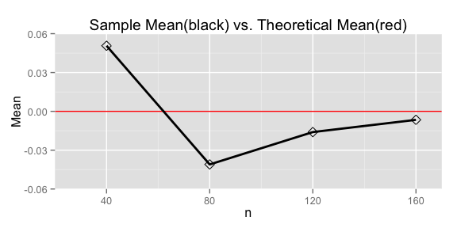

## Sample Variance versus Theoretical Variance

Based on the **CLT** the **theoretical variance** is $σ^{2}=1$ and the value of the sample variance is **1.0607617** for n = 40. The **sample variance** is around the **theoretical variance** for n = 40 and it converges more and more to it increasing the size of n (n = 80, 120, 160).

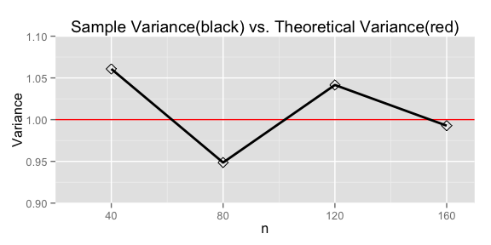

## Distribution

Lets plot the distribution of the averages for n = 40, 80, 120, 160 previously calculated over all of the simulations together with the standard normal distribution $N(0,1)$ (black bell curve). We can see from the plot below that the distribution of averages ($\frac{{\overline{X}}_{n}−μ}{σ/\sqrt{n}}$) for n = 40 is already a good approximation of the standard normal distribution $N(0,1)$ and gets better and better increasing the size of n as expected from the Central Limit Theorem.

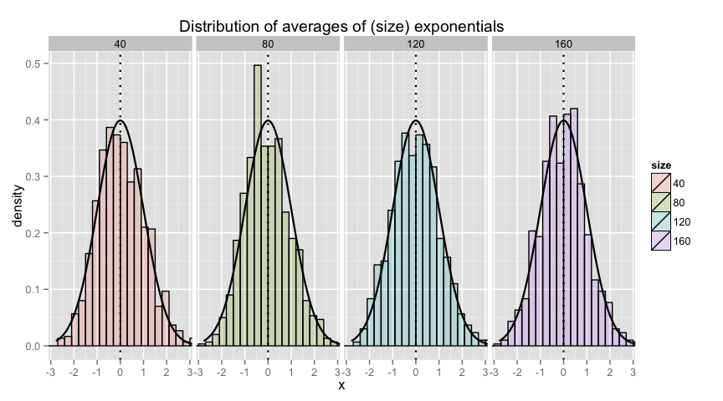

## Appendix

Code chunk used to generate plot in **Sample Mean versus Theoretical Mean** section.

meanSims <- c(  
 mean(dat[dat$size == n,]$x),   
 mean(dat[dat$size == (2*n),]$x),   
 mean(dat[dat$size == (3*n),]$x),   
 mean(dat[dat$size == (4*n),]$x)  
 )  
g <- ggplot(data.frame(x = c(n, 2*n, 3*n, 4*n), y = meanSims), aes(x = x, y = y))   
g <- g + geom_hline(yintercept = 0, color = "red") + geom_line(size = 1) + geom_point(shape = 5, size = 3)   
g <- g + labs(x = "n", y = "Mean", title ="Sample Mean(black) vs. Theoretical Mean(red)")  
g <- g + coord_cartesian(xlim= c(20,170), ylim=c(-0.06,0.06))  
g



Code chunk used to generate plot in **Sample Variance versus Theoretical Variance** section.

varianceSims <- c(  
 sd(dat[dat$size == n,]$x)^2,   
 sd(dat[dat$size == (2*n),]$x)^2,   
 sd(dat[dat$size == (3*n),]$x)^2,   
 sd(dat[dat$size == (4*n),]$x)^2  
 )  
g <- ggplot(data.frame(x = c(n, 2*n, 3*n, 4*n), y = varianceSims), aes(x = x, y = y))   
g <- g + geom_hline(yintercept = 1, color = "red") + geom_line(size = 1) + geom_point(shape = 5, size = 3)   
g <- g + labs(x = "n", y = "Variance", title ="Sample Variance(black) vs. Theoretical Variance(red)")  
g <- g + coord_cartesian(xlim= c(20,170), ylim=c(0.9,1.1))  
g



Code chunk used to generate plot in **Distribution** section.

g <- ggplot(dat, aes(x = x, fill = size)) + geom_histogram(alpha = .20, binwidth=.3, colour = "black", aes(y = ..density..))   
g <- g + stat_function(fun = dnorm, size = 0.8)  
g <- g + geom_vline(xintercept=c(0,0), color="black", linetype="dotted", size = 0.8)  
g <- g + coord_cartesian(xlim= c(-3.1,3.1)) + labs(title = "Distribution of averages of (size) exponentials")  
g + facet_grid(. ~ size)

