Master Thesis

Efficient Context Management in LLMs to Mitigate Attention Decay Using Human Memory-Inspired Prioritization

Introduction
Large Language Models (LLMs) have emerged as powerful tools in recent years. They can generate text, question answers, writing code, and even engage in conversations that can feel surprisingly human-like. However, these models face a significant challenge that they often struggle to remember earlier parts of long texts. As the input becomes longer, LLMs tend to lose track of important details from the beginning, which can lead to less accurate and sometimes inconsistent outputs. This issue is commonly known as "context forgetting" [1] [2]. This challenge becomes particularly evident in practical situations. For instance, if you ask an LLM to summarize a lengthy article, it may focus too much on the last few paragraphs and overlook crucial points introduced at the start. In conversations, it might forget the user’s original question after just a few answers. Additionally, in question answering tasks, the model may miss relevant information that was mentioned earlier in the document simply because it is far back in the input [3].

The underlying reason for this behavior can be attributed to how these models operate. Transformers of the architecture behind most LLMs employ a mechanism known as attention to determine which parts of the input are most important. However, they typically prioritize the most recent tokens, which can result in older parts of the text being gradually ignored unless they are particularly relevant or repeated later [4]. This tendency makes LLMs more short-term focused than we might prefer. In contrast, human memory operates differently. Psychological studies have shown that people tend to remember information from both the beginning and the end of an experience better than from the middle. This phenomenon is known as the serial position effect. Moreover, humans naturally prioritize information that is significant, interesting, emotional, or surprising, even if it occurred a long time ago [5]. While people also forget things, their memory does not work in the same way that LLMs works.

Objective
This master thesis will investigate how large language models handle long text inputs, with a focus on how LLMs tend to forget or lose track of earlier parts as the input gets longer. This issue is called attention decay which affects how well these models perform on tasks where remembering the beginning part of the input is important. The concept is based on the way human memory functions, such as the fact that people often recall the beginning and finish of an event better than others. The objective is to identify straightforward, model-agnostic strategies that support LLMs in retaining prior, crucial information. A lightweight, model-independent strategy that does not require model retraining will be implemented as part of the approach. The approach will be evaluated on tasks where recalling previous inputs is crucial, such as document summarization, lengthy chats, and question answering systems. The results will be measured using standard metrics, and the model’s memory for prior inputs will be displayed using graphs that simulate attention maps. The main objective is to build a working prototype and write a research paper based on the findings.

Background and Motivation
Many researchers have explored ways to improve how LLMs manage long inputs, and many methods have been proposed. Some of these involve modifying the model architecture or applying fine-tuning to better handle longer context. While these approaches show strong results, they can also require significant computational resources or access to the model internals, which may not always be feasible in every setting. This opens the opportunity to explore lighter, more accessible methods that work with existing models as they are. Instead of that by using models in their current state it might be feasible to enhance long-context handling by implementing useful strategies based on how people prioritize and retain information. The objective of this thesis is to create effective and approachable methods for improving LLM performance on lengthy inputs without requiring significant model retraining.

Planned Approach
The work will start with a literature review to understand how attention decay happens in LLMs and what kinds of solutions have already been suggested. After that, I will run experiments using smaller open-source models, like GPT-2, Mistral or Llama to see how they lose track of context when given longer inputs. Next, I will try out different approaches such as splitting the input into chunks, ranking tokens by their importance, or dividing the text into memory-like segments to see if these help the models keep better track of context.

Timeline / Milestones

Task Description | Start Date | End Date | Duration (Days)
Topic basic research and finalization | 05/10/25 | 05/17/25 | 7
Conduct literature review | 05/18/25 | 06/07/25 | 20 | Thesis Registration - 05.06.2025
Submit requirement analysis/expose | 06/08/25 | 06/16/25 | 8
Work environment setup | 06/16/25 | 06/18/25 | 2
Initial design phase | 06/18/25 | 07/08/25 | 20
Actual Implementation and documentation for findings | 07/09/25 | 08/10/25 | 32
Evaluation | 08/11/25 | 09/10/25 | 30 | Evaluating the model with  test datasets to check the  accuracy and efficiency of the  detection models.
Reporting | 09/11/25 | 10/05/25 | 24 | First draft of the thesis which  explains the motivation,  research problem,  challenges,  implementation details,  evaluation and results
Document updating and Paper Writing | 10/06/25 | 11/05/25 | 30
Final correction and submission | 11/05/25 | 12/05/25 | 30

Phase | Description | Start Date | End Date | Deliverable
Phase 1 | Setting up the development environment, installing Python and VS Code, getting the necessary libraries running, testing GPT-2/Mistral locally, reviewing key papers, designing the chunking/salience parts, and replicating the EM-LLM baseline code while keeping a technical journal | 05-Jul-2025 | 19-Jul-2025 | Technical readiness report
Phase 2 | Building the core modules including chunking logic, cosine similarity, memory buffer, and the prompt builder. Then integrating everything for a first working prototype, with proper module-level notes along the way | 20-Jul-2025 | 20-Aug-2025 | Prototype running on a small test set
Phase 3 | Extending retrieval by adding hidden-state pooling and FAISS indexing, setting up evaluation metrics (ROUGE, BLEU, F1), collecting evaluation data, and preparing templates for a qualitative comparison | 21-Aug-2025 | 15-Sep-2025 | Advanced retrieval system with evaluation tools
Phase 4 | Running experiments on tasks like summarization or QA, comparing the baseline with the memory-augmented version, analyzing and visualizing the results, and starting to write up the results and discussion sections | 16-Sep-2025 | 05-Oct-2025 | Results with visualizations
Phase 5 | Structuring the final thesis chapters, refining diagrams and references, drafting a short publication paper, incorporating feedback from the supervisor, and proofreading everything | 06-Oct-2025 | 20-Oct-2025 | Final thesis draft
Phase 6 | Keeping a small buffer to address last-minute feedback, validate formatting, and make the final submission | 21-Oct-2025 | 25-Oct-2025 | Final thesis submission
Parallel | Throughout all phases, keep a living technical journal, document progress weekly, maintain well-commented code, and work on publication writing in parallel | 05-Jul-2025 | 25-Oct-2025 | Consistent documentation and paper draft

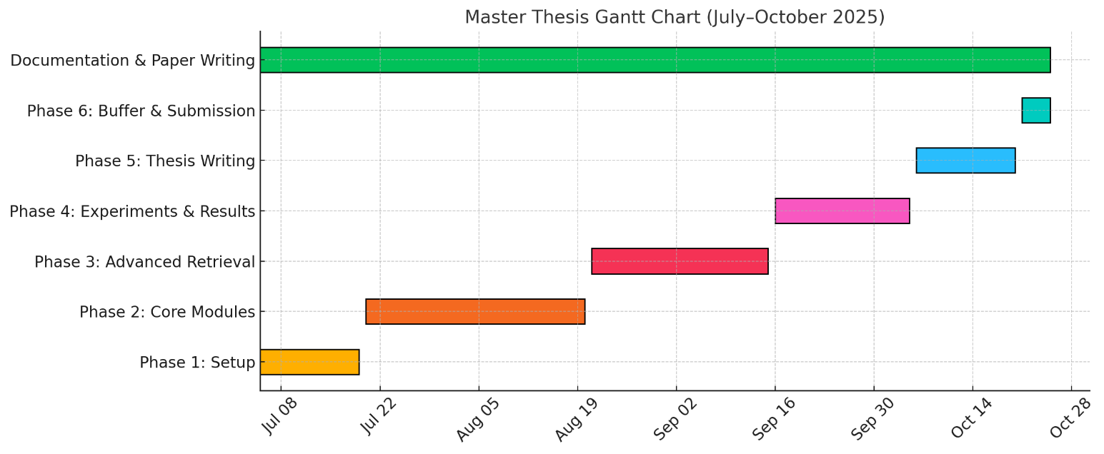

Expected Outcomes

This thesis will work on creating a method to help language models remember longer inputs better. The method will be tested on different tasks like summarizing, answering questions, and having long conversations like chatbots. To check how well the model remembers earlier parts, graphs and attention maps will be used. At the end, a working prototype will be made, and a paper will be written to publish the results.

References

[1] Y. Zhu et al., “Findings of the Association for Computational Linguistics Can Large Language Models Understand Context?” [Online]. Available: https://github.com/
[2] Z. Lin, E. Nikishin, X. O. He, and A. Courville, “Forgetting Transformer: Softmax Attention with a Forget Gate,” Mar. 2025, [Online]. Available: http://arxiv.org/abs/2503.02130
[3] J. Huang et al., “Mitigating Catastrophic Forgetting in Large Language Models with Self-Synthesized Rehearsal.”
[4] A. Vaswani et al., “Attention Is All You Need,” Jun. 2017, [Online]. Available: http://arxiv.org/abs/1706.03762
[5] S. Schonbach-Medina and E. Vakil, “Encoding Factors Affecting Context Effects on Memory: Congruency, Attention and Exposure Time,” Psychology, vol. 08, no. 03, pp. 463–476, 2017, doi: 10.4236/psych.2017.83029.

