EM-LLM + RAG Hybrid: Problem Statement and Detailed Solution
This document explains the problem (attention decay), how EM-LLM works in plain language and in detail, how it differs from RAG, why a hybrid approach is needed, exactly what I will build, what the UI will look like, where the data is stored, and how I will evaluate the system. All approaches are training-free, open-source, and model-agnostic.

Executive summary
Large Language Models struggle with long contexts due to attention decay, earlier information fades as sequences grow. Retrieval-Augmented Generation (RAG) searches across a large corpus but uses fixed-size chunks that can break narrative flow. EM-LLM (episodic memory for LLMs) segments long inputs into coherent episodes and later recalls only the few that matter.
The proposed system combines both approaches, utilizing RAG to select relevant documents, and then using EM-LLM to identify the appropriate episodes within those documents. It re-injects these episodes at inference time as either text or as key-value (KV) cache slices. The result is accurate, coherent, explainable answers over long contexts, running locally with open-source tools and no retraining.

Problem statement: Attention decay in long contexts
Transformers tend to focus on recent tokens and underweight earlier ones as inputs get longer. Two effects drive this:
- Attention dilution (weights spread over many tokens)
- Recency bias (recent tokens dominate).
The practical result is that key details from the beginning of a document or early turns of a conversation are effectively forgotten when answering later questions.
Standard fixes fall short:
- Enlarging context windows is compute-heavy and does not address recency bias.
- Plain RAG retrieves external chunks but often splits ideas mid-paragraph, losing reasoning and temporal continuity.

EM-LLM:
EM-LLM gives the model a short-term journal of essential moments. Instead of remembering every token, it remembers events: surprising or topic-shifting segments. When asked a question, it brings back only the few relevant events, in order so that the model can answer coherently.
How EM-LLM works:
- Event segmentation: As the model ingests a long stream (document or dialogue), EM-LLM computes token surprise (negative log probability). Spikes mark candidate boundaries. A small similarity graph around each candidate refines the boundary so tokens that belong together stay together. Each episode gets a compact representation (a few token vectors).
- Two-stage retrieval: Later, a user query is embedded and matched to episodes semantically, then EM-LLM expands to include neighboring episodes to preserve narrative flow.
- Reinjection: The selected episodes are fed back to the model either as brief text blocks at the front of the prompt or, in an optimized path, as KV cache slices in selected layers/heads. This priming is ephemeral: KV exists only for the current generation, while the episode store persists on disk.

RAG versus EM-LLM (and why combine)
- RAG operates at corpus scale: it finds which documents matter. It typically uses fixed-size chunks (e.g., 500 tokens) for retrieval, which is simple and fast but can cut through sentences and sections, leading to incomplete evidence.
- EM-LLM operates inside a long sequence: it preserves coherence by selecting meaningful episodes and their neighbors.
The hybrid uses each where it shines: RAG narrows to the right documents, EM-LLM extracts the right episodes inside those documents, keeping context intact.

Proposed hybrid: Lite-RAG + EM-LLM episodes
Pipeline per query:
- Embed the user query and retrieve top-M documents from a local FAISS doc index.
- For each doc, load precomputed episodes (or segment on the fly).
- Score episodes with a goal-conditioned objective that balances surprise, semantic match, novelty, redundancy, and temporal coverage.
- Select k episodes per doc and add ±1 neighbor for continuity.
- Assemble a compact memory pack and reinject as text or via KV.
- Generate the answer with citations to [Doc-ID, Episode-ID].
This is training-free, local, and explainable: users can inspect the exact episodes used.

Architecture and data flow
Ingestion (one-time or on updates): load documents, extract text, run EM-LLM segmentation to produce episodes, and build two FAISS indexes: a doc-level index for coarse retrieval and an optional event-level index for fine-grained lookup. Store episodes as Parquet with metadata and representative vectors.
Serving: for each query, retrieve top-M docs, within those, score and select episodes, assemble and reinject, generate answer, log choices and timings.
Storage layout:
- data/raw/: original texts (txt/md/pdf→text)
- data/events/: Parquet per document (event_id, spans, text, rep vectors, surprise stats)
- data/index/: FAISS_docs (documents), FAISS_events (episodes, PCA-compressed)
- data/sqlite/app.db: metadata (documents, events, runs), plus run hits and selected episodes
- logs/: JSONL traces for reproducibility

User interface (simple, convincing)
- Left panel: query box and controls (M documents, k episodes per doc, temporal buffer, mode: text or KV).
- Center: the answer with inline citations and a button to show evidence.
- Right: a memory inspector showing each retrieved document as a timeline with selected episodes highlighted, clicking reveals the exact text and scores.

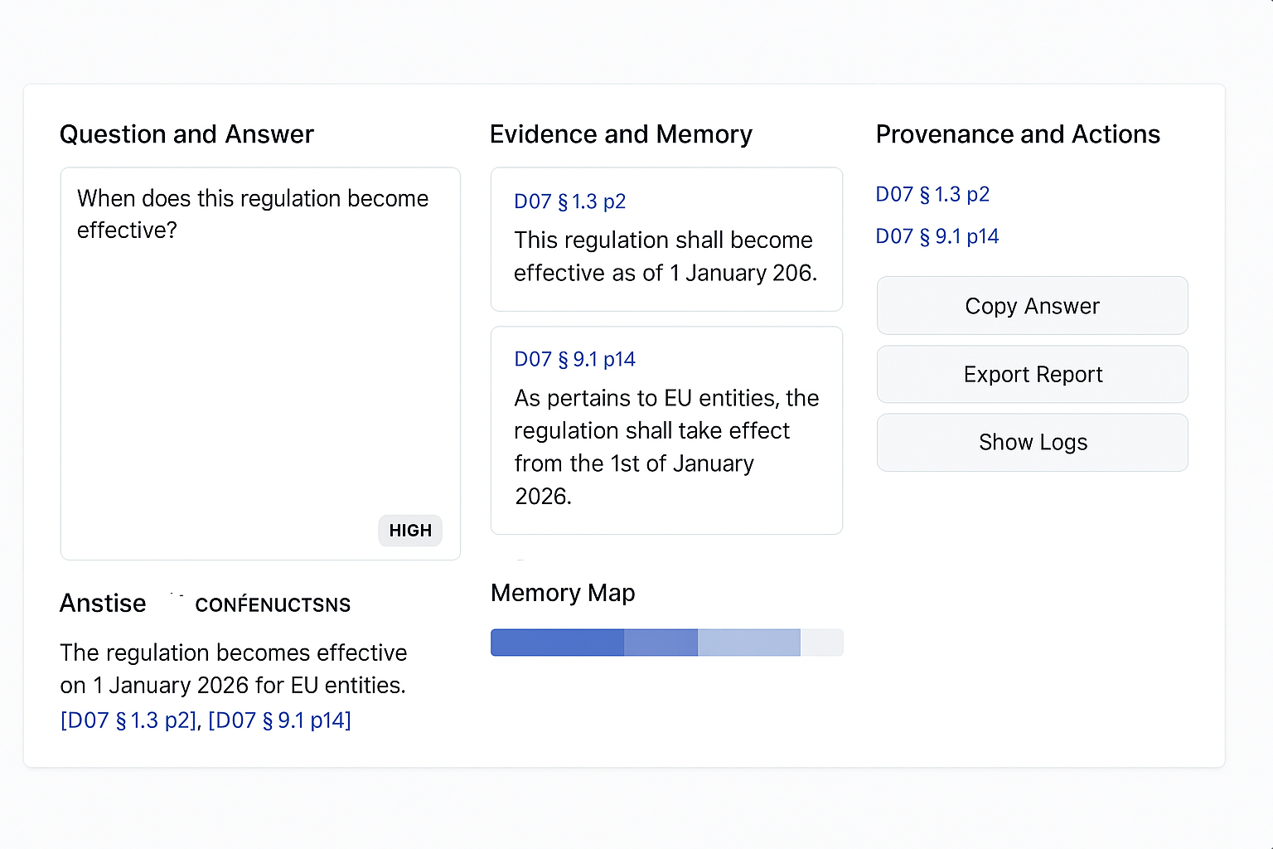

Key-value cache behavior
Injected KV is temporary and exists only for the current generation. It is not a durable memory. The durable source of truth is the episodic store on disk. On each turn, the system retrieves episodes again and re-primes the model.

Implementation plan (no APIs, open-source only)
- Runtime: vLLM on GPU or llama.cpp with quantization.
- Models: Llama-3.1-8B-Instruct or Qwen2-7B-Instruct.
- Embeddings: bge-m3 or e5-base-v2.
- Vector store: FAISS.
- Backend: FastAPI, Frontend: Streamlit.
- Storage: SQLite + Parquet.
Week 1: ingest + doc-level RAG.
Week 2: eventization + episodic selection.
Week 3: UI + evidence.
Week 4: optional KV path and performance tuning.

Evaluation plan
- Datasets: LongBench tasks (e.g., GovReport summarization, NarrativeQA) and your own academic corpus.
- Baselines: plain RAG, EM-LLM without RAG, the hybrid.
- Metrics: EM/F1 for QA, ROUGE-L for summarization, latency per 1k tokens, VRAM, total injected tokens.
- Ablations: no neighbor vs neighbor, text vs KV, k=1 vs k=3, with vs without reranked.
Success criteria: improved accuracy and coherence over plain RAG at equal or smaller token budgets, transparent evidence, stable latency on local hardware.

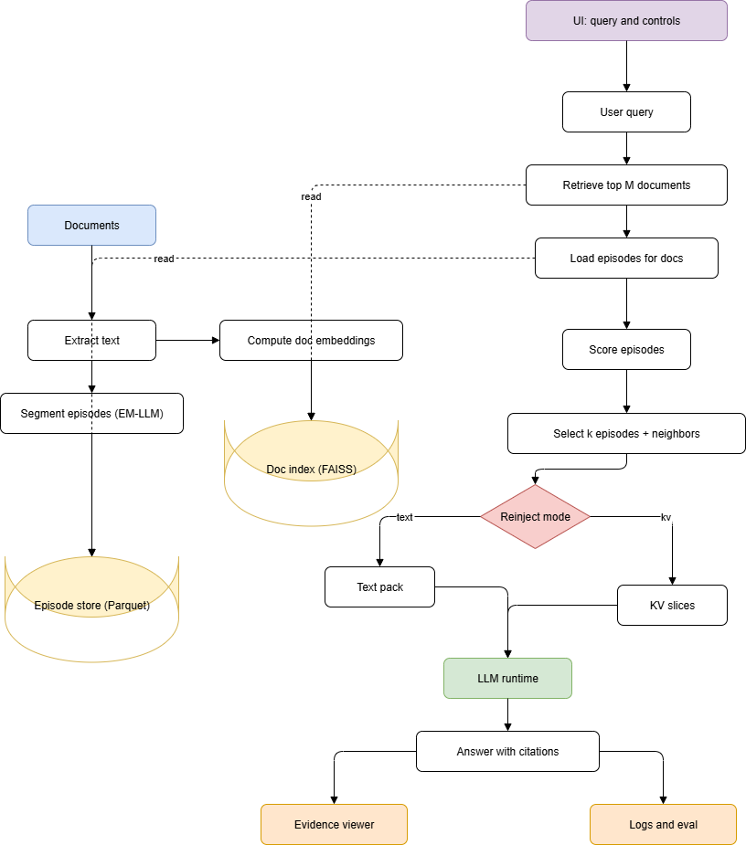

Illustrative examples:
Long document QA (attention decay):
- Without EM-LLM: model forgets an early recommendation buried thousands of tokens back and answers from recent sections, incorrectly.
- With EM-LLM: the recommendation is stored as an episode, when asked, the system retrieves that episode and its neighbor, re-primes the model, and answers correctly.
Academic library question, why the hybrid wins:
- Query: Which studies recommend carbon pricing and what evidence supports it?
- Plain RAG: finds papers mentioning the term but may miss the actual recommendation section due to fixed chunking.
- EM-LLM alone: cannot search across all papers.
- Hybrid: picks the right documents (RAG), then selects coherent recommendation episodes plus their evidence neighbors (EM-LLM), producing a complete, cited answer.

Planned enhancements over the EM-LLM base:
- Layer-specific episodic KV reinjection: reduce prompt bloat by inserting only the top episodes into selected layers/heads with similarity gating.
- Goal-conditioned episodic selection: optimize selection with a multi-factor objective balancing surprise, relevance, novelty, redundancy, and temporal coverage.
These remain training-free and model-agnostic.

Risks and mitigations:
- Segmentation cost: batch logits or approximate surprise with entropy spikes/hidden-state drift.
- Prompt growth: cap total episode tokens and favor KV for top episodes.
- Index growth: PCA compress representatives and evict rarely used docs.
- Stability: start with text reinjection, then enable KV for top episode only.

Why is this idea strong:
- Complementary strengths: RAG provides global coverage, EM-LLM preserves local coherence.
- Interpretability: every answer shows its evidence episodes.
- Efficiency: fewer injected tokens and optional KV keep latency and VRAM controlled.
- Practicality: fully open-source and training-free, suitable for local deployment.

Conclusion
The hybrid system addresses attention decay by externalizing long-context memory as human-like episodes and re-introducing only what matters at answer time. Using RAG as a light document picker and EM-LLM for coherent episodic recall yields accurate, explainable outputs without retraining. This is a pragmatic approach to reliable long-context reasoning in real-world applications, ranging from literature reviews to multi-turn academic assistants.

