Master Thesis

Efficient Context Management in LLMs to Mitigate Attention Decay Using Human Memory-Inspired Prioritization

Submitted by: | Poonam Dashrath Paraskar
First examiner: | Prof. Dr. Andreas Pech
Second examiner: | Prof. Dr. Peter Nauth
Supervisor: | Mr. Indraneel Pole
Date of start: | 06.06.2025
Date of submission: | 05.01.2026

Statement
I confirm that I have written this thesis on my own. No other sources were used except those referenced. Content that is taken literally or analogously from published or unpublished sources is identified as such. The drawings or figures of this work have been created by me or are provided with an appropriate reference. This work has not been submitted in the same or similar form or to any other examination board.

05.01.2026
_______________________________
Date, Signature of the Student

Abstract
Large Language Models (LLMs) perform well on many natural language processing (NLP) tasks. Still, they struggle to handle very long inputs because they tend to forget earlier information as the input grows. This attention decay can cause problems in tasks like long-form question answering, multi-turn conversations, and long-document summarization, leading to weaker reasoning, missing details, and a strong focus on recent information.
This thesis examines this limitation as both an opportunity to add human-like memory prioritization to LLMs and a design challenge. It explores ways to organize long-context inputs into more useful and easy-to-retrieve parts, using ideas from episodic memory, event segmentation, and salience-based recall. The Episodic Memory LLM (EM-LLM) architecture is the main approach, breaking text into events, saving them as small memory blocks, and finding relevant episodes using semantic similarity and surprisal. EM-LLM does not require additional training and works with various models, yet it performs well compared to other long-context methods such as InfLLM and retrieval-augmented generation (RAG).
The main technical contribution of this thesis is the Cross-Event Reasoner (CXR), which allows the model to reason directly across retrieved events. Instead of treating episodes as separate blocks, CXR lets the model focus on connections between events, combine related events into stronger joint representations, and adjust their importance based on the current query before adding them back into the model. The thesis extends the original framework with CXR, builds an EM-LLM pipeline that follows this design, and tests it on standard long-context benchmarks. The results show promising ways to improve cross-event prioritization inspired by human memory, with modest but steady improvements, and also point out the remaining limits of EM-LLM.
Content
1 Introduction 6
1.1 Motivation 7
1.2 Thesis Structure and Overview 8
2 Theoretical Background 10
2.1 Large Language Models and Transformer 10
2.1.1 Self-Attention and Context Windows 11
2.1.2 Attention Decay and Context Forgetting 13
2.1.3 Long-Range Context Benchmarks 15
2.2 Human Memory and Episodic Memory 16
2.2.1 Cognitive Models of Human Memory 16
2.2.2 Serial Position Effects and Surprise 18
2.2.3 Event Segmentation in Human Cognition 19
2.3 Memory-Augmented Neural Architectures 21
2.3.1 Retrieval-Augmented Generation (RAG) 22
2.3.2 Memory Networks and Memorizing Transformers 24
2.3.3 Efficient and Long-Context Transformers 26
2.3.4 Summary and Positioning 27
2.4 EM-LLM: Human-Inspired Episodic Memory for LLMs 27
2.4.1 Surprisal-Based Event Segmentation 29
2.4.2 Graph-Theoretic Boundary Refinement 29
2.4.3 Episodic Memory Storage and Hierarchy 30
2.4.4 Retrieval and Multi-Stage Attention 30
2.4.5 Limitations of EM-LLM: 31
2.5 Cross-Event Reasoning and Event-Level Modeling 31
2.5.1 Event Representations and Event Graphs 32
2.5.2 Multi-Hop Reasoning Across Events 32
2.5.3 Design Principles for Cross-Event Reasoners 32
3 Requirement Analysis 33
3.1 General Objectives 33
3.2 Problem Context and Use Cases 34
3.2.1 Long-Document Summarisation: 35
3.2.2 Multi-Turn Conversational Memory 35
3.2.3 Multi-Hop Question Answering and Narrative Understanding 36
3.3 Functional Requirements 36
3.3.1 Baseline LLM and EM-LLM Restoration 37
3.3.2 Cross-Event Reasoner Integration 38
3.3.3 Evaluation of results 38
3.4 Non-Functional Requirements 38
3.4.1 Model-Agnostic and Training-Free Design 39
3.4.2 Efficiency and Scalability (Infinite Context) 39
3.4.3 Reproducibility, GitHub Project, and Open-Source Compatibility 39
3.5 Dataset and Benchmark Requirements 39
3.5.1 Multi-Hop Reasoning Datasets (HotpotQA, 2WikiMultihopQA) 39
3.5.2 Narrative and Summarisation Benchmarks (NarrativeQA, QMSum) 40
3.5.3 Long-Context Evaluation Suites (LongBench Tasks) 40
3.6 Time Frames and Milestones 40
3.7 Target State / Target Objectives 43
4 System Design and Implementation 44
4.1 Overall System Architecture 44
4.1.1 High-Level System Pipeline 44
4.1.2 Software Architecture and Module Overview 46
4.2 Non-Episodic Baseline Pipeline: Mistral Bench 46
4.2.1 Design Goals and Role in the Thesis 47
4.2.2 Dataset Handling and Schema Mapping (Arrow / JSON / JSONL) 48
4.2.3 Ollama-Mistral Inference and Prompt Construction 49
4.2.4 Output Formats and EM-LLM-Compatible Results 51
4.3 EM-LLM Baseline and Restoration 53
4.3.1 Architectural Overview of the EM-LLM Baseline 53
4.3.2 Re-Implementation of Surprisal-Based Event Segmentation 55
4.3.3 Graph-Based Memory Structuring Using Topological Metrics (Modularity, Conductance) 57
4.3.4 Contiguity Buffer and Episodic Memory Management 59
4.3.5 Interaction Between Local Context Window and Global Episodic Memory 60
4.3.6 Inference-Time Memory Retrieval and Conditioning 62
4.3.7 Practical Constraints of Single-GPU Baseline Restoration 63

Introduction
Applications such as document summarization, conversational assistants, knowledge extraction systems, and multi-hop question answering are all built using large language models (LLMs), which have become a central part of modern natural language processing. They are attractive in both research and industry because they can generate coherent text and follow complex instructions. However, one recurring limitation remains: even as model sizes grow and context windows expand, LLMs still struggle to reliably use information that appears far earlier in long inputs. Although those tokens are technically within the context window, the models often “forget” earlier parts of the input and place too much emphasis on more recent tokens as the sequence length increases.
This phenomenon, often called attention decay or context forgetting, becomes clearly visible in practice. For example, when an LLM is asked to summarize a lengthy report, it usually focuses on the later sections and overlooks important definitions or assumptions introduced at the beginning. In multi-turn conversations, as new exchanges are added, earlier user instructions such as style guidelines, safety constraints, or personal preferences are gradually ignored, leading to replies that contradict or override previous agreements. Similarly, when the model answers a long-context query, relevant information that appeared many pages earlier may be effectively invisible to it.
*(A. Vaswani et al., “Attention Is All You Need,” Aug. 2023, [Online]. Available: http://arxiv.org/abs/1706.03762)
These errors arise from how transformers compute self-attention and are not just based on a few isolated examples. Attention weights are obtained by taking dot products between the query and key vectors and then applying a softmax. As the sequence length grows, representations of distant tokens become less aligned, their dot products decrease, and the softmax further down-weights them. Consequently, the model develops a strong recency bias: tokens that appear later in the sequence receive most of the attention, while earlier tokens contribute very little, if at all. Long-context variants with larger windows can access more tokens, but they do not always use them evenly, leaving them vulnerable to this problem.
(Y. Tay et al., “Long Range Arena: A Benchmark for Efficient Transformers,” Nov. 2020, [Online]. Available: http://arxiv.org/abs/2011.04006)
Human memory works in a very different way. Instead of keeping experiences as a single, continuous stream, people naturally break them into separate episodes and store them as episodic memories. Psychological studies show that surprising, emotionally important, or goal-related events are remembered more strongly than routine details, and that people are especially good at recalling the beginnings and endings of episodes (the serial position effect). When reasoning, humans rarely replay every detail; they remember a few key moments and mentally link them together to reconstruct the story or find an answer. This difference has motivated a growing body of research aimed at improving LLMs by leveraging memory systems inspired by human memory.
A more recent approach that directly mimics human episodic memory is the Episodic Memory LLM (EM-LLM). EM-LLM uses surprisal-based boundary detection to break long text streams into separate events. It then refines these boundaries using graph-theoretic metrics and stores compact representations of each event as memory “cards.” When a query comes in, EM-LLM retrieves the relevant events based on temporal structure and similarity and feeds them back into the model so the LLM can reason over them. Because this architecture is training-free, model-agnostic, and can handle extremely long histories, it offers a practical way to extend context without retraining the base LLM.
*(Z. Fountas et al., “Human-inspired Episodic Memory for Infinite Context LLMs,” Oct. 2025, [Online]. Available: http://arxiv.org/abs/2407.09450)
However, EM-LLM also has several limitations. It requires substantial computation to compute surprisal and graph metrics for every token. In the retrieval step, it mainly relies on semantic similarity and temporal proximity; task-related aspects such as novelty and redundancy are not explicitly considered. A key point of this thesis is that EM-LLM treats each retrieved event as a separate block, which gives the model the right pieces of memory but does not directly help link them together. The base transformer is still affected by attention decays and is fully responsible for connecting, combining, and reasoning over these pieces in multi-hop questions or stories where the evidence is spread across multiple events.
The gap between how humans use episodic memory and how current memory-augmented LLMs work is the primary motivation for this thesis. It examines whether human-inspired memory prioritization can not only retrieve relevant episodes but also support cross-event reasoning over them. This work introduces the Cross-Event Reasoner (CXR). This lightweight module explicitly models connections between retrieved events and extends the original segmentation and retrieval pipeline built on the EM-LLM framework. To evaluate the proposed system, it systematically compares three setups on long-context benchmarks that require multi-hop reasoning, narrative understanding, and reliable use of distant information: the EM-LLM baseline, EM-LLM enhanced with CXR, and an LLM without episodic memory.

Motivation
How LLMs are used today motivates this work. Many applications need models that can keep track of ongoing projects, follow instructions over many steps, and manage large document collections. Users want systems that remember what happened earlier, not ones that forget anything beyond a few thousand tokens. They expect models to keep a clear picture of the story, connect distant facts, and recall earlier limits. Until attention decay is solved, long-context LLMs act more like advanced short-term memory than reliable reasoning tools.
* (Chen, Lv, Y., Luan, A., Wang, J., Liu, B. & Wei. (2024). HoPE: A Novel Positional Encoding Without Long-Term Decay for Enhanced Context Awareness and Extrapolation. https://arxiv.org/abs/2410.21216)
From a research perspective, there is a gap between how machines model memory and what we know about human memory. Cognitive science shows that people break experiences into separate events, keep only some details, and recall them in context when needed.
In contrast, many current LLM methods treat memory in one of three ways:
- a larger attention window,
- an external retrieval system with fixed chunks, or
- learned architectural changes inside the transformer.
These methods help models handle more data, but they do not capture the way humans link memories through events and associations over time.
Looking closer, many long-context models that claim to use long histories rely on only a small part of that history for their predictions. Earlier tokens often have little impact on the final output, even when they remain in the context window.
*(2025). Context Is What You Need: The Maximum Effective Context Window for Real World Limits of LLMs. https://arxiv.org/abs/2509.21361
This raises the question of whether current long-range models really use the extra context or just work around it. By comparing a memory-augmented LLM with a standard LLM on the same datasets and controlled inputs, we can better see the effect of episodic memory.
EM-LLM is a useful baseline because it matches the idea of human episodic memory and is practical to use. It breaks long sequences into clear events, stores them compactly, and retrieves them when needed. However, as shown in earlier work and this thesis, EM-LLM still struggles with tasks that require information from multiple events. The model often finds the right pieces but cannot always combine them into a single explanation.
*(Zhu, Wei, D., Zhao, X., Wu, G., Zou, W., Ran, H., Wang, J., Sun, X., Zhang, L., Li, X. & Sujian. (2025). Chain-of-Thought Matters: Improving Long-Context Language Models with Reasoning Path Supervision. https://arxiv.org/abs/2502.20790)
This suggests that memory-augmented models need a special reasoning step that works across events, not just better retrieval.
To solve this problem, this thesis introduces the Cross-Event Reasoner (CXR). Instead of just joining the retrieved episodes and letting the base transformer handle everything, CXR summarizes events into compact vectors, uses self-attention to find relationships, merges related events, and then re-scores them based on the query. This creates a smaller, more focused, and more useful memory set. Importantly, CXR does this without retraining the main LLM, since it is a lightweight module that works on hidden states and can be added to different models.
Besides scientific interest, there is also a practical engineering reason. Many organizations lack the resources or permission to use large, custom transformer models or to fine-tune large, proprietary models.
*((2024). FedBiOT: LLM Local Fine-tuning in Federated Learning without Full Model. https://arxiv.org/abs/2406.17706)
Instead, they rely on open-source models or API-based LLMs, which only allow limited changes and restricted access to internal states. These limits make a human-inspired, training-free approach especially attractive for improving long-context reasoning without retraining. The method in this thesis—cross-event reasoning, prioritization, and episodic segmentation—is designed to work with any model and fit these real-world settings.
All these factors lead to the main research questions of this thesis:
Research Question 1: When standard LLMs are applied to long-context tasks such as multi-hop question answering, document summarization, and narrative understanding, what does attention degradation look like in practice?
Research Question 2: Compared to a non-episodic baseline on the same datasets, to what extent does adding a human-inspired episodic memory system like EM-LLM reduce context forgetting and improve performance?
Research Question 3: Does explicit cross-event reasoning with the proposed Cross-Event Reasoner (CXR) provide additional benefits beyond EM-LLM alone, especially for tasks where the relevant evidence is distributed across multiple events?
By running controlled experiments that compare models with and without episodic memory on the same inputs, this thesis aims to show how much of the long-context problem can be solved with human-inspired memory prioritization and how much larger changes to model design are still needed.

Thesis Structure and Overview
The rest of this thesis moves from theoretical foundations to practical design, and then to empirical evaluation and reflection. Each chapter builds on the previous one so that the reader can follow the path from the core problem to the final findings and conclusions.
Chapter 2-Theoretical Background: This chapter provides the theoretical and empirical basis for the work. It first introduces large language models and the transformer architecture, with a focus on self-attention, context windows, and the problem of attention decay in long sequences. It then reviews cognitive theories of human memory, in particular episodic memory, event segmentation, and serial position effects. Building on this, the chapter surveys existing methods for long-context modeling, including efficient/long-context transformers, retrieval-augmented generation, and memory-augmented architectures.
Chapter 3-Requirements Analysis: Chapter 3 formalizes the core problem of the thesis and defines the requirements for the proposed solution. It explains the overall goals of using human-inspired memory mechanisms to reduce attention degradation in LLMs and grounds in specific use cases, such as multi-turn dialogue, long-document summarization, and multi-hop question answering. The chapter then sets out both functional and non-functional requirements, including model-agnostic design, efficiency, and reproducibility, as well as the restoration of the EM-LLM pipeline, integration of the Cross-Event Reasoner, and evaluation tooling. It also specifies datasets and benchmark requirements, describes the intended target state of the system, and outlines the main project milestones and timelines.
Chapter 4-System Design and Implementation: Chapter 4 describes the architecture and implementation of the proposed system in detail. It begins with an overview of the software architecture and the data flow from raw text input to model predictions. The chapter then explains how the original EM-LLM baseline was reconstructed and extended, including contiguity handling, graph-based boundary refinement, surprisal-based event segmentation, and episodic memory storage and retrieval. Next, it presents the design of the Cross-Event Reasoner (CXR). It shows how it incorporates query-conditioned scoring, event fusion, event representation pooling, and event-to-event self-attention into the EM-LLM retrieval loop. Finally, it covers practical implementation aspects, including the hardware and software environment, model and tokenizer settings, decoding and perplexity computation, logging, and visualization support.
Chapter 5-Evaluation and Results: Chapter 5 presents the experimental setup and results. It describes the preprocessing steps, the evaluation metrics (including F1, exact match, ROUGE, and perplexity), and the selected benchmarks for long-context reasoning. The chapter then introduces the systems being compared: a baseline LLM without episodic memory, the EM-LLM baseline, and the extended EM-LLM with CXR. After reporting quantitative results for the different tasks, it presents ablation studies that analyze the contribution of each component of CXR. In addition, the chapter includes case studies and qualitative analyses that illustrate how cross-event reasoning and episodic memory affect the practical use of distant context.
Chapter 6-Conclusion and Future Work: Chapter 6 summarizes the main findings and contributions of the thesis. It revisits the research questions and discusses how well the proposed episodic memory pipeline and Cross-Event Reasoner reduce attention decay and improve long-context reasoning. It then outlines directions for future work, such as tighter integration with external knowledge sources, partial end-to-end learning of the memory pipeline, and extending the ideas to other modalities and application settings. The limitations of the current approach are also critically discussed.
Chapter 7-Abbreviations: This chapter lists the abbreviations used throughout the thesis to maintain consistency and readability.
Chapter 8-References: Chapter 8 contains the bibliographic references cited in the thesis, formatted according to the university’s recommended citation style.
Chapter 9-Appendix: Chapter 9 provides additional material that would otherwise interrupt the flow of the main text. It includes extended quantitative tables, extra figures and system diagrams, model outputs and example prompts, and detailed implementation notes and configuration files that support reproducibility.

Theoretical Background
This chapter discusses the theoretical grounds of the thesis. It begins with a summary of the transformer architecture and large language models (LLMs), emphasizing context windows, self-attention, and the processes that lead to attention decay. It then discusses how this deterioration manifests as context forgetting and why this is detrimental for long-range reasoning. Finally, the chapter briefly discusses the primary benchmarks used to assess long-context understanding.

These principles are important to illustrate why additional memory mechanisms such as EM-LLM and the proposed Cross-Event Reasoner (CXR) are useful, and to construct the vocabulary used later for describing and evaluating the system.

Large Language Models and Transformer
Neural networks trained on massive text corpora to predict the next token in a sequence are known as large language models (LLMs). When model size, training data, and context duration are scaled up, they achieve strong performance across numerous tasks, such as question answering, dialogue, summarization, and code generation. The majority of contemporary LLMs use the transformer design developed by Vaswani et al. (2017*).
*(Vaswani et al. (2017*))
Transformers differ from preceding recurrent systems in two fundamental ways. Initially, rather than processing tokens one at a time, they process the whole input sequence in parallel. Second, they adopt a self-attention method that allows each token to attend to all other tokens in the sequence, rather than simply transferring information through a recurrent hidden state. This architecture leads to more stable training and makes it easier to capture long-range dependencies in sequences of modest length.
Conceptually, a transformer layer has three significant components: multi-head self-attention, where each token computes attention scores over all other tokens via learnt projections known as queries, keys, and values; and position-wise feed-forward networks, which perform non-linear changes independently for each token embedding. Layer normalization and residual connections facilitate gradient flow over deep stacks of layers and stabilize training.
Typically, LLMs combine many of these layers with positional encodings and token embeddings. In decoder-only architectures (often used for generative LLMs), tokens are processed from left to right with a causal mask that prohibits the model from “looking into the future”.
During inference, the model is given an input context (for example, 4k, 32k, or 128k tokens) and then generates new tokens one at a time, using internal key–value caches so it does not need to recompute attention across the entire sequence.

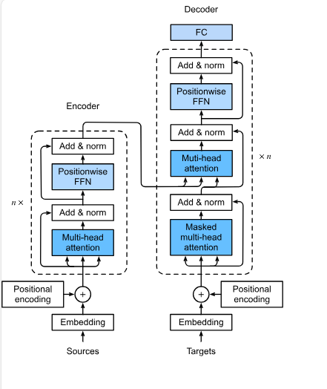
Figure 2.1.Transformer Architecture
Figure 2.1 shows a high-level transformer architecture: embeddings and positional encodings feeding into stacked self-attention and feed-forward blocks. This figure helps situate where self-attention and the context window reside within the overall model.

Self-Attention and Context Windows
Self-attention is the main process that allows transformers to share information between different positions. For each token at position i, the model creates a query vector q_{i}, a key vector k_{i}, and a value vector v_{i} from the token’s current hidden state using learned linear layers. The attention weight from token i to token j is calculated using the scaled dot product.

$$α_{ij}=softmax_{j}\left(\frac{q_{i}⋅k_{j}}{\sqrt{d_{k}}}\right)$$

where $d_{k}$ is the dimensionality of the key vectors. The updated representation of token $i$ is then a weighted sum of value vectors

$$h_{i}^{'}= \sum_{j}{α_{ij}v_{j}}$$

In multi-head attention, the process is repeated several times using different learned projections. The resulting vectors are concatenated and fed into a feed-forward network.
Because every token in a layer attends to all other tokens in that layer, self-attention has quadratic complexity in the sequence length n for both time and memory. For short and medium sequences, this remains manageable. As n grows, however, the cost increases quickly, and in practice, models are deployed with a fixed context window that caps the number of tokens that can be processed at once.
Modern LLMs claim to handle context windows ranging from thousands to hundreds of thousands of tokens. But the formal context length is not the same as the effective context length, which is how far tokens still meaningfully affect predictions. Studies show that tokens far from the current position have tiny attention weights and gradient signals. As a result, earlier tokens have little effect on the model’s output, even when they remain in context.
*(https://www.matterai.so/blog/llm-attention)
Absolute or rotational positional embeddings are often used to represent where each token is in a sequence. These encodings help the model tell tokens apart based on their positions, but they also make the model focus more on nearby tokens. Tokens that are close together tend to pay more attention to each other than to those that are far apart, since their position encodings match better. In practice, many systems use methods like block-wise processing or sliding-window attention to save memory, which makes it even less likely for distant tokens to interact directly.

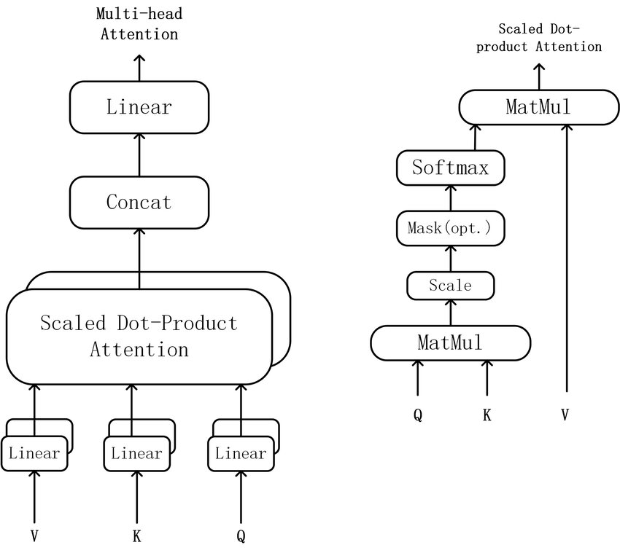
Figure 2.2. Scaled dot-product and multi-head self-attention
*(The structure of scaled dot-product and multi-head attention is shown in Figure 2.2 (adapted from Vaswani et al., 2017).)
Figure 2.2 illustrates the scaled dot-product attention mechanism. Queries (Q), keys (K), and values (V) are first projected using separate linear layers before being fed into the attention module. Inside scaled dot-product attention, Q is multiplied by $K^{⊤}$, the result is scaled by $1/\sqrt{d_{k}}$, optionally masked (as in causal decoder-only models), and passed through a SoftMax to obtain attention weights. These weights are then multiplied by V to produce the head output.
The left panel shows how multiple such heads are concatenated and fed through a final linear projection to form multi-head attention. The right panel expands the internal operations of a single attention head and highlights the role of the causal mask in restricting each query to attend only to earlier positions.

Attention Decay and Context Forgetting
Transformers are designed so that any token can attend to any earlier token, but they rarely use information from far back in the sequence. Attention decay means that as sequences get longer, earlier tokens get less attention and have little effect on predictions.
There are several reasons for this behavior:
- Early tokens experience representation drift:
When the model processes very long sequences, the hidden states of early tokens can change so much that they no longer match well with later query vectors. As a result, the dot products q_{i} · k_{j} for distant tokens become small, even if the content is important.
- Softmax amplifies small differences:
The softmax function converts similarity scores into probabilities. If recent tokens have slightly higher scores than older ones, softmax gives most of the attention to the recent tokens and reduces the influence of distant tokens.

- Training dynamics and where loss is applied:
In many training setups, the predictive loss is calculated for later positions in the sequence. This causes the model to focus on short-range patterns near the end, which strengthens a bias toward recent tokens. Just making the context window longer at inference does not fix this learned behavior.

- Effects of positional encoding and architectural shortcuts:
Positional encoding methods and sparse attention techniques, such as sliding windows or dilated patterns, are typically designed to focus on nearby tokens. This makes it even harder for the model to use information from far away unless a retrieval or memory system brings those tokens back into focus.
For users, attention decay looks like the model forgetting earlier context. Common problems include that when summarizing long documents, the model often focuses too much on the end and misses key definitions or assumptions from the start. In multi-turn conversations, instructions given at the beginning, such as “answer concisely” or “use a formal tone,” are often forgotten as the conversation progresses. In multi-hop reasoning tasks, the model may see all the relevant facts in the context, but it struggles to connect them if they are far apart.
These problems show that standard transformers act more like strong working memory systems with a limited range, rather than reliable long-term memory systems. Because this is different from how human memory works, methods like EM-LLM have been developed. These methods break experiences into episodes and store them, bringing them back when the model’s attention can no longer keep track of them.

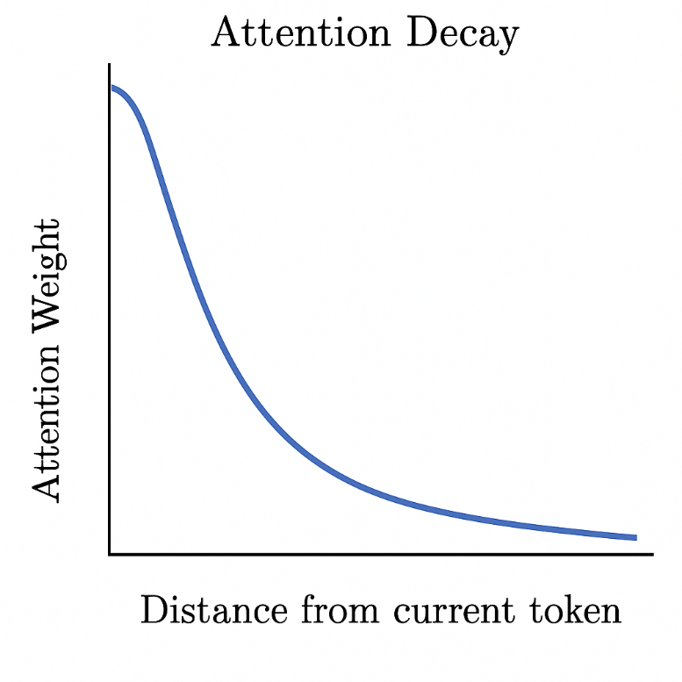
Figure 2.3. Conceptual illustration of attention decay
Figure 2.3 provides a schematic view of this behavior, showing how a token’s attention to earlier positions declines as the sequence grows longer.

Long-Range Context Benchmarks
Researchers have developed metrics that specifically assess how effectively LLMs handle complex situations, thereby going beyond anecdotal evidence. These benchmarks differ in task type, length, and domain, but they all aim to determine whether models can exploit information that appears distant from the query rather than simply adding more tokens to the input.
One of the most well-known long-context benchmarks is LongBench. With an average context length of several thousand words, it is a bilingual, multi-task suite that comprises summarisation, few-shot learning, code completion, single-document and multi-document question answering, and synthetic reasoning tasks. Evaluations reveal that as input length increases, even powerful commercial models experience performance declines, particularly on tasks that require reasoning across widely separated passages of text.
With average context durations reaching 100,000 tokens, ∞-Bench and InfiniteBench aim to push into even more severe circumstances. It blends realistic and synthetic activities, and its design requires models to retain and integrate information throughout lengthy text segments rather than only retrieving a few sentences. Current long-context models continue to struggle with genuinely "super-long" contexts, according to InfiniteBench results.
Long dialogues, code repositories, and structured data with contexts ranging from 8k to millions of tokens are all covered by more recent suites like LongBench v2, LoongBench, and associated long-context evaluations. These benchmarks show attention decay in a controlled manner: performance deteriorates when pertinent evidence is relocated farther into the context, or when the context length increases while task difficulty remains constant.
These benchmarks have three functions in this thesis, on long-range assignments, it highlights the shortcomings of a simple transformer-based LLM. It offers a fair comparison of the extended EM-LLM+CXR system, an EM-LLM configuration, and a baseline LLM under the same circumstances.
To determine whether episodic memory and cross-event reasoning generalise across domains, it provides a variety of tasks, such as multi-hop question-answering and narrative comprehension.

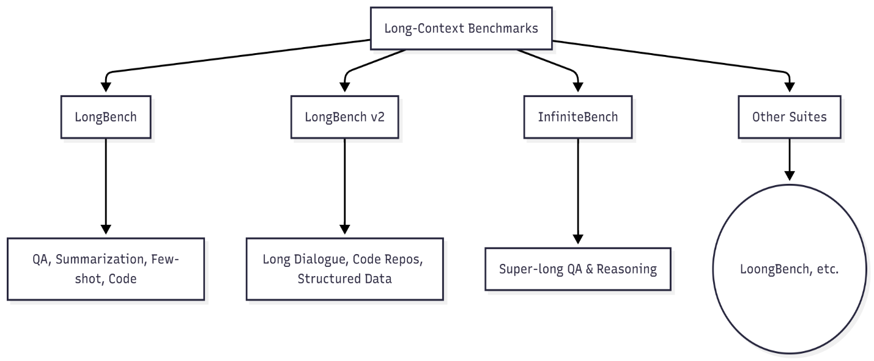
Figure 2.4.Long-context benchmark overview

Human Memory and Episodic Memory
Transformers and large language models read text as a long string of tokens, spreading their attention across the whole sequence. Human memory is different. People organize and condense information, using special memory systems to find what they need instead of remembering every detail in order. Learning about these systems shows why humans can reason over long periods, whereas transformer-based models often struggle to do so.
*( (Vaswani et al., 2017)), ((Atkinson & Shiffrin, 1968))
Cognitive psychology distinguishes between working memory and long-term memory. Working memory helps with tasks like remembering a phone number or following short instructions by holding a small amount of information for a few seconds. Long-term memory, which includes episodic memory (personal experiences) and semantic memory (facts and general knowledge), stores information much longer—sometimes for minutes, days, or even years.
* (Baddeley & Hitch, 1974). (Baddeley, 2000). (Tulving, 1983).
Episodic memory is significant here. Experiences like meeting a friend at a café, going to a lecture, or reading an article in the morning are stored as events. Instead of keeping raw sensory recordings, people save these events as organized, condensed memories that retain key details such as who was there, where it happened, and why it mattered. When reasoning later, people do not recall every detail. Instead, they remember a few relevant examples and connect them in their minds.
* (Anderson & Bower, 1973).
Transformer-based LLMs work very differently. They have a large but fragile working memory, limited to the current context window. Once tokens leave that window, they cannot be retrieved. Even within the window, attention fades, so earlier tokens have little effect on new predictions. In contrast, humans can remember past events, especially if those events were important, emotional, or surprising.
* (Press et al., 2022). (Vaswani et al., 2017) (Kensinger, 2009).
This thesis focuses on three main aspects of human episodic memory: First, we organize our experiences into separate events. Instead of remembering everything as one long stream, we break it into meaningful units called events. Second, we often forget some details of an event. People usually remember the beginnings, endings, and surprising parts more easily, often because of where they appear or how noticeable they are. Third, memories are connected by associations. Remembering one event usually brings up related ones, especially if they share people, situations, or topics. These links help us think more deeply.
* (Anderson & Bower, 1973)(Murdock, 1962). (Zacks et al., 2007).
These concepts are used in the EM-LLM framework and the Cross-Event Reasoner (CXR). CXR shows how recalled events are connected to the imitation of human memory. EM-LLM uses graph-based methods and surprisal signals to split text into events and save them as separate memory blocks.
* (Rescorla & Wagner, 1972).

Cognitive Models of Human Memory
Traditional cognitive theories view memory as a system composed of several interconnected parts. A common way to describe these parts is: Sensory memory stores raw information for a few milliseconds to a few seconds. Working memory, also called short-term memory, lets us use a small amount of information while we solve problems or talk with others. Long-term memory stores information for much longer periods.
*( D'Alessandro, D'Amato, M., Elkano, L., Uriz, M., Pezzulo, M. & Giovanni. (2025). GENESIS: A Generative Model of Episodic-Semantic Interaction. https://arxiv.org/abs/2510.15828)
Within long-term memory, semantic and episodic memory operate independently. Episodic memory stores detailed experiences, such as "I visited Paris last summer and saw the Eiffel Tower at night." Semantic memory stores general facts, such as "Paris is the capital of France."
Episodic memories are usually organized by who was there, what happened, where it took place, and when. These memories help us feel like we are relieving the event and include details about time and place. However, not all moments are stored in the same way:
What we notice and remember depends on where we focus our attention. Information that seems useful for future decisions is more likely to stay in our memory. We remember surprising or emotional events more easily because strong feelings and surprises help memories last.
*( (n.d.). Episodic memory. en.wikipedia.org/wiki/Episodic_memory. https://en.wikipedia.org/wiki/Episodic_memory)
Episodic memories depend on context and connections; not just how recent events are. For example, if someone asks, "Why did I choose that route yesterday?" the brain connects memories with similar places, people, or goals to answer. In contrast, transformers do not deliberately create chains of related events. They focus on individual tokens, and their attention fades as the distance between tokens increases.
This thesis clearly shows that humans do not process experiences as a continuous stream of tokens. Instead, we break them into episodes, store them in long-term memory, and recall them based on what matters, not just the order. EM-LLM architecture is built on this idea by:
Treating sections of text as whole events instead of single tokens and storing them as memory blocks instead of keeping all tokens active at once. Retrieving events based on how similar, important, or connected they are, not just how recent they are. The model builds on this by adding a reasoning layer over events, which reflects how humans compare, combine, and re-rank memories when answering complex questions.
*( Burke, Heuer, A., Reisberg, F. & Daniel. (1992). Remembering Emotional Events. Memory & Cognition 20. https://pubmed.ncbi.nlm.nih.gov/1508053/
Folkerts, Rutishauser, S., Howard, U. & W., M. (2018). Human Episodic Memory Retrieval Is Accompanied by a Neural Contiguity Effect. Journal of Neuroscience 38. https://pubmed.ncbi.nlm.nih.gov/29615486/
Zhang, Zhang, S., Ma, P., Wei, X., Wang, J., Liu, N. & Qun. (2020). TensorCoder: Dimension-Wise Attention via Tensor Representation for Natural Language Modeling. https://arxiv.org/abs/2008.01547)
Humans usually remember the first and last items in a list better than those in the middle. When recall accuracy is plotted by list position, it forms a U-shaped curve high at the beginning (primacy), low in the middle, and high again at the end (recency).
*( (2025). Serial position effect. EBSCO Research Starters. https://www.ebsco.com/research-starters/psychology/serial-position-effect)

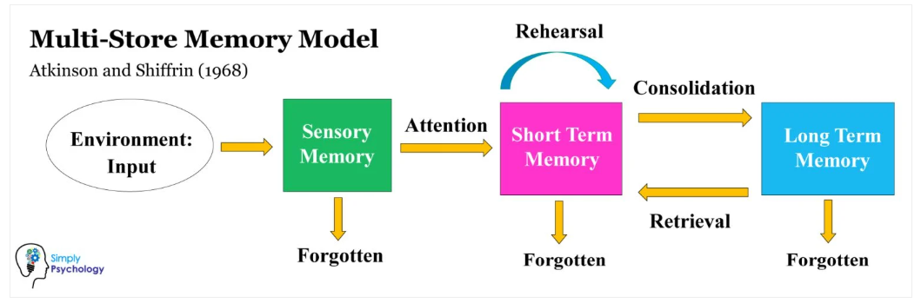
Figure 2.5.Multi-store model of human memory (sensory, short-term/working, and long-term memory)
*( Multi-Store Memory Model: Atkinson and Shiffrin)
Figure 2.5 shows the multi-store memory model by Atkinson and Shiffrin (1968), which describes memory as a flow through three leading stores. Information first enters sensory memory from the environment, and most of it is quickly forgotten unless attention moves it into short-term memory. In short-term memory, rehearsal helps keep information active and can consolidate it into long-term memory. Long-term memory stores information more permanently, and relevant items can later be retrieved from long-term memory into short-term memory. In contrast, unused information in any store may eventually be forgotten.

Serial Position Effects and Surprise
The serial position effect has two main components. The primacy effect is linked to deeper encoding, because early items are rehearsed more often and are more likely to be stored in long-term memory. The recency effect is usually explained by working memory, since the most recent items are still active and easy to recall without needing long-term storage.
In this thesis, the serial position effect is significant because it shows that human memory does not treat all parts of a sequence equally. Humans naturally focus on the beginning and end, while the middle is often less well remembered. This differs from models that assign equal weight to every token within a context window. It suggests that focusing on certain parts of input is a valuable feature of memory, not a flaw in the connected component. We are much more likely to remember experiences that run counter to our expectations. Greater memory capacity is another essential factor. We tend to remember things that go against our expectations. When something unexpected happens, it leaves a stronger memory trace and gets more attention. These are the moments we recall later, like an unusual comment in a meeting, a sudden twist in a story, or an odd result in an experiment: "before X happened" and "after X happened." EM-LLM has a similar concept: a signal for possible event boundaries is token-level surprisal, the extent to which a token is unexpected given the model's current expectations. Surprisal spikes indicate potential boundaries between occurrences.
*( Fountas, Benfeghoul, Z., Oomerjee, M. A., Christopoulou, A., Lampouras, F., Bou-Ammar, G., Wang, H. & Jun. (2024). Human-like Episodic Memory for Infinite Context LLMs. https://arxiv.org/abs/2407.09450)
To put it another way, EM-LLM converts two human memory intuitions into a tangible algorithmic form; EM-LLM turns two ideas from human memory into a real algorithm, significant consideration. The segmentation and storage of the input should be influenced by sudden changes or unexpected tokens (i.e., high surprisal). Like primacy and recency, the beginning and end of an episode are likely to be essential and deserve extra attention and the architecture of the episodic memory pipeline. These ideas are present later in the thesis, both in how the Cross-Event Reasoner handles event boundaries and in the design of the episodic memory pipeline. The algorithm picks segments that are more likely to matter for long-term reasoning, instead of treating every token the same. This is much like how human memory focuses on beginnings, endings, and surprises.

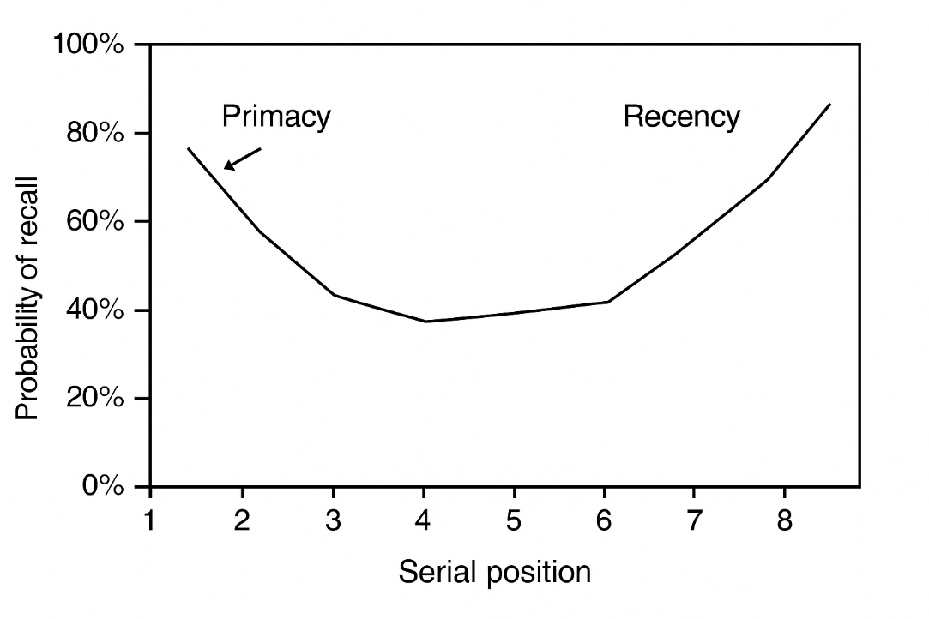
Figure 2.6.Serial position curve.
Figure 2.6. shows a Simple graph with serial position on the x-axis and recall probability on the y-axis, showing the U-shape (high at start and end). Items at the beginning of the list (primacy) and at the end (recency) show higher recall than items in the middle. Adapted from Practical Psychology and standard serial position effect demonstrations.
*( Serial Position Effect (Example + Definition) - Practical Psychology)

Event Segmentation in Human Cognition
According to event segmentation theory, people naturally divide continuous experience into distinct events with distinct internal structures and smooth transitions between them. For example, going into a room, saying hello, and striking up a conversation are considered one event, whereas driving home and leaving the place are considered the start of another. Changes in location, people, objectives, or activities frequently align with these boundaries.
*( Zacks, M., J., Tversky, B., Iyer, &. & G. (2001). Perceiving, remembering, and communicating structure in events. Psychological Science 12. https://doi.org/10.1111/1467-9280.00364)
Event borders are times of enhanced processing, according to behavioral and neuroscientific research. Prediction errors, changes in goals, or changes in sensory information cause our internal picture of "what is happening now" to be updated. These updates mark the conclusion of one episode and the beginning of the next. The following episodes eventually develop into the basic building blocks of episodic memory.
*( Nery, B., Ventura, &. & R. (2010). Online event segmentation in active perception using adaptive strong anticipation. https://arxiv.org/abs/1006.5829)

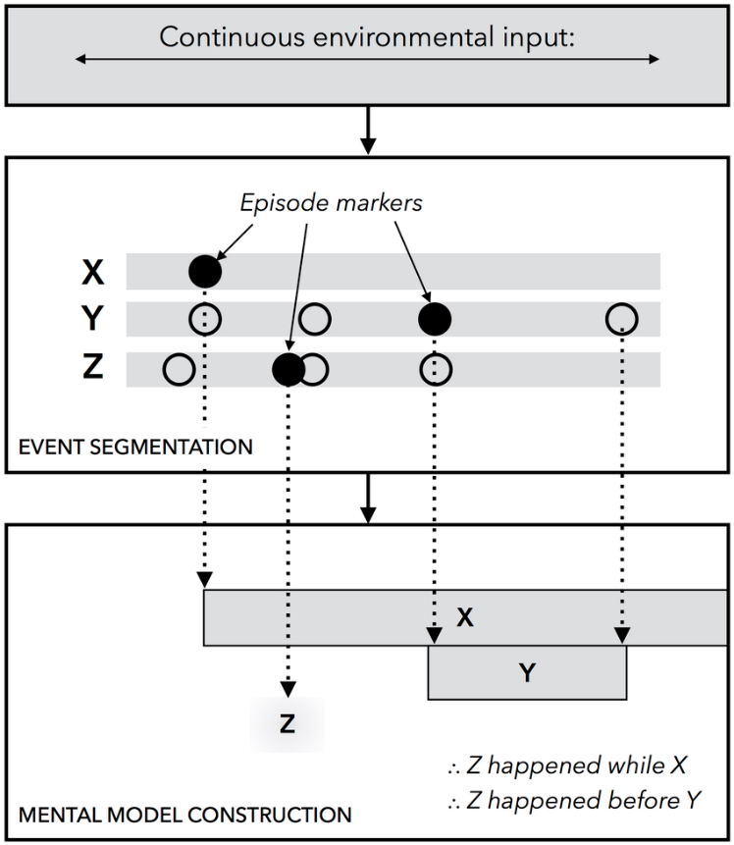
Figure.2.7. An illustration of the unified theory of event representation and segmentation. Changes in continuous environmental input across a limited set of perceptual stimuli, denoted by X, Y, and Z in the diagram, are identified by the system event segmentation
Figure 2.7. illustrates the unified theory of event representation and segmentation. Changes in continuous environmental input across a limited set of perceptual stimuli, denoted by X, Y, and Z in the diagram, are identified by the system's event segmentation component, which runs online and concurrently with other cognitive processes. A new episodic marker is created at the beginning of a stimulus, which is denoted by a black circle. A new episodic marker is also produced when a stimulus is neutralized. The markers are used to create a discrete event model when the system is asked for information about temporal relationships. After that, the model is scanned by the system to draw conclusions.
*( A diagram of the unified theory of event segmentation and... | Download Scientific Diagram)
This procedure and the EM-LLM architecture are directly compared in the requirement analysis for this thesis. Instead of using individual words, humans divide experience into episodic experiences, such as scenes, conversations, and acts, which serve as memory units. Long after the initial sensory stream has passed, they can recollect these occurrences because they are stored in long-term memory. They recover events during reasoning, not just based on recentness, but also on context, similarity, and relevance.
EM-LLM offers a computer equivalent to this technique:
1. Event segmentation based on surprise: High-surprisal tokens, which capture significant shifts, topic changes, or unexpected information, are considered provisional boundaries.
2. Graph-theoretic improvement: EM-LLM creates activation adjacency graphs over token representations because raw boundaries can be noisy. It then uses graph metrics such as conductance and modularity to identify coherent clusters that better represent semantically unified events.
3. The storage of episodes: Every event is stored as a small memory block that includes key/value tensors, pooling representations, and metadata such as length and boundaries. Together, these provide the model's global episodic memory, distinct from the local context window. This pipeline is like how humans precisely continue experience into structured episodes; the model saves event-level summaries that can be reactivated later, rather than keeping every token in active memory.
By including a feature crucial to human cognition, explicit interaction between events, the Cross-Event Reasoner expands EM-LLM. "The café reminds you of a meeting which reminds you of a decision" is an example of an associative chain that occurs when people recollect an end.

Memory-Augmented Neural Architectures
Standard transformer-based LLMs struggle with long inputs, which has led to much research on memory-augmented architecture. Instead of relying solely on a fixed context window, these models provide mechanisms for storing and retrieving information beyond what self-attention can retain. The main goal is to reduce attention loss and help models reuse important information over longer texts.
*(Retrieval-Augmented Generation (RAG): Bridging LLMs with External Knowledge https://www.walturn.com/insights/retrieval-augmented-generation-(rag)-bridging-llms-with-external-knowledge)
In general, memory-augmented models add a non-parametric component to the main architecture, working alongside its parametric weights. Parametric memory is built into the model’s parameters and can only change during training. Non-parametric memory, on the other hand, stores explicit representations of past data, like documents, activations, or events, and can be updated while the model is running. Retrieval-augmented generation (RAG) and memory networks are examples of this approach (Lewis et al., 2020; Sukhbaatar et al., 2015).
There are three main types of approaches for handling long-context reasoning:
Retrieval-augmented generation (RAG), which pulls in relevant text from an external corpus and incorporates it into the prompt (Lewis et al., 2020). Memory networks and memorising transformers, which integrate differentiable memory modules directly into the architecture (Sukhbaatar et al., 2015; Wu et al., 2022). Efficient and long-context transformers, which adapt the attention mechanism or positional encoding to accommodate more extended sequences (Dai et al., 2019; Tay et al., 2020).
This section examines three types of models, explains their strengths and weaknesses, and prepares to introduce EM-LLM and the Cross-Event Reasoner.

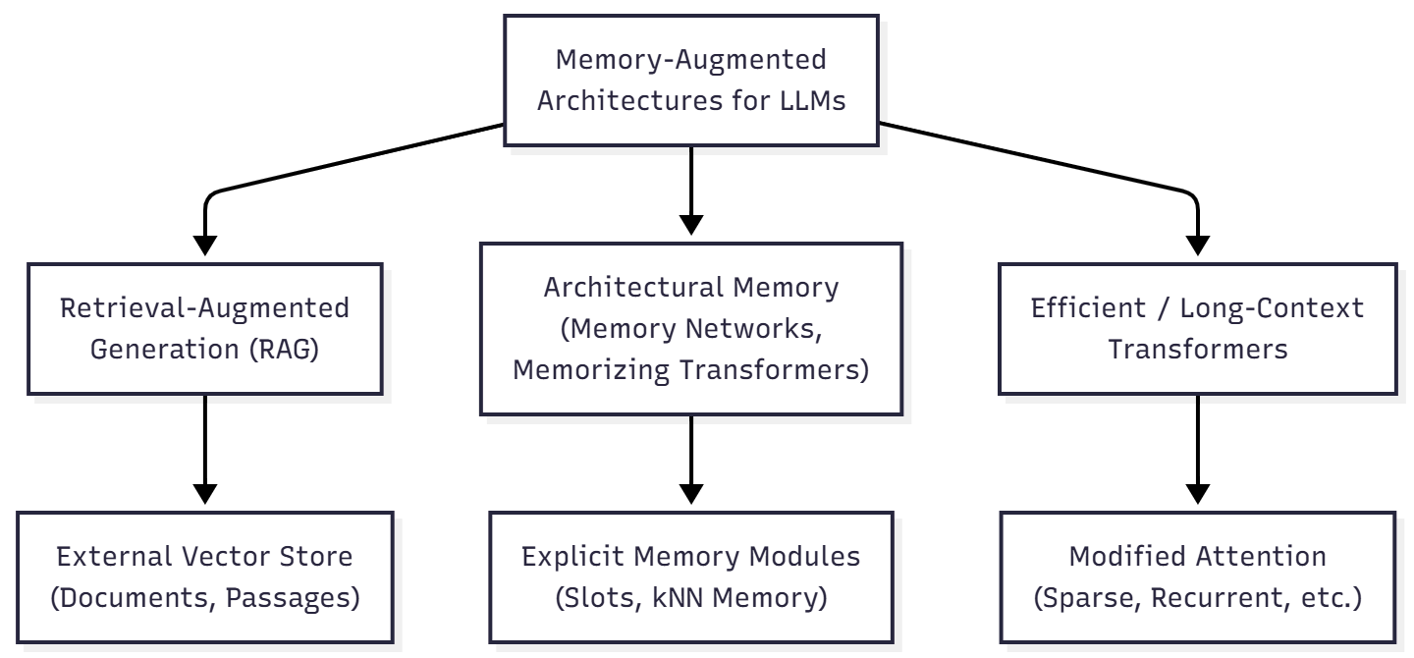
Figure.2.7.High-level taxonomy of memory-augmented architectures: RAG uses an external vector store, architectural memory integrates explicit memory modules; efficient transformers modify attention for longer sequences
Figure 2.7. shows how the three families relate: RAG, memory networks, and efficient transformers. A general overview of memory-boosted designs for large language models is shown in the figure. There are three main types: retrieval-augmented generation, which lets models look up valid documents from an outside database; architectural memory models, which add clear memory features like slot-based or nearest neighbor modules into the system; and efficient or long-context transformers, which change how the model pays attention so it can handle much longer pieces of text.

Retrieval-Augmented Generation (RAG)
Retrieval-augmented generation (RAG) is often used to help large language models (LLMs) leverage additional information, especially when substantial knowledge is required. Instead of storing everything in its own memory or in a single chunk of text, RAG uses a separate memory. This is usually a special list of numbers made from documents or passages, which lets the model find valid text when needed.
A typical RAG system has two main parts:
- Retriever: Given a question (for example, from a user), a neural retriever turns the question into a set of numbers and looks for the closest matches in a list of text pieces. This list is usually compiled from sources such as Wikipedia, special collections of documents, or records of earlier conversations.
- Generator: The top-matching passages are combined with the question and sent to a language model, which generates the final answer. Some versions let the model see different passages at each step, while others use the same set of passages throughout.

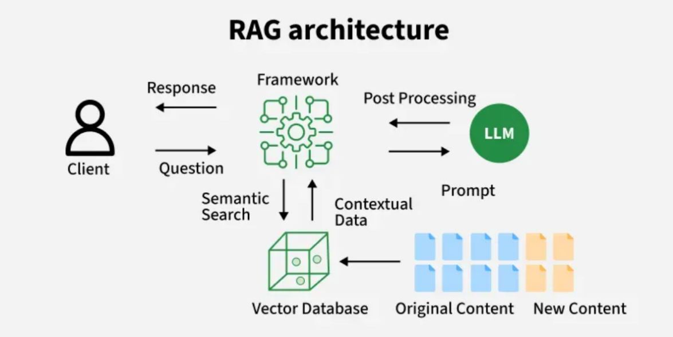
Figure 2.8.RAG Architecture
Retrieval-Augmented Generation (RAG) improves large language models by connecting them to outside knowledge sources. This lets them use current or specialized information and helps prevent hallucinations. RAG has two main parts: a retriever, often using Dense Passage Retrieval (DPR), and a generator based on transformer models like BART or GPT. The retriever converts the user’s question and a set of documents into dense vectors, identifies the passages most like the question, and sends them to the generator. Since these parts operate independently, the system can leverage both the model’s built-in knowledge and information from a vector database.
*( RAG Architecture - GeeksforGeeks)
The generator combines retrieved passages using either the Fusion-in-Decoder (FiD) or the Fusion-in-Encoder (FiE) approach. FiD keeps retrieval and generation separate, merging the information during decoding. This usually gives better answers but needs more computing power. FiE combines the passages earlier in the encoder, which is faster but may be less flexible. The process starts by embedding the query, searching the vector database, finding relevant passages, and then creating a final answer. This way, the model’s response mixes what it already knows with the new information it finds.
Retrieval-augmented generation brings several advantages:
It gives the model access to knowledge that lies beyond its training set, since the external index can be updated independently. It helps the model use more information by showing only the most essential parts of long documents or big collections of text. It works with many different language models, so most existing models can be used as generators without changing their architecture.
From the perspective of this thesis, however, several limitations matter:
- Chunk-based segmentation: Documents are usually split into pieces of a fixed size (for example, 512 to 1024 words), without regard for where stories or ideas naturally break. Important information can be spread across several pieces, so the model ends up reading a mix of texts rather than a smooth story.
- Limited structural reasoning: The retriever assesses how similar each piece of text is to the question. It does not directly consider connections between pieces, such as the order of events, cause-and-effect, or links that involve several steps. Tasks that require combining different pieces of information still rely solely on the generator’s detailed attention.
- Sensitivity to retrieval errors: If retrieval does not find the crucial passages or only finds somewhat related ones, the generator may make up answers that sound right but are wrong. This problem gets worse in tasks with lots of information, where the details needed are hard to find.
Although recent work has suggested improvements such as rewriting questions, reordering results, changing chunk sizes, and finding information across several steps, the basic setup remains the same: the language model receives a set of found text pieces, joined together, as its input. For long stories or tasks that require several steps of thought, this leaves a critical gap that EM-LLM and CXR aim to address: the need to show and think about events rather than just separate pieces of text.

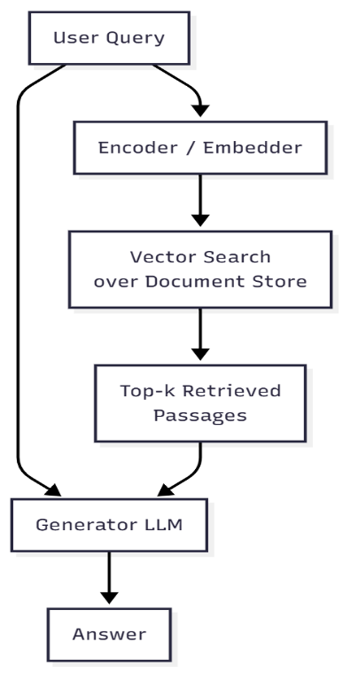
Figure 2.9. Block diagram for RAG
Figure 2.9. shows the main steps in a Retrieval-Augmented Generation (RAG) system. It explains how a user’s question is turned into an answer by using both retrieval and generation.
The process starts when the user submits a question. This question is sent to both the encoder and Generator LLM simultaneously. The encoder converts the question into a set of numbers, which is used to search a database of documents that have been prepared for search. The system finds the most relevant parts and sends them, along with the original question, to Generator LLM. The generator combines this information with what it already knows to produce a final answer that draws on both its own knowledge and the latest external information. The system picks the most relevant passages that match the user’s question. These passages, along with the original question, are sent to Generator LLM. The generator then combines this new information with what it already knows to create a final answer that is accurate and up to date.
In this thesis, RAG is seen as something that works alongside other methods. While RAG finds valid documents or passages from extensive collections, EM-LLM builds an internal memory over a single stream (e.g., a lengthy document or conversation), and CXR reasons about these internal events. The mixed-method approach that combines external retrieval with internal memory is promising, but it is not the primary focus of this work.

Memory Networks and Memorizing Transformers
A second group of methods adds clear memory parts directly into the neural network. Sukhbaatar et al. (2015) introduced End-to-End Memory Networks, in which input facts are stored in a memory table and accessed stepwise via attention. At each step, the model focuses on different memory slots, reads a mix of them, and updates its state, allowing it to reason through the stored facts in several steps.
This area is closely related to Neural Turing Machines and the Differentiable Neural Computer, which connect a controller network with an external memory that can be read from and written to during learning. Even though they work differently, these designs share the main idea of clearly separating thinking from storing information.
Subsequent models integrate memory more tightly into transformer-style architectures: Some add permanent memory slots to transformer layers, updating them over time to retain important information for longer. Others maintain external memory banks of hidden states and regularly update them with important information, allowing the model to look back beyond its current input.
Memorizing Transformers extend this approach by attaching a k-nearest-neighbour (kNN) memory of hidden representations (Wu et al., 2022). During training or inference, selected activations are written to an extensive index. Later, when processing new inputs, the model retrieves similar past representations and attends to them. This provides a form of long-term, non-parametric memory that allows information to be added without modifying model weights.

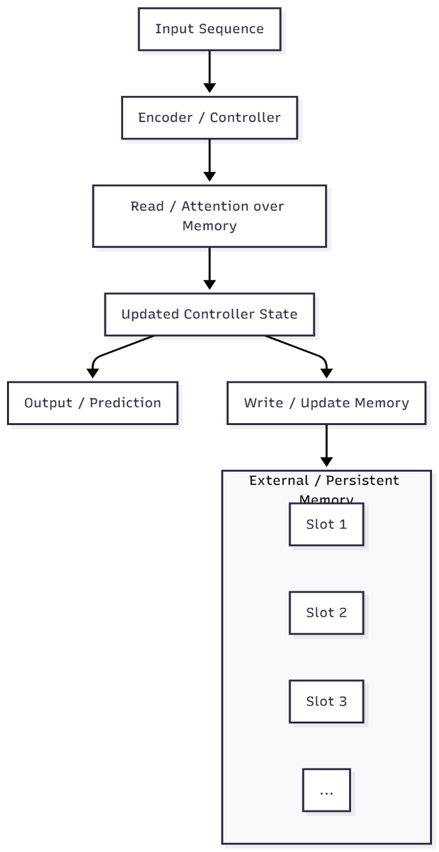
Figure 2.10. Schematic view of memory-augmented neural architectures such as End-to-End Memory Networks and Memorizing Transformers. A controller (e.g. a transformer) reads from and writes to an explicit memory of slots or stored activations
Figure 2.10 shows the main workflow of memory-augmented neural architecture, where the model interacts with an explicit external memory while processing an input sequence. The input is first handled by an encoder or controller, which generates a representation used to read from or attend to the memory. Using the retrieved information, the controller updates its internal state, which then leads to two parallel operations: producing an output or prediction and writing updated information back into the external memory. The memory is organized into individual slots that persist across steps, enabling the model to store, retrieve, and refine information over time. This read–update cycle supports long-term reasoning, retrieval, and contextual coherence beyond what a standard transformer or recurrent model can maintain using only its internal hidden states.
These architectures illustrate that explicit memory can: Improve performance on tasks involving long-term dependencies and multi-step reasoning. Enable models to acquire new information during inference by writing to memory instead of retraining.
It also has a few limitations, such as often requiring specialized training to learn to read and write well and to keep learning steadily. The memory is unorganized primarily, usually just raw hidden states or slots, with no clear way to represent events, episodes, or stories.
These systems are complex to build and require significant computer power and hardware. For this thesis, these models show the value of explicit memory, but they do not target the human-inspired, event-based memory organization central to EM-LLM. They are also less suitable when the goal is to build a training-free wrapper around existing LLMs, a key design constraint for EM-LLM and CXR.

Efficient and Long-Context Transformers
Another critical area of research focuses on making transformers faster and able to handle more extended sequences by changing how they attend to words, how they keep track of position, or both. Standard transformer self-attention requires much more computing power as the sequence length increases, which becomes too much for sequences longer than a few thousand words. Efficient transformer designs try to lower this cost while still working well.

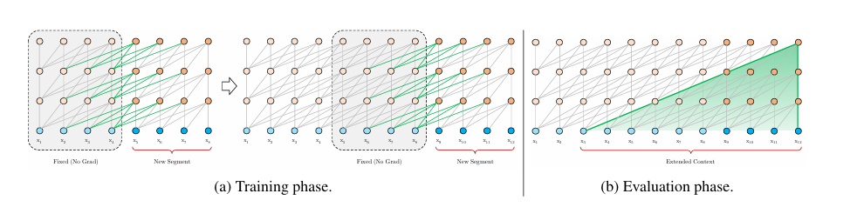
Figure 2.11. Illustration of the Transformer-XL model with a segment length 4
The mechanism is shown in Figure 2.11. rather than processing each segment in isolation, Transformer-XL reuses the hidden states from the preceding segment as cached memory when encoding the current one (Dai et al., 2019). At evaluation time, these cached states are concatenated with the current segment’s representations and serve as keys and values in self-attention, allowing each token to attend not only to others within its own segment but also to tokens from earlier segments. This segment-level recurrence extends the effective context length without recomputing attention over the entire history and reduces the context fragmentation that results from naively splitting long sequences into separate chunks.
The Long-Range (LRA) benchmark tests several efficient transformer models, including Reformer, Linformer, Performer, Sparse Transformer, and Long former, on tasks with sequences up to 16,000 tokens (Tay et al., 2020). These models use techniques such as sparse attention, which limits attention to local windows or a chosen subset of positions, thereby compressing memory or splitting data into smaller parts.
New long-context large language models can handle much longer text, even tens or hundreds of thousands of words at once. They do this by using faster attention methods, along with tricks such as rope scaling, sliding windows, and paged attention. Because of this, these models can read and process entire books or codebases at once.
However, there are still some limitations:
Making the context window longer does not solve the problem of attention decay. Studies show that even in long-context models, the model mostly pays attention to recent tokens, and tokens farther away have little effect on predictions. The input is still processed as a straight sequence of tokens. The model lacks a built-in mechanism for representing events, episodes, or higher-level structures, so it must learn these patterns on its own.
Many efficient transformer types need to be trained from scratch or require extensive additional training. This is not practical for large models that cannot be changed or for situations where there are not enough resources for training. These transformers primarily serve as tools for handling long texts and working alongside memory-boosting methods. In this thesis, these models show how changing the design can help with longer context, but they still do not replace the need for a clear, event-based memory that works more like human memory.

Summary and Positioning
In retrieval-augmented generation (RAG), memory networks, and efficient transformers, models obtain additional information via external retrieval, memory modules, or larger context windows. Still, this information is usually handled as unstructured tokens or chunks. As a result, the base transformer is mainly responsible for organizing, interpreting, and integrating these elements.
EM-LLM and the Cross-Event Reasoner use a different approach. These models treat events as primary units, drawing inspiration from human episodic memory. They clearly separate local context, which acts like working memory, from global episodic memory, which serves as long-term storage. These systems serve as training-free wrappers for existing models, making them usable even when fine-tuning is not possible.

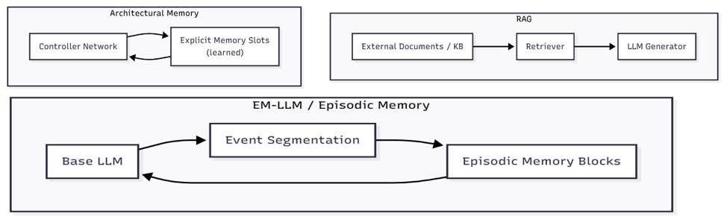
Figure 2.12. Comparison overview of RAG, Architectural Memory and EM-LLM
Figure 2.12 shows conceptual comparison of RAG, architectural memory models, and EM-LLM. RAG retrieves external documents to augment the generator, architectural memory networks maintain learned memory slots that the controller reads from and writes to during processing, and EM-LLM segments long input streams into events that are stored in episodic memory for later retrieval.
EM-LLM and CXR bring together several research ideas. They use non-parametric memory from RAG and memory networks, address scalability issues in efficient transformers, and add an event-based structure grounded in cognitive theories of human memory. The following sections explain how EM-LLM uses this episodic memory pipeline and how CXR builds on it with cross-event reasoning.

EM-LLM: Human-Inspired Episodic Memory for LLMs
Standard LLMs struggle to manage very large amounts of information, whereas the human brain can organise and retain experiences across a lifetime. In this work, the authors introduce EM-LLM, a design inspired by key principles of human event memory and experience understanding, implemented without any additional training. This approach enables models to handle effectively unlimited input lengths while remaining computationally efficient. EM-LLM groups token sequences into coherent events by detecting surprising changes and refining boundaries through graph-based methods, all performed online as data arrives. When information is needed, the system retrieves events through a two-stage process that first identifies semantically similar events and then incorporates those that occurred nearby in time, supporting efficient, human-like recall of relevant material.
Experiments on the LongBench and ∞Bench benchmarks show that EM-LLM consistently outperforms the leading retrieval method, InfLLM, across multiple base LLMs. EM-LLM also surpasses RAG on many tasks while using comparable computational resources. It even outperforms full-context models on most evaluations and can successfully retrieve information across 10 million tokens a scale that full-context approaches cannot reach.
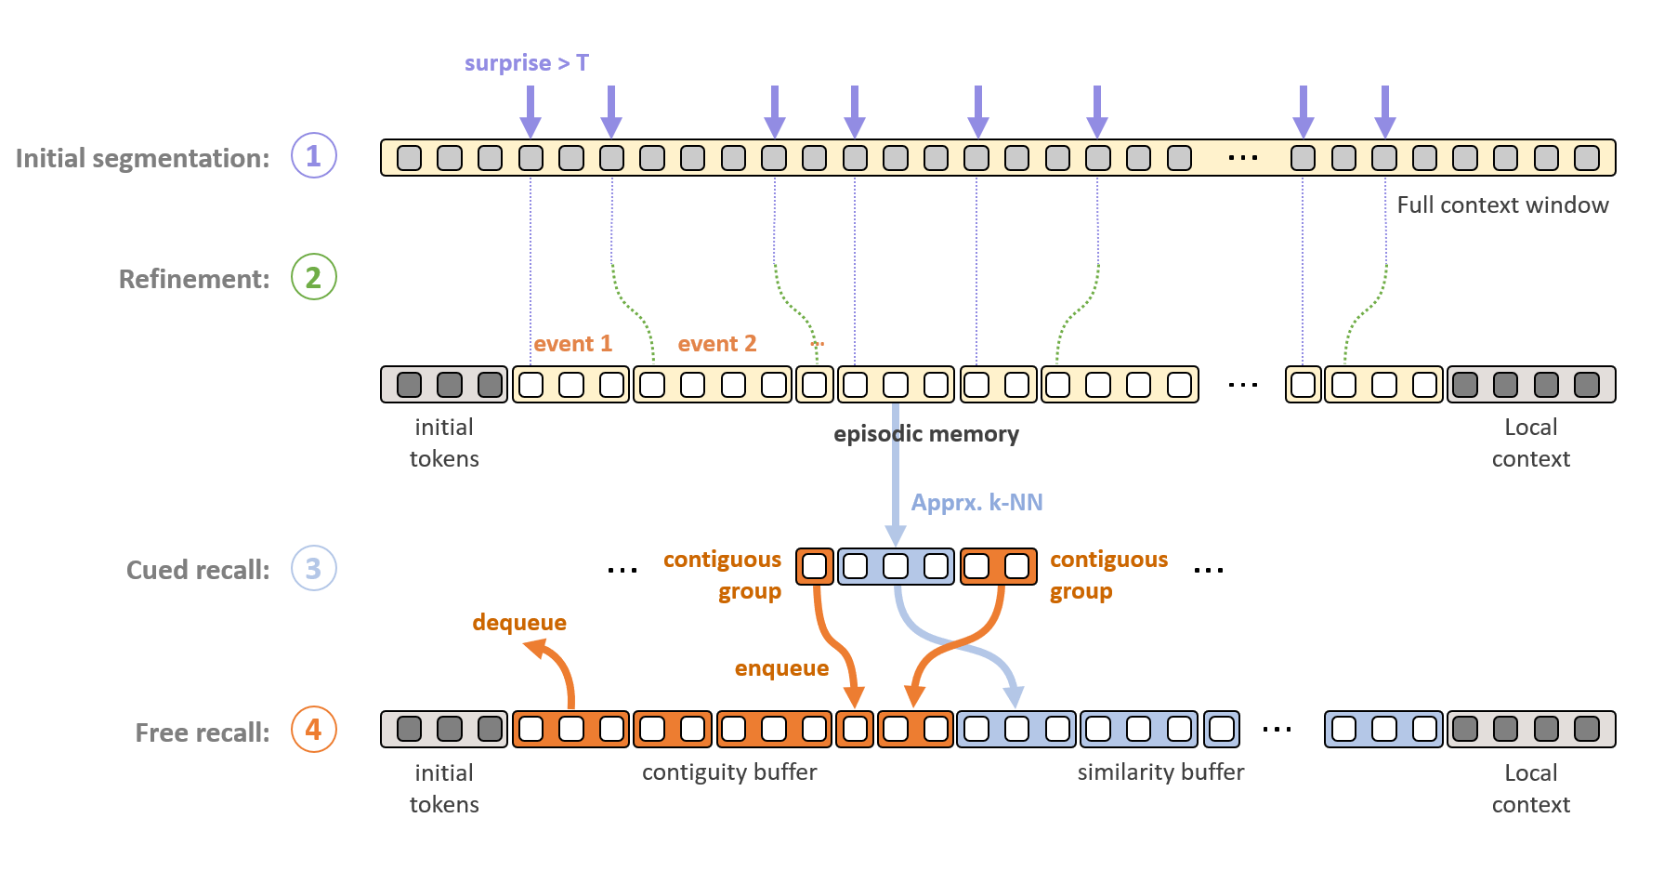
Figure 2.13Architecture of memory formation and retrieval in each LLM layer.
The overall EM-LLM architecture is shown in Figure 2.13. A long token stream is first processed by a base LLM, whose surprisals and hidden states are used to segment the input into events. These candidate event boundaries are refined using a graph-based step to ensure that segments align with semantically coherent regions. Each resulting event is then stored as an episodic memory block containing pooled representations and key-value tensors outside the standard context window. At inference time, a retrieval module ranks these events by similarity and importance, selects a small subset (plus neighbouring events), and injects their key-value tensors back into the model’s attention, allowing the LLM to condition on information far beyond its native context length.
*( HUMAN-INSPIRED EPISODIC MEMORY FOR INFINITE CONTEXT LLMS Zafeirios Fountas1, Martin A Benfeghoul1,*, Adnan Oomerjee1,*, Fenia Christopoulou1, Gerasimos Lampouras1, Haitham Bou-Ammar1,2 and Jun Wang2)
EM-LLM helps language models get closer to human-like memory, but it still has some significant problems.
The main problem is that the model struggles to link information across different events. It gets each event as a separate piece and must connect them on its own. When important details are spread out, this often does not work well.
For example: One event may introduce an entity and its attributes. A later event may describe an action involving that entity. A third event may present an outcome that only makes sense when connected back to the earlier details.
People can easily connect these events and build stories that explain what happened and why. EM-LLM can remember the events, but it cannot put them together or show why they matter as a group. Because of this, the model may see each event in isolation and miss the bigger picture, especially when it cannot attend to everything at once.

Surprisal-Based Event Segmentation
EM-LLM splits text based on the idea that people remember life as separate episodes rather than a continuous stream. To mimic this, EM-LLM uses surprisal as a real-time signal to find where one event ends and another starts.
$$s_{t}= -\log{p\left(x_{t} ∣ x_{<t}\right)}$$
In this equation, $x_{t}$ stands for the current word or symbol, and $p\left(x_{t}| x_{<t}\right)$ is the model’s predicted probability. Low surprisal means the token is expected, so the narrative continues smoothly. High surprisal means the word or symbol is unexpected. This could signal a topic change, a new character, a shift in the story, or a change in style. In practice, EM-LLM calculates surprisal at one or more points as it moves through the text. To avoid random spikes, surprisal can be averaged or made less sensitive, and the cut-off points can be adjusted for each dataset. When surprisal exceeds a set threshold or rises rapidly, EM-LLM flags a possible event boundary.
There are a few practical points to consider:
- Granularity: If boundaries are too frequent, events become too short and lose coherence if they are too sparse, events become long and behave like ordinary chunks. Segmentation parameters, therefore, determine the effective “episode length” and can be adapted to different domains (e.g., dialogue vs. narrative).
- Model dependence: Since the main LLM calculates surprisal, splitting depends on what the model finds surprising. Boundaries appear where the model is surprised, which is where extra memory is most useful.
- Online processing: Surprisal can be calculated step by step as the model reads the text. This lets EM-LLM process streaming text without loading the whole document at once.at once.
However, surprisal alone does not guarantee clear semantic boundaries. Small errors, style changes, or rare words can cause minor spikes that do not show real changes in events. This is why EM-LLM uses a second segmentation stage called graph-theoretic refinement.

Graph-Theoretic Boundary Refinement
The original EM-LLM design includes a graph-based refinement module that aligns surprisal-based boundaries with the semantic structure in hidden states. In the public version, this module was partly disabled. This thesis restores and efficiently integrates it. The method creates an activation adjacent graph using token-level hidden states.
- Select one or more transformer layers that capture higher-level semantics, usually the top layers.
- For each token, extract its hidden vector and measure its similarity to nearby tokens, either within a sliding window or using k-nearest neighbours in the embedding space.
- Build a graph where each node is a token, and edges connect highly similar tokens.
EM-LLM then applies metrics like modularity and conductance to this graph. Modularity measures how well the graph can be split into tightly connected groups. Clusters with high modularity often match semantically coherent segments. The conductance measure quantifies the quality of a cut between two node sets; low-conductance cuts indicate firm boundaries with relatively few edges crossing between them. The method then refines surprisal-based boundaries by aligning them with meaningful cuts in the graph. If an event boundary falls within a high-modularity cluster, it can be moved to the nearest low-conductance cut. This helps avoid splitting into different coherent events. New boundaries can be added where the graph clearly separates two communities, even if surprisal does not show a strong spike.
This refinement solves two main problems, first it captures gradual topic shifts that might not cause strong surprisal peaks but do show up as changes in the representation space. Second, it reduces boundary artefacts caused by noise or stylistic quirks, which improves event stability and interpretability.
Building full graphs for very long sequences is expensive. In practice, EM-LLM systems use approximate graphs, such as local windows or kNN graphs, and focus their analysis on areas near candidate boundaries. This thesis uses methods that balance segmentation quality and computational efficiency.

Episodic Memory Storage and Hierarchy
After identifying events, EM-LLM saves them in a special episodic memory. The main goal is to keep short-term and long-term information separate. A local context window, such as the most recent few thousand tokens, is handled with standard transformer attention. Earlier content is compressed into event-level memory blocks and removed from the active context.
Each memory block usually contains the following:
- Key and value tensors for attention linked to the event’s tokens.
- Token or span embeddings that help with similarity scoring and pooling.
- A pooled event embedding that sums up the whole event as one vector.
- An importance score, like repr_score, shows how often the event has been retrieved and used.
- Metadata includes things like token indices, event length, and where it is stored (GPU, CPU, or disk).
This setup creates a layered memory system:
- At the base level, there are raw tokens in the current local window.
- Above that are event representations of earlier parts from the same document or conversation.
- There could also be higher-level summaries made by merging events, but this feature is not fully developed in the original EM-LLM.
This structure is like how human memory works. Recent details remain active and detailed, while older information is grouped into episodes and brought back only when needed. In practice, EM-LLM manages its memory pool using several policies:
- Offloading means moving rarely used events to the CPU or disk.
- Garbage collection involves removing very old events that are never retrieved.
- Priority updates raise an event’s repr_score when it is retrieved and slowly lower it otherwise. This helps the system find episodes that are still useful.
With these mechanisms, EM-LLM can handle much longer input streams than a fixed context window and keep access to important past events.

Retrieval and Multi-Stage Attention
When the model needs to answer a question or keep writing, it cannot reload every saved event. Instead, EM-LLM selects and ranks events, then sends only a small subset to the transformer. Event ranking usually relies on three main signals:
- Usage-based importance (repr_score): events that were helpful in previous retrieval steps get a higher score.
- Semantic similarity: a query from the current state is compared to stored events using simple math methods to see how similar they are.
- Contiguity: events that are close in time to high-scoring ones are also included. This helps keep local continuity and avoids retrieving isolated fragments.
These signals are adjusted and combined, often using simple arithmetic, to produce a final ranking. The top events and their nearby neighbors are then picked and added back into the model’s context.
EM-LLM uses a multi-stage attention process:
- The transformer first attends the current local tokens as it usually does.
- The retrieved events provide additional information to the attention process, allowing the model to use details from earlier.
- The outputs from local and episodic attention are combined using special connections and layers to produce the final prediction state—information from much further back without reprocessing the entire history.
However, in the original EM-LLM, events are still treated as separate units. Retrieval primarily operates at the event level, and there is no special way to reason about relationships between events before they enter the transformer.

Limitations of EM-LLM:
EM-LLM helps language models get closer to human-like memory, but it still has some significant problems. The main problem is that the model struggles to link information across different events. It gets each event as a separate piece and must connect them on its own. When important details are spread out, this often does not work well.
For instance:
- One event may introduce an entity and its attributes.
- A later event may describe an action involving that entity.
- A third event may present an outcome that only makes sense when connected back to the earlier details.
The human brain can easily connect these events and build stories that explain what happened and why. EM-LLM can remember the events, but it cannot put them together or show why they matter as a group. Because of this, the model may see each event in isolation and miss the bigger picture, especially when it cannot attend to everything at once.

Cross-Event Reasoning and Event-Level Modeling
As explained in Section 2.4, EM-LLM improves on standard LLMs by dividing long token streams into episodic events, storing them as compressed memory blocks, and retrieving them using similarity and contiguity signals. However, in the original EM-LLM framework, these retrieved events are mainly treated as separate pieces of evidence. They are chosen and placed back into the context window, but their interactions are not directly modeled.
Research in narrative understanding, knowledge graphs, and multi-hop question answering shows that reasoning often depends on relationships between events rather than isolated facts. For example, narrative event-chain models show stories as sequences of linked events connected by a shared protagonist and 'before/after' time relations ([wisecube.ai][1]). Multi-hop QA methods use a similar idea, treating question answering as a series of steps over a graph of entities or sentences, where each step builds on the previous one to form an explanation ([wisecube.ai][1]).
The Cross-Event Reasoner (CXR) in this thesis builds on these ideas. It adds an event-level reasoning layer to EM-LLM’s episodic memory. Instead of just retrieving a list of relevant events, CXR represents events as nodes in a graph, models their relationships with learned or heuristic edges, and runs a simple reasoning step over this graph before sending the final event set to the base LLM.

Event Representations and Event Graphs
Many cognitive and computational models treat events as organized units rather than just pieces of text. Events include people, actions, and timing. For example, narrative event-chain models represent each event as a pair that connects an action to a main character, such as (pleaded, subj) or (convicted, obj), and learn which events often occur together in a row. Similarly, script learning and event schema research produce graphs in which each point represents a typical situation, such as “enter restaurant,” “order food,” or “pay bill,” and the lines show typical time or causal connections.
For EM-LLM and CXR, we use a more straightforward but related approach. Here, an event is a text segment made by EM-LLM’s segmentation process, along with a vector embedding that captures its main meaning. EM-LLM forms event-level representations by pooling token activations into episodic memory blocks. CXR then uses these embeddings as nodes in an event graph, where the edges can show:
Temporal relations, like how close or far apart events are in the original document.
Topical or semantic similarity, based on the event embeddings. Entity overlaps, for example, occur when events share names or refer to the same thing. This approach is similar to earlier methods that model narratives, knowledge bases, or scenes as graphs and use their structures to support reasoning.

Multi-Hop Reasoning Across Events
To answer questions on multi-hop QA benchmarks like HotpotQA or newer long-context datasets, models need to collect evidence across several sentences or chapters. Traditional systems often create graph structures that link phrases using shared items or hyperlinks. These systems learn to follow a path in the graph that connects the question to the answer. In knowledge-graph Question Answers, this approach turns into a direct search over entities and their relationships. CXR uses a similar approach but works at the event level.
Rather than sending every candidate event that EM-LLM finds for a query to the LLM, CXR carries out a simple multi-hop reasoning process that:
- Spreads relevance across the event graph. Events directly linked to the query are important, but nearby events that help complete the reasoning chain also matter, especially those that add connecting details or intermediate entities.
- Rather than treating events as separate pieces of evidence, CXR focuses on chains of events that together support a theory. Events that are distant or only loosely related are less likely to contribute to a clear explanation.
In simple terms, this acts like a quick message-passing or attention step across the event graph. Event embeddings share information and update their scores based on the query and their neighbors. This process produces a reweighted set of events that reflects both local similarity and their part in possible multi-hop reasoning paths.

Design Principles for Cross-Event Reasoners
Since EM-LLM is already a complex framework, CXR is based on a few practical principles. CXR works at the event level rather than the token level. Using event representations instead of raw tokens simplifies computation. This approach aligns with EM-LLM’s memory structure and supports cognitive theories that treat events as the primary units of episodic memory.
CXR is made to work with existing episodic memory pipelines. After EM-LLM retrieves events, CXR takes these events and their details, refines them using graphs, and produces a filtered, re-ranked list. This method is like recent plug-in episodic memory modules that add features to LLMs without retraining the main model.
CXR uses a simple, question-based approach to decision-making. Unlike large networks that need training, CXR works well with pre-trained models. Later chapters will describe versions in which events can
pay attention to each other, share information at random, and use basic scoring methods. The main idea is that the question highlights the most essential event chains, as people recall and connect experiences.
In summary, it is a cross-event reasoning layer inspired by narrative event chains and multi-hop question answering but made for the episodic-memory setup of EM-LLM. The following chapters will discuss architecture, algorithms, and ablation studies, comparing CXR to EM-LLM without cross-event reasoning and to models without episodic memory.

Requirement Analysis
This chapter describes the goals, requirements, and design constraints for the system developed in this thesis. The system aims to efficiently manage context in LLMs to address attention decay, drawing on ideas inspired by human memory. It also defines non-functional requirements like scalability, modularity, and reproducibility, and turns the concepts from Chapter 2 into specific implementation steps. These include breaking long inputs into meaningful events, storing them in episodic memory, and retrieving relevant context when needed. The chapter also covers practical challenges, such as working with the EM-LLM research codebase, using a single-GPU lab setup, and maintaining a training-free wrapper compatible with current LLMs. Finally, it summarizes the datasets, benchmarks, and project-management tools that shape the system's design, implementation, and evaluation in the following chapters.

General Objectives
The initial research question for this project was, "How can concepts from human memory be used to mitigate attention decay in large language models?" As a result, the first stage was mostly experimental. Long-context transformers, retrieval-augmented generation, memory networks, and cognitive models of episodic memory were among the many publications that were studied. The objective was to find methods that prioritize and organize data in ways similar to human memory systems, rather than simply expanding the context window.
Recurrent or sparse-attention transformers, external memory modules, and retrieval-based techniques are among the potential approaches that appeared during this analysis. However, the majority of these either handled memory as an unstructured bundle of passages or required a significant retraining of the base model. EM-LLM, a training-free wrapper around existing LLMs that directly incorporates human memory-inspired ideas (episodic events, surprisal-based boundaries, contiguity, and relevance), was selected among the examined approaches as a particularly relevant and effective solution. As a result, EM-LLM emerged as the thesis’s primary reference system and starting point.
After choosing EM-LLM, the project objectives were divided into three main areas.

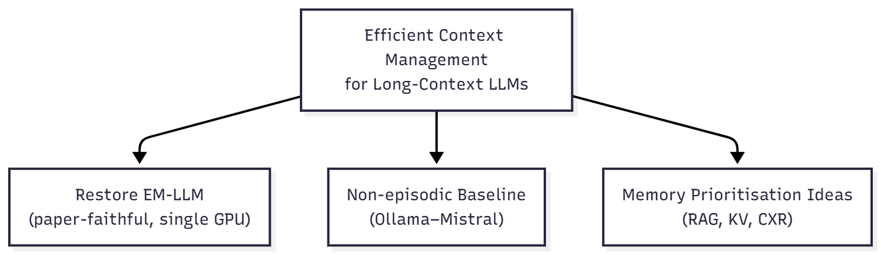
Figure 3.1. High-level objectives of the thesis
Figure 3.1 gives a compact overview of these three objectives and how they relate to the overall thesis topic.
- Using the same LLM to create a strong non-episodic baseline. The thesis also aims to create an independent evaluation method by using Ollama to run the same model (Mistral) on the chosen datasets, but without episodic memory or perplexity-based segmentation. This approach helps show the effect of episodic memory and prioritization. As a baseline, this Mistral pipeline shows how attention decay can limit performance when handling longer inputs in the usual way.
- Explore ways to prioritize information in EM-LLM, inspired by how human memory works:
The last goal is to find simple ways to better manage context after setting up a reliable EM-LLM and a non-episodic starting point. Several ideas are being tested now, either as designs or early versions. These include adding a step to pick which episodic events to show the LLM, combining extra information retrieval with EM-LLM, and creating easy methods to highlight important information across the model’s layers.
A Gantt-style timeline and a GitHub Projects board is used to keep all code, configuration files, and planning documents for these three parts up to date in a separate GitHub repository. These resources formed the practical basis for the specifications and limitations discussed later in this chapter.

Problem Context and Use Cases
Chapter number explained that attention decay causes LLMs to struggle with long inputs. They may forget earlier content, have trouble with multi-step reasoning, and create summaries that focus too much on the end of documents. To clarify these issues, this section presents three examples of the proposed framework: summarizing long documents, remembering conversations across several turns, and answering questions or understanding stories that require information from different parts.

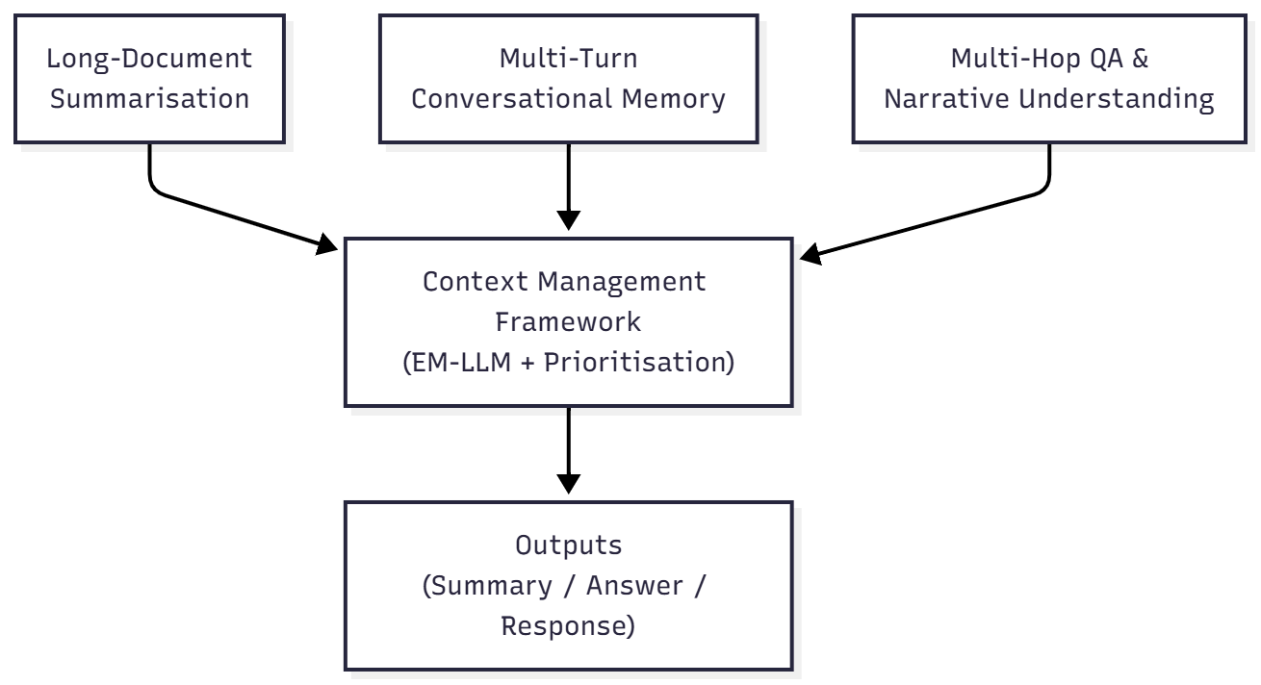
Figure 3.2. Use cases targeted by the framework
Figure 3.2 illustrates how these three scenarios fit into the proposed framework. Use cases targeted by the framework. Long-document summarisation, multi-turn conversational memory, and multi-hop QA or narrative understanding all feed long inputs into the same context-management layer. This layer segments text into events, stores them in episodic memory, and prioritises relevant events before handing them to the underlying LLM to produce summaries, answers, or responses.

Long-Document Summarisation:
In long-document summarization, the model is given an entire scientific paper, report, or story and must generate a succinct summary. The conclusion and recent sections are overemphasized in the resulting summary because standard transformer models tend to focus primarily on the concluding segments of the input, effectively removing the start and early parts from the model's effective context.
In this scenario, the structure should be as follows: Divide the text into episodic events, usually corresponding to scenes, paragraphs, or sections. Keep these events in an episodic memory that includes not only the latest few thousand tokens but the entire document. Prioritize globally significant events, problem statements, important findings, and significant conclusions during summarization, even if these occur at the start of the text.

Multi-Turn Conversational Memory

Users often set general guidelines or preferences at the start of multi-turn conversations, like "always answer in JSON" or "use short bullet points." Standard LLMs may forget these instructions as the conversation goes on, and even the initial system message or early turns can lose context.
In multi-turn conversation, the framework should respond as follows:
Think of the conversation history as a series of interaction events, including phases like problem definition, planning, and debugging. Key directives, choices, and limitations should be saved in episodic memory as high-priority events. Make it so that the retrieval process pulls not just the most recent turns, but also relevant earlier events when a new user message comes in.

Multi-Hop Question Answering and Narrative Understanding

Multi-hop question answering involves collecting evidence from different parts of one or more documents. Benchmarks like HotpotQA and 2WikiMultihopQA ensure that no single passage contains all the necessary information. Models must connect facts from different places to find the answer. Datasets like NarrativeQA go even further by asking questions about entire books or movie scripts.
In these situations, EM-LLM helps by finding supporting events that are far apart. But the original version treats each event separately. As a result, the model might identify both parts of a reasoning chain but fail to link them clearly.
To solve this problem, the framework should respond as follows:
Find multiple events that together give the answer, even if they are spread out in the input.
Add a method, even a simple one, to re-score or group related events. This helps the LLM see them as a connected reasoning chain. Include evaluation and logging tools that show these cross-event effects. For example, keep track of which events were found and how often they were used during decoding.

Functional Requirements
Functional requirements describe how system works. For this thesis scope is grouped into three categories:
- Restoration of the baseline LLM and EM-LLM pipeline,
- Integration of a lightweight event-level prioritisation component, and
- Evaluation of results.
To make the difference between the two main evaluation pipelines explicit, Figure 3.3 contrasts the Ollama-based baseline with the EM-LLM-based system.

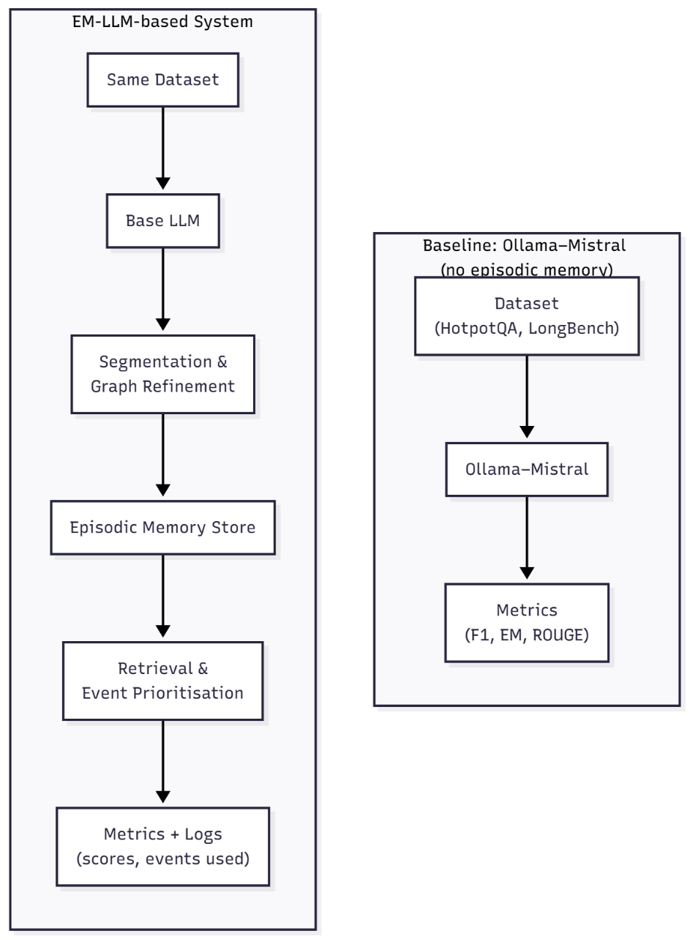
Figure 3.314. Restored EM-LLM pipeline and the non-episodic baseline tool
Figure 3.3 shows a comparison of the two evaluation pipelines used in this thesis. The baseline pipeline (right) runs the same underlying Mistral model via Ollama on the datasets without any episodic memory. The EM-LLM pipeline (left) passes the input through surprisal-based segmentation and graph refinement, stores events in an episodic memory, applies retrieval and event-level prioritisation, and then feeds the selected events back to the LLM. Both pipelines use the same datasets and metrics, making the impact of episodic memory and prioritisation directly comparable.

Baseline LLM and EM-LLM Restoration
- Baseline LLM inference (Ollama Mistral):
Run Mistral-7B with Ollama on chosen LongBench or HotpotQA-style question sets, making sure not to use episodic memory. Keep the tokenization, answer generation settings, and evaluation methods the same. This will make it easier to compare results with EM-LLM later.
- EM-LLM segmentation and episodic memory:
Reintroduce event splitting based on surprise, following the method described in the EM-LLM paper. Enable the feature that uses connection graphs to improve event boundaries and adjust how events are stored in memory. Each event should be saved as a block with key-value data, combined summaries, an importance score, and additional details such as length and boundaries.
- Retrieval and multi-stage attention:
Set up the EM-LLM (S+M+C) system to retrieve information. It should use scores based on usage frequency, question-key similarity, and a buffer to include nearby events. Feed the retrieved events back into the model using EM-LLM’s multi-stage attention, combining a close focus on current information with a broader view of memory blocks.
- Robust execution on the lab machine:
Check that the restored EM-LLM works well on the lab computer with a single GPU. If memory is low, shift some tasks to the CPU or disk as needed.

Cross-Event Reasoner Integration
This thesis explores how to prioritize context, inspired by how human memory works. EM-LLM is a valid starting point, but it typically retrieves events one at a time. Instead of building a large new model, the goal is to add a simple event-level prioritization step that can be tested with available resources.

Based on this, the system should do the following:
- Make summaries of each event:
For each event found, write a short summary that captures its main idea, for example, by combining the key parts.
- Identify connections between events:
For a small group of events, determine how similar each pair is, or use a simple method to find which events are most closely linked.
- Update event scores based on the current question:
Combine the original retrieval score from EM-LLM with structure-based signals and a query embedding from the current LLM state to make a new priority score for each event. If needed, merge closely linked events into one summary to avoid repeating similar information.
- Integrate the new step without disrupting the system:
Add this step between finding events and the next processing stage. This keeps the main LLM settings unchanged and allows testing with or without the new part.

Evaluation of results
To determine whether the framework reduces attention decay, use appropriate evaluation and analysis tools.
- Per-dataset evaluation scripts:
For each dataset chosen (like HotpotQA, 2WikiMultihopQA, NarrativeQA, QMSum, and relevant LongBench tasks), use scripts that test all model versions on the same data. Then, we evaluated the results using standard metrics such as F1, exact match, and ROUGE.
- Context and memory logging:
For each example, kept track of which events were split, which ones were saved in memory, which were retrieved at each step, and how their scores changed over time.

Non-Functional Requirements
Non-functional requirements describe how the system should behave in areas such as architecture, performance, and the ease with which results can be reproduced.

Model-Agnostic and Training-Free Design
Training large models is not possible with the limited resources available. The current framework should work with any decoder-only transformer that produces outputs, has hidden layers, and stores key-value information. All context-management features in EM-LLM and its add-ons work without needing extra training. The main LLM settings remain the same, and only memory structures and simple scoring methods are updated during runtime. We can set model options like model path, maximum context length, and offload settings using setup files and command-line options.

Efficiency and Scalability (Infinite Context)
EM-LLM aims to provide “infinite context” by using episodic memory and offloading. However, GPU memory and Input/Output bandwidth still limit its performance.

To address this, the framework must:
Reduce GPU usage by moving unused events to the computer’s central processor or storage, and load only the minimum memory needed for each task. Allow long inputs to be split into smaller sections, so even documents that are much longer than the usual limit can be processed step by step.
While using episodic memory and focusing on specific data may slow things down compared to a basic LLM, everything should still run on a single-GPU lab computer.

Reproducibility, GitHub Project, and Open-Source Compatibility
The system should be easy to reproduce and simple to build on:
The GitHub repository includes environment files (requirements.txt) listing all packages and their versions, along with configuration files for different experiments. A GitHub Projects board managed tasks like setup, literature review, EM-LLM restoration, baseline tool development, evaluation, and writing. It also helped keep the work on track with the milestones in section 3.6. All experiments in the thesis are supported by corresponding configuration files and scripts, allowing results to be rerun. The framework works with standard open-source tools, especially Hugging Face Transformers and Datasets, so models and benchmarks are easy to reuse or extend.

Dataset and Benchmark Requirements
To test context management, it should be evaluated on datasets that require understanding information spread across long sections and summarizing it. The main types to consider are multi-hop reasoning datasets, narrative/summarisation benchmarks, and dedicated long-context suites.

Multi-Hop Reasoning Datasets (HotpotQA, 2WikiMultihopQA)
HotpotQA: It is a question-answering task that uses Wikipedia, where each question requires information from multiple documents. It provides supporting facts at the sentence level and uses F1 and exact-match scores.

2WikiMultihopQA: It is similar, but it asks for answers by linking information across several Wikipedia pages. The questions are harder and need reasoning across multiple steps.

Requirements: The system should combine both datasets into a single format and generate long texts that include all necessary paragraphs. It should support exact match and F1 scoring, which work with standard evaluation scripts. The system should record which events match the correct supporting facts so it can be checked for how well it remembers and selects essential information.

Narrative and Summarisation Benchmarks (NarrativeQA, QMSum)
NarrativeQA: It asks questions about whole books and movie scripts, so models need to understand the whole story.

QMSum: It gives summaries based on specific questions from long meetings with many speakers, where the transcripts are often much longer than usual.

Requirements: The system should handle long stories and meeting transcripts by breaking the text into sections and remembering earlier parts to cover the entire text. It should use summarisation metrics like ROUGE for QMSum and the same metrics as earlier work for NarrativeQA. There should be tools to check how well the system tracks people and events across chapters or meeting sections, as mentioned earlier in Chapter 2 about the risk of losing focus over time.

Long-Context Evaluation Suites (LongBench Tasks)
LongBench and similar datasets offer tests made for models that handle long pieces of text.

Requirements: Choose LongBench tasks that can run on the available computers and match the examples in Section 3.2. Use or adjust LongBench’s evaluation scripts to make sure results can be compared to those for EM-LLM and other long-context baselines. The system should run Mistral, EM-LLM, and EM-LLM with prioritisation, all with similar text length limits, to see how memory and event selection affect results.

Time Frames and Milestones
Planning has started with setting up the environment and restoring the codebase. To manage this process and track our progress, we used two primary methods:

We tracked our tasks on a GitHub Projects board, using columns such as “To do”, “In progress”, “Done”, and “Reviewed”. We have also used a Gantt-style timeline, either in a spreadsheet or a diagram, to schedule our main milestones from June to December 2025.

Figure 3.4 shows snapshots from the GitHub project board, and Figure 3.5 summarises the planned milestones in Gantt form.

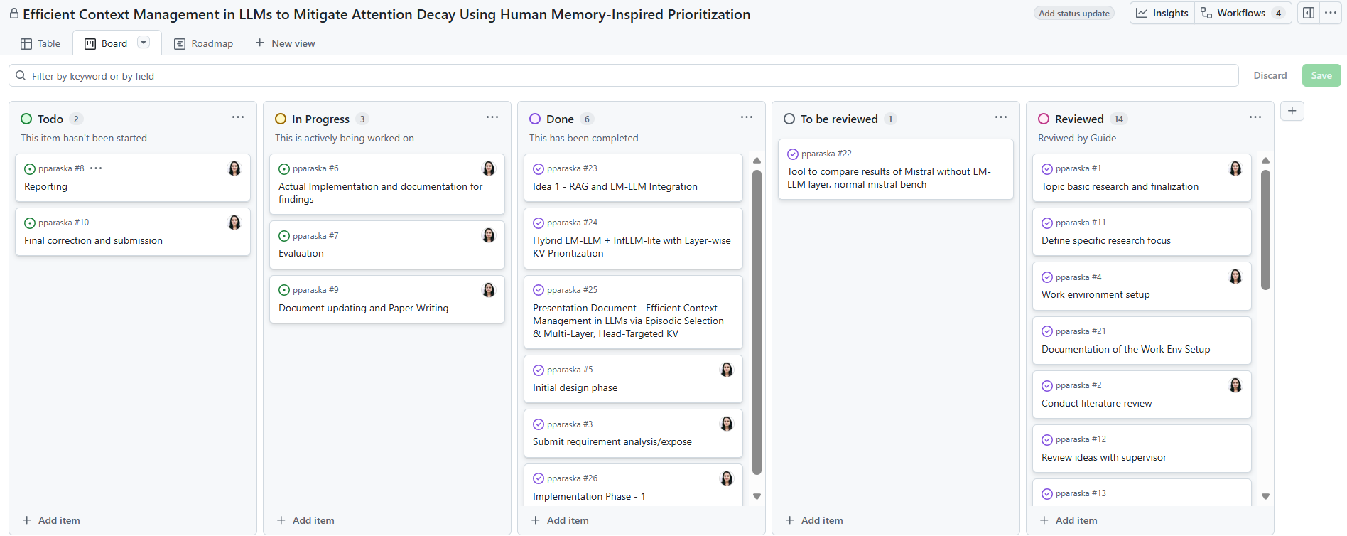
Figure 3.4. GitHub Projects Kanban Board
Figure 3.4 shows the GitHub Projects Kanban board used for this thesis. Tasks move from “Todo” through “In Progress” and “To be reviewed” to “Done” and “Reviewed”. The board captures environment setup, literature review, EM-LLM restoration, baseline tool development, evaluation, and reporting, mapping directly to the phases described in this section.

Figure 15.Gantt chart for the thesis
Figure 3.6 shows a Gantt chart for the thesis (June–January 2026). Each colored bar represents major milestones like topic selection and basic research, literature review, requirement analysis, work-environment setup, initial design, implementation and documentation of findings, evaluation, reporting, document updating and paper writing, and final correction and submission.

Using these tools, we divided the project into the following phases:

1. Environment set up and familiarization:
We set up the lab computer with a single GPU, installed the required software, and resolved early issues with Hugging Face and Ollama on Windows. Forked the EM-LLM code, ran basic tests to verify it worked, and identified missing components, such as graph improvement, a buffer for organization, and tools for checking results.

2. Restoring EM-LLM:
Re-enabled and debugged surprisal-based segmentation, graph-theoretic boundary refinement, and episodic retrieval, making sure the implementation matched the version described in the EM-LLM paper. Verified the small part of LongBench to see whether our results and patterns matched those reported on paper, using the computers we had available.

3. Baseline tool for non-episodic Mistral:
Developed a separate evaluation tool to run Ollama-Mistral on LongBench/HotpotQA without episodic memory, using the same prompts and metrics as EM-LLM and comparing the results to show how performance drops due to attention decay when no memory mechanism is used.

4. Exploration of prioritisation ideas:
Designed and partially prototyped the RAG+EM-LLM and InfLLM-lite-style KV prioritisation ideas, focusing on data flow, and we built an initial version of the Cross-Event Reasoner to sort events by importance, at least for small-scale tests. all tests.

5. Evaluation and reporting:
Ran final experiments on the selected datasets for baseline Mistral, restored EM-LLM, and EM-LLM with event-level prioritisation, collecting metrics and qualitative examples.

Target State / Target Objectives
Considering the previously outlined objectives and constraints, the target state of the project is summarised as follows:
- A stable, paper-faithful EM-LLM implementation operating on a single-GPU laboratory machine. The restored system implements the primary components of EM-LLM, including surprisal-based segmentation, graph-theoretic boundary refinement, episodic storage, and (S+M+C) retrieval. It also reproduces the qualitative behaviour and approximate metric ranges reported in the original work.
- A clear baseline comparison is established using the same LLM without episodic memory.
The Ollama-Mistral evaluation tool demonstrates the performance of the same underlying model when used conventionally, without episodic memory or perplexity-driven segmentation. This approach quantifies the impact of attention decay on long-context tasks.
- A prototype of human memory-inspired prioritisation is developed. At least one event-level prioritisation mechanism, specifically the initial Cross-Event Reasoner, is integrated into the EM-LLM pipeline and evaluated at prototype scale. This integration demonstrates how simple, training-free re-ranking can influence the LLM's event selection. Additional concepts, such as RAG+EM-LLM and InfLLM-lite KV prioritisation, are documented in sufficient detail to guide future implementation.
- A reproducible GitHub repository and associated planning artefacts are provided. The final GitHub repository contains the environment setup, EM-LLM changes, the baseline Mistral tool, dataset loaders, evaluation scripts, and the project board and timeline. This setup lets others rerun key experiments or build on the framework without recreating it.

Reaching this goal makes the thesis both an engineering and research achievement. It turns a complex research model into a tool that runs on simple computers, clearly compares memory-based and standard behavior within the same LLM, and begins using ideas from human memory to help the model stay focused on long texts.

System Design and Implementation
This chapter explains the design and implementation of the system developed in this thesis for efficient context management in LLMs. Based on the requirements defined in Chapter 3, the system brings together the scope of work:
- A non-episodic baseline pipeline, implemented as an open-source Mistral Bench tool that runs the same underlying Mistral model via Ollama on LongBench datasets.
- A paper-faithful restoration of EM-LLM on a single-GPU lab machine.
- An initial memory-prioritisation layer built on top of EM-LLM in the form of a lightweight Cross-Event Reasoner (CXR).

Overall System Architecture
The system consists of two tools, or pipelines, that work together and use the same type of base LLM. The first pipeline is a baseline that runs Mistral-7B Instruct through Ollama. It does not use episodic memory and works directly with LongBench-style inputs. The second pipeline, called EM-LLM, uses a Hugging Face version of the same model. It adds a step to split data into episodes, improves boundaries with graphs, stores and retrieves past information, and can be extended by CXR if needed. Both pipelines use the same evaluation layer, which calculates scores for each task (e.g., F1, exact match, and ROUGE) and generates logs and charts.

High-Level System Pipeline
The system compares a standard inference pipeline with a pipeline that uses episodic memory. To keep results consistent and reproducible, all benchmark datasets undergo a normalization step that converts different input formats into a single unified format. In this manner, every part of the system uses the same type of input, irrespective of the original format.
Once the data is normalized, the system takes two paths. The first is a baseline pipeline based on Mistral Bench, where each example is handled separately with a standard prompt-based method. This baseline does not keep information from earlier inputs, showing how a typical long-context model works. The results from this path are used as a reference to compare with memory-augmented methods.
The second path uses the new EM-LLM pipeline, which adds context management to the baseline. It splits inputs into segments based on how surprising or informative inputs are, then uses a graph-based method to make the segments more coherent. These segments are stored in episodic memory, so the system can pull up relevant past information when needed. Before generating an answer, an optional Cross Event Reasoner (CXR) step can re-rank the retrieved events to highlight the most relevant details for the current input.
Predictions and logs are generated by both inference paths and forwarded to a common evaluation stage. In addition to producing summary tables and charts for analysis, this step computes common metrics including Exact Match, F1, and ROUGE. Any performance discrepancies are due to episodic memory and context prioritization rather than to the processing or assessment of the data, since all approaches are based on identical datasets, evaluation procedures, and metrics.
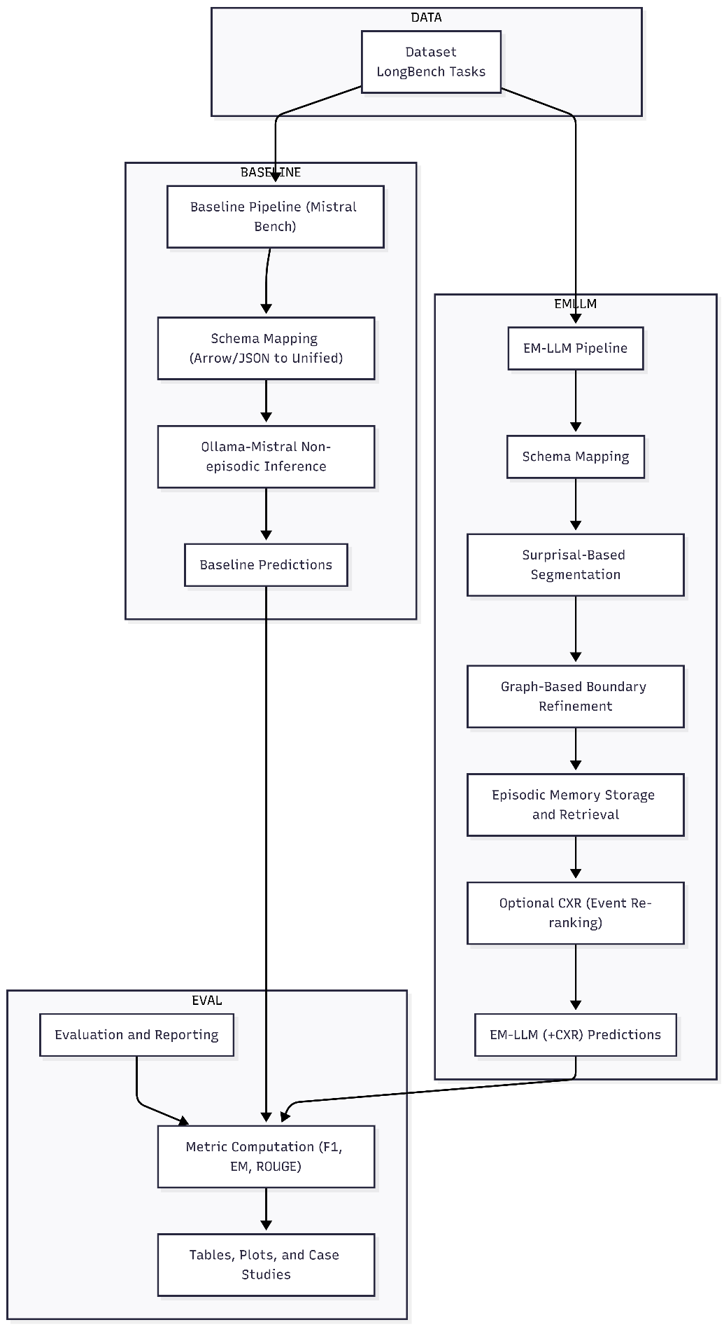
Figure.4.1.Overall System Pipeline
Figure 4.1 shows High-level system pipeline. Normalised datasets feed into two inference routes:
  - Mistral Bench (non-episodic baseline), and
  - EM-LLM with optional CXR. Both routes write predictions and logs to disk, from which evaluation scripts compute metrics and produce tables and plots.

Software Architecture and Module Overview
Internally, the system is implemented as a Python package with separate modules:
- Data: Dataset loaders and schema converters
- LLM-backend: Wrappers for Hugging Face models (EM-LLM pipeline) and for the Ollama HTTP API (Mistral Bench)
- EM_LLM-core: Restored EM-LLM components (segmentation, graph metrics, episodic memory, retrieval)
- CXR: Cross-Event Reasoner functions (event pooling, similarity computation, re-ranking)
- Decoding: Greedy search and perplexity computation
- Evaluation: Metric computation, result aggregation, plotting
- CLI: Command-line interfaces (EM_LLM-run, mistral-bench, etc.)

The system interacts with two types of the same model:
- For EM-LLM, the base model is loaded through Hugging Face Transformers using a checkpoint such as mistralai/Mistral-7B-Instruct.
- For Mistral Bench, the model is accessed through Ollama, which exposes Mistral as a local HTTP API (/api/generate) and handles model loading.
In both cases, the system requires tokenisation and de-tokenisation compatible with the model’s vocabulary. Access to token-level probabilities (or at least logits) for EM-LLM to compute surprisal and perplexity. (Ollama’s API does not currently support log-probabilities, so Mistral Bench sets perplexity fields to null while keeping file formats compatible.) Efficient management of the key/value cache during autoregressive decoding, particularly when re-using episodic memory blocks across steps. The next sections describe how these requirements shape the open-source mistral bench, EM-LLM baseline and the CXR extension.

Non-Episodic Baseline Pipeline: Mistral Bench
Mistral Bench is a tool for testing stateless LLM inference on standard QA and summarization datasets. It supports EM-LLM output format, making it easy to compare results with memory-augmented systems. We can use datasets in Hugging Face Arrow or JSON/JSONL formats; the tool converts them to a standard format before sending fixed queries to a Mistral model running on Ollama. The model stays separate from any memory system. Each example is processed in its own context window, so the results show only the model and prompt, without influence from episodic retrieval or changes in event order.

Mistral Bench is designed to be clear and easy to use for experiments. For each run, it saves predictions, timing data, and standard QA metrics, such as Exact Match and F1, for each item. The tool creates per-item JSON/JSONL files and summary files in res.json or CSV format, which work with EM-LLM comparison tools. This makes Mistral Bench a reliable reference for your thesis. Any performance differences between Mistral Bench and memory-based pipelines are due to the memory mechanisms, not the evaluation process. Saving results for each item also helps with error analysis and the creation of visualizations.

Design Goals and Role in the Thesis
Mistral Bench is a reproducible, non-episodic reference pipeline that runs stateless LLM inference on standard datasets and produces outputs compatible with the EM-LLM evaluation framework. The main design goals are portability via an HTTP-based Ollama adapter; compatibility with EM-LLM output formats; simplicity by running one example at a time with fixed context windows; and transparency by recording details and timing for each item. In this thesis, the baseline sets the minimum performance level. The differences between Mistral Bench and episodic systems like EM-LLM and CXR highlight the effects of memory and prioritisation, while limiting confusion caused by changes in preprocessing or scoring.

Figure 4.2.1 below shows the main steps of the pipeline. It outlines how datasets are converted and preprocessed, then sent to the evaluator, which uses the Ollama-hosted Mistral model. The outputs and plots are then used in the comparison tools for the thesis tables and figures.

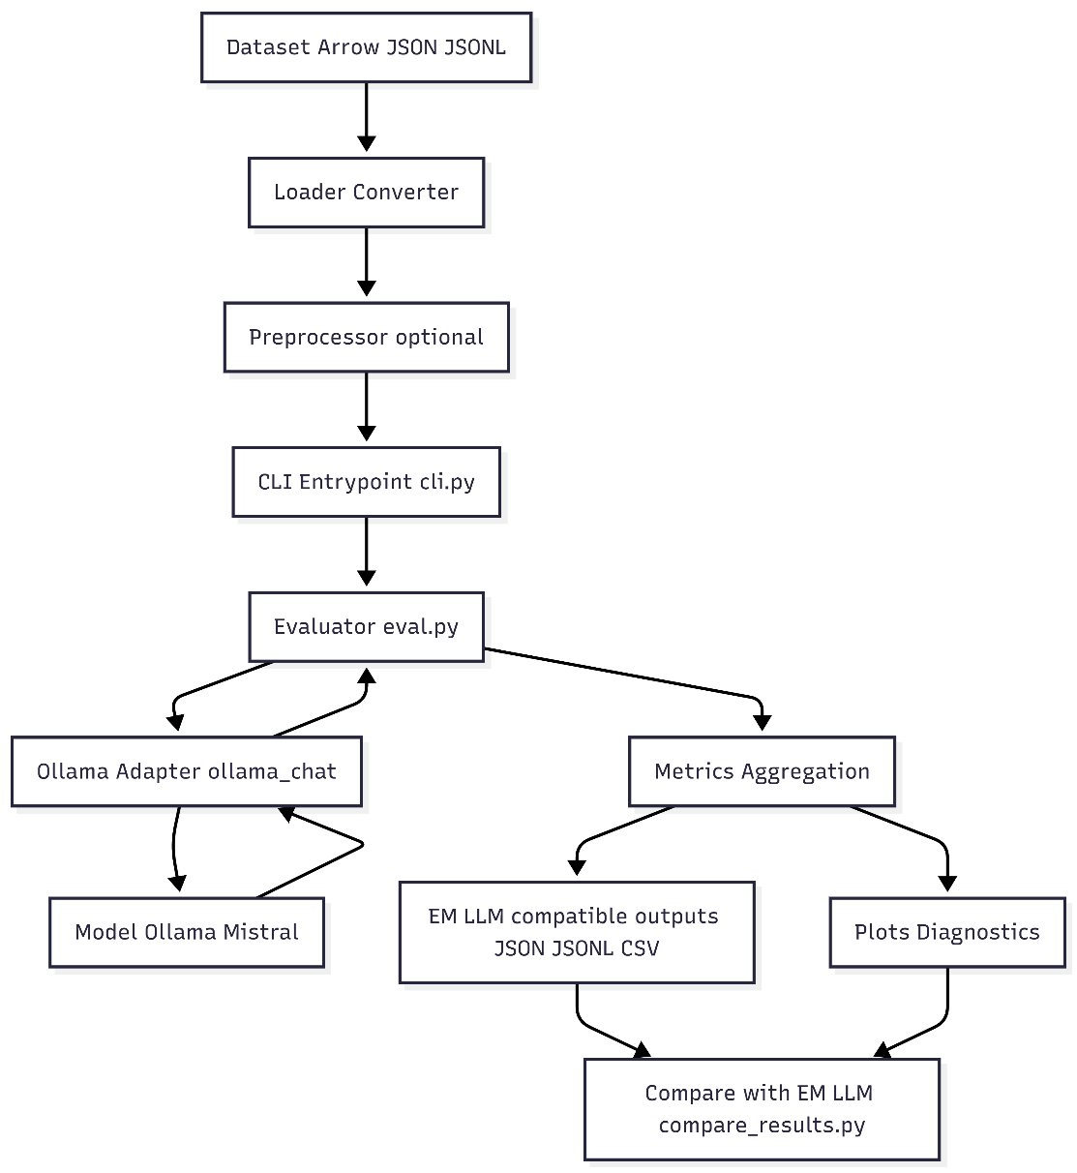
Figure 4.2. High‑level pipeline for non-episodic test
Figure 4.2.1 shows that all flow inputs are standardized, checked using an HTTP adapter with the Mistral model, and that the process produces both individual results and overall metrics used in the comparison stage.

Dataset Handling and Schema Mapping (Arrow / JSON / JSONL)
This subsection documents how raw dataset files, available in several standard formats, are translated into the single, stable input representation used by the rest of the pipeline. The goal is to guarantee that the same textual inputs reach the Mistral baseline and the episodic systems, so measured differences reflect model/architecture changes rather than input mismatches.
The flow of the pipeline is as follows:
- Entry point and format detection:
- The CLI (cli.py) passes the --data path to the evaluator (evaluate() in eval.py). The evaluator calls load_any(data_path).
- load_any() implements detection: if data_path is a directory or ends with. arrow it dispatches to load_longbench_arrow(); otherwise it calls load_json_or_jsonl().

- Arrow loader behavior:
- Uses Hugging Face datasets API (Dataset.from_file) to read them. arrow file. The code expects records to contain fields such as input, context (a long text), answers (list), and _id. For each row, the loader:
- Reads input - as an internal question.
- Reads context - it splits on double newlines (\n\n) to produce paragraph-level items; this produces the internal contexts list.
- Reads -id or id - reads internal id and if no id is present, the loader generates q{index}.
- Reads answers (string or list) - creates a list and stores it as answers.
- This produces a canonical record for every example:
{
"id": "q123",
"question": "What is the main conclusion?",
"contexts": ["First paragraph...", "Second paragraph..."],
"answers": ["The model converges on X"]
}

- JSON / JSONL loader:
When parsing the file as newline-delimited JSON (JSONL), it reads lines and parses each line as JSON (memory‑friendly). If that fails, it parses the file as a JSON array. The same normalization rules as above are applied.

- Conversion utilities and dataset cleanup:
Arrow_to_json.py converts Arrow datasets to JSON or JSONL for inspection or manual filtering. Use it when you need to examine rows or create a filtered subset. json_to_arrow.py shows how filtered JSON can be saved back to HF Arrow using datasets.Dataset.from_list(...). save_to_disk(...). This is useful for persisting with clean subsets across repeated experiments. For dataset-specific normalization (field names, nested structures), we include example scripts (e.g., filter_json_initial_check_hotpot.py) that adapt a dataset to the canonical schema.

- Reason for the context to split into blank lines:
Many datasets store multi‑passage contexts concatenated with blank lines separating passages. Splitting on \n\n yields clean passage candidates for the evaluator to select the first k_ctx passages. This deterministic heuristic avoids token-level segmentation differences across systems.

- Robustness and edge cases:
Missing answers or contexts are handled defensively: strings are coerced to single-element lists, empty contexts are not fatal (the evaluator will pass empty context lists), and missing packages (datasets / pyarrow) will raise a clear error instructing the user to install them.

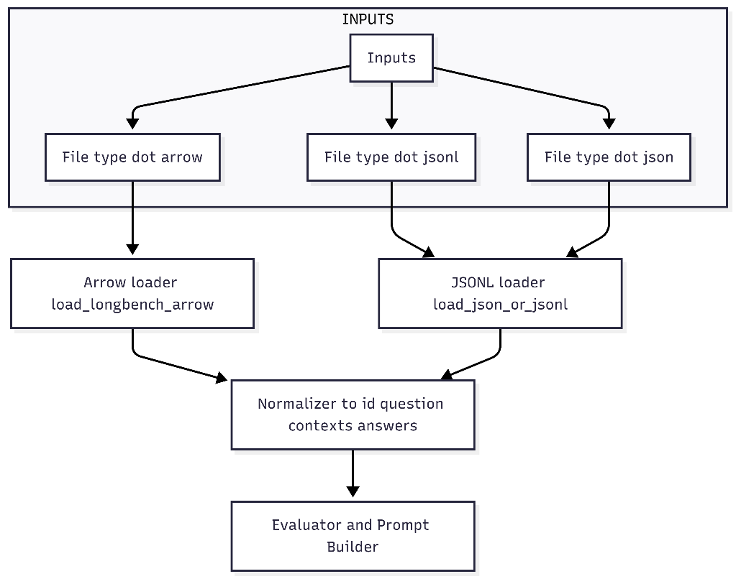
Figure 4.3.Data Ingestion & normalization
Figure 4.3. shows file-level entry points converging to a single normalized representation. This canonical shape keeps prompt construction and metric computation identical across datasets.

Ollama-Mistral Inference and Prompt Construction
This subsection describes how the pipeline converts a normalized input record (question + selected context passages) into a concrete HTTP request to the Mistral model (via Ollama) and how that request is constructed to produce short, comparable answers suitable for automatic scoring. In the thesis context, this stage is critical as the exact prompt template, the selection of context blocks (k_ctx), and the generation settings determine the behavior of the non‑episodic baseline. They therefore must be identical across baseline and episodic comparisons.
Prompt design and generation policy:
- Each prompt consists of two parts: a short system instruction that constrains the model to use only the provided context and to answer concisely, and a user message that places the selected context passages, followed by the question. The system instruction used throughout the experiments is:
"You answer multi-hop questions using only the provided context. Cite minimal spans if needed. Answer with a single short sentence." The user message is formatted as:
"Context:" followed by the first k context passages separated by blank lines, then a blank line and "Question: <question>" followed by "Answer:".
- For example, if k = 3 the prompt body appears as:
Context:
<context passage 1>
<context passage 2>
<context passage 3>
Question: <the question>
- Answer: The benchmark uses deterministic generation settings where possible: temperature is set to 0.0, and a maximum token cap is applied. This reduces sampling variance and makes Exact Match (EM) and F1 comparisons more stable.
Per-item runtime flow:
- The loader provides a normalized record containing the item identifier, the question, the list of context passages, and the list of reference answers.
- The evaluator selects the first k context passages (the local context window) and creates the system and user messages described above.
- The evaluator sends a single synchronous POST request to the model-backed HTTP endpoint with the chat payload and generation options. The call waits for the model response and records wall-clock generation time.
- The evaluator extracts the first non-empty line of the model’s returned text as the predicted answer.
- The evaluator appends a per-item record that includes the id, question, contexts used, prediction, generation time, and placeholder fields for token-level diagnostics that are unavailable from this backend. After processing the batch, the evaluator computes per-item EM and F1 with the standard normalization used across the project and writes per-item JSON/JSONL, a CSV table, and aggregated summary JSON.
Reproducibility and practical notes:
- The prompt template, the value of k, the maximum token cap, the model tag, and the base URL of the model server are all recorded for each run. These values must be included with any published experimental artifacts to enable exact reproduction.
- The approach uses short, deterministic answers to make automatic scoring meaningful and to reduce variance between runs. If token log-probabilities or perplexities are required, use a backend that exposes logits; the current HTTP adapter does not expose token logprobs so perplexity fields remain empty in the outputs.
- Choosing k (the number of context passages) trades off between giving the model more information and keeping the input small and comparable to a constrained non-episodic setting. For experiments reported in this thesis, k is kept consistent across baseline and episodic runs unless a specific study of context window size is performed.
In summary, the Ollama-Mistral inference stage constructs a short, constrained chat prompt from the first k context passages, issues a single synchronous HTTP call per example to the model server, takes the first returned line as the answer, records timing, and then computes EM and F1; these artifacts are saved in standardized formats so the baseline can be directly compared with episodic and memory-prioritised systems.

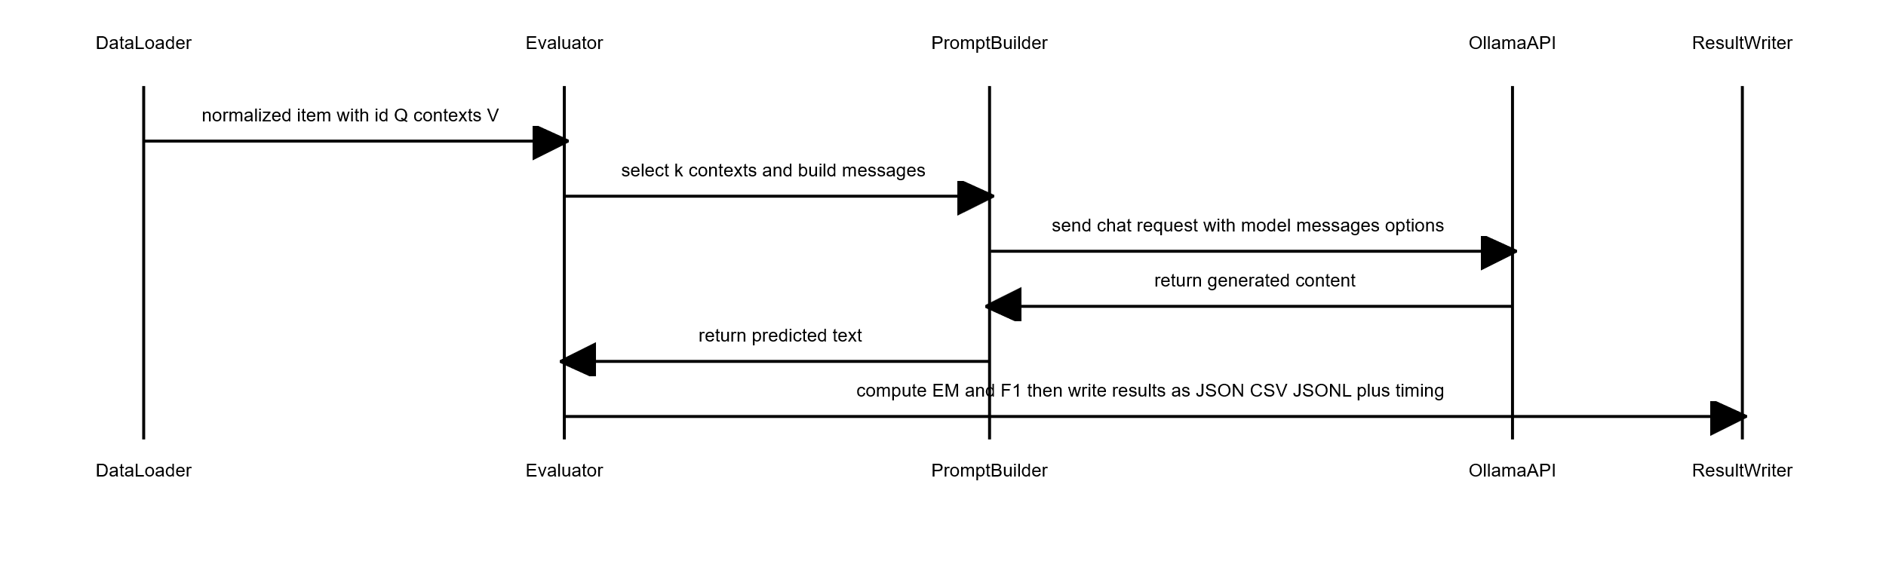
The above sequence diagram shows the synchronous per-example call sequence used in the Mistral Bench: the evaluator builds a constrained prompt from the first k_ctx context passages, calls the Ollama adapter, extracts the prediction, and records it with timing and metrics.

Output Formats and EM-LLM-Compatible Results
This section describes the exact artifacts produced by the Mistral Bench for each dataset, explains why the outputs are structured, and shows how those files are used to compare the non‑episodic baseline with episodic systems. The goal is to create outputs that are immediately usable for tables, figures, and per‑item qualitative analysis in the thesis.
Primary outputs:
- For each dataset processed by the evaluator, the following files are created under:
- <out_dir>/results/<dataset_name>/:
- "<dataset_name>_predictions.json" - a pretty-printed JSON array containing the full per‑example objects. Each object includes id, question, answers, the contexts used (first k_ctx), pred (model output), generation_time, and placeholder fields (total_ppl, block_sizes, etc.) that remain null when the backend does not provide them.
- "<dataset_name>_result.json"- a top‑level EM‑LLM style summary mapping the dataset name to aggregated metrics and meta fields. The score field contains the mean F1 scaled to percentage, and other fields such as ppl_mean are null when unavailable.
- "<dataset_name>.jsonl" - EM‑LLM‑compatible per‑item JSON Lines: one compact object per line, with keys like id, pred, answers, and generation_time. This format is convenient for streaming and comparison tools.
- "<dataset_name>.json" - the same per‑item objects as a JSON array.
- "<dataset_name>_results.csv"- CSV table with columns id,question,answers,pred, EM, F1, generation_time.

- Diagnostic plots are saved under <out_dir>/plots/<dataset_name>/ and include:
- <dataset_name>_agg_metrics_bar.png - bar chart of mean EM and F1.
- <dataset_name>_f1_hist.png - histogram of per‑item F1 values.
- <dataset_name>_em_hist.png - histogram for EM (usually coarse bins).
- <dataset_name>_time_hist.png - generation time distribution.

Example file content:
- One line in <dataset_name>.jsonl (EM‑LLM compatible per-item line):
{
"id":"q123",
"pred":"Paris",
"answers":["Paris"],
"length":123,
"token_length":null,
"chunk_ppl":null,
"total_ppl":null,
"block_sizes":null,
"mean_block_size":null,
"generation_time":0.345
}
- A row in <dataset_name>_results.csv:
id | question | answers | pred | EM | F1 | generation_time
q123 | "What is the capital of France?" | "['Paris']" | "Paris" | 1 | 1 | 0.345

- The top-level "<dataset_name>_result.json":
{
"hotpotqa": {
"score": 12.34,
"len_predictions": 100,
"ppl_mean": null,
"ppl_std": null,
"block_sizes_mean": null,
"block_sizes_std": null
}

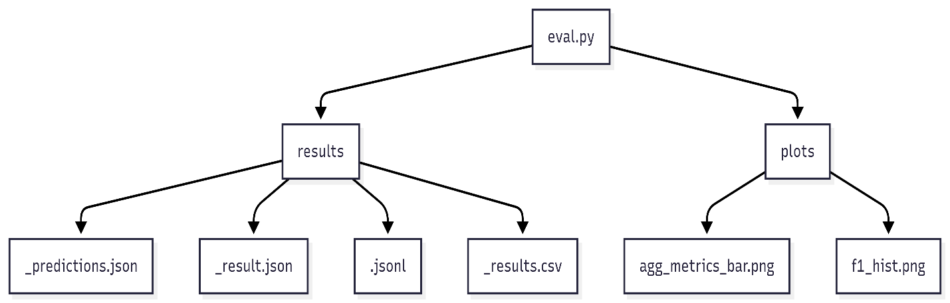
Figure 4.5. Output results and plots
Figure 4.5 shows the output artifacts produced by the evaluator and aggregate statistics, plots, and intervals used in the thesis analysis.

EM-LLM Baseline and Restoration
EM-LLM is a tool that equips transformer-based language models with a form of human-like episodic memory. It segments the input into events using a combination of Bayesian surprise and graph-theoretic boundary refinement, stores those events as memory blocks, and retrieves them via a two-stage process that combines similarity and temporal contiguity.
*(Human-episodic-memory-paper)
The public codebase, however, is difficult to run on a standard single-GPU lab machine. Several components were incomplete, and environment assumptions (CUDA version, Linux-only scripts, specific filesystem paths) caused repeated failures. Restoring EM-LLM to a paper-faithful state, therefore, became a major engineering task.

Architectural Overview of the EM-LLM Baseline
The episodic memory extension improves pre-trained language models by adding a separate memory system that mimics how people remember events, without retraining the model. Instead of making the model process more data at once, this approach breaks the input into clear, meaningful events, compresses them, and brings them back only when needed. This lets the model handle very long pieces of text without going over hardware limits.

The system uses a dual attention mechanism across two types of memory. A local sliding window that spans several thousand words retains all details from recent input, enabling the model to understand nearby context and keep the conversation clear. At the same time, a global episodic memory stores only clear sections of text that stand out as separate events, rather than every word. This design is based on research showing that people remember experiences as individual events, especially when the situation or story changes.

Figure 4.6. explains the high-level Architectural Overview of the EM-LLM. Event segmentation combines how surprising each word is with how well its parts stick together. First, it checks which words are unexpected to find possible breaks between events. Then it uses graph analysis methods to fine-tune these breaks by measuring token similarity. This helps remove mistakes and create event boundaries that align with how people naturally perceive changes between events. Then the system stores the final events as memory blocks, and it preserves the original key-value data. Then, a set of important tokens is selected by attention-based scoring. Memory is organized in layers: recent events are kept in GPU memory, and older ones are moved to CPU memory or disk. This setup lets the system process documents with millions of tokens using just one GPU.

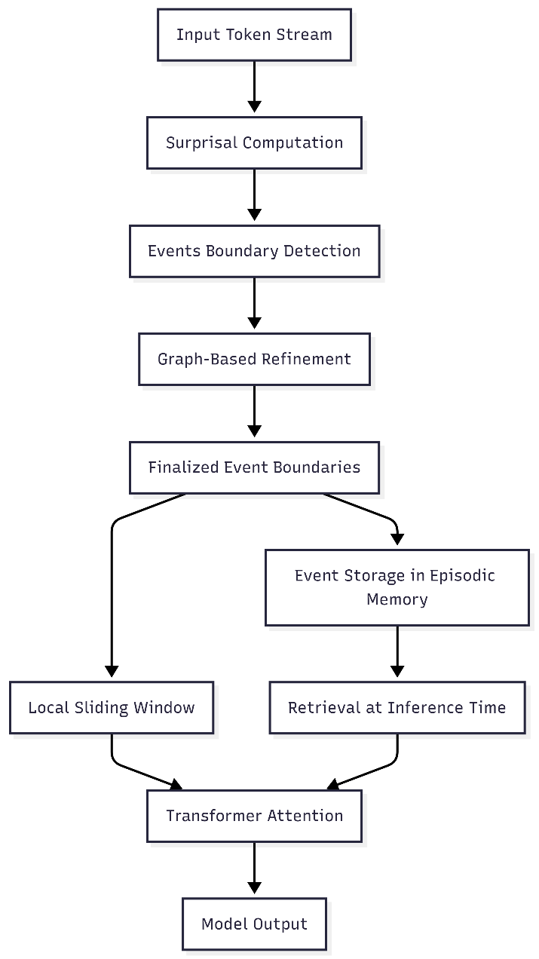
Figure.4.6. Architectural Overview of the EM-LLM
While making predictions, retrieval happens in two steps. First, the system finds the most similar events by comparing the query to the important tokens. Then it adds the events that occurred right before or after these, keeping the story connected, as humans do when they remember things that happened close together in time.
To combine the information, the model joins the key-value states from the current window with those from the retrieved events, creating a mixed context for standard transformer attention. This add-on can be used with any autoregressive language model without changing its design, allowing the model to handle longer texts than it was initially trained on while retaining what it has learned. The restoration ensured that all parts matched the original research, making it ready for use on devices with limited resources.

Re-Implementation of Surprisal-Based Event Segmentation
Event segmentation uses surprisal, a measure of how unexpected a token is based on the tokens that came before it. Surprisal shows that sudden changes in how predictable a word is, which appear as quick jumps in uncertainty about what word comes next, often happen when the topic or meaning of the text changes.

For token $x_{t}$ at position t, surprisal is defined as:

$$surprisal\left(x_{t}\right)= -\log{p\left(x_{t} ∣ x_{<t}\right)}$$

where, $p\left(x_{t}\right| x_{<t})$ denotes the conditional probability from the language model's softmax-normalized logits.
Higher surprisal means the model has difficult time to predict the next word, which often happens when the topic changes, a story starts, or the type of information changes. Peaks that exceed set limits are used to automatically identify possible breaks between clear sections, without requiring someone to mark them by hand.
The restoration setup used surprisal calculation to run in real time and fit on a single GPU. First, the model runs in teacher-forcing mode, where it is given the correct word at each step and the chance it assigns to that word is saved. These values are kept in a moving buffer that holds surprisal scores for a recent group of words, usually covering a few hundred at a time. In this group, the system looks for high points where surprisal is higher than the words right before and after, and higher than a changing limit based on recent data:

$$θ\left(t\right)= μ\left(t\right)+γ.σ\left(t\right)$$
where, $μ(t)$ and $σ(t)$ represent mean and standard deviation of windowed surprisal values, and $γ$ is a tunable scaling factor controlling detection sensitivity. Values of $γ=1.0$ mark boundaries at peaks exceeding one standard deviation above local means; higher values produce fewer, more pronounced boundaries. This adaptive thresholding ensures robustness across documents with varying linguistic characteristics, automatically adjusting to baseline unpredictability inherent in each text.
To handle sequences that are extremely large for the GPU, the data is split into smaller parts and processed one after another, ensuring the cross-chunks remain connected.
- Chunk-level processing: Each part has a set number of tokens, usually matching the main model's size or a portion of it, to use memory well and work efficiently.
- Cross-chunk continuity: The surprisal buffer moves from one part to the next, ensuring important points near the edges are not missed.
- Boundary candidate accumulation: Peaks found in each part are added to a main list, which is then improved further.

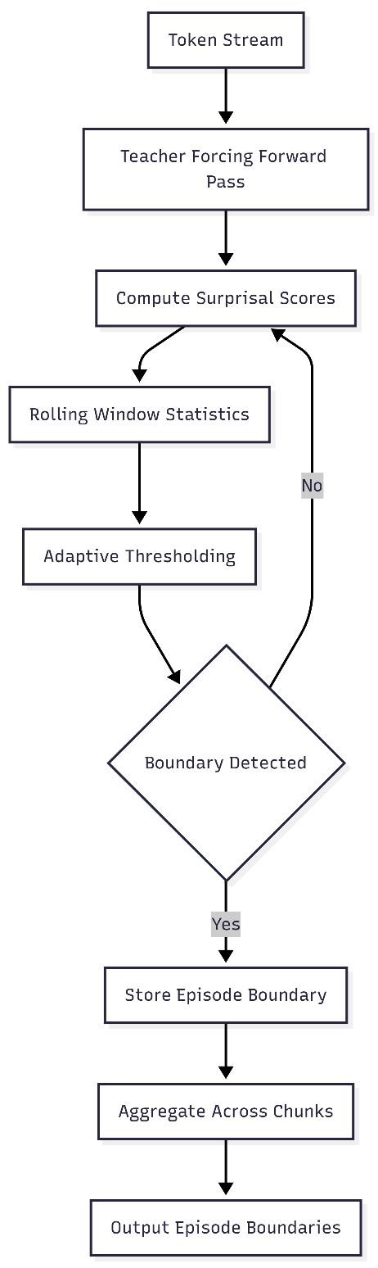
Figure 4.716.Surprisal-Based Boundary Detection Pipeline
Figure 4.7 shows how the chunked architecture handles documents of any size by sending the text through the model in smaller, manageable chunks, while ongoing surprisal buffers help maintain consistent event detection over time. Event segmentation based on surprisal uses only the main model’s probability outputs and does not require external supervision or special rules for specific topics. The restoration ensured that all settings, buffer sizes, threshold adjustments, and chunking methods matched the original research, preserving the intended event-splitting method. The possible boundaries found at this point are then sent to a graph-based step, which assesses how well each segment fits together and adjusts the boundaries to better align with meaningful events. Together, detection based on information and validation based on graphs yield strong segmentations that break long sequences into episodes suitable for selective retention and retrieval.

Graph-Based Memory Structuring Using Topological Metrics (Modularity, Conductance)
Surprisal-based segmentation provides initial episodic boundaries, but they are often noisy and may not capture meaningful transitions. The surprisal signal responds to unexpected events, such as lexical surprises, syntactic ambiguities, or brief shifts in discourse, rather than to true episodic boundaries. To improve this, the baseline uses graph-based refinement. It evaluates and adjusts candidates using topological metrics derived from the model’s internal representations. This process builds similarity graphs over token representations and uses community-detection methods to find cuts that keep segments internally cohesive and separate them where there are real content breaks. This way, the final boundaries mark areas of strong semantic unity divided by actual discontinuities in content.

The similarity graph constructs from hidden-state representations extracted during the forward pass. For tokens spanning windows around candidate boundaries, final-layer hidden states compute pairwise cosine similarities, yielding symmetric adjacency matrix $A$ where entry $A_{ij}$ quantifies representational similarity between positions $i$ and $j$. Formally, for hidden-state vectors $h_{i}$ and $h_{j}$:
$$A_{ij}=\frac{h_{i}⋅h_{j}}{∥h_{i}∥∥h_{j}∥}$$

This encodes the intuition that tokens within coherent segments exhibit higher mutual similarity than tokens spanning boundaries between distinct topics. The graph undergoes community detection analysis wherein potential boundary positions are evaluated by how well they partition the graph into internally cohesive communities.
Modularity, from network science, measures partition quality by concentration of edges within versus between communities. For partition dividing the graph into communities $C_{1}$ and $C_{2}$ at boundary $b$:

$$Q=\frac{1}{4m}Σ_{cϵ}\left\{C_{1},C_{2}\right\}Σ_{ijϵc}(A_{ij}-\frac{k_{i}k_{j}}{2m})$$

where $m=\frac{1}{2}\sum_{ij}{A_{ij}}$ is the total edge weight, and $k_{i}=\sum_{j}{A_{ij}}$ is node $i$ degree. The term $\frac{k_{i}k_{j}}{2m}$ represents the expected similarity under a null model with random edge placement that preserves degrees. High modularity indicates observed within-community connections significantly exceed random expectations, suggesting successful separation of cohesive but distinct segments. Refinement evaluates candidate positions within local search windows, selecting maximum-modularity positions as refined boundaries.
Conductance provides alternative perspective by directly quantifying segment separation. For community $S$ and complement $\overset{ˉ}{S}$:
$$ϕ\left(S\right)=\frac{cut\left(S,\overset{ˉ}{S}\right)}{\min\left(vol\left(S\right), vol\left(\overset{ˉ}{S}\right)\right)}$$

where $\text{cut}(S,\overset{ˉ}{S})=\sum_{i∈S,j∈\overset{ˉ}{S}}{A_{ij}}$ measures boundary-crossing similarity, and $\text{vol}(S)=\sum_{i,j∈S}{A_{ij}}$ measures internal volume. Low conductance indicates few connections relative to internal density, signifying clean separation. Refinement minimizes conductance, selecting positions achieving lowest values to identify cuts most effectively isolating adjacent segments.
The refinement process employs adaptive search balancing precision with efficiency. For each candidate boundary, local search windows are defined with bounds proportional to preceding event size, extending symmetrically around original positions. Within windows:
- Submatrix extraction: Relevant adjacency matrix portions are extracted, reducing metric evaluation cost.
- Candidate evaluation: Selected metrics (modularity or conductance) compute for all positions satisfying minimum event size constraints, producing score profiles.
- Optimal selection: Positions achieving optimal scores (maximum for modularity, minimum for conductance) replace original candidates.
- Constraint enforcement: Minimum event size thresholds prevent excessively short segments violating design assumptions.
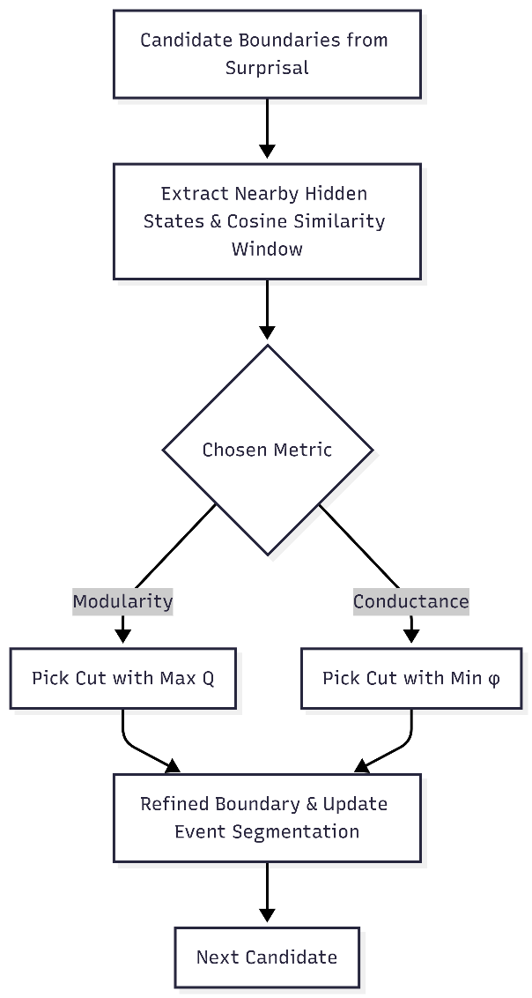
Figure 4.8. Graph based refined Boundary Detection Pipeline
Figure 4.8. shows graph-based refinement which addresses the problem of relying solely on surprisal by basing decisions on patterns in the data. Modularity makes sure that segments are more connected inside than you would expect by chance, while conductance makes sure that segments are clearly separated with little overlap at their edges. The review confirmed that both measures were used exactly as described and that the flexible search method balanced improving small parts with the overall quality of the segments. Combining surprise with how groups form in graphs creates event boundaries that match well with how people naturally see episode changes, like what was found in the original research with human-marked boundaries. This two-step process, first finding surprising points and then refining the structure, turns a stream of tokens into organized memories that can be stored and found later.

Contiguity Buffer and Episodic Memory Management
The episodic memory system is built to preserve the natural order and story-like flow of human memory, rather than just saving and finding individual events by what they mean. Research shows that when people remember something, they often also remember other things at the same time. This is called temporal contiguity. The system copies this by keeping events that happened just before and after the one being remembered in a special memory area. By making these similar events easy to find when a memory is recalled, the system keeps the story clear and builds links between different events. To find the most similar events, the special memory area needs enough space, often saving 20 to 40 percent of nearby events.
The memory system stores information in layers, allowing it to handle sequences of any length, even with a single GPU. Each event is saved as a memory block containing the original data and smaller versions generated from selected parts using specialized scoring methods. These blocks are split into three groups, active blocks stay in GPU memory for quick access, warm blocks move to CPU memory and can be brought back fast, and cold blocks are stored on disk, which takes longer to reach but lets the system handle much longer sequences. The system decides where to place each block based on when it was last used and manages space in advance. When there are too many active blocks, the least recently used are moved to CPU memory to make space for new events. If the system is almost full, more blocks are moved to disk and saved as small files in neat folders for quick searching and loading. The special memory area is used when getting memories by changing which events are shown to the model during predictions. After finding the most similar events, the system checks their original order.

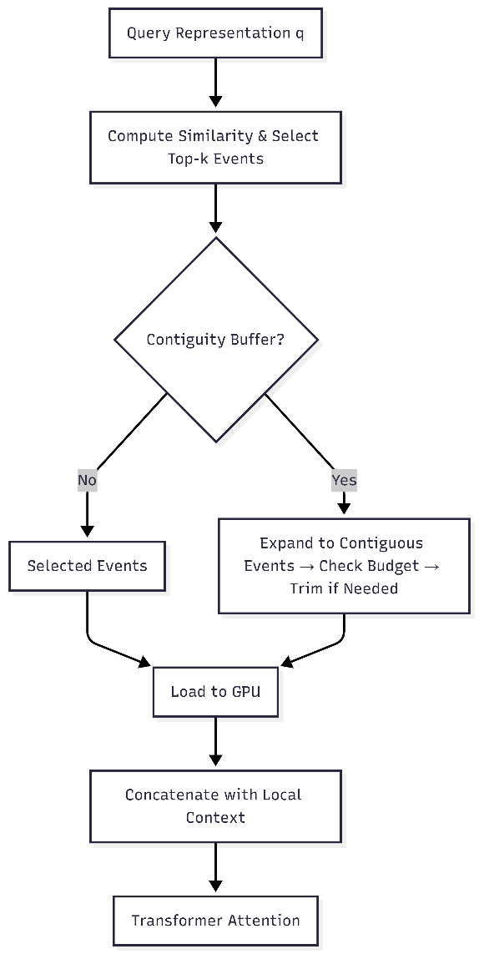
Figure.4.9. Hierarchical Episodic Memory Management and Retrieval
Figure 4.18 shows how the system manages and quickly finds event blocks. It first checks if a block is already in GPU memory. If it is not, it loads it from the CPU or, if needed, from disk, and moves it up through the different levels. A special cache keeps only the most recently used blocks on the GPU, so the system does not move the same data more than once.
When a search finds the top-k most relevant events, the system can also include nearby events to keep the story connected. If this larger group is too big, the system removes the farthest events until it fits the allowed size. The final group of events is then combined with the local context and sent to the Transformer. By using similarity-based searches, keeping related events close in time, and storing data across layers, the system enables fast, well-organized memory access even with limited GPU space.

Interaction Between Local Context Window and Global Episodic Memory
The episodic memory system uses two parts that work together: a local context window that provides detailed access to recent words, and a global memory that retrieves important information from earlier events. These parts operate in parallel while the model is making predictions, with the attention system attending to both sets of data so that results include both recent and important past information. Their combination is managed by a step-by-step attention process that lets information flow smoothly while preserving the unique timing and meaning of each memory type.
The local context window keeps a moving list of the most recent words, usually set to match or slightly go beyond the model’s usual limit. It works like a line: as new words are created, the oldest ones are removed from the window and placed in a global buffer, where they wait to be grouped into events. This window catches short-term links like references, grammar agreement, and immediate clues in the text that are needed for smooth writing. It provides a clear view of the current language by maintaining the exact word order rather than using shorter versions, which is important for tasks that require exact word or grammar details. It is also where surprise values and scores are computed, which are later used when moving words from local to global memory. The data for the local window is kept in full detail in fast memory during predictions, so checking recent context is very quick.
Global episodic memory, on the other hand, serves as a store that only retains and retrieves important information. Instead of removing every word from the local window, it keeps only words that are part of events deemed important to the current question, based on how similar they are and how close in time they occurred. Events are shown with their original details, along with shorter summary versions generated from keywords, making it easy to compare them without having to look at every word from the past. Each time the model needs more context than the local window gives, the global memory system looks for matches: it compares the current question, usually by averaging the new word details, to the summaries of all saved events, ranks them by how similar they are, and loads the best matches into fast memory if they are not already there. This process varies by question, so different parts of a document may bring up different sets of past events depending on what is being discussed and how closely the topics match.
Bringing together local and global data for attention uses a step-by-step process that keeps their distinct roles clear while allowing them to work together. Each time the model runs, attention first looks at the local context window, using a standard way to compare the current question to local data and make a partial result based on recent context. Then, the system adds the global memory data it found, joining it with the local data in order they appear. Global data looks like extra input words to the model, but their positions are set to match where they were in the original document, not just where they are in the combined list. This ensures the model’s sense of word order remains correct, even when it recalls information from much earlier in the text.

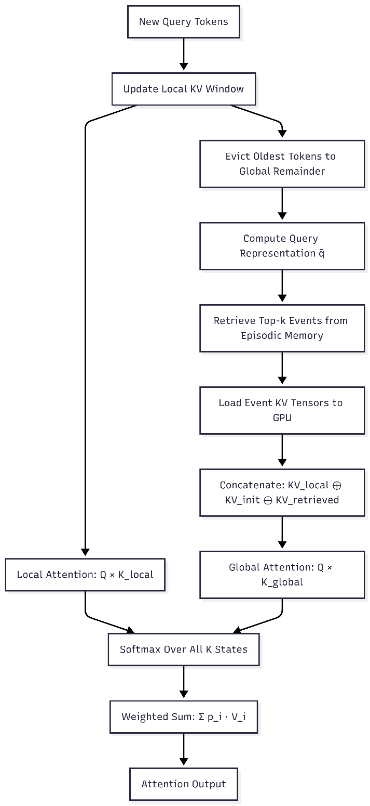
Figure.4.10. Attention Computation Using Sliding Window and Global Memory
Figure 4.10. explains that attention in the system operates over a combination of local, prefix, and retrieved memory states. The local window uses a simple rule, so each token considers only earlier tokens in the nearby buffer. This keeps the order of information and avoids extra work on far-away tokens. Retrieved events, on the other hand, act as background knowledge that can be used from any position, not just the current stream.
The model also keeps a buffer with the first tokens of the document. Even though these tokens are usually not very important for meaning, they help keep attention steady in very long sequences. Studies show that keeping these early tokens stops the attention system from breaking down, especially when dealing with very long sequences. That is why the prefix part is always included in the main set and comes before any retrieved events.
When the system calculates attention, it combines and balances the scores from the local, prefix, and episodic parts. This allows the model to focus on nearby context, steady starting points, and chosen long-range information. By keeping local and global attention rules separate, the design stays both accurate and flexible.
Altogether, this three-part memory setup local recency, important events, and prefix stability lets the model handle much more information than usual. It helps the model make sense of large documents while remaining efficient and maintaining steady attention, which is needed for tasks that require long-range understanding.

Inference-Time Memory Retrieval and Conditioning
Inference-time retrieval helps a language model leverage important past information without having to read entire documents each time. By selecting only the most useful earlier events, the system allows a standard Transformer to leverage selected long-term memory. Because retrieval has to work with limited memory and speed, it needs to quickly find similarities, move data easily between different storage, and add the retrieved content into the attention process.
Retrieval begins when the model processes a new group of tokens. After generating the query, key, and value versions, the system averages the query vectors from the current group to produce a summary query vector. This vector captures the model’s current context and serves as the retrieval signal. The system compares this signal to smaller versions of all stored events and ranks them by how similar they are to it. Each event’s smaller vector is derived from the key token representations chosen during the first step. The top events are picked based on the memory limit, so the total number of retrieved tokens stays within set limits.
Once events are chosen, the system makes sure their key-value data is on the GPU before attention runs. It does this in steps: events already on the GPU are used right away, those on the CPU are copied to the GPU, and those on disk are first loaded to the CPU, then moved to the GPU. To manage GPU space, the system removes the items used least recently and keeps recent ones, expecting they will be needed again soon. This step-by-step method lets the model handle very large documents while keeping GPU memory use reasonable.
Using retrieved events in the model means the system must handle position information carefully. Transformers use position codes to indicate order and distance, so retrieved tokens need to retain their original positions rather than being assigned new ones based on where they are added. The system uses rotary position codes with clear offset handling, so each event’s keys and values show their real positions in the original document. This helps the model keep its understanding of grammar and meaning over long distances, treating retrieved events as if they were still part of the original input. The system runs queries and stores events for each attention head separately. Because different heads look at different language patterns, scoring for each head can make retrieval more accurate by finding events important to specific parts of the model. These head-level similarities are then combined into one relevance score for each event. While this method needs more computing power, it allows for more precise retrieval for tasks that need detailed language differences.
After retrieval, events are loaded, and their positions are set correctly. They are combined with the local context window and given to the Transformer as a longer input. The model then runs its usual attention process, where learned attention weights balance local context and retrieved content. This smooth combination is key to the system’s design: it works with any pre-trained Transformer without changing its structure or retraining. In practice, retrieval speed stays reasonable even for documents with hundreds of thousands of tokens, cache hit rates stay high, and model performance is better than with shorter fixed windows. By using similarity-based retrieval, layered memory management, and correct positions, the system can handle unlimited contexts while keeping clear long-range reasoning.

Practical Constraints of Single-GPU Baseline Restoration
Restoring the episodic memory system on a single-GPU computer posed real-world challenges that affected its design and use. Unlike the original research setup, which likely used several computers with ample memory, the single-GPU setup required careful management of memory use, data transfer, and system-specific limits. Because of this, the restoration became mostly a technical task focused on keeping the original design working with fewer resources, demonstrating how memory-augmented models can operate in typical academic settings.
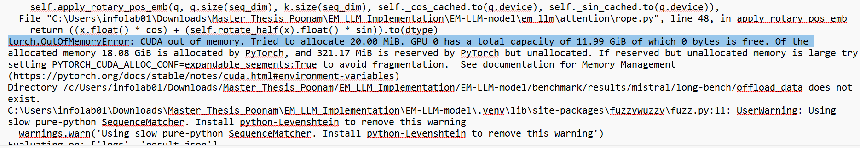
Figure.4.11. CUDA Out of memory error
GPU memory capacity was the most severe limitation. Modern large-scale Transformers already occupy several gigabytes of VRAM for model weights alone, leaving limited space for key-value caches, activations, and episodic memory blocks. Early experiments using default configurations frequently triggered out-of-memory failures, as illustrated by the representative CUDA error shown in Figure 4.11. System profiling indicated that cache sizes, batch dimensions, and block allocation policies required careful tuning. The final configuration adopted a three-level memory hierarchy: active blocks remain on the GPU, recently accessed blocks are moved to host memory, and older blocks are serialized to disk. This design enabled access to an effectively unbounded history while keeping VRAM usage within the 16–24 GB range typical of consumer GPUs. The primary drawback was increased latency when loading disk-resident blocks, making the cache's behavior critical to maintaining acceptable throughput.
The layered memory system also caused slowdowns when moving data. Moving blocks from the computer's main memory to the GPU over the PCIe connection takes a few milliseconds, and this adds up if many blocks are loaded at once. To make this faster, the restoration used transfers that occurred at the same time as other work, so memory could be moved while the model was running. Using a special kind of memory in the computer also made transfers faster. Even with these improvements, there were still limits, as shown by slowdowns when too many blocks were loaded at once. The final setup limited memory retrieval to about 2,000 tokens per run, balancing the amount of history that could be used with the speed of data transfer.
Differences between computer systems caused more problems. The original version expected a Linux system with certain file behaviors, but the restoration was done on Windows, which handles file paths, shortcuts, and memory files differently. These differences caused errors such as incorrect file paths and failures when saving to disk. The restoration fixed these problems by making file paths behave consistently, creating folders directly, and avoiding shortcuts. Hugging Face model caching, which uses shortcuts to save space, also did not work well with Windows permissions, so saving full copies of models fixed these errors but used more disk space.
Software version requirements added more limits. The system needed Python 3.10.11 to work with certain versions of the Transformer libraries, CUDA, and other needed software. Even small version changes caused errors or hard-to-find problems, so the setup had to use carefully controlled environments with exact software versions. Logging in to protected model repositories also required special setup, since mistakes in environment settings caused confusing errors that appeared to be model-loading problems.
Despite these challenges, the restoration demonstrated that episodic memory systems can operate effectively on a single-GPU computer. The final setup handled documents with tens of thousands of tokens, maintained reasonable processing times, and retained the main ideas of the original research. Even though it was slower than setups with more GPUs, the speed was still good enough for research. Overall, the experiement shows how important it is to carefully design memory systems, move data efficiently, handle diverse computer systems effectively, and control the software environment when using advanced memory models outside powerful computing setups.

