Master Thesis

Efficient Context Management in LLMs to Mitigate Attention Decay Using Human Memory-Inspired Prioritization

Poonam Dashrath Paraskar
1427297

Introduction

Large Language Models (LLMs) have evolved rapidly, becoming essential tools for tasks requiring natural language understanding and reasoning, such as document summarization, conversational agents, knowledge extraction, and multi-hop question answering. However, despite growing model sizes and context windows, LLMs still struggle with long-term retention; they gradually forget information as text length increases.

The limitations of existing Large Language Models become especially visible when they are required to process, retain, and reason over very long sequences of text. Although LLMs excel at sentence or paragraph-level reasoning, they struggle with coherence and accuracy when important information appears far earlier in the input.

This issue manifests across multiple real-world scenarios:

- Summarizing Long Documents: Details from the beginning fade out. When an LLM is asked to summarize a long article, report, or book chapter, it tends to give disproportionate weight to the most recent sections. Information appearing early in the document becomes nearly invisible to the model due to attention decay. This leads to several problems. Key facts introduced earlier are omitted from the summary. The model often repeats themes from the last few paragraphs because they dominate the distribution of attention. Connections between distant sections, such as the introduction and conclusion of a research paper, are usually not captured, causing summaries to lose global coherence. In practice, this means the model does not understand the document; instead, it focuses on the final chunk it processed. This is fundamentally different from how humans remember texts, who often recall the beginning and end more clearly.[1]

- Multi-Turn Conversations: The model forgets previous user instructions. LLMs often act as conversational assistants, where users interact over multiple turns. As the conversation grows, Earlier instructions, preferences, or constraints are forgotten. The model may contradict earlier statements or ignore previously agreed-upon rules. Long-term tasks, such as step-by-step project planning or debugging, break because the model loses access to the initial context.

For example:
User: “In this whole conversation, reply only in JSON.”
- essages later: The model responds in plain text.
This behavior occurs because the transformer architecture prioritizes recent tokens. As the sequence grows, older conversational turns fall outside the model’s effective “attention horizon,” even though they remain within the context window. Humans, however, naturally maintain conversational context by remembering earlier interaction goals and continuously linking new information to prior discourse.[2]

- Multi-Hop Reasoning: Evidence is distributed across distant parts of the input. Many reasoning tasks require combining multiple pieces of information scattered across different parts of a document or conversation.

For example:
Paragraph 2 mentions who Alice met.
Paragraph 37 explains where the meeting happened.
Paragraph 58 clarifies why the meeting was critical.
To answer a question like: “Why did Alice meet Bob on Baker Street?” the model must retrieve and combine evidence across all three locations in the text. LLMs struggle here because they retrieve each piece individually but do not connect them; their attention weakens over long distances, and they lack mechanisms for chaining events or facts. This is a direct consequence of the independent-token attention design, which was not initially built for multi-step relational reasoning. Humans handle this naturally through episodic recall, in which memories linked by shared context, entities, or events are activated together.[2]

- Story and Narrative Comprehension: The model loses track of characters, events, and locations. Narratives such as novels, news stories, and transcripts often contain: Characters appearing at different times, Multiple locations, Events unfolding over chapters, Cross-references or callbacks to earlier content. LLMs usually confuse characters, merge them, or forget them entirely; misinterpret relationships or timelines; lose awareness of earlier subplots; and fail to reconstruct story arcs that span long sequences. Example: A character introduced in chapter 1 is misrepresented in chapter 7 because the model’s internal representation no longer contains the relevant details. This happens because transformers do not store “concepts” or “entities” as persistent memory objects. Everything is encoded in token-level hidden states, which degrade significantly as the sequence length increases. Humans, meanwhile, maintain a structured mental model of a story that evolves with each new event.

At the core of this problem lies a phenomenon called attention decay. Transformers use self-attention to determine which parts of the input are relevant to the current token. However, as the input sequence grows longer, earlier tokens contribute less to the attention weights. The result is a strong recency bias: models focus more on recent tokens than on older information. This is fundamentally different from how human memory works. Humans naturally break long experiences into events, store them as episodic memories, recall them when relevant, and link them together when reasoning. For example, if you read a story in the morning and a related article in the afternoon, your brain automatically associates the two through event linking.[3]

This project aims to bridge this gap by building a system inspired by human episodic memory, implemented using the Episodic Memory LLM (EM-LLM) architecture. EM-LLM already provides mechanisms for segmenting and retrieving memory blocks, but it lacks cross-event reasoning, so retrieved events are never combined or linked. To overcome this limitation, I propose a new architecture: the Cross-Event Reasoner (CXR).

Problem Background
Transformers compute attention by comparing each token in the input with every other token using a dot-product operation between their query (Q) and key (K) vectors. The relevance score is then fed through a SoftMax layer:
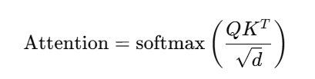

While this mechanism works exceptionally well on short sequences, it begins to break down as sequences grow very long.

There are several reasons for this:
- Distant tokens produce small dot-product scores: As the model processes more tokens, the hidden representations of earlier tokens drift farther away in the embedding space.
This means the dot products between the current query and earlier keys become numerically very small, even if the earlier information is still relevant.
- SoftMax suppresses small scores even further: SoftMax exaggerates the difference between the most significant and most minor scores. So, if earlier tokens already have smaller dot-products, softmax turns them into almost negligible weights, making the model effectively “blind” to the earlier part of the sequence.[4]
- Gradients diminish early tokens during training: Early tokens contribute less to the loss during backpropagation. As a result, the model gradually becomes biased toward learning patterns from more recent positions. This creates a built-in recency bias during both training and inference.
- Positional encodings weaken long-range interactions. Even sinusoidal or positional embeddings do not address this issue. The positional distance between tokens affects their attention compatibility, meaning the model naturally favors nearby tokens.

Practical Consequences of Attention Decay:
These mathematical effects lead to several consistent real-world observations:
- Early 1–3k tokens are almost ignored when the total sequence length exceeds 8k or more.
- Even long-context models (32k, 128k, 1M) show uneven recall, with sharp drop-offs in attention for early segments.
- LLMs struggle to combine information across distant parts of a text because the attention mechanism does not preserve strong links over long ranges.
Transformers were not designed for stable long-range memory. They work like short-term memory systems, not long-term reasoning systems. Human cognition handles long streams of information using a completely different strategy from transformers. Instead of treating every word as part of one giant sequence, humans naturally:[5]

- Segment information into episodic events
We break continuous experience into meaningful chunks: conversations, scenes, actions, locations, emotional moments, etc. These become memory units, not individual tokens.
- Store events in long-term memory, not short-term working memory: Once an event is encoded, it becomes a stable memory trace that can be recalled long after the original experience. We do not rely on the continuity of recent tokens.
- Retrieve memories based on context, similarity, and relevance: When thinking about a question or topic, humans recall related memories, not just recent ones. Retrieval is driven by semantic relevance, emotional salience, associations, and learned importance. This is very different from transformers, which retrieve based on token proximity.

This relates to EM-LLM and the Need for CXR: The EM-LLM paper already attempts to mimic some aspects of human episodic memory. It segments input using surprisal signals and refines event boundaries using graph metrics. It stores crucial events in a memory system and retrieves relevant events when needed.
However, EM-LLM does not connect retrieved events. Each memory block is treated as an isolated piece of information. Humans, on the other hand, almost always reason by linking related events, forming chains of meaning, and merging memories when necessary. This is precisely the missing capability that the Cross-Event Reasoner provides.

CXR allows the model to:
- Compare events to each other
- Discover relationships between them
- Fuse or combine related events
- Re-rank memories based on structural importance
- Perform multi-hop reasoning across multiple events

Thus, CXR brings EM-LLM closer to true human-like episodic reasoning.

EM-LLM Architecture:

The Episodic Memory LLM (EM-LLM) is designed to overcome one of the most fundamental limitations of transformer-based models, their inability to maintain and utilize long-range dependencies. Instead of forcing the model to attend over the entire input sequence, which becomes computationally expensive and suffers from attention decay, EM-LLM restructures how long text is processed. EM-LLM enhances the transformer by introducing a dedicated episodic memory subsystem that mirrors how humans process continuous information. Instead of treating a long text as a flat sequence of tokens, EM-LLM breaks the text into discrete events, stores these events efficiently, and retrieves them intelligently when needed.
Below is a deeper explanation of each component of the EM-LLM architecture.[6]

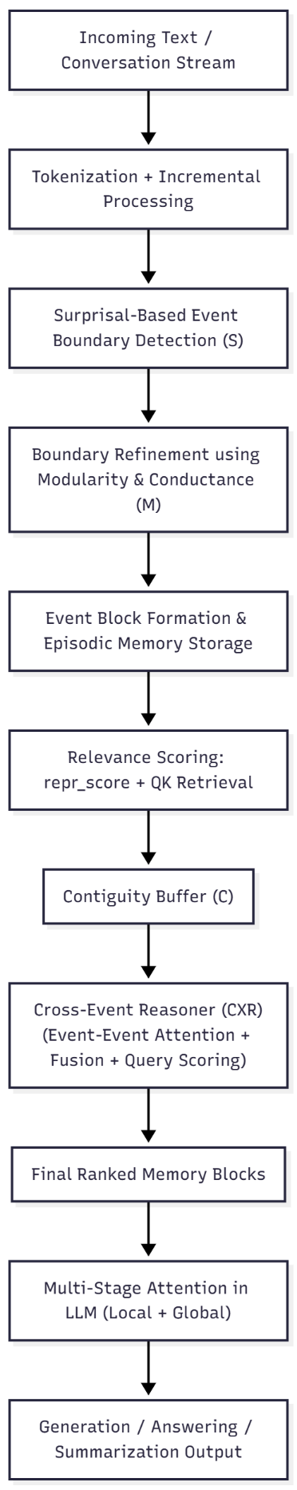
Figure 1. EM-LLM System Pipeline

  - Surprisal-Based Event Segmentation (S):

A core insight from cognitive science is that humans perceive experiences as a sequence of events rather than as continuous streams of raw sensory input. EM-LLM brings this principle into machine learning by using surprisal as a signal for detecting event boundaries. Surprisal measures how “unexpected” the next token is to the model:
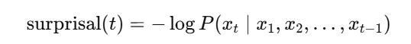

A low surprisal value indicates that the token was expected based on previous context. High surprisal value means the token was unexpected and may indicate a shift in topic, context, or narrative. Natural language often contains sudden transitions, topic shifts, new characters, new scenes, and surprising facts. Humans intuitively recognize these as boundaries. Surprisal gives a mathematical equivalent of this intuition.[6]

  - Graph-Theoretic Boundary Refinement (M):

It was disabled in the public implementation but described as essential in the original EM-LLM paper). While surprisal detects coarse boundaries, these raw boundaries may be noisy or misaligned with true semantic changes. The EM-LLM paper, therefore, adds a refinement step that uses graph-theoretic metrics applied to hidden-state adjacency graphs from deeper transformer layers.

Metrics Used:
  - Modularity: Measures the strength of community structure. High modularity suggests the tokens belong to the same semantic group.
  - Conductance: Measures the quality of a boundary between two groups of tokens.
Low conductance = strong boundary = good event split.
  - Activation Adjacency Graphs: Token representations from layers 20–31 are used to compute token similarity graphs. These graphs are used to detect semantic clusters.

Surprisal captures unexpectedness, but semantic shifts may occur smoothly without large surprisal spikes. Graph metrics allow the model to identify gradual topic transitions, shifts in entity roles, changes in story setting, and structural breaks (such as section boundaries). Event boundaries become more accurate, resulting in cleaner and more coherent episodic memory blocks. This directly improves retrieval quality downstream.

  - Episodic Memory Storage:

Once events are identified, EM-LLM stores them in a long-term memory structure. Instead of keeping all past tokens in GPU memory (which is infeasible), EM-LLM compresses and organizes them. Each event is stored as a memory block containing:
- Key/Value tensors for transformer attention
- Token embeddings (for later similarity computation)
- A pooled representation (event-level embedding)
- Importance score (repr_score) based on past usage
- Length metadata, timestamp, and boundaries
- Optional offloading to CPU or disk for infinite context
This allows EM-LLM to scale beyond the fixed context window of standard transformers.

Memory Hierarchy: EM-LLM maintains two simultaneous memory stores:
- Local Context Window: A sliding window of the most recent tokens and its fully visible to the transformer.
- Global Episodic Memory: All past events stored in block form and retrieved only when relevant.

  - Retrieval Mechanism:

When answering a question or generating the next token, EM-LLM must choose which past events are relevant.
Retrieval occurs based on several signals:
- Representation Score (repr_score): Tracks how frequently an event was used in previous reasoning steps. Events with higher repr_score are considered more important.
- Query–Key Similarity (QK Retrieval): The current transformer query is compared with each event’s key representation. Higher similarity is responsible for higher relevance. It helps match up context-dependent information.
- Contiguity Buffer (C): Humans recall memories together with neighboring events.
EM-LLM mimics this by always retrieving events adjacent to the top-ranked ones.

Benefits of Retrieval:
- Reduces the memory footprint
- Enhances reasoning by showing the model only relevant portions of the past
- Avoids full-sequence attention
However, retrieved events are still treated independently.

  - Multi-Stage Attention:

The final step in EM-LLM’s pipeline is its multi-stage attention mechanism, which incorporates:
Local attention which is applied to the current window and Global attention applied to retrieved event blocks. Aggregation is attention outputs from local and global stages are merged.
This gives transformers an extended receptive field still, the memory blocks are interpreted in isolation, limiting model reasoning.

Key Limitation: No Cross-Event Reasoning

Although EM-LLM significantly improves scalability and long-context retention, a fundamental limitation remains that retrieved events do not interact with one another. The system treats each event as an independent memory block. Even if two events contain related or complementary information, EM-LLM fails to connect them.

Example of Failure:
Event 1: “John left his keys at home.”
Event 2: “John could not open his office.”
A human immediately infers: John couldn’t open his office because he forgot his keys. EM-LLM retrieves both events but since they are processed independently, the model does not connect cause and effect, does not build a reasoning chain, does not fuse the two events, may fail the question: “Why couldn’t John open his office?”
The model selects the N best events, but they never communicate with each other. There is no event–event relational modeling present. There is no mechanism to determine whether Event A is related to Event B, whether two events should be combined, whether multiple events support the same answer. Transformers see them only as separate context pieces. During the multi-stage attention phase, each event is just another block of K/V states. The model does not know which events relate to each other. Multi-hop reasoning is impossible. Many tasks require information to be assembled across multiple events.[7]

For example: Seeing a café reminds you of a meeting, that meeting reminds you of a conversation, that conversation reminds you of a decision you made. This associative chain is missing in EM-LLM. To address this major gap, the EM-LLM architecture needs a reasoning layer that models relationships between retrieved events, builds an event-interaction graph, fuses related events, re-ranks events based on structural importance, links evidence across multiple blocks, and produces a coherent memory representation before attention. This leads directly to the development of the Cross-Event Reasoner (CXR), the core contribution of the work.

Cross-Event Reasoner (CXR):

A primary limitation of the EM-LLM architecture is that, although it successfully segments long text into events and retrieves relevant ones, the retrieved events are treated as independent memory blocks. The model never analyzes how these events relate to each other, whether they refer to the same entities, or whether two events together form a reasoning chain. This prevents EM-LLM from performing the type of association-based reasoning that humans naturally use when understanding stories, explanations, or multi-hop questions. The Cross-Event Reasoner (CXR) addresses this limitation by enabling explicit interaction, comparison, and composition of memory events before they are passed into the LLM’s attention mechanism. Instead of simply retrieving and concatenating events, the CXR transforms them into a structured, context-aware representation that captures relationships across events. This extension elevates EM-LLM from a memory retriever to a true memory reasoner.[2]
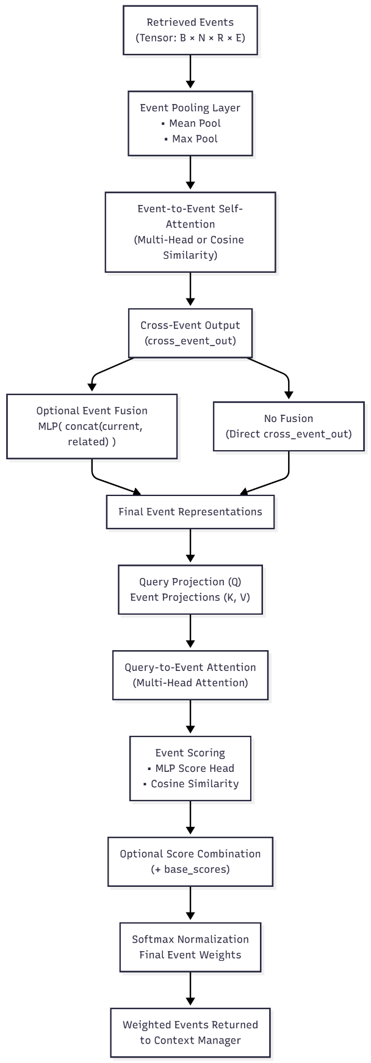
Figure 2. Cross Event Reasoning Internal Architecture

CXR is inspired by how humans recall and combine memories. When we try to answer a question, we do not recall isolated pieces of information. Instead, we retrieve several related memories and mentally link them together.

For example:
- “Alice met Bob at Café Central.”
- “Café Central is located on Baker Street.”

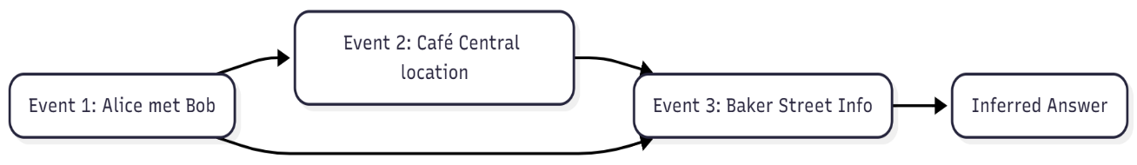
Figure 3.Multi-Hop Reasoning Example

Humans naturally infer the connection: Alice met Bob on Baker Street. EM-LLM, in its original form, retrieves such events independently and leaves the responsibility of connecting them to the transformer model. However, when these events are hundreds or thousands of tokens apart, the transformer often lacks the ability to form such connections effectively. The CXR inserts a small but powerful reasoning module between retrieval and attention, ensuring that events first undergo interaction, linking, and relevance scoring before the LLM consumes them. This dramatically improves the model’s ability to perform multi-hop reasoning and extract information spread across multiple events.

- Step 1: Event Representation Pooling:
Each event retrieved from EM-LLM’s episodic memory contains many token-level embeddings. Passing all tokens through CXR would be inefficient and unnecessary. Therefore, CXR summarizes each event into a compact vector using pooling mechanisms such as:
- Mean pooling of token embeddings
- Pooling over K/V states
- Other aggregation strategies
This produces a single vector per event that captures its core meaning. These vectors act like the “gist” representation of each memory event, comparable to how humans remember the overall content of an episode rather than the exact sentence structure.

- Step 2: Event-to-Event Multi-Head Self-Attention:
Once the event summaries are prepared, CXR applies multi-head self-attention across all retrieved events. This allows each event to attend every other event and determine their relationships. [8]
Through this process, the CXR discovers:
- if two events refer to the same entities,
- if one event expands on another,
- temporal or causal relationships,
- topic continuity,
- cross-references in narrative or factual data.

This step produces a cross-event relationship graph, a structure that establishes how events cluster or connect. This is crucial for long-context understanding, where relevant evidence is rarely located in a single event.

- Step 3: Event Fusion:
In many cases, two or more events may describe complementary aspects of the same situation. For instance, a biography may introduce a character in one paragraph and represent their profession in another. Instead of making the model attend to these separately, CXR fuses strongly related events into a single enriched representation. This is done by concatenating the related event vectors and feeding them through a small MLP to generate a new fused vector. The fusion process mirrors the human cognitive mechanism of recollection, where multiple connected memories blend into a unified understanding.[9]

- Step 4: Query-Conditioned Scoring:
Even after identifying relationships among events, CXR must determine which of them help answer the current question or continue the generation. To achieve this, the current query representation (from the LLM’s internal state) is compared with each event using cosine similarity, or a small trainable scoring head. This produces a relevance score that reflects how closely each event aligns with the model’s current objective. Thus, the selection of events becomes not only structure-aware (via event-to-event attention) but also context-aware (aligned with the user query or decoding state).

- Step 5: Final Event Reordering and Pruning:
Finally, the CXR combines three different types of signals into a single score, the original EM-LLM retrieval score, structural importance from event-to-event relationships, query-conditioned relevance from the comparison step. Events with the highest combined scores are kept and ordered first; irrelevant or weakly related events are dropped. Only this refined and structurally enriched memory representation is passed into EM-LLM’s multi-stage attention. This produces a smaller, cleaner, more coherent, and more relevant memory set. As a result, the transformer receives not just a list of events, but a contextually organized and relationally connected set of memory representations.

The CXR addresses EM-LLM’s limitations and brings the model closer to human-like episodic memory and associative reasoning. It replaces flat, unstructured memory output with a relational, context-aware representation, enabling more profound understanding and more accurate long-term reasoning.

Implementation Plan:
Phase 1 - Baseline Restoration (S + M + C):
Tasks:
- Re-enable graph metrics (modularity, conductance)
- Fix event segmentation pipeline
- Restore contiguity buffer
- Validate performance

Phase 2 - Cross-Event Reasoner Implementation:

Modules to implement:
- Multi-Head Attention Layer
- Use PyTorch nn.MultiheadAttention
- Input: event vectors
- Output: updated event graph

Integration with EM-LLM:
- context_manager.py retrieval loop
- place CXR right before multi-stage attention

Phase 3 – Evaluation:
Datasets:
- HotpotQA
- 2WikiMultihopQA
- NarrativeQA
- QMSum
- LongBench summarization/memory tasks etc.
Metrics:
- F1
- EM (exact match)
- Rouge
- BLEU
- Event attention visualization

Phase 5 - Reporting
- Explainable attention graphs
- Fusion diagrams
- Final thesis report

Expected Results:
Quantitative
- +2 to +4 improvement in F1 for multi-hop QA
- Reduced hallucinations
- Higher recall for distant context
Qualitative
- More coherent narrative reasoning
- Better entity tracking across long texts
- Transparent visualizations using event graphs

Conclusion:
This research enhances EM-LLM by adding a fundamentally new capability, cross-event reasoning, which enables LLMs to connect, combine, and understand complex relationships across long contexts, like human episodic memory. By building the Cross-Event Reasoner and restoring the original EM-LLM’s intended features, this project provides a substantial, publishable advancement in the architecture of long-context LLMs.

References:

[1] A. Vaswani et al., “Attention Is All You Need,” Aug. 2023, [Online]. Available: http://arxiv.org/abs/1706.03762
[2] Y. Tay et al., “Long Range Arena: A Benchmark for Efficient Transformers,” Nov. 2020, [Online]. Available: http://arxiv.org/abs/2011.04006
[3] D. Bahdanau, K. Cho, and Y. Bengio, “Neural Machine Translation by Jointly Learning to Align and Translate,” May 2016, [Online]. Available: http://arxiv.org/abs/1409.0473
[4] Z. Dai, Z. Yang, Y. Yang, J. Carbonell, Q. V. Le, and R. Salakhutdinov, “Transformer-XL: Attentive Language Models Beyond a Fixed-Length Context,” Jun. 2019, [Online]. Available: http://arxiv.org/abs/1901.02860
[5] S. Sukhbaatar, A. Szlam, J. Weston, and R. Fergus, “End-To-End Memory Networks,” Nov. 2015, [Online]. Available: http://arxiv.org/abs/1503.08895
[6] Z. Fountas et al., “Human-inspired Episodic Memory for Infinite Context LLMs,” Oct. 2025, [Online]. Available: http://arxiv.org/abs/2407.09450
[7] Y. Wu, M. N. Rabe, D. Hutchins, and C. Szegedy, “Memorizing Transformers,” Mar. 2022, [Online]. Available: http://arxiv.org/abs/2203.08913
[8] S. Sun, K. Krishna, A. Mattarella-Micke, and M. Iyyer, “Do Long-Range Language Models Actually Use Long-Range Context?,” Sep. 2021, [Online]. Available: http://arxiv.org/abs/2109.09115
[9] P. Veličkovi´veličkovi´c, G. Cucurull, A. Casanova, A. Romero, P. Lì, and Y. Bengio, “GRAPH ATTENTION NETWORKS.”

