odl_user_898865@simplilearnhol55.onmicrosoft.com

dpco23BCX*7F

Deployment ID- 898865

azureuser

xzjj66OJP*5N

labvmiptcszltbxzsroe.eastus.cloudapp.azure.com

User 1

User 2

User 3

User 4

User 5

Group 1

Group 2

Group 3

Group 4

Group 5

________________

Subscription 1

RG1

RG2

RG3

Subscription 2

RG4

RG5

__

Start with

Create Management Group

Subscription group 1

RG1 -- Group 1 - User 1

RG2 -- Group 2 - User 2

RG3 -- Group 3 - User 3

Subscription group 2

RG4 - Group 4 - User 4

RG5 - Group 5 - User 5

***to save time and easy managemnt

***Avoid adding multiple users

________________________________

Need to study

More on Storage

Redundent storage

Cross Region replication

https://learn.microsoft.com/en-us/azure/reliability/cross-region-replication-azure

Subscription and servie limits

________________________________

Topics:

1. Azure Address

2. Azure Virtual MAchine

3. High Availability

4. Storage and Redundency

5. VM

6. Virtual Network

Representation of your own network in cloudapp

CIDR (ClassLess Interdomain Routing)

Address Space: 10.0.0.0/16

Subnet: Vnet segmented into one ot more subnets

Service Endpoint - Extends vitrual network to service

1 NSG can be applied to per subnets

VNIC is attached to VM's for network Traffic

7. Network Security Group (NSG)

A service to limit the network traffic to resources in Virtual network

1 nsg per subnets

inbound and outbound rules

8. Axure load Balancer

High availablity and Network Performance to the application

OSI layer 4

Frontend --> LoadBalancer --> LD rule and Health Probe ---> Backend tool (VM's)

***Health Probe to check the healh of VM

** Multi tier application

PIP-- Public IP

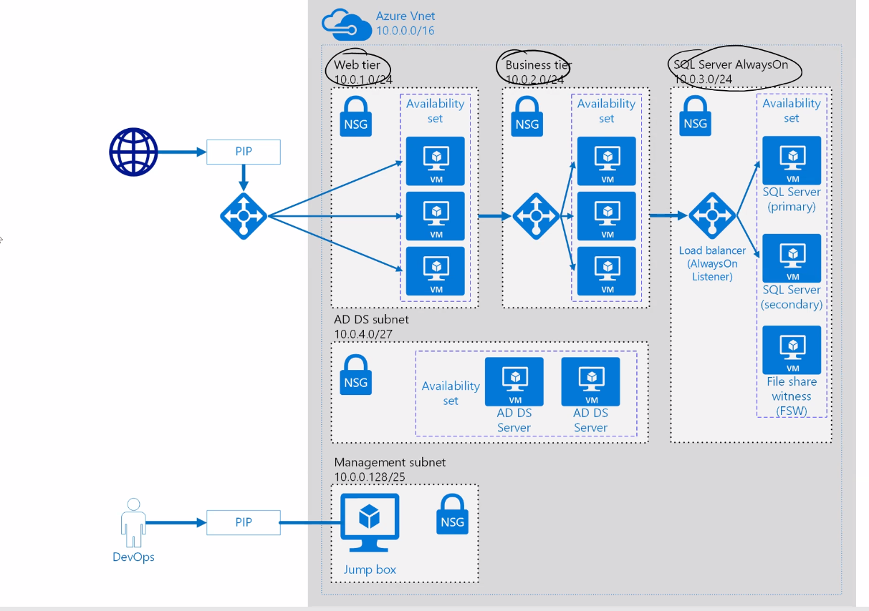

9. Azure App Service

PaaS from MS to deploy, design and scale ewb apps

App Service

App Servie Plan

App Service

VScode

Github

FTP

Containers if u wanna manage the backend

AKS when micro services are required

Container Instance

AKS

______________________________________