BGB’s CYD Remote Controller for Robots
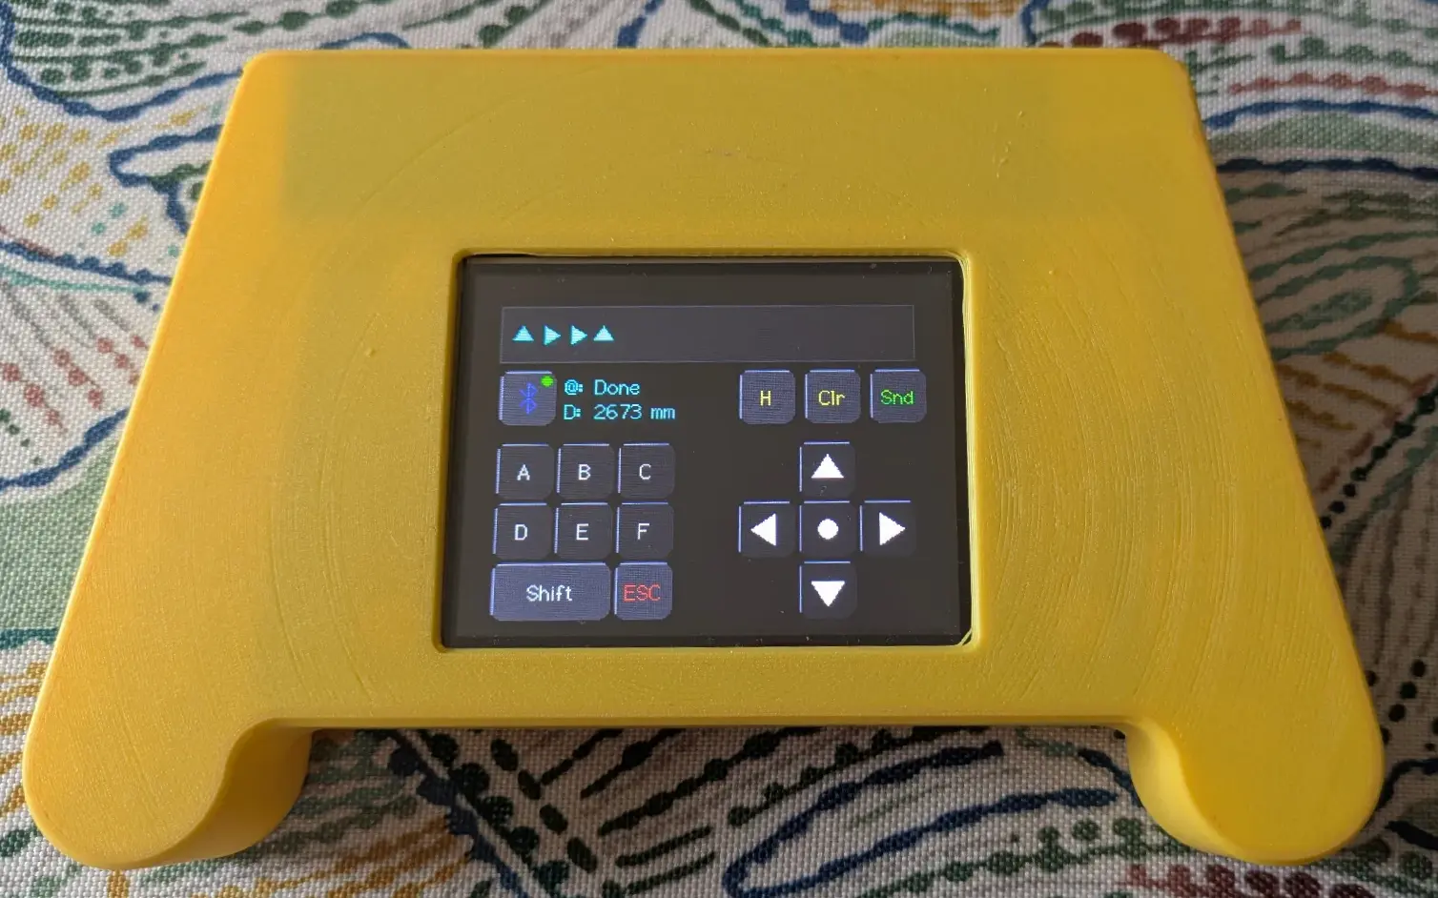
Hardware remotes are complicated to build, smartphone app remotes aren’t always practical or appropriate for children, and neither expose the full potential of programmable robots like OTTO and QB. I wanted an easy to build standalone, inexpensive, tactile device that gives even children full control of the robot. I also wanted a remote that not only moves the robot, but also provides a degree of two way interaction, and provides even young children with the ability to “program” sequences of robot movements and functions.
The ESP32 "Cheap Yellow Display" (CYD) allowed me to build a versatile, Bluetooth-enabled controller that ticks many of the boxes. BGB’s CYD Remote Controller has several unique robot-friendly features:
- Tactile Sequencing (Q Mode): This is the feature I’m most proud of. In Queue mode, the controller stores up to 12 commands, which are displayed on the screen but are only only executed when [Send] is pressed. This mode requires that the child or a person who may not know how to code to visualize the path and think in sequences—the fundamental logic of programming—before the robot ever moves.
- Direct Control (H Mode): History mode sends each command immediately after each button is pressed and displays the last 12 commands sent, providing a clear visual record of the interaction.
- Two-Way Feedback: The display shows real-time data coming back from the robot, for example, status reports such as "Waiting” or “Moving”, or sensor readings like HC-SR04 distance readings. This turns the controller into a window into the robot’s "brain."
- Autonomous Routines: A dedicated keypad allows the user to trigger up to 12 pre-programmed routines, like Obstacle avoidance or the "Hokey Pokey" dance shown in the videos.
Photographs, STLs, Arduino code, and full instructions are all available on Printables for anyone to build, modify, or use as a teaching tool. BGB CYD Remote Controller for Robots
Links to Videos of the Controller in Action
- BGB CYD Remote controlling QB in "H" mode Shows initialization, HC-06 connection, the status display, and direct control of movement. QB dances the Hockey Pokey after ‘c’ is pressed on the key pad.
- BGB CYD Remote controlling QB in "Q" mode Shows the same sequence of movements and the Hockey Pockey, but this time the sequence of moves is entered in Q mode. QB does not move until the [Send] button is pressed.

