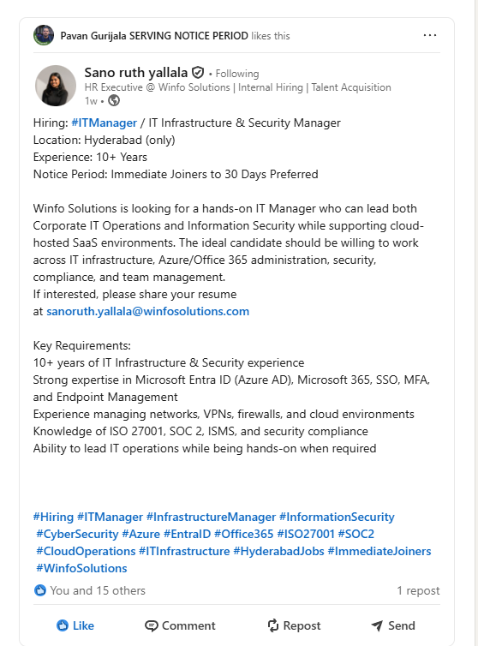
Home - Winfo Solutions

Hiring: hashtag#ITManager / IT Infrastructure & Security Manager
Location: Hyderabad (only)
Experience: 10+ Years
Notice Period: Immediate Joiners to 30 Days Preferred
Winfo Solutions is looking for a hands-on IT Manager who can lead both Corporate IT Operations and Information Security while supporting cloud-hosted SaaS environments. The ideal candidate should be willing to work across IT infrastructure, Azure/Office 365 administration, security, compliance, and team management.
If interested, please share your resume at sanoruth.yallala@winfosolutions.com
Key Requirements:
10+ years of IT Infrastructure & Security experience
Strong expertise in Microsoft Entra ID (Azure AD), Microsoft 365, SSO, MFA, and Endpoint Management
Experience managing networks, VPNs, firewalls, and cloud environments
Knowledge of ISO 27001, SOC 2, ISMS, and security compliance
Ability to lead IT operations while being hands-on when required

winfosolutions.keka.com/careers/jobdetails/125726
Role Summary
We are looking for a hands-on IT leader to own Winfo's digital foundation end-to-end — corporate IT, network and endpoint security, and the operations of our SaaS products hosted in the cloud. The role is both a builder (maturing our ISMS, hardening cloud workloads, scaling IT for a growing consulting + product workforce) and an operator (keeping employees productive, customers' SaaS environments reliable, and audits clean).

Key Responsibilities
1. Corporate IT & End-User Computing
- Own laptop lifecycle, MDM, identity (Entra/AD, SSO, MFA), email, collaboration (M365), and helpdesk for all Winfo employees across India and overseas locations.
- Manage office network, Wi-Fi, VPN, firewalls, and physical IT infrastructure at Hyderabad and other sites.
- Drive employee onboarding/offboarding from an IT and access-control standpoint.
2. Cloud & SaaS Operations
- Operate the cloud infrastructure (Azure/AWS/OCI as applicable) hosting Winfo's SaaS products — uptime, monitoring, backups, DR, patching, cost governance.
- Partner with product engineering on environment hygiene, secrets management, network segmentation, and production access controls.
- Build incident response, on-call, and change-management practices for customer-facing workloads.
3. Information Security & Compliance
- Own the ISMS — drive and maintain ISO 27001 and SOC 2 Type II certifications, including policies, controls, internal audits, evidence collection, and external auditor engagement.
- Run vulnerability management, endpoint protection (EDR), email security, DLP, and access reviews.
- Lead customer security reviews and questionnaires; act as the security point-of-contact for enterprise customers and partners.
- Partner with delivery and product teams on secure SDLC, data classification, and customer data handling — especially for Oracle Cloud / EBS implementation engagements.
4. Governance, Risk & Vendor Management
- Maintain the risk register, BCP/DR plans, and run periodic tabletop exercises.
- Manage IT/security vendors, licenses, and renewals; optimize spend.
- Report security and IT KPIs to leadership.

