e
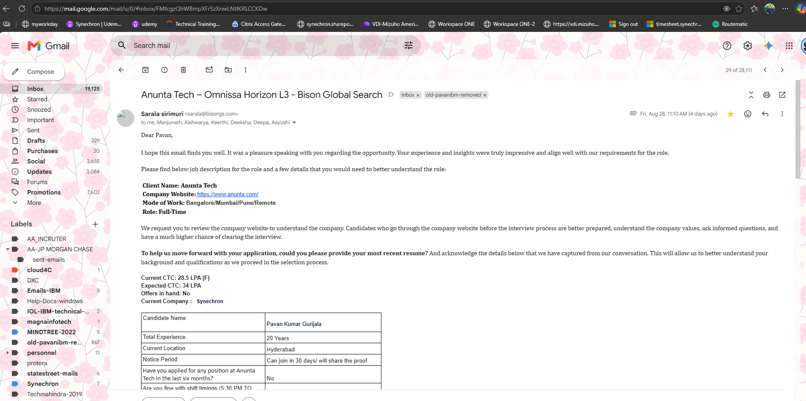

 | Fri, Aug 28, 11:10 AM (4 days ago)
  Sarala sirimuri <sarala@bisongs.com>
to me, Manjunath, Aishwarya, Keerthi, Deeksha, Deepa, Aayushi

Dear Pavan,
I hope this email finds you well. It was a pleasure speaking with you regarding the opportunity. Your experience and insights were truly impressive and align well with our requirements for the role.

Please find below job description for the role and a few details that you would need to better understand the role:

Client Name: Anunta Tech
Company Website: https://www.anunta.com/
Mode of Work: Bangalore/Mumbai/Pune/Remote
Role: Full-Time

We request you to review the company website to understand the company. Candidates who go through the company website before the interview process are better prepared, understand the company values, ask informed questions, and have a much higher chance of clearing the interview.

To help us move forward with your application, could you please provide your most recent resume? And acknowledge the details below that we have captured from our conversation. This will allow us to better understand your background and qualifications as we proceed in the selection process.

Current CTC: 28.5 LPA (F)
Expected CTC: 34 LPA
Offers in hand: No
Current Company : Synechron
Candidate Name | Pavan Kumar gurijala
Total Experience | 20 Years
Current Location | Hyderabad
Notice Period | Can join in 30 days/ will share the proof
Have you applied for any position at Anunta Tech in the last six months? | No
Are you fine with shift timings (5:30 PM TO 2:30 AM ) – Remote | Remote- Yes
How many years of hands-on experience do you have with VMware/Omnissa Horizon, and have you personally deployed or implemented Horizon infrastructure in a large enterprise environment? | Yes, hands-on with Horizon, vSphere, ESXi, and vCenter VMware, Nutanix, Horizon, Windows Server
Have you designed a Horizon solution or created HLD/LLD documents? What parts of the architecture/design were you personally responsible for? | Yes
How many years of experience in Omnissa Horizon L3 support/troubleshooting? | 6 Years
Do you have hands-on experience with the wider Horizon ecosystem— VMware vSphere/ESXi/vCenter, Omnissa DEM, Omnissa Workspace ONE Access? Which of these have you actually configured yourself? | VMware vSphere/ESXi/vCenter, Omnissa DEM
Total IT Infrastructure experience (8+ years)? | Yes, experienced with Windows Server 2008/2008 R2/2012 and Nutanix HCI, including Prism Central, Prism Element, and LCM.
Have you worked on Windows Server administration and Hyper-Converged Infrastructure (HCI)? | 20 years of hands-on experience with Windows Server
Do you have good knowledge of TCP/IP, DNS, LAN switching and routing? | Experienced with VMware switching and VLANs
Have you directly handled customers, OEMs/HW vendors and Microsoft/VMware support cases, Horizon log analysis and diagnostics? | Yes
Do you hold any relevant VMware VCAP/VCIX (Desktop & Mobility)/Omnissa/AWS/Azure certification? | Yes
Have you worked in hybrid cloud environments (AWS/Azure + On-Premises)? | Azure- 3.5 yrs
How many years of experience do you have with VMware Enterprise Products, EUC Horizon, Enterprise VDI? | 10+ years of hands-on experience with VMware Enterprise Products
Reason for job change? Any active offers or career gaps? | He is currently on bench looking for opportunities; he has no career gaps. He is open to negotiation.

--


  Sarala Sirimuri
  Senior Recruiter
  +91-8019735327 | Bison Global Search | sarala@bisongs.com | Bangalore

